Table of contents
List of illustrations Page 2.
Project proposal Page 3.
Digital & Hand drawn united Page 4-6
Eindhoven: A new perspective Page 7-16
Exploring emotional and multisensory design Page 17-18
Intended outcomes – proposal for collection Page 19
Bibliography Page 20
List of illustrations
Figure 1, Daniel Heath - Jay on apple branch.
Figure 2, Daniel Heath - Astoria Coffee Table
Figure 3, Daniel Heath – Bespoke bathroom project
Figure 4, Jan Koen Lomans (2017) Nocturne.
Figure 5, Jan Koen Lomans, (2018) Garden of Resonance, Authors own pictures.
Figure 6 & 7 Van Abbe Museum, Eindhoven, Authors own pictures.
Figure 8, Coffee Hub, Eindhoven, Authors own pictures.
Figure 9 & 10, Gusy Market, Authors own pictures.
Figure 11, Glossy Box, Authors own pictures.
Figure 12, Transient Matter – Youichi Sakamoto, 2018, Authors own pictures.
Project Proposal
As a fourth-year student and I am keen to ensure my portfolio, end of year show, and digital presence confidently translate who I am as a designer. I am extremely excited to immerse myself into this project, demonstrating the technical processes learnt whilst studying Surface Pattern Design, and how the research trip to Eindhoven at the start of the year has re-shaped my identity as a designer and essentially, my outcomes for Creative Venture.
Outcomes envisioned are to be a body of textile samples, exploring both hard and soft substrates. These samples will be a refinement on the innovative experimenting I have undertaken combining the digital laser engraver with my hand drawings. My portfolio will display these samples space-mapped onto a wide range of surfaces, from interior furnishings to exterior spaces, capturing the idea of sensory design and essentially promoting me as a versatile freelance designer.
Digital & Hand drawn united.
In much of my work, my creative journey begins with technical and material testing. Most recently this technical innovation has focused on the digital laser engraver. It is at this stage I am inspired the most. This period of playing, discovering, engaging with material and process is vital to me; exploring the effects of this technical process alongside materiality often informs the direction of my project. The design process proceeds with simplicity, my hands, pencil, and paper. This for me is an important stage in my practice, as I’m then able to apply my own designs to the technical knowledge I have discovered whilst testing. Within my Design Experiment, I began a journey to find balance between my drawing skill and the opportunity of technical processes. Lucy Johnson author of Digital Handmade, promotes the harmony between traditional hand craft and the power of technology, “In the right hands, these two contrasting approaches are combining in new ways to spark a renaissance in the art of making beautiful bespoke objects”, (Johnston, 2017, p.7). An example of this is Surface Designer, Daniel Heath. Heath combines his exquisite hand drawings, with techniques such as silk screen printing, and digital laser engraving, to create beautiful, bespoke interior furnishings. Heath works across soft and hard substrates, (wallpaper, linens, velvets, and harder materials such as slate, mirrors, and oak panels) which are made into one-off pieces. I am interested in the way he combines his hand-drawn illustrations with the digital laser technology. (figure 1).

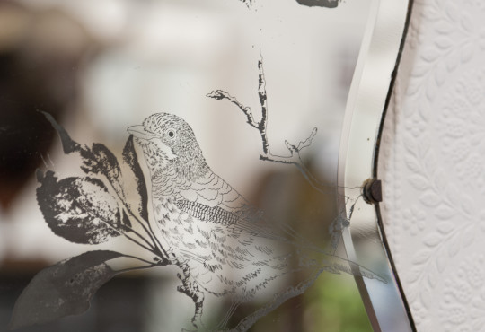
Figure 1, Daniel Heath, Jay on apple branch – Antique wall mirror.
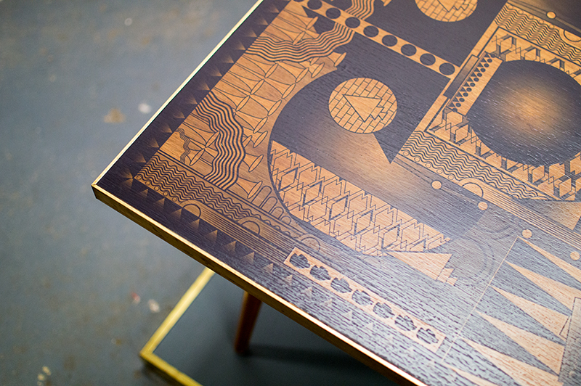
Figure 2, Daniel Heath – Astoria Coffee Table
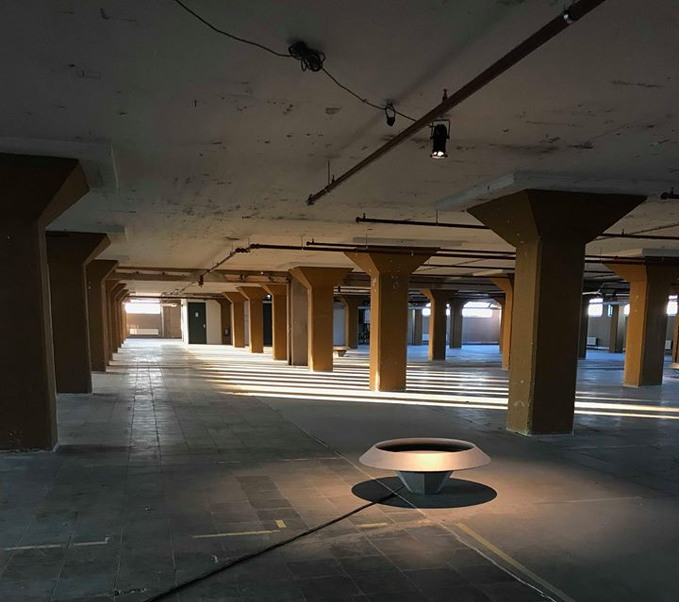
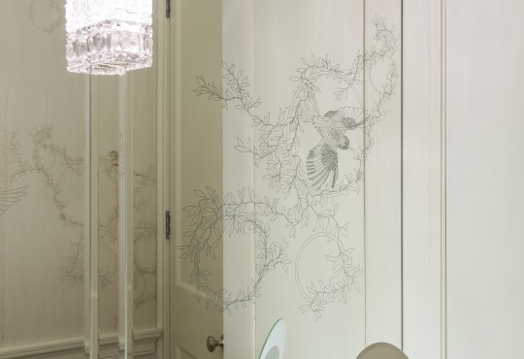
Figure 3, Daniel heath – Bespoke bathroom project, Hampstead Heath.
Heath expresses, ‘I think it is vital for artisans to ask what possibilities these new technologies might allow’ (Johnston, 2017, p.103). Heath’s statement resonates with me entirely, using the digital laser engraver to replicate my drawings, has empowered my drawing skill across a breadth of surface, which can then be specified for three dimensional products.
Eindhoven: A new perspective.
Mdes started with a research trip to Eindhoven. I was selected for this exciting opportunity to work with international Artist Jan Koen Lomans for Dutch Design week. My first experience with Lomans was within a lecture he presented at UWTSD in 2017. Within this lecture, he discussed his series of tapestries, ‘Nocturne’ (figure 4), pieces inspired by the birth, re-birth and transitions within nature. However, it was not the artwork in particular which fascinated me, more so, how it has meaning, beyond aesthetics. Lomans work has an abstract quality which is always deep in meaning and emotion. This resonated with my own ideas. I found myself fascinated and extremely curious by his choice in materials, ranging from cloth, lighting and glass, and it was essentially his lecture which inspired me to explore and expand my work thinking in different materials. Working alongside Lomans, within a different country, whilst exploring one of the biggest design fairs in the world, changed my perception of design completely. Insight, which I never would of comprehend without this experience.
(Figure 4) Jan Koen Lomans – Nocturne, 2017.
Working with Jan Koen Lomans in Eindhoven.
Lomans gave me insight regarding his success, his work process, and generally what it was like to be an Artist exhibiting at Dutch Design week, and when he is not. Lomans discussed how research is an extremely important aspect in his work, how nature is always the centre of this, and how he spends months prior to making, undertaking extensive research for his projects. He stresses the importance of collaboration, not just with like-minded individuals, but with specialists outside of your own field. I experienced this first hand as I met, and worked alongside his team, which included students from sound, lighting and technical engineering. This selection of cross disciplinary individuals meant there was no clashing of artistic ideas, simply problem solving and learning from one another, a positive cross pollination of ideas.
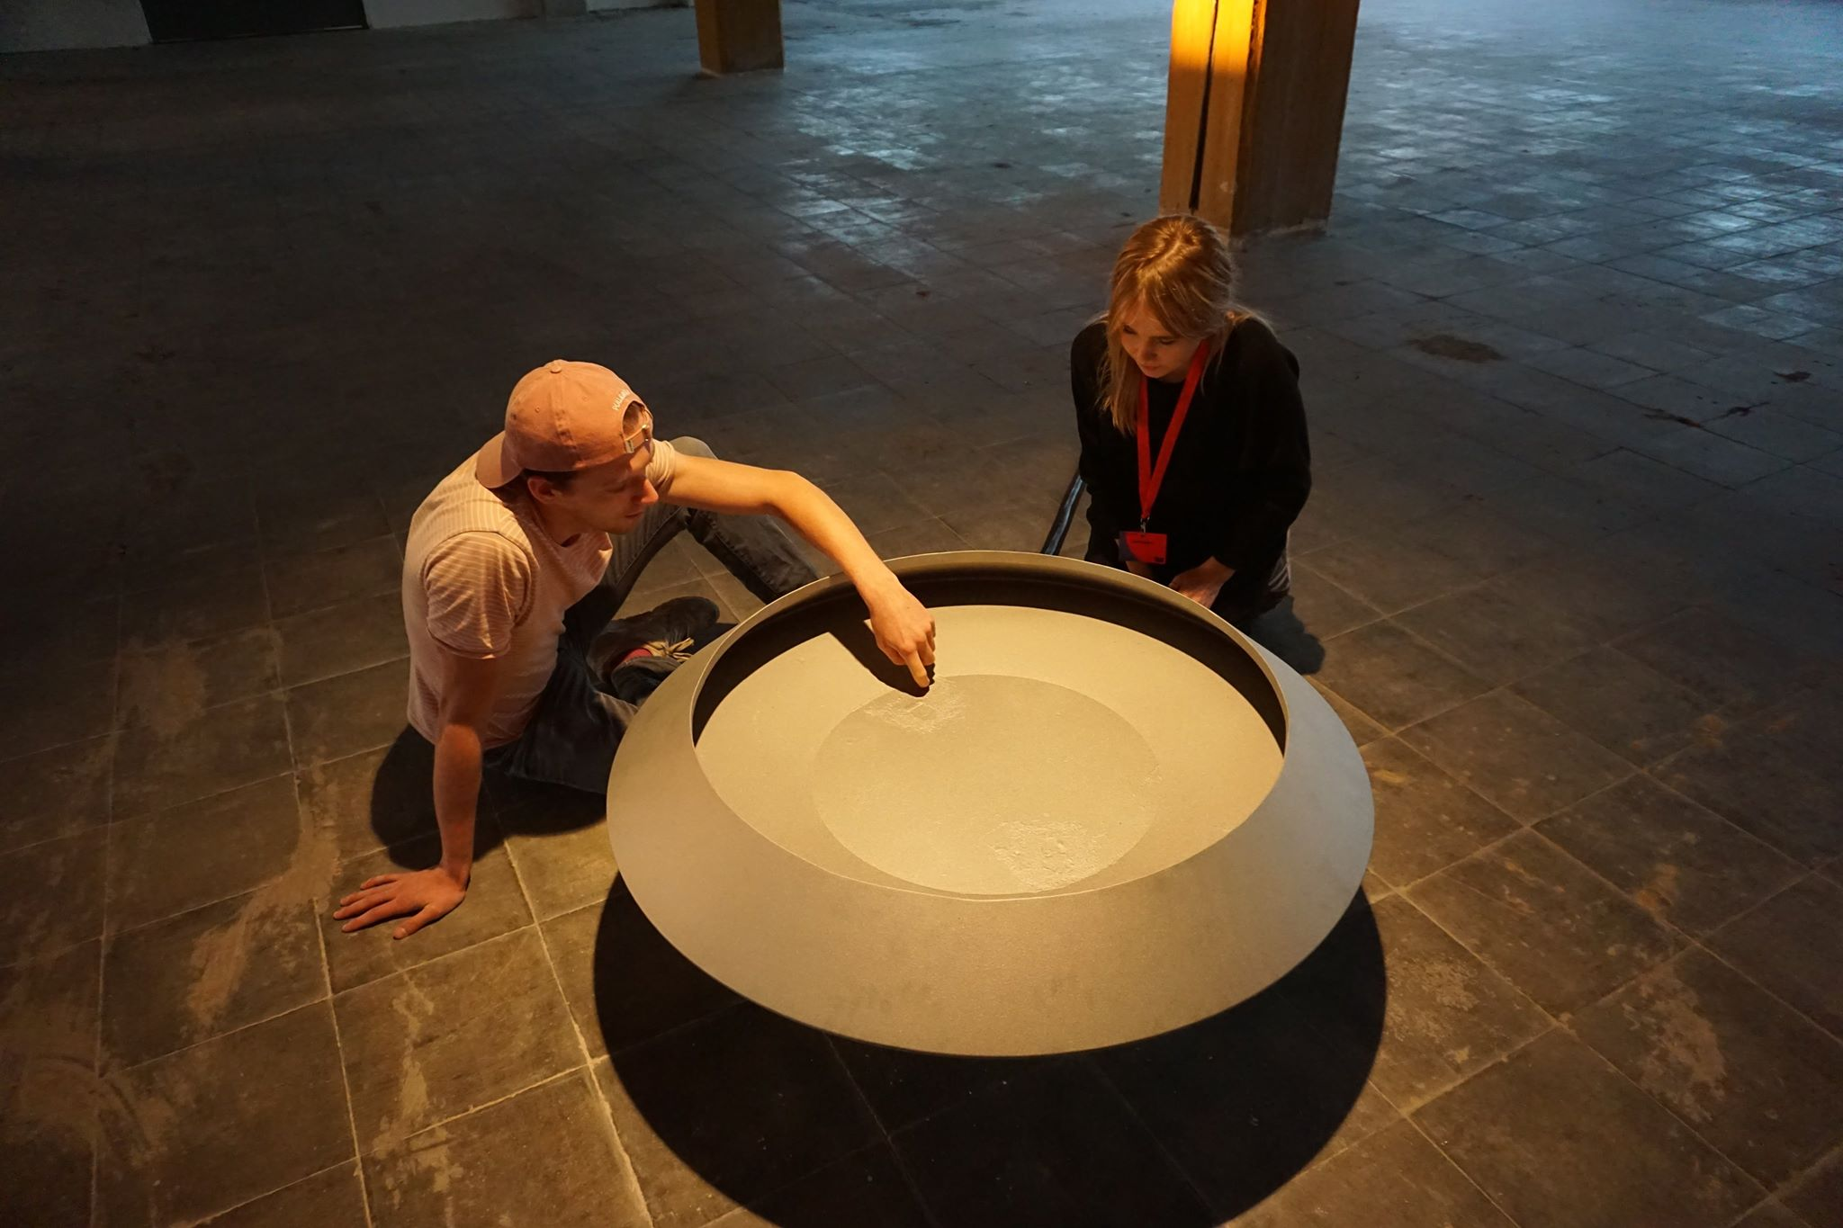
(Figure 5), JKL Studios, Garden of Resonance, (2018)
Our team worked on the Exhibition ‘Garden of Resonance (figure 5). The exhibition was dominated by sound. Large bowls within an even larger space, acting as speakers to exaggerate the minuscule sounds produced by nature, which were unheard by the human ear. This was meant to be a place of contemplation, unique for every person who entered. Some interactions were extremely positive, the people with open minds and who had taken time to read Lomans proposal, embraced his work. They lay next to the bowls with their eyes closed, entirely focused on the sound and their own thoughts, with that, there was positive feedback. Others stepped into the large space and because they could not understand what they were seeing in that moment, the connection was lost. Those people wandered around the room trying to physically touch the bowls, which was not permitted. As soon as they then realised the work was not interactive in that aspect, they became frustrated, lost interest, and hurried out of the room. I learnt a valid lesson in that moment. The majority of consumers look at art and allow their eyes to determine the interest or time they will offer to it. I understand, that the first form of contact we have with a design is through sight, and this forms that ever so important first impression. This corresponds with a piece written by Donald Norman within his book ‘emotional design’, according to Norman there are three stages in emotional design, “visceral, behavioural and reflective… visceral design is about initial reactions… good graphics, cleanliness and beauty play a role” (Norman, 2013, p. 67) Being aware that if I want my audience to fully engage with my work, I first need to draw them in, using design which is aesthetically pleasing and interesting. Hand drawn illustrations will play a large role here, along with colour choices, motifs and the presentation of my work. Thus, making my audience more receptive to engaging with it further, through the sense of touch. This leads me onto the next stage in Norman’s theory, behavioural design, “What matters here are four components…. Function, understandability, usability and physical feel” (Norman, 2013 p.70), by using the digital laser engraver combined with hand drawings, on materials such as velvet, glass, and wood, I’m able to challenge the tactile possibilities, completely unique to each material, responding to the heat of the laser. This will allow me to create interesting textures, which encourage my audience to feel, and hopefully ‘play’ with the outcomes. The final aspect within emotional design is considered reflective, Norman explains, “Reflective design is about providing a personal touch and a warm interaction… it is about the meaning of things, the personal remembrance some-thing evokes.” (Norman, 2013 p.87-88), creating work which not only entices my audience visually, but physically, as they touch, and create their own experience with the materials, will create a reflective and individual moment. One they create themselves and take away to keep.
Whilst in Eindhoven, I was inspired by the large art culture in the Netherlands. David Pye, author of ‘The Nature & Aesthetics of Design’, makes an important observation, “In towns there is hardly anything in sight except what has been designed… The man-made world, our environment is potentially a work of art, all of it, every bit of it’ (Pye, 2007 p.1), this concept was especially true within Eindhoven’s structure, and to me, it has earnt its label as ‘The City of Design”. (Daniel, 2018)
Innovative design is consistent throughout the city of Eindhoven, structures unlike anything I’d seen before. From museums, to high street shops. Countless buildings were made from glass, allowing people to watch the shifts in atmosphere through lighting, reflections and shadows. Free flowing plants were intertwined within modernistic steel structures, these man-made and natural combinations made indoor spaces calm and helped fuel creativity, in a way you felt at bliss. To better understand this effect, Stanley Abercrombie, author of ‘A philosophy of interior design’, best explains the impact plants have within interior spaces, “Plants can bring life to an otherwise static room… when thoughtfully chosen and thoughtfully placed, plants can evoke the bower, the walled garden, even Arcadia” (Abercrombie, 1990 p.139-142), Everything is strategically placed, Abercrombie furthers by explaining the health benefits of indoor plants, which include, the “oxygenation and purifying of air” (Abercrombie, 1990 p.142), the consciousness of the human health and organic living seems to be a matter of course throughout the city. This calmness and purified air wasn’t disturbed when you stepped outside, as the primary use of bicycles meant the ‘city’ like feeling was reduced. Eindhoven perfectly showcases the impact that design has within interior and exterior settings. This first impression to the city helped open and prepare my mind for all I was about to learn.
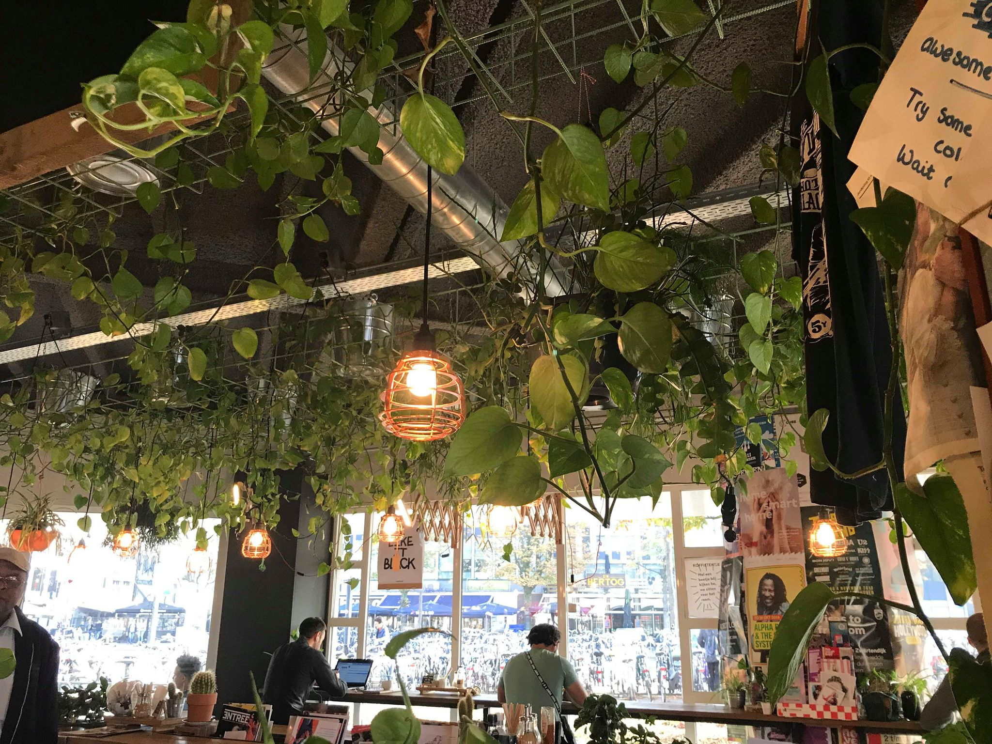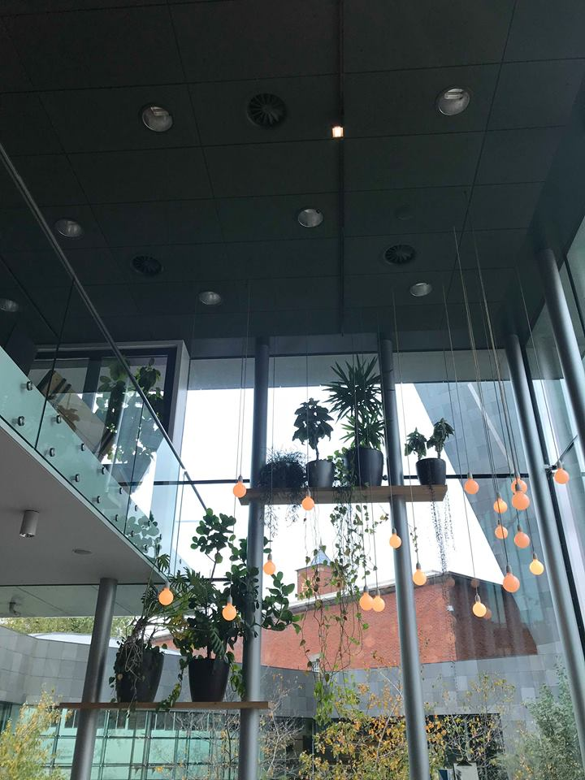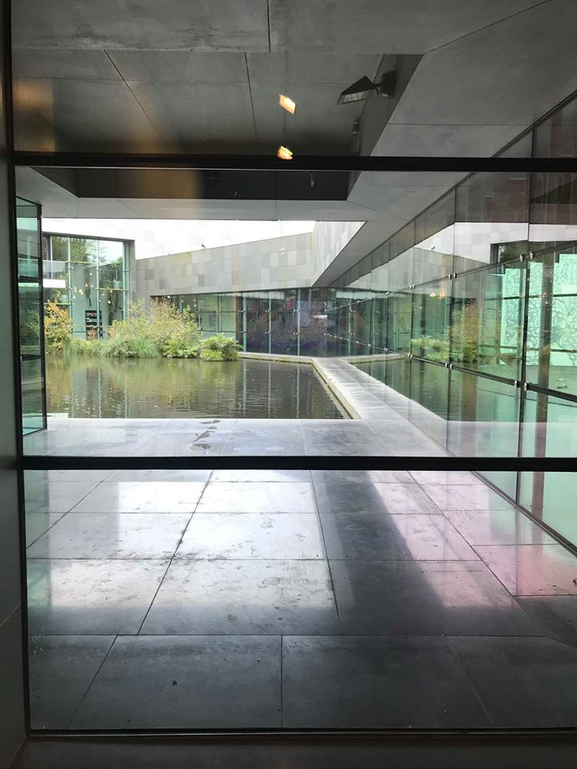
(Figure 6 & 7) Van Abbe Museum, Eindhoven–Natural/Man-made combinations
(Figure 8) Coffee Hub, Eindhoven – Free flowing plants within interiors.
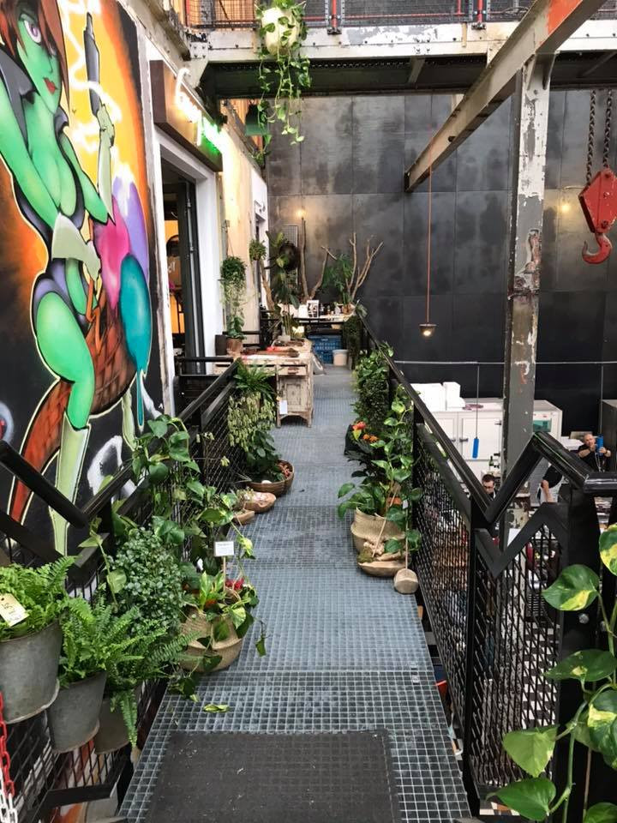
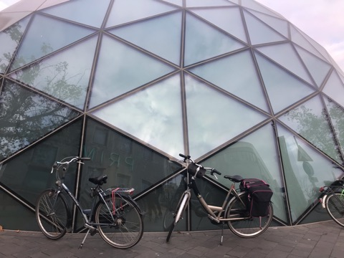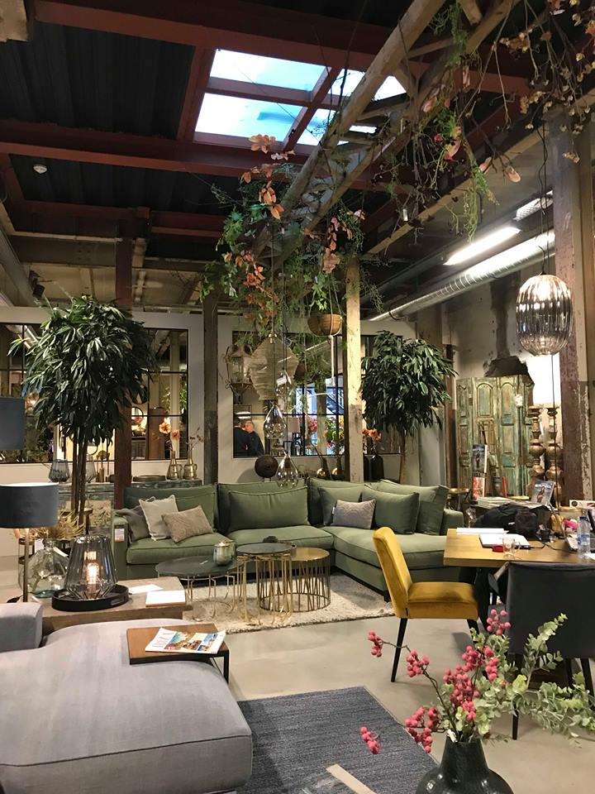
(Figure 9 & 10) Gusy Market, Eindhoven – Free flowing plants Indoors.
(Figure 11), Glossybox – High street shop.
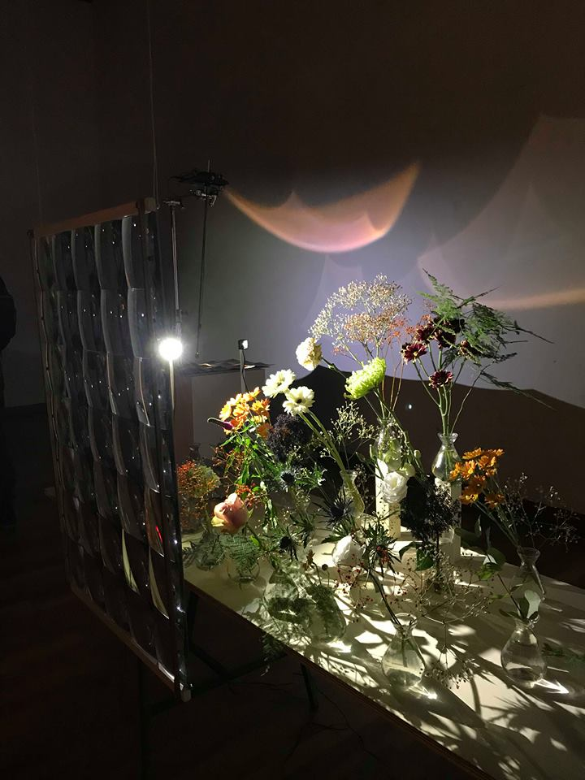I explored over 20 exhibitions in Eindhoven, all showcasing the world’s leading contemporary practitioners. From innovative textiles, to installation art, and product design which could shape the future. My exposure to Dutch Design Week reminded me of the important role we as designers have, challenging the environmental and political issues in the world, from conceptual to aesthetic art. Witnessing the sector has made me more aware of the design market, and in essence, I was reminded that design is constantly moving forward, striving to become more innovative, with this, so was I.
(Figure 12) Transient Matter – Youichi Sakamoto, 2018
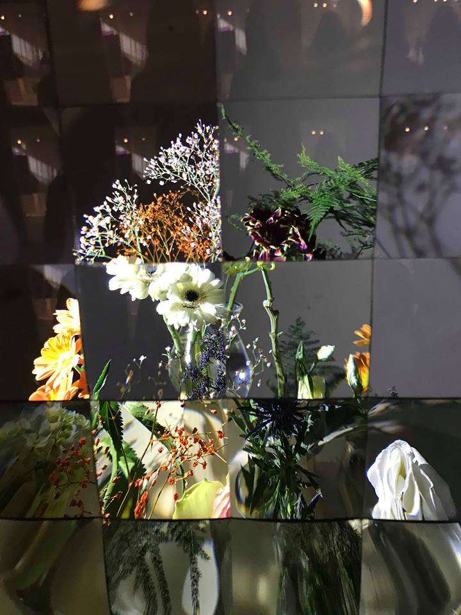
Transient Matter – Youichi Sakamoto, 2018
Transient matter: An example of visceral, behavioural and reflective.
The piece which impacted me the most from Dutch Design week, was part of the exhibition ‘9+1’. A collective, multidisciplinary project which comprised of interactive art pieces, built upon the principles of Japanese craft and advanced technology. The exhibition space was dim lit, which enhanced the exquisite cast reflections that were dancing along the walls, almost like electric waves, but elegant and fragile. This drew the audience in, wanting to discover more. I did not know then, but what was happening here was the first level in emotional design, ‘Visceral’. The first piece I was drawn to, was called ‘Transient Matter’ (figure 12). Light projected onto magnified panels of glass, windowing an array of fresh flowers. The floral arrangement began distorting and magnifying with your movement. The piece got more enticing the more you interact, 35 individual squares, almost like a mosaic painting, which was constantly shifting. This piece drew a large number of participants, and certainly captured the essence of ‘Behavioural’ design. The ‘Reflective’ level would be completely different for everybody in that room. For me, I left with a sense of joy, and a personal, emotional connection to the piece built on my engagement. The exhibition ‘9+1’ was a beautiful example of the potential between hand craft and technology. Allowing its audience to admire the beauty in botanicals and the simplicity in light, reflection, and interaction. Unlike a lot of the products I had been exposed to within Dutch Design week, the pieces within this expo did not hold a functional purpose, merely the enjoyment and interaction of the audience. My engagement with the pieces in this room, made the experience personal and memorable. I’d like to encourage a similar experience through my Creative Venture, through choice of materials and processes which create a sense of joy through play, creating aesthetically, physically and emotionally pleasing experiences
Creative Venture; emotional and multisensory design.
Being a designer is integrated into my soul. Naturally things happen in my life which alter the way I see design and how I wish to create it, for example my trip to Eindhoven. It is my ability to touch, to feel surfaces and textures in my surroundings which heighten my emotions and engagement most with the world, thus fuelling my creativity to produce work. This is a personal experience, entirely individual, but existent to a varying degree within everyone.
The botanical world has been source of inspiration within design amongst cultures and creative fields since early man.
I find myself captivated with the aesthetic fluidity and delicacy of plants. This inspiration is cause for the delicate drawing style I have developed to-date. Since exploring the ideas of emotional design, my fascination with botanicals has burrowed deeper than aesthetics. I have become particularly interested in the impact that plants have on our health and wellbeing, the study of pharmacognosy, which discovers the health benefits of plants, and the continuous life cycles, and transitions that occur within them. Humans are so engrossed with their beauty. Stanley Abercrombie explains this as, “plants appeal because like our-selves, they are a living part of nature, and “nature is beautiful”.” (Abercrombie, 1990 p.139). This ethos will help underpin the aesthetic of my Creative Venture, but I also aim to create tactile work around this theme which people can personally engage and interact with.
Touch will play a large role in this, drawing from my own desire to touch every art piece I encounter as example. This behaviour for me, was best explained by author Peter Dent. Within his book ‘Sculpture and Touch’.
Touch, touching and being touched are essential aspects for human existence’
…A large body of research demonstrates that tactile contact can have a positive
effect on our emotional and cognitive processes and our general well-being
(Dent, 2014 p.32/115).
Whilst researching the power of touch, I was keen to gain first-hand insight from somebody who appreciates and relies on touch more than the average person. I collaborated with Danielle Brewster, who is visually impaired and relies on touch to communicate with the world. Why is the sense of touch important to her? how could I help people with visual impairments through design? Danielle gave her perception on this, “Touching has to be my way of finding and coping with things. There are certain textures which, when they feel nice, they feel nicer than they would to the normal person. It is interesting to feel patterns, and by making things textural would make design more interesting for the visually impaired.” Danielle expresses how she appreciates the quality of fabrics such as velvets and soft silk, this is supported by Peter Dent who writes, ‘It has been shown that certain areas of the brain… respond to ‘pleasant touch’… such as the feel of velvet on the skin’ (Dent, 2014 p.116).
It is interesting to note that Danielle informs us, “People who see only light and dark, often enjoy reflective objects, things which catch the light”, Thus supporting my use of hard materials such as Glass, and possibly mirror within my Creative Venture.
It is important for me to generate ‘visually beautiful’ designs, as this will be the first impression for my audience, but I am keen to introduce multisensory qualities to my work. Encouraging an emotional and physical response, more than visuals could alone, and also engaging a wider audience, for people such as Danielle Brewster. ‘Allowing people to touch objects… increases the attention of the visitor and their subsequent ability to recall the experience (Dent, 2014 p.115), for me, this is validated by my own experience with the piece ‘Transient matter’ (figure 12).
Creative Venture Outcomes.
The exposure to the originality and level of design at Dutch Design week has propelled my own thinking, and the standard of work that I want to produce for Creative Venture. I am going to challenge my previous design ethos, which was primarily focused on aesthetics alone, by exploring the theory of visceral, behavioural and reflective design. Similar, to the exhibitions at DDW, I’m going to explore the possibilities of displaying my work within its own room. Thus, curating my own solo exhibition, which my audience can experience, without the distraction of others.
The space and format that my collection is presented in, will be well considered to ensure that my exhibitions’ environment has a strong emphasis on mood, lighting, physical touch, and engagement. To encourage interaction, I will visually communicate the permission to touch through the format of film, this possibly encountered before the work itself. The idea of this, is to ensure my audience do not see my exhibition as a visual representation of me, but, an invitation to engage with my work, creating a memorable experience for themselves.
The physical outcome of my Creative Venture will display a pharmacognosy narrative told through materiality, hand drawing, and the innovative technical and traditional processes I have learnt whilst studying. This diverse body of work will explore hard and soft substrates, to be considered for interior, and exterior settings. I will ensure my portfolio shows awareness of the commercial market within interiors, whilst also promoting myself as a designer who can take on bespoke, freelance projects.
Bibliography
Books
Abercrombie, S. (1990). A philosophy of interior design. 1st ed. New York: Harper & Row.
Dent, P. (2014). Sculpture and touch. Aldershot: Gower Publishing Co. Ltd.
Johnston, L. (2017). Digital handmade. 2nd ed. London: Thames & Hudson Ltd.
Norman, D. (2013). The design of everyday things. New York: Basic Books.
Pye, D. (2007). The nature and aesthetics of design. London: Herbert Press.

Websites
Daniel, D. (2018), Eindhoven, A city of Design [online] Available at: https://www.thisiseindhoven.com/en/start/editors-picks/inspiring-stories/eindhoven-a-city-of-design (Accessed 12/1/2019)

