
BA Business Management
LCBB5003 Management Economics

Assessment Component 1

Essay on

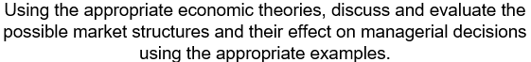

Contents
Introduction 3
Economic and Business Management 3
Economic Theories and Their Application 4
Understanding Market Structure 4
Types of Market 4
➢ Perfect Competition 4
Monopolistic: 5
➢ Oligopoly: 6
➢ Monopoly: 7
Duopoly: 8
Application of economic theories in decision making 8
➢ Pricing: 8
➢ Elastic vs Inelastic goods: 9
➢ Operations and production: 9
➢ Investments: 9
➢ Risks: 9
How managers use economics for decision making 9
Conclusion 10
References 11

Introduction

In the contemporary business world, the economic activity of almost every organization is concentrated at its core. From an analytical point of view, economics is a scientific area that studies the workings of the economy and the decisions that are made in it. The economic seed that was seeded in the business sector appears to have produced the progeny known as business economics, according to some sources. Management economics, sometimes known as applied managerial economics, is the branch of economics that combines elements of management and economics to form a cohesive whole (Jung, 2018). The concepts of business management and economics are linked within the field of managerial economics. It is the purpose of managerial economics to assist businesses in maximizing their earnings while consuming the least number of resources and labor as is practicable.

Economic and Business Management
Economics is primarily known to be concerned with the study of human behavior, movement, and cognitive processes as they occur in everyday life, which is the principal focus of the academic area. When it comes to making business-related decisions that have the potential to lead to expansion and development, management economics is to be studied. For instance, if a company's size and breadth increase, the managers realize that they needed to come up with practical solutions to satisfy the changing requirements of the business environment, and they set out to accomplish just that, partnering with consultants and other experts (Shepherd, 2017). Management economics necessitates that a decision is made after examining all of the available possibilities, and then determining which option is the best option among those options.
An organization's primary purpose is to make the most of limited resources such as labor, land, and money by utilizing them to their fullest potential. To ensure the greatest potential profit in the face of future uncertainty, the best solutions should be chosen, and it is vital that one exercise caution when making these decisions. Management economics and the concept of a business are fundamentally opposed to one another. In economic theory, the marginal income and marginal cost of a corporation are equated to estimate the output that will maximize profits (Shepherd, 2017). The need of being able to make solid decisions is emphasized in every discipline, including mathematics. People in business require economics to make decisions, which is why it is such a critical tool in their arsenal. Because of the constraints imposed by limited resources, many businesses are forced to strike a careful balance between competing aims to survive.

Economic Theories and Their Application
Economic theories study the functioning of the different economies that exist around the world. A business may use a range of theories to attain a variety of objectives, depending on their field of study and objectives. Applied economic theory to real-world conditions is the focus of management economics. It is possible to utilize statistical approaches in conjunction with a computer program to apply economic theory to decisions regarding pricing, operations, risk, investment, and production decisions (Casson, 2012).
Management economics makes use of three economic theories: neoclassical economics, classical economics, and classical economics. Neoclassical economics is the most widely used theory. It is the notion of the corporation that explains why businesses make the decisions that they take in their daily operations. Essentially, the decision-making processes that customers go through are described by this theory of consumer behavior. The economic theory that investigates how markets function and how businesses price their goods and services to maximize profits is known as market microeconomics.

Understanding Market Structure
According to the degree and type of demand for goods and services, market structure is a phrase used in economics to explain how distinct sectors are differentiated and separated from one another. Because each market has its own set of features, the conduct and consequences of a firm are affected by these differences (Jung, 2018). Evaluation of a market's buyer and seller populations, as well as their bargaining abilities, concentrations of buyers and sellers, and the ease or difficulty with which buyers and sellers can enter and depart the market are all significant.

Types of Market
- Perfect Competition: When there are a huge number of tiny businesses fighting against one another, this is referred to be pure or ideal competition, depending on who you ask. Because there aren't enough companies that can influence market pricing, if only one firm can influence market pricing, the industry will be able to produce the maximum amount of goods possible. Pricing in the market is determined by supply and demand, which have an impact on the number of things and services that are manufactured and the level of competition in the marketplace. Neither entering nor departing the market is complicated, and the products on offer are equal to those offered by competitors in terms of quality and functionality.
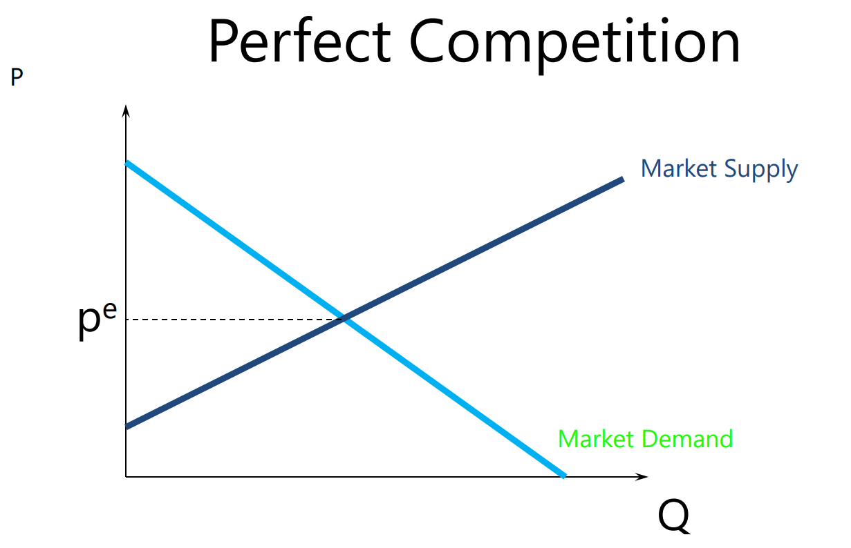
Market systems that are based solely on competition are extremely unusual to come across in today's society. Models such as this one may be useful when comparing companies that are similar to one another (Shubik, 2019). Although the profit margin is fixed in a perfectly competitive market, sellers are unable to raise prices without endangering their customers' business. The stock, agricultural, and craft markets are some of the most successful examples of pure competitive market systems that exist today.
Monopolistic: In economics, monopolistic competition is a word used to characterize an imperfectly competitive market that exhibits characteristics of both a market with a monopoly and a market with a competitive environment at the same time. Product quality and brand awareness are two of how vendors compete against one another in their respective markets. In this sort of competition, merchants assess the prices supplied by their competitors while dismissing the impact of their pricing on those of their competitors. When comparing the short and long term, the following two key characteristics of monopolistic competition can be identified: When it comes to maximizing short-term profit margins, monopolistic firms are the best in the business.
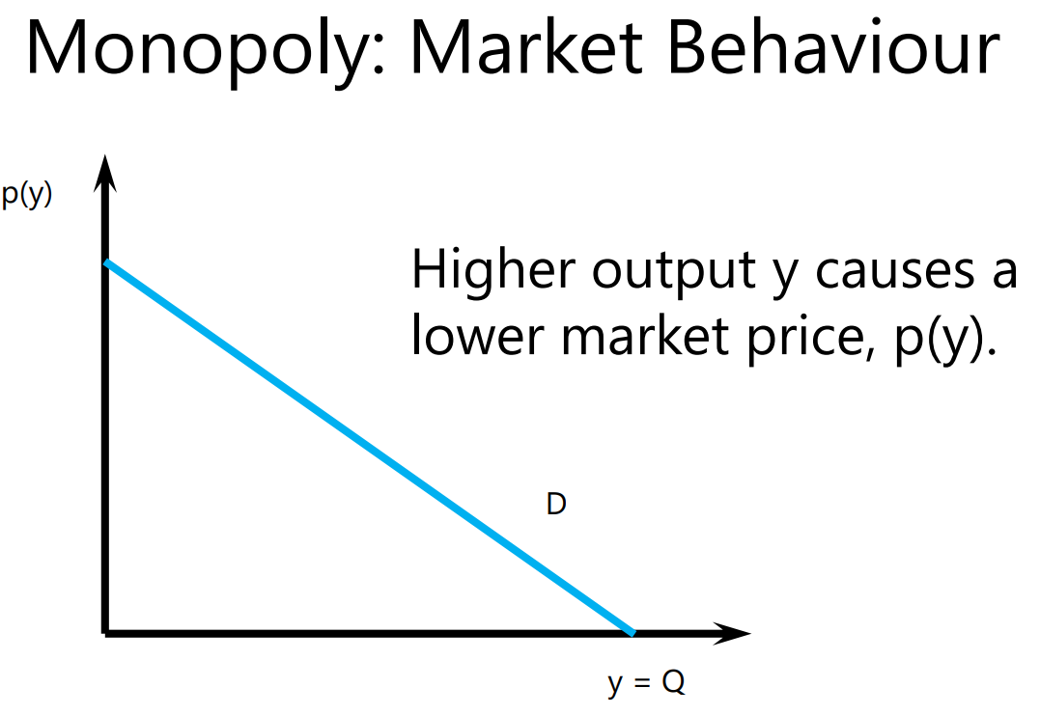
Among the types of businesses that fit under this category are restaurants, clothes stores, cereal firms, service, and repair marketplaces, tutoring companies, and beauty salons and spas, to name a few. Even though the products and services given by a beauty salon may be comparable, these businesses can differentiate themselves by providing value propositions to customers, such as high-quality treatments at an affordable price, their clients (Ricketts, 2012). This is because there is little difference between cosmetics and hair products in terms of what they are and how they are used, and they may even be in direct competition with one another in terms of price.
- Oligopoly: Such markets are characterized by the presence of a small number of important enterprises that compete against one another by offering items that are either similar to or identical to each other (Ricketts, 2012). A consequence of the limited number of participants is that their opposing methods become intertwined with each other. Businesses operating in a competitive environment may agree to share the market by restricting output, which may result in profits that are much higher than typical for the industry. To break into an oligopoly is a challenging endeavor. New competitors can’t enter the market because raw materials, patents, financial and physical resources are all concentrated in the hands of the largest businesses. This is one of the factors contributing to the high cost of living. If the price is too high, on the other hand, they will look for lower-cost alternatives to the product or service.
A homogeneous object differs from a distinct item in terms of size and shape. The number of dominant corporations varies from market to market, but it is typically between three and five in number in most cases. For example, Microsoft, Sony, and Nintendo control the video game console market, which is dominated by Sony and Nintendo. Microsoft also controls the video game publishing sector. Oligopolies can be seen in a variety of industries, including the automobile and petroleum industries, among others (Teece, 2011).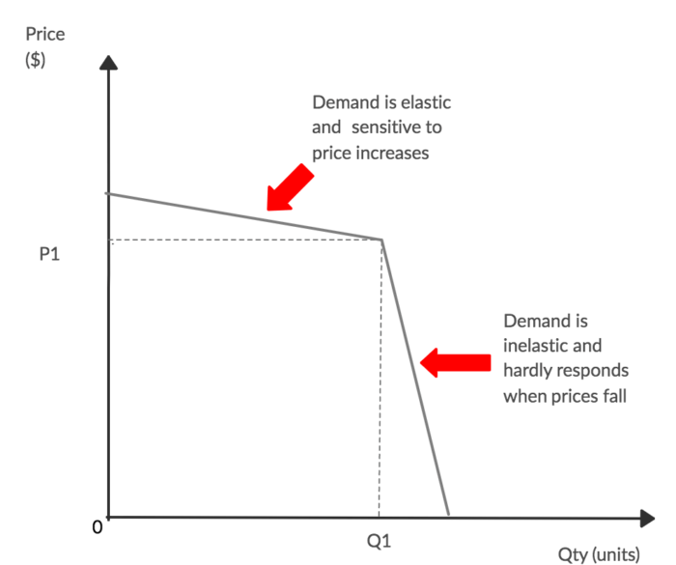
- Monopoly: In a monopoly market structure, one company represents the whole industry, and that company is only one among many. It also has no competition for its services, as it is the only vendor of goods in the entire market and the only provider of services. When it comes to this type of product market, elements such as patent and copyright ownership, government-issued licenses, and high starting costs all play a role in determining the competitive landscape. In light of the aforementioned characteristics, it is extremely difficult for any other company to enter the industry. The corporation will continue to function as an exclusive supplier to maintain its market dominance and the flexibility to set its tariffs for the services it provides.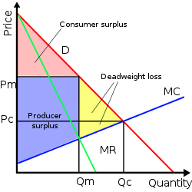
When a corporation has a monopoly, there are no other options for entering or exiting the market. Public utilities are referred to as natural monopolies because of the enormous economies of scale that they enjoy – a firm enjoys certain cost benefits as a result of its size – and because of the monopoly power they have over their respective markets. It is difficult for new businesses to enter the market because of the high costs associated with achieving scale in a short period. Therefore, natural monopolies are usually subjected to monopolies or rules established by the government on an as-needed basis.

Duopoly:
A duopoly is a situation where two companies together own all, or nearly all, of the market for a given product or service. A duopoly is the most basic form of oligopoly, a market dominated by a small number of companies. A duopoly can have the same impact on the market as a monopoly if the two players collude on prices or output.
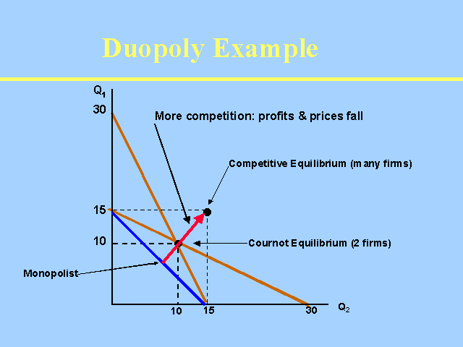
In a duopoly, two competing businesses control the majority of the market sector for a particular product or service they provide. A business can be part of a duopoly even if it provides other services that do not fall into the market sector in question. For example, Google and Meta (formerly Facebook) have dominated digital advertising for much of the 21st century, and function as a duopoly in that field. But Google is not associated with a duopoly in its other product sectors, such as computer software.

Application of economic theories in decision making
The use of statistical approaches in conjunction with a computer program can be used to apply economic theory to decisions relating to price and production decisions as well as operations, risk, and investment decisions (Rumelt, 2011). Management economics' primary goal is profit maximization, which is achieved by improving the effectiveness of business decision-making to increase profits.
- Pricing: To design price plans and set acceptable pricing levels for their products and services, small and medium-sized business managers rely on the assistance of economists. Many different pricing approaches are commonly used in the business world, including price discrimination, value-based pricing, and cost-plus pricing.

- Elastic vs Inelastic goods: The use of price elasticity studies in economics is a technique that economists use to determine how sensitive a product is to changes in its price. When it comes to necessities such as milk, the vast majority of people are willing to pay whatever price is necessary to ensure that they have access to these supplies (Keller, 2015). Inelastic products are products that do not have any elasticity to them and are therefore referred to as such. Recognizing that a business is producing an inelastic product makes making marketing and pricing decisions much simpler and less complicated.
- Operations and production: Optimization of production schedules, economies of scale, and resource analysis are just a few of the quantitative tools used in management economics to assess, among other things, the efficiency of production and operations. In addition, marginal revenue and operational leverage should be taken into account when determining profitability (Von, 2010). Having the ability to fine-tune a company's operations and output results in increased earnings while expenses are reduced.
- Investments: The use of management economic tools and analytical models to assist large corporations and individual investors with a great deal of experience can be extremely beneficial. Financial Instruments for Investing The use of these financial instruments is required for both stock market investments and capital investments in a company. A corporation can use managerial economic theory to help them decide whether to purchase or develop operations management equipment, or whether to lease it. For example, a corporation can use managerial economic theory to help them decide whether to purchase, develop, or lease operations management equipment.
- Risks: Risk Management is an important part of any organization's success. Considering that uncertainty exists in every business, managerial economics may be able to assist organizations in reducing risk by utilizing techniques such as uncertainty model analysis and decision-theory analysis In business, the application of statistical probability theory increases the likelihood of a company's success by a factor of several hundred (Stackelberg, 2010).

How managers use economics for decision making
By utilizing the tools of management economics, it is possible to achieve all of a company's objectives cost-effectively and efficiently. Managers frequently base their judgments on one or more of the considerations listed below, which include:
- The decision on the price of a product as well as the quantity of a commodity that will be produced is both critical decisions.
- Deciding on whether to create a product yourself or to purchase one from another source is a difficult one.
- The technique or procedure that will be used to create a specific product is determined.
- Choosing how much of a product or raw material a company will keep on hand is referred to as inventory management (Granstrand, 2019).
- The selection of advertising channels, as well as the amount of promotional energy to be deployed, are both important considerations.
- Making decisions about one's future career and educational path.
- Making investment selections that will be beneficial to the company's long-term survival and growth.
Profit-seeking firms, on the other hand, are not the only ones that can benefit from studying management economics. Nonprofit companies, in addition to for-profit corporations, may reap the benefits of management economics techniques.

Conclusion

Application of economics is required by businesses if they are to maintain their market position in the current competitive market climate. This action includes making solid business decisions and establishing new business strategies, among other things. Business managers are putting out tremendous efforts to preserve the relationship between their changing business environment and their strategic decisions to flourish in today's fiercely competitive marketplace (Fischer, 2020). Many internal and external environmental elements have a significant impact on the functional and operational activities of a company, and these variables can have a significant impact on the firm's sales revenue and profitability. The policies, rules, and regulations created by a myriad of economic theories and regulatory bodies must be followed by any corporation conducting market business to avoid being penalized.

References

Albarran, A.B., Mierzejewska, B. and Jung, J. eds., 2018. Handbook of management and economics. New York: Routledge.
Begg, D.K., Fischer, S., Dornbusch, R. and Dornbusch, R., 2020. Economics. New York: McGraw-Hill.
Besanko, D., Dranove, D., Shanley, M. and Schaefer, S., 2009. Economics of strategy. John Wiley & Sons.
Casson, M., 2012. The entrepreneur: An economic theory. Rowman & Littlefield.
Grandstand, O., 2019. The economics and management of the intellectual property. Books.
Keller, G., 2015. Statistics for management and economics abbreviated. Cengage Learning.
Ricketts, M., 2012. The economics of business enterprise: an introduction to economic organization and the theory of the firm. Edward Elgar Publishing.
Rumelt, R.P., Schendel, D. and Teece, D.J., 2011. Strategic management and economics. Strategic management journal, 12(S2), pp.5-29.
Shepherd, W.G., 2017. The elements of market structure. The review of economics and business, pp.25-37.
Shubik, M., 2019. Strategy and market structure: competition, oligopoly, and the theory of games.
Von, Stackelberg, H., 2010. Market structure and equilibrium. Springer Science & Business Media.
Griffiths, A. and Wall, S. (2011) Economics for business and management. Third edition. Harlow, England: Pearson Education Limited
Sloman, J. and Garratt, D. (2019) Essentials of economics. 8th ed. Harlow: Pearson
Marks, SG 2014, Managerial Economics, Wiley Textbooks, New York.
Keat, P.G., Young, P.K.Y. and Erfle, S.E. (2014) Managerial economics : economic tools for today’s decision makers. Seventh edition. Harlow, England: Pearson Education Limited.

Management economists are individuals who have managerial economics abilities and who work in a knowledge-based economy and organization. Managers are responsible for a variety of tasks, including making choices and reviewing data. Good decision-making requires that managers gather, assess, and utilize information if they are to be effective leaders.
.

