STUDENT NAME/ MARIA AVRAM
STUDENT ID / 1809524
MODULE NAME/ MARKETING MANAGEMENT
MODULE CODE/ LCMB7001
LECTURE’S NAME/TUSHARA BALENDRAN

MARKETING MANAGEMENT
Assessment 2

Table of Contents
Introduction 2
Business Overview 2
Conduction of environmental marketing analysis 3
External market analysis: PESTLE 3
Internal market analysis: SWOT 7
Role of marketing play on Morrisons 8
Recommendations for future 9
Conclusion 9
References 11

Introduction
Marketing management refers to organisational discipline that has focused on practical application of promotional techniques. Main intention of marketing management is to conduct market efforts that have ability to transfer potential customers into actual customers. Morrison’s, which is largest supermarket chain supermarket of UK has adopted marketing strategies to respond business environmental factors. Impact of marketing strategies that are included for achieving sustainable competitive advantage that supports in developing immunity to faced challenges is analysed in this study.

Business Overview
Morrison’s has become 4th largest supermarket chain and won "grocer of the year 2021" through offering food and grocery products. Effective strategies are constructed by this company for delivering responses to pandemic situations and have received Grocer Gold award in 2021. Online platforms are adopted by this company, which helped this organisation to fulfil demands of online consumers. For instance, festival feasts are arranged by Morison’s during Christmas,olso has highlighted farmers as heroes in festival period through displaying their performances for offering high-quality products. Precautions that are adopted by this company in its store are also specified in its official websites.
Health safety of workers along with customers is also maintained by Morissons during post-Covid period. Other than this, Morissons has developed a "loyalty app", which is named "Make good things happen". Personalised offers are provided by this company to their loyal customers by tailoring digital vouchers that create money-off in next shopping. Traditional customers also get a scope to receive rewards through application of physical cards. On contrary, pandemic situation has created a travel barrier for customers and in that situation approach of home delivery service has increased attachment of buyers to Morrison. "Convenient 1-hour delivery windows" along with low prices increases competitive advantages of this company.
Waiting in line at stores has reduced purchasing intention of customers, which is also mitigated through adoption of “Click & Collect service”. This organisation has also focused on partnership approach through developing negotiation deals with Deliveroo. 500 grocery items are delivered through Deliveroo (MORRISONS, 2021). Favourite dishes of customers are delivered at doorsteps of buyers within 30 minutes. Product promotions are also conducted in partnership in terms of delivered scope to buy products from Morison who has prime membership at Amazon on same day through orders over £40.

Conduction of environmental marketing analysis

External market analysis: PESTLE
Factors | Aspects | Impacts
Political | Effect of Brexit on grocery stores. | Import and export costs have increased by 62%.  Staff shortages have also increased by 49% and that has slowed the supply chain. | Negative
Political | Incorporation of “Free Trade Agreement (FTA)” (WTO, 2021). | Cuts living cost according to WTO’s global system that has reduced global trading barrier | Positive
Political | Outbreak of Covid-19 has influenced UK government to apply multiple protocols such as social distancing, wearing masks, Lockdown. | Grocery industry has faced barriers to consumer.Physical stores are closed for following social distancing. Employees have faced challenges in wearing masks for longer periods and it has reduced their engagement in departmental stores in post Covid period. | Negative
Economic | Growth of inflation rate by 1.1% from previous year (TRADINGECONOMICS, 2020). | Product prices are increased for creation of high profit. However, global financial crisis has limited investing ability of buyers and it has reduced sales volume. | Neutral
Economic | 6.76% is the current annual GDP rate of UK (O'Neill, 2021) | Grocery industry gets a scope to improve business processes through proper cash flow. | Positive
Social | In 2021, unemployment rate remained at 0.3% (Clark, 2021). | Labour shortage issues in grocery industry are solved through hiring right person and it delivers scope of making the country economy. | Positive
Social | Gender gap among full-time workers is 7.9% (Clark, 2021) | Effective organisational culture is maintained through offering equal opportunity to workers. | Positive
Technical | Promotional Mobile Apps | Customers get a scope to watch store catalogues through using mobile apps of grocery companies | Positive
Technical | Integrating Payment Wallets (IPW) | Digital wallets are used by buyers that support online shopping. | Positive
Legal | “Consumer Rights Act 2015 (C, 9)” (LEGISLATION, 2021). | Satisfactory goods need to be offered by organisations through incorporation of these regulations. | Neutral
Environment | Implementation of waste management policy. | Health awareness remains maintained through avoiding emission of toxic residue in nature. | Neutral
Table 1: Macro factor analysis of UK grocery industry
(Sources: Influenced by O'Neill, 2021)
Political
Brexit has created a no-deal scenario as UK has left EU, which created uncertainty in purchasing trends. Supermarket shelves remain empty for Brexit due to disruption of UK food supply. FTA has offered scope to grocery industry of UK in declining manufacturing costs that deliver more choices in grocery products (WTO, 2021). Better cash flow on manufacturing of products has offered scope to grocery companies in fulfilling demands of customers and solving issues that are faced by customers during their daily activities. Supply chains get disrupted for cross-border travel barriers. In this particular context, product demonstrations at department stores cannot be conducted so grocery companies need to generate proper marketing strategies for grabbing attention of customers. However, online sales volume increased by 33.9% during a pandemic session due to alteration of consumption behaviour (ONS, 2020). Effective services are not offered by staff during pandemic situations due to lack of flexibility in a working pattern. Frontline workers have to work without availing themselves of work from home facilities.
Economic
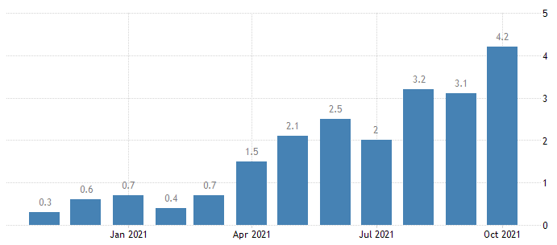
Figure 1: Inflation rate of UK
(Sources: TRADINGECONOMICS, 2020)
Buying actions are not developed by customers towards non-essential products due to high price of product. Marketing of expensive products through specification of utility of product may increase sales volume, which brings flexibility to their lifestyle. On contrary, grocery organisations get a scope to make an investment on marketing effort by construction of effective budget based on previous return value.
Social
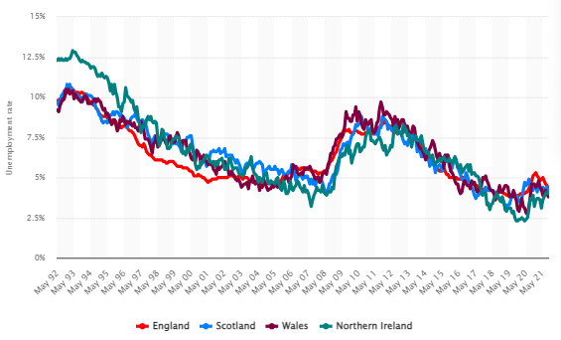
Figure 2: Unemployment rate of UK
(Sources: Clark, 2021)
Grocery industry becomes capable of recovery from its financial loss through a continuation of a business process during post Covid period through using their human capital. Effective marketing efforts are conducted through hiring skilled employees in organisations. Apart from this, internal conflict at grocery organisation is reduced through avoiding workplaces discrimination for gender.
Technical
Exclusive discounts are easily availed by customers through accessing digital apps and it encourages repetition of their buying actions. Product promotional opportunities are increased mobile apps that offer personalised shopper experience. Use of IPW that is supports grocery companies to maintain their sales volume through strengthening their brand loyalty.
Legal
“Consumer Rights Act 2015 (c. 9)” needs to be included in grocery industry to offer accurate products. For instance, Morrison’s has offered food products so this company needs to maintain food safety so that public health remains secured. On the other hand, high investment needs to be conducted so that proper training could be offered to production team for maintaining quality of products.
Environmental
Grocery companies need to focus waste management approach so that environmental pollution is avoided. Waste management may add value to marketing efforts as consumers prefer to associate with companies that are focusing on environmental awareness.

Internal market analysis: SWOT
Strengths | Weaknesses
- High variety in grocery and food products.  - Serving thousands of new customers through adoption of an online platform.  - Development of a culture-based team through offering remote working options. | - Closure of store during a lockdown.  - Expensive products.
Opportunities | Threats
- Partnership with Deliveroo that supports Doorstep Delivery service.  - Offering local jobs has influenced communities.  - Development of loyalty apps and Scan and Go app has improved shopping experiences.  - Construction of hygiene culture through increasing cleaning hours | - Slow down supply chain activities due to travel restrictions.  - Shortage of drivers has slowed down in receiving resources.  - Not offering proper pension schemes.
Table 2: Micro factor analysis of Morrisons
(Sources: MORRISONS, 2021)
Morrison’s has offered broader scope to customers for selection of products based on their preferences. Improvement of product specification has increased investing scope to customers. Marketing efforts are conducted for conveying information regarding customer services. Official websites have promoted information regarding home delivery services. Culture-based teamwork has supported organisations to develop accurate marketing strategies (MORRISONS, 2021). Offering flexibilities is to workers during pandemic situations through providing "work from home".
Accurate services are offered to customers through reducing health risks. Delivering technical support to office-based colleagues has strength sites and stores. Workload of employees is reduced through improving technology. Card holder buyers experience flexible shopping experiences in terms of utilising "scan and go" (MORRISONS, 2021). Stock less or surplus issues are overcome by this organisation through application of innovative technology that stores the buying history of customers. Management becomes capable of predicting the buying behaviour of customers. Changes in marketing strategies are easily identified from shopping practice. On the other hand, maintenance of hygiene factors at stores increases awareness towards public health risk. Traditional customers who have less knowledge regarding digital transformation are facing challenges due to closure of stores during pandemic situations. In contrast, this organisation has faced barriers in managing stock due to travel restriction and that has reduced involvement of drivers.

Role of marketing play on Morrisons
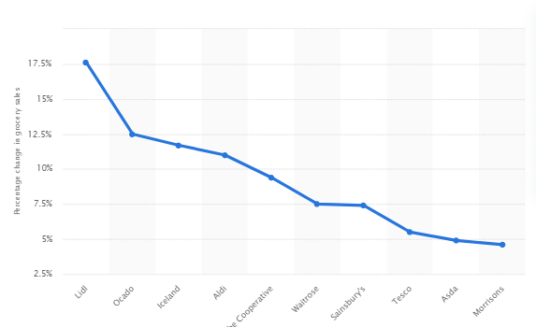
Figure 3: Sales volume fall during pandemic situation
(Sources: Influenced by Tighe, 2020)
Morrison has adopted digital marketing approaches for targeting border audiences in terms of uploading content on digital platforms. Approximately, 276K followers of Morison on Instagram have explored its social media presence and strengthen its organisational reputation. Involvement of new customers is increased through watching high definition videos. In this context, approximately 29.1K subscribers on YouTube have shared information regarding variety of food products. As claimed by Rountree (2020), attractive content regarding specific brands has increased brand values. Product differentiation becomes possible through improvement of brand values. Morison has offered 10% discounts for NHS workers that have supported this company to target NHS workers.
Application of specific hash tags has increased the reach of content to customers based on their search result. Social media has created open spaces for communication between stakeholders. Updated information through aligning with government regulation has increased also customer awareness.

Recommendations for future
“Search engine optimization (SEO)” is a marketing strategy that has increased awareness among customers through evaluation of traffic occurring on a particular website. As mentioned by Hooley (2020) business performances are improved through application of right resources for establishment of marketing strategies. Search result of specific product on Google by customer has offered scope to identify target market based on their productions. In addition, adoption of referral programs can support Morison to conduct specific affiliation programs. As reported by Kotler (2018), electronic word of mouth has reduced operating cost as existing customers share their opinion regarding products on digital platforms. This approach may offer value to existing customers and that increases their interest to share positive news .

Conclusion
Satisfaction of customers is increased through fulfilling demands of customers by offering accurate goods. Selection of proper marketing channel is support organisation to promote products or goods to right audiences. In this context, proper strategies need to be developed for marketing, which are conducted through identifying influences of business environment. Official website of this company has offered scope to receive proper information regarding product. Discounts are addressed by customers through signing official websites, which has increased customer satisfaction. Thus, it can be concluded that marketing strategy increases customer bases through sharing accurate information to them. Buying actions are developed quickly through evaluation of shared information via marketing efforts.

References
Clark, D., (2021) Gender pay gap for median gross hourly earnings in the United Kingdom from 1997 to 2021. Available at: https://www.statista.com/statistics/280710/uk-gender-pay-gap/#:~:text=In%202021%20the%20difference%20between,percent%20for%20part%2Dtime%20workers. [Accessed on: 9th December, 2021]
Clark, D., (2021) Unemployment rate in the United Kingdom from May 1992 to September 2021, by country. Available at: https://www.statista.com/statistics/279990/unemployment-rate-in-the-uk-by-country/ [Accessed on: 9th December, 2021]
Hooley, G.J. (2020) Marketing strategy and competitive positioning . Seventh edition. Brigitte Nicoulaud, John M. Rudd, & Nick Lee (eds.). Harlow, England ; New York :; Harlow, England ; New York :, Pearson
Kotler, P. (2018) Principles of marketing [electronic resource]. 17th, global ed. Gary. Armstrong & Marc Oliver. Opresnik (eds.). Harlow :, Pearson.
LEGISLATION (2021) Consumer Rights Act 2015. Available at: https://www.legislation.gov.uk/ukpga/2015/15/contents/enacted [Accessed on: 9th December, 2021]
O'Neill , A., (2021) United Kingdom: Real gross domestic product (GDP) growth rate from 2016 to 2026. Available at: https://www.statista.com/statistics/263613/gross-domestic-product-gdp-growth-rate-in-the-united-kingdom/ [Accessed on: 9th December, 2021]
ONS (2020) Impact of the coronavirus (COVID-19) pandemic on retail sales in 2020. Available at: https://www.ons.gov.uk/economy/grossdomesticproductgdp/articles/impactofthecoronaviruscovid19pandemiconretailsalesin2020/2021-01-28 [Accessed on: 9th December, 2021]
Rountree, A., (2020) Which supermarket has the best performing social media post. Available at: https://www.maybetech.com/blog/uncategorised/supermarkets-best-performing-post/[Accessed on: 9th December, 2021]
Tighe, D., (2020) Y-o-y grocery sales changes due to the coronavirus outbreak in the United Kingdom in the 12 weeks ending on the 22nd of March, by store. Available at: https://www.statista.com/statistics/1108853/grocery-sales-increase-in-the-united-kingdom-coronavirus/ [Accessed on: 9th December, 2021]
TRADINGECONOMICS (2020) United Kingdom Inflation Rate. Available at: https://tradingeconomics.com/united-kingdom/inflation-cpi [Accessed on: 9th December, 2021]
WTO (2021) 1 The WTO can ... cut living costs and raise living standards. Available at: https://www.wto.org/english/thewto_e/whatis_e/10thi_e/10thi01_e.htm [Accessed on: 9th December, 2021]

