Database Design of Abertawe Arts Centre Information Management System Based on SQL Server

Abstract
The research content of this article designed an information resource management system for Abertawe Art Center. The structure of the database management system based on SQL Server. The SQL Server database has better integration and has the advantage of quick response to information resource management. To this end, the art center information resource management system based on SQL Server is designed. It can classify and query information resources required by customers. The database designed in this paper has a reasonable structure, which provides a reference plan for the development of the information management system.

Contents
Abstract 1
1. Introduction 3
2. SQL vs. NoSQL 3
3. Performance Tuning 5
4. Transaction 7
5. Distributed Database Solution 10
Conclusion 13
References 13

Introduction
Case background
The Abertawe Arts Centre has three theaters in different regions. They can provide different performance companies with rental theater services to facilitate their performance activities. Customers can use the Abertawe Arts Centre's publicity to choose programs of interest, select seats, and buy tickets. The Abertawe Arts Centre required the design of a complete database and corresponding operations to realize the performance company’s venue rental services and audience ticketing services.
Demand analysis
Due to various factors, the management of the Abertawe Arts Centre hopes that while maintaining its service level, the theater can also develop. In order to gain more and more customers, the company decided to increase the function of rapid information retrieval and processing in database management. In addition to designing the database, they also need to solve their problems, which are: 1. Generally, the theater will record the detailed information of the venue reservation, but sometimes the film and television company does not give a specific date. 2. Customers can book performances that are not registered as events through pre-sales.

SQL vs. NoSQL
Nowadays, society is constantly generating a lot of data every day, and it contains a lot of valuable information to be analyzed and excavated. For example, data warehouse systems often contain a lot of valuable information for query and analysis, and the analysis of this information can help companies make decisions. How to quickly obtain this valuable information to improve the work efficiency of the enterprise while saving the cost of machine resources has become the focus of many researchers. The traditional RDBMS is no longer suitable for huge data query and analysis, mainly because of its fixed relationship. Models and inefficient table join operations restrict the efficiency of queries, and new NoSQL databases are suitable for solving such problems because they have more flexible storage modes and query modes. Below I will compare the differences between SQL and NoSQL and their respective advantages and disadvantages.
SQL (Structured Query Language) database, refers to the relational database. The main representatives are SQL Server, Oracle, MySQL (open source), PostgreSQL (open source).
NoSQL (NoSQL = not only SQL) generally refers to non-relational databases. The main representatives are MongoDB, Redis, CouchDB.
Main difference
a.Storage method
The SQL data storage table has a specific structure. NoSQL is extensible, so it is more flexible. It can be stored as a JSON document or a hash table. SQL usually stores data in the form of database tables.
The NoSQL storage method is more flexible, such as using JSON file storage. Key-value databases are the simplest form of NoSQL databases. The basic data structure is a dictionary or map. If you want to store a value, you can store it as an integer, string, a JSON structure, or an array, along with a key used to reference that value. After that, you can quickly and easily read a given record based on its key.
b.The relationship between data collection and table
In SQL, you must define the table and field structure, and then you can add data without reporting an error.
In NoSQL, data can be added at any time and anywhere without first defining tables. NoSQL can create indexes in data sets. So it may be more suitable for projects where the initialization data is not yet clear or undecided.
c.Store external data
If you need to add external related data in SQL, the standardized approach is to add a foreign key to the original table to associate the external data table. In this case, if we need to update some information in the original table, we only need to update the external data table and do not need to update the original table.
In NoSQL, in addition to the standardized storage of external data tables, we can use another method to put external data directly into the original data set. But the disadvantage is that it will be more troublesome to update the external data table.
d. SQL query: JOIN
In SQL, you can use the JOIN table link method to query the data in multiple relational data tables with a simple query statement (such as left join and right join).
NoSQL currently does not provide a query method similar to JOIN. It is very troublesome to query data in multiple data sets. Therefore, most NoSQL uses non-standardized data storage methods to store data.
e. Transaction
Does the data of multiple tables in SQL need to be updated at once? If one of the tables cannot be updated, the other tables will also not be updated. At this point, the transaction can be controlled, and the transaction can be committed uniformly after completing all commands.
There is no concept of transaction in NoSQL, and the operation of each data set is atomic.
SQL database also has the advantage of being easy to understand. Because the ‘row + column’ two-dimensional table logic is very close to a concept in the logical world. The relational model is easier to understand than other models such as network and hierarchy. In addition, the data of the SQL database is persisted to the disk, there is no risk of data loss, it supports massive data storage and stable services, the server has excellent performance, and the service is stable, and there is usually no abnormal downtime.
Overall, although NoSQL has some advantages when the scenario is very complex, NoSQL usually has poor support. The advantage of using SQL is that it can maintain data consistency when processing a large amount of data. It can use join query statements that NoSQL does not have, and it is technically mature. So we choose to use SQL.

Performance Tuning
First, I want to briefly explain the creation of the table and the data I inserted. As shown in the following three figures. You can see my code and results from the picture. As can be seen from ‘SeatNo’, ‘S001’ means ‘Stalls Seats 001’. ‘B259’ represents the seat type is ‘Back stall’. The seat types of ‘C115’ and ‘U081’ are ‘Circle’ and ‘Upper stalls’ respectively.
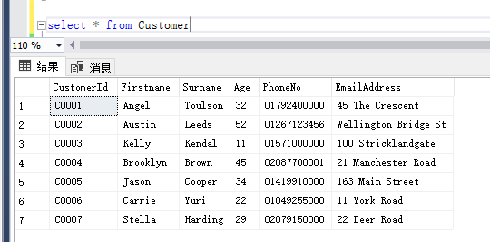
Fig. 1
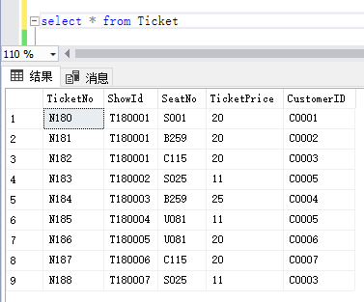
Fig. 2
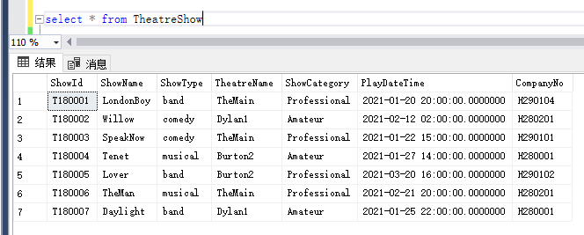
Fig. 3
In addition, the database relationship diagram is shown in Figure 4.
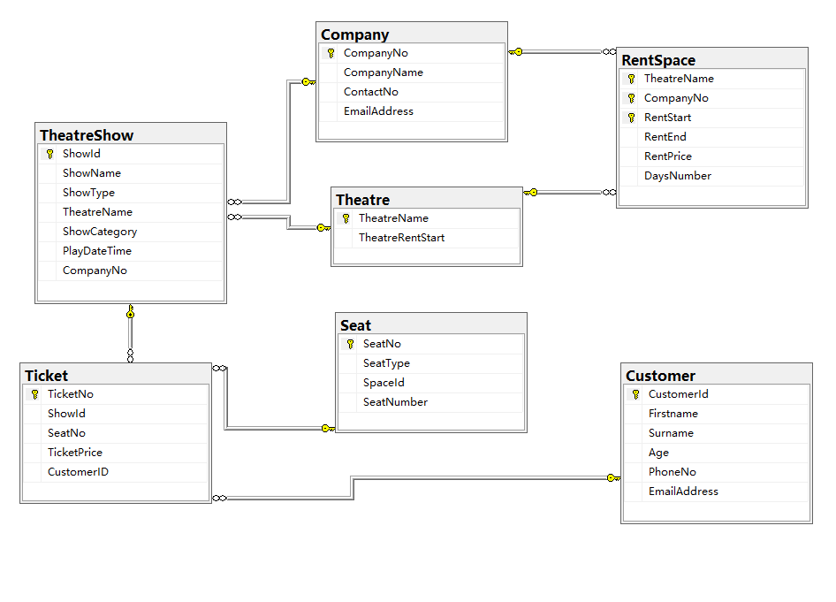
Fig. 4
Taking into account the needs of some customers who want to inquire about when the show will be released, we build an index of shows and performance times to meet customer needs. We have established an index of companies and performance types so that customers can easily see all performance types under a company name. If the customer wants to check all the dramas he has purchased, the third line of code can fulfill his needs, which is shown in Figure 5 below.
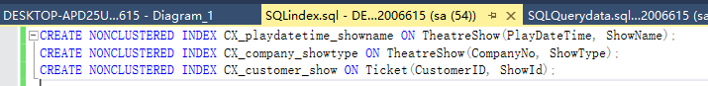
Fig. 5

Transaction
The problems of Abertawe Arts Centre are:
A. Generally, the theater will record the detailed information of the venue reservation, but sometimes the film and television company does not give a specific date.
B. Customers can book performances that are not registered as events through pre-sales.
In order to deal with these two issues, the following is the annotated SQL code I provided which includes rollback and commit related operations.
--question A
BEGIN TRANSACTION NewRentSpace
BEGIN TRY -- add try to catch any errors
-- Add new company rent the theatre
INSERT INTO RentSpace (TheatreName, CompanyNo, RentStart, RentEnd, RentPrice)
VALUES ('TheMain', 'H290104', '2021-1-19 20:00', '2021-1-21 20:00', 1000)

-- Add the new company managed by H290784
INSERT INTO RentSpace (TheatreName, CompanyNo, RentStart, RentEnd, RentPrice)
VALUES ('TheMain', 'H290784', '2021-1-19 20:00', '2021-1-21 20:00', 1000)

-- Commit ALL changes, inserts successful
COMMIT TRANSACTION NewRentSpace;
END TRY
BEGIN CATCH -- add catch to handle error
-- Rollback ALL inserts, an error has occurred.
ROLLBACK TRANSACTION NewRentSpace;
RAISERROR('Rolling back, an error occurred!', 16, 1);
END CATCH;
select * from RentSpace
The screenshot of the result.

The RentSpace table is unchanged. Therefore, when the registration time is empty, the code implements a rollback operation.
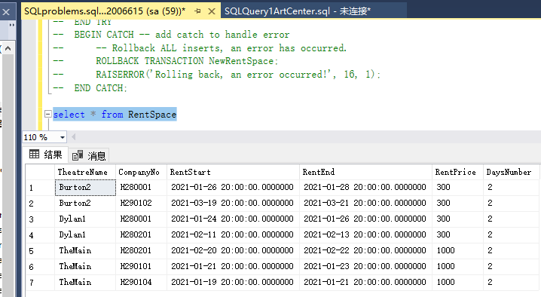
Fig. 6

--question B
CREATE PROCEDURE [dbo].[ticketbuying]
@TicketNo VARCHAR(4),
@ShowId VARCHAR(7)
@SeatNo VARCHAR(4)
@TicketPrice INT
@CustomerID VARCHAR(7)
@Ticketdate DATE,
AS
BEGIN
BEGIN TRANSACTION
INSERT INTO Ticket VALUES (@TicketNo,@ShowId,@SeatNo,@TicketPrice,@CustomerID);
IF (
(SELECT COUNT(*) FROM TheatreShow s1,RentSpace r2
WHERE s1.ShowId=r2.TheatreName
AND RentStart=@Ticketdate)=0
)
BEGIN
ROLLBACK TRANSACTION
END
ELSE
BEGIN
COMMIT TRANSACTION
END
END
GO
EXEC [dbo].[ticketbuying] 'N222', 'T180009', 'S001', 20, 'C0001', '2021-1-19 20:00'
select * from ticket
In my code, T180009 is an unregistered event. The result is shown in the screenshot figure 7.
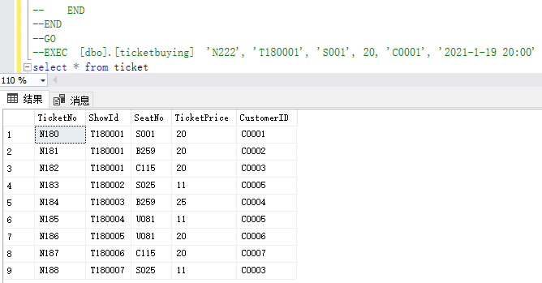
Fig. 7
The above shows part of the code and screenshots. So far, this database design has completed the two questions raised by the Art Center.

Distributed Database Solution
A distributed database system is composed of multiple database systems of the same or different types distributed on multiple sites. These independent database systems are small and physically decentralized, but each is realized through a computer network. The interconnection between the systems, and then through a distributed integrated management system to manage each small independent database uniformly, so the distributed database system is logically centralized, it will split each job into multiple The subtasks allow each node to coordinate and execute in parallel. Compared with the traditional centralized database system, the business logic it can handle is more complex, the operation efficiency is higher, and the storage data capacity is larger.
According to the requirements of the Abertawe Art Center, I need to design the database in a distributed manner. After studying this course, we know that fragmentation is to divide the database into disjoint fragments, and each fragment is assigned to a site.
Distributed database system can not only centrally control all sites when they coordinate to execute global tasks, but also can realize the autonomous management of databases between sites to serve local users. For the data stored on a local site for all users of the site, the user can query or process the data stored on the site through the support of the local database management system on the site. These data are only common to users of the site. ; But if the system is running distributed tasks or users need to use the data of any node in the distributed system, this requires the support of a centralized control mechanism with global management functions. It will perform operations such as query copying fragments or data transmission on the site. The data stored in the sites in the entire cluster are interconnected and mutually accessible. By adopting the control structure that combines centralized and autonomous, the functions of data storage, task parallel processing and data query in distributed database system can be better realized. According to different needs, the degree of system concentration and autonomy is different. Some systems have a higher degree of centralized control, and some sites have higher autonomy.
For the case study of the Abertawe Art Center, I designed a total of seven tables. As shown in Figure 4, they are ‘customer’, ‘company’, ‘theatre’, ‘theatreshow’, ‘seat’, ‘ticket’, and ‘rentspace’. For the first ‘Customer’ table, I decide to use Horizontal Fragmentation to distribute the table. I think this table does not need to be distributed, because it is a distributed database, and each theater stores the customer information of its own theater.
The second Company table stores the basic information of the performance company, plus the venue type. The horizontal distribution can be carried out according to the type of venues, and it can be concluded which performance companies have reserved a certain venue.
The third Theatre table has only two attributes. One is the name of the theater, and the other is the capacity. I also think that this table does not need to be distributed. In the database of each theater, these two attributes are fixed values.
I will horizontally distribute the fourth TheatreShow table. Because there are differences between professional and non-professional performance types, this is the basis for horizontal distribution. After the distribution is completed, you can see which shows are professional and which are amateur. Figure 8 shows the original TheatreShow table. Figure 9 and Figure 10 are the two tables after the distribution.
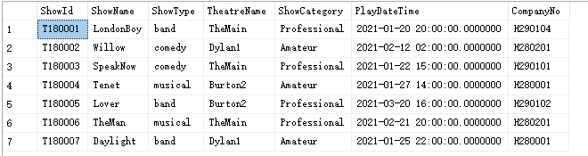
Fig. 8
ShowId | ShowName | ShowType | TheatreName | ShowCategory | PlayDateTime | CompanyNo
T180001 | LondonBoy | band | TheMain | Professional | 2021-01-20 20:00:00 | H290104
T180003 | SpeakNow | comedy | TheMain | Professional | 2021-01-22 15:00:00. | H290101
T180006 | TheMan | musical | TheMain | Professional | 2021-02-21 20:00:00 | H280201
Fig. 9
ShowId | ShowName | ShowType | TheatreName | ShowCategory | PlayDateTime | CompanyNo
T180002 | Willow | comedy | Dylan1 | Amateur | 2021-02-12 02:00:00 | H280201
T180004 | Tenet | musical | Burton2 | Amateur | 2021-01-27 14:00:00 | H280001
T180007 | Daylight | band | Dylan1 | Amateur | 2021-01-25 22:00:00 | H280001
Fig. 10
The fifth Seat table has the attribute SeatType. It has four types, namely Stalls seats, Back stall, Circle, and Upper stalls. So I divide it horizontally into four tables. After dividing the table, get the different types of seats that have been reserved, which seats have not been reserved, and know their seat numbers.
The sixth Ticket table has attributes ShowId and CustomerID. They can be divided into tables according to the horizontal distribution. If you divide the table according to the ShowId attribute, and according to different program names, you can see the booking status of the same program. If you divide the table according to the CustomerID attribute, according to different customers, you can see the names of the performances that the same person has seen before and the performances to be watched. And these will depend on a large amount of data and the two attributes have duplicate values ​​to be more useful.
For the last RentSpace table, I want to divide the table horizontally according to price. Because the price is only two cases, one is 300 pounds a day, and the other is 1,000 pounds a day. After dividing the table according to the rent, you can see whether the team of a certain show is amateur or professional. Figure 11 shows the original RentSpace table. Figure 12 and Figure 13 are the two tables after the distribution.
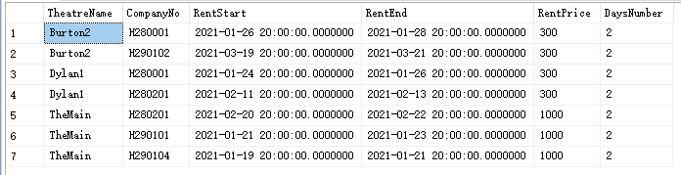
Fig. 11
TheatreName | CompanyNo | RentStart | RentEnd | RentPrice | DaysNumber
Burton2 | H280001 | 2021-01-26 20:00:00 | 2021-01-28 20:00:00 | 300 | 2
Burton2 | H290102 | 2021-03-19 20:00:00 | 2021-03-21 20:00:00 | 300 | 2
Dylan1 | H280001 | 2021-01-24 20:00:00 | 2021-01-26 20:00:00 | 300 | 2
Dylan1 | H280201 | 2021-02-11 20:00:00 | 2021-02-13 20:00:00 | 300 | 2
Fig. 12
TheatreName | CompanyNo | RentStart | RentEnd | RentPrice | DaysNumber
TheMain | H280201 | 2021-02-20 20:00:00 | 2021-02-22 20:00:00 | 1000 | 2
TheMain | H290101 | 2021-01-21 20:00:00 | 2021-01-23 20:00:00 | 1000 | 2
TheMain | H290104 | 2021-01-19 20:00:00 | 2021-01-21 20:00:00 | 1000 | 2
Fig. 13

Conclusion
This paper designs a theater information resource management system based on SQL Server, and verifies whether the use of the system meets the requirements of the theater.
In the actual theatre SQL database system design work, we are faced with various problems, which are a bit complicated and difficult for us to solve. However, when we carried out the design work, we combined the actual situation of the theater and formulated reasonable design plans for different performance companies. In this way, the efficiency of operations such as scheduling is improved, and the overall design of the information management system is realized.
In summary, the system in this article can provide assistance for the management of theater information resources. But this system is not perfect. Each functional module of the system in this article needs to be optimized step by step to improve the interaction with users and performance companies.

References
[1]Bai Ying. SQL Server Database Programming with Visual Basic.NET:Concepts, Designs and Implementations[M].John Wiley &amp; Sons, Inc.:2020-06-10.
[2]Kline, Kevin. Getting Up-to-Speed on the SQL Server Social Media Scene[J]. Database Trends and Applications,2009,23(3).
[3]Ahsan Malik,Aqil Burney,Fawad Ahmed. A Comparative Study of Unstructured Data with SQL and NO-SQL Database Management Systems[J]. Journal of Computer and Communications,2020,08(04).
[4]Baosheng Qi. The Analyze of the student's grades processing based on the SQL Server[A]. Institute of Management Science and Industrial Engineering.Proceedings of 2019 7th International Conference on Machinery,Materials and Computing Technology(ICMMCT 2019)[C].Institute of Management Science and Industrial Engineering: (Computer Science and Electronic Technology International Society),2019:5.
[5]Bjeladinovic. A fresh approach for hybrid SQL/NoSQL database design based on data structuredness[J]. Enterprise Information Systems,2018,12(8-9).
[6]Henning Köhler,Sebastian Link. SQL schema design: foundations, normal forms, and normalization[J]. Information Systems,2018,76.
[7]Wenshuai Ge,Gang He,Xinwen Liu. Business-oriented customized big data query system and its SQL parser design and implementation[J]. MATEC Web of Conferences,2018,232.
[8]Mastan Vali Shaik,P Sujatha. TEMPORAL QUERY PROCESSIG USING SQL SERVER[J]. International Journal on Smart Sensing and Intelligent Systems,2017,10(4).
[9]Yingjie Wang,Jianjun Liu,Xiang He,Bing Wang. Design and realization of rock salt gas storage database management system based on SQL Server[J]. Petroleum,2017,4(4).
[10]Louis&nbsp;Davidson,Jessica&nbsp;Moss. Pro SQL Server Relational Database Design and Implementation[M].Apress, Berkeley, CA:2016-01-01.
[11]Zhe Li,Houhua Shen. Database Design on Teaching Management System Based on SQL Server[A]. International Informatization and Engineering Associations、Atlantis Press.Proceedings of 2015 3rd International Conference on Education,Management,Arts,Economics and Social Science (ICEMAESS 2015)[C].International Informatization and Engineering Associations、Atlantis Press: (Computer Science and Electronic Technology International Society),2015:5.
[12]Robert J. Mills PhD,Pamela A. Dupin‐Bryant PhD,David H. Olsen PhD. Designing SQL Database Modules Using Correlation Coefficients and Linear Regression: A Content‐Centered Approach[J]. Performance Improvement,2015,54(6).
[13]Samir Mahmoud A. Abdallah,Magdy Shayboub A. Mahmoud,Nasreldin M. El-Tayeb,Mohamed I. Abdel Magid. Designing and Implementing of Electronic Health Record System in Ksa using Sql &amp; Asp.Net[J]. Innovative Systems Design and Engineering,2015.
[14]Andy&nbsp;Leonard,Tim&nbsp;Mitchell,Matt&nbsp;Masson,Jessica&nbsp;Moss,Michelle&nbsp;Ufford. SQL Server Integration Services Design Patterns[M].Apress, Berkeley, CA:2014-01-01.
[15]Fan Jin Zeng,Hui Li,Li Ding. Database Design of Merchandise Management System Based on SQL Server[J]. Applied Mechanics and Materials,2013,2617.
[16]Sven Hartmann,Markus Kirchberg,Sebastian Link. Design by example for SQL table definitions with functional dependencies[J]. The VLDB Journal,2012,21(1).
[17]Louis&nbsp;Davidson,Jessica&nbsp;M.&nbsp;Moss. Pro SQL Server 2012 Relational Database Design and Implementation[M].Apress, Berkeley, CA:2012-01-01.
[18]Jung Young Jin,Ryu Keun Ho. Design and Implementation of a SQL based Moving Object Query Process System for Controling Transportation Vehicle[J]. The KIPS Transactions:PartD,2005,12D(5s101).
[19]Lahdenmäki Tapio,Leach Michael. Relational Database Index Design and the Optimizers:DB2, Oracle, SQL Server, et al.[M].John Wiley &amp; Sons, Inc.:2005-01-27.
[20]ZHe Li,HouHua Shen. Database Design on Teaching Management System Based on SQL Server[P]. Proceedings of the 2015 3rd International Conference on Education, Management, Arts, Economics and Social Science,2015.

