University of Wales Trinity Saint David’s
05-04-2019
THOHURA AHMED
1806406
Communication within the workplace
Effective team-working & communication

Executive summary

Michelle toy store in Swansea started off with 5 employees and is now a growing company with 27 employees whom all are of various ages with various experiences. The business is facing ineffective communications issues among the employees as there is no real structure of work or teams with no leadership in place. All members are experiencing systematic barriers in work place which is affecting the productivity of the company and breakdown in communication.
This report outlines the best way to form teams for this group of people and suggests ways to increase effectiveness of communications between team members. Improving interpersonal skills of individuals will see positivity and targets will be met to pull the business forward.
Tuckman and Belbin’s theories, models of communications, recommendation and action plan will show way forward for this organisation. How verbal and non-verbal communication with interpersonal skills plays an important part communication being effective. In this report is an action plan and shift rota management can use. Overall the report finds soft skills (verbal and non-verbal skills) are as important as interpersonal skills. With listening skills and trust taking the centre stage. For effective communications one must possess all the elements of interpersonal skills.

Table of Contents
1.0 Introduction 3
2.0 Findings 3
2.1 Effective communication 3
2.2 Verbal communication 3
2.3 Non-verbal communication 4
2.4 Interpersonal skills 4
2.5 Schramm’s model of communication 5
2.6 Communication barriers 7
2.7 Belbin’s theory 8
2.8 Tuckman’s theory 8
3.0 Recommendation and Cost (financially/socially) 9
4.0 Shift Rota 11
5.0 Action Plan 12
6.0 Conclusion 13
7.0 References 14
8.0 Appendices 15
8.3 Benefits of training 19

1.0 Introduction

Michelle toy store is a growing company with a total of 27 employees, 6 employees work in stockroom, accepting deliveries and filling shelves, 2 cleaners, 14 sales assistant, 2 security guards and 3 managers. The company is running on ad hoc teams and there is no formal team structure and there are systematic barriers between the workforce. Included in this report are recommendations drawn from findings to help the toy company employees work effectively to yield growth.

2.0 Findings

2.1 Effective communication

Communication is a process for sharing information from one person (organisation) to another person (organisation). It is an element of perception with personal experience playing an important part in the reaction.
Effective communication between employees is very important for any organisation to work productively. It is a two-way information sharing process which involves one party (sender) sending a message that is easily understood by the other party, the receiver. ‘An Effective Communication is a communication between two or more persons wherein the intended message is successfully delivered, received and understood. communication is said to be effective when all the parties (sender and receiver) assign similar meanings to the message’ (business Jargon, 2019).
Effective communication is a vital tool for personal and business use. Successfully getting a point across can be the difference between sealing a deal and missing out on a potential opportunity. Two important ways people communicate are using verbal and non-verbal methods of communication.

2.2 Verbal communication

Verbal communication involves using voice and words to communicate and share information with one another. This type of communication is usually made face to face. With advanced technology at one’s disposal, Face times, live conferences between towns, cities and countries, telephone conversations are few to name as a mean of verbal of communication. ‘Verbal message is created through language’ (Maund et al, 2017).

2.3 Non-verbal communication

Non-verbal communications involve message being sent without the use of spoken words. These are as important as verbal communications. Non-verbal ways of communications are forming impressions and is a perception of how one sees things. Sometimes actions may speak louder than words. Methods of this type of communication are letters/notes/email/text message/pictures.
In a face to face interaction, non-verbal communications compliment and complete the whole message one is trying to portray. These are; paralinguistic cues involve the volume, speech and tone of voice used to express one’s self. Active listening, Body gestures, facial expressions displayed when connecting to another individual or group. Scent and appearances all play a part in judging and interpreting the message. Other non-verbal methods of communications are through post, messages, social media, smell, touch and taste to name few.

2.4 Interpersonal skills

“People with good interpersonal skills tend to work well in a team or group. They can communicate effectively with others, whether family, friends, colleagues, customers or clients. Interpersonal skills are therefore vital in all areas of life at work, in education and socially” (skills you need, 2019). Good interpersonal skills, also known as soft skills, people skills and social skills is the foundation of good working and social relationships. These skills are used in every area of everyday life.
See appendices 8.4 for more detail.

2.5 Schramm’s model of communication

Diagram 2.6 Wilbur Lang Schramm communication model

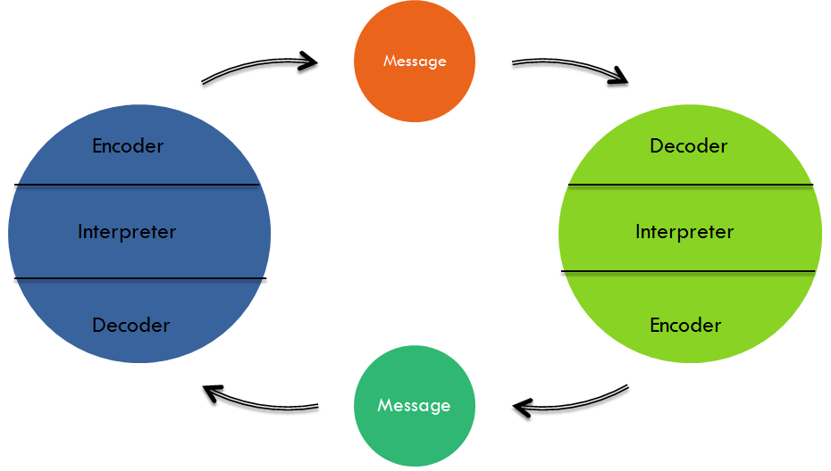

“Schramm’s Model has different parts for communications where
- Sender is the person who sends the message.
- Encoder is the person who turns the message to be sent into codes.
- Decoder is the person who gets the encoded message which has been sent by the encoder and converts it into the language understandable by the person.
- Interpreter is the person who works to understand and analyse the message. The message is received after interpretation. Interpreter and receiver are the same person.
- Receiver is the person who gets the message. He/she decodes and interprets the actual message.
- Message is the data sent by the sender and information that the receiver gets.
- Feedback is the process of acknowledging to the received message by the receiver.
- Medium or media is the channel used to send the message.
- Noise is the interference and interruptions caused during the process. It is also created when the intended meaning of the message sent by the sender and the meaning interpreted by the receiver is different which is known as Semantic Noise” (QS study, 2019).

The best method to use for this company is the Schram’s model of communication. This model is an open, circular communication model which involves a feedback unlike Shannon Weaver and David Berlo’s models which are linear with difficulty giving feedback. Weaver and Berlo’s model contain too much. Schram’s model involves a sender who encodes a message, a recipient (interpreter) who decodes and analyses the message. The receiver now sends a feedback (encodes) in the form of a response. This makes the receiver now a sender. This model has less noise and the sender and receiver hold both roles of sending message and receiving.
Getting a feedback is vital in any communication. It lets the sender know if the message is acknowledged and understood. This helps maintain a good working environment which reflects on targets met on time. Feedbacks and open communications help identify any problems and help overcome arising conflicts.
Schramm’s communication model is the most effective for this group of people as it is best for face to face communication with less noise than other models. For effective communication to take place, individuals must use their interpersonal communication skills. This requires using all the mentioned skills and most importantly active listening. Both the sender and receiver (team leaders especially) must be assertive listeners with undivided attention to verbal messages as well as observing all the non-verbal signs to completely understand the message and give appropriate feedback enabling a harmonious working environment.
Study shows 55% of message is perceived through perception (non-verbal) and only 7% by verbal communication (Mehrabian, 1967)

Diagram shows how people perceive information

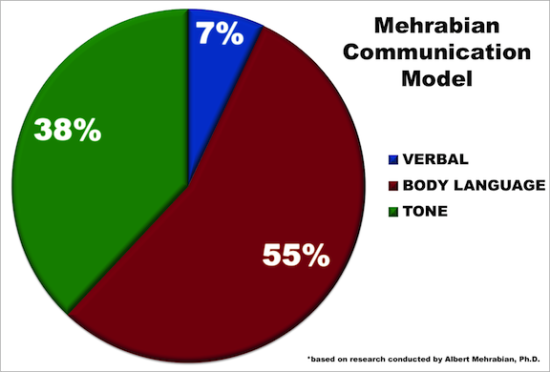

2.6 Communication barriers

However, there are many barriers to effective communications. These barriers can cause misinterpretation of message received and understood. These barriers come in many forms and effect everyone differently and cause communication to be less effective. These are;
Language; Individual may find difficulty in understanding and interpreting messages in language they are not familiar with.
Paralinguistic cues; Tone, speed and volume of voice lets others know the emotional level individual is at. Example. A raised voice sometimes could mean angry and upset. It could be there is too much surrounding noise for the others to hear them. Therefore, individual had to raise their voice.
The content/choice of words; The content of speech may vary from profession to profession. Example if a surgeon speaks to an accountant using medical terms, the accountant will find it difficult to completely understand the surgeon. This works both ways. The surgeon may not understand the accountant’s choice of words. Here the message sent and received will be less effective.
Ignoring non-verbal communication; Not paying attention to the person speaking. Not looking out for gestures leads to incomplete message received.
Perception; differences in viewpoint may hinder the message being understood.
Physiological and emotional; individual may find it difficult to express their emotions and some topics may be off limits or taboos. Examples politics, religion, racism, disabilities etc. individual may be stressed and pre-occupied by personal concerns and is not very receptive to message.
Physiological; not being able to see the non-verbal elements of communication like general body language and facial expressions. A receiver with reduced hearing will not grasp the content of spoken conversation if there is background noise. Example telephone conversations, text messages, emails.
Attitudinal; is behaviour/perception which prevents people from communicating effectively. These may result from personal conflicts, poor management, resistant to change of environment, lack of interests and motivation.
Other barriers which cause communication to be less effective are distrust, power struggle, distortion past, cultural barrier and selective hearing where individual may listen when it suits them.
Systematic; “these exist in structures and organisations where there are inefficient or inappropriate information systems and communication channels, or where there is lack of understanding of the roles and responsibilities for communications” (skills you need, 2019).

2.7 Belbin’s theory
Belbin’s team theory is an integral building block in the success of any organisation. Any team is made up of unique individuals. Each with their own traits, ambitions and personalities. This theory is used to identify behavioural strengths and weaknesses in the workplace among employees. Belbin’s theory ensures members communicate and work well together with exceptional understandings, individually and as a team. It helps to enhance self-awareness and personal effectiveness. It is best used to match people to the right jobs. Belbin’s theory not only helps selecting effective teams, it is also used to diagnose the cause of underperforming teams. According to Belbin’s theory there are nine roles team members need to possess for team to function well.
See appendices 8.1 for more detail this theory.
Using this theory, the employees can be put in the roles best suits them. Examples of this would be; the manager will fill the roles of the monitor, evaluator, shaper, coordinator, and team worker.
Sales assistants will fill the roles of Team worker and specialist. They are responsible for providing good customer services.
Security guards and cleaners have the roles of being specialist and team worker. Both are experts in their fields of expertise.
Stockroom employees may fill the roles of team workers, implementors, monitor and evaluator. They are responsible for receiving stock, monitoring stock count, shelving.

2.8 Tuckman’s theory
Bruce Wayne Tuckman developed a theory in 1965, known as "Tuckman's Stages" explains how individuals work in a group. This theory explains a group of people pass through five stages of development before becoming goal-oriented team. Stages known as Forming, storming, norming, performing and adjourning. “Tuckman's theory is one of the many theories that aim to help managers with team building process” (work spirited, 2019).
See appendices 8.2 for more detail this theory.

3.0 Recommendation and Cost (financially/socially)

The following will allow the expanding company to run smoothly.
- Employees to work and communicate effectively, the managers play a very important part. As there are many people working in this organisation with different levels of qualifications and experiences, it would be wise for the managers to ask all employees to carry out a personal swot analysis and encourage employees to fill in interpersonal skills assessment forms. This will help management and employees to identify individuals’ strengths and weakness. With identified weaknesses in sight, it will allow all members to work on converting their existing weaknesses in to strengths.

This will give a clear picture and self-awareness of the skill’s individual holds Example. Staff could be inexperienced or underqualified in are using IT, this shows further training is required. Or there could be language barriers, employee can get more support from firm to go to language classes to improve one’s language skills.

- Improve key communication skills for building positive interpersonal relationships include:
- active listening
- understanding non-verbal signals
- maintaining eye contact
- assertiveness
- being mindful of people's individual space
- using positive body language
- dealing with different points of view.
- Building trust of others

Personal awareness skills that help with communication include:
- understanding the benefits of a positive attitude
- awareness of how others perceive you
- self-confidence
- presentation - dressing appropriately for different occasions.

- Rota system should be made with three shifts a day with reduce working hours for both full time and part time workers. This will improve the performance of the team.

Rota system may disrupt peoples personal and social life but given advance information of shifts and using open communication with members can find a solution for suitable shifts. There may be difficulty in team members getting to work at certain time of the day/evening due to traveling arrangements. (See action plan).

4.0 Training should be provided to improve team’s performance by keeping up to date with information. May it be informing of regulation changes or about improved technology. See appendices for Benefits of training.

5.0 Delegate responsibilities using Stewardship delegation. This type of delegate provides employees with resources and clear accountability of task set. It helps carrying out tasks in ways which suits members for desired results. Gofer delegation may be used at minimum level to advice employees of issues which need immediate attention. Between the two, stewardship delegation lets people learn through exploring ways to reach goals whereas gofer delegation only takes away initiative and invalidates one’s skills (Covey. S, 1989).

6.0 Give individual or group incentives for achieving set targets/goals. Reward for reaching goal.

7.0 Set realistic goals which members can achieve. Unrealistic goals will cause loose of interest resulting in poor performance.

Shift Rota

Week 1  Shift 1 | Shift 2 | Shift 3
7am-1pm | 1pm-7pm | 7pm-11pm
Manager 1  Sales assistants (1,2,3,4,5)  Stock room assistants  (1 and 2)  Security guard (no.1)  7am-4pm  Cleaner (no.1) 12pm-1pm | Manager 2  Sales assistants (6,7,8,9,10)  Stock room assistants  (3 and 4)  Security guard (no.2)  4pm-11pm | Manager 3  Part time Sales assistants (11,12,13)  Stock room assistants  (5 and 6)  Cleaner (no.2) 10pm-11pm
Week 2
Manager 2  Sales assistants (6,7,8,9,10)  Stock room assistants  (3 and 4)  Security guard  (no.2) 4pm-11pm  Cleaner (no.2) 12pm-1pm | Manager 3  Sales assistants (1,2,3,4,5)  Stock room assistants  (5 and 6)  Security guard (no.1)  7am-4pm | Manager 1  Part time Sales assistants (11,12,13)  Stock room assistants  (1 and 2)  Cleaner (no.1) 10pm-11pm

5.0 Action Plan

Task | Responsible personnel | By when/date
Train stockroom staff to use tills. | Manager on duty | 1 week
Carry out personal Swot analysis | Managers on duty and all employees | 1 week
Carry out Interpersonal skills assessment | Managers on duty and all employees | 2 weeks
Inform of any issues related to work/shifts (or personal circumstances) | All employees and managers.  Managers should be approachable. | Whenever necessary
Feedback on personal/business progress. Inform members of rewards if goals achieved. | Managers | weekly
Follow shift rota. If any inconvenience, then let management know. | Employees | Monthly when rota is out.

6.0 Conclusion

It is impossible to succeed and achieve goals without effective communications in any area. Individuals with higher Interpersonal communication skills tend to be good leaders. When combined with good personality, these skills improve work and social environment for all employees. As the report finds active listening and trust are the key to effective communication with other life skills and with continuously improving theses skills will contribute towards communicating effectively. Resulting in fewer conflicts and peaceful environment. Working in a team opens opportunities for learning and discovering new talent. With structuring working environment, team leaders can build strong minded team full of confidence which will allow business growth. Keeping in mind all elements which improves the quality of workmanship, it is in the best interest of the managers and team leaders to look out for the well being of there employees and give them appropriate training where necessary.

7.0 References

British library, (2019) [online] available at:
https://www.bl.uk/people/albert-mehrabian#
accessed 03-04-2019

Business jargon, (2019) [online] available at:
https://businessjargons.com/effective-communication.html
accessed 23-03-2019

Communication theory, (2017) [online] available at:
https://www.communicationtheory.org/shannon-and-weaver-model-of-communication/
accessed 02-04-2019

Jane Hurst, (2017) [online] available at:
https://www.salesforce.com/blog/2017/02/improve-team-efficiency-productivity.html
Accessed 01-04-2019

Maund, A., Schriek, M. and Tinkler, P. K. (2o17) Certificate in higher education: skills for the workplace student year book, London: sage

Mindtools, (2019) [online] available at: https://www.mindtools.com/pages/article/newLDR_83.htm accessed
Accessed 29-03-2019

QS Study, 2019 [online] available at:
https://www.qsstudy.com/business-studies/schramms-model-communication
accessed 02-04-2019

Queensland government, (2017) [online] available at:
https://www.business.qld.gov.au/running-business/marketing-sales/managing-relationships/communicating-effectively
Accessed 24-03-2019

Queensland government, (2017) [online] available at:
https://www.business.qld.gov.au/running-business/marketing-sales/managing-relationships/communicating-effectively/understanding-communication
Accessed 29-03-2019

Skills you need, (2019) [online] available at:
https://www.skillsyouneed.com/ips/barriers-communication.html
Accessed 30-03-2019

Skills you need, (2019) [online] available at:
https://www.skillsyouneed.com/interpersonal-skills.html
accessed 01-04-2019

Work spirited, (2019) [online] available at:
https://workspirited.com/tuckmans-stages-of-group-development
accessed 03-04-2019

8.0 Appendices

8.1 Belbin’s theory
According to Belbin’s theory there are nine roles team members must possess to have a balanced team and below is the quality found in each role.
The monitor/evaluator; serious minded and prudent team member. Has high critical thinking abilities. Has good judgement, make fewer or no mistakes. Take time in decision making after careful analysis. Critic and assessor which stops team from making mistakes.
Plant; innovative and highly creative personal with new inventions. Work mostly independently, regarded as being clever. Uses their imagination. Reacts to praise and critics. Provides suggestions to complex problems. Usually the originator of products.
Specialist; has specific attributes, intelligent and often single minded and resolute. Experts at their field of expertise. Provides the team with special expert advice.
Shaper; is a task leader. Converts ideas into decisions and action. Flexible but can be impulsive and impatient. Goal oriented personnel have great drive, energy, determination and assertiveness. Managerial type.
Implementor; converts ideas into briefs and works through brief systematically. Puts ideas into action. Have high level of self-control and discipline to work hard and meet targets.
Completer/finisher; strives for perfection and corrects errors, pays close attention to details and sets high standard. Meets deadline on time.
Co-ordinator; helps others to achieve shared goal. Mature, confident and is trusted by others. Can delegate readily. Have a broad outlook. Have good interpersonal skills. Well organised and good communicators.
Team worker; sociable and supportive individual. They are flexible and can adapt to any situation. Good listeners. They have a diplomatic and caring nature and get along with other team members. Are unassertive and avoid conflicts. Most active internal communicator.
Resource investigator; individual good at investigating. Well connected to resources and information. Have good networking skills and are good negotiators. They explore new opportunities and are good at developing contacts. Quick thinkers and will probe others for information.

8.2 Tuckman’s theory

Five stages
Forming is the initial stage where group members spend time getting to know each other and their leader. Members may feel shy and anxious.
Storming is the second stage where group members get clear sense of what is expected of them. It also marks the beginning of conflicts as members start to question the roles of other members. Here, individuals start to compete for rewards, leadership, power and authority. “The role of the group leader is very important at this stage as the prospects of the team can be harmed to a great extent if the team is not managed properly” (work spirited, 2019). Good leaders tend to have higher interpersonal skills which enables them to resolve issues and keep the team together.
Norming is the third stage where group members shed their prejudices against the other members of and strive to work as a team. Members acknowledge each other’s contribution to the group and work together to develop a cohesive team. They learn new things from each other and there is a flow of idea between them. Team bonding is developed in this stage. Some drawbacks of this stage are team members may resist any change and may feel uncomfortable when working with people outside the group.
Performing, the fourth stage is the most productive stage as team members perform to their full potential. Here the team starts delivering on all parameters and members are now autonomous with no conflicts between them.
Adjourning is the final stage when the team is dissolved after desired goal achieved.

Diagram 1. Shannon Weaver, (1949) communication model

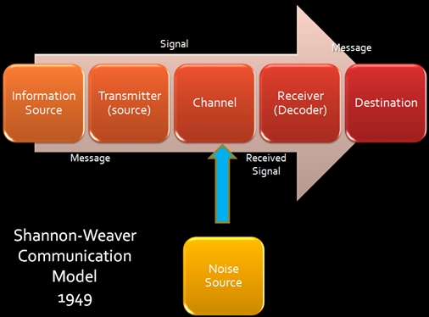

Sender is the originator of message or information.
Encoder is the transmitter which converts the message into signals
Decoder is the recipient of the message who converts signals into message. A reverse process of encode.
Receiver is the destination of the message from sender.
Based on the decoded message the receiver gives their feedback to sender. If the message distracted by noise it will affect the communication flow between sender and receiver
Noise is the messages transferred from encoder to decoder through channel. During this process the messages may get distracted or affected by physical noise like thunder and crowd noise. The receiver may receive be incorrect message.
The model is clearly dealing with external noises only which affect the messages or signals from external sources. For example: If there are any problems occur in network which directly affect the mobile phone communication or distract the messages” (communication theory, 2017).

Diagram 2. David Berlo (1960) communication model

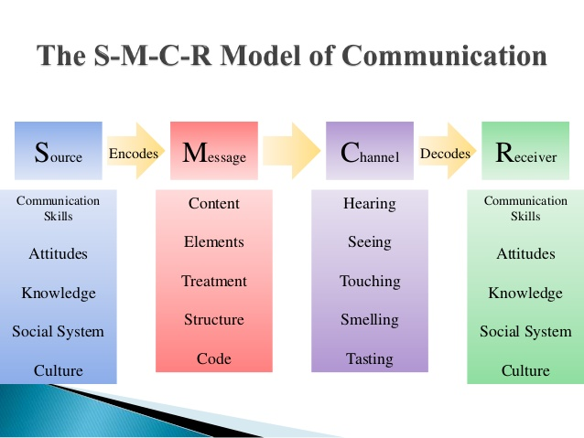

This model has many flaws, these are
- There is no feedback therefore effect of message is unknown.
- Does not mention barriers to communication
- No room for noise
- Complex model
- It is a linear model of communication
(Communication Theory, 2017)

8.3 Benefits of training

  - Given the correct training, it can improve business performance, profit and staff morale. If employee skills and knowledge are up to date, business can grow and boost competitiveness.

  - Help staff open opportunities for promotions. Gives new responsibilities and pay rise.

  - Better job satisfaction and more motivated staff. Improve physical and mental well-being.

  - Retain existing staff. Training existing employees shows the company values its staff and their development (skills gateway, 2019).

  - Staff can fill in the roles of absent employee if necessary.

8.4 Interpersonal skills

Interpersonal skills are communication skills, which covers;
“Verbal Communication – what we say and how we say it.
Non-Verbal Communication – what we communicate without words, for example through body language, or tone of voice; and
Active Listening Skills – how we interpret both the verbal and non-verbal messages sent by others” (skills you need, 2019).
Emotional intelligence skills are being able to understand and manage your own and other’s emotions.
Team working skills is when an individual who can work in formal and informal groups and teams with others.
Negotiation skills are persuasive and influencing skills when working with others find mutual agreeable outcome. These are also known as win-win situation.
Conflict resolution and mediation skills are to be able with others to resolve interpersonal conflicts and disagreements in a positive way.
Problem solving and decision-making skills allows one to work with others to identify and solve problems and making decisions about the best course of action to be taken for any situation.

