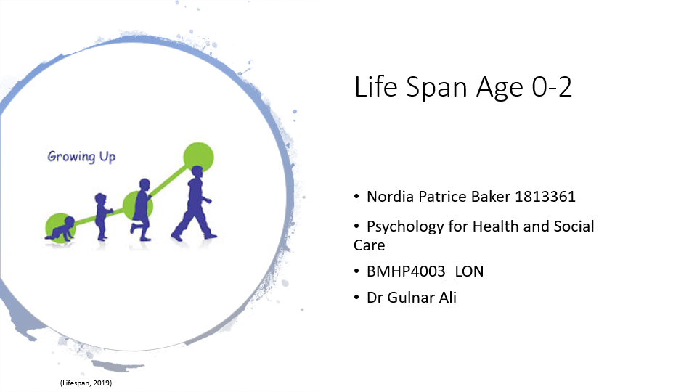
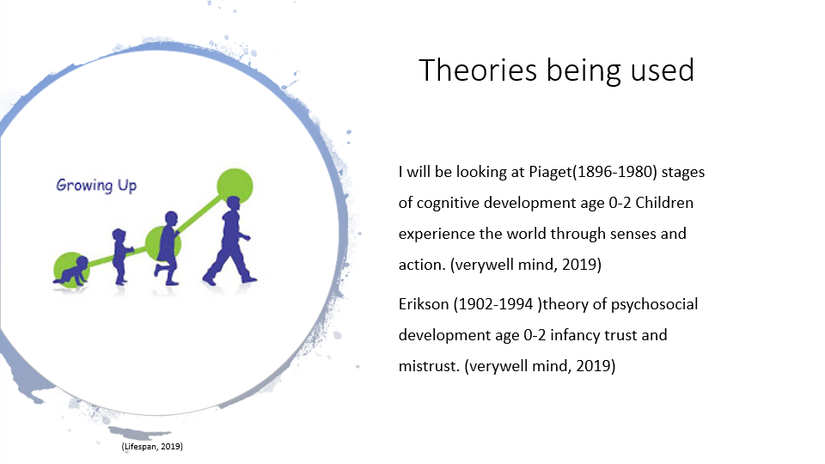
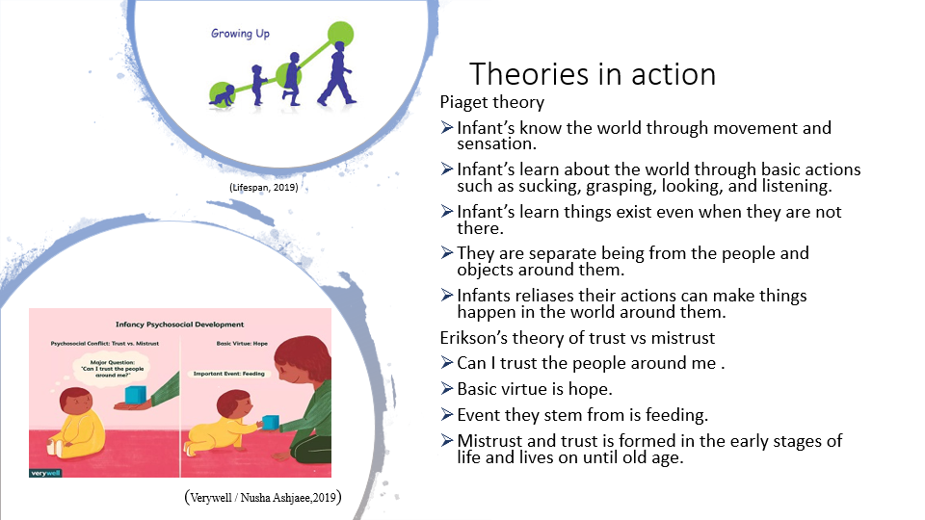
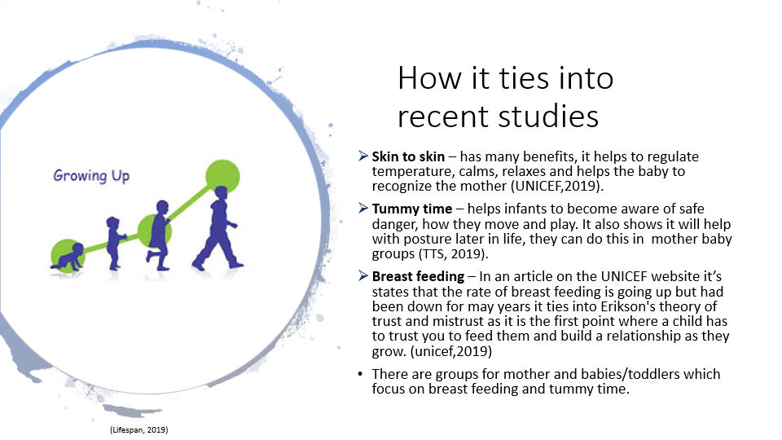
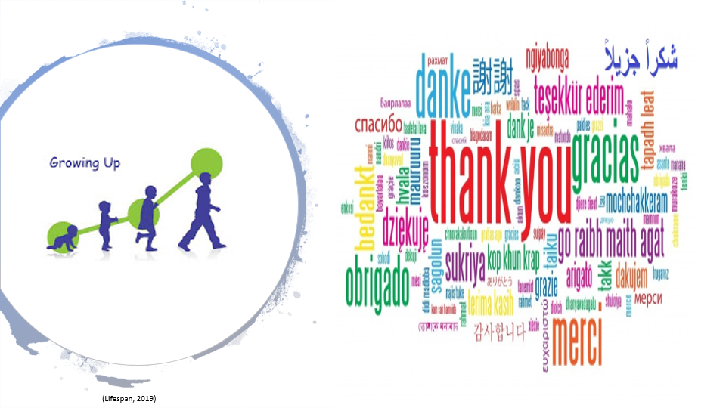
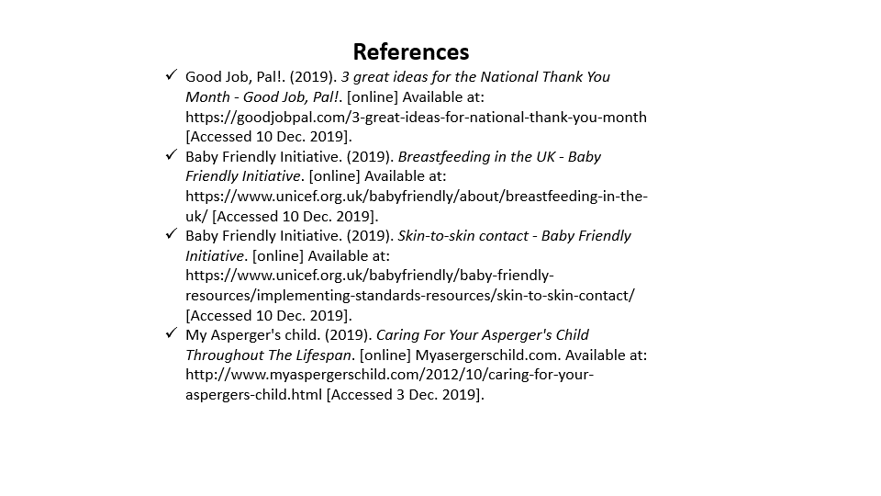
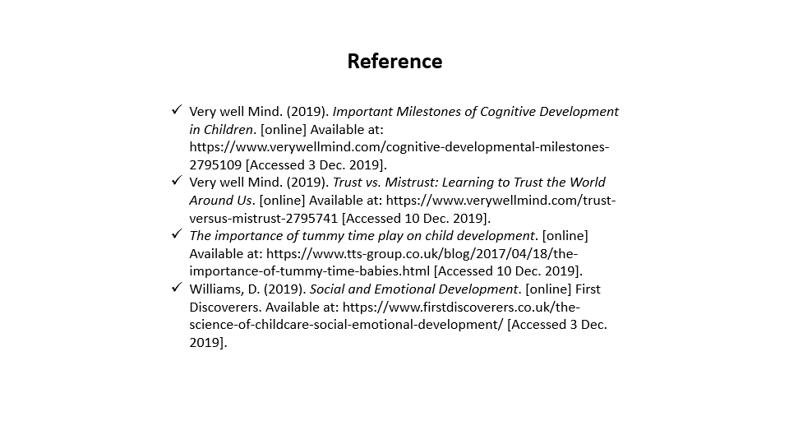

Name | Nordia Patrice Baker 1813361
course | Psychology for health and social care
Course reference | BMHP4003_LON
tutor | Dr Gulnar Ali

Rational for presentation
For the presentation I looked at Piaget (1896-1980) cognitive development, sensorimotor stage age 0-2, while doing his research he realised children were not smaller versions of adults but their minds where in the first stages of development. In the sensorimotor stage’s children tend to rely on basic reflexes, senses, and motor responses (Verywell Mind, 2019), it is during this time they’re growth and leaning will develop. Children at this age tend to put things into their mouths as a way to taste and distinguish the difference in textures. Some of the major characteristics of Piaget theory was children learned that things continue to exist whether they can see them or not this was part of his object permanence. They start to learn this through play for example peek-a-boo Once children realise that objects stay where they are, they are then able to give objects the true names that they have. They also learn at this stage that they are separate from the people and objects around them so their hands are their hands their feet are there feet what they do and interact with are completely different to them and this is where they start at around 7 months to grow anxiety to being separated from a loved ones and then forms attachment to other objects like blankets or dummies, also at this age children realise they impact the world around them so if they make noises they can get attention from their care giver, imitate the things the adult, child of the same age or older children do. Children of this age can also move things around, so the objects don't stay right where they are, they have control over them.
The other theory I investigated was Erikson 1902-1994, he had 8 stages which made up his psychosocial theory the stage I will look at is the trust vs miss trust. This is the first stage that he looks at, this is the first point that a child will know who they can trust and how to trust, he believed children needed to learn a balance to successfully develop. During this stage a child is dependent upon the care giver that is around them. Because they are dependent on the caregiver there is an expectation which will help them to grow and know who they can trust or not trust for example when the child cries does the person help them with their needs? When they are frightened are, they comforted? When they are hungry will they be fed? As a child they only way they can communicate is through cry’s or sounds an example of this is where I work as a paediatric phlebotomist, most children are frightened and need to hear comforting words from their mother/father to know they are safe. The child who respond best currently are the children who’s care givers consistently give support at the time and have built up the trust that being there is for the best. But parents who are inconsistent the children tend to be more frightened and fight. Mistrust and trust is something that lives on to old age and people who are nurtured and have their needs fulfilled during infancy tend to form easier relation which trust is balanced, but a child who is let down infancy tend for form unbalanced relationships where trust is easily broken and their friendships fall apart.
The relevant studies I used to back these theories up is skin to skin, when a child is first born and encounters their mothers’ skin for the first time it has many benefits. Skin to skin can help to regulate the new-borns temperature and breathing, stimulates the production of milk, enables the child to look at the mother for the first time and helps them to bond as well as many other things.
Breastfeeding is one of the most natural ways of a child getting to know their mothers and bonding in this time the child will be able to take in their mothers’ scent which they will be able to identify from other. It also helps mother and child to relax, it is also comforting for child for example when a child is sick or scared it also ties into Erikson trust and mistrust as the child during breast feeding is totally reliant on the mother for food.
Tummy time is very important as it introduce children to safe danger, it introduces them to their surrounds and has many benefits for their health, this ties into Piaget’s theory of how children start to know the world around them. They will learn how far they can go and develop awareness of self and others. They start to learn how to move and play, how to grasp smaller objects.
All these relevant studies are available in the NHS and are provided by the brough for all mothers and fathers to attend.
When looking at Piaget and Erikson’s theories, it is not for us to judge and say which is better but instead to compare them and understand the unique qualities which come from human development in the infancy stage. Piaget and Erikson theories helped to show that the beginning stages of life are very important and can make or break the person as they go through life and most things are determined by they we are taught and treated in infancy.
References
Baby Friendly Initiative. (2019). Breastfeeding in the UK - Baby Friendly Initiative. [online] Available at: https://www.unicef.org.uk/babyfriendly/about/breastfeeding-in-the-uk/ [Accessed 10 Dec. 2019].
Faure, M. (2019). Choosing and introducing a security blanket. [online] Baby Sense USA. Available at: https://www.babysense.com/advice-and-tips/choosing-and-introducing-a-security-blanket/ [Accessed 20 Dec. 2019].
Verywell Mind. (2019). Important Milestones of Cognitive Development in Children. [online] Available at: https://www.verywellmind.com/cognitive-developmental-milestones-2795109 [Accessed 3 Dec. 2019].
Raypole, C. (2019). Healthline: Medical information and health advice you can trust. [online] Healthline.com. Available at: https://www.healthline.com [Accessed 20 Dec. 2019].
Baby Friendly Initiative. (2019). Skin-to-skin contact - Baby Friendly Initiative. [online] Available at: https://www.unicef.org.uk/babyfriendly/baby-friendly-resources/implementing-standards-resources/skin-to-skin-contact/ [Accessed 10 Dec. 2019].
TTS. (2019). The importance of tummy time play on child development. [online] Available at: https://www.tts-group.co.uk/blog/2017/04/18/the-importance-of-tummy-time-babies.html [Accessed 10 Dec. 2019].
Verywell Mind. (2019). Trust vs. Mistrust: Learning to Trust the World Around Us. [online] Available at: https://www.verywellmind.com/trust-versus-mistrust-2795741 [Accessed 10 Dec. 2019].
Verywell Mind. (2019). Understanding Erikson's Stages of Psychosocial Development. [online] Available at: https://www.verywellmind.com/erik-eriksons-stages-of-psychosocial-development-2795740 [Accessed 5 Dec. 2019].
Verywell Mind. (2019). What Are Piaget's Four Stages of Development? [online] Available at: https://www.verywellmind.com/piagets-stages-of-cognitive-development-2795457 [Accessed 5 Dec. 2019].
Williams, D. (2019). Social and Emotional Development. [online] First Discoverers. Available at: https://www.firstdiscoverers.co.uk/the-science-of-childcare-social-emotional-development/ [Accessed 3 Dec. 2019].

