Engine workshop
Date – 08/10/19
Time – 1:30
Location – engine workshop
Instructor- John Kinsella
Aim for session – to document an engine strip down

Health and safety –
- attending the online work shop safety test
- following all safety procedures for equipment in the work shop
- lectured check our PPE on entrance to the work shop

PPE –
- steel toe capped boots
- blue lab coat
- safety glasses

processes to complete task’s –
first, I formularised myself with the Honda VFR 400 engine assessing how I should start breaking the engine down in to easily manageable parts.
The Honda VFR 400 is a 399cc motorcycle engine with 16 valves and is a four stroke V4 engine producing 59 HP and 40 NM of torque.
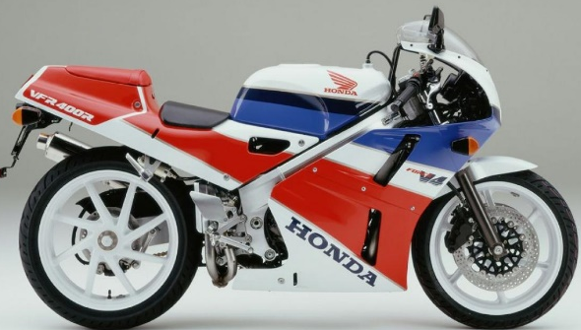
Engine workshop

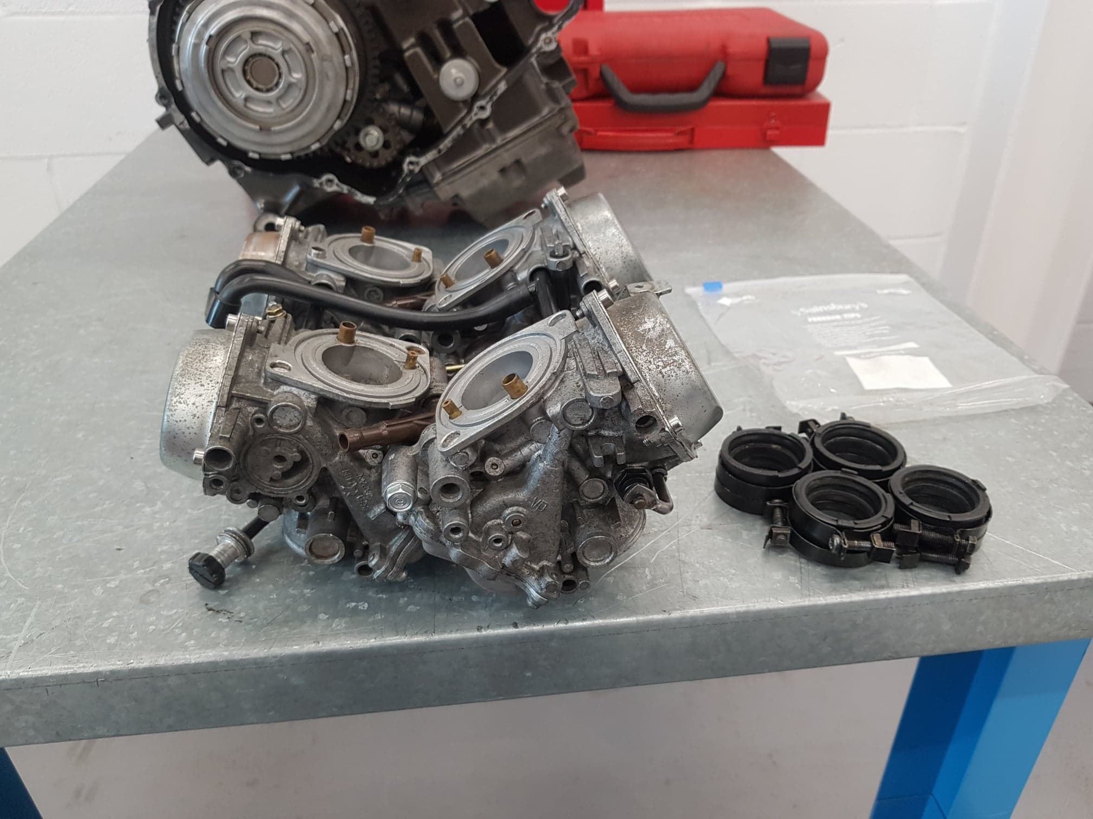
Four Keihin carburettors 32mm
The first thing I will remove from the engine is the four carburettors that are mounted to the top side of the engine these are fixed down using carb rubber they have jubilee clips that compress the rubber the hold them in place they are easily removed by unscrewing the clips by undoing them with a p2 screwdriver.

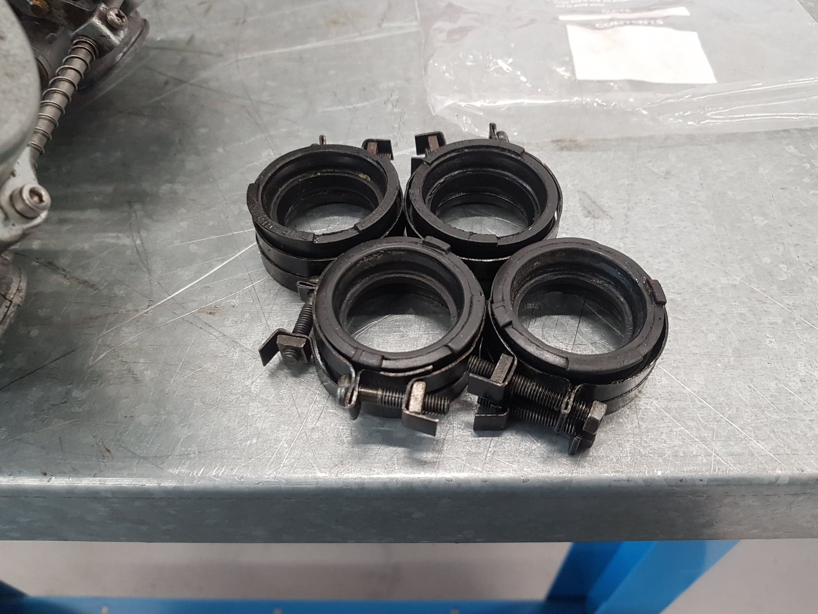
Four carburettor rubbers also 32mm internal diameter

I then used the p2 Philips screwdriver again to remove four more further clips that retain the carburettor rubbers to the inlet ports on the top of the engine where the air and fule is combined to enter past the valves to the piston cylinder chambers before the intake stroke of the four strokes of the engine.

Engine workshop
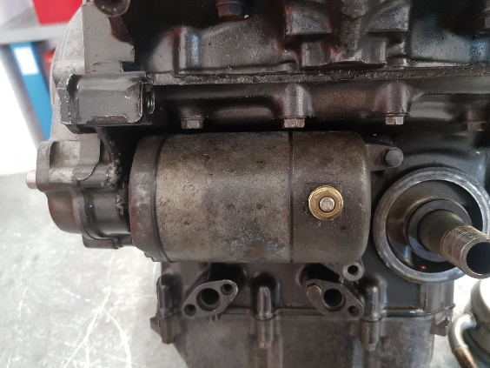
Electrical starter motor

I then proceeded to remove the starter motor from the engine to do this I go a ¼ inch rachet and an 8mm socket to remove the two m6 0.75 pitch-tired bolts that retain the starter motor it positioned on the front side of the engine.

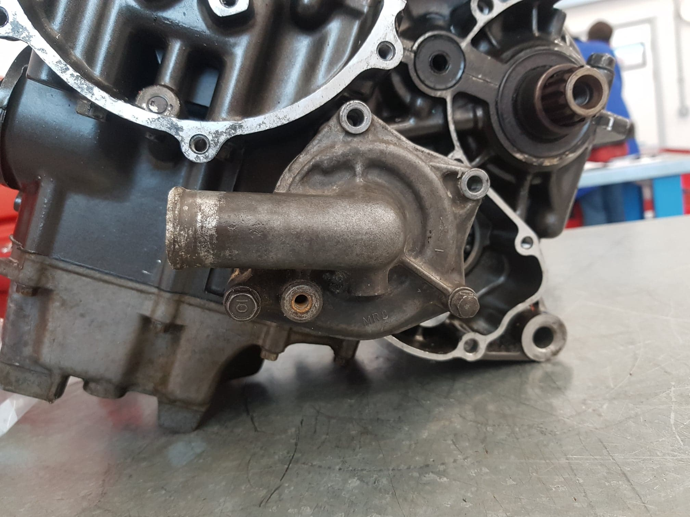
Water pump

Using the same ¼ inch ratchet and 8mm socket I remove two further m6 1.0 thread pitch bolts that hold the water pump in place to the engine and there are another two bolts that hold the two water pump castings together where the impeller is housed that circulates the water and coolant throughout the engine and radiator.

Engine workshop

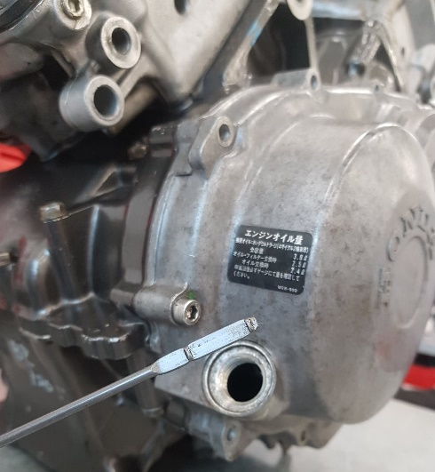
Oil dip stick
I unscrewed the top of the dip stick from the engine to check the oil level there are two marks on the dipstick marked H for high and L for low this is checked when the engine is in a level position generally in the motorcycle frame as there is no oil in the engine I am stripping I can return the dip stick to the engine.

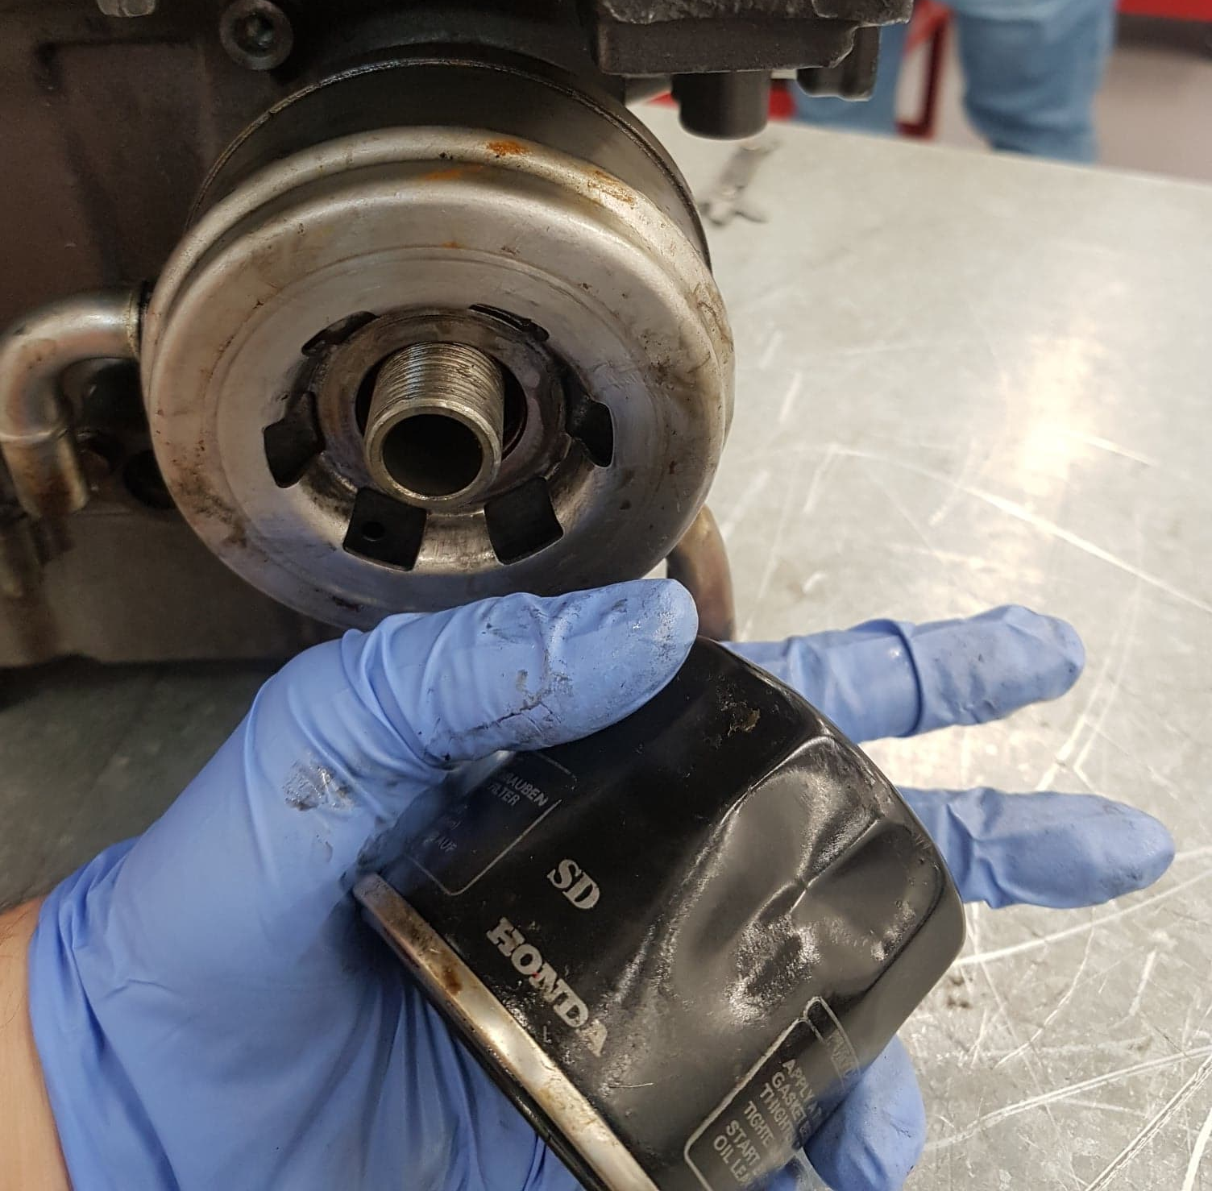
Oil filter
To remove the oil filter, I will use an oil filter removal tool there are several types that can do the same job there are universal options strap filter removal tools with chain, rubber, fabric and flat metal strap a three armed compression tool that is used in conjunction with a rachet and also cap removal tools that you have many different size caps that have a mounting point for a rachet as well.
Engine workshop

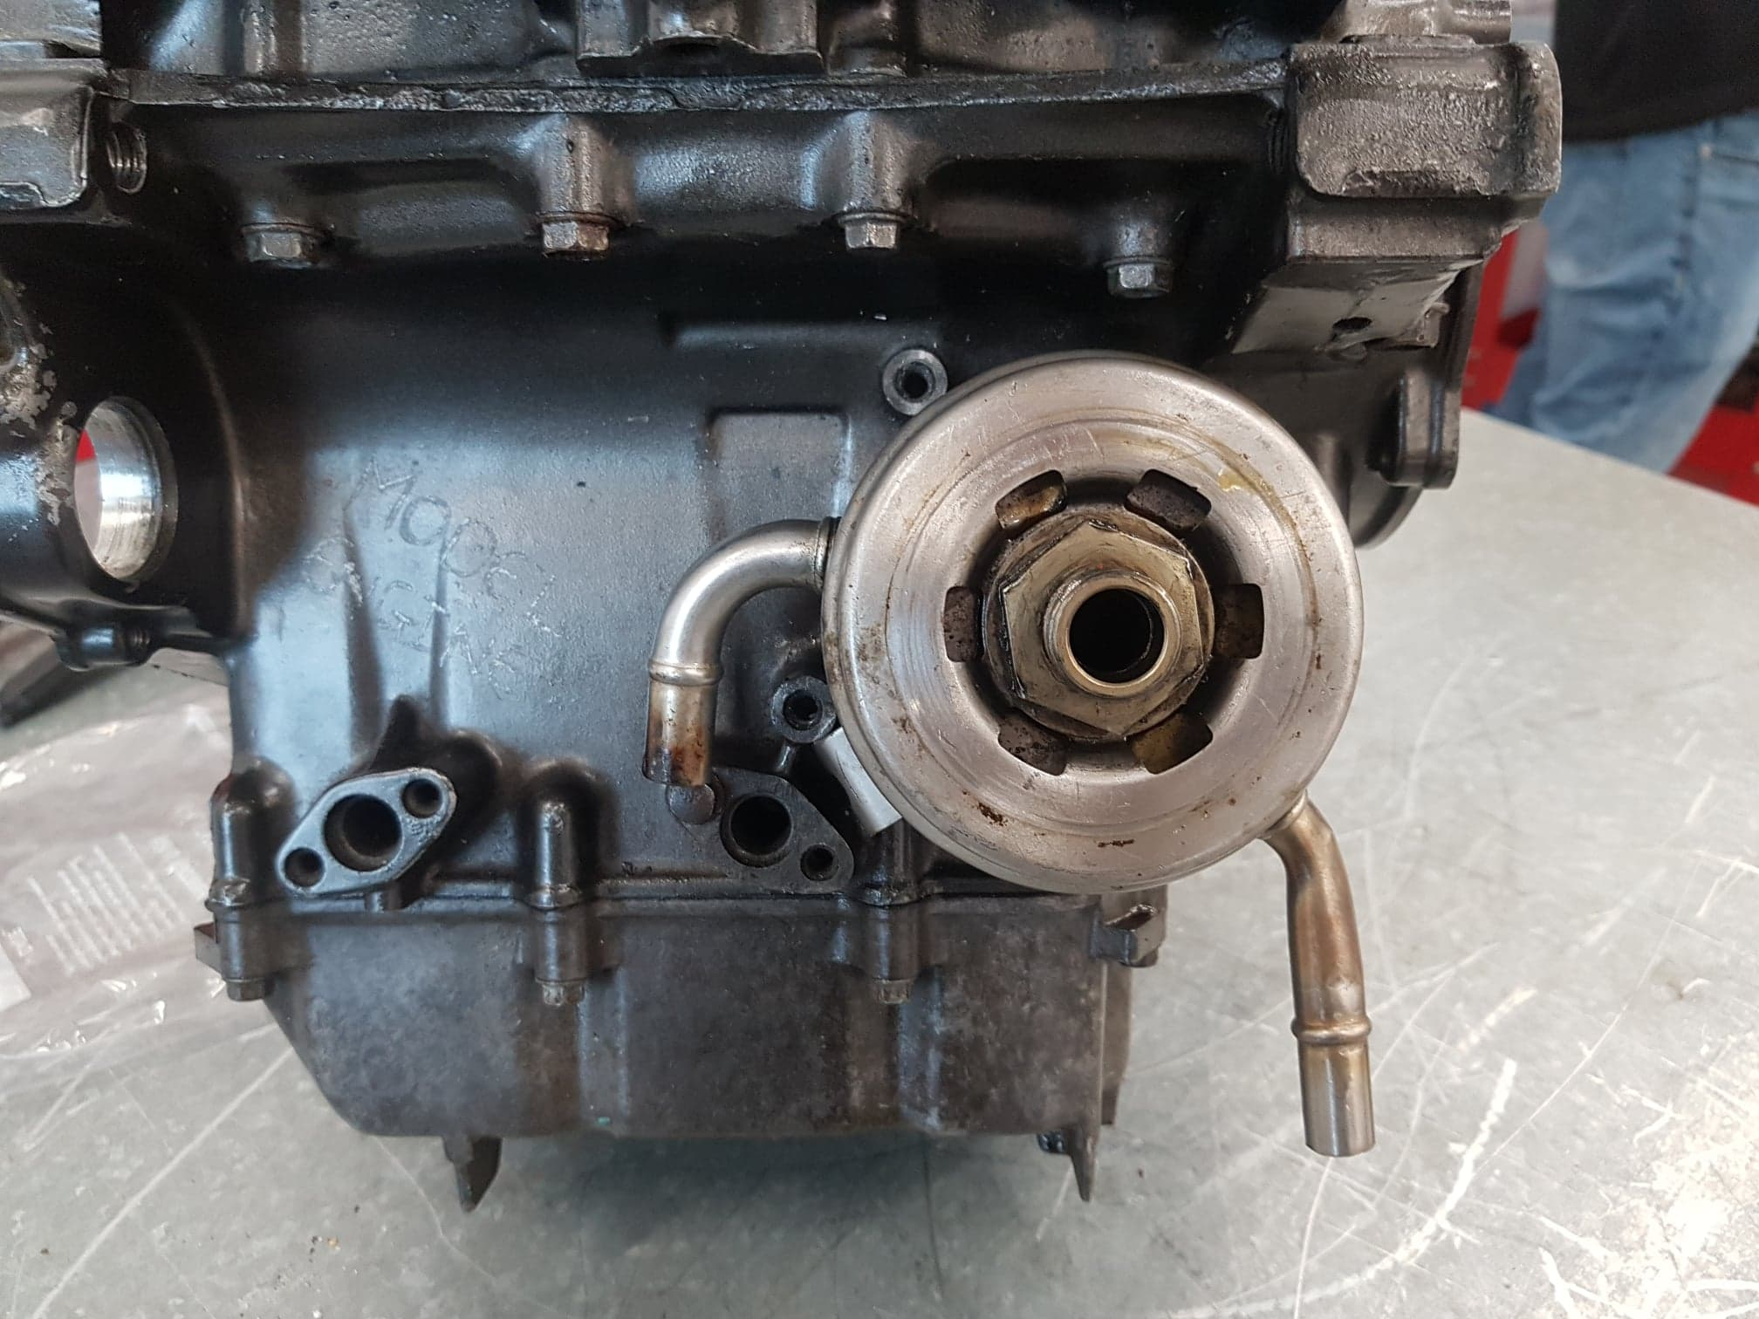
Oil cooler

There is a oil cooler where there is a recirculating system that pumps oil from the oil pan located on the bottom side of the engine through the oil cooler where air will flow to cool the oil. There is a 30mm nut that holds the oil cooler in to position to the engine this is removed with a 3/8 rachet and a 30mm socket

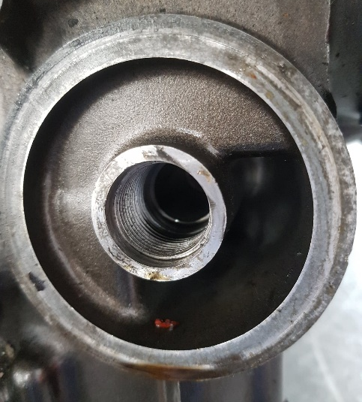
Oil ports on the engine

These oil ports are where the oil flows to and from the oil filter that is in place to clean any foreran partials in the oil that could slow the engine down or cores damage to the moving parts within the engine.
Engine workshop

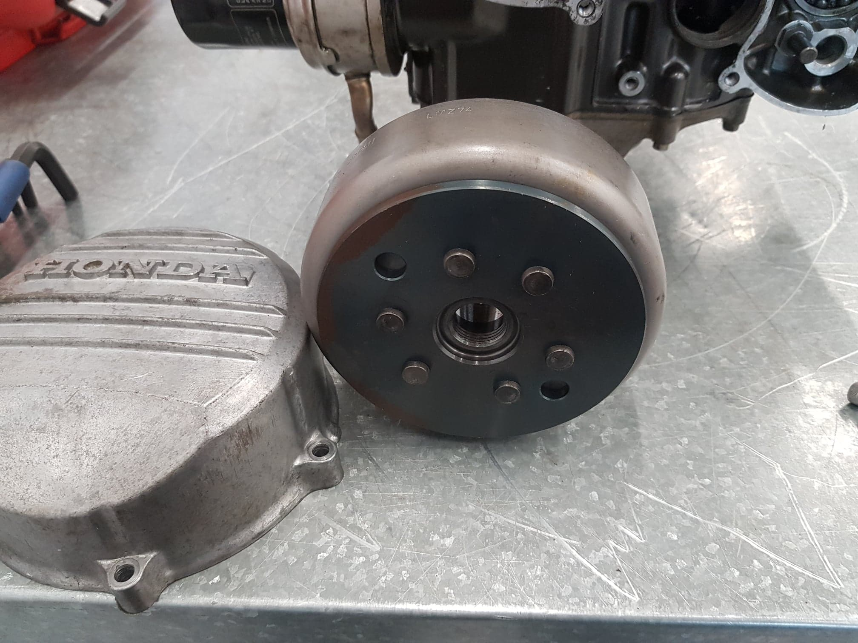
Engine casing and flywheel magnet
Moving forward with the removal of the engine casing and magnetic fly wheel I started with the six bolts that hold the outer casing I use a ¼ inch rachet and an 8mm socket. Then using ½ inch breaker bar or a long solid bar and a 16mm socket attached to it as the nut will not only the to a torque setting but also have thread locking liquid to stop the nut releasing during the running of the engine.
Once the nut is removed there is a specialist too needed to release the flywheel from the tapered shaft from the engine it is a fly wheel puller there is a few different types a three armed version that pulls from the outer of the flywheel and pushes of the shaft and also a puller that uses a double thread system where it mounts on to the shaft and as you wined it inwards it forces the flywheel off the shaft.

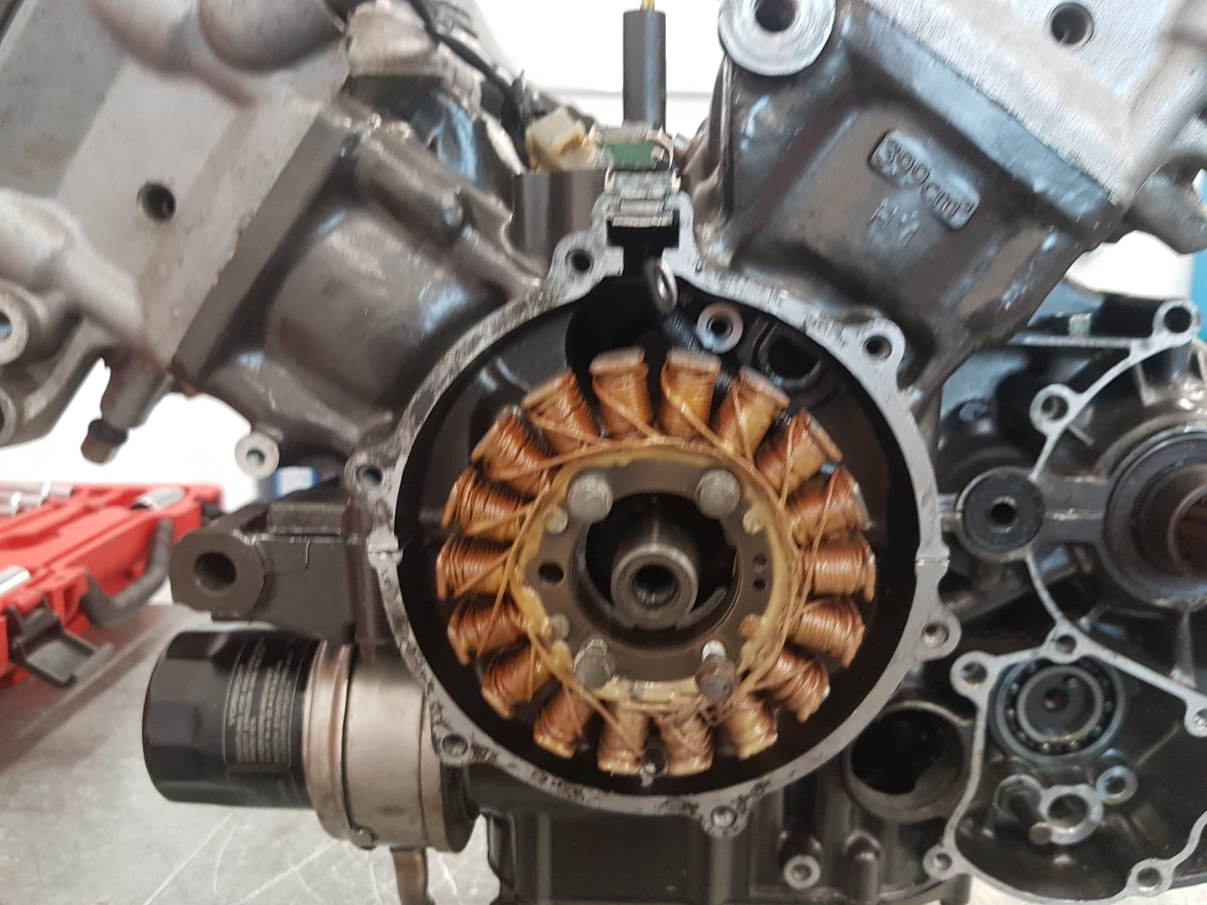
Electrical stator
The electrical stator is there the electrical power is generated to recirculate energy back in to the battery so the bike dose not drain the battery by using all the different sensors and other ancillaries on the bike. This was easily removed from the engine there is four m6 1.0 thread bolts that retain the stator I use a ¼ inch rachet and an 8mm socket

