Coexsistent Perspectives (ADAA7000)

Essay Question 3: Explore the heterotopia space and place in Control, analysis how Control borrowed and developed the theory of six principles in Foucault’s heterotopia.

Control × Heterotopia

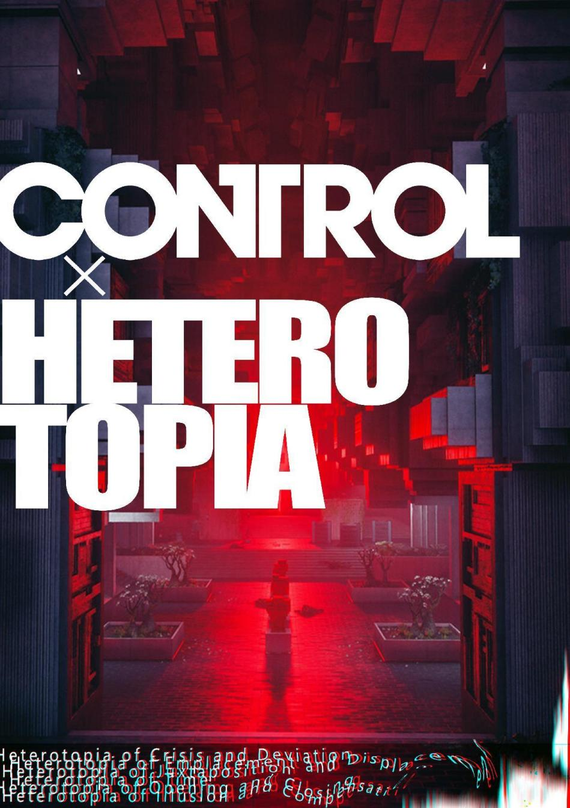
Fig 1. Coexistent Perspectives Poster

Abstract
This essay studies a game called Control published by Remedy and the heterotopic space and place in this game based on Foucault’s Six Principle of Heterotopia. Along with the study of Control, this essay talks about the concept of space and place proposed by Yi-Fu Tuan. The concept of space and place mentioned by him is positive, which compared place to a space endowed with meaning and emotion by humans, so people become attached to such palce. The connection and difference heterotopia share with it is mentioned, which lead to how Control realizes the heterotopic sense oh its design on these basis, that is, shuffle the order and defamiliarize the familiar. This essay then mainly focuses on the connection between Control and Foucault's six heterotopian principles, how control physicalize these principles in games, and how it develops these principles based on the concretization of these principles one by one. Moreover, How it attempts to spread the concept of heterotopia on more than just physical levels is also mentioned. By defamiliarizing existing buildings and disrupting the way they are divided in reality, Control physicalizes the concept of heterotopia. Besides, it incorporated the concept of heterotopia into the plot through mystification and the narrative method that first familiarizes and then defamiliarizes certain characters for the player. It break through the broad sense of heterotopia, and try to explore in the realm of thought for heterotopic space through storytelling, giving future researchers who study the theory of heterotopia in this field more research directions to explore.

Introduction
As the form increasingly accepted as the ninth art, games becomes an important role in express creativity and ideas intuitively. These video games are based on reality, transform reality, and challenge reality. They stitch together scenes that seem to be unable to exist in the same dimension, presenting a hyper-realistic heterotopic space that transcends traditional boundaries and allows people to immerse themselves in it.

Moreover, their very existence are the realization of heterotopic spaces. According to Foucault, who theorized the heterotopia theory, the mirror reflects an illusory and intangible material world, but at the same time the mirror actually exists in reality, which makes space exist both absolutely real and absolutely unreal. (1986, p.24) And yet, video games both mirroring and deviate from the reality, and accommodates countless vast spaces into LCD screens that seem impossible to contain them all. Besides, games designed heterotopic places within the games, created the worlds within worlds. Like Death Stranding (2019), Assassin’s Creed Series (2007- now) and Control (2019), either created a place during crises, or places providing a temporary escape from the real world in the game.
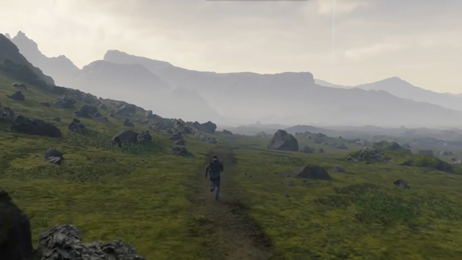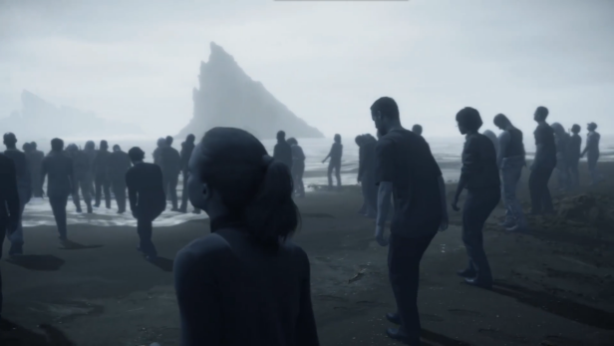
Fig 2. Reality and illusional world in Death Stranding. Death Stranding, (2019).
This essay will solely focus on one game, Control, a game vividly illustrates the theory of different principles of heterotopias, in which players not only interact with the objects and NPCs, but also participate in shaping the intricate, moving buildings and spaces within them. The design of Control points more than once to Foucault and his heterotopia theory. It not only establishes complex mirage-like animations in the architectures and NPCs, but also leaves a lot of gaps in the narrative, making the game exist in an illusion that is understood and cannot be fully understood to players. This embodied reality and the illusory experience that is still not fully revealed also exist within the framework of heterotopia, giving players a unique gaming experience.

In addition to giving players a sense of heterotopic space, it devoted to exploring the connections that video games can have, both as a heterotopia and with other heterotopic principles. The dual shaping of gaming experience and philosophical core gives a defamiliarized new perspective to explore more possibilities of the connection between games and heterotopias. This essay aims to discuss how Control is related to Foucault’s concept and principles of heterotopia, how it implements each principle in the game, and how it developed on the theory, giving new perspective and possibility to heterotopic spaces. This essay will started by looking into Foucault’s six principles of heterotopia, and mainly focus on how Control visualizes and extends it into further concept.

Space, place and Heterotopia
To begin with, Yi-Fu Tuan described that “Place is security, space is freedom”. (1977, p.3) The spaces and places he explains are not just geographical, but mixed with human experience. He proposed in Space and Place: The Perspective of Experience that space is fluid, open and free, while place is static, safe and stable, giving people a sense of intimacy, security and attachment. (1977)

Space is an abstract concept that is not concrete and has no boundaries. Dong-po Su, a literary giant figure in Northern Song Dynasty mentioned in Ode to the Red Cliff, "A mayflies in the sky is like a drop in the vast ocean; I grieve for the transient of our lives, and envy the eternal flow of the mighty river." (1082) When people's perspective of observation changes, the abstract concept of space will change accordingly. Moreover, when spaces are given meaning, it transformed from a physical, abstract space to places that people are attached to. (Yi-Fu Tuan, 1977) Space is abstract, complex, and has no practical meaning. In order to understand it, people give it meaning and divide it into areas of different scales, types, and functions, which made space transformed to place. Tuan also mentioned the sense of attachment to a place in Topophilia, that people put their emotions on a place, and when people recall that place they will recall the emotions they were placed in, thus generating nostalgia and love for the place, giving the place meaning. (1990)

It can be seen that space and place were often regarded as equivalent to harmonious and tranquil, which seems to be significant for human beings to constructing self-awareness and finding their place: the unearthed Guimei Hexagram of the Qin Dynasty (1993) show the imagination of ancient Oriental humans about the unreachable lunar space, which record the romantic myth of Chang’e flying to the moon. Moreover, this theory can also be related to More’s Utopia, in which the space and place are the security places with a high degree of unity of order and rational logic and where people can make choices freely. This implantation of the concepts of security and freedom can be found in most of imagination.

Instead, rather than keep digging into the ideal logical order of space and place, Michel Foucault takes another approach. He reconstructed the vocabulary Heterotopia from medical field and rewritten the concept of space and place, in which heterotopia deconstructed the familiar cognition that people have categorized for space and place, and transformed it into an exotic, disturbing, unsettling taxonomy of otherness. (Foucault, 1994, preface) In The Order of Things, he saw an idea that deconstructing the original familiar classification method and re-constructing it through defamiliarization, from the alternative classifications in a Chinese Encyclopedia. This classification method of otherness was conceived in his philosophical thinking, disrupting the space and place defined by Tuan, breaking the categories of space, place, home and attachment, and causing the classification rules to break away from order and become disorder. (Foucault, 1994)

Furthermore, Foucault explained the construction of heterotopia in the subsequent research, Of Other Spaces, that compared to the non-existent utopia, heterotopia is a place that exists in every civilization that present in many forms. Like the mirror mentioned above, it is a utopia that is realized and exists both in illusion and reality, self-questioning and self-opposing, the other that self-contrary. (1993, p.442) Foucault explained that, standing in front of a mirror, one can see their own reflection in a place that does not exist, which allows them to truly see themselves. On the other hand, one in reality cannot see themselves directly. The self can only construct their cognition of their own image in the projection of other objects, so the mirror here becomes a carrier of heterotopic space.(1986, p.24) At this level, the game once again carries the role of the mirror in the concept of heterotopia Foucault explains, that is, reflecting an illusory projection of the real world. Even though it is different from the concept of this example, it still reconstructs a real world and becomes an integral part of people's cognitive world.

Besides, in a broad sense, heterotopia refers to spaces and places that are ‘other’, off-centre, mirroring with the real space yet upsetting, and where normal behavior decease to exist. (Jones, 2010) They can have several real space exist simultaneously, yet each places or spaces are incompatible with each other, which appears in Control’s scenes design repeatedly. A place called Quarry Threshold takes an essential place in the game, where is the Federal Bureau of Control mine for the materials that are necessary to maintain the operation of Bureau. In this quarry, players can simultaneously see the muddy mines, the rocks arranged like a city in the distance, and the vast starry sky above their heads. However, this quarry is placed on Maintenance Sector of The Oldest House,which is a middle floor of a skyscraper located in New York City. These kind of place breaks people's inherent understanding of the existing space, which is separated from reality and appears as an abnormal space. Control creates surreal heterotopic spaces by putting these contradictory places in the same one, which gives the players an unreal experience when they enter the filed. And through its unique art style and mysterious narrative method, it makes players more curious about the space and place in it.
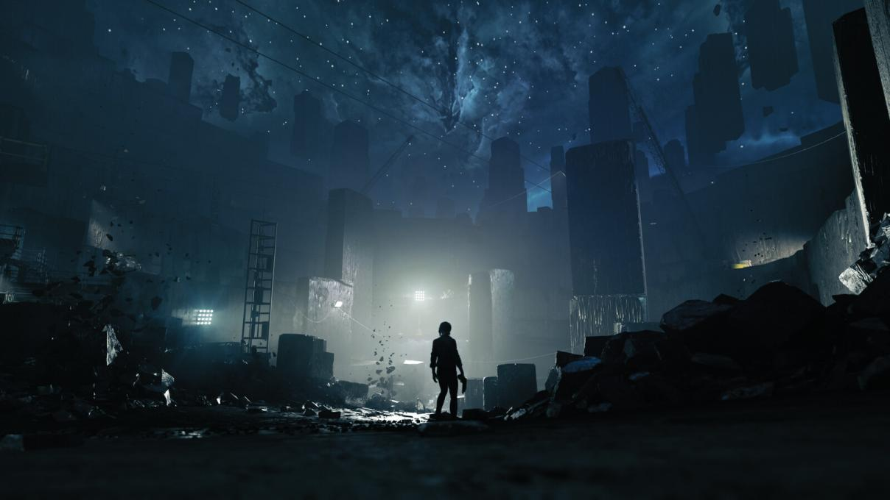
Fig 3. Blackrock quarry threshold visual development. Leonardo Calamati, (2019).

Control
As a homage that respectful imitate and inspired by SPC foundation, Control seems can be seen as a hardcore horror game, in which the player plays a newly appointed director, Jesse Faden, trying to regain a government building belongs to the Federal Bureau of Control (Bureau), that has been corrupt by supernatural phenomena Altered World Events (AWEs) caused by Objects of Power and things called the Hiss from other world.

The gameplay and storyline sounds similar to other FPS games, however, the moment players enter the game map they will notice the difference in its design style. In games, players often have long and narrow or wide moving spaces, but whether it is the contrast of color between the highly saturated red light source and the heavy blue-gray stone building, or the quiet, weird and lack of background music sound effects, these spaces give players a lasting sense of oppression. Whether it is the title of the newly appointed director or the information that the entire space is occupied by alien beings, it gives players a message that while the place is completely open, it is closed and not welcoming. From these small details starting from the prologue, Control has already built heterotopic concept in players’ mind, even they do not know that these spaces are temporary or closing heterotopia.

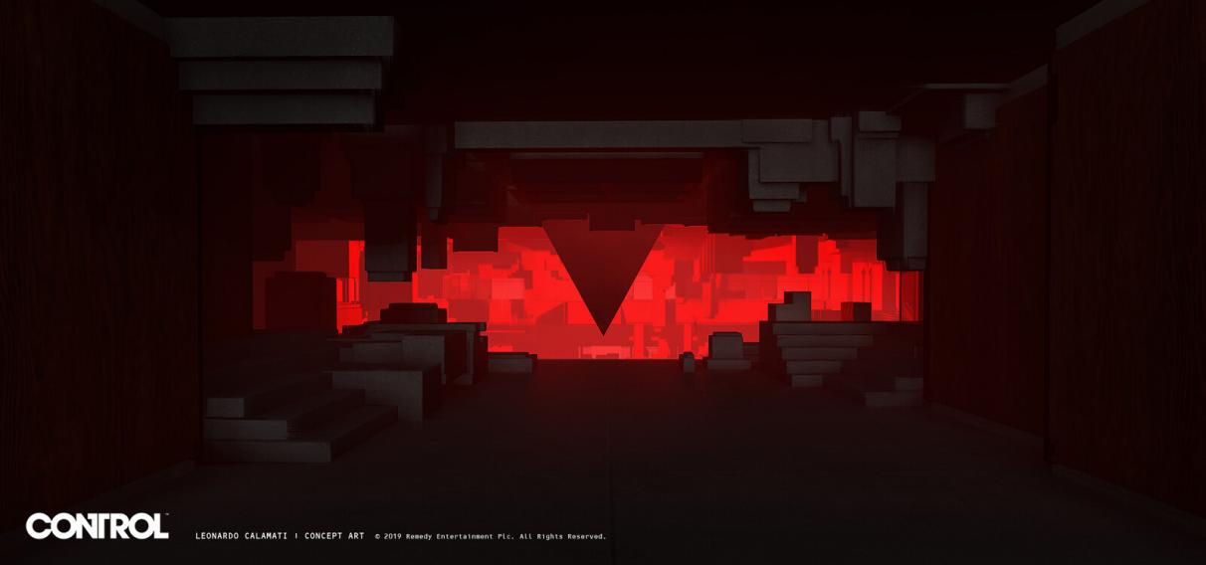
Fig 4. Hiss presence visual development. Leonardo Calamati, (2019).

Moreover, as players learn more about the plot, they will find that the forces in the game do not have absolute justice. Although the mission of director is to defend the building and the world from foreign invasion, when the player controls the character to pick up the files left by the agents on the ground due to the hasty escape, they can find that Bureau has its own set of procedures and templates for informing the victims or the families of the victims when investigating AWEs, and they will even kidnapping innocent people to follow the procedures. This sense of strangeness towards the familiar Bureau as the understanding deepens also gives players the feeling that the Bureau itself has been heterotopized and defamiliarized. The feeling of fragmentation reaches its peak near the end of the game: Jesse gradually discovers that the Hiss' appearance is because of the former director's desire for power and over-judgment of his own strength. At this moment, Control not only experimented with the concept of practical, physical heterotopia in the game, but also heterospatialized the corroded power structure and the former director distorted by it.

Furthermore, instead of being a overall and general concept, Control attempts to give its own implementation of all six of Foucault’s principles of heterotopia, which will be discussed separately in detail to show how Control blend the concept with it perfectly.

Six Principle of Foucault's Heterotopia
- Heterotopia of Crisis and Deviation
The first principle Foucault proposed contain two categories: heterotopia of crisis and heterotopia of deviation. The former form of heterotopia originates from the privileges of primitive society, or religious forbidden areas, which trap people in a biological sense of crisis. (Foucault, 1986, pp.24-25) In the game however, it not only is a certain place, but also a taboo area in the mind that is forbidden to touch. When the game first started, Jesse were seeking for the location of the agency that kidnapped her brother. She cannot find The Oldest House until it allows her entry, since the Bureau is in crisis and it decide she is needed. It is because Bureau is a sacred place where the AWEs are investigated, and only the staffs who work inside are aware of the building’s existence, which can be seen as a conceptual taboo for ordinary people.

However, heterotopia of crisis is slowly disappearing and being replaced by heterotopia of deviation, where specific groups of people deviate from the social average and become marginalized groups. (1986, p.23) Panopticon, a prison that contain Objects of Power in Control, can be seen as a place of heterotopia of deviation, since Objects of Power affect human irreversible, moreover fatally, which goes against the norms of society and publicity.

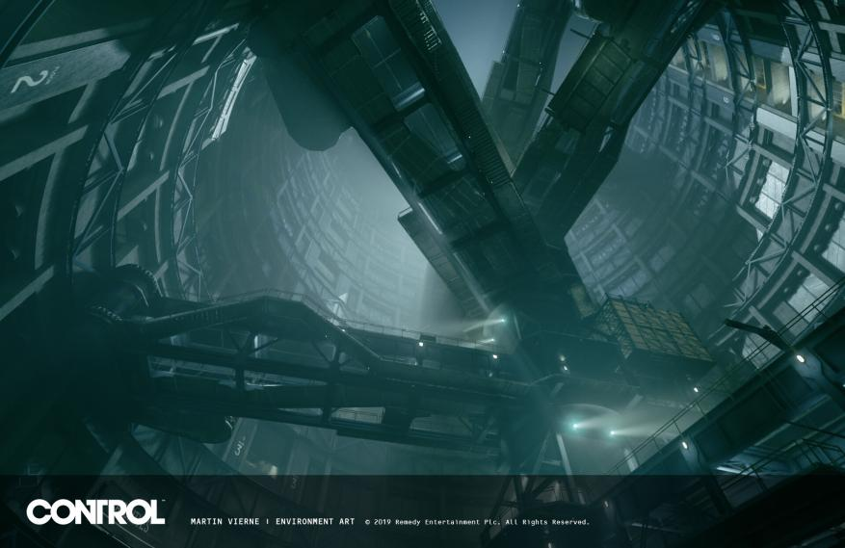
Fig 5. CONTROL: Panopticon. Martin Vierne, (2019).
- Heterotopia of Emplacement and Displacement
It should be noted that Foucault did not clearly define the name of this category of heterotopia. However, this kind of heterotopia, which is constantly established and succeeded, and diachronic and synchronic coexists, could be called as heterotopia of emplacement and displacement, according to Sajjad and Perveen. (2019, p.3)

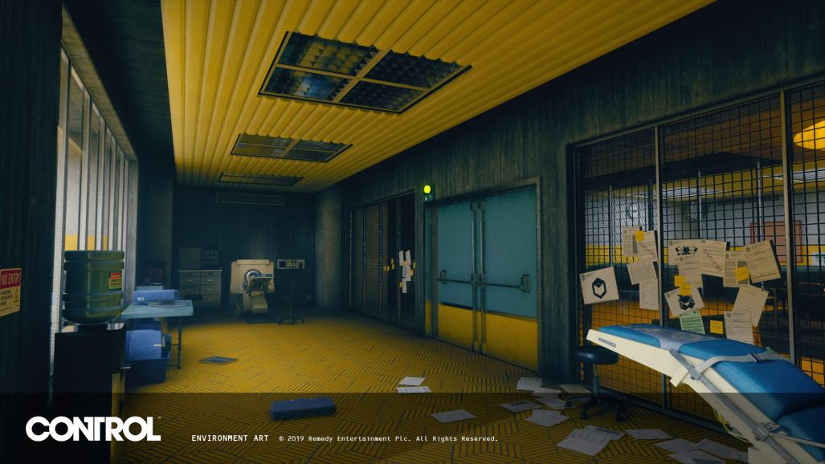
Fig 6. CONTROL - Hypnosis Lab (Central Research). Raja Ghosh, (2019).

The Oldest House in Control carries different responsibilities in different historical periods. In its early days, the main role was to study AWEs. Subsequently, it began to contain Object of Power, because this allowed the ordinary world to continue to be safe for ordinary people. At the beginning of the game, it became a barrier to protect the world from the Hiss, and also where Jesse and her ability Polaris fought for the battlefield with it. As a heterotopia of emplacement and displacement, the Oldest House “make an existing heterotopia function in a very different fashion” as the history develops. (Foucault, 1986, p.25) In addition, in the eyes of Jesse’s group and Hiss’ group, their community operation methods and forms are completely different. On Jesse’s side, the Hiss’ community is a heterotopia, and vice versa. Both heterotopias operate on their own internal “synchrony of the culture”. (Foucault, 1986, p.25) Therefore, Control display the two small points in the second principle separately in the game, and interweaves them together through the promotion of the plot, showing an exploration of heterotopia’s new context.

- Heterotopia of Juxtaposition
The third principle refers to a real location that combines two or more seemingly incompatible and contradictory space or place. One example Foucault give is “the Orient the garden”, in which plants come from worldwide. (Foucault, 1986, p.25) It is a microcosm, a replica of plants around the world. In addition to Quarry Threshold, which “juxtaposing in a single real place several spaces”, Panopticon can be seen as a heterotipia of juxtaposition as well. (Foucault, 1986, p.25) The Objects of Power contained in Panopticon come from different periods and various locations, collected by Bureau over the years. While it has become a heterotopia of deviation, it has also become a museum, a heterotopia of juxtaposition, with the continuity and eternity of time, for the agents and players to learn the history of Bureau.

Moreover, the game itself is a heterotopia of juxtaposition. As a video game, Control exists as a heterotopia. And within this heterotopia, many different heterotopias are juxtaposed in it. In addition, these space and place seems cannot be placed in the Oldest House, since the place inside is physically larger than the volume the building can contain.

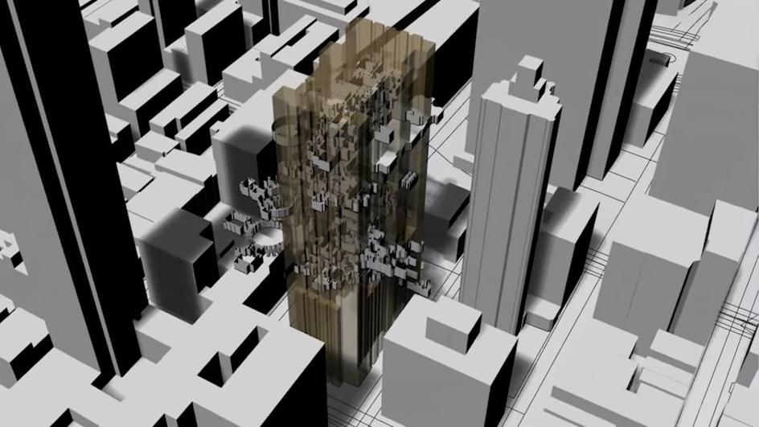
Fig 7. Architectural Drawings of Control. Extra Office, (2021).

Control explains this as the Oldest House is an Object of Power itself, but we can also interpret it as a physical extension of heterotopia of juxtaposition, which is an aspect Foucault does not discuss in this principle: what happened if it seems impossible from a physical or three-dimensional perspective that these spaces can be contained in one place? Will that be a heterotopia of juxtaposition? Control provides the answer in this regard.

- Heterotopia of Time
The forth principle of heterotopia shows qualities of instantaneous and fragmented. Opposite with heterotopia of juxtaposition, “which accumulating everything” (Foucault, 1986, p.26), this heterotopia is escapist and temporary. It opens a transitory gateway to a foreign land. Jukebox, one of the Objects of Power, takes on this role in Control. It has the ability that can temporarily transport anyone who hears its song to a random location, and when the song ends, the person will return to where they were before. This can relate to festivals in Of Other Spaces, where people briefly break away from the normal order of life and enter a temporary existence with alien rules. (1986, p.26)

However, this instantaneity also takes another form. People invented a new heterotopia that combine temporality and eternity, like vacation viallages. (1986, p.26) In this hybrid heterotopia, travelers living in contemporary cities comes to indigenous villages, where the heterogeneous rules are temporarily to tourists, while the lives for indigenous people are permanent.(1986, p.26) Control materialized this heterotopia in the game by briefly putting Jesse in crisis of being assimilated by the Hiss. In the game, Jesse mentioned Hiss has its own way of operating, which can be compared to a heterotopian vacation villages. By allowing Jesse to be assimilated, Control allows the protagonist and players to be in the heterotopia under the Hiss’ system, and experience a rule different from Bureau temporarily. Against the process of being assimilated, Jesse both exist in Bureau’s system, and is briefly separated from it since she is in the stage of being assimilated. The two different times and systems overlap at this moment.

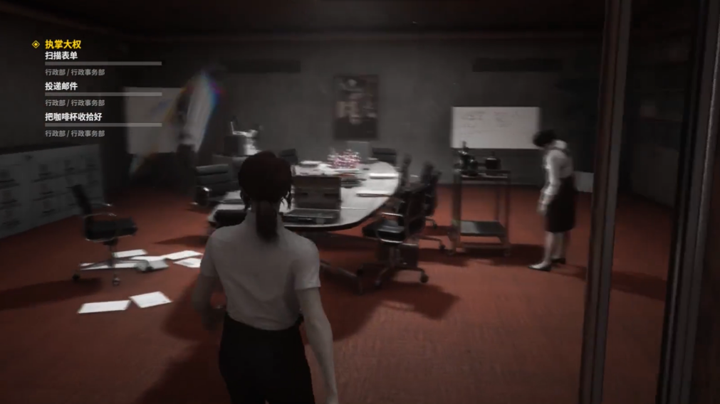
Fig 8. Jesse in the Hiss' system. Control, (2019).

- Heterotopia of Opening and Closing
Like its title, this heterotopia has two trait. On the one hand, this heterotopia has its own rules of entry, such as people needing to purchase tickets, or to be qualified to enter it, they must go through a series of admission rituals. As mentioned, at the beginning Jesse wanted to enter the Oldest House but could not, because she did not have qualifications. Only when she got “a certain permission” does the opening heterotopia welcome her. (Foucault, 1986, p.26)

On the other hand, there are places “everyone can enter into, but in fact that is only an illusion”. (Foucault, 1986, p.26) This heterotopia appears to be open, but in fact it excludes people from entering. In addition to the feeling of not being welcome in this building mentioned earlier, there is also a third-party force called Board in Control. When the player touches the Object of Power, Jesse can be allowed to enter a heterotopia because she is permitted. But her purpose is only to learn the skills brought by the Object of Power. When she learns the skills, the Board will transport her back to the outside world: the space is exclusive. This place can also be linked to Foucault’s explanation in Of Other Spaces: like “American motel”, this unnamed space of Board is “absolutely sheltered and absolutely hidden” from outside world. (Foucault, 1986, p.27)

Besides, Control combine the two traits in the fifth principle together. The unnamed place is an opening heterotopia: entering it requires permission from the Board. Before Jesse, other agents of Bureau who tried to enter were unable to enter cause the lack of permission and were killed by Objects of Power’s fatal affect. At the same time, the unnamed place is a closing heterotopia either, since it is inherently repellent. This mixture of the two in Control is also an exploration of new possibilities for Foucault's heterotopia.

- Heterotopia of Illusion and Compensation
This principle has been discussed many times due to its abstract nature. Foucault said in Of Other Spaces, that this heterotopia has two completely different functions: one is to reveal real space by creating an illusory space, and another is “to create a space that is other”. (1986, p.27) One group of researchers, such as Sajjad and Perveen, understands it as two concepts in the same principle that are separated due to different choices, which leads to the differentiation into either the real place becoming more intense and pure to an extent that is difficult to reach in the real place, or it becoming a heterotopia that is arranged as well-organized as the real space, but crumbling at the same time. (2019, pp.4-5) Another group of researchers believe that the two aspects of the principle are combined, that is, this heterotopia creates an illusory space, and at the same time creates the real space it reveals in the illusory one. (Shang, 2005)

From the perspective of game content, the sixth principle presented in a physical form by Control belongs to the latter interpretation. The former director died under the corruption, but his thoughts still echo in Jesse’s mind - this is a connection between directors called Hotline, which can give both warning and guidance to the new director. This echo appears in the form of a vision when Jesse enters a specific place, revealing the stories happened there, and Jesse acts after receiving revelation from a dead director, an illusion, which caused real space changed or created.

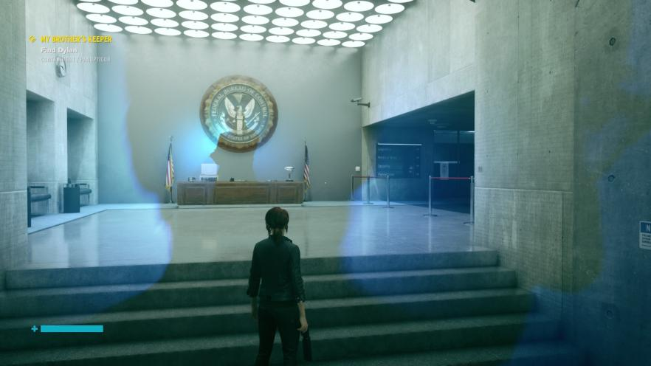
Fig 9. Jesse received the hotline. Control, (2019).

However, when observing from outside of the game, we can draw the conclusion of the former researcher. When the game is created, it projects the illusive reality that the game developer had in mind. The most typical example is, artists who designed the architectures borrowed and twisted the design from famous buildings worldwide, thereby achieving the purpose of modifying them to serve the atmosphere of the game. For instance, the outside of the Oldest House is based on AT&T Longline Building, a windowless Brutalism skyscraper, which not only creates a sense of isolated heterotopia space for the building, but also demonstrates its unchallengeable majesty as an investigative bureau through its architectural style. (Gamedevdotcom, 2019)

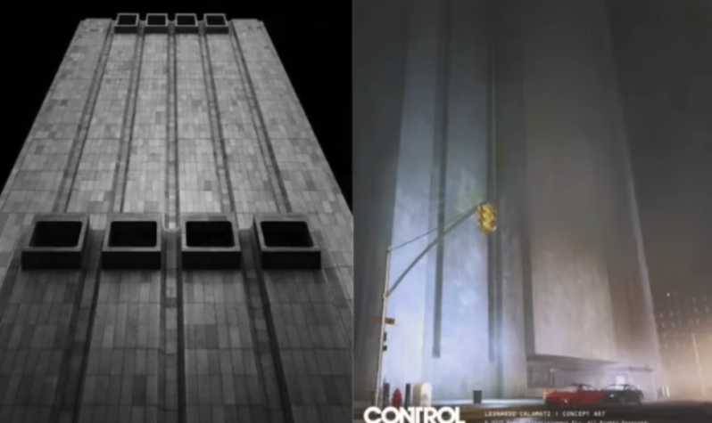
Fig 10. AT&T Longline Building and the Oldest House. Zhou Ke-Er, (2022).
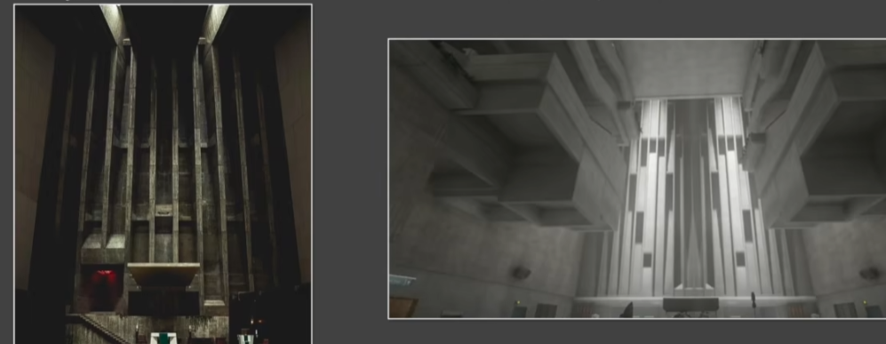
Fig 11. Church of St Francis de Sales and Dead Letters. Zhou Ke-Er, (2022).
Another example is, Church of St Francis de Sales was almost completely copied into the game, but the part of the altar that designers did not need was discarded. (Gamedevdotcom, 2019) The church part also enhances the feeling Control wants players to experience. It uses the design of a sacred building to bring its sense of sublimity into the game, making players feel insignificance when their character encounter those unknown things. Furthermore, game designers have added animations that cannot be completed in reality, such as a building that moves from brick to tile, making this heterotopia cannot be achieved in reality. This kind of trade-off and choice made by the designer can be regarded as heterotopia of illusion. On the other hand, when players feel that the design and planning of Control are orderly, they can also observe asymmetry and disharmony in it. Whether it is the box of Hotline Chamber that is not lined in the same perspective, or the cracks in the wall and floors that look fine but do not match up, they all show disorder within order, which can matched with the heterotopia of compensation.(Extra Office, 2021)

Overall, this principle does not have a definite conclusion currently. From the perspective of this essay, the existence of norms within heterotopia of illusion and compensation can be separated or aggregated depending on the perspective of observation.

Conclusion
This essay discussed Control’s interpretation and application of the concept of Foucault’s heterotopia. By defamiliarizing existing buildings and disrupting the way they are divided in reality, Control physicalizes the concept of heterotopia. Besides, it incorporated the concept of heterotopia into the plot through mystification and the narrative method that first familiarizes and then defamiliarizes certain characters for the player. It break through the broad sense of heterotopia, and try to explore in the realm of thought for heterotopic space through storytelling.

Control chose Foucault's path when facing the topic of space and place, deconstructing the place that should originally belong to security and attachment, and redefining this space through exotic classification methods - Hiss-occupied area and recovered area, and using different light source and building arrangement method distinguish them. Through this approach, Control successfully covered the area divided by office functions with a new division method, destroying the arrangement where belongs to Bureau's office structure, and successfully heterotopized the seemingly ordinary building, and the space and place in it. In addition, it physically reproduces Foucault’s heterotopia principles through its unique design of space and place. It even expresses the principles that researchers have difficulty in drawing conclusions through different forms, and explores the possibility of heterotopia in the game to the greatest extent possible.

While each principle is demonstrated by architecture themselves, it also develops in storyline, making heterotopia exist not only in its architectural space but also in its plot concept, which is a discussion that is rarely covered in heterotopia studies. Control defamiliarizes the concept of heterotopia by expanding the theory into mind-space and storyline, allowing people to observe it from a different perspective, and inspired to find the possibility of expanding the concept in future exploration.

Furthermore, by leaving a void in the plot, Control gives its audience a space full of possibilities for free interpretation. When performing game tasks, players can always pick up documents scattered on the ground, where the confidential information blurred out in black leaves room for imagination in the plot that are not interpreted. This inability to be understood in understanding once again strengthens the confusing heterotopic part in plot. As a heterotopic space itself, Control successfully demonstrate the concept pf heterotopia and tells the story while leaving spacious place for players to contemplate and imagine. While interpreting the artistic possibilities of Control, this also leaves us with more mysteries: What other concepts does Control want to convey through these blank spaces? What is its relationship with the heterotopia Control interpreted repeatedly?

References
Extra Office, (2021). Architecture Critic on Control - it's more than Brutalism!. [video] Available at: https://www.youtube.com/watch?v=4gbWOhxTpr8/ (Accessed 10 Dec. 2022)

Foucault, M. and Miskowiec, J.(1986). Of other spaces. diacritics, 16(1), pp.22-27. [Online] Available at: https://www.jstor.org/stable/464648/ (Accessed 30 Nov. 2023)

Foucault, M., (1994). The Order of Things: an Archaeology of the Human Sciences. [Online] Available at: https://monoskop.org/images/a/a2/Foucault_Michel_The_Order_of_Things_1994.pdf/ (Accessed 3 Dec. 2023)

Gamedevdotcom, (2019). The real buildings that inspired Control's Oldest House. [video] Available at: https://www.gamedeveloper.com/art/the-real-buildings-that-inspired-i-control-i-s-oldest-house#close-modal/ (Accessed 6 Dec. 2023)

Wang, L.Y., (2023). Heterogeneous Space, Deep Space and Hors-scientific Space：On the Grotesque Space Writing in Dune. Journal of Shenyang Institute of Engineering (Social Sciences), 19(4), pp.15-21. Doi: 10.13888/j.cnki.jsie(ss).2023.04.004.

Sajjad, N.U.A. and Perveen, A., (2019). Private heterotopia and the public space: An incongruity explored through Orhan Pamuk’s My Name is Red. SAGE Open, 9(1), p.2158244018824490. Doi: 10.1177/2158244018824490.

Shang, J., (2005). 空问的哲学: 福柯的 “异托邦” 概念 The Philosophy of Empty Questions: Foucault’s Concept of “Heterotopia”. 同济大学学报: 社会科学版 Journal of Tongji University (Social Sciences Edition) , 16(3), pp.18-24. Doi: CNKI:SUN:TJDS.0.2005-03-004.

Su, S., (2017). 赤壁赋 Ode to the Red Cliff. 中华活页文选: 高二, 高三年级版 Selected Chinese Loose-Leaf Articles: Grade 2 and Grade 3 Editions, (12), pp.47-51. [Online] Available at: https://www.cqvip.com/qk/60056x/201712/674173299.html/ (Accessed 13 Dec. 2023)

Tuan, Y.F., (1977). Space and place: The perspective of experience. U of Minnesota Press.

Tuan, Y.F., (1990). Topophilia: A study of environmental perception, attitudes, and values. Columbia University Press.

Victoria J E Jones, (2010). An Outline of Foucault's Six Principles of Heterotopia. [video] Available at: https://www.youtube.com/watch?v=qFcxzoPbJis/ (Accessed 3 Nov. 2023)

Xing, W., (2000). 秦简《归藏》与《周易》用商 Qin's bamboo slips "Gui Zang" and "Zhou Yi" useage. 文物 relics, (2), pp.58-63. [Online] Available at: https://www.cqvip.com/qk/97337x/200002/12390523.html/ (Accessed 3 Dec. 2023)

Bibliography
Aipaizhaodejialaoshi, (2020). 如何理解空间、区域、地方这三个重要的地理学传统概念。它们该如何区分？How to understand the three important traditional geographical concepts of space, region and place. How to distinguish them?. [Online] Available at: https://www.zhihu.com/question/381678229/ (Accessed 13 Nov. 2023)

Extra Office, (2021). Architecture Critic on Control - it's more than Brutalism!. [video] Available at: https://www.youtube.com/watch?v=4gbWOhxTpr8/ (Accessed 10 Dec. 2022)

Foucault, M. and Miskowiec, J.(1986). Of other spaces. diacritics, 16(1), pp.22-27. [Online] Available at: https://www.jstor.org/stable/464648/ (Accessed 30 Nov. 2023)

Foucault, M. (2015). Of other spaces. Translated by Z. Wang. [Online] Available at: https://www.chinawriter.com.cn/theory/2015/2015-12-01/259453.html/ (Accessed 4 Dec. 2023)

Foucault, M., (1994). The Order of Things: an Archaeology of the Human Sciences. [Online] Available at: https://monoskop.org/images/a/a2/Foucault_Michel_The_Order_of_Things_1994.pdf/ (Accessed 3 Dec. 2023)

Gamedevdotcom, (2019). The real buildings that inspired Control's Oldest House. [video] Available at: https://www.gamedeveloper.com/art/the-real-buildings-that-inspired-i-control-i-s-oldest-house#close-modal/ (Accessed 6 Dec. 2023)

Geng, S.Z., (2020). 读书｜耿苏志：空间与地方 Reading | Geng Suzhi: Space and Place. [Online] Available at: https://zhuanlan.zhihu.com/p/109382911?utm_id=0/ (Accessed 13 Dec. 2023)

Human, (2023). 【笔记】异托邦究竟是什么 [Notes] What exactly is heterotopia?. [Online] Available at: https://www.douban.com/note/854119238/?_i=2141071xxW43fn,2575538xxW43fn/ (Accessed 9 Dec. 2023)

Lanhouzi et al., (2017). 如何通俗易懂的解释异托邦？How to explain heterotopia in an easy-to-understand way? . [Online] Available at: https://www.zhihu.com/question/67991704/ (Accessed 13 Dec. 2023)

Luo, H., (2022). Games as Heterotopias: Realist Games in China. British Journal of Chinese Studies, 12(2), pp. 180-187. Doi: 10.51661/bjocs.v12i2.194.

Miller,J., (2000). The passion of Michel Foucault. Harvard University Press.

Wang, L.Y., (2023). Heterogeneous Space, Deep Space and Hors-scientific Space：On the Grotesque Space Writing in Dune. Journal of Shenyang Institute of Engineering (Social Sciences), 19(4), pp.15-21. Doi: 10.13888/j.cnki.jsie(ss).2023.04.004.

Rhetoricalquestions, (2016). Video Games as Heterotopias: On Magic Circles and Other Spaces. [Online] Available at: https://rhetoricalquestions2016.wordpress.com/2016/02/28/video-games-as-heterotopias-on-magic-circles-and-other-spaces/ (Accessed 11 Dec. 2023)

Sajjad, N.U.A. and Perveen, A., (2019). Private heterotopia and the public space: An incongruity explored through Orhan Pamuk’s My Name is Red. SAGE Open, 9(1), p.2158244018824490. Doi: 10.1177/2158244018824490.

Shang, J., (2005). 空问的哲学: 福柯的 “异托邦” 概念 The Philosophy of Empty Questions: Foucault’s Concept of “Heterotopia”. 同济大学学报: 社会科学版 Journal of Tongji University (Social Sciences Edition) , 16(3), pp.18-24. Doi: CNKI:SUN:TJDS.0.2005-03-004.

Su, S., (2017). 赤壁赋 Ode to the Red Cliff. 中华活页文选: 高二, 高三年级版 Selected Chinese Loose-Leaf Articles: Grade 2 and Grade 3 Editions, (12), pp.47-51. [Online] Available at: https://www.cqvip.com/qk/60056x/201712/674173299.html/ (Accessed 13 Dec. 2023)

Tuan, Y.F., (1977). Space and place: The perspective of experience. U of Minnesota Press.

Tuan, Y.F., (1990). Topophilia: A study of environmental perception, attitudes, and values. Columbia University Press.

Victoria J E Jones, (2010). An Outline of Foucault's Six Principles of Heterotopia. [video] Available at: https://www.youtube.com/watch?v=qFcxzoPbJis/ (Accessed 3 Nov. 2023)

Wood, A., (no date). Summary of Michel Foucault’s “Of other spaces”. [Online] Available at: https://www.sjsu.edu/faculty/wooda/149F/149-Foucault.html/ (Accessed 5 Nov. 2023)

Xing, W., (2000). 秦简《归藏》与《周易》用商 Qin's bamboo slips "Gui Zang" and "Zhou Yi" useage. 文物 relics, (2), pp.58-63. [Online] Available at: https://www.cqvip.com/qk/97337x/200002/12390523.html/ (Accessed 3 Dec. 2023)

Zhou, K.E., (2022). 【不硬核游戏鉴赏】从《控制/Control》中的建筑学设计了解现代监视系统，权力结构，以及官僚主义 【Not Hardcore Game Appreciation】 Learn about modern surveillance systems, power structures, and bureaucracy from the architectural design in "Control". [Online] Available at: https://www.bilibili.com/video/BV1bT411j71E/

Figures
Fig 1. Cheng, Y.Y., (2023). Coexistent Perspectives Poster. [Digital image]

Fig 2. Death Stranding, (2019). Reality and illusional world in Death Stranding. [Video screenshot] Available at: https://www.bilibili.com/video/BV1JE411q7NJ/

Fig 3. Leonardo Calamati, (2019). Blackrock quarry threshold visual development. [Digital image] Available at: https://alihai.artstation.com/projects/JlWKvv/

Fig 4. Leonardo Calamati, (2019). Hiss presence visual development. [Digital image] Available at: https://alihai.artstation.com/projects/zANVVL/

Fig 5. Martin Vierne, (2019). CONTROL: Panopticon. [Digital image] Available at: https://www.artstation.com/artwork/YaVywP/

Fig 6. Raja Ghosh, (2019). CONTROL - Hypnosis Lab (Central Research). [Digital image] Available at: https://www.artstation.com/artwork/VdZx2g/

Fig 7. Extra Office, (2021). Architectural Drawings of Control. [Video screenshot] Available at: https://www.youtube.com/watch?v=4gbWOhxTpr8/

Fig 8. Control, (2019). Jesse in the Hiss' system. [Video screenshot] Available at: https://www.bilibili.com/video/BV1H4411z7Bj/

Fig 9. Control, (2019). Jesse received the hotline. Captured by Y.Y. Cheng. [Screenshot in Game] (Accessed 14 Dec. 2022)

Fig 10. Zhou Ke-Er, (2022). AT&T Longline Building and the Oldest House. [Video screenshot] Available at: https://www.bilibili.com/video/BV1bT411j71E/

Fig 11. Zhou Ke-Er, (2022). Church of St Francis de Sales and Dead Letters. [Video screenshot] Available at: https://www.bilibili.com/video/BV1bT411j71E/

