COST REPORTS AND METHOD STATEMENTS
FOR HENDROFOILEN DEVELOPMENT
PREPARED BY: SHALOM JOSEPH
COURSE: PROJECT PLANNING FOR CONSTRUCTION
DEGREE: BSc CIVIL ENGINEERING

PREPARED FOR: RHODRI THOMAS

Cost Reports

Figure 1 Report Showing Cost Overruns

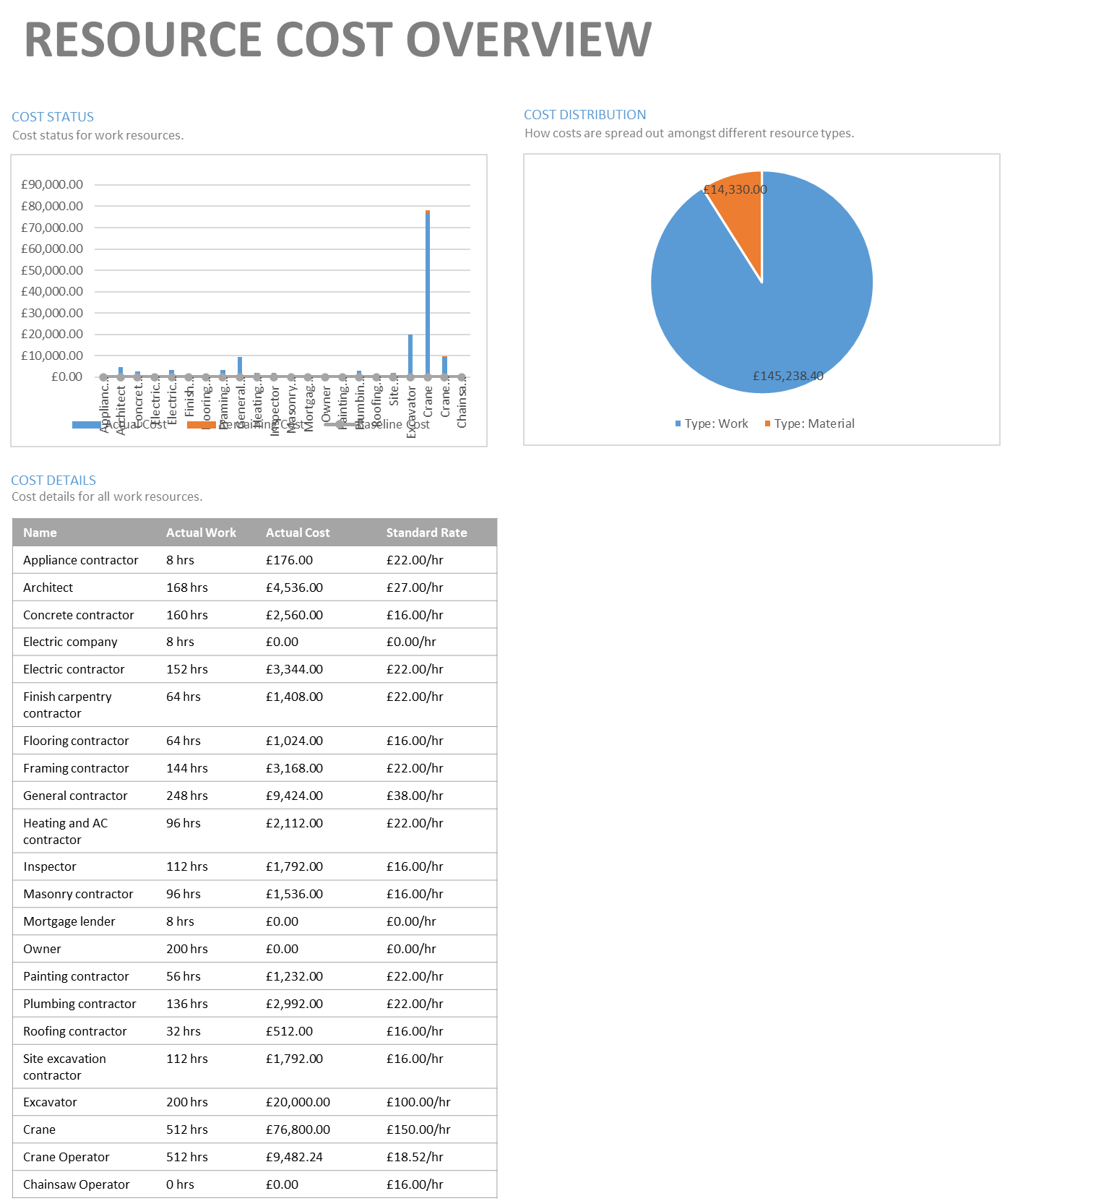
Figure 2 Report Showing Resource Cost Overview


Figure 3 Report Showing Task Cost Overview

Method Statement: Installation of Strip Foundations for Two-Storey Residential Building

Overview
This method statement provides a detailed explanation of the steps and criteria that must be adhered to when installing strip foundations in a two-storey residential building. The installation process will be carried out by the British Standards BS 8004:2015 and BS 8110-1:1997, which specifically address the guidelines and requirements for foundations and the design and construction of concrete structures, respectively.

Occupational health and safety
Before starting, a thorough risk assessment will be carried out, following the norms and regulations set by the Health and Safety Executive (HSE).
Personnel will undergo training following the rules set by the Construction Industry Training Board (CITB). The training will cover the proper use of machinery, excavation techniques, and emergency response methods.
Personal protective equipment (PPE) will be supplied and utilized consistently on-site, by the Personal Protective Equipment at Work Regulations 1992.

Safety measures unique to the site will be put in place, such as the installation of barriers and warning signs, to prevent unlawful entry and reduce the likelihood of accidents.
Regular toolbox discussions and safety briefings will be conducted by HSE guidelines to foster a safety-oriented culture among all staff members.

Preparing the site
A site investigation will be carried out following the guidelines set by the British Standard BS 5930:2015, which is the "Code of Practice for ground investigations".
The layout and size of the strip foundations will adhere to the architectural plans and specifications provided by the structural engineer, by the guidelines outlined in BS 8103-3:2009, which pertains to the structural design of low-rise buildings.
Temporary fencing or barricades will be erected to limit access to the excavation area, by the Health and Safety (Safety Signs and Signals) Regulations of 1996.
Access routes for construction vehicles and machinery will be created by the Construction (Design and Management) Regulations 2015.

Digging
The excavation will be carried out to the stipulated depth and width as indicated in the structural designs and engineer's calculations, by the requirements of BS 8004:2015.
The excavated dirt will be disposed of responsibly, following the guidelines set by the Environmental Protection Act of 1990 and the Waste Management Regulations of 1996.
The excavated area will be flattened and compressed to create a sturdy foundation for installing the structure, according to the specifications outlined in BS 8004:2015.
The engineer will recommend and implement stabilization measures for any soft patches or unstable regions identified during excavation.

Construction of the Foundation
Formwork will be constructed to enclose the concrete during pouring, following the guidelines set down in BS 5975:2008 "Code of practice for temporary works procedures and the permissible stress design of falsework".
Reinforcement bars, also known as rebars, will be placed in the formwork according to the guidelines outlined in BS 8666:2005 "Specification for scheduling, dimensioning, bending and cutting of steel reinforcement for concrete".
Concrete shall be poured according to the mix designs described in BS EN 206-1:2013 "Concrete - Part 1: Specification, performance, production and conformity".

Treatment and Safeguarding
Curing methods will be carried out in compliance with BS EN 13670:2009 "Execution of concrete structures".
Concrete surfaces will be safeguarded from unfavourable weather conditions and excessive drying, by the guidelines outlined in BS 8007:1987 "Code of practice for the design of concrete structures for retaining aqueous liquids".

Refilling
The backfilling materials and compaction procedures used will adhere to the standards defined by BS 8004:2015 and BS 8103-3:2009. This will help limit settlement and guarantee consistent support for the foundations.

Assurance of Quality
Regular inspections will be carried out to verify adherence to British standards and specifications, encompassing assessments of dimensions, installation of reinforcement, quality of concrete, and curing methods.

Conclusion
A final inspection will be conducted to confirm adherence to design specifications and British standards, guaranteeing that all work meets the prescribed standards of quality and craftsmanship.
Site clearance will be conducted in compliance with the Waste Management Regulations of 1996 and other applicable laws.

Documentation
Thorough documentation of the foundation installation procedure, which includes excavation, formwork, concrete pouring, curing, backfilling, and inspections, shall be kept for future reference and auditing.

Adherence to rules or regulations.
This method statement has been created in line with British rules and regulations that regulate the installation of strip foundations for residential buildings. All actions will be conducted in adherence to these requirements.
Method Statement: Paintworks for a Two-Storey Residential Building
Overview
This method statement provides a comprehensive overview of the procedures and regulations that must be adhered to while carrying out paintworks on a two-storey residential building, to ensure full conformity with British standards. The paintworks will cover both the inside and outside surfaces, to improve appearance, safeguard surfaces, and ensure long-lasting performance.

Occupational Health and Safety
Before starting, a comprehensive risk assessment will be carried out to detect possible dangers related to paintworks, such as exposure to chemicals, falls from high places, and electrical hazards.
All staff participating in paintworks will undergo suitable instruction on health and safety measures, encompassing the proper handling of painting supplies, ladder safety, and emergency procedures.
Personal protective equipment (PPE) will be supplied and is mandatory for all individuals, encompassing gloves, goggles, and respiratory protection, particularly while handling solvent-based paints.
Sufficient ventilation will be provided during the application of paint to reduce the inhalation of fumes and maintain the air quality in the work area.
All painting materials will be safely stored, kept away from sources of fire, and in compliance with the instructions provided by the manufacturer.

Preparing the Surface
Before painting, all surfaces that will be painted will undergo a comprehensive cleaning process to eliminate dirt, dust, grease, and other impurities, utilizing suitable cleaning products and techniques.
Any paint coatings that are deteriorating, peeling or flaking will be eliminated using scrapers, wire brushes, or appropriate chemical stripping agents. This will ensure that the surface is smooth and solid before applying the new paint.
Surfaces that have cracks or faults will undergo repairs using appropriate fillers or sealants, followed by sanding to attain a consistent and even surface.
Before painting, a thorough inspection will be conducted on the exterior surfaces to identify any evidence of dampness or moisture penetration. If necessary, appropriate measures such as waterproofing or repairing faulty waterproofing systems will be undertaken.

Choosing the Paint
The selection of paint products will be based on their appropriateness for the particular surface to be painted, as well as their adherence to British standards on quality, longevity, and environmental effects.
Whenever feasible, low-VOC (volatile organic compound) paints shall be prioritized to mitigate environmental harm and reduce indoor air pollution.
The selection of paint colours will be made in collaboration with the customer, considering their aesthetic preferences, architectural style, and adherence to local planning restrictions.

Procedures for applying finish
The paint application will be performed with appropriate techniques such as brushing, rolling, or spraying, based on the surface type and the intended outcome.
The paint will be evenly applied in thin layers to obtain the appropriate coverage and finish while avoiding any drips, runs, or brush marks.
Proper drying intervals between coats will be observed according to the manufacturer's specifications, and the ambient temperature and humidity conditions will be monitored to maximize the effectiveness of drying and curing.
The exterior surfaces will be painted in alignment with the prevailing weather conditions to decrease the likelihood of paint problems, such as blistering or peeling.

Assurance of Quality
Regular inspections will be carried out during the paintworks process to guarantee adherence to British standards and quality requirements.
The paint finish will be evaluated for its consistency, adherence, extent of coverage, and lack of imperfections such as brush strokes, streaks, or air bubbles.
Any shortcomings or imperfections discovered during inspections will be swiftly corrected, which may involve applying additional layers of paint or doing touch-ups as needed.

Disposal and handling of waste materials
The waste produced during the process of preparing surfaces and applying paint, such as used brushes, rollers, and paint containers, shall be gathered and properly disposed of in compliance with the waste management requirements of the local area.
Any remaining paint products shall be stored properly for future touch-up or disposal, following the manufacturer's recommendations and environmental guidelines.

Conclusion
After the paintworks are finished, a final examination will be conducted to ensure that all surfaces satisfy the necessary standards of finish and quality.
The client will be allowed to examine the painted surfaces and offer their input. Any remaining problems or touch-up needs will be swiftly resolved.
All equipment and supplies shall be cleared from the premises, and the work area will be left in a neat and orderly condition.

Documentation
A detailed log of painting operations, which encompasses risk evaluations, inspections, material specifications, and client authorizations, will be upheld for future reference and auditing objectives.

Adherence to rules and regulations
This method statement has been formulated in line with British norms and laws that regulate paintworks for residential structures. All actions will be conducted in adherence to these requirements.

Method Statement: Installing a Prefabricated Roof for a Two-Storey Residential Building

Overview
This method statement outlines the specific procedures and guidelines that must be adhered to when installing a pre-made roof on a two-story residential building. The installation process will comply with the British Standards BS 5534:2014+A2:2018, which covers the requirements for slating, tiling, and vertical cladding on pitched roofs. Additionally, the installation will also follow the guidelines outlined in BS 6399-2:1997, which provides the code of practice for wind loads on buildings.

Occupational Health and Safety
Before starting, a comprehensive risk assessment will be carried out, by the Health and Safety at Work Act 1974 and the Construction (Design and Management) Regulations 2015.
All staff engaged in roof installation will undergo suitable training in working at elevated levels, manual labour techniques, and the secure utilization of tools and equipment.
Personal protection equipment (PPE), such as helmets, safety harnesses, and non-slip footwear, will be supplied and must be always worn while on the premises.
Safe access to the roof will be ensured, by the criteria specified in the Work at Height Regulations 2005.
Regular safety briefings and toolbox discussions will be provided to strengthen safe working practices and foster a safety-oriented culture among all staff members.

Preparing the site
The roof structure will undergo an inspection to verify its structural integrity and ability to bear the load of the prefabricated roof system.
The roof area will be thoroughly cleansed of any debris, blockages, or loose objects that could potentially disrupt the installation procedure.

Sufficient room will be provided for the assembly and movement of preconstructed roof parts, guaranteeing a secure and effective installation process.
Temporary weather protection measures will be put in place to shield the interior of the structure from being exposed to the elements while the roof is being installed.

Preconstructed Roof Assembly
Before commencing construction, the site will receive delivery of prefabricated roof components, which will then undergo a thorough inspection to identify any damage or faults.
Roof trusses, panels, or modules will be elevated into position utilizing cranes, hoists, or other lifting equipment, in compliance with the Lifting Operations and Lifting Equipment Regulations of 1998.
The roof components will be firmly fastened and positioned according to the manufacturer's instructions and technical drawings, guaranteeing correct attachment and distribution of weight.
The installation of the roof membrane or underlayment will adhere to the specifications outlined in BS 5534:2014+A2:2018 to ensure weather resistance and prevent moisture from entering.

Installation of Roofing Materials
The installation of roof covering materials, such as tiles, slates, or metal sheets, will adhere to the guidelines provided by the manufacturer and the best practices specified in BS 5534:2014+A2:2018.
The roof tiles or slates will be securely attached to the roof structure using suitable fasteners and procedures, ensuring optimum overlap and alignment.
The installation of flashings, ridge tiles, and other roof accessories shall adhere to the guidelines set out in BS 5534:2014+A2:2018. This will ensure that watertight seals are created and water infiltration is prevented at areas of the roof that are susceptible to vulnerability.

Roof insulation materials, if necessary, will be placed according to Building Regulations Part L and the specifications provided by the manufacturer to achieve the specified thermal efficiency.

Aeration and removal of excess liquid
Roof ventilation systems will be implemented by BS 5250:2011 "Code of practice for control of condensation in buildings" to avoid the accumulation of moisture and uphold the quality of indoor air.
The installation of roof drainage systems, such as gutters, downpipes, and outlets, will effectively direct rainfall away from the building by the specifications outlined in BS EN 12056-3:2000 "Gravity drainage systems inside buildings".

Quality Assurance
Regular inspections will be carried out during the roof installation process to ensure that it adheres to the manufacturer's requirements, engineering drawings, and British regulations.
The roof covering materials will undergo an inspection to identify any faults, ensure proper alignment, and verify secure attachment to the roof structure.
The flashings, seals, and connectors will undergo inspection to verify their water resistance and structural soundness, thereby ensuring efficient protection against weather elements.

Conclusion
Once the roof installation is finished, a final examination will be carried out to confirm that it meets the design requirements and British standards.
Any shortcomings or problems discovered during the inspection will be swiftly resolved to maintain the integrity and effectiveness of the roof system.
The site will be thoroughly cleaned, and all construction debris, equipment, and temporary structures will be removed, ensuring that the area is left in a neat and orderly condition.

Documentation
Thorough documentation of the roof installation process, which includes inspections, material specifications, and compliance documents, will be kept for future reference and audit purposes.

Adherence to rules and regulations
The method statement has been formulated in line with British rules and laws that regulate the construction of prefabricated roofing for residential buildings. All operations will be conducted in strict adherence to these requirements.

