A reflection on St Fagans: How the site educates visitors on the history of Wales

As a child raised in Wales, I have always been familiar with St Fagans and other iconic sites such as Big Pit and Dan yr Ogof caves, making this visit quite nostalgic, reflective of my upbringing and the places which formed my interest in history. The site, covering 100 acres, with over 50 buildings (Art and Culture, 2019) – spanning hundreds of years of history – has a range of reconstructed buildings, to offer interest to a wide range of audiences. For those who may view the site from a more anthropological perspective, the home life seen within the structure and decoration of the castle would offer good focus, for the archaeological enthusiast, the iron-age roundhouses situated towards the edge of the site will fascinate.
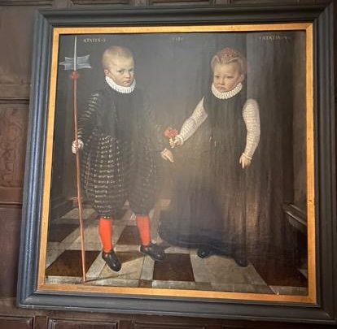
Upon entering the site, the first and possibly most informative area regarding the history of the everyday life of Welsh people, were the two exhibitions within the entrance building, just above the gift shop. A collection of both clothing items, and archaeological discoveries were evident, with their identification placards placed beside them, written in both Welsh and English. As a first language Welsh speaker, this experience combined my native language and native history, an experience often missed in other heritage sites. The informational placards were all written bilingually, promoting some use of the Welsh language. However it is an incomplete ‘Welsh’ experience. If I had not spoken Welsh to a guide in the gardens, this attempt at inclusion would have been partial – it was purely decided by my own choice to speak Welsh. There were no obvious attempts made by any of the guides within the buildings to speak in Welsh first and foremost – an oversight, but one which subtly continues the anglicized connotations of everyday Welsh life. This is certainly far more subtle than the sight of the preserved ‘Welsh Not’s seen within the reconstructed school. In addition to this, many cultural aspects of Welsh life were missing from the galleries within the museum. Very little was shown about Capel Celyn, one of the most famous incidents in modern Welsh history. Hundreds of non-Welsh people are familiar with the iconic red-brick wall with ‘Cofiwch Tryweryn’. While there was in fact a small interactive discussion board on the topic, there is little emphasis on the actions of Welsh Nationalists – the union of the men who formed Mudiad Amddifyn Cymru, and their bombing of the dam in their attempts to defend their hometown (BBC, 2023). Aspects such as this, a true display of the strength and local history of areas in Wales are overlooked within the museum, and therefore restrict the image given to visiting historians of Welsh life in the 20th century.
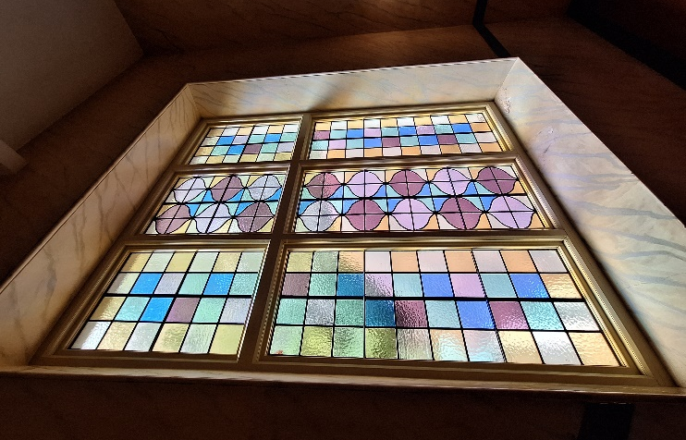
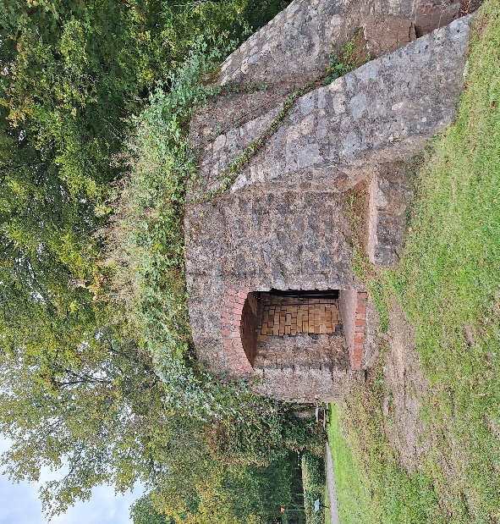
Further examples of this theme of incomplete education at a museum are evident within the site. The origin locations of buildings are unclear, nor is whether they are replicas or original reconstructions. The Ewenny kiln stands tucked behind the Fish and Chip shop, but is a significant item when observed and understood in greater detail. Many people have heard of Ewenny pottery, but not that the kiln itself was relocated by a team of archaeologists from Ewenny, Bridgend, a team which included my own grandfather Paul Hughes, both a member of the Cardiff Museum team, and the Oxford Archaeological Unit, but such a close sense, and I’m sure many others would have a connection like this, are not seen within the glass-fronted displays and brick buildings. Very little of what stands at the site are originally from the areas surrounding Cardiff, which poses a conundrum for historians and archaeologists alike – these are not reflections of the local history, or the original layouts of these buildings. St Fagans instead creates an idealistic image of these items, rather than a wholly truthful view of the landscape and history. The south of Wales, especially Swansea, is renowned for its industrial history, with its oldest mine founded in 1720(Swansea Museum, no date) – but there is no evidence of this within St Fagans, demonstrating the restricted view it portrays of Welsh history. While the museum does show some aspects of Welsh life – the exhibits show quite a pleasant image of the restored Worker’s Institute, with its stained-glass windows, and the castle, with its paintings of two children – it is barely a glimpse to the various lives seen throughout the country. Traditional images of the Welsh copper and coal mining industries are hardly seen or mentioned, which for some, from a historical perspective, may be more important than the recreation of a farmhouse. For others, it may evoke a sense of nationalistic pride which is lacking in most of Wales. Rugby matches act as a clear example of this – walk through Cardiff on any match day and the anthem will roar from any pub. However, this social history is hidden – Welsh social culture is portrayed in a poster of Tom Jones, but there are no mentions of the hundreds of people who have celebrated Welsh sports, music, and most shockingly: The Eisteddfod. For such an intrinsic aspect of Welsh culture, it is entirely overlooked in St Fagans, when surely it should be a point of pride in one of the national museums of Wales.
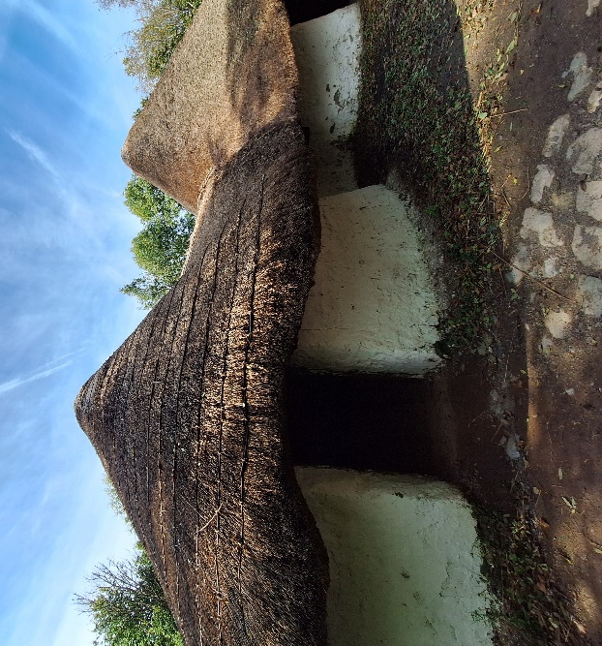
Though it makes for a pleasant day out, accessible to all sorts of groups – academics, curious tourists, school groups making their memories – for many, this is all it is. A pleasant day out. What can be learned here is greatly restricted, and narrowed by those who have co-ordinated the exhibitions and building projects. As an archaeologist and historian, with a mind that favours the everyday wonder of antiquitarian ideology, very little has truly remained with me from this visit, aside from the realisation of how much is missed. Generations past, the miners, toiling away each day, nobles and gentry battling against invading forces, even neolithic communities, they are overlooked, and their stories told in small fragments. For an in-depth understanding of each group, St Fagans is lacking, but as a method to attract people, to spark their curiosity (much like myself, as a child wandering through the expanses of paths, pausing to occasionally marvel at a red-walled home or a wooden mill), it offers a foundation for each individual to mould their following research or works around.
Bibliography
St Fagans National Museum of History - Google Arts & Culture (2019). https://artsandculture.google.com/story/fgVBWzqoG3aS6Q.
The Ewenny kiln (no date) https://museum.wales/stfagans/buildings/pottery/#:~:text=The%20Ewenny%20kiln.%2027.%20By%20the.
Evans, N.B.& L. (2023) Tryweryn: The man who bombed a dam to save a village. https://www.bbc.co.uk/news/uk-wales-64560239.
The beginning of the copper industry (no date). http://www.swanseamuseum.co.uk/whats-on/past-exhibitions/copperopolis/the-beginning-of-the-copper-industry#:~:text=The%20first%20copper%20works%20in%20Swansea.
Painting of a pair of children – Image taken by Soli-Anne Green (2024)
All other images taken by Lexin Jessopp (2024)

