

Module Name – Strategic Management
Module Code - LCMB7003
Name – Atishaya Kadam
Student Id - 2318625
Assignment Title – Strategic Management Report
Submission Date – 23.08.2024
Lecturer – Prof Amare Desta

Table of Contents
Introduction 3
Emergence of Virtual Organizations 4
Challenges in Virtual Management 4
Opportunities in Virtual Management 6
Conclusion 9
References ..10
Presentation Slides………...………………………………………………………………….11
Precis……………..…………………………………………………………………………..12
Summary……………………………………………………………………………………..13

Introduction
The rapid growth in digital technology has fostered the emergence of virtual organizations (VOs), where teams operate, often dispersed across different geographical locations. Virtual management is a core sub-element of these organizations, as it deals with managing distributed teams through the use of digital tools and communication media. This paper will critically assess the emergence of virtual organizations by taking a firm called Buffer as an example, fully remote and imaginably transparent and rather innovative in its approach to virtual management. In particular, we will look at the challenges and opportunities facing Buffer in planning, designing, and leading operations within an increasingly competitive global business environment.

Emergence of Virtual Organizations
Virtual organizations are the necessities in the globalized economy, bringing with them flexibility, agility, and cost efficiency. The traditional model of an office-based paradigm is rapidly giving way to virtual teams that pool together people across the globe and usher them into the mainstream through technology toward pursuing the organizational goals. This shift becomes an outcome of technological advancement, globalization, needs for cost savings, and growing emphasis on work-life balance among employees (Biçer, 2021).

Founded in 2010, Buffer represents the absolute virtual organization model because it adopted remote work right from its establishment. Headquartered nowhere, Buffer allows its employees to work from any location within the globe, hence giving it the enabling power to hire the best available talent irrespective of any geographical location. That surely did extend their pool of potential workers but also helped them save a lot from spending on infrastructural facilities like offices and all the other overheads associated with them.
Success from Buffer proves that virtual organizations have better flexibility, faster reaction time for market changes, and lesser degree of operational cost. On the other hand, it also brings forth an angle of good virtual management: leading a remote team comes with totally different challenges in the areas of communication, collaboration, and firm culture. As virtual organizational models grow in popularity day by day, understanding and addressing in detail these very challenges are going to be the cornerstone of their continued success (Adamovic et al., 2022).

Challenges in Virtual Management
Despite the advantages, virtual management presents several challenges that organizations like Buffer must navigate.
1. Communication and Collaboration
This produces one of the larger challenges for a virtually-based organization: maintaining effective communication and collaboration for people that are physically apart. Working in a physical office, face-to-face interaction creates an automatic sensation of collaboration that solves problems pretty fast. virtualise sets communication mostly enabled by digital tools like Slack, Zoom, and e-mail, which sometimes allow for misunderstandings and a lower personal touch (Biemans, 2023).
The challenge in this regard is effectively dealt with by Buffer, a completely remote company, as it develops a culture of transparent communication and uses a varied set of tools in accomplishing collaborative tasks. For real-time communication, Slack is used, while Asana serves the purpose for project management to make the tasks and roles lately clear. Regular video calls are done in order to keep the personal touch intact among the people, thus reiterating that there is a human element behind even distance communication (Arowolo, 2022).
In this regard, Buffer is a strong advocate for asynchronous communication because team members could be living in different time zones or have different schedules. This delivers the ability for everyone to contribute towards team goals at their pace, making interactions smooth and fluid in communication and collaboration alike—whether virtual or otherwise. These practices, integrated by Buffer, reduce to a large extent the challenges to communication faced by a virtual organization.
2. Building and Maintaining a Strong Organizational Culture
Therefore, creating and developing a strong organizational culture in a virtual environment is one of the foremost challenges facing an offsite workforce. Employees, in many cases, find themselves isolated from the organization's value system and mission; therefore, they are not working with motivation, commitment, and high performance, reflected through low job satisfaction. Buffer, being a fully remote company, tackles this challenge with a high degree of transparency and openness in its operations (Azeem et al., 2021).
The company opens up revenue and salaries for everybody to see and even share in decision-making. This, therefore, creates a culture in which trust is upheld and employees are accountable to the company. Employees are going to feel more connected to the company's mission and values, even if working remotely. Additionally, Buffer invests in regular team retreats, bringing employees together in person to bond and reinforce the company's values. These retreats bridge the gap between team members caused by physical distance and guide them in cultivating personal relations and coming closer to the organizational culture (Azeem et al., 2021).
3. Performance Management and Accountability
There are challenges in performance management and ensuring accountability when the organization is virtual, especially where there is no direct manager. Traditional performance management techniques may prove less effective in these virtual organizations because many of them rely on direct observation. That means new innovative ways would have to be devised through which workers could be monitored as well as motivated (Han, 2020).
Buffer is able to overcome these challenges with a results-driven culture: it's outcomes over hours. It has set specific measurable goals for each team member; expectations are clear. Continuous feedback from one-on-one meetings and performance reviews characterize Buffer's approach, facilitating open communication. These reviews aren't solely evaluative but have actually been geared to help the employee see how they can achieve their goals (George, 2024).
4. Technological Dependence and Security Risks
This is also a weakness or vulnerability since it heavily relies on technology to operate. Even though digital tools make communication and collaboration easy, they also bring about several risks related to cybersecurity and protection of data. Security breaches and technical failures can be very detrimental to a virtual organization by revealing very vital information and causing chaos in the working process (Pashchenko et al., 2020).
Buffer secures against such risks by utilizing the best cybersecurity practices and ensuring that its system is consistently updated to avoid potential threats. The company also educates its employees on best practices for maintaining security, such as using strong passwords, enabling two-factor authentication, and being cautious with sharing sensitive information online.

Opportunities in Virtual Management
While virtual management presents several challenges, it also offers numerous opportunities that organizations like Buffer can leverage to gain a competitive advantage.
1. Access to a Global Talent Pool
This is one of the greatest opportunities in virtual management: the ability to literally receive talent from any part of the world. Remote work, as a strategy, opens an organization to some of the finest talent found in various regions, enriching the workforce with multiple perspectives and skill sets. This type of global approach fosters creativity, innovation, and creates real insight into the different markets that will better position an organization to effectively serve a worldwide customer base (Elo and Silva, 2022).
This advantage is well reflected in Buffer, a remote work company. A team of more than fifty countries and cultures has not only enriched Buffer's organizational culture but also gave eyes on different cultural nuances. Such diversities have kept creativity and innovation charged within the firm, which further contributes to its success in developing products that would appeal globally. Not only has Buffer been able to access worldwide talent, but it also began doing business more effectively among changing market demands and created a more inclusive workplace. In line with such an approach, Buffer's time at the forefront in virtual management, as well as the deep illustration of an indefinite number of huge benefits stemming from tapping into a worldwide talent pool, are notable (Williams Jr, 2022).
2. Cost Savings and Increased Efficiency
This virtual organizational model entails significant cost savings and efficiency gains, as is affirmed by the huge success that Buffer has recorded in running a completely remote team. With no need for physical offices, companies will reduce expenses on rent, utilities, office supplies, among others. This freeing of resources will allow organizations to perform more investments in critical areas such as product development and customer support. Additionally, virtual management enables employees to work in environments that help them be most productive, be it from home, a coworking space, or another country (Bagga et al., 2023).
This flexibility increases efficiency and has the added advantage of increased satisfaction and reduced turnover of employees, thereby decreasing related costs of turnover and recruitment. The case of Buffer's remote work model makes a fine example of how a virtual organization is better equipped to pool its resources, promote an excellent work culture, and which helps them stay competitive in today's commerce. It is a strategy that has not only reduced operational costs for Buffer but also made it more agile, resilient, and better positioned for long-term success (Bagga et al., 2023).
3. Flexibility and Agility in Operations
Virtual organizations are renowned for being flexible and nimble—both qualities are an advantage in the VUCA business world of today. Freed from the constraints of bricks and mortar, virtual teams can be very flexible because of being able to react to market changes, be that changes in customer demands or an economic downturn. This increase, then, their agility in response to any issues and seizing of opportunities (Kuusisto, 2022).
Buffer is a remote-first company that, perhaps more than most, exemplifies this flexibility. Not being tied down has given Buffer the freedom to know when to pivot due to quick changes in the market. This has been especially critical during the COVID-19 pandemic. Many other companies struggled to turn remote in response to the crisis, but Buffer continued without disruption because it was already set up with infrastructure and company culture for this way of working.
Buffer's remote-first model provides not just resilience during crises but also results in a global talent pool, hence creating a strong capacity to innovate, make changes, and react to altering market demands. This model illustrates how virtual organizations can leverage flexibility and agility to maintain a competitive edge, even in the face of unprecedented challenges (Miceli et al., 2021).
4. Enhanced Work-Life Balance for Employees
Virtual management will allow employees to have a much more balanced life, having no long drives to and from work and the flexibility of working from any location. This makes people happier with their jobs, increases productivity levels, and sustains personnel well-being. One company, Buffer, has strongly emphasized work-life balance. The company encourages staff to maintain boundaries between work and personal life, acknowledging that this is important for mental health and job satisfaction.
It supports its employees with flexible working hours, unlimited vacation time, and a stipend toward the necessary equipment in setting up a home office for comfort and effectiveness while working. Because it broadly focuses on the welfare of its employees, this has created a culture of positivity and support for one another at Buffer, where people feel valued and empowered to balance work and personal life. In the process, Buffer has been able to achieve overall high levels of employee satisfaction and productivity, proving the efficiency of virtual management in creating a thriving and engaged workforce.

Conclusion
The coming up of virtual organizations thus marks a very great evolution in how business is conducted in the modern world. In contrast to the virtual management that comes along with problems related to communication, organizational culture, and performance management, it also opens an avenue with opportunities such as access to a worldwide talent base, saving on operation costs incurred, flexibility in its operation, and better work/life balance for workers.
Buffer has been able to prove that even a completely remote company can thrive in business, thus showing the ability of virtual organizations to perform well in the most competitive business environment globally. The emphasis on transparency and concern for their staff's welfare have helped Buffer in the adoption of digital tools to counteract several challenges of virtual management while capitalizing on its several opportunities. With more organizations now recognizing the benefits of telecommuting, the virtual organization model is likely to broach a surge in its application, thereby changing the future of work for several years.

References
Adamovic, M., Gahan, P., Olsen, J., Gulyas, A., Shallcross, D. and Mendoza, A., 2022. Exploring the adoption of virtual work: the role of virtual work self-efficacy and virtual work climate. The International Journal of Human Resource Management, 33(17), pp.3492-3525. https://www.researchgate.net/profile/Mladen-Adamovic-2/publication/351477234_Exploring_the_adoption_of_virtual_work_the_role_of_virtual_work_self-efficacy_and_virtual_work_climate/links/60a1be1ba6fdcccacb5d2939/Exploring-the-adoption-of-virtual-work-the-role-of-virtual-work-self-efficacy-and-virtual-work-climate.pdf
Arowolo, A., 2022. Virtual Teams: The Impact of Varying Levels of Virtuality On Project Team Performance. https://dr.library.brocku.ca/bitstream/handle/10464/16541/Brock_Arowolo_Adeoluwa_2022.pdf?sequence=1&isAllowed=y
Azeem, M., Ahmed, M., Haider, S. and Sajjad, M., 2021. Expanding competitive advantage through organizational culture, knowledge sharing and organizational innovation. Technology in Society, 66, p.101635. https://farapaper.com/wp-content/uploads/2022/01/Fardapaper-Expanding-competitive-advantage-through-organizational-culture-knowledge-sharing-and-organizational-innovation.pdf
Bagga, S.K., Gera, S. and Haque, S.N., 2023. The mediating role of organizational culture: Transformational leadership and change management in virtual teams. Asia Pacific Management Review, 28(2), pp.120-131. https://www.sciencedirect.com/science/article/pii/S1029313222000355
Biçer, M., 2021. The Advantage of Being an Agile Organization in the Pandemic Crisis. Stratejik Yönetim Araştırmaları Dergisi, 4(2), pp.123-141. https://dergipark.org.tr/en/download/article-file/1800342
Biemans, W., 2023. The impact of digital tools on sales-marketing interactions and perceptions. Industrial Marketing Management, 115, pp.395-407. https://www.sciencedirect.com/science/article/pii/S0019850123002055
Elo, M. and Silva, S., 2022. Who creates international marketing agility? Diasporic agility guiding new market entry processes in emerging contexts. Thunderbird International Business Review, 64(5), pp.443-463. https://portal.findresearcher.sdu.dk/files/224685136/tie.22284.pdf
George, A.S., 2024. The Metamorphosis of Work: How Technology is Transforming the Employee Experience from Industrial to Digital. Partners Universal Innovative Research Publication, 2(1), pp.93-112. https://puirp.com/index.php/research/article/download/33/28
Han, Y., 2020. The impact of accountability deficit on agency performance: Performance-accountability regime. Public Management Review, 22(6), pp.927-948. https://www.academia.edu/download/61307495/The_Impact_of_Institutional_Accountability_on_Agency_Performance_A_Performance-Accountability_Regime20191123-74308-191dpwi.pdf
Kuusisto, E., 2022. Approaching VUCA Environment with Enterprise Agility in Government Organization: Case Business Finland and COVID-19. https://osuva.uwasa.fi/bitstream/handle/10024/14079/Emmi%20Kuusisto-Master%27s%20thesis.pdf?sequence=2&isAllowed=y
Miceli, A., Hagen, B., Riccardi, M.P., Sotti, F. and Settembre-Blundo, D., 2021. Thriving, not just surviving in changing times: How sustainability, agility and digitalization intertwine with organizational resilience. Sustainability, 13(4), p.2052. https://www.mdpi.com/2071-1050/13/4/2052
Pashchenko, I., Vu, D.L. and Massacci, F., 2020, October. A qualitative study of dependency management and its security implications. In Proceedings of the 2020 ACM SIGSAC conference on computer and communications security (pp. 1513-1531). https://doi.org/10.1145/3372297.3417232
Williams Jr, H.L., 2022. Examining the Cross-Cultural Adaptation of Department of Defense Leaders in Joint Multinational Military Training Environments. Trident University International. https://search.proquest.com/openview/202bfe3ac3f6e6a67ecfe83c972d3cc1/1?pq-origsite=gscholar&cbl=18750&diss=y

Assessment- PPT PRESENTATION
- PRESENTATION SLIDES
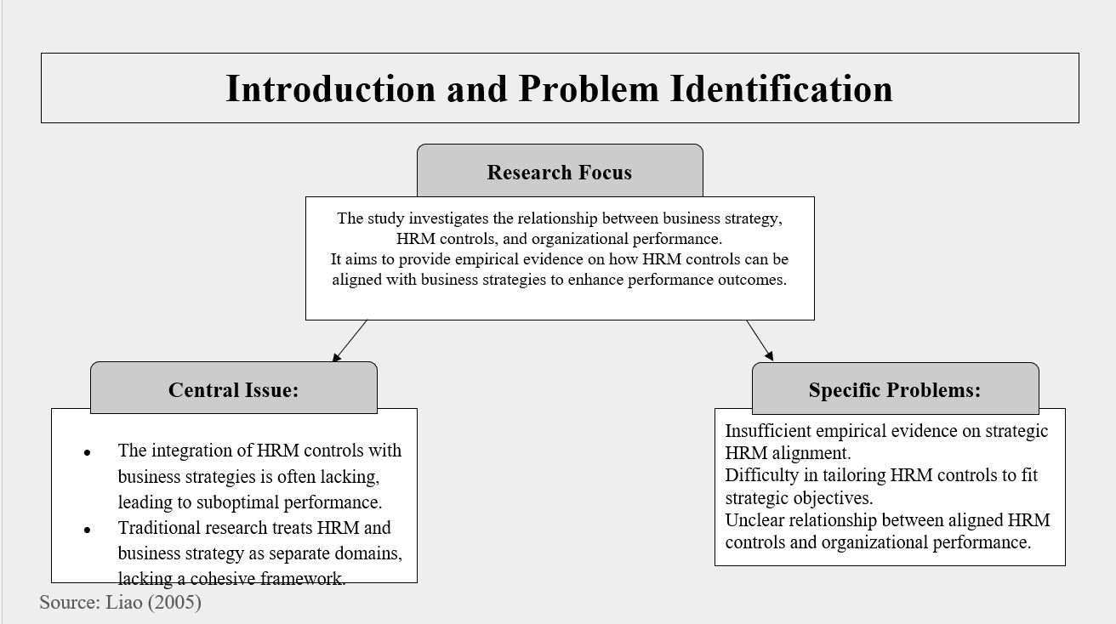
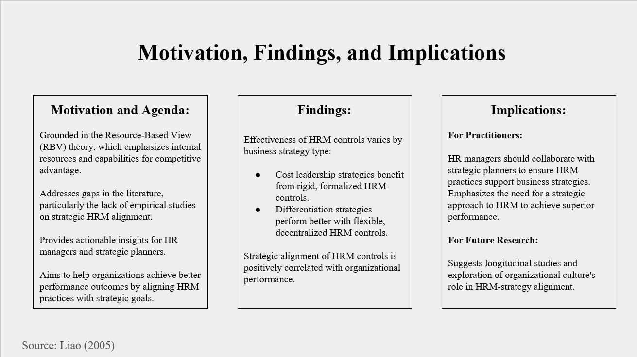
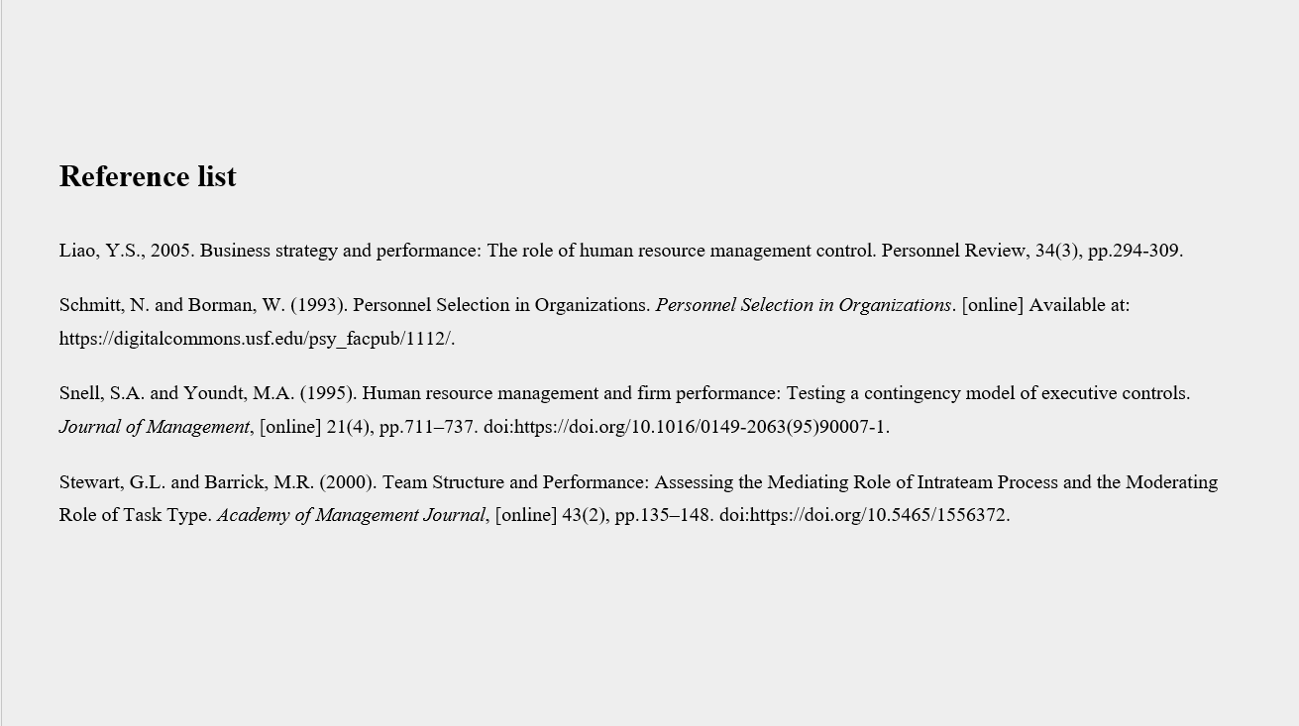
- PRECIS
The document critically examines the integration of Human Resource Management (HRM) controls with business techniques to improve organizational performance, as tended to by Yao-Sheng Liao. It highlights noteworthy issues, such as the need for observational proof connecting HRM controls to commerce techniques and their execution suggestions. Liao's investigation, propelled by theoretical holes and viable needs is grounded within the Resource-Based See (RBV) hypothesis, pointing to adjusting HRM hones with key business targets to accomplish a competitive edge.
Key findings indicate that strategic HRM alignment significantly influences organizational performance. However, the study's cross-sectional plan limits causal assertions, and potential response inclinations may influence outside validity. Recommendations for future exploration consolidate embracing longitudinal plans and coordination of diverse data sources to make strides in unflinching quality. In showing disdain toward impediments, Liao's work offers productive encounters for HR bosses and imperative organizers, emphasizing the need to alter HRM systems with trade strategies to achieve overwhelming execution and competitive advantage.

- SUMMARY
Problem Identification:
The central issue addressed in Yao-Sheng Liao's paper is the integration of Human Resource Management (HRM) controls with business strategies to enhance organisational performance. Traditional research often treats HRM and business strategy as separate entities, lacking a cohesive framework for their integration. This disconnect leads to suboptimal performance outcomes, as HRM practices may not fully support the strategic goals of the organisation. Liao’s research aims to bridge this gap by exploring how various HRM control mechanisms can be aligned with different strategic orientations, such as cost leadership and differentiation, to drive better performance.
The specific problems identified in the paper include:
- Lack of Empirical Evidence: There is still a lack of empirical research that would indicate how HRM controls are linked with business strategies for achieving better strategic outcomes and to what extent that link influences performance.
- Strategic Fit of HRM Practices: It is common that in practice organisations face challenges in aligning the choice of HRM controls with the requirements of organisational strategy.
- Performance Implications: The direct connection between matched HRM controls and the organisation’s performance cannot be explained clearly, which raises more queries about it and demands further comprehensive analysis.
Motivation and Agenda:
The rationale for undertaking this research is therefore based on theoretical and practical factors:
- Theoretical Motivation:
Resource-Based View (RBV): The research is based on the RBV theory which strongly propounds that the internal resources/ capabilities, which include, HRM practices must be cultivated to attain a competitive edge. In this vein, by exemplifying the HRM controls that are consistent with strategic business objectives, Liao enriches the theoretical conversation about RBV and integrated strategic HRM.
Filling Research Gaps: The study aims at filling the gaps that have been pointed out in the current literature mainly the absence of a theoretical framework in establishing the relationship between HRM controls and the extent of their strategic compatibility and the subsequent performance consequences. This helps to address a gap in the literature, which can give a more extensive view of the HMRS’s contribution to strategic management.
- Practical Motivation:
Guidance for Practitioners: Liao aims to provide actionable insights for HR managers and strategic planners. By identifying effective HRM control mechanisms for different strategic contexts, the research offers practical guidance on how to design HRM systems that support strategic objectives, ultimately enhancing organisational performance.
Improving Organisational Performance: The practical agenda is to help organisations achieve better performance outcomes by ensuring that HRM practices are not only aligned with but also actively support their strategic goals. This alignment is seen as a pathway to gaining competitive advantage and achieving superior performance.
Evidence of Agenda and Motivation:
From the beginning of the paper, the research agenda and the motivation for the study is evident through Liao’s insistence on the role of strategic HRM and its effects on performance. Key points include:
Introduction and Literature Review: The introduction and literature review sections set the stage by discussing the theoretical underpinnings of strategic HRM and the gaps in existing research. Liao stresses the need to pursue empirical research on the factors that determine the strategic fit of HRM controls, and consequently, she points out the RBV theory and prior research that has confirmed that internal resources are critical to competitive advantage.
Hypotheses Development: The development of hypotheses stems from the RBV and Strategic HRM concepts established in the literature. Liao (2005) clearly explains particular expectations about how various kinds of HRM controls will either enhance or detract from business strategies thereby outlining why the study was undertaken.

Methodology: The methodological approach, including the use of survey data and statistical analysis, is designed to provide robust empirical evidence on the relationships between HRM controls, business strategies, and performance. Such empirical emphasis, in turn, enforces the desire to meet the research gaps and pay pertinent rather than abstract dividends.
- Discussion and Implications: Discussion derives implications from results based on the analysis of the research employing the tenets of strategic HRM, proven useful for the key HR practitioners together with strategic decision-makers. Hence, the study offers clear recommendations on how to integrate the principles of HRM practices with company strategy, strongly supporting the useful motivation of the study.
- Conclusion and Future Research: At the end, Liao summarizes and emphasizes on the strategic HRM alignment and finally points out some suggestions for future research where some being longitudinal and some are about the study of how organisational culture influences the concepts of HRM strategic alignment. Indeed, this forward-looking perspective is in line with the continuous research agenda of fleshing out the phenomena of strategic HRM and its relationship with performance.
Critical Evaluation:
Yao-Sheng Liao's paper "Business Strategy and Performance: In the paper “The Role of Human Resource Management Control” an attempt was made to explicate how business strategy, HRM control and organisational performance are connected. Specifically, the study seeks to establish how competently the instruments of HRM can be managed to fit in with the business strategies especially to improve performance results. The research is motivated by the following objectives: To fill gaps in the current literature, especially regarding analysis of the factors that contribute to the strategic HRM alignment; To offer practical recommendations to the managers of human resources and strategic planners.
The analysis offers strong empirical support to the proposition that firms’ strategic preferences influence the nature of their HRM controls, thus filling a major void in the literature. Thus, while using the RBV theory for the research, Liao (2005) advances the theoretical knowledge on the nature of SHRM and its impact on achieving competitive advantage. The implication of the research is useful for HR managers and strategic planners, especially concerning the need to ensure that the practices of HRM are aligned with business strategies.
However, one has to note that due to the cross-sectional design, is it possible to assert causality. To get a better perspective of the process as a longitudinal one, more longitudinal research studies could give a better picture of the dynamism of the process of HRM-strategy alignment. However, it should be noted that the potential response bias present in the survey data can influence the results’ external validity. Future studies are advised to integrate more than one data source in a bid to increase the levels of reliability. One limitation of the study is that there is an obvious overemphasis on the measures or controls of HRM and therefore, it is possible to harm other important features of HRM, development, motivation and engagement of the employees who contribute greatly to the strategic outcomes and performance of the firms.
In general, Yao-Sheng Liao’s paper provides important insights on this particular field of strategic HRM as the author confirms the existence of the relations between the control mechanisms of human resource management and organisational performance. This is the reason for stressing the connection of HRM systems with business strategies, and it lays the basis for additional studies on the strategic link of HRM. The following are the practical implications of the study for the consideration of the HR managers and strategic planners; The study called for a negotiated process of designing the HRM to ensure that the systems provide support for the achievement of the organisational objectives. With regards to the present research, future studies should extend the analysis beyond the specified time horizon, to further investigate the long-term impact of HRM controls on organisational capabilities and investigate how the organisational culture moderates the impact of SHRM strategic actions.

