


BMMB7012 – Marketing Management
Assignment 1
Submission Template

Printed Name: _ _ _ _ _ _ _ _ _ Rudra Pankajbhai Patel_ _ _ _ _ _ _ _ _ _ _ _ _ _

Signature: _ _ _ _ _ _ _ _ _ _ _ _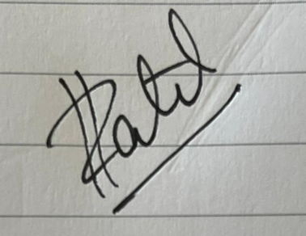 _ _ _ _ _ _ _ _ _ _ _ _ _ _ _

Please list your group members (names & ID) in the box below:
Rudra Pankajbhai Patel (2229997) (Slides 2,3,4)

Anushi Fernando (2222875) (Slides 5, 6, 7)

Syed Asad Husain Zaidi (2213561) (Slides 8, 9) (Group Leader)

Sumit Gauri (2227583) (Slides 10, 11, 12)

Please state your chosen organisation & contemporary issue in the box below:
Selected Organisation: Virgin Group
Selected Contemporary Issue: The development of technology and/or artificial intelligence (AI)

