Peter Worth:

Using examples, discuss how technology may enable heritage management and presentation.

Before I explore how technology is enabling the ‘management and presentation’ of heritage, I want to explain that Archaeological Heritage refers to the study of human activity through the recovery of remains. Heritage is broad, and studies traditions, art and culture, and narratives.
Culture is part of heritage and is the way people live and interact with each other and the environment around them. Culture is what binds people together, the ideas and beliefs they share. Narrative is the story, the beginning the middle and the end. Heritage explores all of this.
A range of technologies exist today which are being used for the management of heritage projects, including archaeological projects. These digital technologies can help to manage heritage projects and present them to a wider public, so they have the power to increase the number of people able to access and enjoy them.
Heritage today, is now digitally influenced and shaped. Digital technologies are enabling heritage to be documented, recorded, presented to an audience and conserved all over the globe. Technology is helping to re-create the past, and the way we understand the past, is as a result, being radically transformed.

So, technology has led to the development of a new term, ‘Digital Heritage.’

And this new concept combines existing expertise of heritage management, museology, history, and archaeology, with powerful new tools of digital technologies.

Digital Heritage combines technology with tradition enabling heritage to be managed and presented in dynamic ways in the 21st century, as I have already stated.

‘Digital heritage’ enables new opportunities for access to heritage, which increase exposure for the public, to heritage projects. It does this by attracting the attention of greater numbers of people, both in the real world and online. Technology is also changing the way heritage is presented, and nowadays takes many forms. The word technology is an umbrella term which needs explaining. It could mean mobile phones, computers, laptops, 3d visualisation, computer software, television, radio, augmented reality or heritage presentation.

The purpose of using technology for heritage presentation, is to provide visitors with opportunities to appreciate and understand heritage. Technology also creates exciting new opportunities to find out about and analyse history and culture. Technology used within heritage has the potential to motivate and engage people, to participate in the preservation of heritage. Participation is a key element of new technology and the way it is applied to heritage. Interactive projects are the way this has developed.

Due to technological advances, interactive heritage experiences are now popular and available at many heritage projects and museums. Interactive experience takes place in a specific social and physical context, and is personal to the individual enjoying the activity, and may be experienced in a variety of ways: replication, immersion or sensation.

In the second life project, for example, the user gets a unique identity and access to video choices via infopoint, The user can also participate, communicate, receive awards, and even embark on fantasy enterprise projects. This project has world-wide reach because it is accessed online.

Museums are actively exploring digital and mobile technologies to enhance visitor experience. They are offering visitors the chance to use AR and VR technologies, to enhance the experience of viewing items in collections on their phones. AR is augmented reality and VR is virtual reality. The public is used to holding up their phone and scanning objects and QR codes; it is as natural as taking a photograph.

All these experiences demand an excellent high speed wi-fi connection, and connectivity is the key issue. This causes some difficulties in certain buildings of historic interest which may house heritage collections. The wi-fi needs to be high speed to transfer the image from the visitor’s phone to the image databases. This technology needs access points to be installed and wiring. In some museums, this is just not feasible. So difficulties do exist, which I won’t explore in detail here.

An excellent example of QR codes and Apps being used to present heritage to the public can be found at the New York City, Museum of Jewish Heritage. This museum heritage project has created a free mobile walking tour App, that gives visitors a chance to experience the ‘Gilded Age’ of New York, as seen through the eyes of the Jewish American poet, Emma Lazarus, who is the subject of the Museum’s exhibition.

This is a brilliant example of technology enhancing an existing heritage experience. It manages a heritage project and presents a companion walking tour, which includes 19 historic sites in Lower Manhattan, Greenwich Village, Union Square, Chinatown, Chelsea, Midtown and the East River.

Each stop includes notes, on a number of historic tour sites, a slideshow, and audio commentary. The tour is created using an interactive platform called AUTOUR, and includes a map and GPS. The tour is narrated by an actress, and even has a reading by Meryl Streep of Emma Lazarus’ famous poem ‘The New Colossus.’

http://www.newyorkholocaustmuseum.org/emma/newyork.html

The website includes the phrase:



These words show perfectly that this is an immersive experience, because the site presents images, events and the life of the poet, and quotations of Emma’s poetry. It is an exploration of New York in the Gilded age through the eyes of the poet. It paints a detailed story of Emma’s life set against the backdrop of 19th century New York.

A rare map on the website reveals more than just geography, it shows landscape and human details, and includes memories of the poet’s ancestors. This is a powerful way of sharing Emma’s story of her life with the public globally.

Here is a copy of an image on the site to demonstrate the style of the site and the way that the public is being encouraged to download the App to android or iphone.

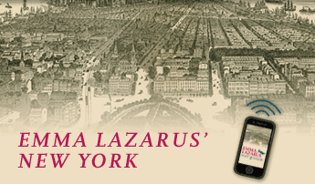
is a downloadable walking tour app visiting 19
historic sites in New York City that helped shape
Lazarus’ legacy.
Download for iPhone > | Download for Android >

On the site there is a separate but related installation:

The Museum’s award-winning “Voices of Liberty” installation serves as a powerful living history experience for visitors. The sound installation overlooks the Statue of Liberty, and plays iPod recordings of immigrants who recall their journeys to America. Log on to www.mjhnyc.org/khc for more information.’ This uses technology to manage and present unique content to a large audience, worldwide.

Here is a quotation from the website:

Walking Tour Sunday, October 30, 2 P.M. Gilded Age New York: Through the Eyes of Emma Lazarus Walk with us through Union Square, Greenwich Village, and other neighbourhoods as we explore Emma Lazarus’s New York, and learn more about the cultural and political landscape that inspired her to write the famous poem that now graces the Statue of Liberty. $15, $12 students/seniors, $10 members

So, the public can learn all about the poet’s life as well as the cultural world she experienced in her life, and the political landscape.

http://mashable.com/2011/09/14/high-tech-museums/#l9S8vSnB0kqR
.
The website highlights The Smithsonian in Washington DC, and shows their display which says that they have an ‘array of mobile apps and websites to allow museum visitors to interact. ‘
They add that this is either interactively or by physically going through an exhibit.

As I wrote earlier, Technology used within heritage has the potential to motivate and engage people, to participate in the preservation of heritage
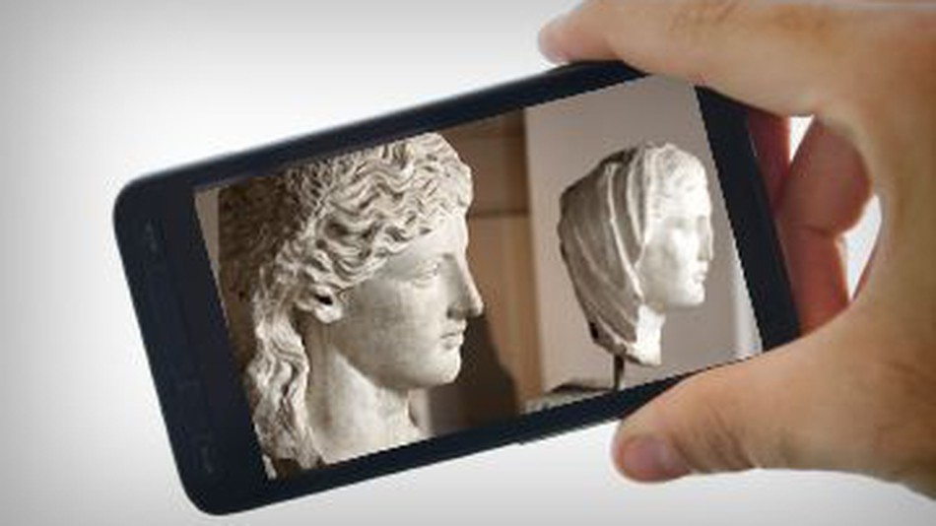

Museums are trying to create interactive experiences for visitors to museum. But they are also working on developing remote experiences for people who cannot visit the museum, to make the experience interactive and engaging.

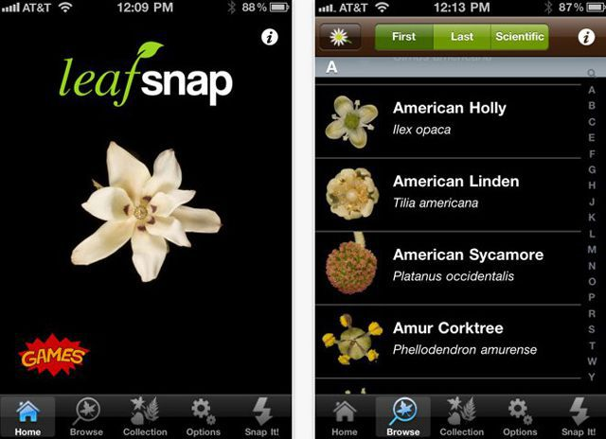

The Smithsonian has even appointed a head of mobile strategy, and the museum has become a world leader, inspiring others. The Smithsonian has adopted augmented reality technology as well as mobile apps and interactive gaming.
The museum has a huge range of mobile apps and websites that enable visitor interaction, in reality or online. The museum has also developed a range of mobile apps:
Infinity of nations
National Museum of the American Indians
Yves Klein. With the void full powers ( provides video, audio and artist quotes)
‘Artists in dialogue2 for the National Museum of African Art provides a mobile tour in English and Brazilian Portuguese, led by curator Karen Milbourne and the artists — Sandile Zulu and Henrique Oliveira. They discuss the the art, their fellow artists and and their collaborative process. A user can also join the related conversation via Twitter, test their knowledge of South Africa and Brazil, and even experiment virtually with the artists’ technique in a built-in game.

