

Postgraduate/Distance Learning
Assignment coversheet & feedback form

THIS SHEET MUST BE THE FIRST PAGE OF THE ASSIGNMENT YOU ARE SUBMITTING (DO NOT SEND AS A SEPARATE FILE)

For completion by the student:
Student Name: Sarah Fae

Student University Email: 2126250@UWTSD.student.ac.uk
Module code: HPCA 2078  Module title Sacred Skies | Student ID number:  2126250 |  |  | Educational support needs:  Yes/No
Assignment title: C. MEASUREMENT BASED ON A PHYSICAL SITE

Conduct a simple fieldwork exercise, investigating the likelihood of celestial alignments of a site(s). We can suggest places and projects, depending upon where in the world you live or would like to travel. Separate guidance will be posted. If you choose this approach, you will have to provide a literary justification and context.

Assignment due date: 16.5.24
This assignment is for the 1st 2nd 3rd 4th 5th 6th module of the degree
I confirm that this is my original work and that I have adhered to the University policy on plagiarism.
Signed ……………Sarah Fae………………………………………………
Email submission:if you are submitting this form via email, please tick this box □
(as a substitute for your signature) to confirm that you agree to the above declaration.
Assignment Mark
1st Marker’s Provisional mark
2nd Marker’s/Moderator’s provisional mark
External Examiner’s mark (if relevant)
Final Mark

NB. All marks are provisional until confirmed by the Final Examination Board.

For completion by Marker 1 :
Comments:

Marker’s signature: |  |  | Date:
For completion by Marker 2/Moderator:

Comments:

Marker’s Signature: |  | Date:
External Examiner’s comments (if relevant)

External Examiner’s Signature: |  | Date:

Oh Little Town of Bethlehem
Arguing for a solar narrative using the footprint of the Anglo-Saxon church of St Andrews, Hexham, Northumberland built between 674-875AD.
Can we find any evidence to suggest solar alignments were taken into consideration with the orientation of the Anglo-Saxon church of St Andrews? The aim of this assignment is to investigate whether the sun, and its central position through sunrise, and or sunset has any relationship with Hexham Abbeys (formerly ‘St Andrews’) east/west orientation? Furthermore, could the dates relate to events in the Christian Calendar? Afterall, evocations, and manifestations of light may be associated with what we deem holy and are crucial aspects to sacred spaces.
French Sociologist Emile Durkheim (1858-1917) proposed that ‘all known religious beliefs, whether simple or complex, present one common characteristic: they presuppose a classification of all the things into two classes or opposed groups, profane and sacred.’ Therefore, due to the religious and spiritual significance of the site, the notion of what is sacred must also be considered. For the purposes of this research the definition of sacred is taken from the Cambridge Dictionary to mean ‘considered holy, deserving of respect, especially because of a connection to a god.’
Alongside quantitative methods elements of the fieldwork will also be framed within qualitative sources such as Levi Bruhl’s (1857-1939) concept of ‘participation mystique.’ Bruhl’s work provides academic substance for the phenomenological, and reflexive nature of one’s empirical evidence and experience. Reflexive concerns, such as coincidence will also be addressed in relation to the sun’s role, feast dates and features within the Abbey.
To investigate a connection between the position of sunrise and sunset on any given day, and the orientations of an architectural feature, one needs to consider the landscape and the declination of the sun (which moves along the ecliptic changing position daily). Celestial objects like the sun have coordinates calculated through their declination, which is a fixed address system for the sky. The astronomical term ‘right ascension,’ defines the east-west celestial co-ordinate of a specific celestial object in relation to the celestial equator. Therefore, to investigate the east-west orientation of Hexham Abbey one must (through a variety of measurements) pertain the ‘right ascension,’ of the sun.
Throughout this investigation research on Welsh Cistercian Abbeys (2014) by Dr Brady, Dr Gunzburg and Fabio Silvia will be referenced to support one’s motives, methods, and conclusion. In their fieldwork Brady et al used the relatively new method of ‘horizon astronomy,’ that is to consider a buildings altitude in relationship to the sky. The team investigated four areas, these were the founding history of sites, the rhythm of the liturgical year, the placement of any in situ rose windows, and the west door, both of which could contribute to the uniqueness of the church’s orientation. The focus on the west was important for this work for I was unable to discern the ‘right ascension,’ of the east window in Hexham Abbey for their rose window is no longer in situ. Secondly their findings correlated to either the astronomical, theological equinox, and or the feast date of a saint, and thus provided a strong foundation upon which to base my research questions.
Hopes and Fears of all the Years -Cultural & Historic Context
In the book edited by D.P Kirby, ‘Saint Wilfred at Hexham,’ it states that ‘our knowledge of what happened in England in the seventh century or in Northumbria at the time of Wilfrid is by no means as secure as we might at first imagine.’ Yet despite the disparity in time, culture, and religious traditions there are two variables in the story of St Wilfrid that have stood the test of time. These are the footprint of the original church he built in Hexham known as ‘St Andrews’ through the position of the crypt inside it, and the second variable is the declination of the west facing door.
The aim of this research is to measure and argue for a solar narrative and do so within the cultural context of buildings rich history, specifically the life of Saint Wilfird, ‘for our holy bishop, being taught by the Spirit of God, thought out how to construct these buildings.’ Despite being near Lindisfarne it is clear Bishop Wilfrid sought to experience ecclesiastical and monastic experiences beyond the boundaries of Northumberland and set out for Rome 653AD. Under the guidance of Boniface Archdecon of Rome Wilfrid he was initiated into an education pertaining ‘the sacred sciences,’ and heavily influenced through the Merovingian courts and castles spending three years in Lyon with ‘very learned teachers.’
It is well documented the conception and design of ‘St Andrews,’ was inspired by St Wilfrid’s experience of larger churches in Southern Italy, and in Rome. William of Malmesbury wrote, ‘that those who had visited Italy seemed at Hexham to see the glories of Rome revived before there very eyes.’ Whilst Wilfrid’s biographer Eddius Stephaus shared that ‘there was no church comparable to Hexham this side of the Alps,’ highlighting its importance and impact.
Today everything Wilfrid constructed above ground has gone, only his crypt is essentially as it was first built. Excavations between 1880-1910 by the Abbeys architect C.C. Hodges shows alignment with the west door see figure one, furthermore this relationship carries forth into the 21st Century shown in figure two. Therefore, if there is a solar narrative in Hexham Abbey it will still be measurable, and visible today. Taking later floorplans into consideration, alongside knowledge that Hexham Abbey has been restored and rebuilt throughout its extensive history I propose a further question. Could the sunrise or sunset, and its alignment through the centre of the building have a relationship with any later artefacts, and or artwork inside the Abbey?
So God Imparts to Human Hearts -Literature Review
Archeoastronomy is the study of the orientation of buildings with respect to celestial objects, defined by Fabio Silva as ‘the study of how people have understood, conceptualized and used the phenomena in the sky and what role the sky played in their cultures, by analysing their material remains.’ However, until recently these ‘material remains,’ such as churches, Abbeys and Cathedrals have not been measured using ‘horizon astronomy,’ that is, the altitude of the building in relation to the sky.
For example, in previous scholarship ‘The orientation of early medieval churches in England,’ Peter Hoare and Caroline Sweet (2000) measured a combined total of ‘183 discreet structures,’ to investigate their relationship to the sunrise and sunset. The fieldwork found evidence that Christian churches were set out according to a strongly held purpose, and ‘liturgically correct alignment was regarded as desirable, and that attempts to achieve this were met with considerable success.’ However, the reliability of their data is called into contention for the duo did not have access to remote methods, and measurements took place onsite only. Google Earth launched 2001 and understandably was not referenced in their work which led to the next anomaly their failure to calculate ‘horizon astronomy.’ Hoare, and Sweet also only calculated sites in central, and southern England.
Earlier work by Hugh Benson (1956) discovered churches do align with specific dates, such as their patronal feast days, and share alignment with nearby churches. Although, like previous scholarship his findings also failed to consider the buildings altitude, and thus are called into dispute. These two factors combined; the failure to consider ‘horizon astronomy,’ and measure sites in Northern England present a case for new work in the field and is why an investigation into the former footprint of Hexham Abbey has taken place.
Through their research on Cistercian Monasteries, Dr Brady, Dr Gunzburg and Fabio Silvia propose a deliberate intention was made to orientate Welsh monasteries by embracing their individual landscapes, ‘that there is purpose through placement of sacred buildings, which corresponds to the sky.’ Crucially they found links between solar alignments and key astronomical and theological dates specifically around the March and September equinoxes. Most notably, they found Whitland Abbey, established pre-1145 appears to align with the sunset on 25th March, and that once again builders had stressed the western sun ‘but unlike Margam – that aligned to the astronomical equinox – Whitland’s church is aligned to the theological equinox.’ They concluded the intention may not be an orientation to the theological equinox, but instead to the feast of the Virgin Mary, ‘The Annunciation.’ However, just like Hexham Abbey, Whitland Abbey also has no rose windows in situ so no other orientation could be considered.
The Everlasting Light -Methodology
Although writing by Bede (672/673-735) indicates that astronomical knowledge was known to people in early medieval England obvious implications arise trying to measure early Anglo-Saxon churches, ‘for numerous structures have foundations which are older than the visible fabric.’ Furthermore, those foundations may have deviated, as during the winter months church building was often suspended so any disturbance to the initial markers might have caused change once work restarted in Spring.
Hexham Abbey faces east to west but to argue for a solar narrative the elevation of the landscape must be surveyed, and by taking the elevation into consideration one’s research methods are up to date. Measurements taken remotely on Google Earth Pro in March 2024 calculated the azimuth (orientation) alongside latitude (geographical location) and through the website ‘heywhatsthat’ the altitude, (the buildings relationship to the horizon) was discovered. Consult figures three, four and five to see this process.
Like the previous methods employed by Dr Brady, Dr Gunzsburg, and Silvia results were compared to a table of daily declinations for the sun to determine when the sun rises or sets in alignment with the building. As the calendar dates provided by these tables were calculated for the Gregorian Calendar a deduction of 4-5 days was necessary to stay in line with the building of St Andrews c. 674AD and the Julian calendar. The results, seen in figure six highlight four specific days the sun would rise and set on the horizon in alignment with the east window and western door. The central position of the crypt, and its (above ground) stairway entrance enabled me to take measurements that still line up with building’s original footprint. This data along with the relevant calendar conversion produced meaningful results relating to the declination of the west facing door, pertaining two feast dates of the Virgin Mary, shown in figure seven.
In addition, I visited Hexham Abbey on Saturday 20th April to perform a series of ground truthing exercises through the augmented reality app Theodolite (published 2009 by Craig Hunter). Theodolite is a land surveyance app which I used to measure the west-east azimuth onsite, and the results are shown in figures nine and ten. A disparity of one degree was significant enough to completely change the outcome of this investigation, see figure eight. Through this new data which calculated the west azimuth at 271 degrees I found only one feast date ‘The Annunciation’ had a solar relationship with Hexham Abbey, see figure eleven. This deliberate stress of the west through a connection with the 25th of March correlated with earlier findings by Brady et al on Whitland Abbey. The discovery, underpinned by previous research, meant one was no longer concerned with the dates pertaining the east for this investigation, and thus did not use the new azimuth of 91 degrees in any further calculations.
The Dear Christ Enters In- Discussion of Results
In her paper ‘Sacred Landscapes and the Phenomenon of Light,’ Barbara Weightman highlights the crucial interplay between light and Christianity for its existence ‘proved the eternal presence of an immaterial God.’ Weightman’s work not only highlights the relationship between spiritual experience and light but also how within the religious context fire evokes the sacred. This notion, alongside the measurements and subsequent calculations suggest its highly likely a solar narrative was taken into consideration through the Anglo-Saxon construction and might still be at play in the 21st Century.
As shown in Hodges floorplans, see figure one, the sun would of set in the west and shone through the centre of ‘St Andrews,’ on either the 24th or 25th March ‘The Annunciation.’ Unfortunately, the declination of the east facing window, and subsequent sunrise did not produce any noteworthy results due to the removal of the rose window. Moreover, a visit to the site between 6-6.45pm on the 22nd March produced through the right weather conditions an opportunity to put one’s hypothesis to the test. That is, to find empirical evidence to suggest solar alignments might have been taken into consideration in St. Wilfrid’s church. Created by French anthropologist Lucien Lévy-Bruhl (1857–1939) the concept of ‘participation mystique,’ is a defined as ‘a phenomenon whereby people identify themselves with a physical object such as a holy artefact or a totem.’ The term indicates a mystical involvement, and implies a blurring of boundaries between the individual, their perception, and the environment.
The phenomenon of ‘participation mystique,’ is highlighted in figure twelve as the sun penetrated through the west doors in Hexham Abbey. Standing before the crypt I felt the light was different somehow and had an illuminating quality. Piercing and brilliant, the light was so bright I instinctively dropped to one knee to greet it. Christians describe the conversion as illumination. This type of reaction is encapsulated by Bruhl’s notion of ‘primitive mentality,’ in which logical thought is abandoned in favour of participation. Bruhl wrote ‘whereby the mind is the merely presented with an object but communes with it and participates in it, not only in the ideological, but also in the physical and mystic sense of the word.’
However, despite the palpable awe it must be noted in order to truly test my Annunciation hypothesis I would need to have visited the building on the 29th-30th March to stay in line with the Gregorian calendar and the subsequent 4-5 day subtraction. Nonetheless, due to the size, and scale of the west facing doors, and how slowly the sun moves on the horizon the sunset in figure thirteen is still relevant for it falls within a degree or two of the sun’s movements. This, albeit seven to eight days prior to the direct alignment still provides considerable evidence.
Yet in the Dark Streets Shineth – The Crypt
The structural remains of St Andrews fall into two classes, those evidenced, observed, and recorded during excavations in 1880-1910, and that which can still be seen. There is no doubt that the major church of St Wilfrid monastic complex occupied the site of the present nave. For the purposes of this investigation the structural changes (specifically to the depth of the nave) reinforced by crypts ‘half subterranean nature,’ would not have altered the declination of the west door see figure fifteen. Moreover, the floorplans completed by Hodges report a feature of ‘great liturgical significance’ marked as ‘h’ on the floorplan, known as an ambo, see figure fourteen.
One of the premises to support a solar argument for ‘St Andrews,’ is the ‘ambo theory’ due to its relationship with the crypt. The word ‘ambo,’ is taken from the Greek tradition and means ‘elevation,’ and within the context of religion is a place for the reading of scripture. One theory suggests ‘the position of the ambo in Wilfrid’s church was inspired by 5th-7th Century churches in Jordan.’ Yet it must be noted there are also two other possible interpretations of what ‘h’ might be, the remnants stairs or relating to the crypts physical entrance.
Further support for the sacred interplay between the sun and the ambo can be found in work by Paul Fouracre, ‘Eternal light and earthly concerns, Belief and the shaping of medieval society. Fouracre describes the relationship between light, the tombs/relics of saints, and how combined and through proximity there was a supernatural power. It is said the relics of St Andrews once resided within the crypt, and ‘such veneration included maintaining perpetual light before there tomb.’ Secondly, he notes throughout the seventh Century there was virtually no oil to be hand in England. Could it be, through use of the sun, natures natural light source, veneration could be guaranteed within ‘St Andrews,’ celebrated atop the ambo, albeit only on the 25th March? Although there are two other interpretations for what the remnants of ‘h’ are evidence suggests ‘the ambo theory’ seems the most credible in arguing for a solar narrative.
The Great Glad Tidings Tell - Later Artwork
Now a correlation has been found between Hexham Abbeys orientation and the role of sunlight in honouring ‘The Annunciation,’ of the Virgin Mary the placement of an artefact, and artwork garners interest. A pulpitum, added by Prior Smythson in 1491 see figure eighteen depicts two scenes, ‘over the north side door, there is a painting representing the Annunciation of the Blessed Virgin Mary, and there is another of the Salutation over that on the south.’ The Salutation is a scene taken from Luke 1:39-80 whereupon Mary visits Elizabeth pregnant with John the Baptist who upon seeing her is infused with the Holy Spirit. Shown in figure sixteen and seventeen the two expectant mothers congratulate one another outside Jerusalem, modelled upon Hexham’s Moot Hall.
Furthermore, central to the east facing window raised above the high altar is artwork by Andrea del Sarto which depicts the ‘holy family,’ gifted to the Abbey 1858 shown in figure nineteen. However, as the artwork is removable it does not warrant the same level of interest as the pulpitum. Therefore, to argue for an intentional solar relationship through its central position on the east facing altar would be tenuous, whereas the later addition of the pulpitum due to its scene featuring ‘The Annunciation’ does carry merit.
Christ is born of Mary – Deeper Cultural Context
To contextualise and understand these discoveries the relevance of the Virgin Mary upon the life of St Wilfrid must be addressed. In her book ‘The Cult of the Virgin Mary in Anglo Saxon England,’ Mary Clayton states during his years in Rome, Wilfrid spent several months studying under the influence of Pope Sergius (687-701) who was known for his devotion to Mary. Not only that, in c. 650 Rome introduced Adnuntiatio domini ‘The Annunciation,’ and around 660-70 the feast of the Nativity of Mary. Evidence suggests that there is a sacred, secret celestial interplay between the alignment of the sun through Hexham Abbey and its relationship to the Virgin Mary. This is due to the correlation between Wilfrid’s time studying in Rome in 653AD and how that coincides with the creation of her feast dates.
The impact Mary had on Wilfrid was documented by his biographer Edduis Stephanus who wrote towards the end of his life whilst on a return trip from Rome he took ill and had a holy visitation by Arch Angel Micheal;
‘Now remember that you have built churches in honour of the
Apostles St Peter and St Andrew; but you have built nothing
in honour of St Mary, ever virgin, who is interceding for you.
You have to put this right and to dedicate a church in honour of her.’
Mary’s intercession cured Wilfrid and added years to his life. Clayton (1990) states the words of Arch Angel Micheal chastised Wilfrid, and ‘appear to be a deliberate corrective: and the implication of the tale is that Mary’s intercession is more powerful than that of Peter or Andrew.’ The consequence of the encounter made Wilfrid return to Hexham and dedicate a church to Mary inside the monastery of ‘St Andrews.’
The Blessings of his Heaven- Potential for Further Field Work
Evidently the Virgin played a significant role in the life of Wilfrid, and her presence within Hexham Abbey is still measurable, and thus meaningful 1350 years later. We know after her intercession in 704AD Wilfrid built St. Marys. The church was a rotunda, and although not all-round churches had Marian dedications, many did, and Hexham is the first Anglo Saxon church which fits into this widespread pattern. Unfortunately, ‘St Marys,’ did not survive the Danes, but its existence bodes an interesting thread for further research for ‘the two saxon churches of St Andrews and St Marys were in close proximity to one another, and in one direction, north and south only a narrow lane intervened between them, but east and west there was considerable space, which was occupied by a cemetery.’ Although accounts of holy visitations are tenuous at the best of times it does pose the question, why would Wilfrid need to build another church to the Virgin Mary when through a solar relationship ‘St Andrews’ already paid homage?
If records are correct Wilfrid’s arrangements and plans for ‘St Andrews’ belong to the Merovingian Age, heavily influenced by Frankish Kings, and time spent in Rome, and Lyon at St Martins of Tours. Consequently measurements taken from the sites Wilfrid visited on his European expeditions between 653AD until 674AD could yield more insight. The potential of which is twofold, firstly to learn of any solar relationships, and secondly if they relate to dates pertaining the Virgin Mary. This could uncover the architectural origin and inspiration behind the east-west orientation of ‘St Andrews.’ Furthermore, fieldwork on the site of Ripon Cathedral whose crypt, also built by Wilfrid in 672AD is still intact, could alongside original floor plans argue for further solar narratives.
The use of ambos in other sacred spaces, and their ceremonial relationship with the sun, and Mary warrants a much deeper investigation, so too does the 1491 addition of the pulpitum which frames the central line of the Abbey. Although it must be noted, it could be a coincidence that ‘The Annunciation’ is depicted and has a solar relationship through the declination of the west view on 25th March. Further research on the use of sunlight in the medieval period to evoke the sacred as reverence for Mary could produce a compelling case to either support or negate the reasoning behind this image on the pulpitum.
O Come to Us, Abide with Us- Conclusion
This investigation has shown fieldwork on historic sites can provide fresh insight and alongside cultural context reveal sacred secrets hidden in plain sight. One’s aim was to find evidence to suggest solar alignments were taken into consideration with the east-west orientation of ‘St Andrews.’ Thanks to the previous discoveries made on Welsh Cistercian monasteries I was optimistic that the measurements of Hexham Abbey would produce either an equinox or feast date. In their research, Dr Brady, Dr Gunzsburg and Fabio Silvia concluded;
‘the builders of these abbeys churches embraced the landscape
when situating and aligning their churches so that they received
the physical light of the sun at significant theological days: the
feasts of the Virgin; or the astronomical equinox, the time of
the equal division of the sky; or Michaelmas/Saint David.’
Thus, the results (using the updated azimuth of 271 degrees), see figure eight are congruent with earlier scholarship for they concern a feast date for the Virgin, and like the work in Wales took the altitude of the building (in relation to the sky) into consideration. Therefore, evidence suggests in choosing the position, and location of his church St. Wilfrid considered celestial alignments, and that a sacred solar relationship between sky, spirit and architecture was intentionally created. Through the position of the present-day west door this relationship has stood the test of time, is still visible, and through Bruhl’s ‘participation mystique’ tangible centuries later. Yet, reflexive in nature one’s empirical evidence and experiences are by no means conclusive, for our treatment of objects, people and places is led by our personal judgements of what constitutes ‘sacred,’ and what we imbue with special meaning, and set apart can be different to others. What constitutes sacred experience is still highly subjective, and certainly not measurable through technology, regardless this investigation has shown onsite visits certainly do have their place! Firstly, to gather empirical evidence but more importantly to ‘groundtruth,’ that is to double check remote calculations, for a seemingly small difference in the azimuth can completely change the results.
Discovering a solar narrative for Hexham Abbey means theories can now be put forward as to why the crypts above ground entrance was a necessary feature for Wilfrid, once described as an ‘an irrelevant intrusion’ Excavations noted ‘one of the key issues was to establish the floor level of Wilfrid’s nave into which the crypt was half submerged.’ This, alongside the ‘ambo theory,’ suggests there might have been a deliberate ceremonial intention to orientate the crypt (and its contents) with west door to receive the penetrative force of the sun’s rays. Through its position, and thus symbiotic relationship with the Virgin Mary it is highly likely these two features would have worked in conjunction and were designed to serve a sacred ceremonial sky related function.
Question two asked, if found, does the solar narrative connect with events of the Christian calendar? The azimuth taken remotely of 272 degrees, differed by only one degree to the onsite reading of 271 degrees for the west door. However seemingly insignificant this one degree made all the difference in calculating and converting the dates from Gregorian to Julian. The remote calculation had a highly significant correlation between the placement of the west door, the position of the sunset, and two Feast dates of the Virgin Mary. Whereas the onsite azimuth of 271 degrees highlighted a relationship with only one ‘The Annunciation.’ Clayton states ‘by the end of the Anglo Saxon period six feasts of the Virgin were celebrated in England; this large number represents an honour granted to no other saint.’ This, alongside Wilfrid’s experiences in Rome underpin the cultural significance of Mary in the seventh Century. Thus, it is highly probable through his visits to Rome, alongside studying with Boniface (an ardent supporter of The Virgin), the orientation of ‘St Andrews’ was no coincidence.
Question three asked; does the sunrise and sunset, and its alignment through the centre of the building have a relationship with artefacts or artwork inside the Abbey? There is an obvious connection between the pulpitum, it’s two scenes of Mary, and the use of the sun on her feast date. Yet it must be stated, due to the religious nature of the building you would expect to find artwork featuring the Virgin. Therefore, more comparative research on Abbeys and churches is necessary for a more accurate picture to emerge, perhaps the central placement is merely coincidental? Reflexive concerns such as these are also expressed and evident in the work on Cistercian Monasteries, as the researchers stipulate, ‘Strata Florida, Wales by either design or by chance, held through its position in the Welsh hills, and the footprint of the building the same alignment to Saint Davids Day or Michaelmas.’
It is clear the Bishop of Northumberland had a powerful influence for ‘The Church was definitely moulded into shape during Wilfrid’s lifetime, and Wilfrid himself played a leading part in deciding what that shape should be.’ Previous fieldwork highlights just how unique that shape was for ‘Christian churches with notable exceptions, chiefly in Italy, are broadly in alignment with the east.’ Given previous documentary evidence, alongside quantitative data it is fair to suggest Wilfrid’s time in Rome led him to construct a building in England with an intentional west facing focus. Hoare, and Sweet also proposed that the many buildings which are not orientated sensu stricto are aligned with sunrise on the feast day of the saint to whom they were originally dedicated, one of the solstice days, the day the foundations were prepared or the 1st May.’
As I embarked upon the investigation of Wilfrid’s church dedicated to St Andrew I expected to find a solar relationship for his feast date, that is the 30th of November. Thus, the alignment to Mary was a surprise and unique within this context. However, looking closely at documentary evidence pertaining the life, and travels of Wilfrid it is clear her influence was manifold. This, alongside discoveries concerning the buildings west facing orientation, and artwork/artefacts casts new light on an ancient sacred site. Whilst the building has been revived and restored in various shapes and forms throughout its tumultuous history two things remains true; that is the declination of the west door, and through that space a sacred sky relationship with the Virgin Mary.

Figure one
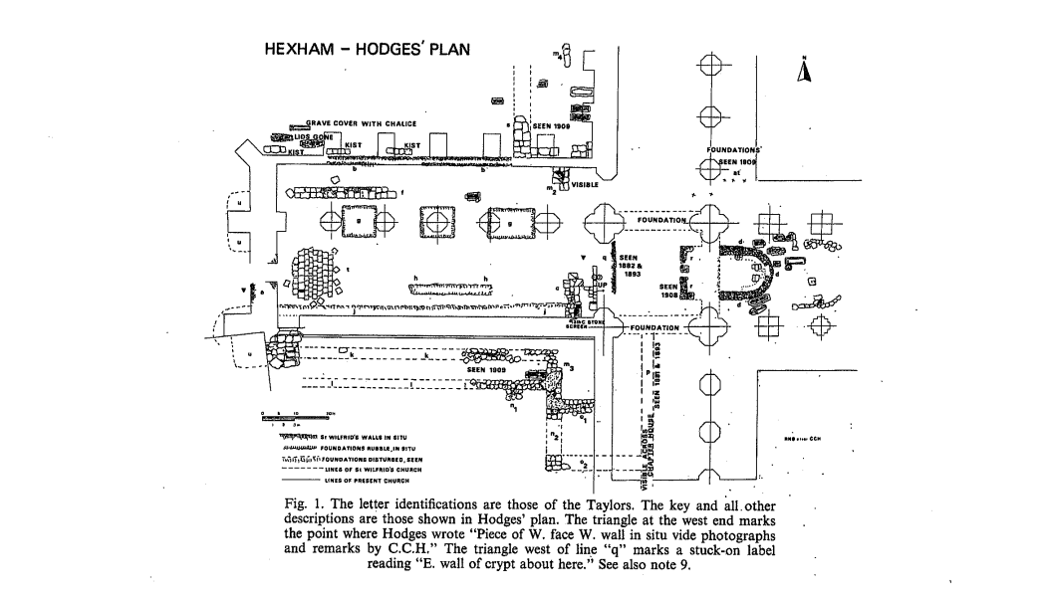
Figure one a floorplan taken from C.C Hodges excavations Hexham Abbey between 1880-1910, and demonstrates the relationship between the west door and internal layout of the site.
Figure two
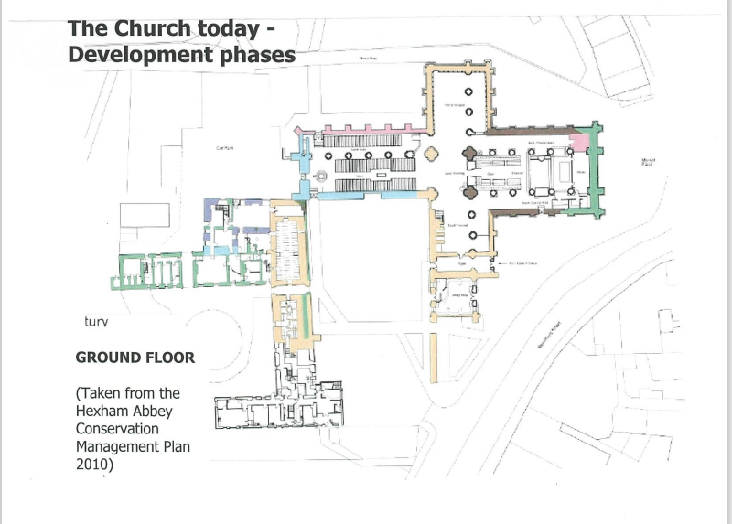
Figure two taken in 2010, the conservation management plan shows the east-west orientation of Hexham Abbey and the 21st Century alignment between the west door, and crypt.
Figure three
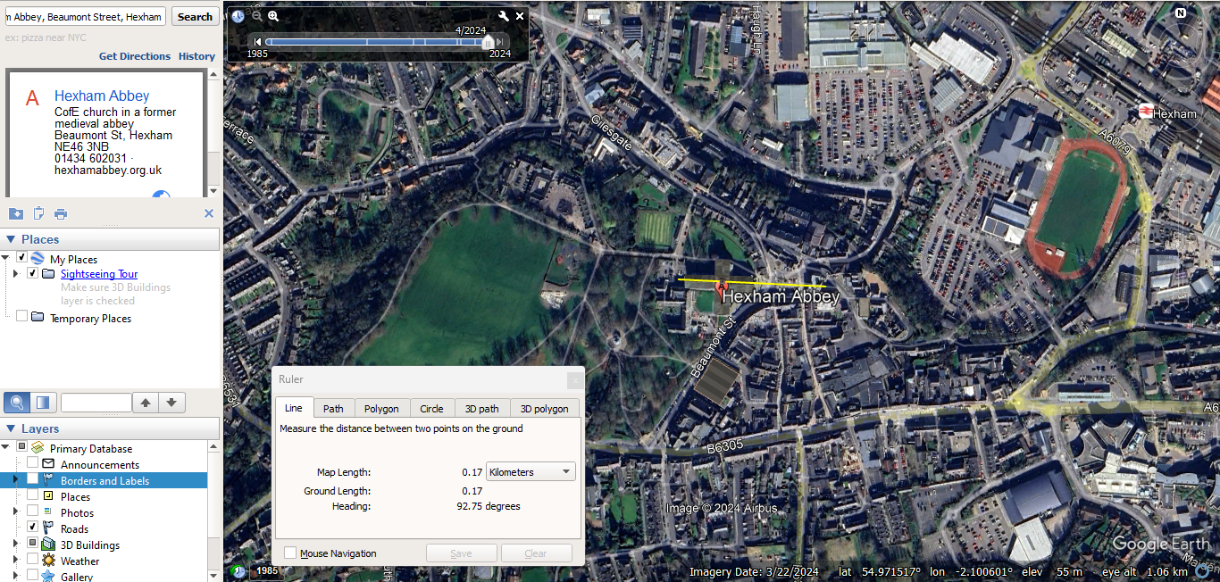
Figure three shows a remotely calculated east facing azimuth of 92 degrees, adding 180 equates to 272 degrees for the declination of the west facing door. Website accessed 14th March 2024 at 3.03pm.
Figure four
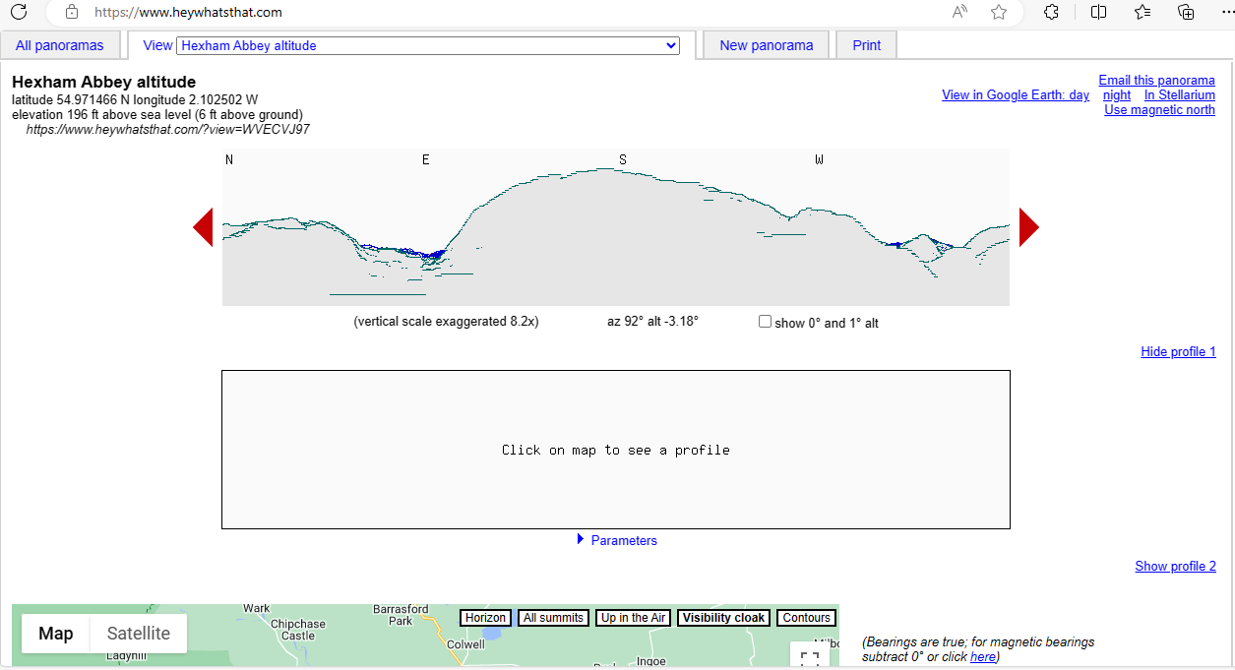
Figure four is a screenshot from the site ‘heywhatsthat,’ and was used to calculate the altitude of east of Hexham Abbey, through input of azimuth, and latitude. Website accessed 14th March 2024 at 3.11pm.
Figure five
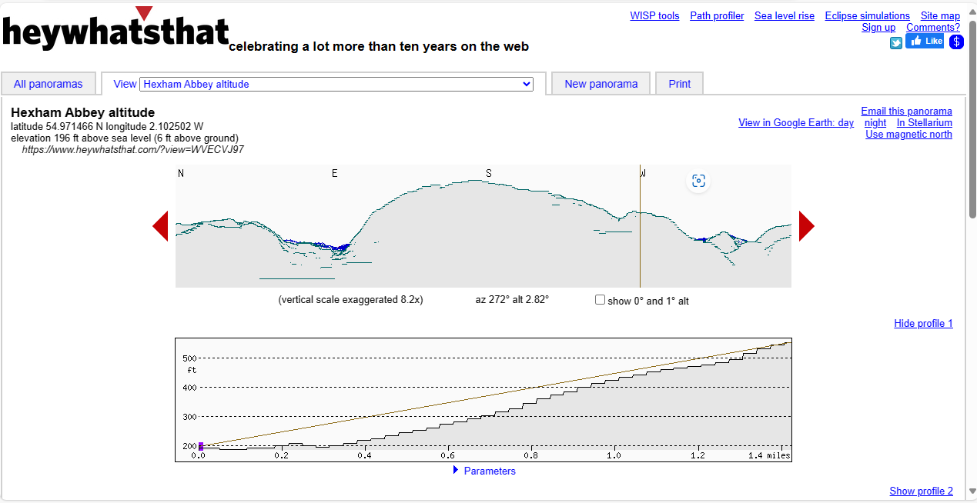
Figure five is a screen shot of the website ‘heywhatsthat,’ and was used to calculate the altitude for west of Hexham Abbey, through the input of the azimuth and latitude. Website accessed 14 March 2024 at 3.33pm.
Figure six
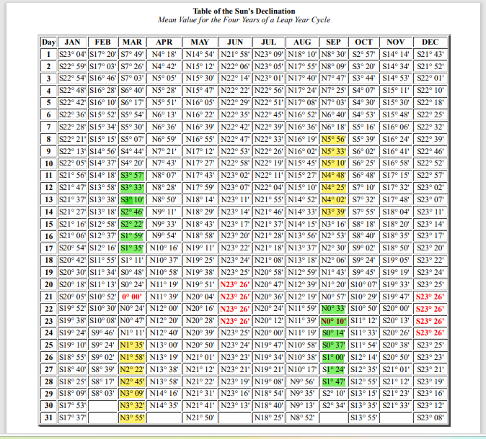
Figure six shows the conversion of solar declination from the Gregorian to the Julian Calendar, the areas highlighted in yellow pertain to the west facing view, whilst those in green show dates for the east. Accessed via website Moodle tool kit page at University of Wales Trinity St David at 21.12pm on 14th March 2024.
Figure Seven- Methodology & Results Table for remote azimuth
Measurements | East | West
Azimuth | 92.34 | 272.34 (+180)
Latitude | 54.9715 | 54.9715
Altitude | -0.26 | 2.82
Declination | -1.56 | 3.69
Conversion calendar  Gregorian into Julian | 674-875 AD  Minus 4-5 days | 674-875AD  Minus 4-5days
Gregorian date 1 | 16-17th March | 30 -31st March
Gregorian date 2 | 27-28th September | 13-14th September
Julian Date 1 | 11- 12th March | 25- 26th March  Feast of the Annunciation
Julian Date 2 | 22- 23rd September | 8- 9th September  Nativity of the Virgin Mary

Figure eight measurements for the onsite azimuth of 271
Measurements | West
Azimuth | 271
Latitude | 54.9715
Altitude | 2.82
Declination | 2.88
Conversion calendar  Gregorian into Julian | 674-875AD  Minus 4-5days
Gregorian date 1 | 29-30th March
Gregorian date 2 | 17th-18th September
Julian Date 1 | 24th -25th March  Feast of the Annunciation
Julian Date 2 | 12- 13th September

Figure nine
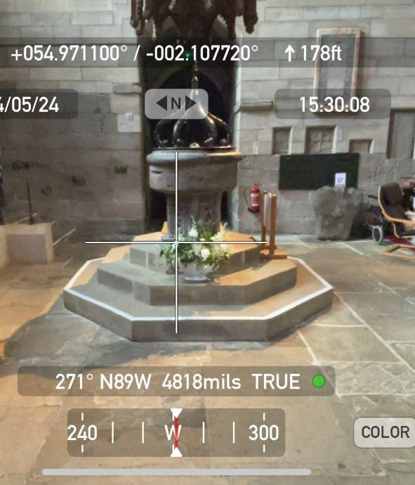
Figure nine is a screenshot of the Theodolite surveyance app (published 2009 by Craig Hunter) on an iPhone 12. This took place on the 20th April 2024 inside Hexham Abbey, Northumberland, and shows an azimuth reading of 271 for the west.
Figure ten
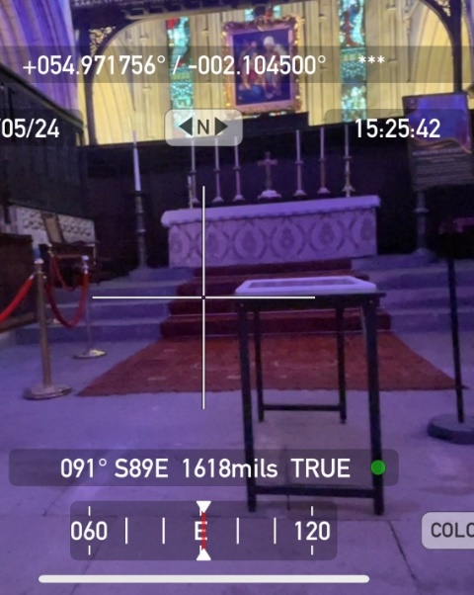
Figure ten is a screenshot of the Theodolite surveyance app (published 2009 by Craig Hunter) on an iPhone 12. This took place on the 20th April 2024 inside Hexham Abbey, Northumberland, and shows an azimuth reading of 91 for the east.
Figure eleven
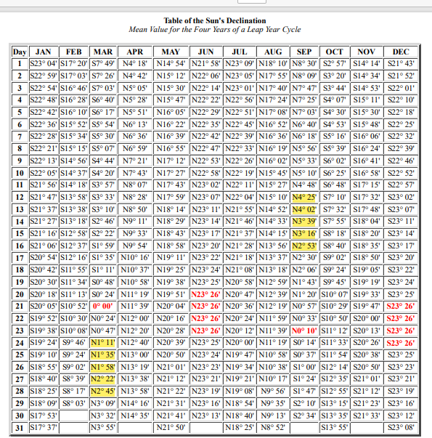
Figure eleven shows the (updated) conversion of solar declination from the Gregorian to the Julian Calendar, the areas highlighted in yellow pertain to the west facing view. Accessed via website Moodle tool kit page at University of Wales Trinity St David at 22.22pm on 15th May 2024.

Figure twelve
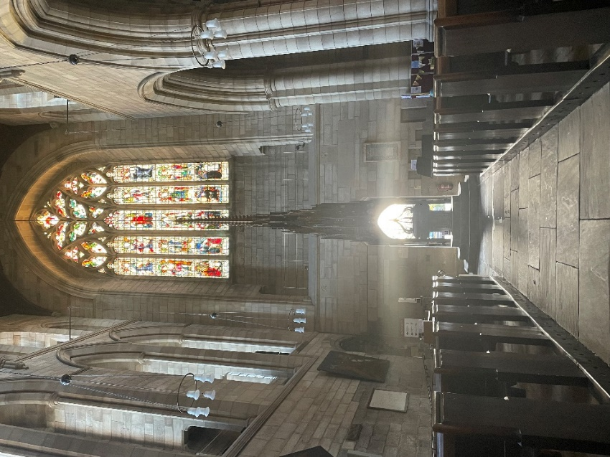
Figure twelve is of Hexham Abbey west door, 22nd March 2024 at 6.35pm. Photo taken in iPhone 12 by Sarah Fae.
Figure thirteen
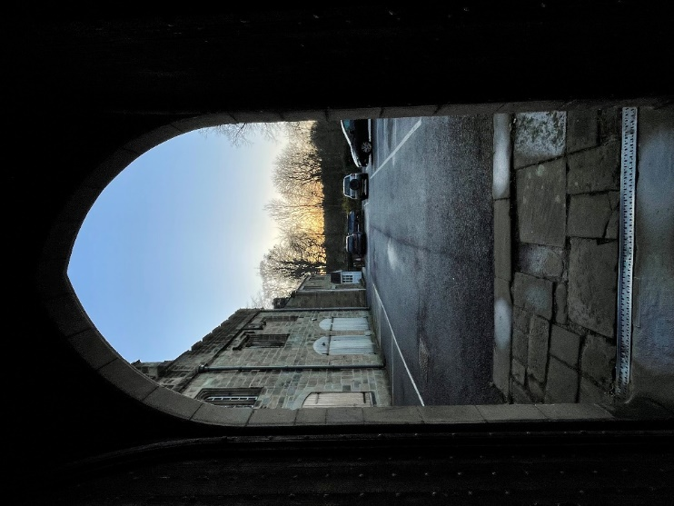
Figure thirteen is of Hexham Abbey west door, taken at sunset 22nd March 2024 at 6.35pm on iPhone 12 by Sarah Fae.

Figure Fourteen
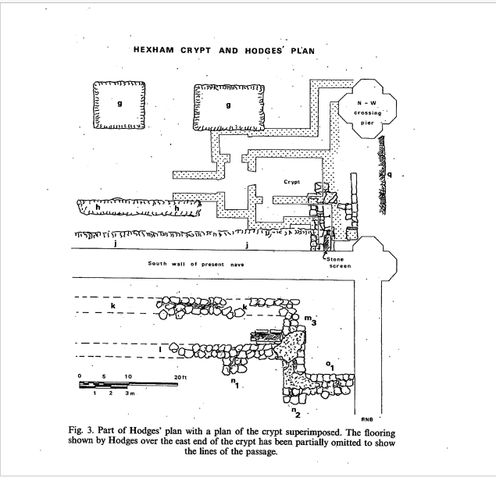Figure fourteen is a floorplan taken from Hodges excavations and shows the relationship between ‘h’ and the crypt.

Figure fifteen
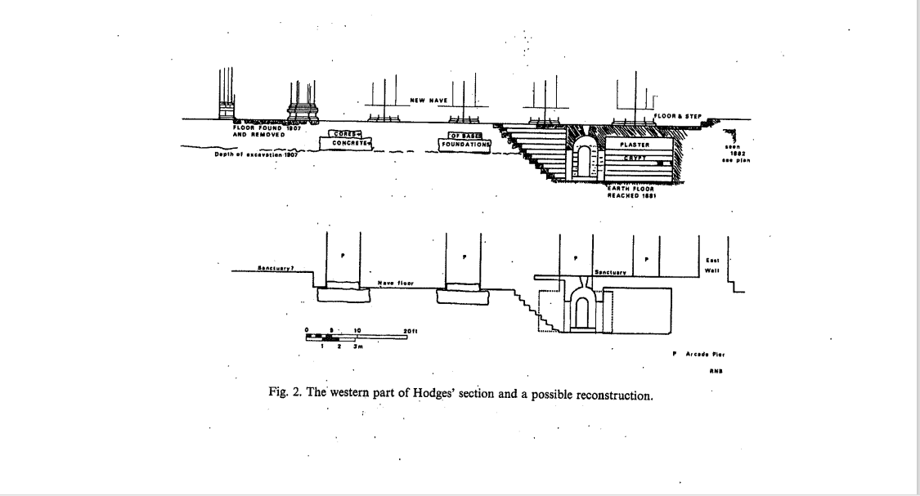
Figure fifteen is another floorplan from Hodges excavations, the top image shows the original level of Wilfrid’s nave, the reduced number of steps to enter the crypt.
Figure sixteen
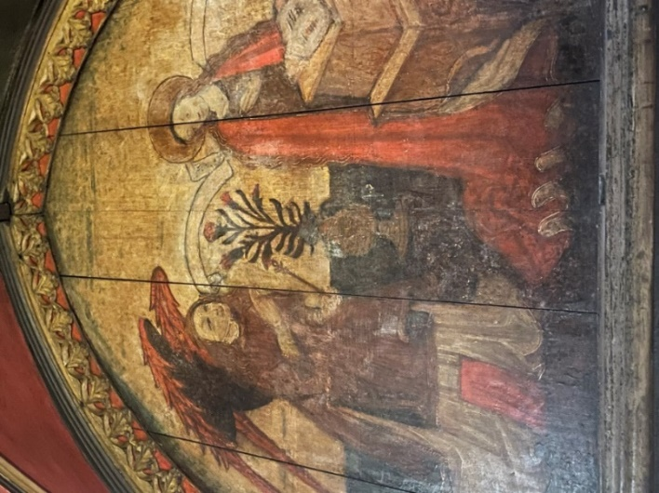
Figure sixteen is of ‘The Annunciation,’ scene on the pulpitum taken 14th Mary 2024 at 2,05pm on iPhone 12 inside Hexham Abbey.
Figure seventeen
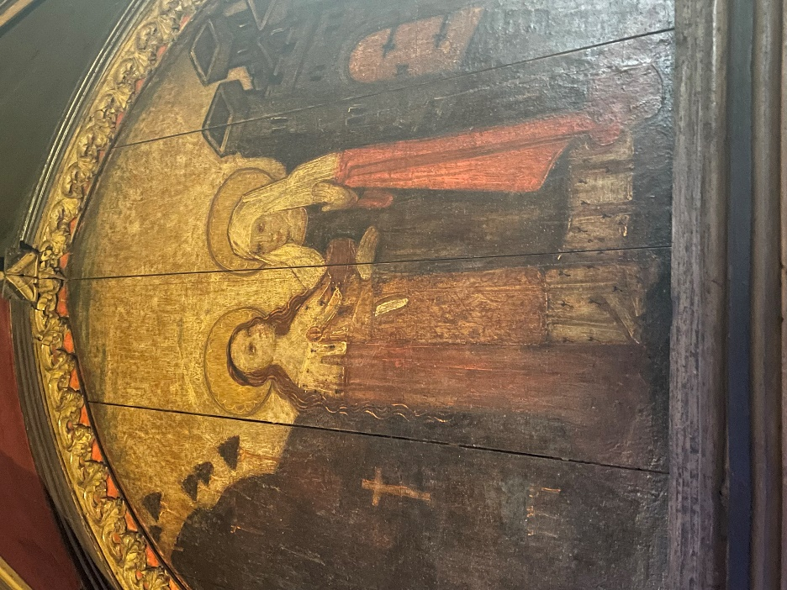
Figure seventeen is of ‘The Salutation,’ son the pulpitum taken 14th Mary 2024 at 2,06pm on iPhone 12 inside Hexham Abbey.
Figure eighteen
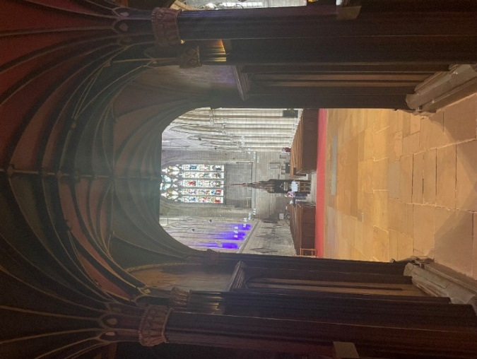
Figure eighteen shows the pulpitums central relationship with the west door. The scenes depicting Mary are either side of the central arch. Photograph was taken 14th May 2024, at 2.07pm inside Hexham Abbey.
Figure nineteen
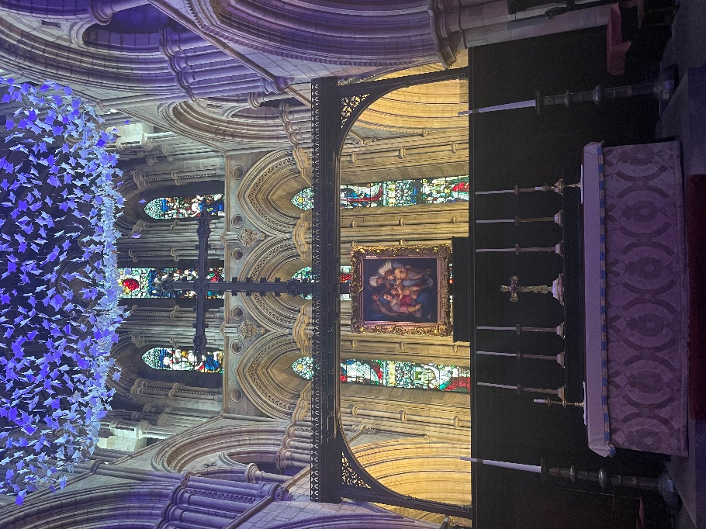
Figure nineteen is artwork of ‘the holy family,’ by the studio of Andrea del Sarto c. 15th. It is positioned in the central line, and hangs in front of the east window. Taken on iPhone 12 14th May at 2.55pm.

Bibliography
Bailey Richard, The Anglo-Saxon Church at Hexham, Archaeologica Aeliana series Vol 4 (1976)

Brady, Bernedette, Darrelyn Gunzburg, and Fabio Silvia, The orientation of Cistercian churches in Wales: A Cultural Astronomy case study, (BURO, 2014)

Clayton Mary, The Cult of the Virgin Mary in Anglo Saxon England, (Cambridge University Press 1990)

Colgrave Bertram, The Life of Bishop Wilfrid by Eddius Stephanus, (Cambridge University Press, 1927)

Evans Mathew T., The Sacred: Differentiating, Clarifying and Extending Concepts, Review of Religious Research Vol 45 No.1, (Springer 2003)

Fouracre Paul, Eternal light and earthly concerns: Belief and the shaping of medieval society, (Manchester University Press, 2021)

Hodges Charles Clement, Hexham and its Abbey, (Gibson and son, 1919)

Hoare Peter, and Caroline Sweet, The orientation of early medieval churches in England, Journal of Historical Geography, volume 26 issue 2 (Elsevier, 2000)

Kirby D.P., Saint Wilfrid at Hexham, (Oriel Press, 1974)

Throop C. Jason, Minding Experience: An exploration of the concept of “experience” in the early anthropology of Durkheim, Levy Bruhl and Levi Strauss, Journal of the History of Behavioural Sciences Volume 39(4), (Wiley Periodicals Inc. 2003)

Weightman, Barbara A Sacred Landscapes and the Phenomenon of Light, Geographical Review volume 86 no.1 (Taylor and Francis Ltd, 1996)

https://dictionary.cambridge.org/dictionary/english/sacred
https://www.oxfordreference.com/display/10.1093/oi/authority.20110803100308436

Weightman, Barbara A, Sacred Landscpaes and the Phenomenon of Light, (Taylor & Francis Ltd, 1996), p. 58.
Evans, Mathew T, The Sacred: Differentiating, Clarifying and Extending Concepts, (Springer 2003), p. 35.
https://dictionary.cambridge.org/dictionary/cambridge/sacred
Brady, Bernedette, Gunzburg, Darrelyn, and Silvia Fabio,The orientation of Cistercian churches in Wales a cultural astronomy case study, (BURO, 2014), p. 280.
Brady, B, The Orientation, p. 297.
Kirby D.P, Saint Wilfrid of Hexham, (Oriel Press, 1974) p. 6.
Colgrave, Bertram, The Life of Bishop Wilfird by Eddius Stephanus, (Cambridge University Press, 1927) p. 47.
Kirby, D.P, Saint, p. 41.
Kirby, D.P. Saint, p. 81.
Brady, B, The orientation, p. 278.
Hoare, Peter, and Sweet, Caroline, The orientation of early medieval churches in England, (Elsevier, 2000) p. 164.
Hoare, Peter, The orientation, p. 165.
Brady et al, the orientation, p. 277.
Ibid, p. 275.
Ibid, p297.
Hoare et al, The orientation, p. 166.
Ibid, p. 162.
Ibid, p. 169.
Brady, The Orientation, p. 284.
Weighgtman, B, Sacred Landscapes, p. 63.
Ibid, p66.
https://www.oxfordreference.com/display/10.1093/oi/authority.20110803100308436
Weightman, Barabara, Sacred, p. 63.
Thropp, Jason, Minding Experience: an exploration of the concept of “experience” in the early French Antrolpolgy of Durkhiem, Levy Bruhl, and Levi Strauss, (Wiley Periodicals Inc. 2003), p. 371.
Bailey, Richard, The Anglo-Saxon church at Hexham, Archeologica Aeliana series, (1976) p. 47.
Bailey, The Anglo, p. 57.
Ibid,’ p. 57.
Fouracre, Paul, ‘Eternal Light and earthly concerns, Belief and the shaping of medieval society, (Manchester University Press, 2021), p. 22.
Fouracre, P ‘Eternal,’ p22.
Ibid, p. 206.
Hodges, Charles Clement, Hexham and its Abbey, (Gibson and son, 1919), p. 63.
Clayton, Mary, The Cult of the Virgin Mary in Anglo Saxon England, (Cambridge University Press, 1990) p. 92.
Clayton, Mary, The Cult, p. 29.
Kirby, D.P, Saint, p. 122-123
Clayton, Mary, The Cult, p. 92.
Ibid, p. 138.
Hodges, Charles, Hexham, p.110.
Kirby, D.P. p. 108.
Brady et al, The orientation, p. 298.
Evans Mathew, The Sacred, p. 44
Kirby, D.P. Saint, p. 85
Bailey, Richard, The Anglo, p. 54
Clayton, The Cult, p. 45.
Brady et al, The orientation, p. 291.
Colgrave, Bertram, The Life, p. x
Hoare et al, The orientation, p. 162.
Ibid, p. 162.
Bailey, Richard, ‘The Anglo,’ p. 49.
Bailey, Richard, The Anglo, p. 53.
Ibid, p. 51.

