University of Wales Trinity Saint David

Wales Institute of Science & Art



TORSION OF SHAFTS EXPERIMENT
Mechanics and Dynamics (ACHA4026)

Isabella Wratten
2405144
Date (01/2026)

Word Count: 1424

Contents
Table of Figures ii
Table of Tables ii
1. Introduction 1
2. Experimental Procedure 2
2.1 Equipment Required 2
2.2 Methodology 3
3. Results 5
4. Analysis 6
4.1 Further Calculations 6
4.2 Modulus of Rigidity (G value) 7
5. Conclusion 11
6. Evaluation 12
6.1 Strengths 12
6.2 Areas to Improve 12
7. Further Work 13
8. References 14

Table of Figures
Figure 1 - Equipment set up 2
Figure 2 - Specimen Rods 3
Figure 3 - Securing the rod specimen (TecQuipment Ltd, 2012) 3
Figure 4 - Setting the Zero Marker (TecQuipment Ltd, 2012) 4
Figure 5 - 100g Mass Added 4
Figure 6 - Brass Results Graph 8
Figure 7 - Aluminium Results Graph 9
Figure 8 - Steel Results Graph 10

Table of Tables
Table 1 - Twist Angle Data (degrees) 5
Table 2 - Rod Measurements 5
Table 3 - Brass Results 7
Table 4 - Aluminium Results 7
Table 5 - Steel Results 7
Table 6 - Textbook Values (TecQuipment Ltd, 2012) 8

Introduction
This report is going to discuss and analyse the findings from the (TecQuipment Ltd, 2012) Torsional of Circular Sections experiment kit. Before going on to further validate and compare these results against that of other similar experiments and proven scientific knowledge to evaluate the success of the experiment. In this report the Modulus of Rigidity (G) value will be the one used to validate the results.
Torsion is a type of mechanical deformation that occurs when a torque (twisting force) is applied to a shaft (EngineerExcel, 2026). In vehicles, this is commonly seen acting upon driveshafts as well as engines and gearboxes.
Torsional stiffness is the measure of an objects resistance towards twisting when a torque is applied. All objects have a modulus of rigidity, and this value describes the materials elastic deformation range (EngineerExcel, 2026). This is the materials maximum point where it can deform whilst still being able to revert to its original state once the torque has been removed.
This value (G) is crucial in the design process as it ensures that ant material chosen will have the suitable qualities to ensure that when placed under torque the shaft will not go beyond the elastic deformation range and break.

Experimental Procedure

2.1 Equipment Required
This experiment requires the following equipment and should be set up as shown in figure 1 below.
- Work Panel
- Fixed Chuck
- Rotating Chuck
- Torque Arm
- Alan Key (for the grub screws in the chucks)
- 3 Different Specimen Rods (Brass, Aluminium, Steel)
- Weight Hanger
- A bag of 10g Masses
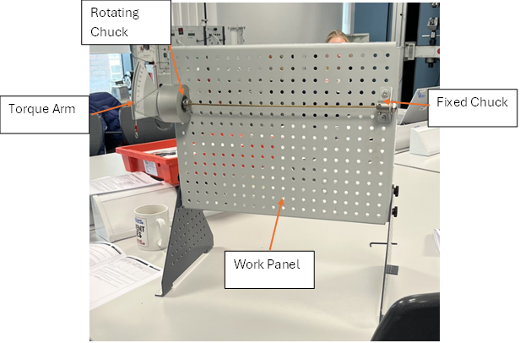
Figure 1 - Equipment set up
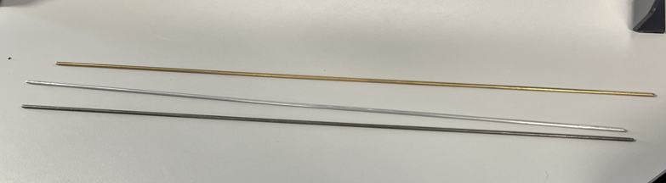
Figure 2 - Specimen Rods

2.2 Methodology
1) (TecQuipment Ltd, 2012), recommends reading through the guidance document fully, so that the aims and objectives are clear. After doing that the equipment should be set up as shown earlier in figure 1.
2) From here, the first specimen can be fitted as shown in figure 3 below, ensuring that the specimen has been pushed into the rotating chuck as far as possible before tightening the grubscrews on the fixed chuck.
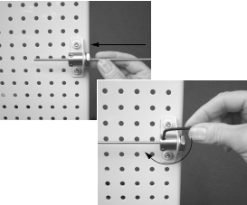
Figure 3 - Securing the rod specimen (TecQuipment Ltd, 2012)
3) The next step is to zero the rotating chuck. To do this, the grub screws must be loose so that when zeroing it doesn’t twist the rod at all when aligning the zero-degree mark against the mark on the cursor as shown in figure 4 (TecQuipment Ltd, 2012).
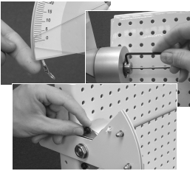
Figure 4 - Setting the Zero Marker (TecQuipment Ltd, 2012)
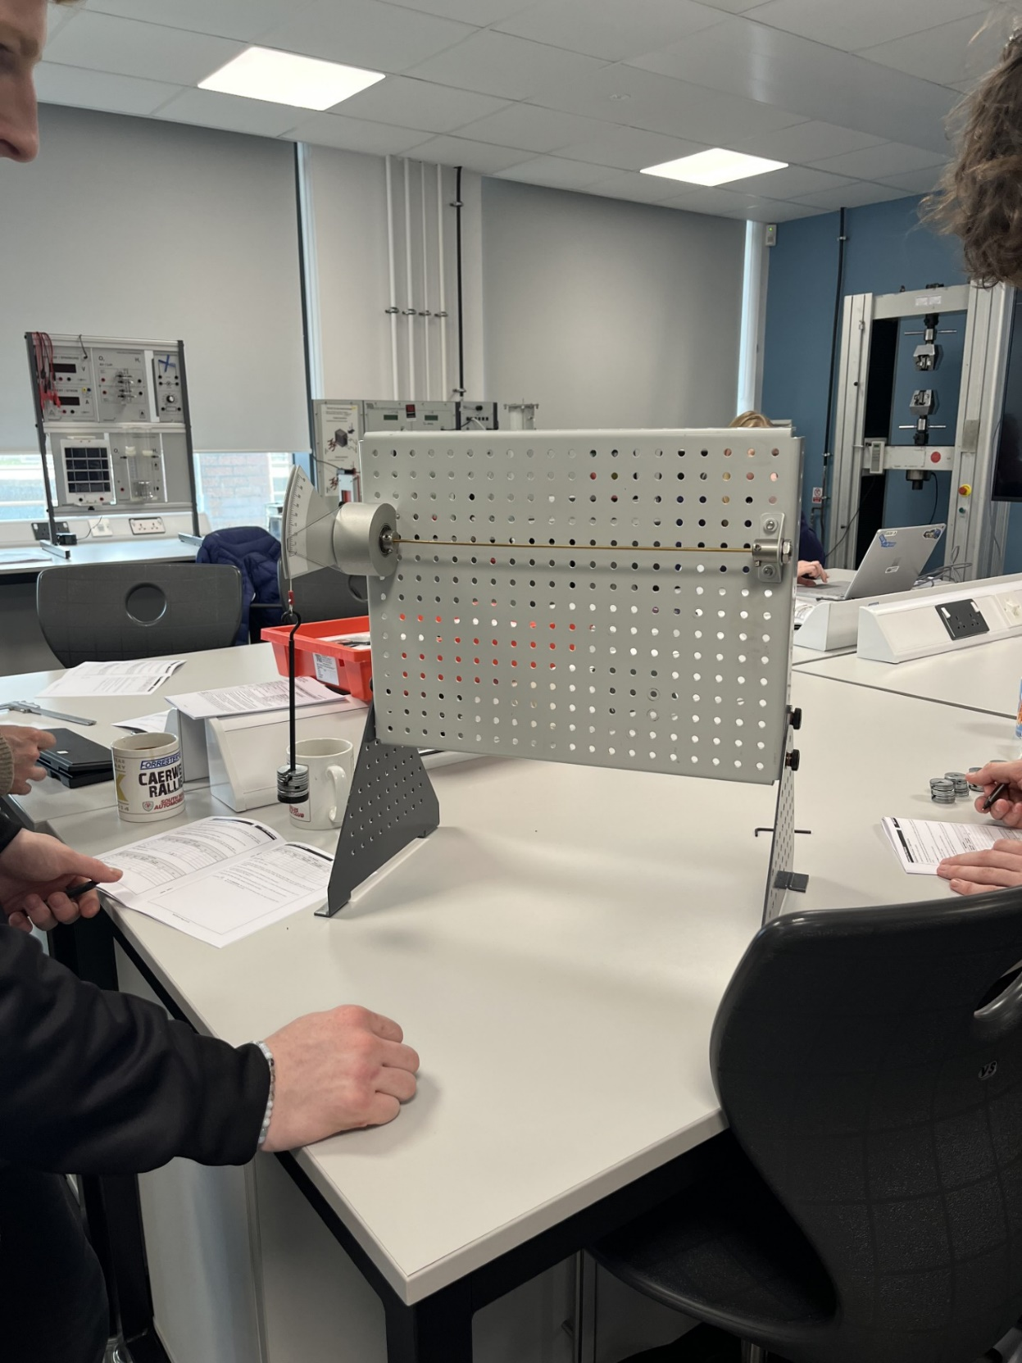
4) From here the grubscrews can be tightened and the first 100g can be applied, as shown in figure 5.
Figure 5 - 100g Mass Added
Weight Hanger

5) This can then be repeated going up in 100g increments until 500g is reached (This is not the case for the aluminium rod as any more than 400g will cause permanent deformation).
6) Once the final measurement has been taken for that rod, the mass can be removed before loosening the grubscrews before swapping over the rod.
7) From here steps 2 till 6 can be repeated until all three specimens have been tested.

Results
Table 1 Below, shows the change in twist angle in degrees, as measured during the experiment. With table 2 Showing the lengths and diameters of all the specimen rods measured in preparation for further analysis.
Table 1 - Twist Angle Data (degrees)
 | Twist Angle (Degrees)
Load (Kg) | Brass | Aluminium | Steel
0.1 | 6 | 8 | 2.5
0.2 | 11.5 | 15.5 | 5
0.3 | 17.5 | 23.5 | 7.5
0.4 | 23.5 | 31 | 10
0.5 | 29.5 | N/A | 12.5

Table 2 - Rod Measurements
 | Brass | Aluminium | Steel
Length (m) | 0.34 | 0.34 | 0.34
Diameter (m) | 0.0035 | 0.0032 | 0.0031

Analysis

4.1 Further Calculations
From these results further information could be calculated to allow for further analysis to take place. The first was to convert twist angle in degrees to radians, as shown in the equation below.
$$Twist Angle Radians \left(θ\right)= \frac{Twist Angle (degrees)×2π}{360}$$
The next step was to calculate the load applied in Newtons as shown below,
$$Load \left(N\right)=Mass \left(Kg\right)×Acceleration (m/s^{2})$$
In this case acceleration the acceleration value given was 9.81m/s as gravity was the acceleration acting upon it.
Next the torque value was calculated, with the torque arm length of 0.1m being supplied by (TecQuipment Ltd, 2012).
$$Torque \left(Nm\right)=Load \left(N\right)×Torque Arm Length (m)$$
This allowed for TL to be calculated,
$$TL=Torque \left(N\right)×Length (m)$$
After that the Polar Second Moment of Area (J) was calculated. This calculation is used to determine the resistance to torsion that shaft is at a cross-sectional area about the central point instead of its axis. It is important to note that a hollow shaft does not use the same equation.
$$J= \frac{π ×D^{4}}{32}$$
This allowed for the final calculation to be made and that was finding JΘ,
$$Jθ=J ×Twist Angle Radians (θ)$$
The results for all these calculations can be found in tables 3,4 and 5 below.
Table 3 - Brass Results
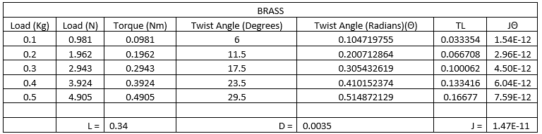

Table 4 - Aluminium Results
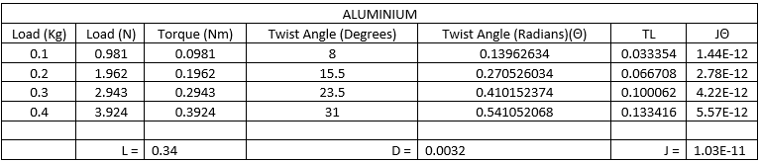

Table 5 - Steel Results
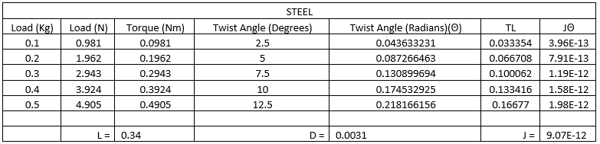

4.2 Modulus of Rigidity (G value)
The equation for torsion is,
$$\frac{T}{J}=\frac{Gθ}{L}$$
So to calculate G it would need to be rearranged to,
$$G= \frac{TL}{Jθ}$$
These results were then plotted on a graph so that the gradient of the trendline would be the calculated G value based off the experiments results. (TecQuipment Ltd, 2012) mentions that whilst metal alloys can come with a variety of different strengths, they each have a small band of tolerance making the modulus of rigidity quite constant. Due to this the textbook G values of the specimen rods was provided (table 6).
Table 6 - Textbook Values (TecQuipment Ltd, 2012)
Material | Value (GPa)
Aluminium | 25.5
Brass | 38
Mild Steel | 79.6

According to the values provided by (TecQuipment Ltd, 2012), brass usually has an approximate shear modulus of 38GPa, whilst (The Engineering Toolbox, 2005) places the value at 40 GPa. These values fit within the general range of 35-42 found across multiple sources. The result from the experiment (figure 6) however was 21.98 GPa, when taken from the gradient. This puts the result as being 42.2% out from the expected result, which suggests that something went wrong during the experiment and that a retest is required. This big of a difference is odd however as the graph shows a near linear correlation with little variance in the results, meaning that it isn’t due to an inaccurate reading of the data as there are no outliers.

Figure 6 - Brass Results Graph
For aluminium, (TecQuipment Ltd, 2012) suggests a value of 25.5 GPa whilst (The Engineering Toolbox, 2005) suggests 27 GPa for an aluminium alloy, with a suggested range of 25-28. Figure 7 shows again a near linear trend with minimal variance from the trendline and no obvious outliers. The G value form this graph is 24.1 GPa and is 5.49% out, meaning it can be taken as a fairly accurate result as it is within 10% of the given value. This is surprising as the specimen rod had been damaged before the experiment.

Figure 7 - Aluminium Results Graph

Figure 8 again shows a linear correlation with no variance from the trendline. The gradient provides a G value of 84.31 GPa. Research suggests that steel sits within a range of 79-80 which is a much smaller range than seen for the other two materials. With (TecQuipment Ltd, 2012) suggesting a value of 79.6 GPa and (The Engineering Toolbox, 2005) suggesting 79.3 GPa for structural steel. This puts the calculated value 5.91% out, meaning that the results for steel can be seen as reliable due to them falling within 10% of the suggested values.

Figure 8 - Steel Results Graph

Conclusion
Overall, this report has explained and analysed an experiment into how torsion values vary depending on the properties of three different materials. The experiment produced three graphs that all showed a near linear trend with little to no deviance in the results, showing that the experiment was completed correctly, with all results being taken accurately from the readings shown.
Two of the three G values can be classed as valid due to them being withing 10% of the expected values presented by (TecQuipment Ltd, 2012). These being steel at 5.91% and aluminium being 5.49% out. However, the brass cannot be validated as it was 42.2% out from the supplied value. Suggesting that the test should be re-run to check if these were accurate results, if there had been a mistake made during set up or if the brass slipped out from the grubscrews during the process and wasn’t noticed by the team.

Evaluation

6.1 Strengths
To prevent inconsistency with setup, the same person zeroed the rotating chuck keeping the marker at eye level to maintain a consistent starting point. Whilst the team checked the change in degrees from the same place individually before using the majorities answer.
As well as that the team nominated two members to check that the rods were in and secure to help eliminate the likelihood of any slippage in the grubscrews.
Before starting, the team set out all the masses into correctly weighted piles so that when the mass was added it would be the correct amount.

6.2 Areas to Improve
Next time, the team could use a different aluminium rod as a previous group had caused a slight bend in the material having taken it beyond the elastic deformation range by going up to 500g.
The guidance suggested checking the chuck was zeroed before each new weight was added to check for slip in the rod. The team did not do this and as a result the steel rod slipped out during one of the measurements.
Once the rod slipped, the team retightened it and continued from there. Next time a better approach would be to remove the weight, zero the chuck and repeat the test again from the start for that material.
All these improvements would have given more accurate results, giving a more insightful analysis.

Further Work
To further improve the experiment, a wider variety of specimen rods could be used, differing in lengths and diameters, to give a more rounded view on how different torques effect rods of differing properties and how one small change can affect the results.
A lubrication of some sort could be used to help remove some of the excess friction from the experiment and could be further analysed to see the effects that has on results.
The chucks could be snugger to the diameter of the rods to lessen the impact that the grubscrews have on the experiment as it has shown to be unreliable once slightly damaged.

References
EngineerExcel. (2026, 01 01). Understanding Torsion: A Comprehensive Guide to Twisting Forces. Retrieved from EngineerExcel: https://engineerexcel.com/torsion/
TecQuipment Ltd. (2012, 01 01). Torsion Kit ES5. Retrieved from Engineering Science Guidance Notes TecQuipment Ltd: https://www.tecquipment.com/
The Engineering Toolbox. (2005, 01 04). Modulus of Rigidity. Retrieved from The Engineering Tool Box: https://www.engineeringtoolbox.com/modulus-rigidity-d_946.html

