Student Name: Jay Johnson – Student ID: 1920319

Module code: (BMSW6104_BIRM)

Strategic Management for SMEs

Lecturer's name: Dr Sampath Liyanage

Contents
Introduction 3
Establishing strategic direction considering Goals, Mission and Objectives for Delicious 4
External Analysis utilising PESTLE & Scenario based analysis. 6
SWOT analysis 9
Utilising Value Chain Analysis alongside SWOT analysis 10
Understanding competition using Michael Porters 5 Forces framework 12
Stakeholder mapping techniques implementing strategy formulation. 13
Reviewing strategic growth options for delicious restaurant 15
Strategy selection and justification for delicious restaurant 17
Implementation of strategy and monitoring of organisational objectives 19
Recommendations 20
Conclusion 21
References 22

Introduction

For this report a specialist has been hired to design a strategic plan and strategy for Delicious food restaurant to expand the business throughout the UK. The report will cover various models and theory that will support what analysis and research should be carried out before any strategy is implemented. Strengths and weaknesses of the business will be fundamental to the decision-making process based on risk analysis, competitive advantage, and continued sustainability. The report will show the advantages of using analysis tools and models and why SME’s and conglomerates should consider these tools as successful applications before making any strategic decisions, organisational change, or large investments. These analysis tools will be used to focus attention on key aspects of the business such as strengths, weaknesses, further opportunities and potential threats or uncertainty. The report will demonstrate that new initiatives, vision, and strategic planning can be achieved by innovation and competitive advantage. According to (M. Harker, R. Brennan, P. Kotler, and G. Armstrong, 2009), by establishing the emergence of competitiveness and effective ideas, this will draw strong focus to new creativity.

.

Establishing strategic direction considering Goals, Mission and Objectives for Delicious

For this report, A business specialist has been hired to formulate a strategic plan to expand this delicious food business throughout the UK. The business has had success as a respected food establishment with positive feedback through customers. The owner has over 20 years’ experience within the food industry but very little experience with other business areas. This section of the report will consider varying elements that take on board environmental factors and their impacts on the economy and the business that are either good or bad. The report will also look at the best possible choices when considering the expansion of the business throughout the UK with as little negative impact to the company, shareholders, stakeholders, and the economy at large and the ability to gain a competitive advantage with strong sustainability. Based on Mr James’s request to expand his business within the food industry over a 2-year span, with the vision of supplying customers with unique foods across the UK, one must consider his current position now and the strength of that position in the market. Other key areas will need to be reviewed such as strategic planning and strategic management. Internal and external analysis is also key to environmental understanding and reviewing the appropriate action that will consider cost, time, impact, and possible threats. Opportunities could also be a possibility for the business. Below is an example of a strategic management framework where all components will need to be fully explored to gather a good understanding of the environmental factors, risk, competitive advantage, opportunities and mission and outcome.

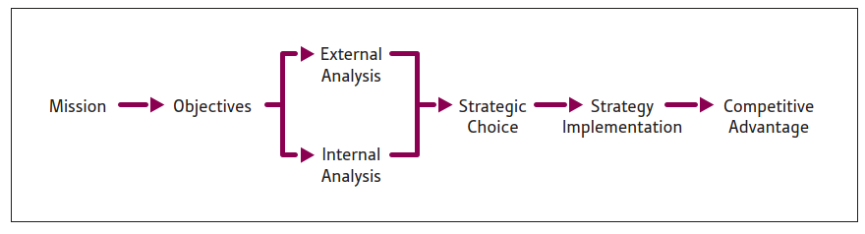
According to (Cole, 2003), Strategic management is the setting the purpose and objectives of the organisation and having the knowledge to choose the appropriate goals, working to meet the aims and achieve both the purpose and objective over a set period of time.

Utilising the strategic management framework above, one would need to consider what the mission and mission statement will be. Mr James had confirmed that his mission is to expand his business throughout the UK, however there was no mention of a mission statement to outlay the organisational purpose. A recommendation to Mr James is to put together a mission statement to demonstrate to stakeholders, shareholders, and investors the purpose of the company in a quick and easy way that will provide a general idea of what the organisation stands for. Strategic management is a planning and direction focused framework of any organisation on a long-term basis. Due to Mr James’s request for business expansion over 2 years, this will fall under the strategic management process. Within the strategic management process there will need to be a strategy. Strategy is based around competitive advantage and reviews key fundamentals such as how to achieve the mission and planning over a long term, analysing competitive advantage, and reassessing managing and allocation processes. To gain a competitive advantage, Mr James will need to deliver a product or service that holds an edge over competitors with more added value to customers and the organisation to be sustainable and with increased revenues. The mission will need to highlight the purpose and the values with all objectives being very specific and measurable to enable the desired target to be met. According to (Davenport et al., 2010), (Fleisher and Bensoussan, 2007), (Jarzabkowski and Spee, 2009), and (Rigby and Bilodeau, 2011), Many key decision-makers are utilising strategic management tools and techniques to mitigate uncertain times when conducting business and competitive analysis. They go on to say that the key reason for strategic tools is to allow key decision makers to make sound decisions that directly lead to better products and services with better processes to boost organisational performance. Below is the mission and the objectives outlay.

Mission: Expand the Delicious restaurant across the UK.
Objective:
- Drew up strategic management and strategy process for organisational expansion.
- Conduct internal and external environmental checks.
- Review strategy choices and planning to go ahead based upon Micro and Macro environments.
- Consider the best route for strategic implementation that mitigates uncertain impacts.
- Proceed with a clear strategy whilst strongly moving toward sustainability.

External Analysis utilising PESTLE & Scenario based analysis.

Based on the above information it is highly recommended to conduct an internal and external environmental check to mitigate risk and impact to the organisation, shareholders, and stakeholders. This would consist of revenues, employees, law, technologies, establishments, politics etc. Having a good understanding of the current economy and possible changes or uncertainties will help map the best route for organisational change or expansion. Due to strategic change, consideration is required when making high profile decisions where major investment or changes are to be made. There are tools available to assess micro and macro environments. According to (Martin, R. 2007), Due to increasing and complex uncertain environments, decision makers are expected to recognise and embrace a more complex understanding of this emerging world, with access to techniques and tools to make the best decisions possible. For this report a PESTLE – Political, Economic, Social, Technological, Legal, Environmental, analysis will be carried out to scan the external environment for any threats or opportunities. This will provide a view of the current position of the external environment and what is happening in current times, but also what has already happened, for example the Covid-19 pandemic, what might happen, and what opportunities present themselves to take advantage of. This pestle in figure 1 was conducted on the delicious restaurant.

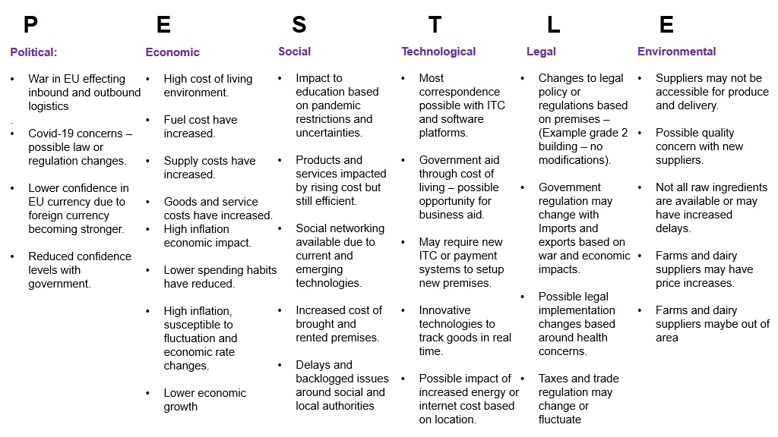
Pestle has given key areas to consider to help formulate a strategy but also highlighted areas of possible investment. Pestle has outlined concerns with political agendas and regulation and tax changes that can impact the new venture. There are also concerns regarding supply of raw produce and delivery locations due to new costings and unfamiliarity of locations. Pestle has given possible opportunity for new food delivery options to streamline the business into a more convenient fast-food establishment based on new vegan and fresh food establishments displaying a positive increase over the last 5 years with more access to delivery services such as, just eat, Deliveroo etc. This opportunity would give Mr James a choice to invest in a small establishment to prepare food for delivery only via software applications such as the above, minimising spending on larger establishments with many employees, and dining facilities, and taking advantage of the easy-to-use mobile technologies and delivery services. This choice would split the business into two segments, one for dinning and the other for delivery, similar to a Chinese takeout. (Martin, 2007) states that strategic tools are helpful in providing many perspectives for the organisation and competitive analysis. The advantages of using PESTLE, is easy functionality and an understandable purpose of the analysis broken down into columns that provide many aspects of the macro environment and will aid in correct decision making. Now pestle has been reviewed, there is another tool that will help in providing options of strategic planning for future events and possible uncertainties. Scenario analysis considers key aspects of the business to help with planning for future opportunities or uncertain events providing greater depth into the decision making process.

Scenario analysis
Data gathering.
- Delicious business is doing well and sustainable in current position.
- There is surplus capital for 2 years for business expansion plan.
- No data on ideal locations for new establishment
- Require data on competition within chosen area.
- Require data on restaurant sales within chosen area.
- Confirm suppliers can commit to Mr James’s desired deliveries and order for business success and sustainability.
Consider all historic business experience.
- Positive sales and good customer feedback regarding products and service. Loyal supply line with no issues or concerns.
Certainties:
- Delicious holds the capital with an option for expansion.
- Over 20 years’ experience within the food industry.
- Unique foods with positive customer feedback
- Excellent suppler in local area
Uncertainties:
- Do not hold data on competitors.
- No data on pricing, suppliers, locations, rents, taxes and produce.
- No data on sales of SME within the same industry based in chosen location.
Best case scenario:
- Successful transition to new location with heavy footfall and dinning locations.
- Excellent customer interest in Unique foods on offer.
- Increased revenues and customer awareness.
- Strong competitive advantage due to strong imitable products.
- Excellent supply lines and pricing.
- Strong security in place.
Base case scenario:
- Successful transition to location with unpredictable footfall or customer interest.
- Other competitors offer the same or similar products at the same price mark.
- Steady business with no increase in sales but enough to maintain premises.
- Produce price increase due to new location.
- Supplier prices increase due to new location.
- Minimal security in place
Worst case scenario:
- Poor transition and setup of premises.
- No customer awareness of new food establishment nor interest.
- Outmatched by competitors either by quality, price, or uniqueness.
- Rented property increases impacting sustainability of restaurant.
- Very poor security in this location.
As (Whittington 2004), has highlighted that a more depth in the understanding of how new strategic tools have been developed, been tested and marketed and how these tools are to be utilised in practice.

SWOT analysis

This next part of the report is based around an internal environmental check. SWOT is mainly used to review internal and external strengths, weaknesses, opportunities, and threats. SWOT will be used to analyse core factors of delicious dinning business that include strategy, formulation, and evaluation and help with the decision-making process. SWOT will give MR James a visual reference of how the business is doing and help build on the strengths of the business, mitigate, or minimise any weaknesses, highlight potential opportunities and show existing or impending threats. According to (Al‐Mubaraki and M. Busler, 2010), SWOT analysis is used to examine the internal and external aspects of an organisation’s strengths, weaknesses, opportunities, and dangers. (H. M. Al-Mubaraki, A. H. Muhammad, and M. Busler 2015), states that to overcome any perceived weaknesses, it is highly recommended to take advantage of external opportunities. Below is the SWOT analysis carried out on delicious restaurant that provides solid internal analysis that will aid Mr James to come to a decision on what type of strategy will be used and how the business could move forward with strategy implementation.

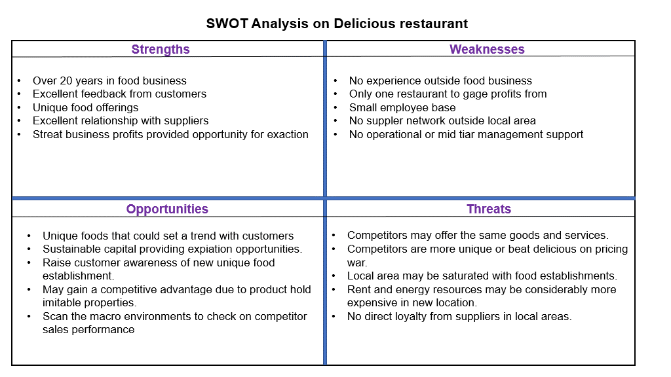
According to (Grant, 2003, Orndoff, 2002, Gray, 2007, Jarzabkowsji, 2004 and (Wilson and Jarzabkowski, 2004), Strategic tools are described as psychological tools of thinking that aid the strategist to generate meaning within their own complex surroundings.

Utilising Value Chain Analysis alongside SWOT analysis

The advantage of using SWOT is to provide a clear view of internal and external factors that help with decision making and risk to reward decisions. To find the value of the delicious establishment products and services, Michael Porters Value chain analysis can be used to measure the value of a product or service with secondary functions supporting the primary functions. An example would be an IT sales agents utilising ITC systems as a primary function, and IT engineers that fix software and hardware as a secondary function. The secondary functions are in place to support and enhance primary functions. If Delicious offers quality foods at a competitive price without large competition based on food differentiation as one of the primary functions, and the supplier of delicious offers excellent rates to Mr James, this will generate value within the business.

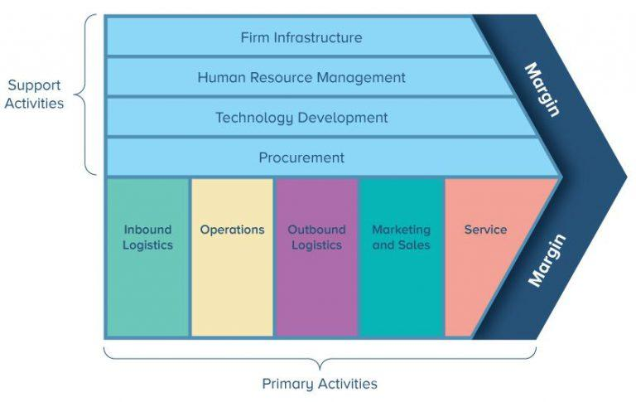
Mr James has confirmed that feed back from customers have been very good with his unique foods having been received very well by customers. In this case Mr James will need to consider if this new premises will require more employees, accountants, HR/HRM, engineers, cooks etc, and if that being the case, then capital will need to be considered for hiring staff as well as new premises with increased rental prices and taxes that were highlighted when conducting PESTLE based around economic and political issues. Mr James may need to also consider possible larger facilities that can accommodate cooks, dining facilities and employees of different skill sets such as chiefs, waiters, offices workers to fulfil primary and secondary duties. (Golsorkhi et al, 2010). states that strategical tools offer a practical way to address problems from a variety of perspectives with a constructivist shift regarding strategy practice research.

There are two strategies that can been considered.
- Low-cost provider = Delicious can focus on cost saving and looking at strategies of how to reduce cost but also create value and competitive advantage.

- Specialization / differentiation = This strategy will be focused on creating new unique products or offering a differentiation within the service delicious offers that will create value and potentially provide higher charging premium to customers.

Based on the initial investigation pre-strategizing. Recommendations would be given to Mr James to mainly focus on the Low-cost strategy due to potentially increased capital costs that will be required for new premises, staff, suppliers, raw materials, taxes, rents and energy payments. The advantage of taking this strategy is a focused approach to cost saving and keeping a close eye on capital spending thus keeping a track on what and how much funds are used. The second main advantage is the foods that are on offer have received positive feedback based on the uniqueness that could create value for customers that do not have a food establishment like delicious within their local area. If that is the case, then by default delicious food will demonstrate differentiation and provide a competitive edge without the need to invest high level capital spending. However, a recommendation to Mr James, would be, to keep a competitive edge in the market the business must maintain a unique main menu and keep creating exciting new dishes to stay ahead of competitors due to competitors imitating the model of delicious restaurant. According to (Clark, 1997), (Jarratt and Stiles, 2010), strategic tools are important in providing the user with power to consider a variety of different perspectives.

Understanding competition using Michael Porters 5 Forces framework

For Mr James to expand his business, he will need to know what the competition will be and how the industry works on a larger or international level. Michael Porters five force provide insight into competitor methods, and how these methods can affect organisations to serve their customers and generate profits. The framework is based on 5 core concepts starting with competitive rivalry. Surrounding that core concept is, Threat of new entrants, Threat of substitute products, Bargaining power of suppliers and bargaining power of customers. Below is an image of Porters 5 forces.

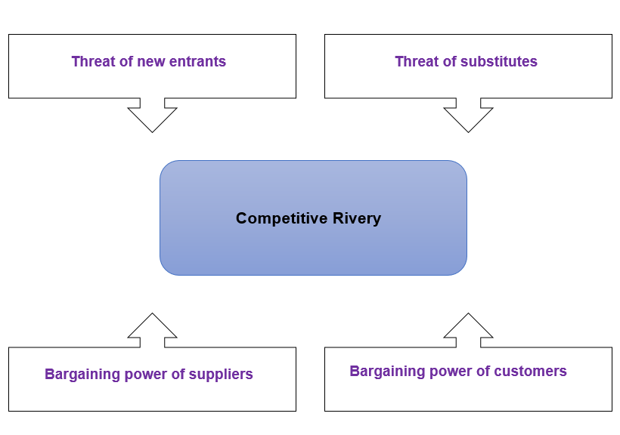
Mr James will need to establish threats to his new venture as a new entry. Though Mr James has knowledge of 20 years within the food industry, he has not tried to compete on a larger scale, and depending on the location of Delicious, his business may need to contend with well-known and prestigious food establishments. Based on the five forces framework, Mr James will need to secure a location that does not offer the same food products. He will also need to make sure his supply line is strong with good bargaining power to keep cost down. Mr James will need to review competitors and their prices and products to establish if there is a viable and profitable market for the delicious restaurant. Mr James will also need to consider if his products and services will be required by customers. Considering PESTEL, SWOT, Scenario analysis and porters 5 forces, this will provide a clear vision and scope of the risks, cost, commitments, and knowledge for delicious expanding. According to (Man et al, 2002), The pursuit of excellence is a concept of competitiveness to keep improving the quality and services and increase profit margins.

Stakeholder mapping techniques implementing strategy formulation.

Mr James will work with different people throughout the time of owning and running a restaurant, however there are important people that have direct power or influence in the day to day running of the organisation. With Mr James request to expand the business, he may need to source new suppliers, staff, and professionals for various works to be carried out. It is vital for Mr James to know all key stakeholders using effective communication. for example, what stakeholder is to be informed and when they need informing. Who needs a prompt to action but holds no strategic influence that affects the business. Strategy is to gain a competitive edge in the market and all stakeholders with or without power or influence must work together effectively and sustainability to success. The Mendelow Matrix is a tool that can be used to map out stakeholders’ power and influence within the organisation. Below the Mendelow Matrix has been utilised for the delicious business placing all high tire and low tire stakeholders in the positions or power and influence. According to (Shleifer and Vishny 1997), Stakeholder theory can be considered as a monist theory of corporate governance which in turn is a contractual relationship with the directing staff and shareholders. The below diagram will show what the Mendelow Matrix is and how it is broken down into segments. The image next to the Mendelow Matrix is a simpler form to understand the model but covers the exact same principles.
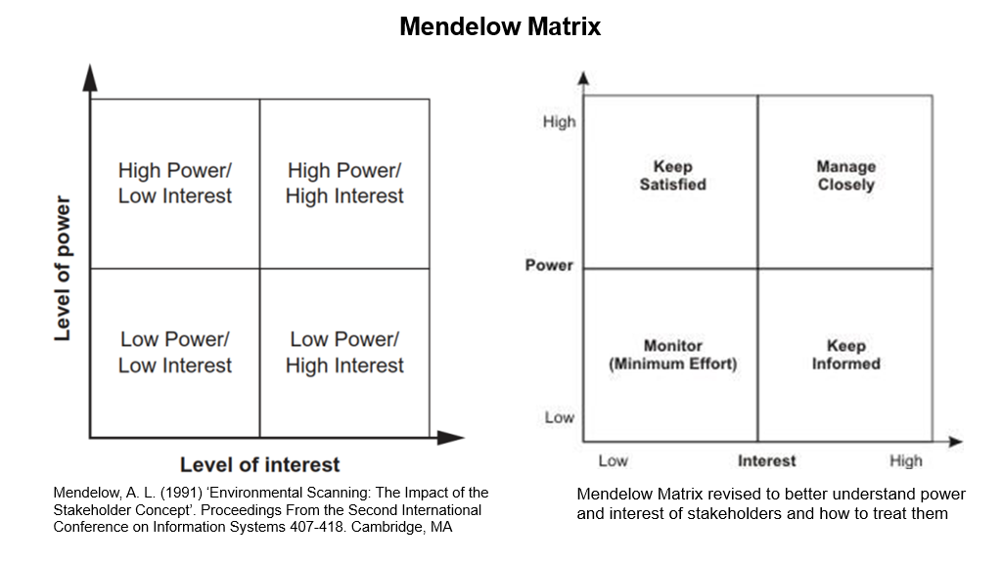
According to (Charreaux and Wirtz, 2006), Partnership value measurement is established through the generated rent of the said organisation in relation to various stakeholders.
By using the Mendelow matrix above, Mr. James can measure the individual importance of all stakeholders in the business, giving him a guided vision of his business relationships and how they are to be managed. Mr. James may not have many stakeholders at present but may develop many more relationships moving forward. Mr. James will need to establish clear communication with stakeholders and inform and monitor the rest. Strong stakeholder management is a key concept for the arranging of strategic formulation, as stakeholders hold both power and influence in a business and can impact business performance if not managed closely. Below is an example of using the mendelow matrix placing stakeholder importance and action within each section.

Basic mendelow matrix setup for delicious restaurant
Suppliers: High power, high interest - due to supply chain and impact on company
Chiefs: High power, High interest – due to food preparation and customer satisfaction
Serving staff: Low power, high interest – due to required work force, no organisational direction required.
Cleaners: Low power, low interest – due to no required organisational direction and possible low retention rate.
Acountant: Low power, high interest – due to no organisational direction but dealing with sensitive business documents and confidential data.
Based on the above information utilizing the mendelow matrix, all stakeholders are to be managed as displayed below.

- Suppliers are to be managed closely and informed of any changes that impact supply lines.
- Chiefs are to be managed closely and informed of changes with menu and produce.
- Serving staff are to be kept informed regarding most changes within the business.
- Cleaners are to be monitored and advised on a need-to-know basis.
- Accounts are to be kept informed of new changes that affect capital, pricing, and revenues.

Reviewing strategic growth options for delicious restaurant

As Mr. James will hold a broader knowledge of stakeholders, objectives, goals, internal and external analysis, Mr. James will need to define a sound strategy that considers market growth products or service and what will be best for his business venture. Mr. James has provided clear instructions to his vision within an allotted timeline. Market growth will be key to what strategy Mr. James should follow and how much risk the business venture should consider. There are tools and models in place that will help Mr. James to take the best strategic direction and generate profits. According to (Madsen and Walker, 2017), Strategy is a fundamental objective of organisations to maintain sustained revenues above other competitors. To Help with strategic decision making, the Ansoff matrix can be used that will help with strategy direction relating to market growth and suitable for new ventures. Below is example of the Ansoff matrix:

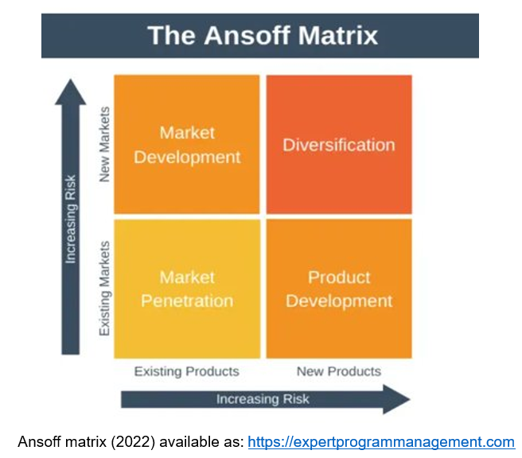
This matrix is based on four segments that are measured by new and existing products and low risk to high-risk direction. Though this model is not the enhanced version of the Ansoff matrix, this model is appropriate for a new or existing SME for strategic decision-making. For Mr. James to decide on the best option that will meet the scope and budget, he will need to consider what market to focus on. According to (Mahoney and Pandian, 1992). A good research strategy reveals resource properties that in turn can isolate organisations from competitive pressures with strategies pursuing to erect the isolated properties that increase their business profits.
To generate increased profits Mr. James needs to decide on what market to target. There are four strategies in the matrix that can be considered. Based on Mr. James’s desire to expand the company, the advice would be to consider cost-saving options due to not having built up a network of various suppliers in different locations. Human capital is also a key aspect for a smooth and sustainable running business.

Market penetration displays low risk, however, delicious offers unique foods that may or may not be welcomed in the chosen location, with that said, delicious is doing well in the current location with good reviews on products and services.

Market Development highlights an increased risk due to time commitments, cost, R&D, law, employees etc, and may not be the type of expansion for Mr James at this time. If Mr James can package his goods with enough customer interest throughout Europe and the international world, then this maybe be a viable option.

Product Development may be an excellent opportunity for Mr James as his focus will be on the existing food markets in a popular location with his competitors not offering the unique foods of delicious restaurant. This would give Mr James a competitive advantage in that market and provide a greater market share.

Diversification may be an option once the delicious venture has gained good traction and generated expected revenues. This will provide Mr James options to produce new food products or begin a new business venture.

Market penetration and product development are the best choices that meet Mr. James’s expansion requirements. If Mr James can promote his unique foods to customers and find an excellent location to set up, customer awareness and popularity will increase. Delicious will need to maintain and provide the same excellent quality foods and uniqueness that not only differentiates his foods from competitors but should also generate increased profits.

Strategy selection and justification for delicious restaurant

Before making the final strategic decision, Mr James will need to confirm that all aspects in the scope are in place and what to expect as the project is moving forward. Good analysis was carried out to establish risk and impact to this new venture and what type of competition or barriers may emerge. Mr James is now able to select a sound strategy. At this point in the process Mr James should be clear in mind to what market he would like to penetrate and how he intends to do this with knowledge of risk, cost, time, and outcomes. Mr James will already have processes in place for his existing restaurant for day-to-day business operation. In this case a strong strategy will need to be implemented based on expanding the organisation and making the processes, premises, and quality reflect one another. For example, McDonalds restaurants are located all over the world but do not differ in the restaurant appearance, food quality and general setup and processes. Mr James will need to arrange and manage his operations concisely so that each of his restaurants follow set protocols that do not deviate from these organisational requirements. Each delicious restaurant must reflect all other delicious restaurants in general layout, food menus, food quality and operational setting. To enable organisational change and change management, A recommendation to Mr James is to consider the Lewins change model that focuses on three core aspects of the business. By agreeing to use this model, Mr James will have a sound strategy in place that should be easy enough to work with and implement the process of change within the organisation. According to (Porras & Robertson, 1992), The Lewin’s change model is initiated in three set by step phases that consist of unfreezing, changing, and refreezing processes with employees being involved and instructed by management teams within that change process. At this time Mr James only holds one business premises and may not require any big changes, however due to business expansion, Mr James will need clear strategy in place for a sustainable business operation across all his restaurants. The Lewin’s change model was selected as Mr James will not have numerous overheads to manage, and as this is his first business expansion, by default the change process should be an easier process. Going forward, if Mr James held multiple restaurants, he may need to consider hiring managing staff to help liaise and update his work force keeping them involved in the change process and supporting their needs. Mr James will have the freedom to implement change due to low employee numbers and commitments. (Moran and Brightman, 2001), state that change management is a process of continued reviewing of the organisational structure, direction and capabilities that serve the changing needs of internal and external customers.
Below is the Lewin’s change model and the process of change that Mr James will need to adhere to for successful change management.

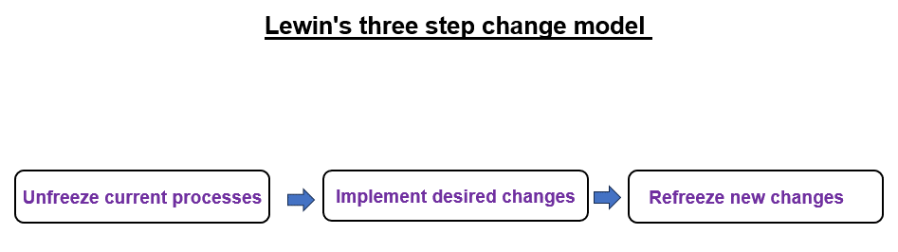
The first stage, unfreezing will require excellent communication and involvement of all employees within the organisation based on people holing a reluctance to changes, habits and belief systems. Key points to consider when moving through the Unfreezing stage are,
- All employees are aware of the changes being made within the organisation.
- All employees embrace the new changes.
- All employees are willing to accept change and leave their comfort zone if required.
- All employees stay motivated and accept new ways of working for better output.

The second stage consisting of the change will require excellent communication with all employees and careful planning as any changes can take various amounts of time and employees may become uncomfortable. Many changes involve new methods of workings and learning new skills, however in Mr James’s case the changes will be based more round new locations, dealing with new suppliers, and working with new employment staff.

Refreezing is the establishing of new changes within the organisation that keep the business stable and motivated with all employees accepting the new ways of working in a positive manner and maintaining a sustainable operation, and based on Mr James’s expansion request, the Lewins change model is best suited for that venture due to an easy-to-understand change management model. Low staff numbers, Focused goals and desires for new implementation with lower capital spending. Morgan and Zeffane (2003), state that within the change process, a leaders’ transparency will enhance trust with employee’s involvement within the organisation change process granting them a sense of control.

Implementation of strategy and monitoring of organisational objectives

Based on all research conducted that covers risk, cost, impacts, internal and external analysis, change management and strategy, Mr James is now ready to implement his strategic plan. To understand if delicious is on target and meeting organisational objectives a balanced score card can be used to measure these segments. A balanced score card is a strategic planning and management system that is used to align business activities toward the strategy and vision of the business. This tool helps with all forms of internal and external communication but also aids in the monitoring of performance level within the organisation and strategic goals. According to (Kaplan and Norton, 1996), A Balance score card is focused on the balancing of non-financial and financial aspects along with long-term and short-term goals with qualitive and quantifiable success measure being reviewed. By Mr James using this strategy management tool, he will be able to monitor all key aspects of his new business venture and provide improved methods for further sustainability and profit generation whist understanding where the business is in terms of performance but also how employees are feeling and what support, training or discipline may need to be provided. The BSC is focus on key fundamentals displayed below.

Financial: Organisational health of the business
Customers: Products and services are compared to other competitors with a focus on customer needs
Internal processes: Reviews the effective nature of internal business processes.
Learning and growth of people: A focus on organisational growth and people development.
Mr James has covered all the necessary measures to consider going ahead with the business expansion plan. It will be vital for Mr James to utilise to models and tools he has to measure, monitor and implement practices and policies to stay sustainable and profitable in this new venture. According to (Brignall 2002; La¨nsiluoto and Ja¨rvenpa¨a¨ 2010), Balance score cards are mainly used to meet the societal expectations and achieve legitimacy.

Recommendations

Looking over the request of Mr James to expand his business. All internal and external checks have been carried out using valid and proven techniques. The recommendation for Mr James will be for him to very much consider if he is desiring to open a like for like business such as the one, he has now or if he wants to advance and change the model. To keep capital spending down, it is recommended that My James follow a similar business model he already understands while improving his products and service and keeping a close eye on external environmental changes and competitors.

Conclusion

Mr James has a successful business with good feed back regarding his products and services. Utilising the various tools and models that have been explored throughout this paper. I would be confident to advise Mr James to go ahead with the business expansion due to positive feedback, Unique produce, and a motivated need to extend the organisation. This is a prime time for Mr James to review expansion as he holds good capital, a strong customer base and carried out all relevant formal checks displaying good strategic decision-making skills.

References

Al-Mubaraki, H. M. and Busler, M. (2010) “Business incubators models of the USA and UK: a SWOT analysis,” Management and Sustainable Development, (2), pp. 78–91.

Al-Mubaraki, H. M., Muhammad, A. H. and Busler, M. (2015) “Categories of incubator success: a case study of three New York incubator programmes,” Technology and Sustainable Development, (4), pp. 335–354.

Arratt, D. and Stiles, D. (2010) “‘How are methodologies and tools framing managers’ strategizing practice in competitive strategy development?,” British Journal of Management, 21, pp. 28–43.

Brignall, S. (2002) PMA conference proceedings-performance measurement and management 2002: Research and action: cranfield school of management. Edited by A. Neely, A. Walters, and R. Austin. Boston, MA: Performance Management Association.

Charreaux, G. and Wirtz, P. (2006) “Gouvernance des entreprises, Nouvelles Perspectives, ” Economica,” Economica.

Chesley, J. A. and Wenger, M. S. (1999) “Transforming an organization: using models to foster a strategic conversation,” California Management Review, 41, pp. 54–73.

Clark, D. N. (1997) “Strategic management tool usage: a comparative study,” Strategic Change, 6, pp. 417–427.

Cole, G. (2003) Strategic Management. 2nd ed. Andover, England: Cengage Learning EMEA.

Davenport, T. and Harris, J. (2010) Analytics at work: Smarter decisions, better results. Harvard Business School Press.

Fleisher, C. S. and Bensoussan, B. E. (2007) Business and Competitive Analysis: Effective Application of New and Classic Methods. Upper Saddle River, NJ: FT Press.

Golsorkhi, D. (2010) “‘Introduction: What is strategy as practice?,” in Golsorkhi, D. (ed.) Cambridge Handbook of Strategy as Practice. Cambridge: Cambridge University Press, pp. 1–20.

Grant, R. M. (2003) “Strategic planning in a turbulent environment: evidence from the oil majors,” Strategic Management Journal, 24, pp. 491–518.

Gray, D. E. (2007) “‘Facilitating management learning: developing critical reflection through reflective tools,” Management Learning, 38, pp. 495–517.

Harker, M. and Brennan, R. (2019) Marketing: An Introduction eBook PDF. 4th ed. London, England: Pearson Education.

Jarzabkowski, P. (2004) “‘Strategy as practice: recursive, adaptive and practices-in-use,” Organization Studies, 25, pp. 529–560.

Jarzabkowski, P. and Spee, A. P. (2009) “‘Strategy-as-practice: a review and future directions for the field,” International Journal of Management Review, 11, pp. 69–95.

Kaplan, R. S. and Norton, D. P. (1996) The balanced scorecard: Translating strategy into action. Boston, MA: Harvard Business School Press.

Lansiluoto, A. and Jarvenpaa, M. (2010) “Greening the balanced scorecard,” Business Horizons, 53(4), pp. 385–395.

Madsen, T. L. and Walker, G. (2017) “Competitive heterogeneity, cohorts, and persistent advantage,” Strategic Management Journal, 38(2), pp. 184–202.

Mahoney, J. T. and Pandian, J. R. (1992) “The resource-based view within the conversation of strategic management,” Strategic Management Journal, 13(5), pp. 363–380.

Man, T. W. Y., Lau, T. and Chan, K. F. (2002) “The competitiveness of small and medium enterprises: A conceptualization with focus on entrepreneurial competencies,” Journal of Business Venturing, 17, pp. 123–142.

Martin, R. (2007) “‘How successful leaders think,” Harvard Business Review, 85, pp. 60–67.

Martin, R. L. (2007) The Opposable Mind: How Successful Leaders Win Through Integrative Thinking. Boston, MA: Harvard Business School Press.

Mendelow, A. L. (1991) “Environmental Scanning: The Impact of the Stakeholder Concept,” in Proceedings From the Second International Conference on Information Systems 407-418. Cambridge, MA.

Moran, J. W. and Brightman, B. K. (2001) “Leading organizational change,” Career Development International, 6(2), pp. 111–118.

Morgan, D. E. and Zeffane, R. (2003) “Employee involvement, organizational change and trust in management,” International Journal of Human Resource Management, 14(1), pp. 55–75.

Orndoff, K. (2002) “Strategic tools for RIM professionals,” Information Management Journal, 36, pp. 65–71.

Porras, J. I. and Robertson, P. J. (1992) Organizational development theory, practice, and research. Palo Alto, CA: Consulting Psychologists Press.

Rigby, D. and Bilodeau, B. (2011) Management Tools and Trends 2011. Boston, MA: Bain & Company.

Schleifer, A. and Vishnhy, R. W. (1997) “A survey of corporate governance,” The Journal of Finance, 52(2), pp. 737–783.

Whittington, R. (2004) “‘Strategy after modernism: recovering practice,” European Management Review, 1, pp. 62–68.

Wilson, D. and Jarzabkowski, P. (2004) “Thinking and acting strategically: new challenges for interrogating strategy,” European Management Review, 1, pp. 14–20.

