

Manufacturing Systems & Simulation (ACMA6002)

Applying LEAN Techniques
David Adams 1908506

Table of Contents
Table of Contents 2
Table of Figures 4
1 Introduction 5
1.1 Company background 5
1.2 Report objectives 7
2 Types of waste 7
Transport 7
Inventory 8
Motion 8
Waiting 8
Overproduction 8
Overprocessing 8
Defects 9
Skills 9
3 Analysis of value from the customer's perspective 9
4 Evaluation of how the process can be made leaner 10
4.1 Value Stream Mapping (VSM) 10
4.2 Gemba Walk 10
4.3 Spaghetti Diagram 13
4.4 OEE (Overall Equipment Efficiency) 14
4.5 5s Activities (Sort, Straighten, Shine, Standardise, Sustain) 14
4.6 Andon System 16
4.7 Standard Work 17
4.8 Kaizen Events 17
5 Consideration of potential problems associated with implementing the improvements 17
5.1 Resistance to change 17
5.2 Cost 17
Cost/benefit analysis 18
5.3 Logistics 19
6 Conclusion 19
7 Bibliography 21
8 Appendices 23
8.1 Appendix 1: Process Flow Diagram for Fault Finding Hydraulic System 23
8.2 Appendix 2: MVSM Framework (Sawhney, 2009) 24
8.3 Appendix 3: Kaizen Event Agenda (Osterling, 2017) 25
8.4 Appendix 4 – Plant Performance Data obtained from production reporting system 27

Table of Figures
Figure 1 - Tata Steel UK Key Markets (Tata Steel UK, 2020) 5
Figure 2 – Steel-making Process (Tata Steel UK, 2023) 5
Figure 3 - Ship Unloading at Tata Steel Port Talbot 6
Figure 4 - Maintenance Value Stream Map 10
Figure 5 - Gemba Walk 11
Figure 6 - Gemba Walk Analysis 12
Figure 7 – Current State Spaghetti Diagram 14
Figure 8 - 5S Satellite Workstation (Tool Keepers, 2021) 15
Figure 9 – 5S Parts Storage (REIV engineering, 2020) 16
Figure 10 - Proposed Layout for Satellite Store and Maintenance Area 16

Introduction

Company background
Tata Steel Port Talbot holds a significant market share in the steel industry, supplying more than “3 million tonnes of steel products to both domestic and international markets annually” and supplying “almost 50% of all UK carmakers’ steel requirements”. The facility's strategic location including a deep-sea port offers a competitive advantage in terms of raw material accessibility and opportunities. (Tata Steel UK, 2020)
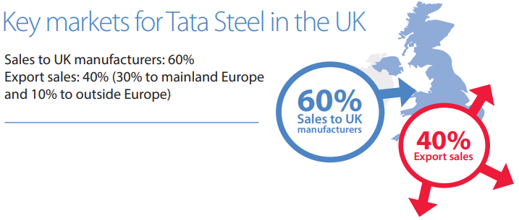
Figure 1 - Tata Steel UK Key Markets (Tata Steel UK, 2020)
“Bulk raw materials arrive by large bulk carrier at the deep-water port at the site. The raw materials are stocked out in discrete stockpiles in the stocking areas. Ferrous raw materials including lump ore and pellets along with non-ferrous inputs such as lump fluxes and purchased coke are fed directly to the blast furnaces and/or the BOS plant. Finer ferrous materials along with fluxes, solid fuel fines and various re-usable by-products from throughout the steel production processes are stored in the ore stockyards before being blended together into a sinter feed bed.” (Tata Steel Europe, 2023)
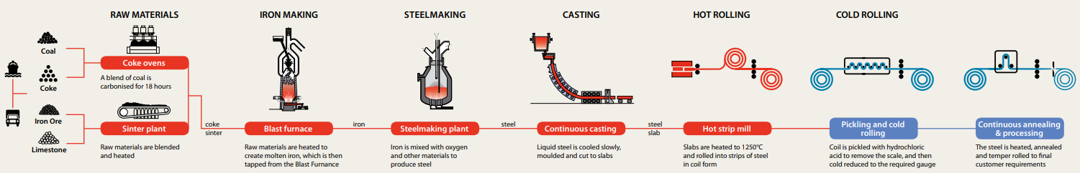
Figure 2 – Steel-making Process (Tata Steel UK, 2023)
The bulk material handling process is a vital component of Tata Steel Port Talbot's overall manufacturing operations. Annually, the plant discharges over 7 million tonnes of bulk iron ore, limestone and carbon product via cargo ship to ensure a continuous supply of raw materials for the steelmaking process. The efficient and effective handling of material is crucial for maintaining stable production schedules, minimizing downtime, and meeting customer demands with high-quality steel products.
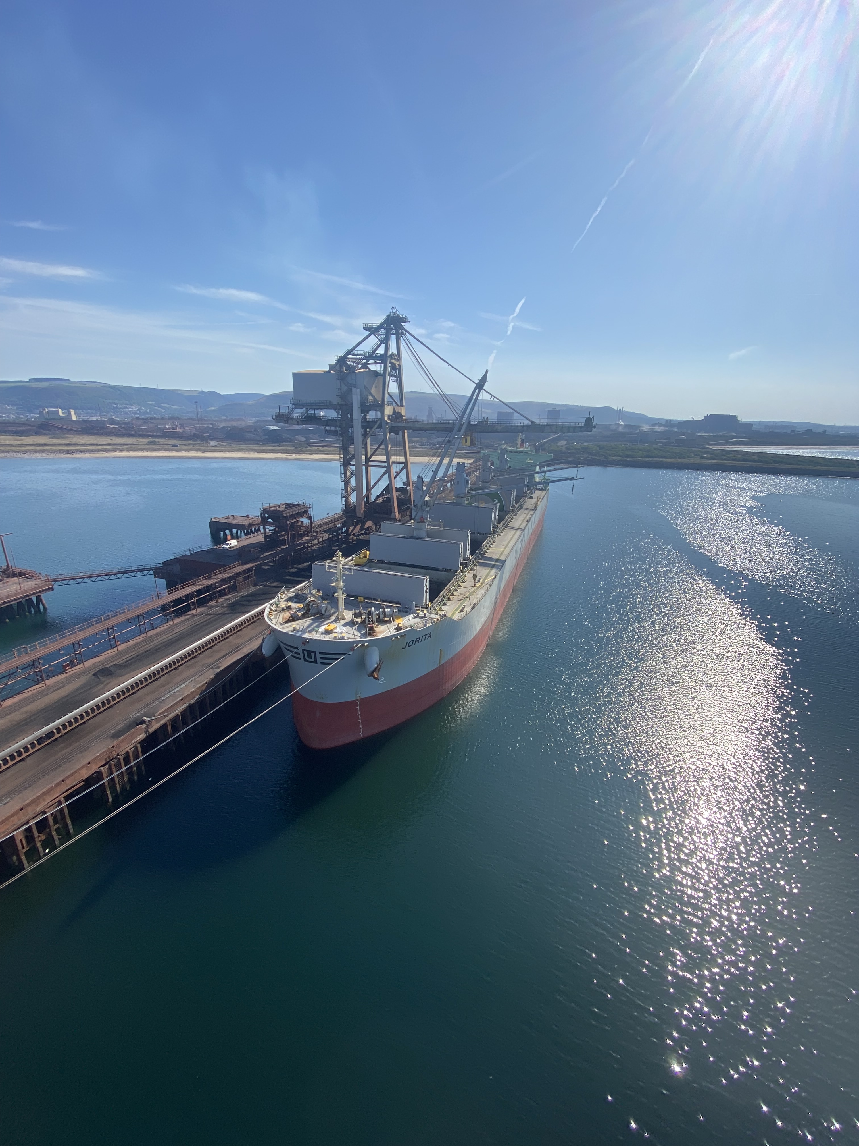
Figure 3 - Ship Unloading at Tata Steel Port Talbot
However, the bulk material handling process at Tata Steel Port Talbot faces inherent challenges that affect its efficiency and productivity. These challenges include extended waiting times for unloading vessels, suboptimal material flow management, excessive inventory levels, and equipment breakdowns. These issues can result in increased costs, reduced throughput, and disruptions to the steel production schedule.
Rooted in the Toyota Production System, Lean Manufacturing emphasizes waste reduction, continuous improvement, and maximizing value for customers. Implementing Lean principles in the handling process can streamline operations, minimize waste, improve productivity, and enhance overall operational efficiency.
This report aims to explore the application of Lean Manufacturing principles specifically to optimize the maintenance processes within the department. By conducting a thorough analysis of the current process and proposing a tailored framework for Lean implementation, this report seeks to provide practical insights and recommendations for optimization.

Report objectives
The objectives of this report are as follows:
- Assess the current state of the bulk material handling process at Tata Steel Port Talbot, including quantitative analysis of key performance indicators (KPIs) such as OEE(overall equipment effectiveness, equipment downtime, waiting times, and inventory levels.
- Explore the key principles and tools of Lean Manufacturing and their applicability to the maintenance process.
- Propose a comprehensive framework for implementing Lean Manufacturing principles, specifically tailored to optimize the maintenance process at the bulk material handling facility.
- Analyse the potential benefits and outcomes that can be achieved through the successful implementation of Lean Manufacturing practices, such as improved process flow, waste reduction, standardized work, Total Productive Maintenance (TPM), and enhanced resource utilization.
- Provide recommendations to the management team on effectively integrating Lean Manufacturing principles into the maintenance process, including strategies for driving cultural change, promoting employee engagement, and fostering a culture of continuous improvement.
By addressing these objectives, this report aims to assist in optimizing the bulk material handling process, thereby improving operational efficiency, reducing costs, and strengthening its position as a leading organisation in the global steel market.

Types of waste
Waste also known as "Muda" in the Toyota Production System, refers to “any activity or task that does not add value” to the final product or service although it may still be important/necessary to complete. There are several types of waste that organizations should aim to identify and eliminate to improve efficiency and productivity. (Pedro García Márquez F, 2020)

Transport
Transportation waste in maintenance arises from unnecessary movements or transfers of equipment or materials during maintenance activities. This includes excessive travel distances to retrieve tools or parts, resulting in increased labour and equipment costs. To minimize transportation waste, organizing the maintenance area for easy access to tools and materials, as well as implementing efficient work procedures, is necessary.

Inventory
Inventory waste in maintenance can arise from excess or obsolete inventory of spare parts, leading to increased carrying costs and potential waste due to obsolescence or deterioration. Conversely, inadequate inventory can result in delays and increased costs due to unplanned equipment downtime. To minimize inventory waste, it is important to implement effective inventory management practices, such as just-in-time inventory replenishment or predictive maintenance strategies.

Motion
Motion waste in maintenance occurs when technicians or maintenance personnel perform unnecessary movements, such as walking long distances to retrieve tools or equipment. This can lead to fatigue, delays, and increased risk of accidents. Organizing workstations, implementing visual management techniques, and optimizing tool and equipment placement can help minimize motion waste.

Waiting
Waiting waste in maintenance occurs when there are delays in accessing essential maintenance resources such as tools, equipment, or spare parts. This can lead to idle maintenance technicians and prolonged equipment downtime. To minimize waiting waste, it is crucial to implement efficient work order management systems, ensure timely availability of resources, and reduce response and resolution times.

Overproduction
Overproduction waste in maintenance occurs when maintenance activities are carried out excessively, beyond what is necessary for optimal equipment performance or to meet customer demands. This can lead to unnecessary maintenance costs, increased downtime due to over-maintenance, and the potential for unintended equipment damage. Adopting a preventive maintenance approach based on equipment condition and performance can help reduce overproduction waste.

Overprocessing
Processing waste in maintenance occurs when maintenance activities are inefficient or involve unnecessary steps. This can include redundant inspections, excessive documentation, or complex procedures. To reduce processing waste, streamlining maintenance processes, standardizing work procedures, and leveraging technology for streamlined data capture and analysis are recommended such as condition-based monitoring systems.

Defects
Defects waste in maintenance relates to errors or mistakes that occur during maintenance activities, leading to rework, increased repair costs, and decreased equipment reliability. Implementing robust maintenance quality control measures, providing proper training to maintenance personnel, and conducting thorough inspections can help reduce defects waste.

Skills
Skills waste in maintenance happens when the knowledge and expertise of maintenance personnel are underutilized or not effectively harnessed. This can result in missed opportunities for proactive maintenance, reduced problem-solving capabilities, and decreased overall maintenance efficiency. Providing ongoing training, promoting knowledge sharing, and involving maintenance personnel in continuous improvement initiatives can help address skills waste. This can be applied in terms of TPM as the operators of the equipment can carry out basic maintenance/changeover tasks such as SMED (single minute exchange of dies), lubrication or cleaning during periods of waiting. (James P. Womack, 2008)

Analysis of value from the customer's perspective
The bulk material handling facility supplies material to 3 departments within the steelworks, the Blast Furnaces, the Sinter Plant and the BOS Plant. For all effects and purposes, these are the customers of the bulk handling facility, despite being within the same organization.
From the customer's perspective, value is created when the bulk material handling facility is efficient, cost-effective, and reliable, this can also be expressed as a LEAN process. The customers expect the facility to operate with minimal delays, and to provide quality product consistently. Additionally, the customers value transparency and communication from the facility, including updates on deliveries and any issues that have arisen. Currently these updates are communicated through daily performance review meetings, where the customers and the bulk material handling facility discuss the demands of the process and the supply of materials - Detailing any changes to production schedules or issues that have arisen whilst discharging the vessel that could affect them.
A key principle of lean manufacturing is Maintainability, “In a pull-through system, long down periods cannot be tolerated. The product must be generated while consumer demand exists.” (Pazek, 2021)

Evaluation of how the process can be made leaner

Value Stream Mapping (VSM)
“Value Stream Mapping is all the various actions (both value added, and non-value added) currently required to bring a product through from raw materials into the arms of the customer” (Mike Rother, 2003)
A value stream map is used to visualize the current state of the process, identify waste, and assess the impact of hydraulic delays, using standard framework as shown in Appendix 2: MVSM Framework (Sawhney, 2009). This tool will help me understand the flow of materials, information, and value-adding activities, enabling me to pinpoint areas for improvement. A Maintenance Value Stream Map (MVSM) as pictured in Figure 4 is tailored towards the maintenance service.

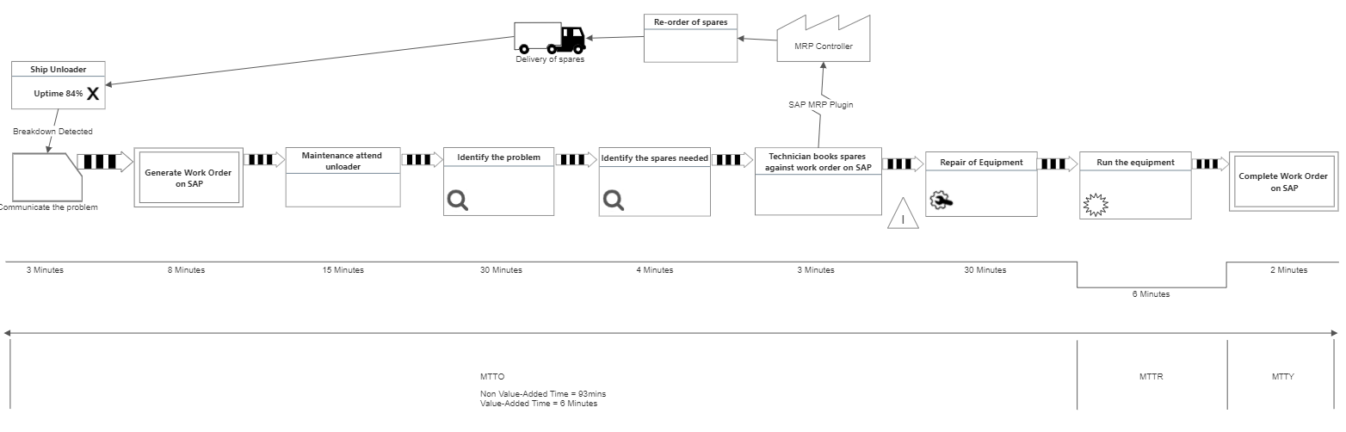
Figure 4 - Maintenance Value Stream Map

Gemba Walk
One method of evaluation used to determine how the process can be made leaner is conducting a Gemba walk, observing the process on the shop floor. This method allows you to directly witness the operations and engage with the operators and maintenance personnel to understand their challenges and gather insights into the impact of hydraulic delays. The results of the study is shown in Figure 5.
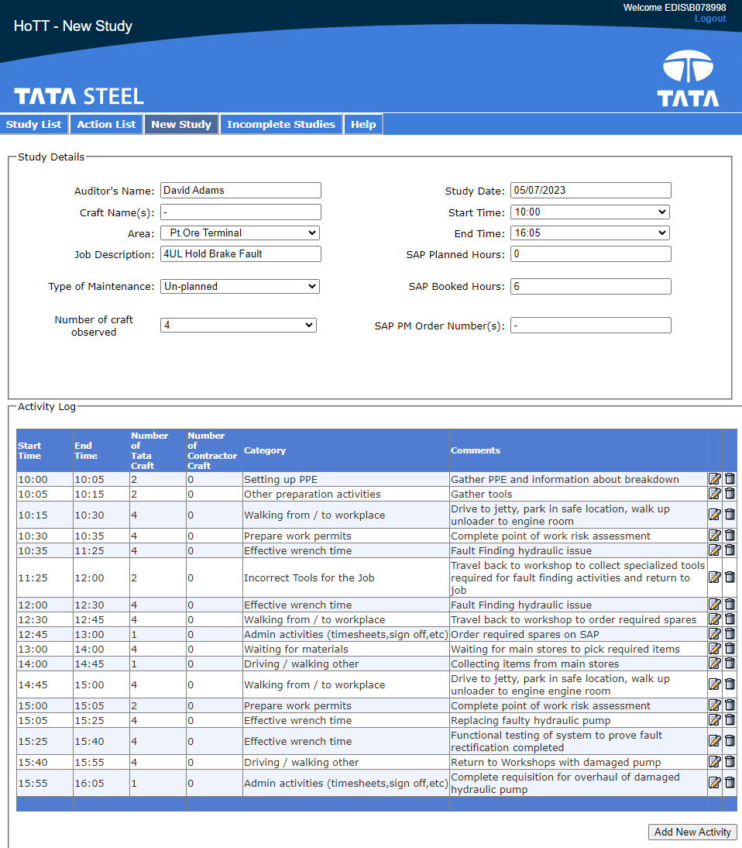
Figure 5 - Gemba Walk
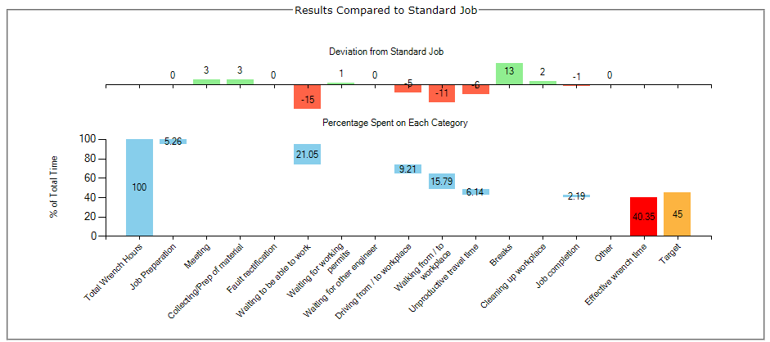
Figure 6 - Gemba Walk Analysis
After conducting a Gemba walk and conducting the analysis in Figure 6, significant transport and waiting waste was observed during the process.
Transport Waste: The observation of excessive material movement during the Gemba walk indicates a need for optimization. Implementing a satellite store brings the frequently used spare parts closer to the ship unloader.
Waiting Waste: The Gemba walk highlights waiting times, indicating delays in obtaining spare parts or materials when needed.
By addressing these specific wastes through the implementation of a satellite store, several benefits can be achieved:
- Reduction in Transportation Waste: By minimizing the need for material transportation, the facility can save costs associated with fuel, labour, and equipment maintenance. It also contributes to a more efficient and streamlined material flow, reducing the potential for errors or delays caused by unnecessary movement.
- Reduction in Waiting Waste: Having readily available spare parts nearby eliminates the need to wait for parts to be sourced and delivered. This leads to faster repairs and maintenance, reducing equipment downtime and improving overall process efficiency. Additionally, it increases the agility and responsiveness of the facility in handling maintenance issues.
- Improved Operational Efficiency: The satellite store allows for quick access to frequently used spare parts, reducing the time required for equipment repairs or replacements. This improves equipment uptime, reduces the likelihood of production delays, and enhances overall operational efficiency.
- Enhanced Employee Productivity: With spare parts readily accessible in the satellite store, operators and maintenance personnel can quickly retrieve the required components and resume their tasks. This reduces non-value-added time spent on searching or waiting for parts, allowing employees to focus on value-adding activities and increasing their productivity.

Spaghetti Diagram
Creating a spaghetti diagram will help me visually analyse the movement and flow of materials, equipment, and personnel within the process. This tool will highlight unnecessary movement and excessive travel distances, providing insights into potential areas for improvement to mitigate hydraulic delays. Due to the large distances currently covered during the process, the use of google maps was required to effectively map the movement of materials and personnel within the process. This is shown in Figure 7.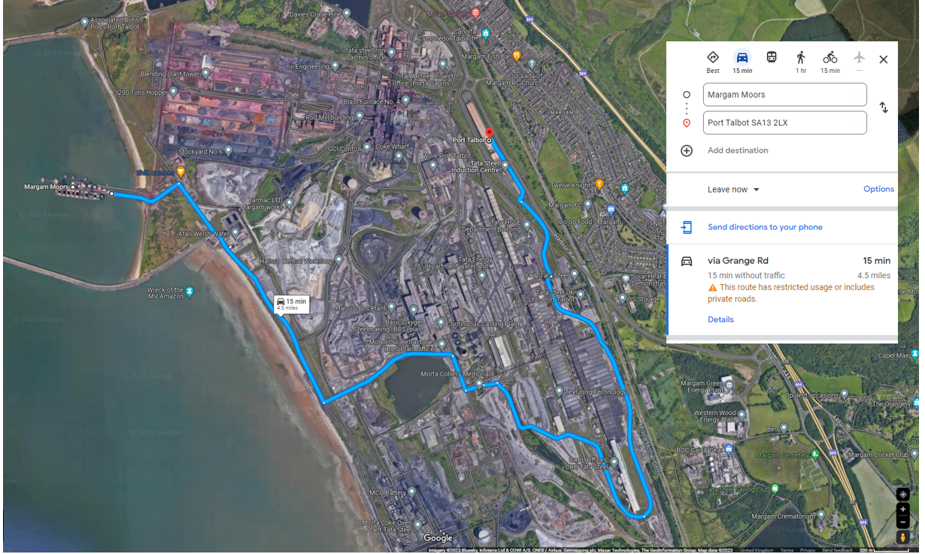
Figure 7 – Current State Spaghetti Diagram

OEE (Overall Equipment Efficiency)
I will calculate the Overall Equipment Efficiency of the ship unloader to assess its performance. By considering availability, performance, and quality factors, I can gauge the impact of hydraulic delays on the equipment's effectiveness and determine if implementing a satellite store is necessary, and its impact when completed.
Using data shown in Appendix 4 – Plant Performance Data obtained from production reporting system, it is determined that Availability is 88%, Performance is 93%, and Quality is 95%. Therefore, the Overall Equipment Effectiveness (OEE) would be calculated as:
OEE = Availability x Performance x Quality
OEE = 0.84 x 0.93 x 0.95
OEE = 0.748 or 74.8%
Compared to industry benchmarks, this score is quite high but slightly lower than the world-class threshold of 85%, indicating some room for further improvement, particularly in performance.

5s Activities (Sort, Straighten, Shine, Standardise, Sustain)
The principles of 5s focus on the philosophy of a place for everything, and everything in its place. What started as a Japanese Automotive Management technique, has now been adopted in organisations across the globe and various sectors of manufacturing. It is widely accepted as a high impact / low cost, lean manufacturing system that improves efficiency and focusses on ownership by all in the organisation. This helps to instil a positive culture of aiding Kaizen activities.
Completion of 5s activities to create a satellite stores and work area in the unloader engine house as per the layout in Figure 10 using the 5S systems shown in Figure 8 and Figure 9, will provide the following benefits;
- Unnecessary motion is reduced, travelling to main stores and workshops to collect parts and to work on equipment is eliminated, Transport and Waiting waste are reduced significantly.
- Unnecessary tools and equipment are removed, providing more space to store only required items, removing the requirement to purchase and store unnecessary items and saving time searching for what is required during breakdowns - reducing Inventory and Waiting waste.
- “A clean and well-maintained work environment is a safer work environment”. (English, 2011)
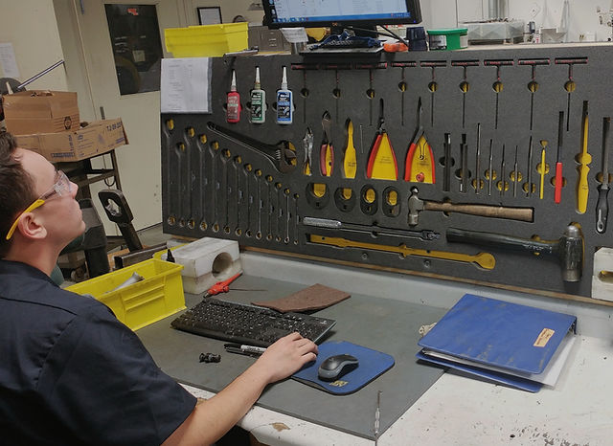
Figure 8 - 5S Satellite Workstation (Tool Keepers, 2021)

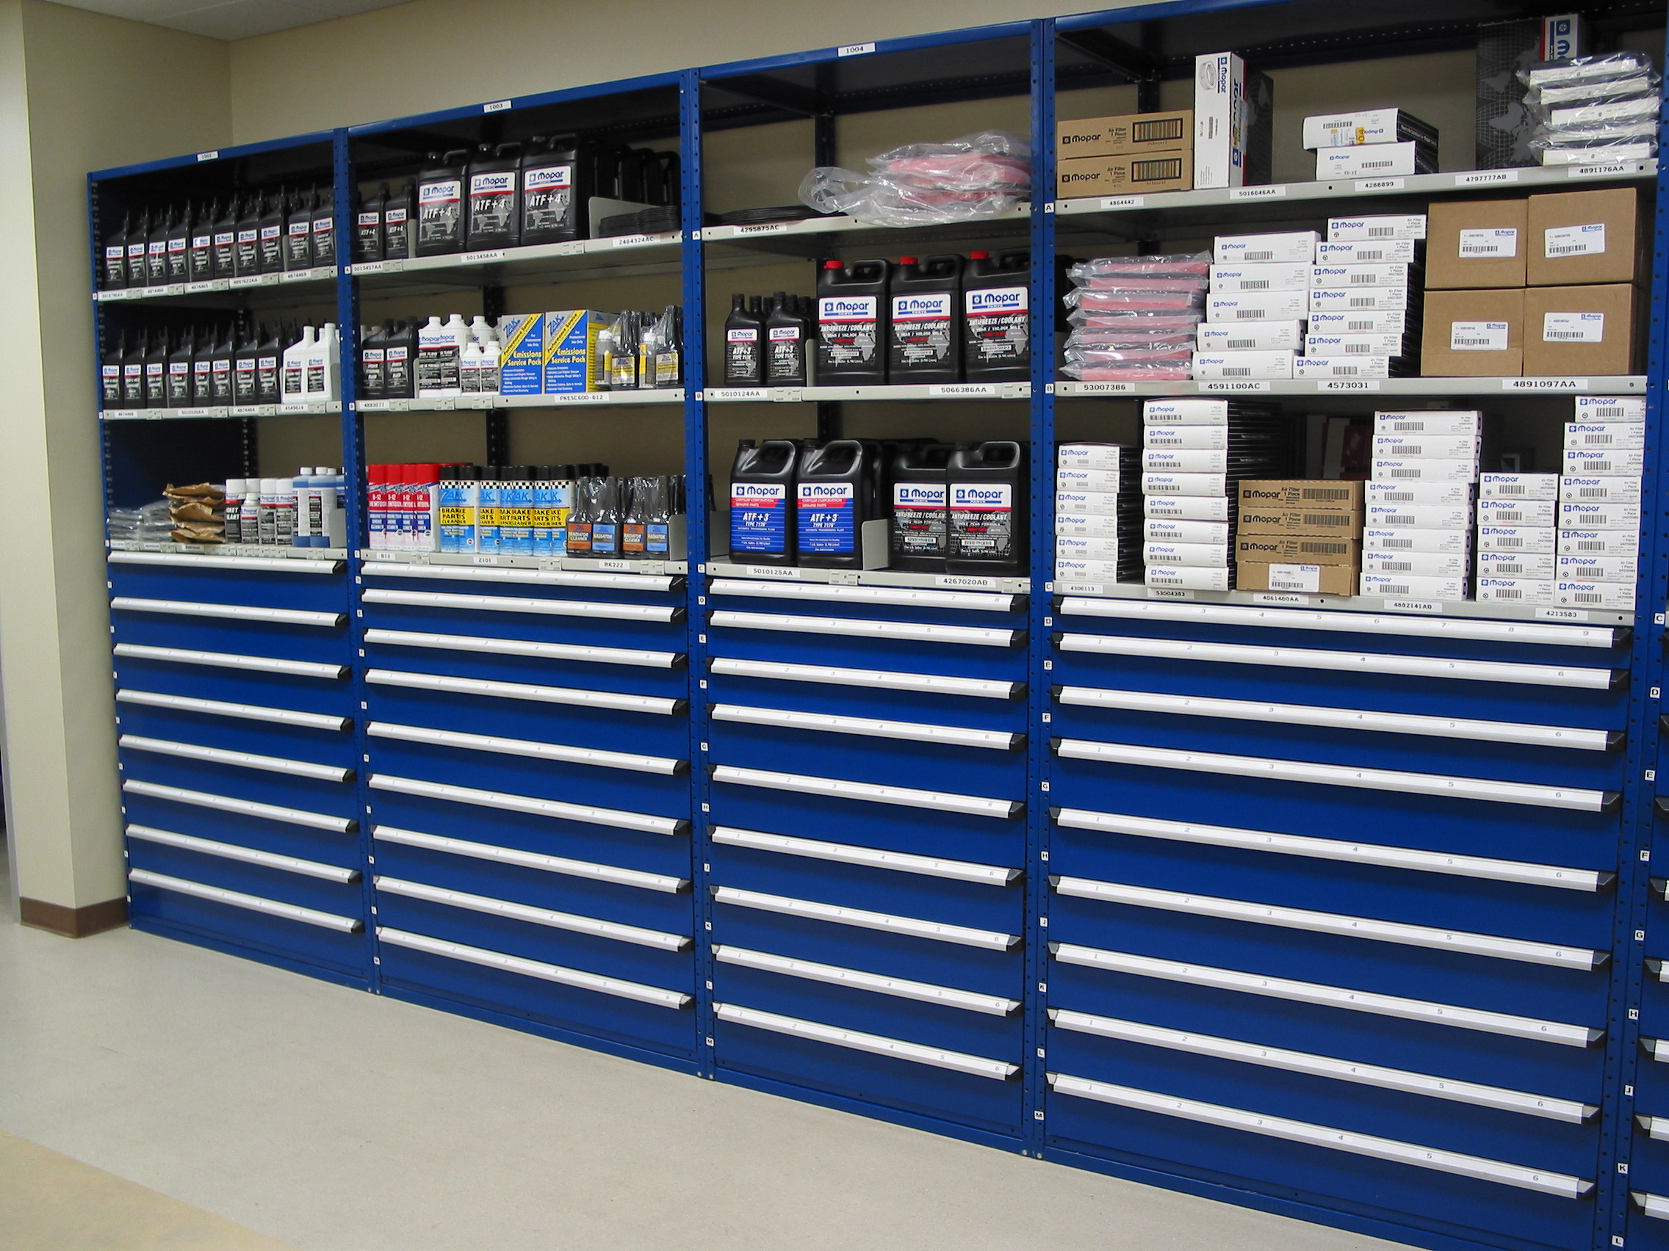
Figure 9 – 5S Parts Storage (REIV engineering, 2020)
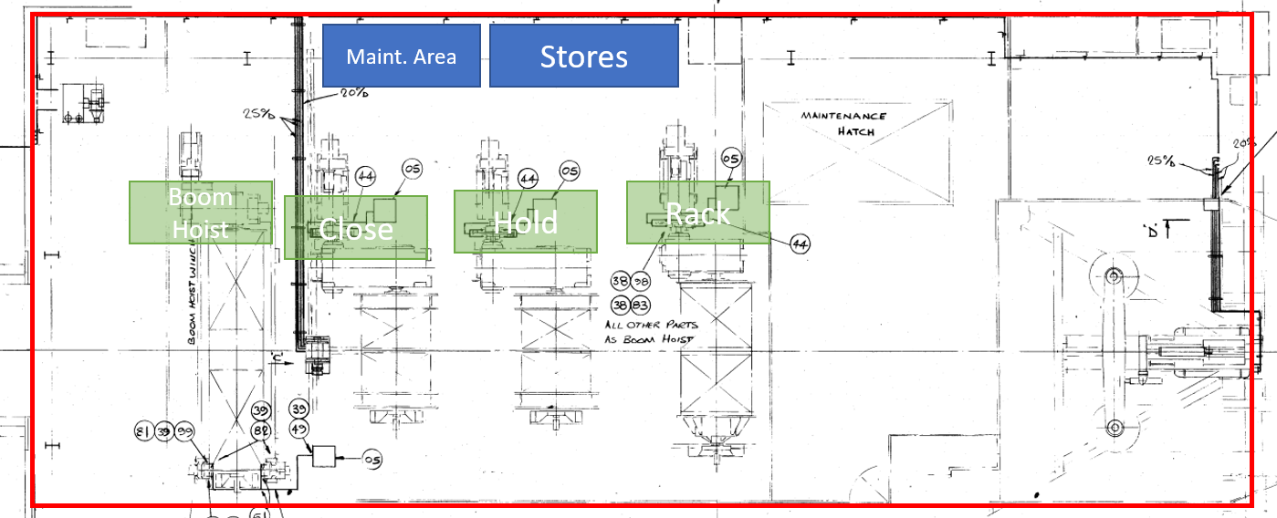
Figure 10 - Proposed Layout for Satellite Store and Maintenance Area

Andon System
Implementing an Andon system will reduce waiting waste and enable operators to quickly notify maintenance personnel or management when delays/slow running occurs, including hydraulic issues. This visual management tool will raise awareness, trigger immediate response, and provide valuable data for analysis, helping quantify the extent and frequency of the delays. This helps transition towards a TPM system from a reactive maintenance system as “Operators are in the best position to note the first signs of a problem” (Peter Willmott, 2001)

Standard Work
Developing standardized work procedures will establish a clear baseline for addressing hydraulic delays. This will provide consistency, clarity, and a measurable framework for evaluating the impact of improvements and determining the necessity of a satellite store.
Appendix 1: Process Flow Diagram for Fault Finding Hydraulic System shows a standardized process flow for fault finding on the hydraulic system.

Kaizen Events
Organizing Kaizen events, involving cross-functional teams, to address specific issues such as hydraulic delays will facilitate rapid problem-solving and the implementation of countermeasures fast. This allows you to evaluate the impact of a satellite store and gain engagement from those directly involved in the process and those who can implement change. A typical meeting agenda for a kaizen event can be seen in Appendix 3: Kaizen Event Agenda (Osterling, 2017).

Consideration of potential problems associated with implementing the improvements

Resistance to change
Employees may resist changes to the process, particularly if they are accustomed to the current way of doing things.
To overcome this, I would seek buy-in from users at different levels of the organization, such as the operators, maintenance personnel, leaders and management, from design and conception to implementation and auditing. Gaining their input at each stage allows for them to feel ownership of the project and this will lead to a greater chance of success. “Change must involve the people – change must not be imposed upon the people” (Passenheim, 2010)
It is also important to show people why change is necessary and how it will benefit them, this will also lead to a greater chance of success. This can be achieved by displaying the results and data of the tools used above and the predicted or actual benefits, not only in terms of cost but also effort required.

Cost
Some of the improvements may require significant investment, such as implementing a preventative maintenance program, purchasing shadow boards and purchasing storage solutions, which may be costly. This is where a business case with a cost benefit analysis breakdown is important to justify the investment and show pay-back time/return on investment.

Cost/benefit analysis
Costs
Implementation Costs: The estimated costs of implementing the satellite stores, including expenses related to training, new equipment, and facility changes = £20,000.
Ongoing Costs: The facility is expected to incur £1,000 per annum for maintenance, upgrades, and other recurring costs after the implementation of the satellite stores.
Benefits
Reduction in Non-Value-Added Waste of Hydraulic Downtime: In 2022, the facility incurred hydraulic-related downtime of 375 hours, of which an average of 59.64% (approximately 224 hours) was identified as non-value-added waste. Implementing the lean improvement process is expected to reduce this non-value-added waste by 100%, resulting in significant cost savings and increased productivity.
Downtime Costs Savings: In 2022, the facility incurred downtime costs totalling £2M. A substantial reduction in hydraulic downtime will contribute significantly to decreasing these costs. The expected reduction in non-value-added waste of hydraulic downtime could result in savings of approximately £419,000 per year (£2M * (224 hours / 1071 hours)).
Maintenance Costs Savings: The facility's maintenance costs in 2022 totalled £1.5M. Implementing a TPM program as part of the lean improvement process could result in further cost savings. These savings would depend on the specific changes made, but even a modest 5% reduction in maintenance costs would result in savings of £75,000 per year.
Intangible benefits:
Service/Product Quality Impact: Reduced downtime will result in improved productivity and therefore customer satisfaction.
Employee Morale: “An improved morale due to better working conditions and safer working environment can indirectly lead to increased productivity and decreased turnover rates, both of which have been shown to positively impact the bottom line.” (Maurice Oxenburgh, 2004)
ROI (return on investment)
ROI = (Annual Savings / Cost of Investment) * 100
Substituting the values:
ROI = (£419,000 / £21,000) * 100
ROI = 19.9523809524 * 100
ROI ≈ 1995.24%
Payback time
Payback Time = Initial Investment / Annual Savings
Payback Time = £21,000 / £419,000
Payback Time ≈ 0.0501 years
Payback Time ≈ 18.3 days (approximately)

Logistics
Implementing just-in-time delivery may require changes to the coordination of the supply chain, which may be challenging to implement. However, using the companies SAP computer system with the MRP control plugin, it is possible to set-up a satellite storage location and assign spare parts and stock levels to this new location. When a part is used from this satellite location, the maintenance technician books out the spare part, this generates a re-order process for the MRP controller to approve, sending a re-stock request to the supplier. Parts are then delivered straight to the satellite storage location and placed in the correct storage areas whilst the machine remains operational. Therefore, eliminating wating waste and reducing inventory waste.

Conclusion
By implementing a satellite store, the business can streamline material flow, improve equipment uptime, and enhance overall operational efficiency. It reduces unnecessary transportation and waiting times, contributing to large cost savings, increased productivity, and improved customer satisfaction. It appears to be a very good investment for the business, with the cost-benefit analysis showing substantial potential savings, and a rapid payback time of just 15 days. Although the OEE score is already relatively high (indicating efficient operation) there remains some potential for further improvement. The facility should continue to strive for increased efficiency, waste reduction, and overall improvement to reach world-class OEE standards.
In addition to implementing a satellite store to the ship unloaders to reduce non-value-added waste during hydraulic faults, it would be beneficial to focus on reducing waste in the production process. Possible improvements could include implementing automated systems, just-in-time (JIT) inventory management systems, training and culture improvements, supplier partnerships, layout optimization and use of technology for equipment monitoring and analytics.
Although the production process was not the area of focus during this study and report, the challenges associated with implementing these improvements may include resistance to change, cost, and planning, but these can be overcome through collaboration with employees, developing a business case, and collaborating with logistics partners. By implementing these improvements, the facility can improve efficiency and reduce costs - providing better value to its customers.

Bibliography
Alspaugh, M. A., 2008. Bulk Material Handling by Conveyor Belt 7. s.l.:Society for Mining, Metallurgy, and Exploration.
burnes, B., 2020. The Origins of Lewin’s Three-Step Model of Change. The Journal of Applied Behavioral Science., 56(1), p. 32–59.
English, P. F., 2011. Safety Performance in a Lean Environment: A Guide to Building Safety into a Process. s.l.:CRC Press.
James P. Womack, D. T. J., 2010. Lean Thinking: Banish Waste and Create Wealth in Your Corporation. 2nd ed. New York: Free Press.
James P. Womack, D. T. J. D. R., 2008. The machine that changed the world. London: Simon & Schuster.
Kannan, S., 2007. DEVELOPING A MAINTENANCE VALUE STREAM MAP.
Levitt, J., 2008. Lean Maintenance. s.l.:Industrial Press.
Liker, J. K., 2004. The Toyota Way: 14 Management Principles from the World's Greatest Manufacturer. s.l.:McGraw-Hill.
Maurice Oxenburgh, P. S. M. A. O., 2004. Increasing Productivity and Profit through Health and Safety. 1st ed. s.l.:CRC Press.
Michael L. George, J. M. D. T. R. M. U., 2004. The Lean Six Sigma Pocket Toolbook. s.l.:McGraw-Hill.
Mike Rother, J. S., 2003. Learning to See: Value Stream Mapping to Add Value and Eliminate Muda. 1.3 ed. Cambridge: The Lean Enterprise Institute.
Osterling, K. M. a. M., 2017. The Kaizen Event Planner. New York: Productivity Press.
Palmer, D., 2019. Maintenance Planning and Scheduling Handbook. 4th ed. s.l.:McGraw-Hill.
Passenheim, P. D. O., 2010. Change Management. s.l.:Ventus Publishing.
Pazek, K., 2021. Lean Manufacturing. London: Intech Open.
Pedro García Márquez F, S. R. I. B. T., 2020. Lean Manufacturing and Six Sigma - Behind the Mask. s.l.:Intech Open.
Peter Willmott, ‎. M., 2001. TPM - A Route to World Class Performance. Boston: Elsevier Science.
REIV engineering, 2020. The 5S System. [Online]
Available at: https://reiv-engineering.com/2020/05/26/the-5s-system/
Sawhney, R. &. K. S. &. L. X., 2009. Developing a value stream map to evaluate breakdown maintenance operations. International Journal of Industrial and Systems Engineering, Volume 4, pp. 229-240.
Tata Steel Europe, 2022. At a glance. [Online]
Available at: https://www.tatasteeleurope.com/about-us/at-a-glance
Tata Steel Europe, 2023. Sustainability performance at our sites: Port Talbot. [Online]
Available at: https://www.tatasteeleurope.com/construction/sustainability/performance-at-our-sites/port-talbot
Tata Steel UK, 2020. Tata Steel UK Factsheet. [Online]
Available at: https://www.tatasteeleurope.com/sites/default/files/Tata%20Steel%20UK%20Factsheet%202020%20%281%29.pdf
Tata Steel UK, 2023. A Guide to Port Talbot Works. s.l.:s.n.
Tool Keepers, 2021. Lean Solutions. [Online]
Available at: https://www.toolkeepers.com/lean-solutions
Vorne Industries Inc., 2023. TPM (TOTAL PRODUCTIVE MAINTENANCE). [Online]
Available at: https://www.leanproduction.com/tpm/

Appendices

Appendix 1: Process Flow Diagram for Fault Finding Hydraulic System
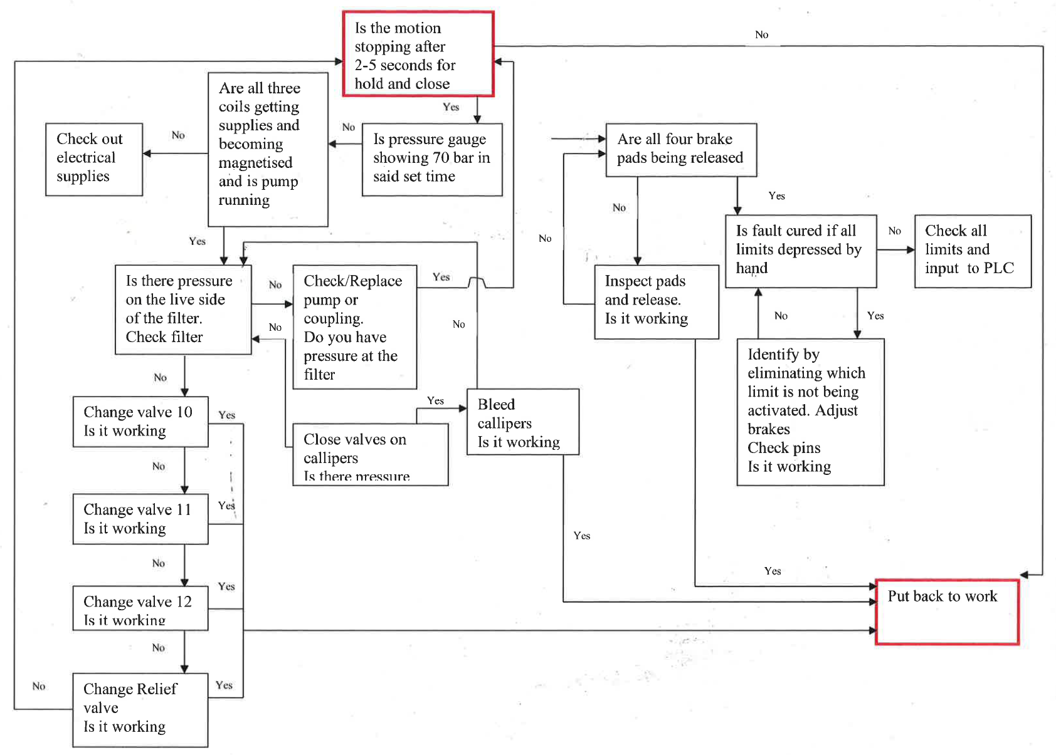

Appendix 2: MVSM Framework (Sawhney, 2009)
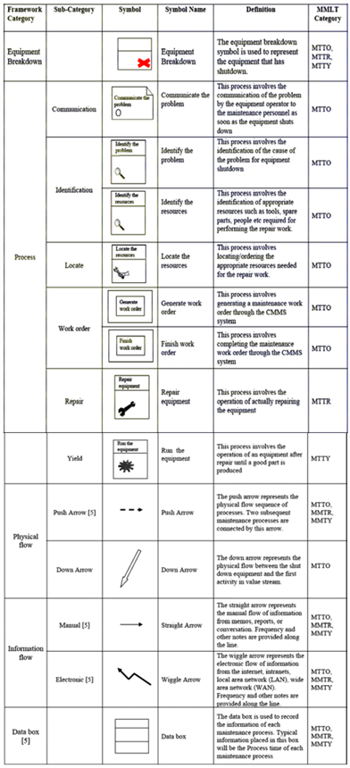

Appendix 3: Kaizen Event Agenda (Osterling, 2017)
“Day 1: Preparation and Planning
Welcome and Introduction
- Introduce the purpose and goals of the Kaizen event.
- Highlight the importance of continuous improvement and employee involvement.
- Overview of Current Process
- Present a detailed overview of the process under review.
- Discuss the current challenges, bottlenecks, and areas for improvement.
Goal Setting and Scope Definition
- Define the specific goals and objectives for the Kaizen event.
- Determine the scope of the event, including the processes and areas to be focused on.
Team Formation and Roles
- Assign team members to different roles, such as facilitator, process owner, and team members.
- Discuss responsibilities, expectations, and collaboration guidelines for the team.
Data Collection and Analysis
- Identify the key performance indicators (KPIs) and metrics to be measured.
- Collect relevant data to evaluate the current process performance.
Gemba Walk
- Conduct a Gemba walk to observe the process in action.
- Engage with frontline employees to gather insights and identify improvement opportunities.
Day 2: Analysis and Idea Generation
Data Analysis and Root Cause Identification
- Analyse the collected data to identify root causes of issues and inefficiencies.
- Use tools such as fishbone diagrams, Pareto charts, and process maps for analysis.
Brainstorming and Idea Generation
- Facilitate a brainstorming session to generate improvement ideas.
- Encourage all team members to contribute and evaluate potential solutions.
Evaluation and Selection of Ideas
- Evaluate the generated ideas based on feasibility, impact, and alignment with goals.
- Select the most promising ideas for further development and implementation.
Day 3: Solution Development and Action Planning
Solution Development
- Develop detailed action plans for the selected improvement ideas.
- Assign responsibilities, timelines, and resources required for each action item.
Lean Tools and Techniques
- Introduce relevant lean tools and techniques that can be applied to the improvement ideas.
- Provide training or refresher sessions on tools such as 5S, standardized work, and visual management.
Implementation Strategy
- Define the implementation strategy, considering potential challenges and change management aspects.
- Discuss how the improvements will be piloted, monitored, and sustained.
Day 4: Implementation and Follow-up
Pilot Implementation
- Begin the pilot implementation of the selected improvement ideas.
- Monitor and document the progress, capturing any issues or observations.
Problem-Solving and Continuous Improvement
- Address any problems or obstacles encountered during implementation.
- Encourage continuous improvement by revisiting the process, collecting feedback, and adjusting.
Documentation and Knowledge Sharing
- Document the implemented improvements, including before-and-after data.
- Share the outcomes, lessons learned, and best practices with the wider organization.
Closing and Next Steps
- Review the achievements and outcomes of the Kaizen event.
- Discuss the next steps, including follow-up actions and plans for future improvement initiatives.”

Appendix 4 – Plant Performance Data obtained from production reporting system
Data Point (2022 Data) | Value
Average Availability | 84%
Performance | 93%
Quality | 95%
Downtime Costs | £2M
Maintenance Costs | £1.5M
Total Downtime | 1071 Hours
Hydraulic Downtime | 375 Hours

