

BA Business Management
Carmarthen Business School

How successful is digital marketing in the conversion of sales?
Undergraduate Dissertation

Author: Dean Chilcott
Student Number: 1403144
Module Code: SBUS6108
Supervisor: Dr. Alex Bell
Date: 08/05/2019

Declaration Form
In submitting this dissertation paper, I confirm that:
- This work has not previously been accepted in substance for any degree and is not being concurrently submitted in candidature for any other degree.
- This dissertation is being submitted in partial fulfilment of the requirements for the degree of BA Business Management.
- This dissertation is the work of my own independent work investigation, except where otherwise stated.
Other sources are acknowledged by footnotes giving explicit references.
A bibliography is appended.
- I hereby give consent for my dissertation, if accepted, to be deposited in the school dissertation library.
Name:

Date of submission: ………………………..

Signature: …………………………………

Acknowledgment
Initially I would like to thank all the lecturers at the University of Wales Trinity Saint David’s in Carmarthen for their help and guidance though my final year of study and prior to this Pembrokeshire College who undertook the first few years of my degree. I would also like to thank Dr. Alex Bell for his efforts as dissertation supervisor, for his valued contribution when choosing a topic and providing guidance in how to proceed with the tasks.
I would also like to thank my Wife Catherine for all her help and patience in dealing with my return to education, from proof reading to motivating me, whilst simultaneously planning a wedding and raising our daughter effortlessly.
Further to this I would like to thank the participants of my Survey who took time out of there day in order to assist with the completion of the study and provide me with a better understanding of the most effective form of Digital Marketing.

Abstract
“Our jobs as marketers are to understand how the customer wants to buy and help them to do so.” - (Eisenberg, 2019)
But what is the most effective way of reaching our customer? And how do we convince them to commit to our product or service, what channel of Digital marketing is the most effective in converting a visitor into a customer and how can we capitalise upon this?
The research obtained from primary and secondary sources looks to identify the answer to these questions, the data utilised focuses of the consumers opinion, and the proven result of a business to identify any comparisons that can be draw from what is perceived and what is achieved.
The study provides the opinion of consumers as to how they respond to marketing, and the measurable results of a business to establish this, the study also provides recommendations as to what the focus of a digital marketing strategy could include.

Contents
Declaration Form 2
Acknowledgment 3
Abstract 4
1 Introduction 7
2 Literature Review 9
2.1 What is digital marketing 9
2.2 Instruments of digital marketing 11
2.2.1 Web 2.0 11
2.2.2 Search Engine Optimization (SEO) 12
2.2.3 Content Marketing 14
2.2.4 Social Media Marketing 16
2.2.5 Pay-Per-Click (PPC) 18
2.2.6 Affiliate Marketing 19
2.2.7 Native Advertising 20
2.2.8 Marketing Automation 21
2.2.9 Email Marketing 21
3 Research Strategy and Methodology 24
3.1 Research aims and objectives 24
3.2 Planning 24
3.3 Research Overview 25
3.4 Research Design 25
3.5 Secondary Research 27
3.6 Survey 29
3.7 Logistical and ethical considerations 30
4 Findings and Analysis 32
4.1 Results 32
4.1.1 Chart - Gender of Survey participants 32
4.1.2 Chart - Country of residence of Survey participants 33
4.1.3 Chart- Age range of Survey participants 33
4.1.4 Chart- Employment status of Survey participants 34
4.1.5 Table – Preferred method of interaction with companies when making a purchase 35
4.1.6 Table – What participants are most responsive to when making a purchase 36
4.1.7 Chart – Average monthly online spend 37
4.1.8 Chart – Highest single online purchase within the last year 37
4.1.9 Table – Use of social media 38
4.1.10 Table – What social media has influenced a purchase with the last year? 39
4.1.11 Table – What forms of Digital Marketing are you exposed to? 40
4.1.12 Table – What forms of Digital Marketing are you most responsive to? 41
4.1.13 Table – What forms of Digital Marketing are you least responsive to? 42
4.1.14 Chart – How often do you make online purchases? 42
4.1.15 Table – What device do you use to make online purchases? 44
4.1.16 Chart – What is your rough household Income? 45
4.1.17 Table – Does gender effect how participants look to make purchases? 46
4.1.18 Table – Does age range determine the success of Digital Marketing? 47
4.1.19 Table – Does the use of social media have an effect on online purchases? 47
4.1.20 Table – Does age range influence how often purchases are made online? 48
4.2 Analysis 49
5 Discussion 52
6 Conclusion 55
7 Recommendations 58
8 Advice for further study 59
9 References 60

Introduction
“Our jobs as marketers are to understand how the customer wants to buy and help them to do so.” - (Eisenberg, 2019)

It is said that traditional marketing is dead, the move to a digital age over the past 29 years has rendered previous marketing techniques outdated and irrelevant, this was identified as early as the 1990’s with the rise of the world wide web (DeMers, 2016) and its demise is attributed to by the increasing distrust of traditional forms of advertising from the up and coming generations.
Due to the fast everchanging nature of technology, advancement in the last 30 years has been astronomical, consumers are able to access the internet in a range of formats, from PC’ and Laptops, to smart phones and tablets, the world has never been more connected. As a result of this the growth of E-commerce in the UK alone up to 2018 reached 17% (Chaffey, 2018).
With this in mind it is only natural to begin questioning if conventional marketing is rendered ineffective by these advancements, what is the most effective form of marketing and how can businesses capitalise upon this?
It is with this question in mind the researcher has undertaken an investigation with the working title “what is the most effective form of digital marketing in the conversion of sales” this title identifies that the research is concerned with identifying the most effective form or forms of digital marketing and capitalising upon these.
The researcher also felt it would be beneficial to include the opinion of both an established business already utilising a range of digital marketing and the consumer to provide a comparison as to what works in practise and theory.

A study entitled “Effectiveness of Digital Marketing in the Challenging Age an Empirical Study” suggests that the main objective of digital marketing is attracting customers and allowing them to interact with the brand through digital media (Fatema, 2015)
The researcher seeks to identify how effective digital marketing is relating to sales revenue and how consumers perceive various forms of digital marketing.
The main points that the research hopes to establish are identified below.
To identify the most highly converted form of digital marketing with regards to the sale of a product or service.
Identify the most successful form of digital marketing and establish any relation between demographic information and the most effective form of digital marketing.
Ascertain if the most successful form of digital marketing from the perspective of the customer and from the perspective of the business differ.
Seek to discover if the use of certain social media results in an increase in the conversion of sales from the platform, identifying the success of different instruments of digital marketing.
A literature review follows with relevant information relating to the subject gathered and secondary research utilised provided, the researcher has also performed a survey with 107 participants with a view to comparing the literature review theory, the business secondary data and the primary data obtained from the survey of UK Consumers. The focus of the research is split between the consumer and the business with a view to establishing how businesses can utilise digital marketing to convert sales, recommendations will also follow as to how the research could be carried forward.

Literature Review

What is digital marketing
Digital marketing can be described as the utilisation of electronic media by marketers to promote the products or services into the market, to further expand upon this it has been suggested that the main objective of digital marketing is attracting customers and allowing them to interact with the brand through digital media. (Yasmin et al., 2015)
A further definition of digital marketing is the monitoring and facilitating of customer’s interaction, participation and sharing through digital media to encourage positive engagement with a company and its brands leading to commercial value. Interactions may occur on a company site, social networks and other third party websites. (Chaffey, 2002)
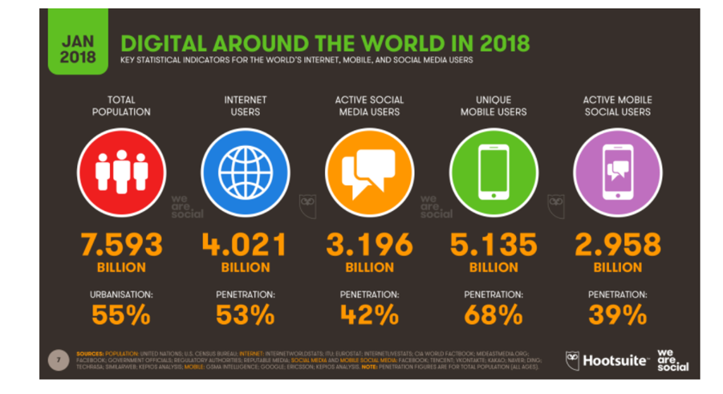
Both of these definitions are indicative that the main focus of digital marketing is the promotion of products or services to a target audience to encourage engagement with the brand and subsequently the purchase of a product or service, this can also take place over a range of platforms and in an increasingly targeted manner.

(Chaffey, 2019)
The global snapshot depicted illustrates how advantageous the use of digital marketing is for businesses due to the high levels of exposure provided by these platforms.

This snapshot identifies that the number of internet users worldwide in 2018 is 4.021 billion, demonstrating an increase of 7 percent year-on-year, furthermore,
The number of social media users worldwide in 2018 is 3.196 billion, up 13 percent year-on-year, it is also noteworthy that the number of mobile phone users in 2018 is 5.135 billion, up 4 percent year-on-year. These stats alone demonstrate the huge benefit to marketers utilising digital marketing for promotion of a product or service. (Chaffey, 2019)
Digital marketing is useful to business for a number of reasons, Stokes suggests that Digital marketing is a powerful tool for two fundamental reasons, he expands by identifying that the use of digital marketing channels allows for an audience to be segmented very precisely, down to factors including locality, recent brand interactions, age range and interests, this is exceptionally useful to business as this means that messages can be personalised and tailored specially for consumer. (Stokes, 2008)

“The digital sphere is almost completely measurable – every minute and every click by a customer can be accounted for. In digital you can see exactly how various campaigns are performing, which channels bring the most benefit, and where your efforts are best focused.” (Stokes, 2008)

Instruments of digital marketing
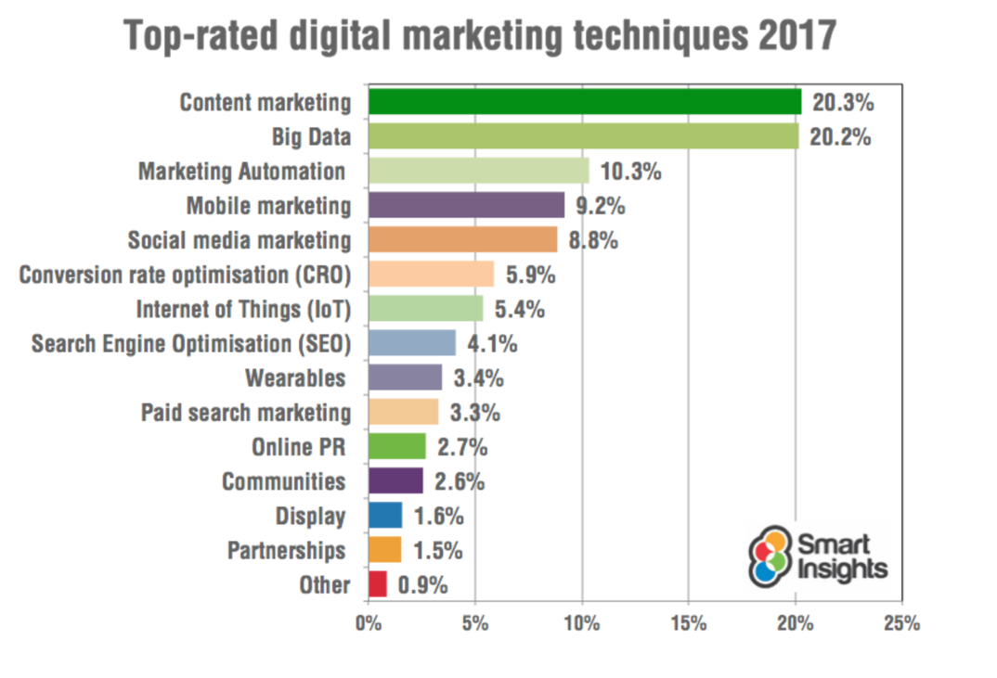

A survey under taken by Smart Insights aimed at marketers suggests that the top-rated forms of digital marketing are content marketing, big data, and marketing automation. (Chaffey, 2017)
For the purpose of this research the researcher has identified a sample of digital marketing methods on which to base the research, a limiting factor is that it would not be possible to delve into all methods and this could be a recommendation for future research.

Web 2.0
Before providing an assessment of the various methods of digital marketing identified for the purpose of this research, it is important to touch upon the phrase Web 2.0.
The JISC suggests that Web 2.0 encompasses a variety of different meanings, these include an increased emphasis on user-generated content, data and content sharing and collaborative effort, together with the use of various kinds of social software, new ways of interacting with web-based applications, and the use of the web as a platform for generating, re-purposing and consuming content. (JISC, 2007)
Notable benefits of Web 2.0 include that information is able to flow more freely, users can easily express ideas and opinions without fear or apprehension, further to this Web 2.0 has encouraged a more personalized experience, allowing users that have different needs or preferences to obtain more tailored information, a further benefit is the optimization of the internet into a more user friendly platform, Web 2.0 has the end user at its focus and as a result navigation and ease of use has improved drastically with this movement, this is important for business as this could have a direct effect on its sales as with an improvement in usability, end users are more likely to complete a purchase. Web 2.0 also enhances interaction between customers from a wide demographic, it enables these users to easily read, post and view experiences of other customers. (SEConsulting, 2011) Overall Web 2.0 has a focus on convenience and interaction laying the foundations for the various forms of digital marketing featured in this research.

Search Engine Optimization (SEO)
Matrinez suggests that search engine optimization is the use or application of algorithms to influence the predictable content and quality of search engine results according to the chosen criteria of the optimizer. (Martinez, 2018)
Search engines arrange any data they collect according to indexing criteria and ranking criteria, Indexing determines what information a search engine will store and how it will be handled, the search engine does this by indexing only quality pages that pass its quality tests and disregarding portions of page content its does not deem applicable to the search term, Ranking criteria dictates a preference to results by use of search terms in titles, page URLs and bolded text and the use of search terms in link anchor text pointing to the page, in simple terms search engines categories pages based on keywords that are relevant to the content of a page, most engines use programs known as spiders or crawlers to search the web and analyze pages, these are then indexed based upon how often the term that is searched for appears on the page.
The search engines goal is to provide the end user with the most relevant and satisfying results, results must not only be relevant but satisfying to the user of the search engine.
Marketers must be aware of the Theorem of Four SEO influences, this dictates how search engines change their rankings in search terms, rankings can be affected due to the following factors;
- a change to the business’s own page
- Another page change on another webpage
- The search engines do something with their data
- End users search for something different
(Martinez, 2018)
In order to visualize how SEO works, it is beneficial to view the world wide web as a network of stops in a subway system, each stop is a unique document, in this instance a webpage, The search engines need a way to “crawl” the entire city and find all the stops along the way, so they use the best path available links as suggested by (moz.com, 2018)
The goal of a marketer using SEO is to drive relevant traffic to its webpage with the intention of a conversion to a sale, this is achieved through making a webpage easy for both customers and search engines to understand, driving the sites popularity and having a direct effect on its ranking and in turn traffic. Smart Insights suggest that 48% of consumers start mobile research with a search engine, and it is for this reason marketers benefit from the utilisation of SEO. (Smart Insights, 2016)

Content Marketing
Content marketing is another form of digital marketing, this differs from other forms of traditional marketing by aiming to provide quality content for a business’s customers over any hard selling or brand plugging tactics. The intent of content marketing is to address the existing needs of the consumer as opposed to trying to initiate new needs. The primary objective of content marketing initiatives is to gain customer attention by identify the need of the customer, once this has been achieved a business can tailor content to its customers through various content marketing tools such as blogs, e-book, and audio-visual mediums, whilst ensuring that these are content types that interest them and position the brand in the desired way. (Kumar, 2016)
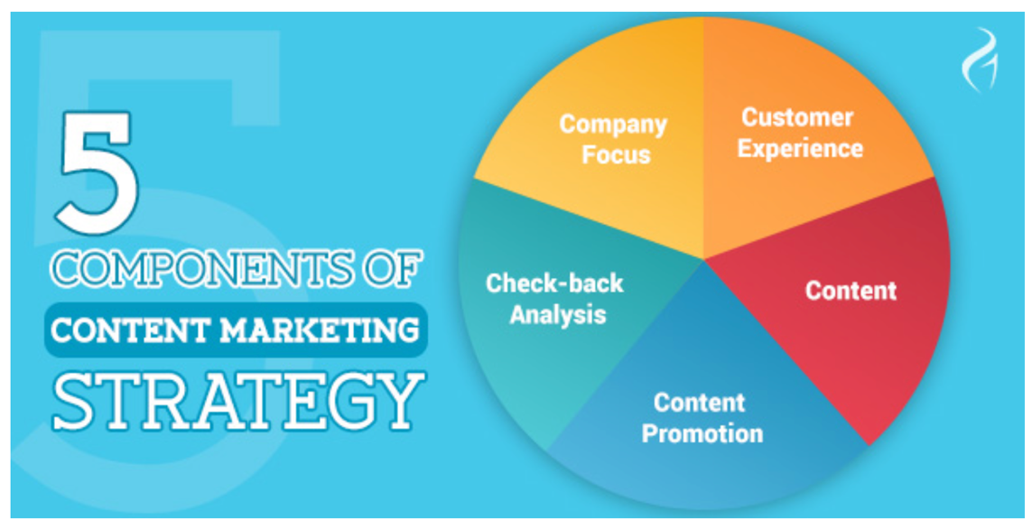
(Kumar, 2016)
The components of content marketing are concerned with the following areas as suggested by Kumar;
- Company focus, this is concerned with the brands goals, core values, unique selling point and philosophies, establishing the brands focus and what it stands for.
- Customer experience, this can be defined by analysing current customer data, creating customer personas and developing a customer’s experience with the brand based on the findings.
- Content, content produced by a brand must define the brands story and message, the content can then take a number of different forms with the view to engaging customers, for example video, audio files, websites.
- Channel promotion, this section is concerned with presenting content in front of the target audience, this is achieved by making content shareable, using a range of both paid and viral techniques to present the brand.
- Check-back analysis, taking into consideration all of the above, checking what works with a business’s target audience and what does not, this gives the brand the opportunity to re-assess its business model, value and redefine any marketing strategy if appropriate.
(Kumar, 2016)
Content marketing increases brand visibility and develops lasting relationships with a business audience, it achieves this by creating loyalty and trust with both current customers and prospective alike, this is beneficial in driving traffic again to a business webpage, by presenting the brand to the target audience effectively this increases the likely hood of a product or service being seen and untimely purchased, content marketing also opens up a channel of communication with a business audience, providing additional value and speeding up the purchase decision. (Murphy, 2018)

Businesses are quickly identifying the benefits of content marketing in a bid to attract customers to a product or service, this is outlined by research conducted by Hubspot relating to what businesses intended content marketing strategy was for the year ahead.
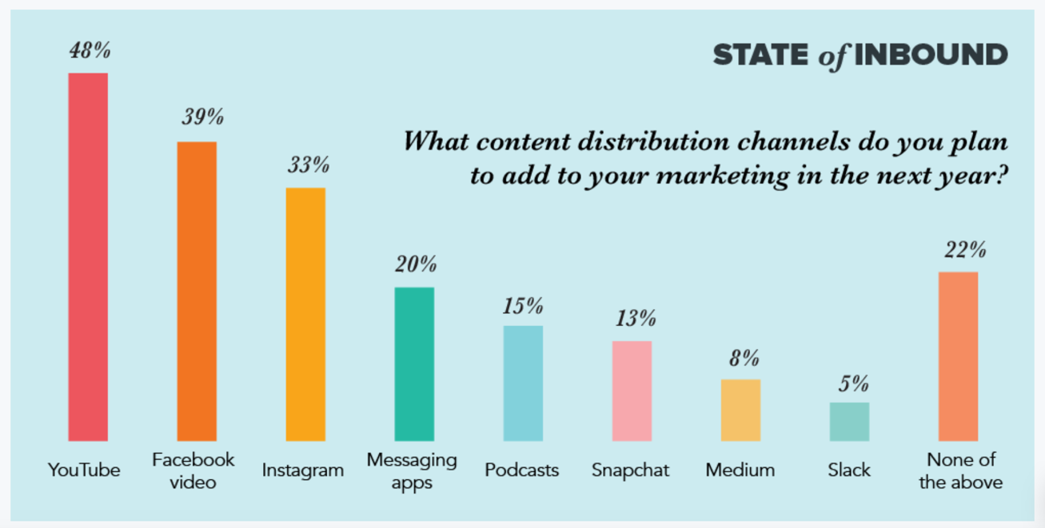
(Hubspot, 2018)
As detailed above there is a clear focus on delivering content through social media and video outlets.

Social Media Marketing
Social Media Marketing can be defined as the use of social media platforms in order to raise the visibility online to promote products or services offered by a business, social media sites are regarded as useful for building social and business networks with a view to exchanging ideas and knowledge.
Social media networking is an element of the new age of the internet, known as “Web 2.0” referring to the way in which end users and developers use the web, this is seen as a more collaborative use of the web that enhances creativity, encourages interactivity and is very user driven as opposed to previous online usage. With this in mind it is crucial that content is available to a business’s target audience. (Innovation PEI, 2013 )
Content marketing and social media marketing naturally lend themselves to each other as social media is a platform for the sharing of the content created for content marketing.
Social Media in a business outlook is a place where consumers can interact with brands and the products or services that they offer, marketers utilise social media as a way to reach their customers and provide a new way to purchase, Shankar suggests that Technological developments such as the rise of powerful search engines, advanced mobile devices and interfaces, peer-to-peer communication vehicles, and online social networks have provided marketers with an increased ability to engage shoppers through new touch points. (Shankar, 2011)

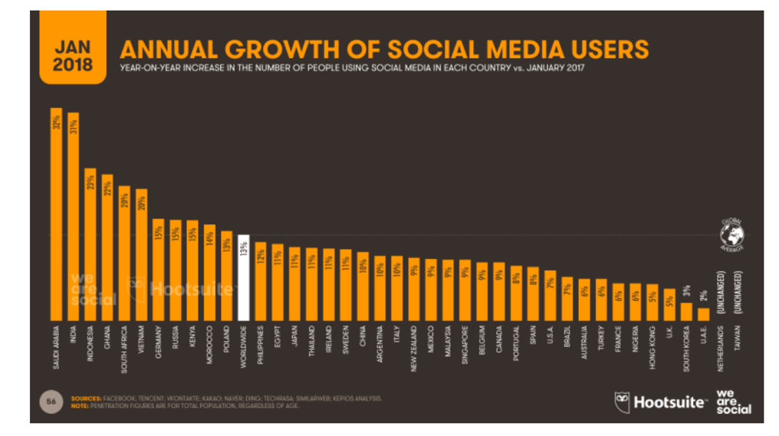 (Chaffey, 2019)
The figure above demonstrates a clear increase in the use of social media across the globe, and it is for this reason, increased exposure that social media marketing is so beneficial to businesses today. (Chaffey, 2019)
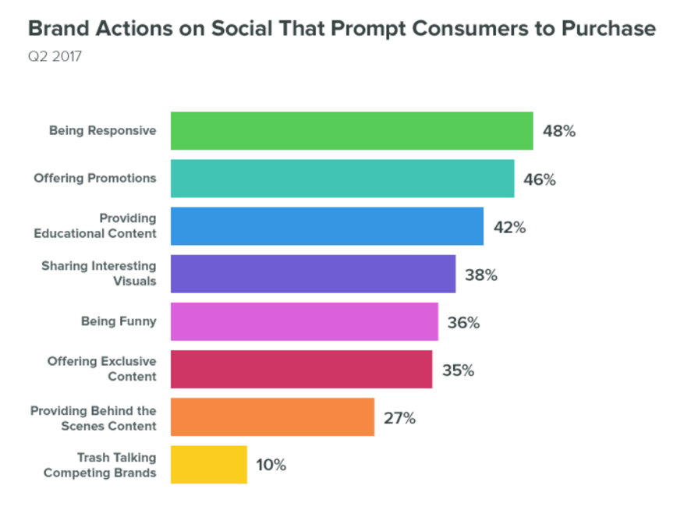 (Chaffey, 2019)
The Graph above by Chaffey also identifies the most beneficial uses of social media for businesses as identified by customers using online presence to purchase.
It is noteworthy that the preferred use of Social media by businesses in the opinion of customers is being responsive, with promotions coming in a close second, the element of the data concerning promotions can be proven or disproven with the primary research undertaken for this research. (Chaffey, 2019)

Pay-Per-Click (PPC)
Pay per click (PPC) is another tool of digital marketing, businesses pay a fee each time an ad of theirs is clicked on a providers site, it is a way of purchasing traffic to a business webpage rather than earning visits organically, an example of this is search engine advertising, this allows marketers to bid for ad placement in a search engines sponsored links when someone searches a key world that is related to the business. (Kim, 2018)
Businesses pay search engines to present their web result whenever a searcher submits a term relevant to the business, then a further payment when a searcher clicks on the link presented to them.
Search engines can tailor this matching algorithm from exact matches to loose matches to include misspellings as well as alternate term usage, these arrangements are usually based upon a period of activation, language, geographical and other constraints, in an instance where a number of businesses want to purchase the same keyword or phrase a process referred to as ranking takes place to determine what result goes to the top of the search, usually the highest paying will have the top result. (Bernard J. Jansen, 2008)

Affiliate Marketing
Affiliate marketing can be defined as a type of performance-based marketing, whereby a business rewards each affiliate for every visitor or customer delivered to a business page through the affiliates efforts. (Brown, 2009)
This method of marketing is beneficial to a business as any payment for advertising only occurs when a sale is made and can be attributed to an affiliate, this is tracked through online tracking that is able to attribute where a customer original came from before purchasing from a business, it is for this reason that marketers see this method as a greatly reduced risk when marketing. (Edelman et al, 2014)
Affiliate marketing compensation is usually purely performance based and works by a consumer visiting an affiliate site, clicking on the affiliates specially coded link to the businesses page, then the user making a purchase of the back of that link from the business, this is referred to as pay per sale (PPS). (Nir Vulkan, 2015)
two examples of affiliate marketing include;
- Cost per mille/click, where the affiliate could potentially not be concerned as to whether the visitor referred is a member of the businesses target audience as the affiliate would only be interested in referring as many people as possible to earn
- Cost per action/ sale, this requires that referrals do more than just visit the business page, and the affiliate would only earn a. Commission if a sale is made from the visit. It is for this reason that it is in the interest of the affiliate and the business that the referral is more targeted and likely to purchase.
(CellarStone Inc, 2006)

Native Advertising
Native advertising is a paid form of advertising where the advertising material match the form, appearance and function of the content of the media on which it appears. (Vinderslev, 2018)
Native marketing aims to deliver its promotional message in a tailored way, with the intention of blending in with the regular content on a platform by mimicking the style of the media, this method is used to avoid the audience’s aversion to explicit advertisements.
Native marketing has gained popularity in the following forms; sponsored, promoted, partner, and other content titles meant to separate it from the core information presented on the website, this type of marketing may avoid a specific call to action in a bid to avoid being immediately identified as an advertisement, rather aims to promote awareness of a demand for the product or service of the business, early examples of native advertising include product placement on T.V. The extent to which native advertising is identified as a paid placement is decided by the editorial policies of the platform (Kenton, 2018)

Marketing Automation
Marketing automation is concerned with software and other technologies specifically designed for marketers to more effectively market across a range of channels such as email, social media and websites by automating repetitive tasks. (Koetsier, 2018)
Marketing automation attempts to maximise customer engagement through delivering campaigns in email, SMS and various other forms automatically without the need for the work force of an organization to produce individual materials per customer. This method of marketing is highly measurable and so success can be identified electronically via reports and engagement scoring performed automatically by the same software distributing the campaign. (Rampton, 2017)
A survey conducted by LinkedIn suggests that around 80% of marketers using automation software generate more leads than those who do not utilise this method of marketing. (Linkedin, 2016) further to this it is also suggested that businesses who make use of marketing automation experience around a 10% or more increase in revenue over a six to nine-month period. (Strategic IC, 2017)

Email Marketing
Email marketing refers to directly mailing commercial messages to groups of people using email, typically email is used to send advertisements, request business or solicit sales with a view to building loyalty and brand awareness. Email marketing previously could be undertaken via “cold lists” meaning the recipient had not specifically requested to be contacted or given consent, in some cases even interacted with the business or from a current customer data base where they have signed up to receive such contact, due to a change in government regulation the only way Email marketing can now take place is as a result of a customer specifically giving consent to be contacted, this is known as GDPR the European Parliament suggest that The General Data Protection Regulation 2016/679 is a regulation in EU law on data protection and privacy for all individuals within the European Union and the European Economic Area. It also addresses the export of personal data outside the EU and EEA areas (European Commission, 2018)
The term email marketing is used to refer to sending emails with a view to increasing the customer base, enhancing the relationship of a business and previous customers with a view of building loyalty and encouraging repeat business or advertising new products or services of interest (Adikesavan, 2014).
Some examples of Email marketing include;
- Transactional Emails: This type of email marketing is usually triggered as a result of the end users interaction with a business, examples of this include dropped basket emails, where an email is sent to prompt the end user to complete an abandoned purchase, purchase order confirmations or receipts, the purpose of these are to convey information, however, due to the typically higher open rate of these emails these are a perfect opportunity to further engage with customers.
- Direct Email: This type of email marketing refers to emails sent solely to communicate a promotional message, examples of this include special offer announcements or a catalogue of products. (Adikesavan, 2014)
Some advantages of Email marketing are that as a result of GDPR this is now permission based, the people being contacted have specifically asked to be and so businesses can be sure that they are reaching their target audience, Email marketing is also highly personalised and can be segmented , messages can be personalised to the end user, with name and offers specific to taste as an example, this deeper level of detail increased engagement by only sending relevant Emails, a further key benefit is that Emails are shareable, if a customer wanted to send on the Email to other interested parties they are able to, again increasing brand exposure, further more Email marketing is highly measurable, from open rates to conversation each stage of the communication can be tracked and reported on. Email marketing is not without its drawbacks, a range of email providers include Spam Filters that sometimes prevent the Email going to the recipient’s main inbox, directly effecting open rates. Emails containing large files can take time to download and recipient interest may be lost and Email addresses are easily changed meaning that businesses may not be reaching their target audience if their email have changed. (nibusinessinfo, 2018)

Research Strategy and Methodology

Research aims and objectives
The primary objective of this research was to identify the most effective method of digital marketing in the conversion of a sale of a product or service; there is also intent with the research to discover any potential links between demographic data, specifically age, locality and gender, relating to the use of certain aspects of digital media, ultimately resulting in a sale.
The research contains a number of elements;
- Identification of various forms of digital marketing
- A review of the benefits of each form of digital marketing
- Review of secondary data available for Bluestone National Park Resort
- Hypothesis of the most effective form of digital marketing utilising theory and secondary data
- Obtain primary data from the general public
- Comparison of hypothesis, secondary data and primary data
- Presentation of findings
- Relevant recommendations

Planning
This research was originally founded by the creation of a dissertation proposal. (Chilcott 2018) detailing the structure of the research and proposing a timeline for completion of various research tasks related to the project. Initial literature surrounding the subject was reviewed and a strategy and methodology for primary and secondary research devised. A series of meetings with the project supervisor were arranged and attended to monitor progress and discuss ideas surrounding the research.

Research Overview

This research features an investigation into the most successful form of digital marketing relating to sales of a product or service, taking into consideration demographic information with a view to identifying the most successful form of digital marketing and seeking to establish any relation between demographic information and the most effective form of digital marketing.
Primary data has been compared with the limited data already available and secondary data supplied by Bluestone National Park resort to establish the most successful form of digital marketing from the perspective of the customer and from the perspective of the business. A secondary outcome of the research was to identify if the use of certain social media resulted in an increase in the conversion of sales from the platform, identifying the success of different instruments of digital marketing.

Research Design

The focus of this research is to identify the most highly converted form of digital marketing with regards to the sale of a product or service, selection of the correct methodology to undertake the research was imperative in discovering the answer to the question pondered by the researcher, with the subject matter; it was identified that quantitative research was the most appropriate methods of answering the question. Afforded by the fact that the research was intended to address the most effective form of digital marketing in converting a sale, this information is not subjective and does not rely upon opinions, the answer is factual and so the use of numbers to prove or disprove any potential findings is the most applicable when answering the question. (DeFranzo, 2011)
Quantitative data is useful when seeking quantifiable data to answer a question by way producing numerical data or data that can be analysed into statistics, this research has utilised this method of research to answer the question as it provides tangible facts as opposed to opinions. (DeFranzo, 2011)
Primary and secondary research was utilised and undertaken to discover an answer to the proposed question. The primary data was collected in the form of a online survey, namely SurveyMonkey, (SurveyMonkey, 1999) this data was then processed using SPSS (IBM, 1968) and Excel (Microsoft, 2018). The survey was aimed at those aged 16+ within the United Kingdom, research was undertaken prior to the surveys creation to ensure that the survey was designed to the highest standard, ensuring high quality data.
The Primary data was collected from participants aged 16+ living in the United Kingdom and achieved a total of 107 respondents, the survey was communicated electronically. The secondary data was provided by Bluestone National Park Resort and had intended to scrutinise various campaigns used by the company and what element of digital media marketing was most successful in securing bookings at the 5* Self Catering accommodation, however, Bluestone were only able to provide information for one of its “Early Bird 17/18” campaign and was not as comprehensive as the researcher had envisaged. the data available was then used to create a comparison between what Bluestone’s consumers felt was effective in securing a sale and what the Primary research identifies, the hope for this research was that it would also be able to provide demographic information specify to age, gender, locality so assumptions can be accurately drawn as to what if the most effective digital marketing for specific groups of people.

Secondary Research

The secondary research was provided by Bluestone National park resort relating to the Early Bird campaign of 2017/2018, Bluestone National Park Resort is a 5* self-catering holiday resort in Wales consisting of Wooden Lodges, Brick Cottages and studios, Various indoor and outdoor activities and a Water Park, The data provided was obtained through the use of Google Analytics and shares information on what channels referred a guest and secured a sale, how many it referred, and a percentage of total revenue generated from this channel during the campaign. Techopedia states that Google Analytics is a website traffic analysis application providing real-time statistics and analysis of a businesses end user interaction with their website, Google analytics provides is users with a tool for analysis of their visitors, with the end goal of interpreting and optimising website’s performance. Google analytics is competently able to track all forms of digital media. (Techopeida, 2019)
The Early Bird campaign was an online campaign offering guests a 15% discount on breaks staying Monday to Friday, Friday to Monday or a week made up thereof over a period of 3 months. unfortunately, due to data protection and the businesses reluctance to share any further information the data was not as comprehensive as the researcher had hoped to have for a comparison. The first figure provided below depicts the various channels utilised by the business in order to generate accommodation revenue, the number of users that channel attracted and a percentage of the overall revenue that channel generated.
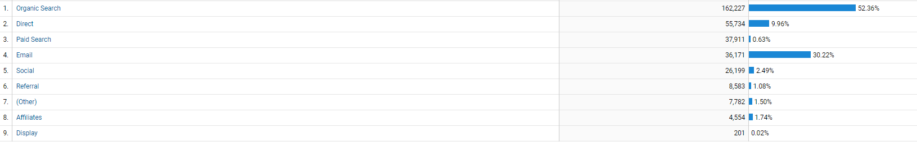
From the information provided it is clear that the organic search option yielded the highest success, Dummies.com suggests that organic search results are the Web page listings that most closely match the search query entered based on relevance (Dummies, 2019), this channel is closely linked to the search engine optimisation tool described previously, this is afforded to the fact that a well optimised page will rank highly in the result of the search engine and as a result drive better traffic to the site, this has clearly had a positive impact upon the revenue generated by this channel as it has attracted 52.36% of the accommodation revenue in the period of 3 months the Early Bird offer ran.
The second highest achieving channel was that of Email marketing, Email marketing at Bluestone consists of transactional and direct email as reference previously. The second figure provided below referrers to instances whereby different marketing events took place and the effect this has on traffic to the businesses webpage, focusing on the “Email” events listed below, it is clear that Email marketing is effective for the organisation as the dates at which traffic spikes typically correlate to a Direct email being issued to the distribution list.
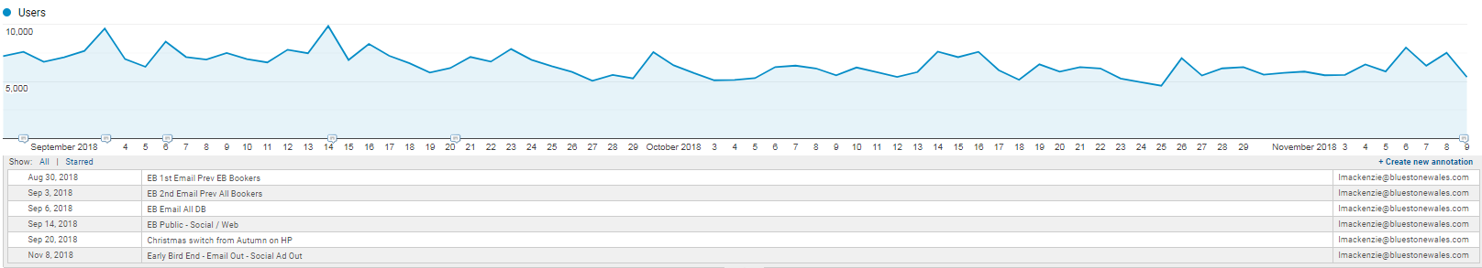
Email marketing was responsible for 30.22% of accommodation revenue during the early bird campaign and its effectivity is demonstrated not only in revenue but in traffic depicted above.
The remaining two channels of interest are that of Direct and Social Media. Direct as dictated by Google analytics refers to the end user directly typing into the search bar, it can be assumed that these visitors are repeat guests who have previously found the site using another channel or recommended guests of previous guests who have provided them a web link, this is typically illustrative of the businesses high repeat guest turnover 9.96% of revenue was generated during the “Early Bird” campaign from Direct search, as this campaign runs annually these guest would have been previously aware and actively seeking this offer.
Finally Social media attracted a 2.49% share of the accommodation revenue, although a relatively small percentage when compared with others Bluestone holds Social Media marketing with high regard as it is clear from the figure above that when coupled with other forms of marketing this has the ability to drive significant traffic to the website, taking September 14th for example, this spike in traffic was as a result of a Social Media post, in a range of other instances Emails and other forms of marketing were coupled with Social Media to increase reach. Further to this Social Media Marketing is not always focused on converting sales at Bluestone, rather a touching point for past present and future guests, it is utilised to plant the seed and keep in contact with these customers to ensure that the brand stays in their mind and is recognisable.

Survey

The primary research conducted was undertaken using a quantitative research approach, using an online survey tool “Survey Monkey” a survey was generated and identified as the most suitable collection method for the statistical data. The survey consisted of 16 questions and were relevant to the information the researcher was looking to establish so that the data could be analysed and compared to secondary data. Participants were generated from social media ensuring a range of demographics were reached all across the UK to establish trends, from the outset of the survey there was a description as to who the researcher was, what it would be used for and the option to not proceed should they not wish to. To avoid any bias when constructing the survey, the survey was checked and tested with a group of colleagues at Bluestone National Park, feedback was taken on board and changes made where necessary to ensure quality data was retrieved.

Logistical and ethical considerations
Logistical factors taken into consideration when conducting the research were mainly time, cost and access to the relevant data, as previously referenced the data provided by Bluestone national park resort was more limited that the researcher had initially hoped but ultimately had little control over. A further factor of consideration was the construction of the survey as a good quality survey would lead to obtaining high quality data, initially this had been thought to be inexpensive, however, upon using the chosen tool Survey Monkey for the number or respondents obtained a fee was required to obtain the data for analysis, the researcher paid a fee of £34.99 for a period of one month to SurveyMonkey in order to obtain the raw data for analysis, the researcher also bought access to the SPSS System for a cost of £38.00 in order to analyse the data. A further cost implication was that of printing when displaying the data, the print services of Doxzoo came recommended due to the professional quality and will be utilised for this reason, the quote obtained for this was £21.09 per copy. There were very limited ethical factors to be considered in undertaking the research as the target audience are free to choose to respond or not do so and it is also not expected to include participants of a vulnerable nature or under the age of consent. A brief description of who the researcher is and what the data is being collected for was provided with the at the beginning of the survey and all surveys were of an anonymous nature. When undertaking the primary research ethical considerations included data protection, each participant had the option to not complete the survey and by continuing agreed that the data could be used for the intended purpose, each record was completely anonymous and is only identifiable by a unique record number to distinguish between responses and only the researcher had access to the password protected laptop and external hard drive where the data was kept to ensure security of the data.

Findings and Analysis
This section is concerned with the results of the research undertaken and analysed from the survey produced. A total of 107 responses were achieved and have been displayed in a range of formats, specifically tables and charts to assist in drawing conclusions from the data created in IBM IPSS and Microsoft Excel and a brief explanation will be provided for each question. In order to provide an in-depth analysis, the researcher has utilised IBM IPSS software to create crosstabulations and identify any correlations in the data set.

Results

Chart - Gender of Survey participants

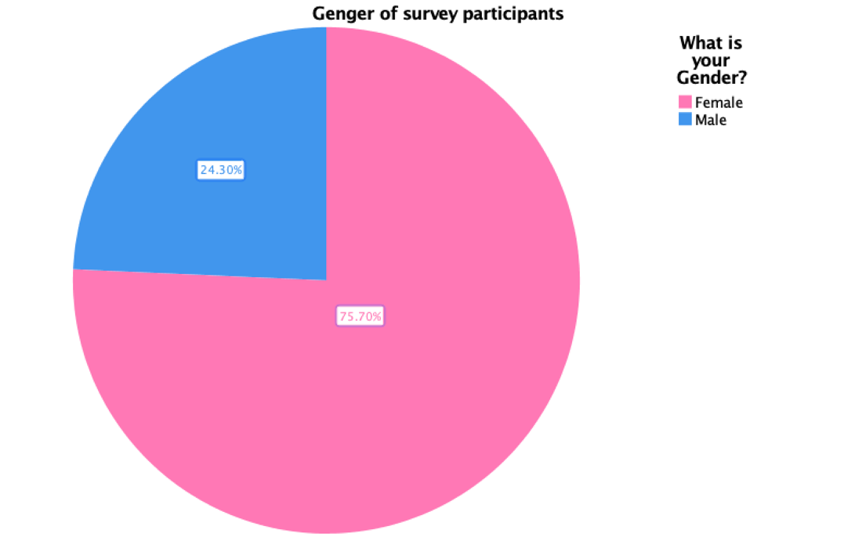
From the pie chart we are able to identify that 24.30% of the participants were Male, whilst 75.70% of the participants were female, with a total of 26 Male participants and 81 Female.

Chart - Country of residence of Survey participants
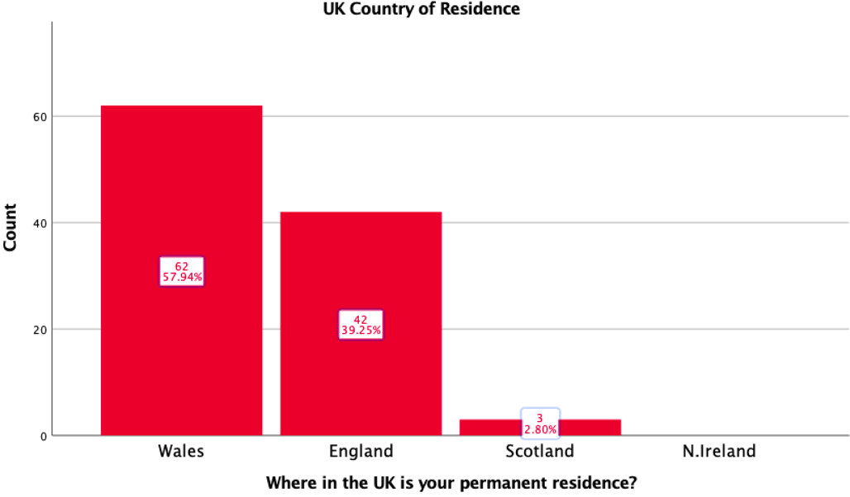
The highest number of participants reside in Wales with 57.94% of the data originating from the country, followed by England with 39.25 with Scotland coming in at 2.80% there was no data obtained from Northern Ireland.

Chart- Age range of Survey participants
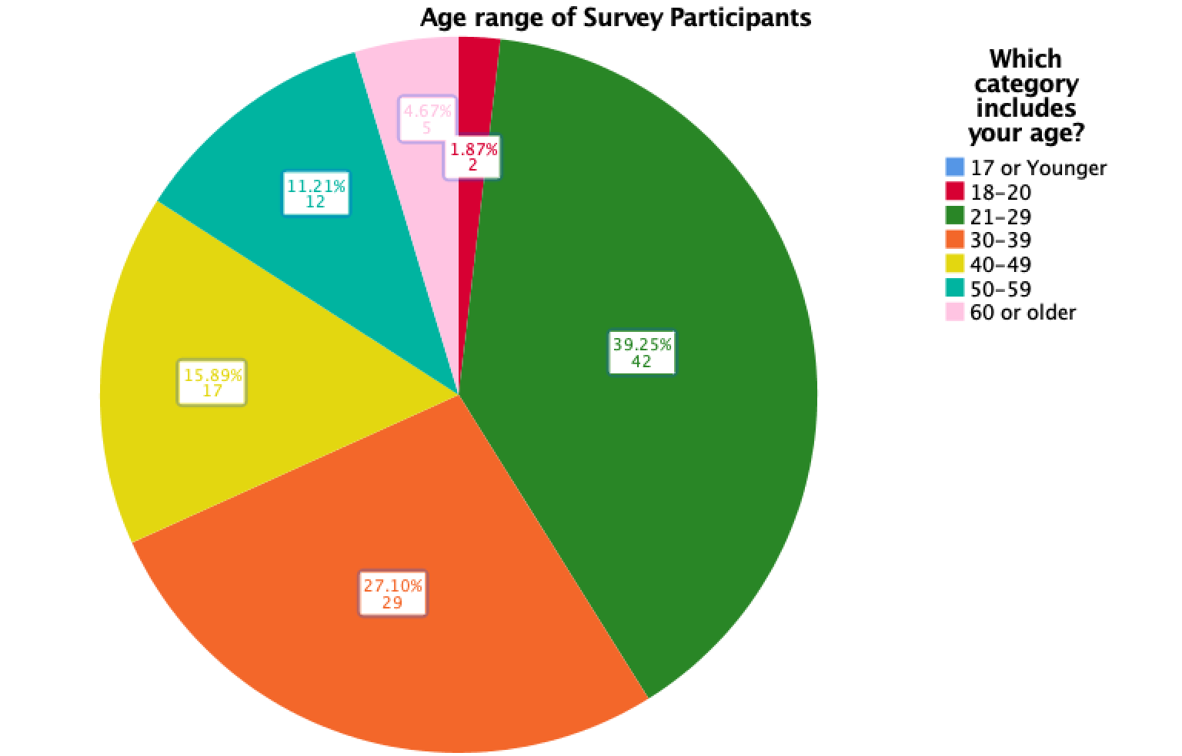
The greatest percentage of Survey participants fall into the “21-29” age range with 39.25% at 42 respondents, followed by “30-39” with 27.10% and 29 responses, “40-49” followed with 15.80% and 17 responses, “50-59” with 11.21% and 12 responses, “60+” 4.67% with 5 respondents, the Survey reached no one 17 years of younger.

Chart- Employment status of Survey participants

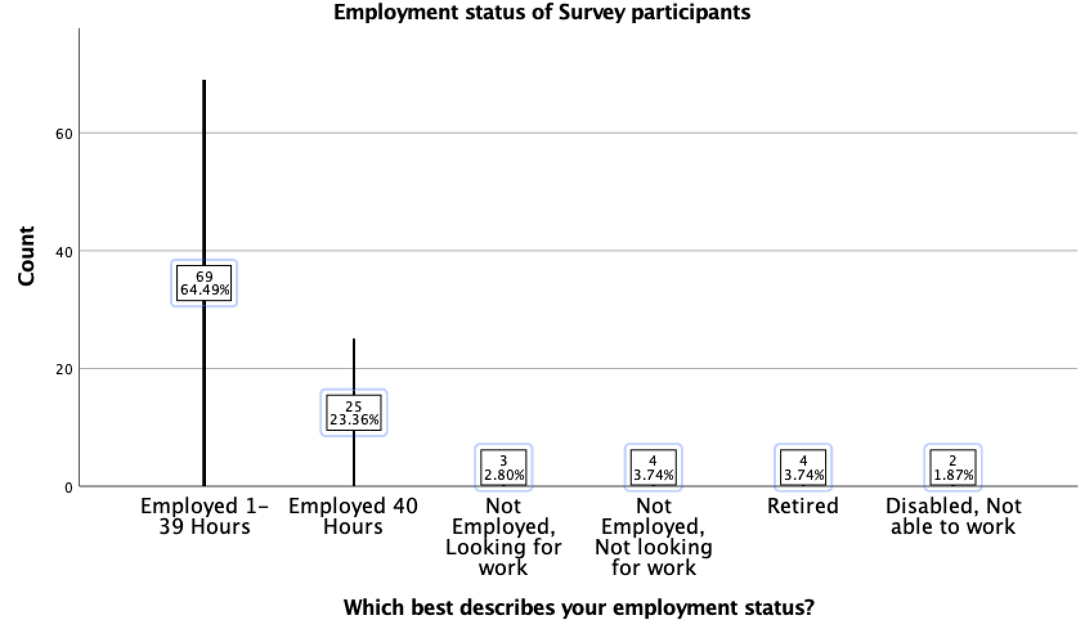
The majority of the participants were employed between “1-39 hours” with 69 responses at 64.49%, this was followed by “40 hours” with 23.36% and 25 responses, 4 responses “not employed, not looking for work” at 3.74% tied with “Retired” with the same amount of responses and percentage, followed by 3 “not employed and looking for work” at 2.80% and finally the survey reached 2 respondents at 1.87% “disabled, not able to work”.

Table – Preferred method of interaction with companies when making a purchase
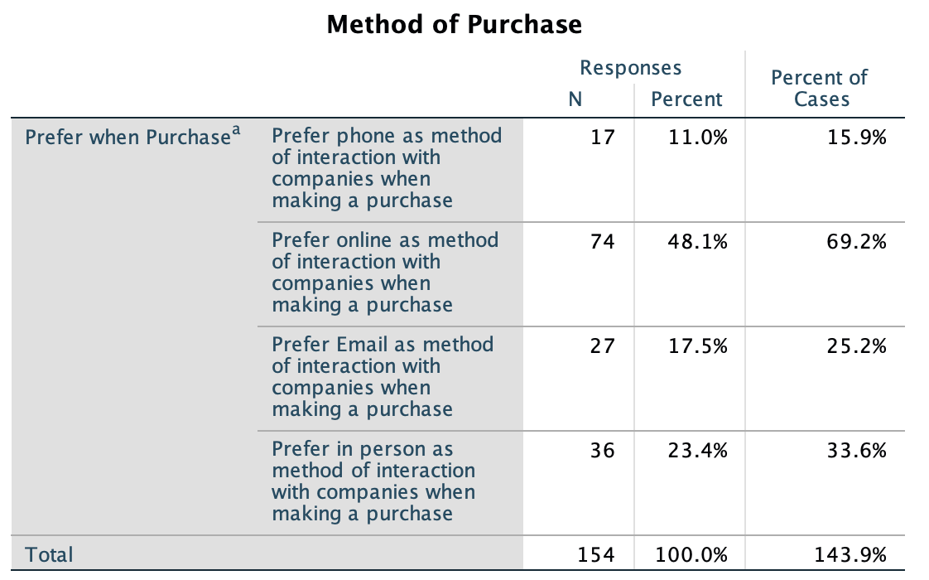
The table above depicts the preferred method of purchase for the 107 participants, the total number of responses exceeds 107 as participants were able to opt for numerous responses and so 154 responses were achieved when choosing how they look to make purchases. The highest percentage of responses was achieved by “Online” with 69.2% of cases opting for this, followed by “In person” with 33.6%, “Email” was the next most popular with 25.2% and “Phone” achieving 15.9%, “Post” is not represented in the table as it achieved no responses.

Table – What participants are most responsive to when making a purchase
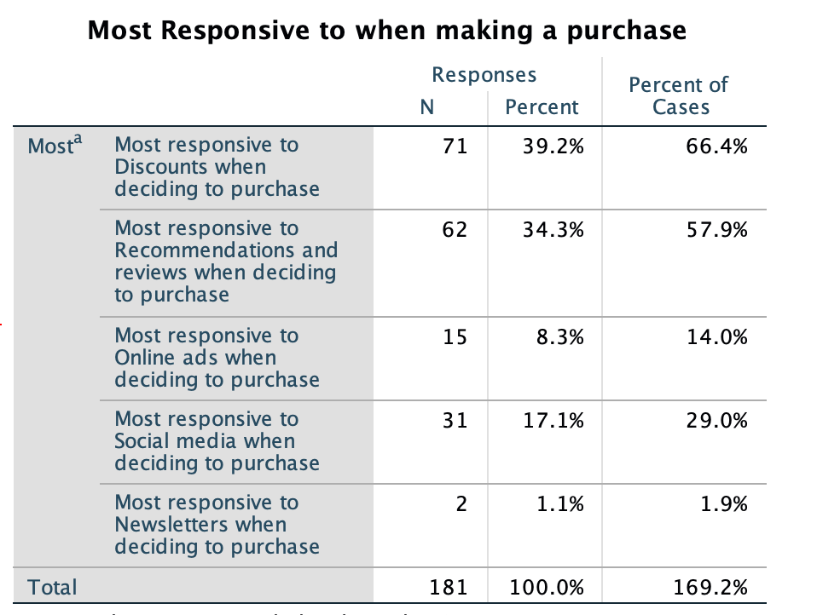
The table above depicts what the participants are most responsive to when making a purchase, of 107 participants the total number of responses exceeds 107 as participants were able to opt for numerous responses and so 181 responses were achieved when choosing what entices them to make purchases. The highest achieving score was that of “Discounts” with 66.4%, this was followed by “Recommendations” at 57.9% then “Social Media” with 29%, followed by “Online Ads” at 14% and “Newsletters” with 1.9%, “Blogs” are not represented in the multiple frequency table as It achieved no responses.

Chart – Average monthly online spend

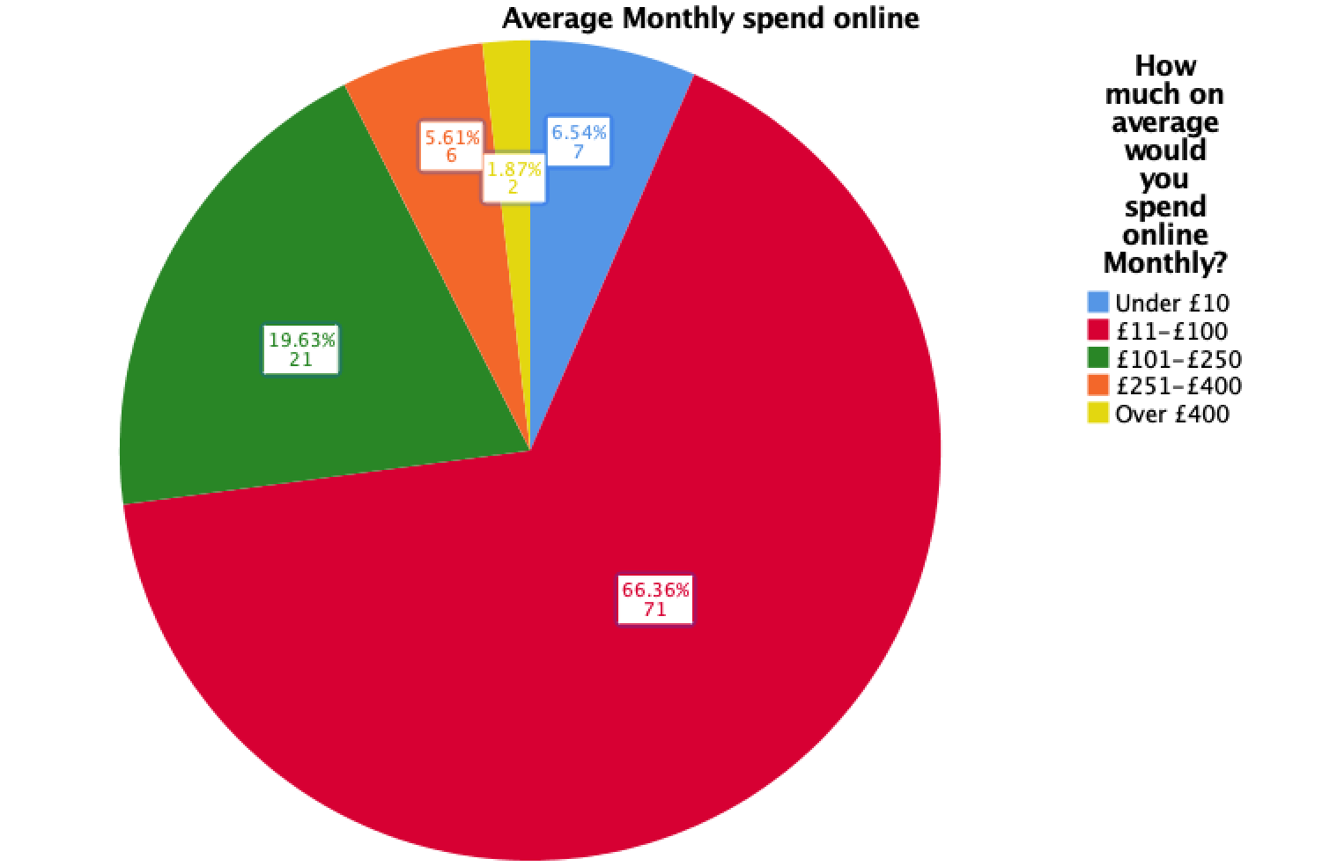
The highest percentage of participants state that they spend between “£11- £100” online achieving 66.36%, followed by “£101- £250” achieving 19.36%, the remaining options received “under £10” 6.54%, “£251 - £400” 5.61% and “over £400” at 1.87%.

Chart – Highest single online purchase within the last year
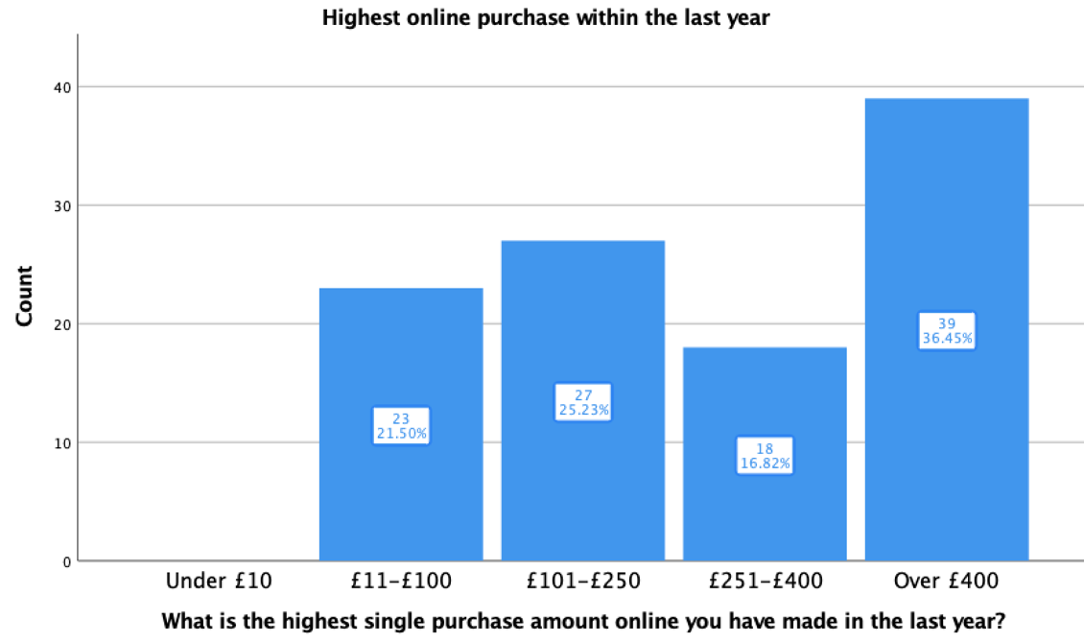
The graph above depicts the single highest online purchase amount as selected by the participants, the highest achieving option being that of “over £400” at 36.45% followed by “£101- £250” at 25.23%, “£11 - £100” with 21.50% and “£251- £400” with 16.82%, under £10 achieved no responses.

Table – Use of social media

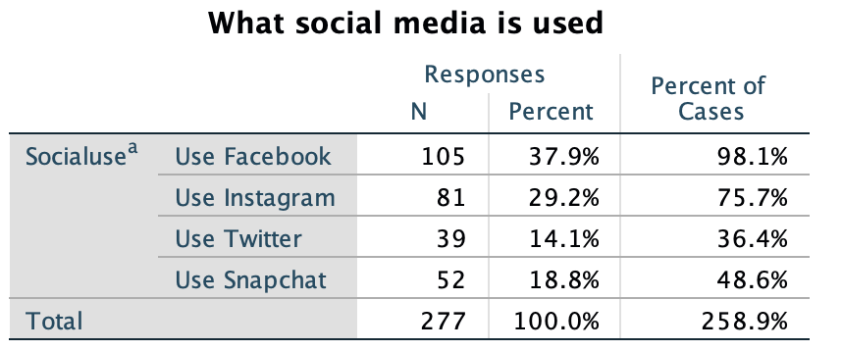

The table above illustrates what social media the participants use, the total number is higher than the total 107 participants as participants were able to choose all of the social media they use hence 277 responses for this question. The highest scoring answer at 98% of cases using the platform was “Facebook”, “Instagram” follows at 75.7%, “Snapchat” at 48.6% of cases and “Twitter at 36.4%.

Table – What social media has influenced a purchase with the last year?

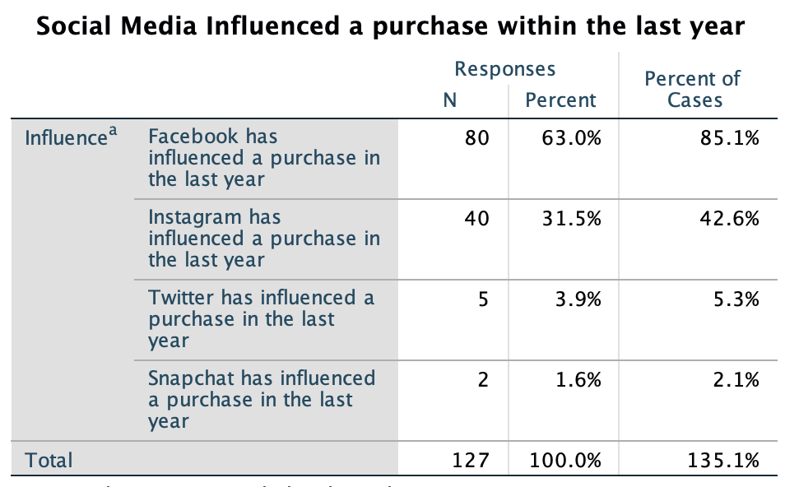

The table above illustrates what social media has influenced the participants to make a purchase within the last year, the total number is higher than the total 107 participants as participants were able to choose all of the social media that had influenced as purchase and so 127 responses were achieved for this question. The highest achieving answer was “Facebook” with 85.1% of cases being influenced by this platform, followed by “Instagram” at 42.6% leaving “Twitter” with a 5.3% share of cases and “Snapchat” with 2.1%.

Table – What forms of Digital Marketing are you exposed to?

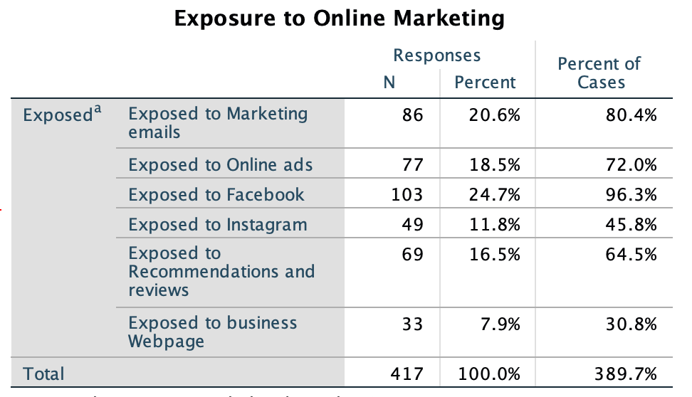

The table above demonstrates what forms of digital marketing the participants have been exposed to, the total number is higher than the total 107 participants as participants were able to choose all of the exposed formats and so 417 responses were achieved for this question. “Facebook Ads” achieved the highest response rate at 96.3% of cases, followed by “Marketing emails” achieving 80.54%, followed by “Online Ads” at 72%, “Recommendations and reviews” at 64.5%, “Instagram Ads” at 45.8% and finally “Business Webpage” at 30.8% of cases.

Table – What forms of Digital Marketing are you most responsive to?
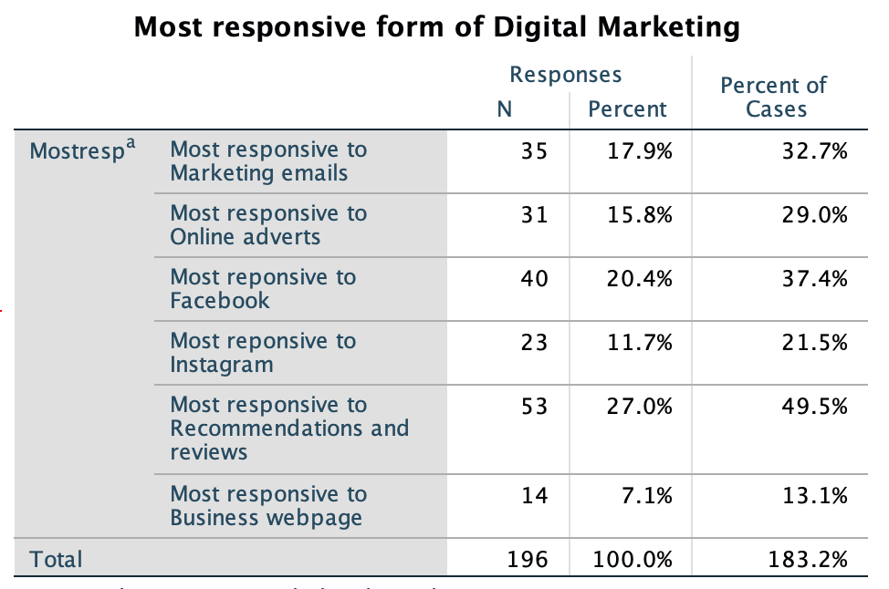
The table above demonstrates what forms of digital marketing the participants feel they are most responsive to, the total number is higher than the total 107 participants as participants were able to choose all of the formats they believe to be effective and so 196 responses were achieved for this question, the highest achieving answer was “Recommendations and Reviews” with 49.5% of cases finding this most influential, followed by “Facebook” at 37.4%, “Marketing Emails” at 32.7%, “Online Ads” at 29%, “Instagram” at 21.5% and “Business Webpage” with 13.1% of cases.

Table – What forms of Digital Marketing are you least responsive to?
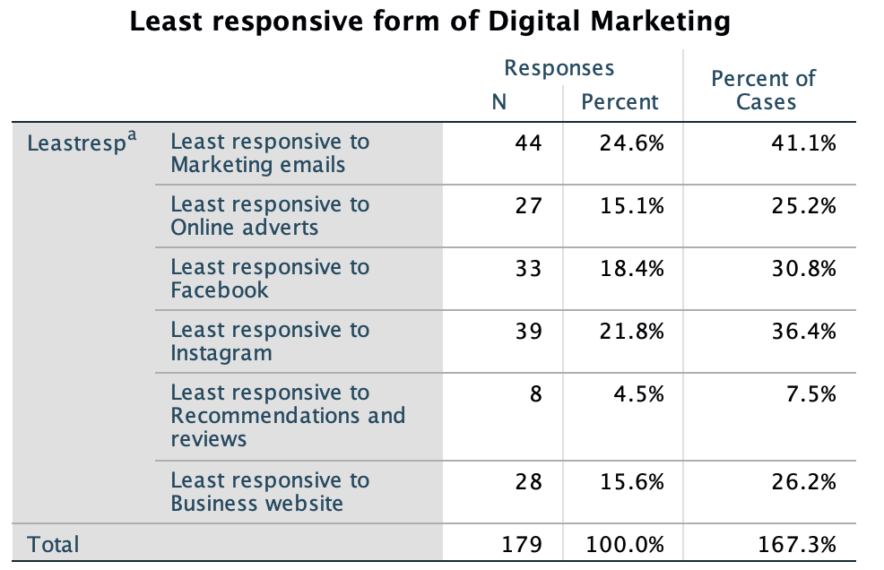
The table above demonstrates what forms of digital marketing the participants feel they are least responsive to, the total number is higher than the total 107 participants as participants were able to choose all of the formats they believe to be least effective and so 179 responses were achieved for this question, the highest achieving answer for this question was “Marketing Emails” with 41.4% of cases deeming them ineffective, followed by “Instagram” at 36.4%, “Facebook” at 30.8%, “Business Webpage” at 26.2%, “Online Adverts” at 25.2% and “Recommendations and reviews” with 7.5% of cases.

Chart – How often do you make online purchases?
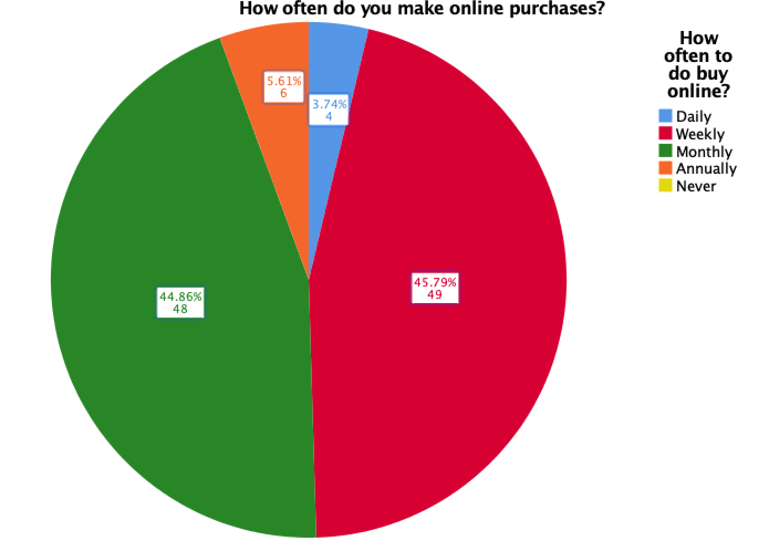
The graph above depicts how frequently online purchases are made as dictated by the participants, “Weekly” achieved the highest response rate with 45.79% of respondents, closely followed by “Monthly” at 44.86%, then “Annually” at 5.61% and “Daily” at 3.74%.

Table – What device do you use to make online purchases?

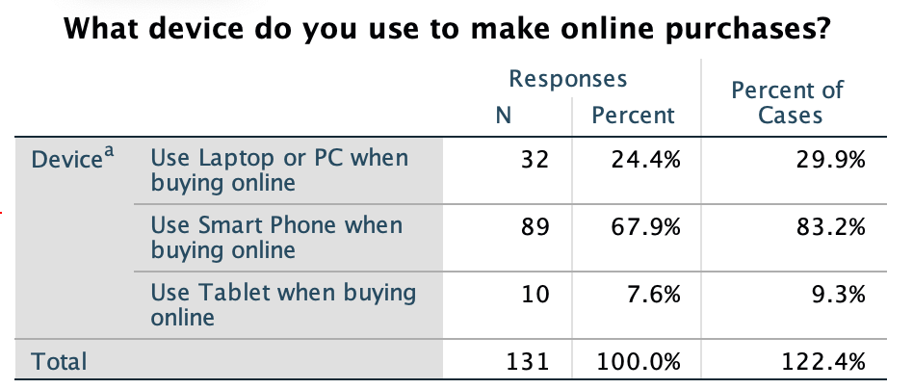
The table above demonstrates what devices the participants use to make online purchases, the total number is higher than the total 107 participants as participants were able to choose all of the devices utilise and so 131 responses were achieved for this question, the highest achieving answer to this question was “Smart Phone” with 83.2% of cases, followed by “Laptop or PC” at 29.9% and finally “Tablet” with 9.3%.

Chart – What is your rough household Income?
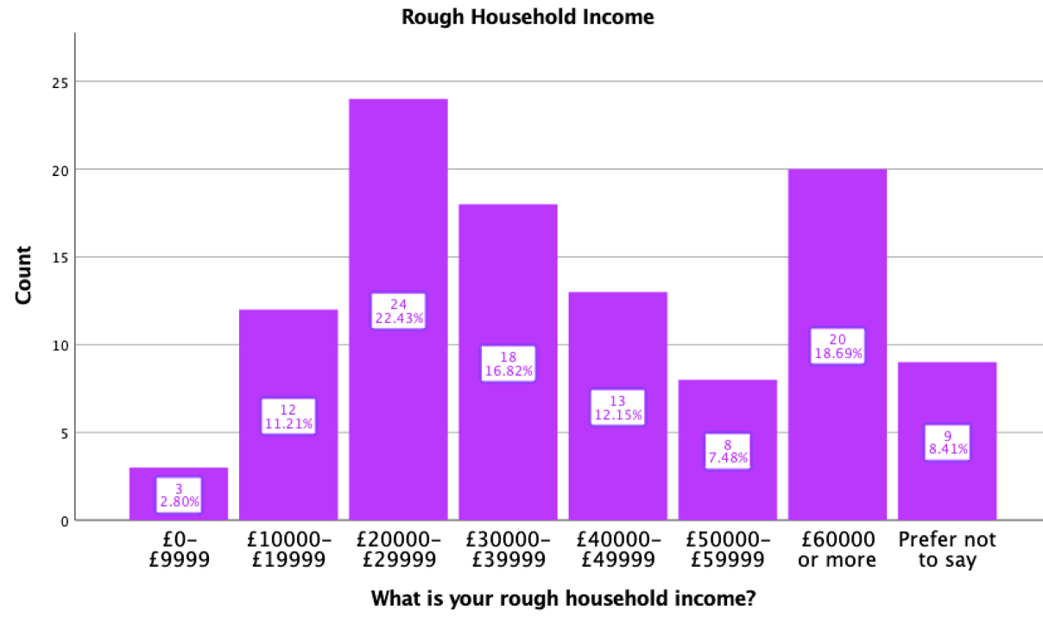
The graph above depicts the rough household income of the participants, the highest achieving answer for this was “£20000-£29999” at 22.43%, followed by “£60000” or more at 18.69%, “£30000-£39999” at 16.82%, “£40000-£49999” at 12.15%, “£10000-£19999” with 11.21%, “Prefer not to say” at 8.41%, “£50000-£59999” at 7.48% and finally “£0-£9999” with 2.80%.

Table – Does gender effect how participants look to make purchases?

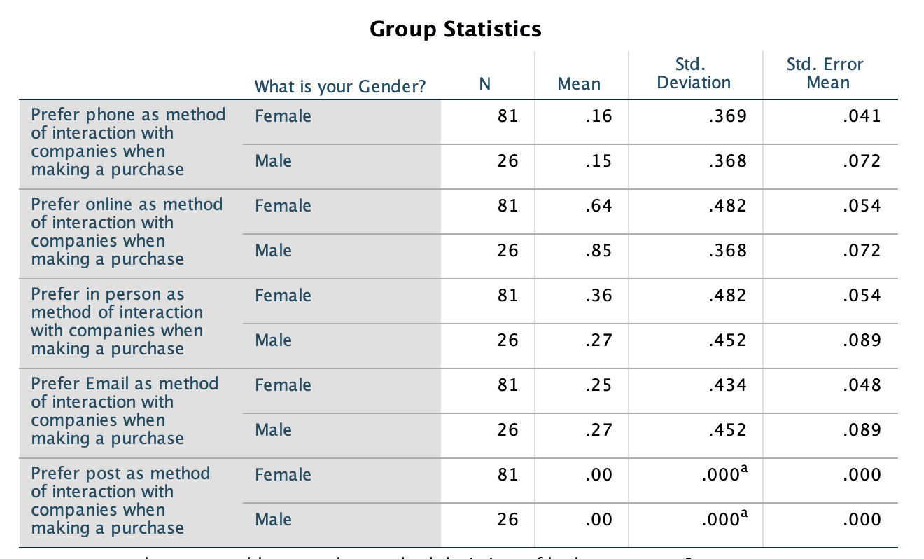
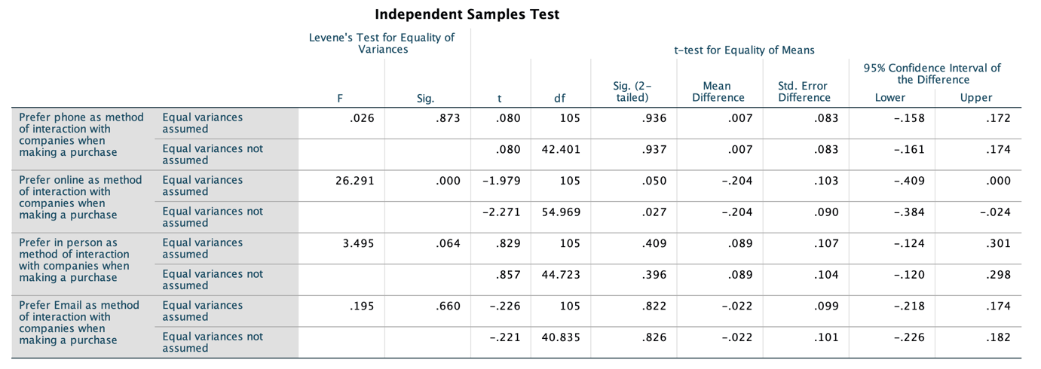
The table above depicts an independent sample test, from which we are able to ascertain that there is no significant difference between male and female participants as to how they look to make purchases.

Table – Does age range determine the success of Digital Marketing?

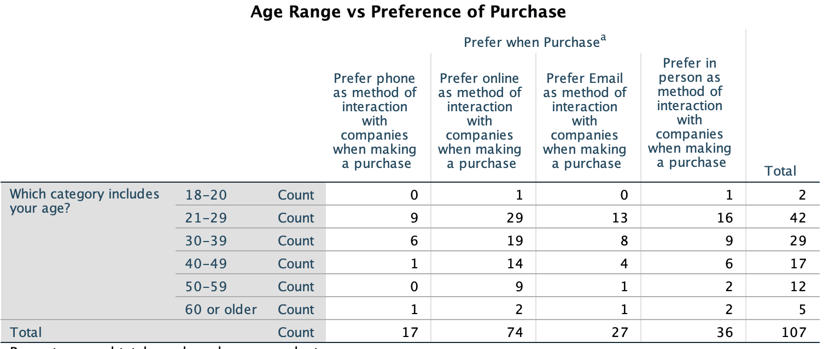
The table above depicts a crosstabulation of age range and preference of purchase, this identifies that digital methods of purchase are more popular across all age ranges, the highest scoring being “Online”, followed in most cases by “In Person”.

Table – Does the use of social media have an effect on online purchases?

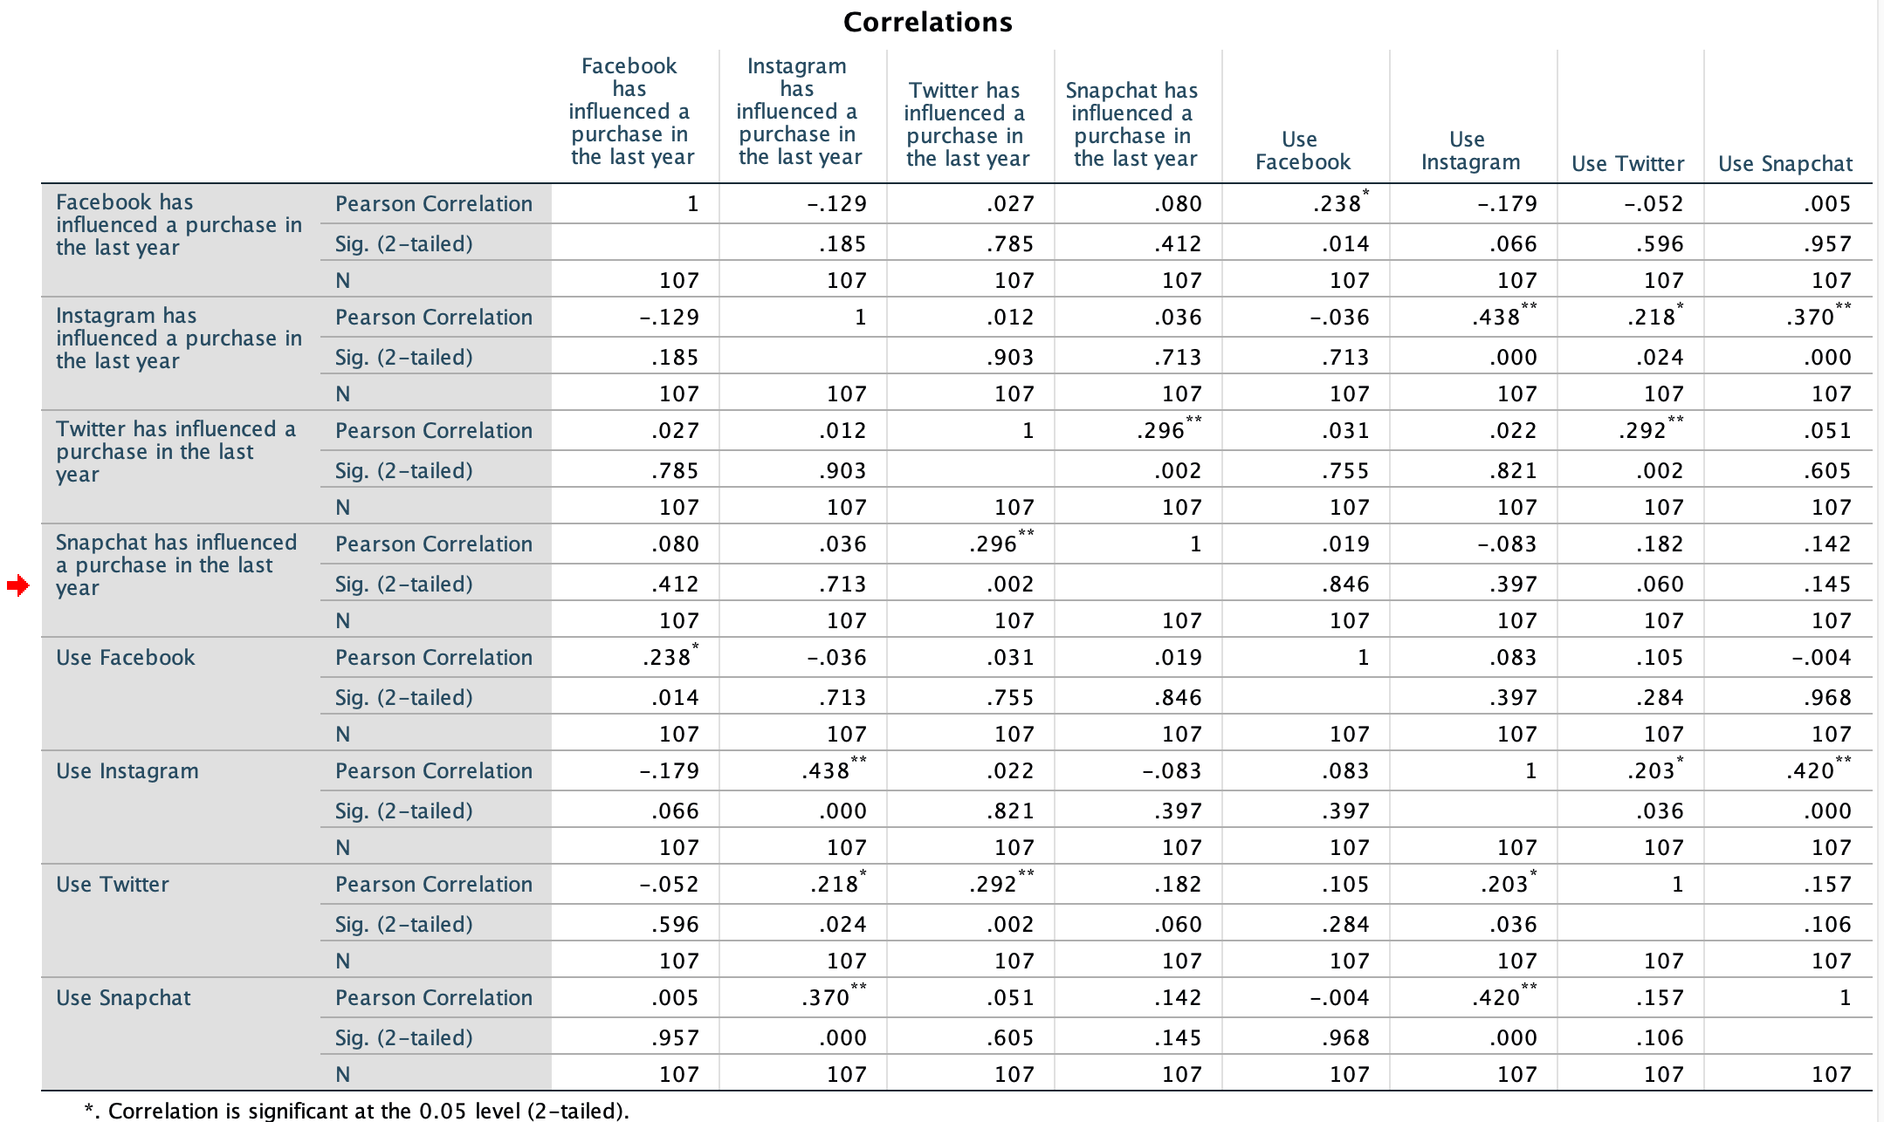
The table above illustrates a correlation test between use of certain social media, and the influence of a sale referral from its use, the table identifies a positive correlation between the use of social media and the influence of a purchase as a result of the social media.

Table – Does age range influence how often purchases are made online?

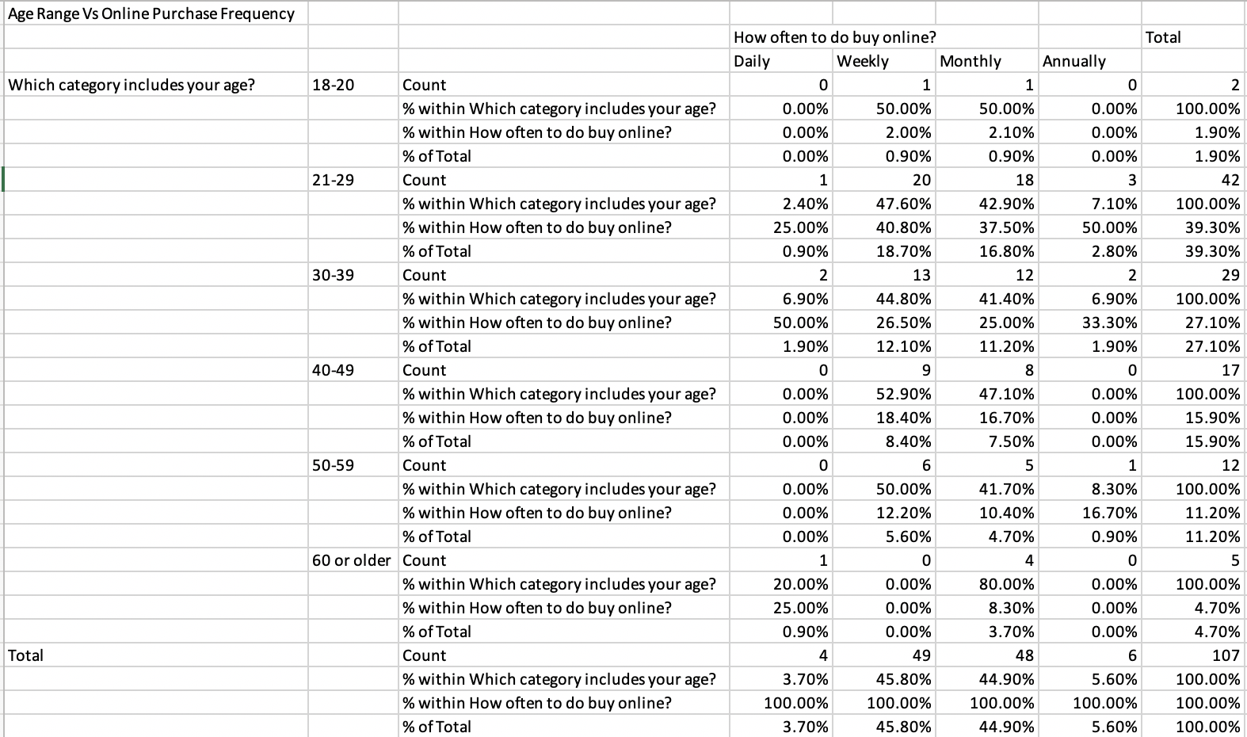
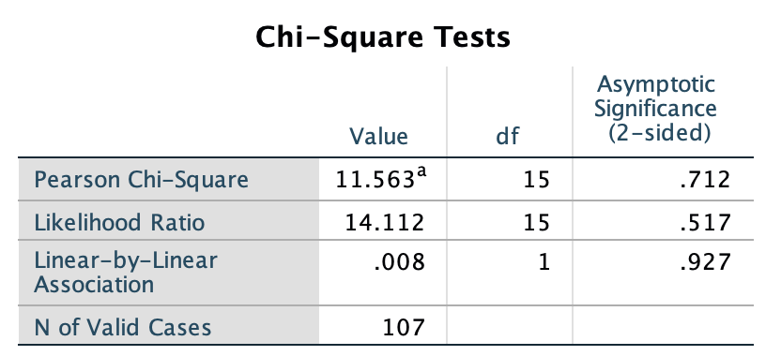
A Chi-Square test identifies that irrespective of age, weekly or monthly online purchases are the most popular.

Analysis

The collection method of the data has been previously outlined in the methodology, analysis of the primary data utilising SPSS and Excel has provided the researcher with a range of information specific to the most effective form of digital marketing from a customer perspective.
Initially it was beneficial to identify the sample group to determine the demographic reached for analysis, the survey reached 107 participants in total 24.3% of which were male and 75.70 female. Participants resided in the UK at a percentage of 57.94% Wales, 39.25% England and %2.80 Scotland, there were no participants from Ireland. the majority of the participants, around 64.49% were employed 1-39 hours. Participants suggest that the most popular spend online is between “£11- £100” online achieving 66.36% of cases, and these purchases are generally made on a weekly or monthly basis “Weekly” achieved the highest response rate with 45.79% of respondents, closely followed by “Monthly” at 44.86%. when asked about their highest online spend within the last year that of “over £400” was most popular at 36.45% followed by “£101- £250” at 25.23%, “£11 - £100” with 21.50% and “£251- £400” with 16.82%, under £10 achieved no responses.
Of the sample group the highest percentage of responses regarding preferred method of interaction with businesses was achieved by “Online” with 69.2% of cases opting for this, followed by “In person” with 33.6%, this demonstrates that Digital marketing should be the pinnacle for which businesses base there strategy around as it is where the vast majority of their customers are most comfortable heading.
Of the sample group, when asked what was most likely to influence an online purchase, the highest achieving answer was discounts” with 66.4%, this was followed by recommendations at 57.9% then Social Media with 29%, unsurprisingly discounts scored highly, however, the researcher was interested to learn of the significance of customer reviews to purchasers of all age ranges, this highlights the importance of content marketing, social media marketing, native and affiliate marketing, in that ensuring reviews and comments surrounding the product or service offered are visible online to promote the sales, social media marketing, native and affiliate marketing in the form of paid for blogs and reviews are typically where people are most comfortable researching a product before purchase.
The use of social media was present in 100% of cases, Facebook proving the most popular with 98% of cases, Instagram follows at 75.7%, coupling this information with the influence of a sale as a result of social media, Facebook was attributed with 85.1% of cases being influenced by this platform, Instagram 42.6% with these to platforms being the most influential it can be accurately concluded that social media marketing is an effective form of digital marketing in the eyes of the consumer.
When diving deeper into the tools of digital marketing, participants suggest that are exposed to Facebook Ads as most frequently with 96.3% of cases, followed by Marketing emails achieving 80.54%, Online Ads at 72%, Recommendations and reviews at 64.5%, Instagram Ads at 45.8% and Business Webpage at 30.8% of cases, when comparing this information to what participants believe to be most effective as identified above Recommendations and Reviews was most highly regarded by the participants with 49.5% of cases finding this most influential, then Facebook at 37.4%, Marketing Emails at 32.7%, Online Ads at 29%, Instagram at 21.5% and Business Webpage with 13.1% of cases, this information paints a positive view of Social media marketing, content marketing and affiliate marketing once again due to its prevalence among recommendations and reviews, however, downplays the significance of online adverts, suggesting a shift from typical banner style web page ads towards a more targeted personalised experience.
When asked what the participants found to be least effective, marketing Emails rated poorly with 41.4% of cases labelling them ineffective similarly Instagram at 36.4%, Facebook at 30.8% performed poorly, this is contradictory to the information provided surrounding the influence of a purchase from social media.
When asked what device participants used most often when making a purchase Smart Phone performed the best with 83.2% of cases, this information speaks volumes towards the importance of content marketing, ensuring that media produced can be viewed on the format at which the customers are accessing it, poorly formatted webpages could lead to reduced interest from consumers and poor sales conversions.
Further analysis identifies that there is no significant difference between male and female participants as to how they look to make purchases, similarly, digital methods of purchase are more popular across all age ranges, this surprised the researcher as this disproves that the younger generation are more responsive to digital marketing.
The research highlights a positive correlation between the use of social media and the influence of a purchase as a result of the social media, once again demonstrating that in the eyes of the consumer social media marketing is deemed to be effective.
Utilising the information obtained from the sample group, in the eyes of the consumer it is evident that Social Media, coupled with affiliate and content marketing are regarded as the most effective, this is reflected in the higher conversation rates of these platforms as dictated by the sample group, it is interesting to learn of the groups distaste for marketing emails.

Discussion
With the primary research concluded the discussion will now look to compare this to the secondary data provided by Bluestone National Park Resort, the first, and most interesting comparison the researcher drew upon was the sample groups distaste for marketing emails, suggesting that they are ineffective when enticing customers to make a purchase, this information is contradictory to the information provided by Bluestone National Park resort, who report Email marketing was responsible for 30.22% of accommodation revenue during the early bird campaign, the researcher hypothesises that the sample group underplay the significance of email marketing due to personal aversion to receiving this correspondence, the secondary data is irrefutable proof that this method of digital marketing is effective.
The data from Bluestone National Park resort suggests that organic search is the most effective source of revenue, this demonstrates the importance of a Search engine optimisation as a marketing technique, as without this a business’s webpage would not rank highly on search engines and not be discovered by searchers, however, consumers once again disagree reporting that they feel a business’s website is one of the least effective sources of influence, the researcher attributes this to the fact that Bluestone National Park Resort has an extremely high level of repeat custom, and so in this case organic search and direct would rank highly for this business as guests who had stayed previously would be aware of the site already, so head immediately to the website, or in-put specific search terms into a search engine in the first instance rather than the need for a referral from other forms of digital marketing.
Bluestone reports that Social media attracted a 2.49% share of the accommodation revenue, whereas the primary research identifies this to be a much more effective source of revenue, once again the research attributes this to the nature of the business used to compare, due to Bluestones higher repeat custom, guests are unlikely to be referred from social media as they are already aware of the offering, the researcher therefore concludes that Social media marketing is a valid and effective form of marketing.
Due to the limited data set provided by Bluestone, further comparison to the primary data was unachievable, the researcher had hoped to compare demographic information from the primary and secondary data to establish any difference here that could explain the difference in findings.
The primary data suggests that the most effective forms of digital marketing are that of Social media, Native and affiliate marketing, the secondary data does not disprove this, but also champions Email marketing and Search engine optimisation, the researcher attributes this difference in findings down to the lack of general awareness of SEO as the general Public are not exposed to search engine optimisation.
The primary research is also not without its limitations, the survey did not reach a range of UK residences and focuses mainly on England and Wales, this will have some baring of the accuracy of this information, furthermore the survey did not provide an “other” section for exposure to online marketing meaning that the researcher could have missed media and the participants could not have shared this.

Conclusion
The primary and secondary data, although providing a range of conflicting information are able to highlight the main champions of digital marketing.
the primary research proves that recommendations and reviews are the most effective in influencing a sale in the eyes of the consumer, these types of reviews can be linked with content marketing, affiliate marketing, native marketing and also coupled with and followed by social media, the researcher therefore agrees with the statement that content marketing opens up a channel of communication with a business audience, providing additional value and speeding up the purchase decision as suggested by (Murphy, 2018) the primary research highlights the value of the in the eyes of the consumer.
Following this with the primary research proving recommendations and reviews to be the most highly regarded by the consumer, Affiliate marketing and native marketing both feature strongly as effective forms of digital marketing, Affiliate marketing as previously defined In the literature review is performance-based marketing, whereby a business rewards each affiliate for every visitor or customer delivered to a business page through the affiliates efforts (Brown, 2009), this could be in the form of a blog, post or any digital media reviewing or promoting a product, similarly as outlined in the literature review native advertising is a paid form of advertising where the advertising material match the form, appearance and function of the content of the media on which it appears. (Vinderslev, 2018)

The secondary research illustrates the most effective form of digital marketing for Bluestone is that of search engine optimisation, similarly in the literature review section Smart Insights suggest that 48% of consumers start mobile research with a search engine, and it is for this reason marketers benefit from the utilisation of SEO. (Smart Insights, 2016) the researcher therefore must conclude that search engine optimisation is one of the most effective forms of digital marketing despite this not having been illustrated in the primary research, once again, the research attributes this to SEO being specialist knowledge and the general public would just regard a well optimised website, as a website at face value.
The secondary research also identifies Email marketing as a strong contender for the most effective form of digital marketing, despite the primary research highlighting that consumers believe they are less receptive to this kind of marketing, Bluestones figure of 30.22% of accommodation revenue during the early bird campaign generated by Email Marketing, it is difficult to come to any other conclusion that its success.
The secondary research also demonstrates that even with a business similar to Bluestone where repeat customer has had an influence on the secondary data, Social media is also a successful form of digital marketing. Although reporting a much lower figure of 2.49% share of the accommodation revenue when coupled with the Primary data, Social media marketing performs in both the eyes of the consumer and the business, as outlined in the literature review (Chaffey, 2019) suggests that consumers are moving more and more towards social media to interact with business and so it makes sense that this is identified as a contender for the most effective form of digital marketing.
In conclusion with the research utilised it has not been possible to identify just one form of digital marketing as the most effective when concerting a sale, rather, this research has identified digital marketing to require a multipronged approach, as demonstrated by Bluestone National Park Resort during its early bird campaign, digital marketing is most effective when a range of elements are utilised in harmony to attract the attention of the consumer, however, with that said the researcher regards Email Marketing, Social Media marketing, and Native, Affiliate and content marketing as the most lucrative forms of digital marketing as a result of the study.

Recommendations
It is recommended that businesses focus not only on identifying one form of digital marketing as the most effective and rather focus on a range of technique to achieve the best conversation of visitors to a business webpage.
For businesses looking to capitalise of digital marketing from this study it is recommended to focus on Email marketing, as proven with the example of Bluestone National Park Resort these are highly effective in attracting revenue despite consumer opinion.
It is also recommended that a focus on Social media marketing, affiliate, native and content marketing in the form of reviews and recommendations receive focus as consumers have self-identified this to be effective.
For businesses utilising social media it is recommended that they ensure quality content is produced and that customer interaction is activity encouraged to promote feedback and reviews, these are typically inexpensive and this study demonstrates them to be highly effective.

Advice for further study
If this study were to be repeated or carried forward there would be a few elements that could be expanded upon or improved, a redesign of the survey to allow for further input from its participants would be advantageous to revive higher quality data for analysis.
For the purpose of this research the researcher had identified a sample of digital marketing methods on which to base the research, a limiting factor is that it would not be possible to delve into all methods and a recommendation for future research would be to focus further on other techniques not touched upon in this research.
The researcher has learned from the research that it is not realistic to identify one form of digital marketing as the most effective, this is as the very nature of the business and the product or service it provides will effect this greatly, however, this research has promoted a further question for the researcher that could form the basis of further study “what forms of digital marketing are most effective when utilised together?” the researcher now feels that this is a more constructive question given the findings of this research.
Even with the mixed findings provided by the study it would be wrong to conclude on a low, although the research has not definitively proven the most effective form of digital marketing, it has provided the top contenders as proven in practise and in the eyes of the consumer and has highlighted a need for a range of Digital Marketing tactics to be deployed for success.

References
Adikesavan, T., 2014. Management Information Systems Best Practises and Applications in Business. Second ed. Delhi: PHI Learning PVT LTD.
Anon, 2012. lardbucket.org. [Online]
Available at: https://2012books.lardbucket.org/pdfs/marketing-principles-v2.0.pdf
[Accessed 14 Oct 2018].

Anon, 2018. professionalacademy.com. [Online]
Available at: https://www.professionalacademy.com/cim-marketing-courses/marketing-theories
[Accessed 14th October 2018].

Bernard J. Jansen, T. M., 2008. Sponsored search: an overview of the concept,history, and technology. Int. J. Electronic Business, Vol. 6(No. 2,).
Brown, B. C., 2009. The Complete Guide to Affiliate Marketing on the Web. In: How to Use and Profit from Affiliate Marketing Programs. Ocala, FL: Atlantic Publishing Company, p. 17.

CellarStone Inc, 2006. QCommission. [Online]
Available at: QCommission.com
[Accessed 03 02 2019].

Chaffey, D., 2002. E-business and e-commerce management. 6th ed. Harlow: Pearson Education.
Chaffey, D., 2017. Smartinsights. [Online]
Available at: www.smartinsights.com/managing-digital-marketing/marketing-innovation/digital-marketing-trends-2016-2017/
[Accessed 07 02 2019].

Chaffey, D., 2018. Forecast growth in percentage of online retail / Ecommerce sales. [Online]
Available at: https://www.smartinsights.com/digital-marketing-strategy/online-retail-sales-growth/
[Accessed 20 04 2019].

Chaffey, D., 2019. Smartinsights. [Online]
Available at: https://www.smartinsights.com/social-media-marketing/social-media-strategy/new-global-social-media-research/
[Accessed 07 02 2019].

Davies, D. J. U., 2016. How has the digital medium revolutionized marketing for SMEs, Carmarthenshire: s.n.

DeFranzo, S. E., 2011. snapsurveys.com. [Online]
Available at: https://www.snapsurveys.com/blog/qualitative-vs-quantitative-research/
[Accessed 14th September 2018].

DeFranzo, S. E., 2011. snapsurveys.com. [Online]
Available at: https://www.snapsurveys.com/blog/qualitative-vs-quantitative-research/
[Accessed 22 02 2019].

DeMers, J., 2016. Is Traditional Advertising Dead?. Forbes, 22 03.
Dummies, 2019. The difference between Organic and Paid Search Engine results. [Online]
Available at: https://www.dummies.com/web-design-development/search-engine-optimization/the-difference-between-organic-and-paid-search-engine-results/
[Accessed 17 04 2019].

Edelman et al, B., 2014. Information and Incentives in Online Affiliate Marketing, Cambridge, Massachusetts: Harvard Business School.

Eisenberg, B., 2019. Marketing Quotes. [Online]
Available at: https://blog.wishpond.com/post/70494294231/50-inspirational-marketing-quotes-2013
[Accessed 20 04 2019].

European Commission, 2018. What does the General Data Protection Regulation (GDPR) govern?. [Online]
Available at: https://ec.europa.eu/info/law/law-topic/data-protection/reform/what-does-general-data-protection-regulation-gdpr-govern_en
[Accessed 17 04 2019].

Facebook, 2018. Facebook. [Online]
Available at: www.facebook.com
[Accessed 2nd November 2018].

Fatema, A. Y. &. S. T. &. K., 2015. Effectiveness of Digital Marketing in the Challenging Age: An Empirical Study. International Journal Of Management Sciene and Bsuiness Administrations, 1 (5), pp. 69-80.

Hubspot, 2018. Hubspot.com. [Online]
Available at: www.hubspot.com/marketing-statistics
[Accessed 07 02 2019].

IBM, 1968. SPSS. s.l.:IBM.
Innovation PEI, 2013 . How You Can Profit from E-Business, Ontario: Province of Prince Edward Island.

JISC, 2007. What is Web 2.0? Ideas, technologies and implications for education, Belfast: TechWatch.

Kenton, W., 2018. investopedia. [Online]
Available at: https://www.investopedia.com/terms/n/native-advertising.asp
[Accessed 03 02 2019].

Kim, L., 2018. wordstream.com. [Online]
Available at: https://www.wordstream.com/ppc
[Accessed 26 01 2019].

Koetsier, J., 2018. Fast-growing marketing automation still has only 3% penetration in non-tech companies. [Online]
Available at: venturebeat.com
[Accessed 03 02 2019].

Kumar, S., 2016. Everything You Need To Know About Content Marketing And How It Works. [Online]
Available at: https://www.pyritetechnologies.com/introduction-to-content-marketing/
[Accessed 20 01 2019].

Linkedin, 2016. Linkedin. [Online]
Available at: Linkedin.com
[Accessed 07 02 2019].

Lunati, M., 2000. REALISING THE POTENTIAL OF ELECTRONIC COMMERCE FOR SMEs IN THE GLOBAL ECONOMY. Bologna, Italy, OECD OCDE.

Martinez, M., 2018. seo-theory.com. [Online]
Available at: https://www.seo-theory.com/the-theory-of-search-engine-optimization/
[Accessed 20 01 2019].

Microsoft, 2018. Word. s.l.:Microsoft.
moz.com, 2018. moz.com. [Online]
Available at: https://moz.com/beginners-guide-to-seo/how-search-engines-operate
[Accessed 20 01 2019].

Murphy, D., 2018. Masterful-marketing.com. [Online]
Available at: https://masterful-marketing.com/content-marketing-benefits-challenges-tips/
[Accessed 20 01 2019].

nibusinessinfo, 2018. NIBusinessInfo. [Online]
Available at: https://www.nibusinessinfo.co.uk/content/advantages-and-disadvantages-email-marketing
[Accessed 17 04 2019].

Nir Vulkan, A. R. a. Z. N., 2015. The Handbook of Market Design. 2 ed. Oxford: Oxford University Press.

P.K.Kannan, 2017. International Journal of Research in Marketing. Digital marketing: A framework, review and research agenda, Volume 34(Issue 1), pp. Pages 22-45 .

Rampton, J., 2017. Forbes.com. [Online]
Available at: https://www.forbes.com/sites/johnrampton/2017/11/20/7-marketing-automation-tools-that-could-change-your-small-business/#1f9dcc95497c
[Accessed 03 02 2019].

Ryan, D., 2014. Understanding Digital Marketing. 3rd Edition ed. London: Kogan Page.
Sathya, P., 2017. A Study on Digital Marketing and its Impact. International Journal of Science and Research (IJSR), Volume 6(Issue 2).

SEConsulting, 2011. Slideshare.net. [Online]
Available at: https://www.slideshare.net/jingzhou/the-benefits-of-using-web-20-applications
[Accessed 20 02 2019].

Shankar, V. J. I. M. M. E. K. a. R. R., 2011. Innovations in Shopper Marketing: Current Insights and Future Research Issues. Journal of Retailing, pp. s29-s42.

Stephen, A. T., 2015. The role of digital and social media marketing in consumer behavior. Current Opinion in Psychology special issue on consumer behavior, p. 3.

Stokes, R., 2008. eMarketing: The essential guide to marketing in a digital world. Fifth Edition ed. s.l.:Quirk eMarketing (Pty) Ltd.

Strategic IC, 2017. Strategic-ic.co.uk. [Online]
Available at: content.strategic-ic.co.uk
[Accessed 07 02 2019].

SurveyMonkey, 1999. SurveyMonkey. [Online]
Available at: www.surveymonkey.co.uk
[Accessed 2nd November 2018].

Techopeida, 2019. Google Analytics. [Online]
Available at: https://www.techopedia.com/definition/1517/google-analytics
[Accessed 17 04 2019].

Vinderslev, A., 2018. nativeadvertisinginstitute.com. [Online]
Available at: https://nativeadvertisinginstitute.com/blog/what-is-definition-native-advertising/
[Accessed 02 02 2019].

Yasmin et al, A., 2015. Effectiveness of Digital Marketing in the Challenging Age: An Empirical Study. International Journal of Management Science and Business Administration, Volume 1(Issue 5), p. 1.

