BA (Hons) Business Management

Portfolio

LCBB5013: Entrepreneurship

Task 1: Business Plan Development

Student Name:
Student ID:
Lecturer’s Name:

Table of Contents
Task 1: Business Plan Development 2
Introduction 2
Element 1: Business Idea, Products/Services, Objectives & USP 2
Element 2: Business Environment & Competitor Analysis 5
Element 3: 4Ps, Market Segmentation & Marketing Strategies 8
Element 4: Financial Planning 12
Conclusion 15
Reference List 16

Task 1: Business Plan Development

Introduction
The purpose of a new business venture is to explore contemporary ideas that are suitable for meeting emerging consumer needs. Entrepreneurship refers to the business strategy where a new idea can challenge the existing practices of the market and create innovative ways of revenue generation (Burns, 2022). The following part includes a business plan named RetrofitIQ, which intends to resolve the carbon footprint of UK-based houses through utilisation of AI-driven smart technologies. The business plan will contain four specific elements to provide a comprehensive analysis of the key considerations for successful business operations.

Element 1: Business Idea, Products/Services, Objectives & USP
Idea and overview of the business plan
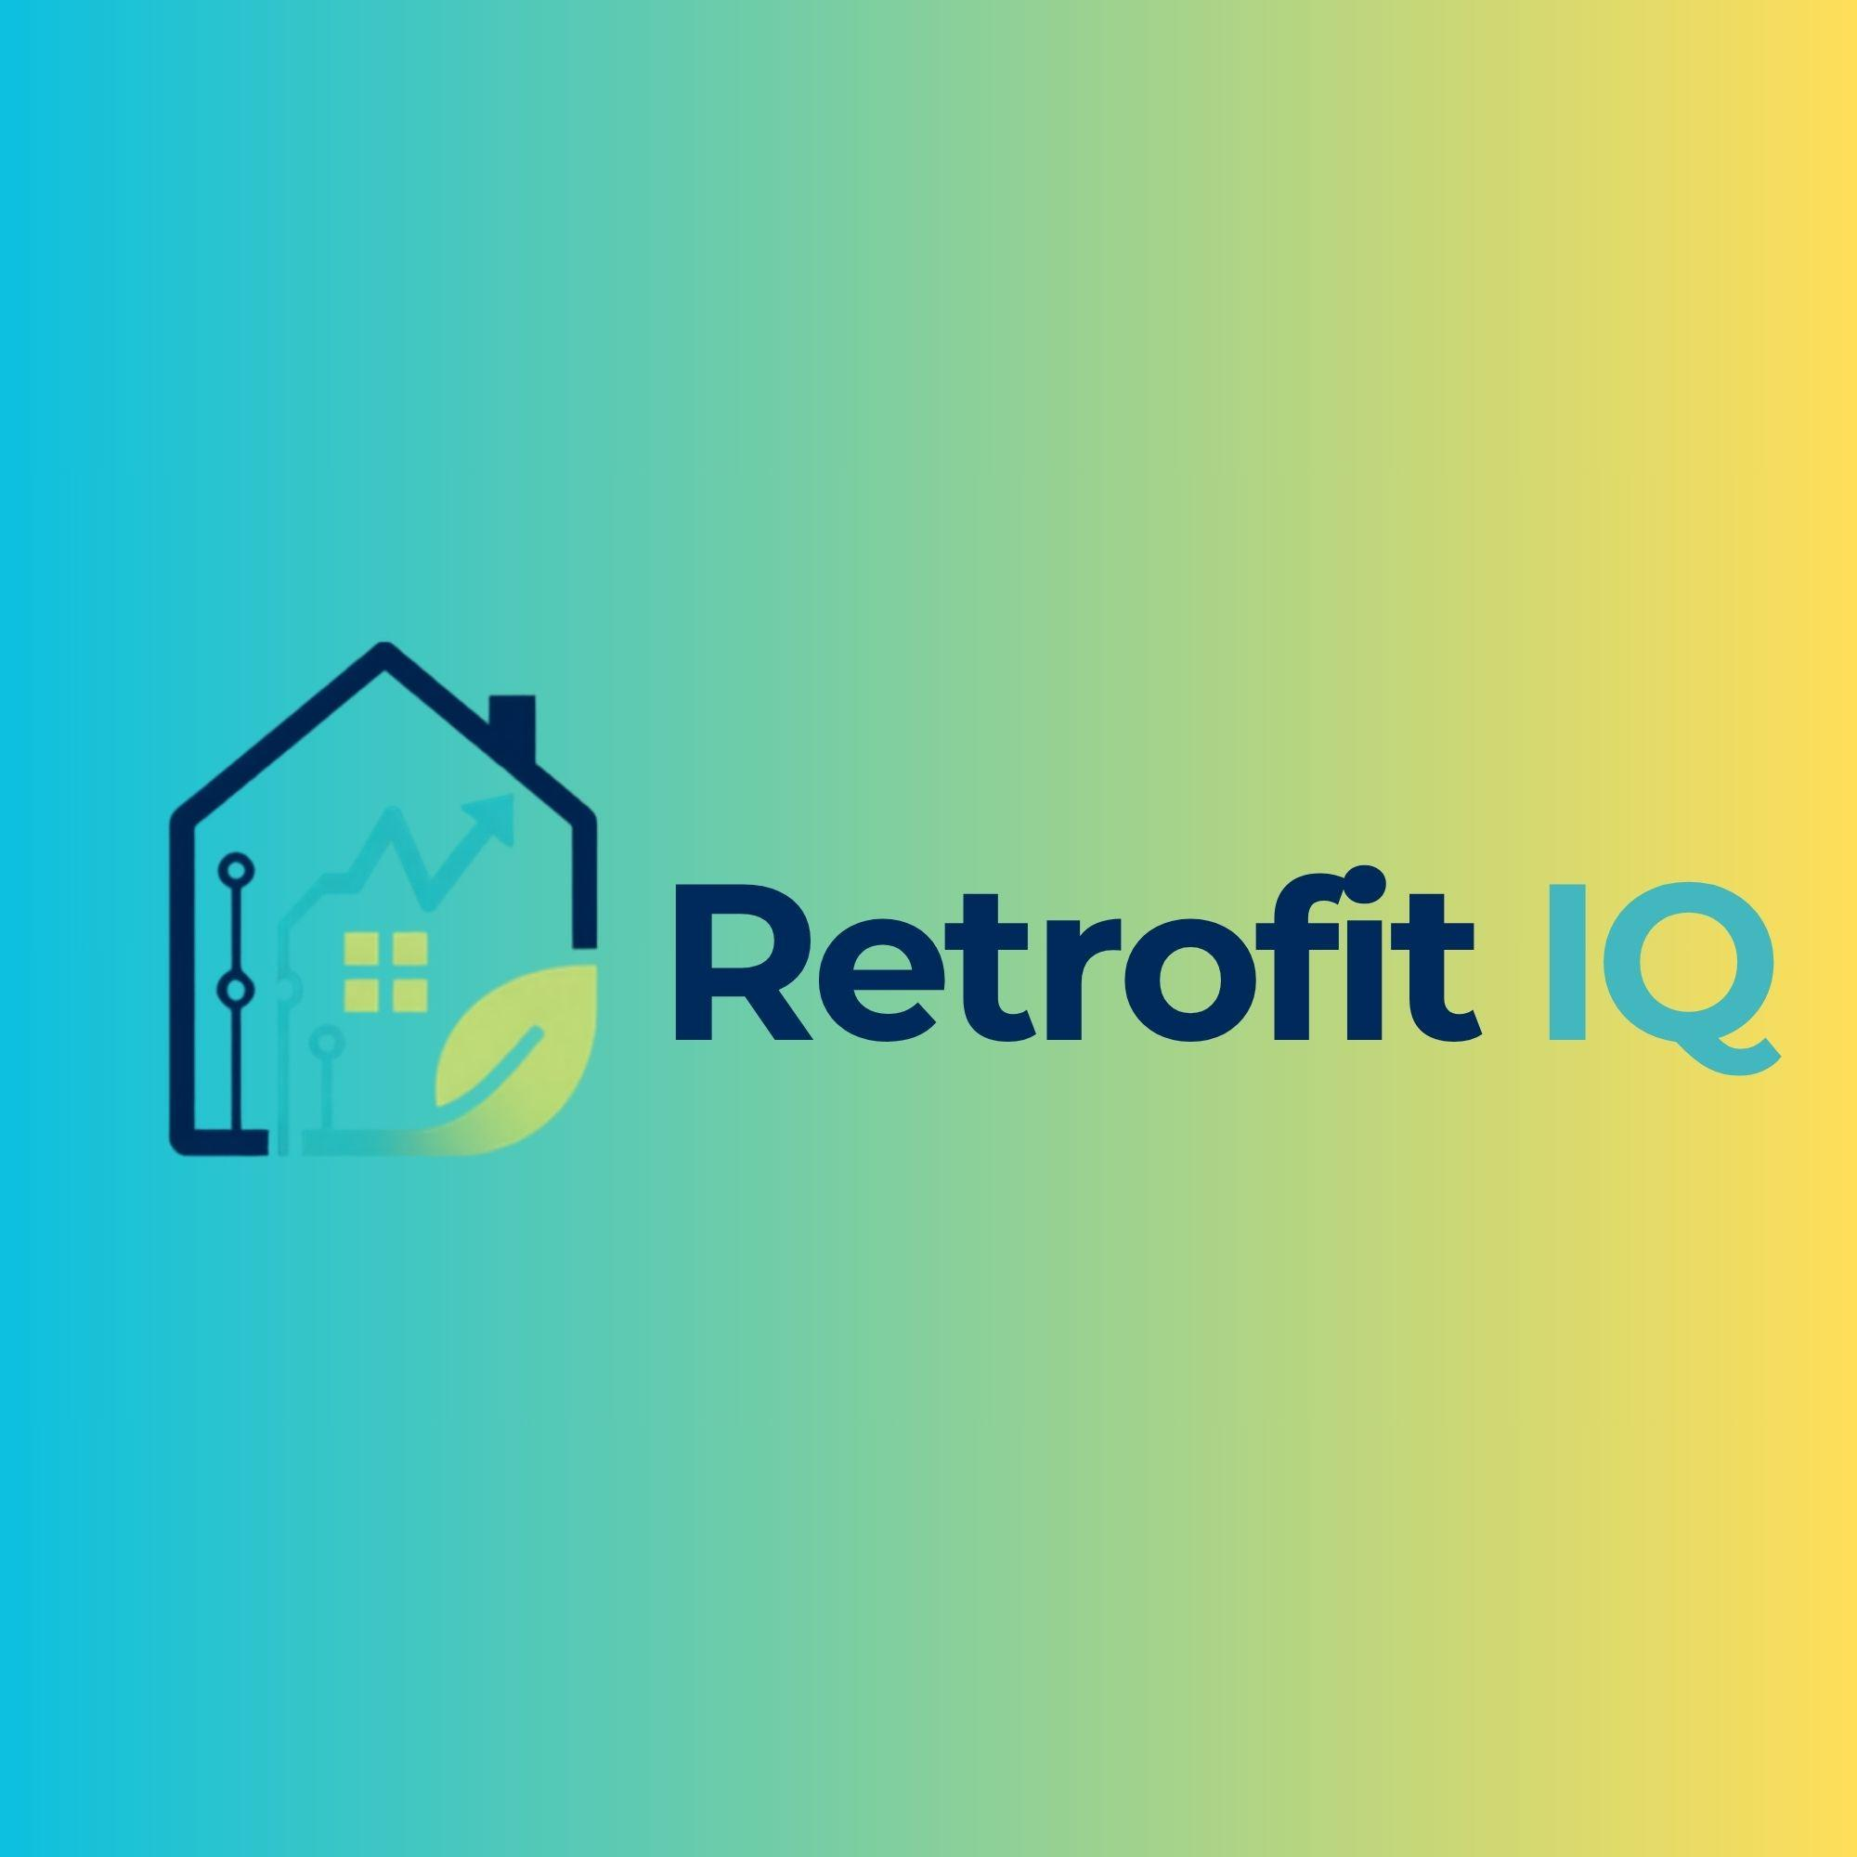
Figure 1: Logo of RetrofitIQ
RetrofitIQ is an innovative idea that intends to implement the power of AI and AI-driven smart technologies to produce exclusive home energy upgrades to reduce the carbon footprint. The idea is to empower the customers with the data accessibility driven by AI regarding the carbon footprint of their household operations and providing the relevant strategies to improve their condition. This business has advantage from the Government-led national decarbonisations initiatives. The primary goal of the decarbonisation of housing initiative is to make UK-based households net zero emissions by 2050 (Ofgem, 2022). Therefore, RetrofitIQ is going to provide its customers with the direct opportunity to become a part of the government-led initiatives as well as any opportunities to access grants.
RetrofitIQ will sell key products and services such as retrofit planning, AI-based energy audits, installation management, and post-installation monitoring of the elements. Each product will have long-term applications into the households, which suggests that the products of RetrofitIQ will provide sustainable passage to these households ensuring their eligibility according to the transforming government norms of sustainable buildings.
Objectives (Short term and Long Term)
Short-term objectives (1 Year)
- To target those houses that are listed for sales and lacks specific sustainable features
- To achieve profitability in two years after the beginning of the business
The first priority RetrofitIQ would be to target those houses, which are in list for sales and they lack innovative sustainable features. According to market research, 93% of the homes listed up for sale lack any kind of “Green” features (Buildersmerchantsnews, 2026). These green features include smart charging points and solar panels, which are minimum needs of a sustainable home in the modern market. The accessibility of nine out of ten listed homes for sale will definitely help RetrofitIQ to access a target market that will help the company to reach profitability in two years of its business, which will be its second short term objective.
Long Term objectives (3 Years)
- To establish at least 10% market share in UK-based housing retrofit services
- To expand the operations in three markets other than the base of operation in Brighton
The long-term objectives of a business mainly involve the intention of developing market leadership through sustainable growth and long-term profitability (Grant, 2021). Therefore, the long-term objectives set for RetrofitIQ would be to maximise its opportunities of low competition in the market and gradually develop its brand reputation as one of the leaders of its respective industry. RetrofitIQ would find its recognition if it becomes eligible to access at least 10% of the market of this emerging industry. Moreover, RetrofitIQ would have to expand its territory in three more locations in the UK so that it could access a greater consumer base available in the UK region.

Unique Selling Point of the company
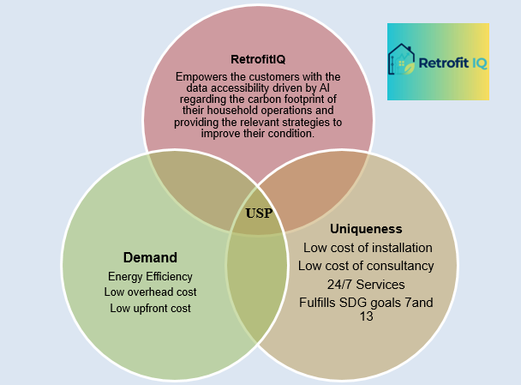
Figure 2: Unique Selling proposition of the business idea
The present scenario of the UK based households reflects the overwhelming condition represented by the volatile economic conditions of the market. However, the government’s initiatives and intention clarifies that the growth only represented through sustainable actions. However, the cost of installation of sustainable materials and their maintenance creates significant routes of continuous costs.
RetrofitIQ will come as a comprehensive solution in this condition and provide the best quality with affordable prices for the retrofit solutions to make these houses compatible with the sustainable demands.
The AI-driven monitoring system adopted within the auditing process will allow the company to use thermal imaging and access public property databases to map out the heat losses of the homes. Moreover, the automated generation of carbon-transition planning will reduce the cost of transportation or any additional costs on behalf of the customers. The automated monitoring system integrated with each feature acquired by customers will resolve the issue of continuous visitation or onsite monitoring, which will reduce the cost of maintenance on a significant scale.

Element 2: Business Environment & Competitor Analysis
SWOT Analysis
Strengths  - Sustainable business proposition  - AI-driven smart features  - Significant target market | Weaknesses  - Lack of awareness among the target consumer  - Emerging segment of the market
Opportunities  - High demand from regulatory and social level  - Major transitions at industry level | Threats  - High economic downturn  - Threat of intense competition

Analysis of internal environment
The business idea of RetrofitIQ will provide itself significant strength considering its primary source of operations. The AI-driven smart auditing and transition planning will provide the company the ability to access and efficiently identify the key heat losses of each house that it will offer its assistance. The business will characterise itself with sustainable goals featuring SDG 7 and SDG 13. SDG 7 targets to achieve universal access to reliable and renewable energy sources for everyone (Guo, 2025). Therefore, the transition planning offered by RetrofitIQ would possess the definite characteristics of sustainable goals. On the other hand, the transition planning and monitoring services provided by the new business will help it to align with the climate action objectives created by global and national regulators. However, the business might face a lack of enthusiasm from the target consumer, as the market is yet to grow enough due to the lack of consumer awareness in the household levels. The business idea can face significant threat in case there is a significant rise of competition and large companies start to invest on this idea. The features offered by the business will definitely provide the long-term benefits required to make a household acceptable according to the criteria set by the government in the next two decades. However, the customers may refrain from choosing this business idea due to the overhead costs and continuous cost of monitoring that equipment.

Analysis of external environment
The key opportunities for RetrofitIQ will come from the emerging changes identified in the external environment. One of the key elements is the requirement of the central government to secure net zero emission levels for every household by the middle of this century. Another great opportunity identified is the market gap present where nine of ten houses that listed for sale in the market lack the minimum features that qualify themselves to secure sustainable identity. However, the economic volatility and downturn produces a serious threat to the growth potentials of the chosen business idea featuring high inflation rates. The latest audits of the UK economy found that the inflation rate of the UK is 2.6% in June 2026 (Harari, 2026). The inflation rate continues to affect consumer expenditure in the UK despite a slight downward trend visible in recent years as the inflation rate remains way above the targeted specifications. The cumulative costs of households remain to be the top challenge that RetrofitIQ will have to overcome in order to; successfully access its growth in the market.
Identification and explanation of four specific competition
The UK based building retrofitting and decarbonisation market is rapidly growing with the direct demand generated from the market. The market projections indicate that 80% of the housing market will have sustainable features by the end of 2050 and 29 million houses are in need of decarbonisation strategies (Parliament, 2024). However, the adoption rate of decarbonisation through retrofitting techniques is very limited, which will help the business idea flourish in the future. The market conditions personify a fragmented ecosystem with more growth of localised and regional SMEs. Therefore, the proposed business could face more localised competition directly rather than organisations with national operations.

Direct competitors
Competitors | Details
Wates Group | The company focuses on large-scale social-housing decarbonisation and its major operations are restricted to the housing complex. The key products sold by Wates Group includes PAS 2035 compliant whose house design, insulations and low-carbon technology rifts (Aegconstruction, 2026).
Mears Group | The primary focus of Mears Group is to target domestic energy improvements in the UK. The core products and services involve onsite surveying, solar PV installation, replacements, and heating efficiency upgrades.

Indirect competitors
Competitors | Details
OVO Group | OVO Group is a large-scale energy equipment supplier for the buildings. The key products sold by this organisation include solar PV, battery storage, thermostats, and heat pump installations. The company can leverage large consumer bases and cross-sell individual green technologies in place of holistic retrofitting programs.
Knauf | Knauf is a UK based building material and insulation manufacturer that supplies raw materials for sustainable housing. The company provides components and parts to the general builders rather than completely involved in the operations of retrofitting.

Element 3: 4Ps, Market Segmentation & Marketing Strategies
Critical discussion on the company’s market segmentation and target customers
Segmentation
The increasing prices of energy bills due to higher consumption rate affect financial stability and livelihoods of the public. In 2022, households in the East of England have been identified to be the largest average domestic consumption while the South East and South West regions reported consumption of national average of 3.4 megawatt hours per household (Rathore, 2026). The target customers RetrofitIQ will be selected based on behavioural, psychographic, and geographic variables under the segmentation process that will allow the company to fulfil dire needs.
Behavioural
Selection of each individual will based on perspective regarding leading a sustainable lifestyle through ethical practices. Based on observation RetrofitIQ will also be able to facilitate a customer centric approach to improve the product for future references.
Psychographic
Psychographic variations will be selected based on habits, values, and interest that will allow the company to promote sustainable awareness and proper use of green energy. Customers will be selected based on lifestyle choices and daily consumption patterns that require a sustainable upgrade for increasing efficiency.
Geographic
Based on the identified area from market research, the product will be marketed in selected regions reporting extensive energy consumption. The target market will be selected based on carbon emission that leads to environmental degradation, harming surrounding neighbourhoods.
Targeting
The process of targeting under the STP context segregates groups of individuals based on traits and characteristics. The process aims to utilise information gathered through everyday observation and online behaviour of consumers, that makes the marketing approach feasible (Gumanti, 2025). RetrofitIQ will target customers based on behavioural traits of purchasing habits, product usages, and buying frequency that will allow them to advertise the product with accuracy.

Psychographic traits will follow aspects of lifestyle, personal values, and interest that reciprocate ethical and sustainable perspectives. Based on market research, geographic variables will select regions of Headington and North ward, Hove Park and Withdean, Bath and North East Somerset in cities like Oxford, Brighton, Hove, Southampton (South East) and Bristol, Bath, Plymouth (South West) throughout the UK.
Behavioural | Purchasing habits | Sustainable products, ethically aware, low carbon output
Behavioural | Product use | Everyday use, reliable, longevity, no waste policy
Behavioural | Buying frequency | Frequent, upgrading as per requirement, affordable products, investment based on returns
Psychographic | Lifestyle | Ethically and sustainably driven, contributes to community wellbeing, ecological practices in everyday life
Psychographic | Values | Environmental protection, long term responsibility, eco-friendly integrity
Psychographic | Interest | Affordability, durability, technologically efficient
Geographic | Location | United Kingdom
Geographic | City | Oxford, Brighton, Hove, Southampton (South East)  Bristol, Bath, Plymouth (South West)
Geographic | Region | Headington and North ward, Hove Park and Withdean, Bath and North East Somerset

Positioning Map
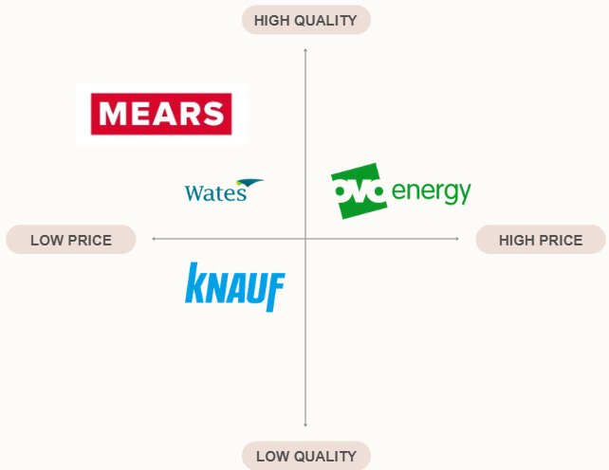
Figure 3: Competitor positioning map for RetrofitIQ
The above illustration represents current competitors for the company, which are, Wates Group, Mears Group, OVO Group, and Knauf. Competition will be significant for RetrofitIQ as both direct and indirect competitors have significant establishments in the UK market. RetrofitIQ will follow the quadrant of high quality and low price to retain customers more prominently.
4Ps of marketing mix
Product:
Comprehension of market gaps helps in product orientation and development process that aims to bridge existing gaps while fulfilling unmet customer needs (Dermawan et al., 2023). RetrofitIQ is an AI driven domestic retrofit business that uses smart software to plan and install home energy upgrades. The company will also focus on empowering customers with data accessibility driven by AI integration to control the carbon footprint of household emission rates in the UK.

Price:
Maintenance of price ranges regarding an innovative idea retains customers for a longer period while promising product durability (Liu, 2025). RetrofitIQ will focus on value based pricing strategies that will allow the company to consider customer perception, benefits, rather than production cost or competitor rates. In addition, the company will be able to foster trust, transparency, and engagement throughout the target base.
Place:
Selection of an area for logistics and distribution ensures that operations and management of a company faces no barriers that can harm supply and demand probability (Setyadi et al., 2025). RetrofitIQ will hold logistics and manufacturing hubs in the UK that will distribute products in cities like Oxford, Brighton, Hove, Southampton (South East) and Bristol, Bath, Plymouth (South West) throughout the UK.
Promotion:
Orientation of an effective promotional strategy helps a company to build online visibility while dealing with increasing competition (Raharjo, 2025). RetrofitIQ will focus on using digital marketing strategy by using several online platforms like Facebook, Instagram, TikTok, Twitter (X), and YouTube to promote the product. This will help the company to gain the attention of customers while building a long-lasting client base.
Online marketing strategy
Probabilities of involving effective online marketing strategies not only boost online visibility but also help to understand current market dynamics, trends, and consumer preferences. Adoption of innovative marketing strategy demonstrates the innovative standpoint of a new business while demonstrating unique product characteristics to target consumers (Nyquist, Farshid, and Brown, 2025). RetrofitIQ will opt for a social media marketing process that will allow the brand to reach a larger audience. Orientation of marketing will based on setting SMART goals that will help to build engagement with customers. Frequent content posting and tracking progress with the help of KPIs will ensure building visibility in different platforms. The company will also invest in Pay per Click advertisement and purchased ads that will help to increase visibility of each post among the target audience.

Explanation on attracting and retaining customers
Social media marketing will be able to draw in customers based on holistic content uploaded frequently online and through paid advertisement. The algorithms of each social media platform will be able to push paid advertisements among target markets that will convert market leads to potential customers. Customers will be retained based on integration of customer value and engagement that will serve the purpose of increasing sustainable awareness. Direct interaction through online channels will be beneficial for the company to understand preferences, and to resolve queries of target audiences.

Element 4: Financial Planning
Projected financial figures
Total Revenue of first six months
Fixed Costs
Software and AI Infrastructure | 45.000
Regulatory & Compliance | 10.000
Core Team Salaries | 10.000
Office & Administration | 5.000
Total | 70.000
Figure 4: projected revenue of first six months
Start-Up Costs
Cloud & AI Processing Fees | 5.000
Claims Pay-outs | 6.000
Customer Acquisition Cost | 600
Third-Party Data & API Costs | 6.500
Total | 140.000
Figure 5: Start-up expenses
The first six months of revenue for the business would be 140.000 GBP while the proposed business would accumulate of worth start-up costs. The table above shows the key elements required to establish the business.

Projected profit
 | Jan | Feb | Mar | Apr | May | Jun
Fixed cost | 60.000 | 60.000 | 60.000 | 60.000 | 60.000 | 60.000
Variable Cost | 130.000 | 143.000 | 157.300 | 173.030 | 190.333 | 209.366
Total Cost | 190.000 | 203.000 | 217.300 | 233.030 | 250.333 | 269.366
Revenue | 160.000 | 184000 | 211600 | 243340 | 279841 | 321817.15
Profit/Loss | -30.000 | -19.000 | -5.700 | 10.310 | 29.508 | 52.451

Figure 6: Six Month projects of profit
The profit statement depicts that the business would start to see profit from its second year of operations.
Break even analysis

Figure 7: Break-even point of the business
The break-even point provides the financial condition where the business is able to accumulate per unit cost from its sales (Rosenbaum and Pearl, 2021). RetrofitIQ will be able to generate income from the end of the first year of its operations as per the graph.

Proposed business funding procedures and relevant risks
Source of funding | Details about reason for selection
Government and innovation sector grants | The Innovate UK grant can provide sector specific grants that are ranging from 50.000 GBP to 1 million GBP (Federation of Small Businesses, 2026). These sources are most secure as they provide limited complications in terms of interest rates and meeting the criteria.
Green Business Loans | Green business loans are exclusive segments of offers provided by financial institutions located in the UK. Key companies such as NatWest, Triodos, and Development Bank of Wales provide dedicated asset lending schemes. The bank loan is a secured source of accessing funding as it provides restrictive policy of interest rates and accessibility of funding (Ivashina, Laeven, and Moral-Benito, 2022).
Personal Investment | Personal investment in entrepreneurship is a popular choice of funding as majority of the time the businesses ideas become unacceptable from the expected lending authorities. Personal investment is advantageous in terms of decision-making, profit earning, and ownership of the business.

Funding process | Risks or limitations
Government and innovation sector grants | RetrofitIQ could face significant competition in accessing the government grants due to the high competition, strict scope regulations, and the milestone-based reimbursements. The grants can affect business decisions of spending and using the funds at the owner’s will and progressive techniques.
Green Business Loans | The green business loans require strict qualification and evidence of the business meeting the principles established by the banks (Matthews, Thompson, and Zhang, 2023). Therefore, RetrofitIQ could face significant barriers in case it intends to borrow money upfront before execution of any business.
Personal Investment | Personal savings can become subject to loss and the business owner has to bear it without any assistance.

Conclusion
This part of the portfolio establishes key alternatives and measures to secure a successful business proposition in the name of RetrofitIQ. The section discusses authentic action and environmental specifications that depicts the feasibility of the dimensions incorporated in the business plan.

Reference List
Task 1
Aegconstruction (2026) Top 10 Retrofit & Decarbonisation Companies UK 2026. [online] AEG Construction Ltd | Energy Efficient Installations & Retrofit. Available at: https://aegconstruction.co.uk/top-10-retrofit-and-decarbonisation-companies-in-the-uk/ (Accessed: 30 June 2026).
Buildersmerchantsnews.co.uk. (2026). Report finds 93% of homes up for sale lack “green” features. [online] Available at: https://www.buildersmerchantsnews.co.uk/news/merchants/report-93-homes-sale-lack-green-features (Accessed: 31 June 2026).
Burns, P., (2022) Entrepreneurship and small business. Bloomsbury Publishing.
Dermawan, M., Rini, E.S., Sembiring, M.T. and Budiman, I., (2023, June) ‘SWOT Analysis and Marketing Mix 4P Model as a Method to Develop Strategic Plan for Newly Marketed Agricultural Corn Seed Product’, In IOP Conference Series: Earth and Environmental Science (Vol. 1188, No. 1, p. 012027). IOP Publishing. https://doi.org/10.1088/1755-1315/1188/1/012027
Federation of Small Businesses (2026) The Small Business Guide to Green Business Grants. [online] Interflora Floristry Trade Club. Available at: https://www.floristrytradeclub.co.uk/post/the-small-business-guide-to-green-business-grants (Accessed: 30 June 2026).
Grant, R.M., (2021) Contemporary strategy analysis. John Wiley & Sons.
Gumanti, R.M., (2025) ‘A Coffee Shop Marketing Strategy Analysis Using STP and the Ansoff Matrix: A Systematic Literature Review’, Al-Kharaj: Journal of Islamic Economic and Business, 7(4). https://ejournal.iainpalopo.ac.id/index.php/alkharaj
Guo, H., (2025) Big Earth Data in Support of the Sustainable Development Goals (2023)-The Belt and Road. Springer.
Harari, D. (2026) Economic update: The new Prime Minister, inflation and the cost of living - House of Commons Library. [online] House of Commons Library. Available at: https://commonslibrary.parliament.uk/research-briefings/cbp-10975/ (Accessed: 30 June 2026).
Ivashina, V., Laeven, L. and Moral-Benito, E., (2022) ‘Loan types and the bank lending channel,’ Journal of Monetary Economics, 126, pp.171-187. https://www.sciencedirect.com/science/article/pii/S0304393221001331
Liu, H., (2025) ‘Research on Digital Marketing Strategy Optimization Based on 4P Theory and Its Empirical Analysis’, MODERN ECONOMICS, 6(1), p.110. https://en.front-sci.com/index.php/memf/article/view/3564/3855
Matthews, K., Thompson, J. and Zhang, T., (2023) Economics Of Banking, The. World Scientific.
Nyquist, A.M., Farshid, M. and Brown, T., (2025) ‘Employing digital twin technology in the pursuit to avert sustainable marketing myopia’, Journal of Research in Marketing and Entrepreneurship, 27(2), pp.277-293. https://doi.org/10.61942/oikonomia.v2i3.358
Ofgem. (2022) Energy Company Obligation (ECO). [online] Available at: https://www.ofgem.gov.uk/environmental-and-social-schemes/energy-company-obligation-eco (Accessed: 1 Aug 2026).
Parliament. (2024) Retrofitting homes for net zero. [online] Available at: https://publications.parliament.uk/pa/cm5901/cmselect/cmesnz/453/report.html (Accessed: 1 Aug 2026).
Raharjo, J.F., (2025, April) ‘Analysis of the Implementation of the 4P Marketing Mix Strategy (Product, Price, Place and Promotion) to Increase the Income of Boarding Business Actors’, In Cirebon Annual Multidiciplinary International Conference (CAMIC) (pp. 465-470). https://conference.ugj.ac.id/index.php/camic/article/view/10092/4552
Rathore, M., (2026) UK electricity consumption - statistics & facts. Available at: https://www.statista.com/topics/4931/electricity-consumption-in-the-united-kingdom-uk/?srsltid=AfmBOooL8_F20DKJAYd8zC7iH-kNv_VHgosGmoX-RYSoAQGDaHr0vL45 (Accessed: 31 June 2026).
Rosenbaum, J. and Pearl, J., (2021) Investment banking: valuation, LBOs, M&A, and IPOs. John Wiley & Sons.
Setyadi, D., Soesanto, R.H., Hidayat, D., Dosinaeng, W.B.N. and Mampouw, H.L., (2025) ‘The Digital Cognitive Partner: A 4P Framework Analysis of Prospective Teacher Creativity in the Age of AI’, Jurnal Pendidikan MIPA, 26(3), pp.1958-1987. http://dx.doi.org/10.23960/jpmipa.v26i3.pp1958-1987

GAI Declaration
"I want to declare that I have not taken any assistance of any AI tools and applications in forming any section of the portfolio. I have read every guidelines of the university and maintained integrity throughout the portfolio."

