Array exercises (SOLUTIONS)

1a. Create an integer array of 8 elements. Store (hard-code) a number in each element.

#define _CRT_SECURE_NO_WARNINGS
#include <stdio.h>

void main()
{
int numbers[8] = { 4,56,23,1,34,21,98,456 };//Part a - set up array
}

1b. Print the array on the screen using a for loop (avoid overflow!)

Sample output:

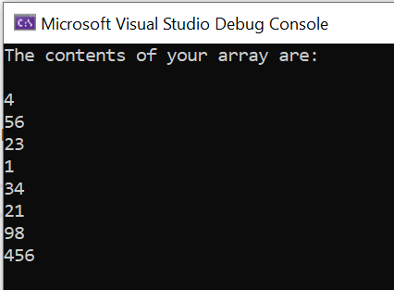

Solution:

#define _CRT_SECURE_NO_WARNINGS
#include <stdio.h>

void main()
{
int numbers[8] = { 4,56,23,1,34,21,98,456 };//Part a - set up array
int i;

printf("The contents of your array are: \n\n");

for (i = 0; i <= 7; i++)
{
printf("%d\n", numbers[i]);
}
}

1c. Print the array on the screen in reverse order (starting with element 7 and go down to element 0).

Sample output:

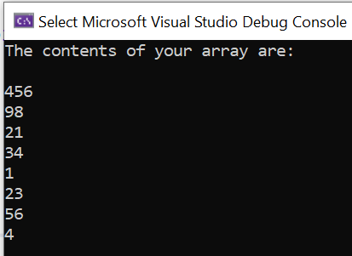

Solution:

#define _CRT_SECURE_NO_WARNINGS
#include <stdio.h>

void main()
{
int numbers[8] = { 4,56,23,1,34,21,98,456 };//Part a - set up array
int i;

for (i = 7; i >= 0; i--)
{
printf("%d\n", numbers[i]);
}
}

1d. Remove the hardcoded-values and instead allow the user to enter the values for the 8 elements (via scanf)

Sample output:

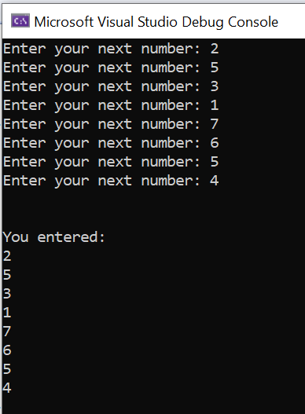

Solution:

#define _CRT_SECURE_NO_WARNINGS
#include <stdio.h>

void main()
{
int numbers[8];
int i;

for (i = 0; i <= 7; i++)
{
printf("Enter your next number: ");
scanf("%d", &numbers[i]);
}

printf("\n\nYou entered:\n");

for (i = 0; i <= 7; i++)
{
printf("%d\n", numbers[i]);
}
}

1e. Declare a variable (int total). Loop through the array, multiply each value by 3 and print the result of each calculations on the screen.

Sample output:

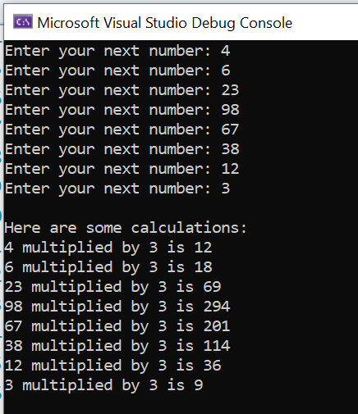

#define _CRT_SECURE_NO_WARNINGS
#include <stdio.h>

void main()
{
int numbers[8];//Part a - set up array
int i, total;

for (i = 0; i <= 7; i++)
{
printf("Enter your next number: ");
scanf("%d", &numbers[i]);
}

printf("\nHere are some calculations: \n");

for (i = 0; i <= 7; i++)
{
total = numbers[i] * 3;
printf("%d multiplied by 3 is %d\n", numbers[i], total);
}
}

2.a. Create a float array of 12 elements which will hold temperature measurements (eg 24.2, 26.3 etc). No need to put any values in, just declare the array

Solution:

#define _CRT_SECURE_NO_WARNINGS
#include <stdio.h>

void main()
{
float temps[12];//Part a - set up array
}

2b. Allow the user to enter values for the 12 elements (via scanf)

Sample output:

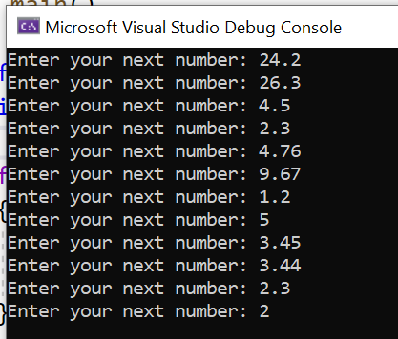

Solution:

#define _CRT_SECURE_NO_WARNINGS
#include <stdio.h>

void main()
{
float temps[12];
int i;

for (i = 0; i < 12; i++)
{
printf("Enter your next temperature: ");
scanf("%f", &temps[i]);
}
}

2c. Print the stored values on the screen.

Sample output:

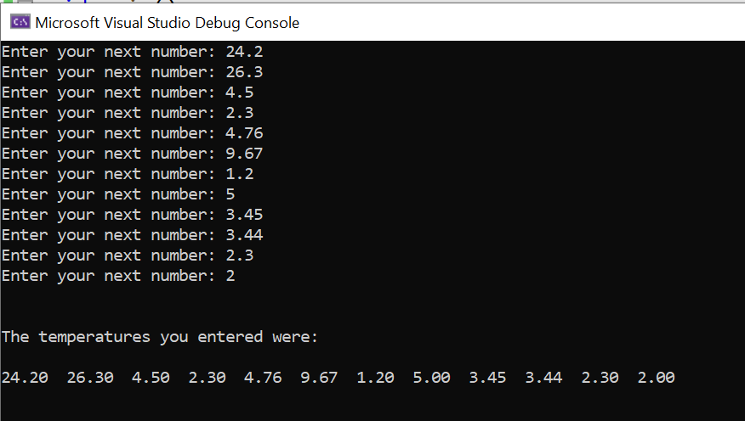

Solution:

#define _CRT_SECURE_NO_WARNINGS
#include <stdio.h>

void main()
{
float temps[12];//Part a - set up array
int i;

for (i = 0; i < 12; i++)
{
printf("Enter your next number: ");
scanf("%f", &temps[i]);
}

printf("\n\nThe temperatures you entered were:\n\n");

for (i = 0; i < 12; i++)
{
printf("%.2f ", temps[i]);
}
printf("\n\n");
}

2d. Allow the user to print out one element of their choice. For example, ask them "Which array element would you like to see?" If the user enters 3, show element 3 and so on.

Sample output:

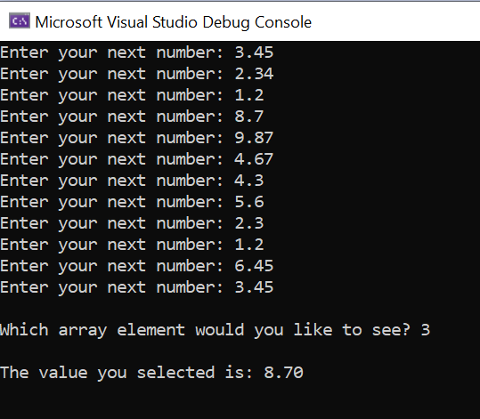

Solution:

#define _CRT_SECURE_NO_WARNINGS
#include <stdio.h>

void main()
{
float temps[12];
int i, choice;

for (i = 0; i < 12; i++)
{
printf("Enter your next number: ");
scanf("%f", &temps[i]);
}

printf("\nWhich array element would you like to see? ");
scanf("%d", &choice);

printf("\nThe value you selected is: %.2f\n\n", temps[choice]);
}

2e. (Harder) Find the average temperature (ie add the values stored in the array and divide by 12)

Sample output:

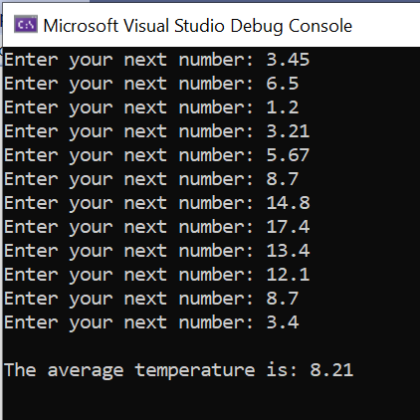

Solution:

#define _CRT_SECURE_NO_WARNINGS
#include <stdio.h>

void main()
{
float temps[12], total=0, average;//Part a - set up array
int i;

for (i = 0; i < 12; i++)
{
printf("Enter your next number: ");
scanf("%f", &temps[i]);
total = total + temps[i];
}

average = total / 12;

printf("\nThe average temperature is: %.2f \n\n", average);
}

3.a. Create a 2D character array to hold 10 names. Store 10 names of your choice (avoiding overflow)

Solution:

#define _CRT_SECURE_NO_WARNINGS
#include <stdio.h>

void main()
{
char names[10][8] = { "Bob", "James", "Kim", "Bev", "Gareth", "Nik", "Gaynor","Gary", "Steve","Kapilan" };
}

3b. Create an integer array to hold 10 short office telephone extension numbers eg 4234, 4235, 4111 etc. (These numbers will correspond to the names in the character array.) A 1D array is fine here.

Solution:

#define _CRT_SECURE_NO_WARNINGS
#include <stdio.h>

void main()
{
char names[10][8] = { "Bob", "James", "Kim", "Bev", "Gareth", "Nik", "Gaynor","Gary", "Steve","Kapilan" };
int phone[10] = { 4234,4235,4111,4121,4656,4325,4512,4511,4792,4987 };
}

3c. Print out the names with the extension numbers next to them

Sample output:

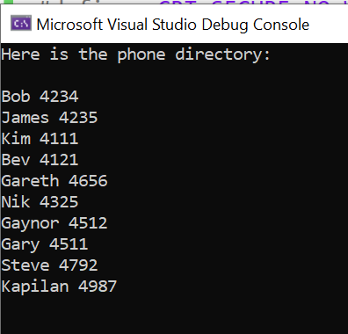

Solution:

#define _CRT_SECURE_NO_WARNINGS
#include <stdio.h>

void main()
{
char names[10][8] = { "Bob", "James", "Kim", "Bev", "Gareth", "Nik", "Gaynor","Gary", "Steve","Kapilan" };
int phone[10] = { 4234,4235,4111,4121,4656,4325,4512,4511,4792,4987 };
int i;

printf("Here is the phone directory:\n\n");

for (i = 0; i < 10; i++)
{
printf("%s %d\n", names[i], phone[i]);
}

printf("\n\n");
}

d. (Harder) Allow the user to enter an extension number into a variable (eg int choice). Search for the number in the array. When (if) you find the number, print out the name associated with that extension number.

Sample output:

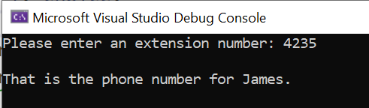

Solution:

#define _CRT_SECURE_NO_WARNINGS
#include <stdio.h>

void main()
{
char names[10][8] = { "Bob", "James", "Kim", "Bev", "Gareth", "Nik", "Gaynor","Gary", "Steve","Kapilan" };
int phone[10] = { 4234,4235,4111,4121,4656,4325,4512,4511,4792,4987 };
int i, choice;

printf("Please enter an extension number: ");
scanf("%d", &choice);

for (i = 0; i <= 9; i++)
{
if (choice == phone[i])
{
printf("\nThat is the phone number for %s.\n", names[i]);
}
}
}

e (Even harder) Allow the user to enter the name and retrieve the extension number. Note: you will need use strcmp() from the string.h library.

Sample output:

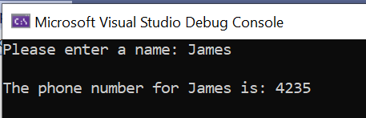

Solution:

#define _CRT_SECURE_NO_WARNINGS
#include <stdio.h>
#include <string.h>

void main()
{
char names[10][8] = { "Bob", "James", "Kim", "Bev", "Gareth", "Nik", "Gaynor","Gary", "Steve","Kapilan" };
int phone[10] = { 4234,4235,4111,4121,4656,4325,4512,4511,4792,4987 };
int i;
char choice[10];

printf("Please enter a name: ");
scanf("%s", &choice);

for (i = 0; i <= 9; i++)
{
if (strcmp(choice,names[i])==0)
{
printf("\nThe phone number for %s is: %d\n",names[i], phone[i]);
}
}
}

4. (Very challenging) For those who would like an extra challenge, try a simple noughts and crosses game with a 2D character array (or at least set up the board and allow users to choose a coordinate)

You could start by setting up a 2D array for the board:

#define _CRT_SECURE_NO_WARNINGS
#include <stdio.h>

void main()
{
char board[3][4] = { "---", "---", "---" };
}

Build up in stages – for example, print out the board first, then go on to ask the user to enter their required space.

Sample output:
: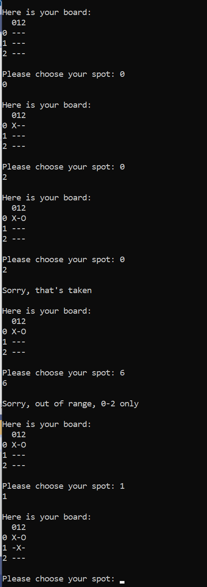
Solution:

Note: I have not written code to find the winner here, simply to stop after all spaces are filled.

#define _CRT_SECURE_NO_WARNINGS
#include <stdio.h>

void main()
{
char board[3][4] = { "---", "---", "---" };
int i;
int across, down, turns=0;
int currentplayer = 0;

while (turns < 9)
{
printf("\nHere is your board: ");

printf("\n 012\n");
for (i = 0; i < 3; i++)
{
printf("%d %s\n", i, board[i]);
}

printf("\nPlease choose your spot: ");
scanf("%d %d", &across, &down);

if ((across > 2 || across < 0) || (down > 2 || down < 0))
{
printf("\nSorry, out of range, 0-2 only\n");
}
else if (board[across][down] != '-')
{
printf("\nSorry, that's taken\n");
}
else if (currentplayer == 0)
{
board[across][down] = 'X';
currentplayer = 1 - currentplayer;
turns++;
}
else
{
board[across][down] = 'O';
currentplayer = 1 - currentplayer;
turns++;
}
}

}

