Name | Eva Afia Begum
Student Number | 1605387
Module Title | BMSK5005
Assignment Title | Workplace Culture and its impact on Organisational
Module Lecturer’s Name | Dr Isaiah Oino

Table of Contents
Introduction 3
1. Impact of external forces on the organisation (PESTLE and SWOT Analysis) 4
SWOT analysis and impact on workplace culture 4
PEST analysis and impact of the factors on culture 5
2. Formal and informal relationships between departments and people 9
3. Organisational culture, ethos and values 10
4. Establishing a culture of sustainability within the workplace 12
5. Corporate social and environmental responsibility 14
6. Personal ethical standards, values and beliefs 16
7. Communication channels for sharing information and building relationships 17
8. Barriers to effective functioning in the organisation and ways to overcome them 18
Conclusion 20
References 21

Introduction
Workplace culture is referred to as the sum of definitive norms, attitudes, beliefs and principles of behaviour in the workplace that defines the uniqueness of an organisation(Badger, 2014). An employee behaves, reacts and handles situations in the organisation as per the workplace suggests. This defines the unique way of the behaviour of the organisations. For a critical assessment of workplace culture, ethics and effective communication channels, GSK is selected. GSK’s operations, management and human resource are meant to reflect the embodiment of its workplace culture. GSK is a pharmaceuticals company which originated inthe UK and currently has a diverse portfolio of products which they supply worldwide. It currently has around 100000 employees worldwide and it claims to have created a unique workplace culture for its employees. It must establish effective communication channels; create a culture of sustainability and an ethical environment to make sure that it can keep its current position and ensure profitability along with being an environmentally sustainable company.

Impact of external forces on the organisation (PESTLE and SWOT Analysis)
To understand GSK’s external environment and undertake the critical evaluation, SWOT and PEST analysis is being considered. Along with the analysis, how these factors are affecting the workplace culture; is also being linked accordingly.

SWOT analysis and impact on workplace culture
SWOT analysis is the framework designed to evaluate an organisation’s particular capabilities and shortcomings which lets it determine its position in the broader environment it operates.

Figure 1: SWOT Analysis of GSK
Source: (Victor, 2016)
- Strengths
Strengths are the factors which act as the positive capabilities on which the organisation can take the business further. These strengths increase positivity in the workplace and motivate commitment of employees(Seth, 2015). GSK has established diverse R&D infrastructure in biotechnology, consumer care and pharmaceutical. It invests 3 billionpounds every year in R&D. Also, it has a global presence in over 150 countries, more than 100 manufacturing facilities and close to 100000 employees worldwide. Besides, it has a strong product portfolio in diverse pharmaceutical sectors and consumer care. This strength makes it the 9th biggest pharmaceutical company in theworld. This strength has a positive impact on workplace culture of GSK.
- Weaknesses
GSK had to pay 2 billion recently to settle illegal drug marketing and also settled 35000 lawsuits all over its existence. These lawsuits act as weaknesses of the company and have negative impacts on the workplace culture as employees lose trust in their company and this decreases commitment. Also, failure to invent newer drugs in recent times (after 2014 till date) and dependence on UK economy are other weaknesses of this organisation. BREXIT will cause 70 millionpounds to the business and failure to the invention is causing the business to losemarket; leaving a negative impact on the workplace culture as employees are pressured to provide results and fasten profitability.
- Opportunities
GSK can expand its sectors to oncology as cancer has become a widespread disease all over the world and it has the infrastructure for research. It can expand business in Asian countries. It can also in integrate its business with other businesses to work united in finding solutions. These types of factors increase the work pace of the employees positively impacting the work culture.
- Threats
GSK faces some threats such as increased competition. Being the 9thpharmaceuticalcompany in the world, ithas to face immense competition to keep the position and advance through the ranking. Also, govt imposes regulations which it cannot avoid which may cause it to fall in price abnormalities. These threats act asa negative constant in the aspect of workplace culture and employee feel threatened about their job status and it harms productivity; thus, harming the workplace culture.

PEST analysis and impact of the factors on culture
PEST analysis is conducted to assess the broader external environment where the business operates. Every organisation tries to mitigate the negative impacts of these factors and tries to focus on the positive aspects as these factors are not controllable by the organisation.
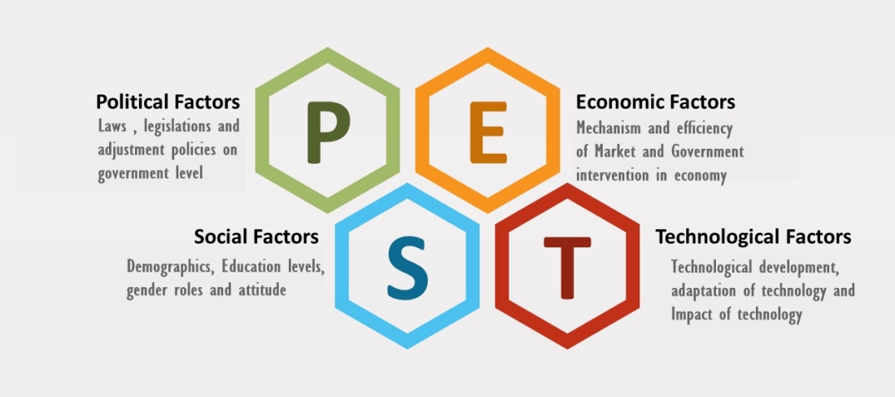
Figure 2: PEST Analysis
Source:(Harrison, 2016)
For a critical evaluation of the external environment where GSK operates, appropriate relevant literature is PEST analysis. PEST analysis of GSK describes the external environmental factors and shows how these factors influence the workplace culture and performance:
- Political factors
Political factors are basically laws, legislation and adjustment of policies on a governmental level. Mainly, government regulations and political stability matter here. The UK has the most political stability as per stability index. But as a pharmaceutical organisation, it has to abide by many laws and regulations. Health and Safety at Work 1974, Equality Act 2010, Medicines Act 1968 etc these are the related legislation. Because of these many rules, GSK sometimes has to abandon some profitable projects which may be harmful to other people. But following these rules create a positive impression of the organisation on the employees which motivates better workplace culture and performance with commitment.Also, the tax laws and export-import laws affect the operations and profitability of the organisation. Positive political factors enhance employee’s confidence in the system and organisation which positively impacts the culture of the workplace.
- Economic factors
UK is facing one of the biggest economic changes in recent history because of their exit from EU. Although BREXIT won’t cause any long-term damage, it will cost GSK 70 million Pounds as the GSK is working on moving the manufacturing facilities to different EU regions. GSK has a better advantage in exchange rates with most of the foreign countries.
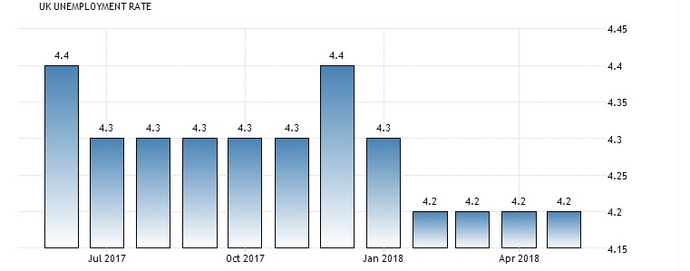
Figure 3: Unemployment statistics of UK
Source:(Stephan, 2018)
Unemployment is lower and interest rates are at the advantageous position. This all proves that GSK is operating in the moderately positive economic environment. Economic positive factors induce that people have jobs, they are economically stable, contented and thus it helps them to work better and create an effective workplace culture.
- Socio-cultural factors
These factors are related to basic human attitudes, lifestyle, religious beliefs and other demographical aspects. As a pharmaceutical industry, GSK has to face social-cultural factors differently in different countries. For example, in the UK, HIV medication is a major source of sale for GSK. Asian countries have relatively conservative social beliefs and norms for which the number of registered HIV patients is low there. GSK cannot pull a profit by selling HIV medication there. It has to focus on ageing demographics, gender-related medications etc. Cultural diversity enhances a team’s ability to work better and make better decisions through team working. This helps create efficient workplace and co-operative workplace culture.
- Technological factors
Manufacturing of medicines from complex formulas requires sophisticated equipment and development in technology is one of the determining factors in the pharmaceutical industry.
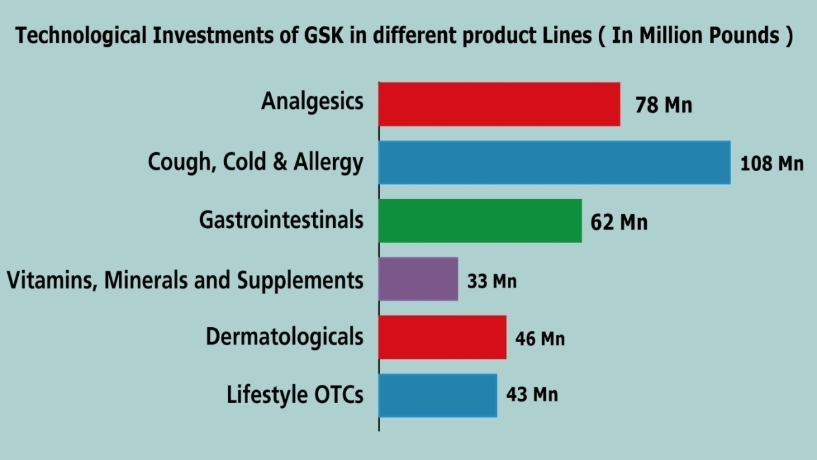
Figure 4: Technological investment of GSK in different sectors
Source:(Victor, 2016)
GSK invests more than 2 billion in infrastructure every year and has technological assets operating in more than 100 manufacturing sites. GSK enjoys the positive technological environment.
This table helps to summarize the overall discussion:
Tools | Factors | Analysis
SWOT | Strengths | 4.07 billion worth of string infrastructure, a portfolio containing over 3000 products and presence in 150 countries
SWOT | Weaknesses | Litigations for settling, lack of recent inventions, BREXIT
SWOT | Opportunities | Integrations with other pharma, expansion in Asian countries and the oncology sector
SWOT | Threats | Increased competition, price abnormalities
PEST | Political factors | Strong political stability, strict regulations
PEST | Economical factors | Impact of BREXIT, less unemployment and strict tax laws
PEST | Socio-cultural factors | Country wise demographics and religious diversity
PEST | Technological factors | Strong technological background
Figure 5: Summary of Analysis on external environment of GSK

Formal and informal relationships between departments and people
Every organisation follows a design which depicts how it would function, how the relationships between departments and the people will be. This is called the organisational chart and it shows who reports to whom; how themessages get delivered and how the relationships are supposed to be.
There are basically two types of relationships that can exist in an organisation; formal relationships and informal relationships. Formal relationships are the official relationships which follow the organisation diagram of communication(Parker, 2013). GSK also has an organisational chart which depicts the degree of their formal relationship:

Figure 6: Formal relationships between departments and people in GSK
Source: (Seth, 2015)
This figure shows the formal relationships between departments and people. It shows that the board is the top management and all other departments report to the members of the board. In the board, there are directors, CEO and the Chairman. It is a hierarchal organisation where formal relationships follow top to bottom approach. It also shows the formal relationships between people. Middle managers report to the department heads like technology, HR, legal etc. These people report to the CEO of GSK who takes decisions on board and passes those decisions down to be executed(Ford, 2011). For formal relationships in GSK, the communication mediums are meetings, email, office memos and notice boards. As GSK is an enormous organisation formal relationship between departments and people are somewhat mandatory and without following these mediums and hierarchy, proper management of the workforce would have been difficult to manage.
Informal relationships are referred to as the relationship that is formed through social interaction and doesn’t follow strict adherence to the formal organisation rule. Informal relationships can form in two ways; through working in projects as teams and through the grapevine. GSK has research teams and execution team where company ranks are overlooked and the sense of expertise is given more value. These types of relationships between people in a team can be referred to as informal relationships. Also, the grapevine of the organisation can create informal relationships through gossip, rumour or office talks. The communication mediums through which informal relationships are formed in GSK are emails, social mediums, and employee’s place of gathering and personal meetings. These informal relationships are of more importance to the organisations like GSK. As it is an enormous organisation, better understanding between people of the workforce can increase their efficiency, commitment towards the organisation and it can benefit from these relationships. GSK has developed many strings of informal relationships. But it should monitor the informal communication channels as these can be used to spread rumours that can harm the harmony of the office.

Organisational culture, ethos and values
Organisational culture is the sum of attitudes, mechanism and sense of things that apply generally in a workplace(Peter, 2016). Every workplace has a unique organisational culture which differentiates it from the other organisations. It can be a point of great distinction to values employees. Organisational ethos and values also depend on the baseline that is set by the organisational culture. These are the constituents of organisational culture, ethos and values which are also applicable to GSK:

Figure 7: Constituents of organisational culture, ethos and values
Source:(Brown, 2013)
- Autonomy
Autonomy in the workplace can be defined as the individual capability to complete responsibility. This is one of the basic pillars of workplace culture. Without autonomy an employee cannot take decisions on his own to carry on his responsibility which disrupts working capability; corrupts the sense of ethos and values. GSK follows a formal organisational structure which facilitates the basic autonomy of the workers so that they can be free while taking their own decisions on how to complete within a certain boundary. It helps maintain efficiency while working maintaining the culture, ethos and workplace values.
- Position structure
Position structure of the employees decides how they will performin the workplace, how they can uphold their ethos and values. If a person with high responsibility is placed within low position structure, he is sure to follow corrupt ways to get the job donewhichviolets the culture and ethos. In GSK, it follows informal organisation in research teams and arranges them according to expertise to make them realise that they are all equal and have the same scope to show creativity. It follows formal organisation from top to bottom. Appropriate position structure in GSK helps it to maintain a harmonious workplace culture and high ethos.
- Reward and appraisal system
If proper rewards are not given to the employees, they will take illegal ways which are against ethos, values and it will corrupt the workplace culture. Besides, a proper appraisal system is also necessary to maintain a better workplace culture. GSK spends more than 30 million pounds on rewards in a year. Besides, it sacked more than 12 employees in 2016 for violating organisational standards. Fear of appraisal and ambition of fair rewards helps GSK maintain an ethical and value driven corporate culture.
- Conflict management
Conflict management is the sum of processes and procedure used to solve disputes between employees and with management(Keet, 2010). Unfair judgement, failure of proper solution pollutes the workplace culture as it increases engagement between employees. Properly managing conflict management facilitates keeping the workplace culture harmony and de-motivates anyone to go against ethos and values. GSK has an executive body of HR having 2 conflict management specialists in every regional officewho work to solve the conflicts between employees. This helps GSK to solve unwanted collisions amongst employees.

Establishing a culture of sustainability within the workplace
Companies with sustainable resources have a competitive edge over those who don’t. Workplace culture and the overall culture of an organisation can also be made sustainable through proper efforts. Companies like GSK follow a specific process to make their workplace culture sustainable in the long run. This process is being graphically presented:
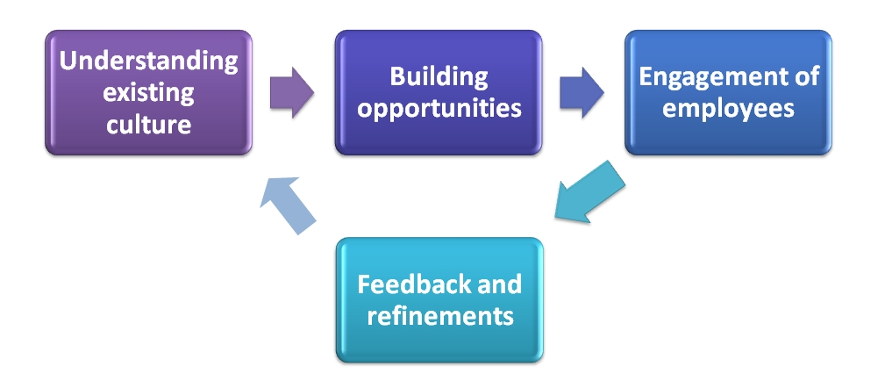
Figure 8: Process of establishing a culture of sustainability
Source:(Jane, 2014)
- Understanding existing culture
Before establishing sustainability, at first, the current culture should be assessed. Before assessing the current culture, no strategy of sustainability will be appropriate. This can be assessed formally through thorough observation, face to face interviews and informally through the grapevine of the office. In a formal way, GSK’s top management observes the employees in the office. They observe how the employees are behaving with each other, how they treat people with diversity, if they are getting a chance to develop themselves or how they are handling things ethically. They also conduct face to face interviews to examine what problems the employees facing in the workplace, how they are coping, what do they need and what suggestions they have. Office grapevine is another source but GSK doesn’t emphasize on that to assess current culture.
- Building opportunities
After the assessment, the next step is to build the plan of sustainability. This is done by creating opportunities for employees. After the assessment, GSK introducestraining programs, rewards plan and compensations benefits for appropriate employees. Also, it focuses on conflict management, re-structuring the position paradigm and re-defining the capabilities. Through doing these, employees understand that they can belong to the organisation in harmony, work to develop themselves and learn how to exist together-thus creating a sustainable workplace culture for the company(Daniel, 2015).
- Engagement of employees
Employee engagement is the most important part of the process as it is the employees whose behaviour is meant to be modified in order to make the culture sustainable. To engage the employees, alignment of their goal with the organisation is necessary. GSK does this by providing everyone with a specific goal or incentives. To achieve the goal or rewards, every employee needs to exploit any of the given opportunities accordingly and achieving their goal, in turn, accomplishes the organisation’s goal to create a sustainable culture.
- Feedback and refinements
This is the last step where evaluation is carried out and if any negative result is found, corrective strategies are taken. Feedback is very significant here as the employees may find some strategies not beneficial and they should be given the courage to report those. Then the organisation re-assesses and creates refinements in the plan. GSK has an executive body which examines the changes in culture in a 6-month cycle and adjusts the strategies accordingly. This process starts once again at checking the current status of culture.

Corporate social and environmental responsibility
Corporate social responsibility is a business model that depicts the responsibility of a business to society, nation and environment outside its prime purpose to make a profit. This philosophy is much needed in today’s world as businesses are often violating ethical standards and environmental standards in order to make a profit. Though profit may be good for short-term ethical degradation and environmental disruption is much concerning in the long run which eventually affects the business. GSK has CSR activities towards people, planet and behaviour:
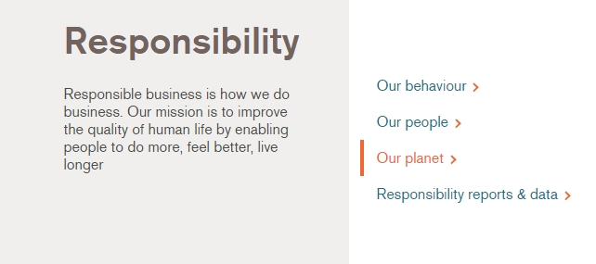
Figure 9: CSR activities of GSK
Source:(Reymond, 2018)
- Behaviour
Pharmaceutical companies often face litigations due to their unethical behaviour in business, illegal promotions and compromising public safety. By changing the way, they do business, they can fulfil their social responsibility of maintaining ethical standards and doing lawful business. GSK has changed their way and implemented different programs which help them to attain those. It follows ethical standards which are written in their Code of Conduct. It advises its representatives to the company to Anti Bribery Law (2010), also, follows international drug promoting standards and its actions are reviewed by the Global Safety Board. Its clinical trial studies are publishing in public. It advises its employees including top management to representatives to follow these standards.
- Towards people
A company also has a responsibility towards its employees as they are an inseparable part of the business. The employees have the right to be feeling needed and feel the organisation’s goal as their own, rewarded when it seems fair(Beckmann, 2015). GSK has reward and compensation programs in place to provide them financial motivations. It also has an Employee Assistance Program to help them with their safety while working with the business. It has a Partnership for Prevention program which provides the employees with healthcare benefits. Employees feel safe and committed towards the organisation which is the main purpose behind ensuring the corporate responsibility of the business to its employees.
- Towards planet
GSK fulfils is environmental responsibility through its ‘our planet’ activities. It focuses on reducing carbon emission, water usage and waste production. Pharmaceutical companies emit a huge volume of carbon through working with chemicals, using massive electronic devices and scientific processes.
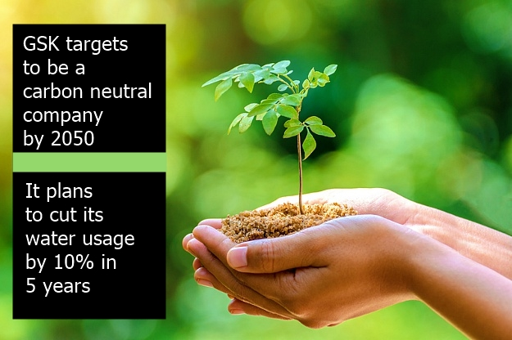
Figure 10: Environmental sustainability plan of GSK
Source:(Leemans, 2017)
GSK focuses on reducing carbon emission. It regularly audits to find any way to reduce carbon emission and plans to be a carbon neutral company by 2050. Also, it uses 14 million m³ amount of water for its operations and it plans to reduce this amount by 10% in 5 years. Besides, the company advises its employees to use better waste management to reduce total wastage amount. It aims to achieve zero landfill wastage by 2020. It already achieved 70% of the target.

Personal ethical standards, values and beliefs
A business fulfils its social duty by fulfilling its corporate social responsibility, but an employee also has responsibilities towards the organisation and society. These responsibilities should be reflected in the employees’ ethical standards, values and moral beliefs(Dewey, 2016). As an employee of GSK, I should be and am bound to the follow ethical and environmental standards as well as maintain ethics and values as a human being.
- Firstly, an employee should abide by the rules set by the organisation he or she works in. This is a general rule as an organisation has a certain standard of rules which employees are ethically bound to oblige while working. As per GSK standards, an employee of GSK should always behave ethically. He should not engage in activities which violates drug promotion laws.
- Secondly, He should not try to make a profitby adopting illegal marketing ways or distribution laws. He should abide by the GSK’s Code of Conduct. Another major ethical violation is taking or providing bribers. GSK advises its employees to follow Anti Bribery Lay (2010) and employee both ethically and morally should not be involved in any bribery transactions.
- Thirdly, an employee working in the research team of GSK should not be involved in harmful research and should always try to solve scientific problems. He should always believe that his services are for the betterment of the people in suffering, not for profit only; this personal belief will help them focus on greater things rather than financial benefits.
- Besides, as GSK is determined to ensure environmental sustainability, an employee of GSK should always look for ways to reduce carbon emissions. He should also try to reduce water wastage. This comes from high ethical perception as saving water and reducing carbon helps improving environment a little more.
- An employee should also hold this as his personal belief as this would benefit them on a personal level also. Moreover, an employee of GSK has to ensure proper waste management as it is beneficial for the environment which would benefit him for organisational and personal perspective.
To conclude, ethics is the sense of right or wrong. Ethics should not only be followed while working in organisations rather ethics should be integrated with personal values and beliefs so that people working in the organisation may do something good for the society and environments besides working for organisations also. As an employee of GSK, behaving ethically will help me fulfil my responsibility towards the society and environment as well as will facilitate the CSR requirements of the organization expected from me.

Communication channels for sharing information and building relationships
Communication channels are basically the mediums or information flows which are used for planning, sharing and execution of those plans. The efficiency of communication channels is much significant to establish proper information flow across the organisation. Any organisation has 3 types of communication channels for sharing information and building relationships; downward, upward and lateral communication channels. This figure depicts the various types of communication channels used in GSK:
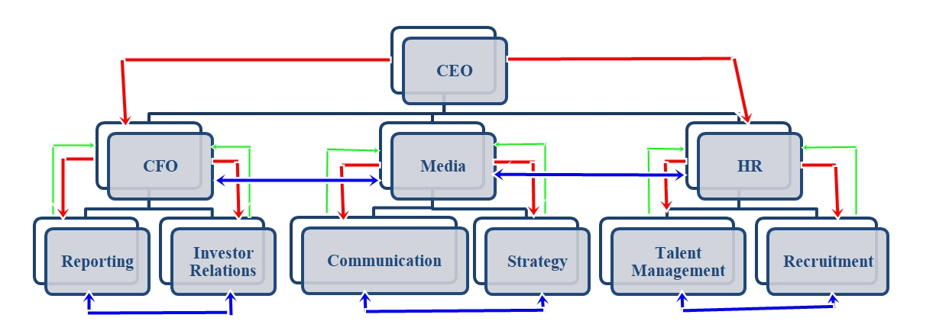
Figure 11: Communication channels in an organisation
Source:(Krein, 2011)
- Downward communication channel
Downward communication channels are used to pass information to the subordinates. The red lines in the figure show the downward communication. In GSK, when CEO asks CFO to pass a finance budget report, it is a downward communication. For the better functioning, the establishment of downward communication is necessary to establish a relation of direction that is needed to execute plans. This is also important in building relationships in the organisation as employees need to know to whom they report and to whom they are responsible. This helps to avoid confusions and focus on the given task only by a specific person. In this medium, information sharing only happens from top management.
- Upward communication channel
The upward communication channel is the one that subordinates use to reach superiors. Although it seems there is not much chance to communicate, actually it is being considered a significant channel in organisations in recent management strategies. Today’s leaders are proactive rather than reactive. For the contentment of the employees, they need to listen to what employees have to say and take their opinions(Ober, 2009). The green lines in the figure show examples of upward communication. For example, GSK uses upward communication to a great extent. GSK has installed complaint boxes and face-to-face feedback systems which allow employees to share their opinions to superiors. Use of upward communication channels has let GSK superiors to build better relationships with their subordinates as they feel that they have the freedom to share their opinions.
- Lateral communication channel
The lateral communication channel is established basically between personnel working at the same level. There are no superior subordinates here, rather colleagues use this channel. This is also called horizontal communication channel. The blue lines in the figure are the lateral communication channels. In GSK, when communication executive contacts strategy executive, this type of channel establishes. But there is a negative side to this channel. These channels can create conflict in the office. This can be done through the grapevine or it can happen mutually. For that, communication specialists should keep an eye on these channels to make sure no rumours are being spread to disrupt the workplace culture.

Barriers to effective functioning in the organisation and ways to overcome them
An organisation needs to function properly and effectively to achieve its goal. Any barrier in the effective functioning of the employees in the organisation can decreases productivity and profitability. Though these barriers are very common and happen in almost all organisations like GSK, there are certain ways these barriers can be removed.

Figure 12: Barriers to the effective functioning
Source:(Stern, 2013)
Firstly, Lack of clear goal among the employees or teams of an organisation serves as the greatest barrier. Without understanding the common goal, everyone will not exert the same effort which ultimately decreases the efficiency of an organisation. If the project teams of GSK are not engaged properly, they may not align their own goals with the organisation and this will bar them from accomplishment. Secondly, if proper communication channels are used, everyone gets the same message or task guidance. Being able to properly communicate among themselvesincreases co-operation. Improper communication channels at GSK will prevent the effective functioning of the teams. Also, if the leadership is directive rather than facilitative, the team cannot function properly as they won’t get proper autonomy needed to get the job done(John, 2010). If the team leader at GSK is task oriented and exerts egoistic pressures on the subordinates, it prevents their functioning and bars efficiency. Lastly, lack of conflict management increases engagement between employees and prevents effective functioning. When employees at GSK will hold grudge against each other, they will not be able to co-exist in harmony and ultimately it will impact performance and decrease efficiency.
Ways to overcome the barriers
These barriers show a negative impact on productivity and organisations should take some steps to overcome the barriers. For GSK, these recommendations are being suggested which will help them to overcome the barriers:
- Alignment of the goal is the first thing to do to overcome the barriers. Every team member should have the same goal. Every project manager will arrange a team meeting in the first 3 days of starting work to convey the objective of the object to all the team members or employees.
- Proper communication channels should be used in communication. Every team member will communicate through the same medium where security, privacy would be ensured. IT team of 3 members should be appointed in 7 days to facilitate the organisation with dedicated digital communication channels.
- The board of directors should observe potential ‘would be’ team leaders for 7 days to see whether they are fit for the position or not. An executive team of the human resource should be hired in 15 days to prepare a guideline for this kind of hiring. Also, a team of 3 conflict resolution specialists should be employed in 30 days to oversee conflict management.

Conclusion
Maintaining a workplace culture with high ethical beliefs and value is much significant for any organisation like GSK. Before thinking of making any adjustment to the workplace culture, assess the external environment is needed. It is also found that the culture should be made sustainable through understanding the culture, building opportunities and engaging employees(Melling, 2017). An organisation’s CSR activities are also necessary so that they fulfil their responsibility towards the environment and society. GSK has CSR programs in 3 categories. Importance of personal ethics and values can also be observed in this case. Personal ethics Establishment of proper communication channels is necessary to let the information flow and build a relationship. At last, it is observed that there are some barriers to functioning like lack of clear goals, communication medium and proper leadership which prevents efficient functioning. GSK should follow the recommendations to ensure that its teams are functioning effectively to keep its competitive edge.

References
Badger, D. (2014). The workplace culture. Cullompton, UK: Willan.
Beckmann, S. (2015). Strategic CSR. Copenhagen: Jurist Pub.
Brown, A. (2013). Organisational culture. London: Financial Times Pitman Publ.
Cooper, C. (2014). Business ethics. Chichester, West Sussex: Wiley.
Daniel, L. (2015). Institutions, culture and sustainable development. Bradford, England: Emerald Group Pub.
Dewey, J. (2016). Ethics. Read Books Ltd.
Ford, D. (2011). Managing business relationships. [Chichester]: John Wiley & Sons Inc.
Harrison, S. (2016). External environment. Deddington, Oxfordshire: Philip Allan.
Jane, B. (2014). Design for a sustainable culture. New York: Sage Pub.
John, K. (2010). Effective functioning of Businesses. New Pub: Gian Pub. House.
Keet, R. (2010). Conflict management. Northlands, Gauteng, South Africa: Macmillan South Africa.
Krein, A. (2011). Business Communication Channels. Australia: South-Western Cengage Learning.
Leemans, R. (2017). Redefining environmental sustainability: GSK. Current Opinion in Environmental Sustainability, 5(3-4), pp.272-277.
Melling, J. (2017). Managing the Modern Workplace. Florence: Taylor and Francis.
Ober, S. (2009). Contemporary business communication. Boston, Mass.: Houghton Mifflin.
Parker, B. (2013). Introduction to Business Relationships. 2nd ed. London: SAGE.
Peter, D. (2016). Workplace Culture. Randburg: KR Publishing.
Reymond, S. (2018). Responsibility | GSK. [online] Gsk.com. Available at: https://www.gsk.com/en-gb/responsibility/ [Accessed 3 Aug. 2018].
Seth, C. (2015). Swot analysis. Namur: Bright Sage Pub.
Stephan, R. (2018). Unemployment: UK perspective. SSRN Electronic Journal, 2.
Stern, J. (2013). Barriers to Corporate culture. New York: Amacom.
Victor, K. (2016). Technological Infrastructures Around the Globe. Hershey, Pa.: IGI Global.

