

Student name: Orinthia Wright-Stevens
Student ID: 2418339
Module name: Physiology
Module code: BMHP5023
Lecturer name: Shaila Hussain

Assessment: Case study report – Asthma

Table of Contents
Introduction 3
Structure of the respiratory system 4
Upper Respiratory Tract 4
Lower Respiratory Tract 5
Gas exchange in lungs 6
Recording and tracking respiratory functions 9
Tracking Flow Readings 9
Clinical Importance and Role in Decision-Making 9
Consequences of Not Recording Peak Flow Readings 10
Evidence-Based Health and Social Care Strategies 10
Patient education and health promotion 11
Lifestyle Changes to Improve Asthma Control 11
Healthy Diet and Weight Management 11
Interventions and individual self-management strategies 11
Conclusion 13
References 14

Introduction
Asthma is a common chronic respiratory condition characterised by inflammation and narrowing of the airways, which can cause symptoms such as wheezing, breathlessness, chest tightness, and coughing. Although asthma cannot currently be cured, it can be managed effectively through medication, lifestyle adjustments, and avoidance of triggers (World Health Organization, 2024). Understanding the structure and function of the respiratory system is crucial in appreciating how asthma affects breathing and gas exchange.
Therefore, in this case study report, the aim will be to explore the structure of the respiratory system, the mechanical processes of respiration, and the gas exchange mechanism in the lungs, using diagrams to illustrate key concepts. It will also discuss how irritants impact lung tissue, causing swelling and reduced airflow, and examine the risk factors associated with asthma, highlighting its physiological consequences.

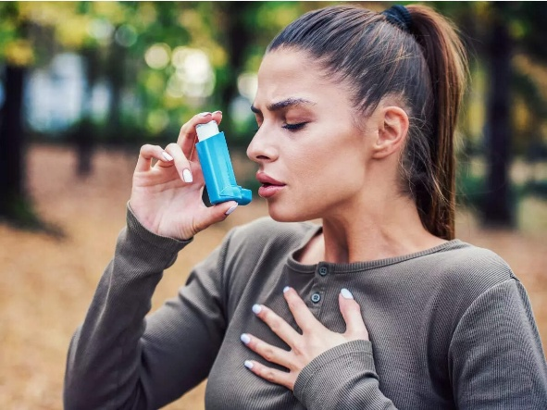
Diagram 1: Stock picture of a woman taking an asthma pump (São Paulo Research Foundation, 2023)

Structure of the respiratory system
The respiratory system is a highly specialised network of organs and tissues designed to deliver oxygen to the body and remove carbon dioxide. Its structure is divided into the upper respiratory tract and the lower respiratory tract, each performing specific protective and functional roles (Cleveland Clinic, 2024). Understanding this structure is crucial to appreciating how conditions such as asthma can disrupt normal respiratory function, as depicted in diagram 2.

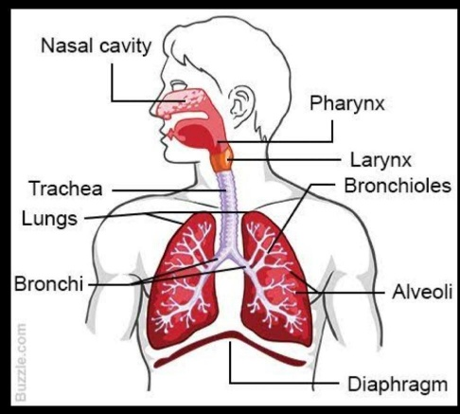
Diagram 2: A picture of the structure of the respiratory system (San, 2025)

Upper Respiratory Tract
The upper respiratory tract consists of the nose, nasal cavity, pharynx, and larynx. Air enters through the nostrils and is directed into the nasal cavity, which serves to filter, warm, and humidify the inspired air. The nasal cavity is lined with cilia and mucous membranes, which trap dust particles, pathogens, and other impurities, preventing them from entering the lower airways. The nasal turbinate increases the surface area inside the nasal cavity, enhancing this protective function (Physiopedia, 2023).
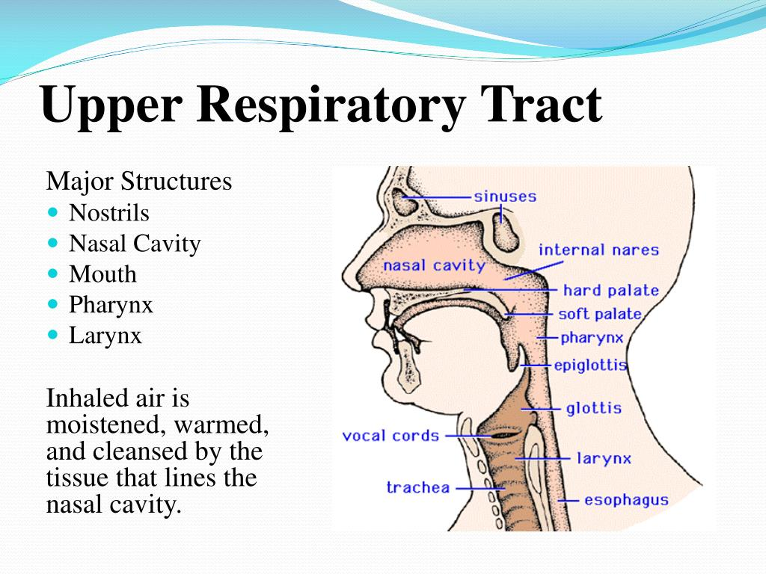
Diagram 3: A picture of the upper respiratory tract (darrin, 2014)

The pharynx, commonly referred to as the throat, is a muscular passageway for both air and food, subdivided into the nasopharynx, oropharynx, and laryngopharynx. The epiglottis, a flap of cartilage, closes over the larynx during swallowing to prevent aspiration of food or liquids into the trachea. The larynx, or voice box, lies below the pharynx and contains the vocal cords. It also serves as a protective mechanism, triggering reflexes such as coughing when foreign particles are detected (Travers, 2020).

Lower Respiratory Tract
The lower respiratory tract comprises the trachea, bronchi, bronchioles, alveoli, and lungs. The trachea, or windpipe, is a rigid structure supported by C-shaped cartilage rings, maintaining airway patency during breathing. Its inner lining consists of ciliated pseudostratified columnar epithelium and goblet cells, which secrete mucus to trap foreign particles. The coordinated movement of cilia, known as the mucociliary escalator, moves mucus upwards towards the pharynx to be expelled or swallowed (The Respiratory System, 2015).

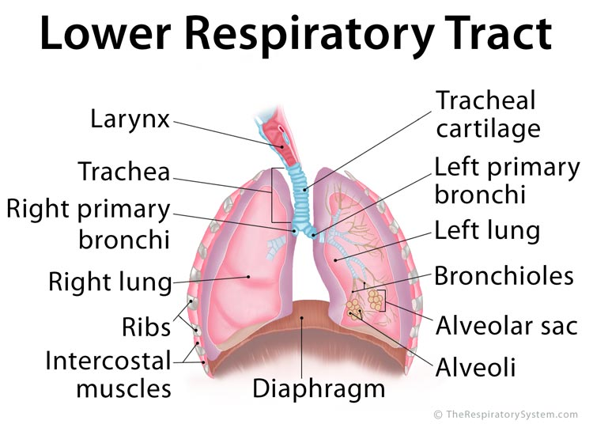
Diagram 3: a picture of the lower Respiratory Tract (The Respiratory System, 2015)

The trachea branches off into the right and left primary bronchus, which lead into the lungs and continue to subdivide into secondary and tertiary bronchi until bronchioles are formed. Corresponding to the size reduction of these passages, there is less cartilage and increased smooth muscle, which enables bronchioles to regulate airflow. Bronchiole regulation of airflow is critical in asthmatic patients because inflammation and smooth muscle contraction reduce the passage size of the bronchioles (Rad, 2020).

Gas exchange in lungs
Gas exchange occurs in the alveoli, small air sacs located at the ends of the bronchioles. Pulmonary capillaries surround each alveolus. When air is inhaled, oxygen reaches the alveoli, where its concentration is higher compared to the blood arriving from the body. Oxygen diffuses across the thin alveolar-capillary membrane and binds to haemoglobin in red blood cells. Meanwhile, carbon dioxide, which is more concentrated in the blood, diffuses out into the alveoli to be exhaled (BBC, 2024).
The process relies on a large surface area, thin membranes, and good ventilation. Conditions such as asthma reduce the efficiency of gas exchange. During an asthma episode, the airways become inflamed, narrowed, and filled with excess mucus, reducing airflow to the alveoli. This limits oxygen availability and prevents carbon dioxide from being removed effectively, leading to breathlessness and reduced oxygen saturation.
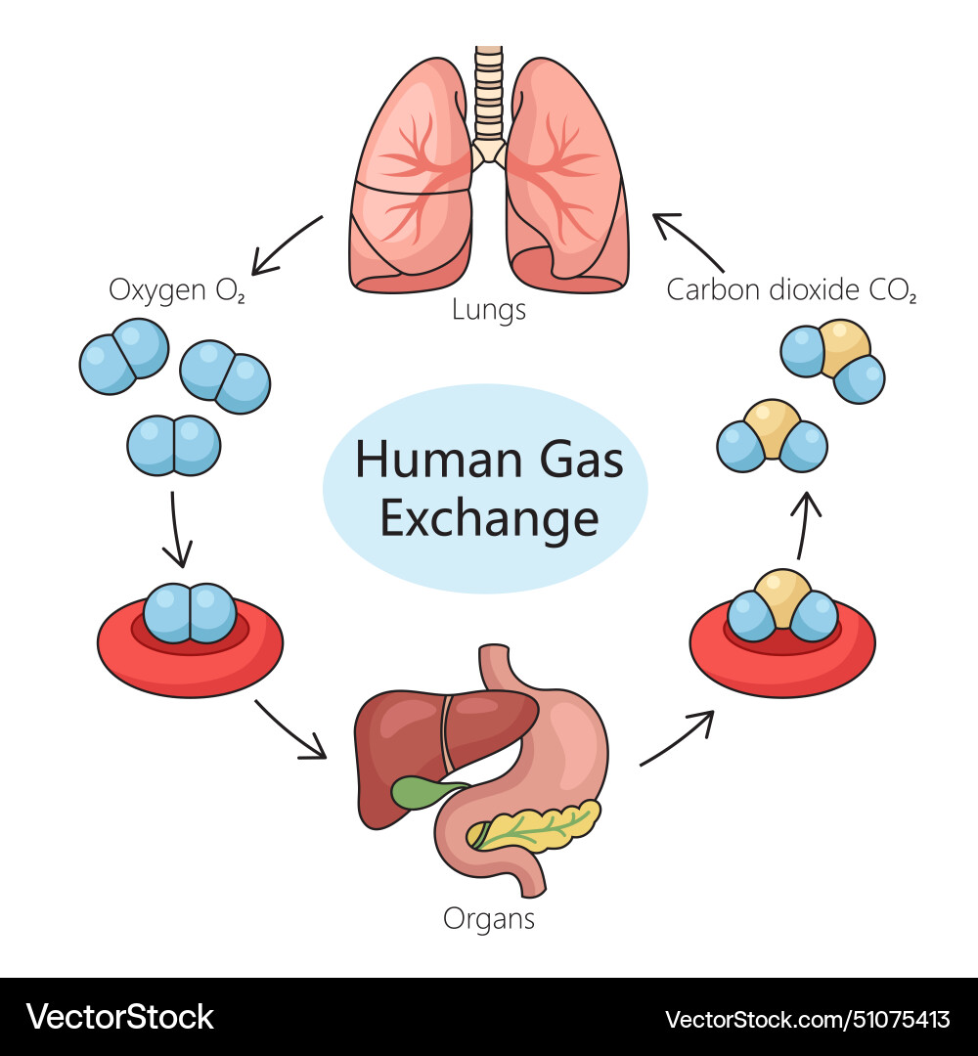
Diagram 5: an image of the gas exchange cycle in lungs (VectorStock, 2024)

However, exposure to respiratory irritants, such as cigarette smoke, air pollution, dust, allergens, and pathogens, can significantly impair this process. These irritants provoke an inflammatory response in the respiratory system, causing swelling of the airway walls, increased mucus production, and recruitment of immune cells such as macrophages. This inflammation narrows the bronchi and bronchioles, thickens the alveolar-capillary membrane, and obstructs airflow. In conditions such as asthma, chronic bronchitis, or acute respiratory infections, these changes reduce oxygen uptake and impede carbon dioxide removal.

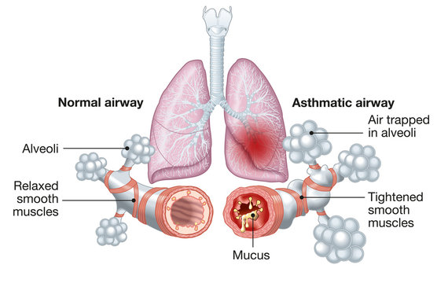
Diagram 6: A picture showing the normal and the asthmatic airways (Orion Pharma, 2024)

The physiological impact of impaired gas exchange extends beyond the lungs. Reduced oxygenation compromises cellular metabolism in vital organs, while elevated carbon dioxide levels, known as hypercapnia, can lead to symptoms such as headache, fatigue, confusion, and, in severe cases, respiratory failure. The body may attempt to compensate by increasing the rate and depth of breathing, but prolonged airway inflammation can overwhelm these compensatory mechanisms.
Maintaining healthy lungs and preventing exposure to irritants are, therefore, critical to sustaining effective respiration. Strategies include avoiding tobacco smoke, minimising exposure to environmental pollutants, managing chronic respiratory conditions, and adopting preventive measures recommended by health authorities. Efficient gas exchange is not only essential for physical health but also underpins overall well-being, highlighting the importance of protecting respiratory function throughout life (WHO, 2024).

Recording and tracking respiratory functions
Recording and tracking peak expiratory flow (PEF) readings is an essential component of asthma self-management, and peak flow readings play a central role in this process. A peak flow meter measures peak expiratory flow (PEF), which shows how fast an individual can blow air out of their lungs. This measurement reflects the degree of airway narrowing, which is commonly affected in asthma due to inflammation, bronchoconstriction, or mucus build-up (NHS, 2023). Regular recording of PEF enables people with asthma to detect early signs of deterioration, often before noticeable symptoms such as wheezing or breathlessness appear (Asthma and Lung UK, 2022).

Tracking Flow Readings
Tracking peak flow readings provides individuals with a clear understanding of how external factors influence their breathing. Common triggers such as pollen, cold air, smoke, viral infections, or exercise can cause sudden reductions in peak flow, and consistent monitoring helps identify patterns and avoidable exposures (NICE, 2025). This information is particularly important because asthma symptoms can fluctuate throughout the day, meaning patients may underestimate the level of airway obstruction without an objective measure.
NICE (2025) notes that monitoring peak flow can be particularly beneficial for people who struggle to recognise when their asthma is worsening. Some people experience what is known as poor symptom perception, meaning their asthma may deteriorate significantly before they feel breathless. In such cases, PEF monitoring acts as an early warning system, helping prevent life-threatening attacks. The British Thoracic Society (BTS) and the Scottish Intercollegiate Guidelines Network (SIGN) also support peak flow monitoring as part of targeted asthma management strategies, particularly during unstable periods of asthma or when adjusting medication.

Clinical Importance and Role in Decision-Making
Peak flow monitoring is not only useful for patients but also for healthcare teams who use these readings to make informed clinical decisions. Recorded data helps clinicians identify whether asthma is well controlled, partially controlled or poorly controlled. Public Health England (2021) emphasises that consistent monitoring provides valuable information during asthma reviews, allowing clinicians to adjust inhalers, check adherence, and identify training needs for inhaler technique.
Accurate recording of peak flow readings also supports the use of Personalised Asthma Action Plans. These plans and actions divide peak flow results into zones, which guide patients on when to continue their normal routine, when to adjust treatment, and when to seek urgent medical help (American Lung Association, 2023). For example, a drop to 50-75% of a person’s best reading may indicate a moderate exacerbation, requiring a reliever inhaler or increased preventer medication as advised by healthcare professionals (NICE, 2025). Healthcare staff rely on recorded data to make treatment adjustments, identify uncontrolled asthma, and assess whether inhaler therapy is effective.

Consequences of Not Recording Peak Flow Readings
Failing to track or record peak flow readings can have serious consequences. Without regular monitoring, early signs of airway narrowing may be missed, allowing symptoms to worsen silently until a severe asthma attack occurs. This increases the risk of emergency admissions. Additionally, the absence of peak flow records makes it difficult to identify triggers or assess the long-term stability of asthma, which leads to ongoing poor control 5. Recommendations for improving the well-being of a person with asthma (Asthma and Lung UK, 2022)
Effectively, asthma management requires a combination of clinical guidance, lifestyle adjustments, and self-management strategies. Health and social care providers play a key role in promoting overall well-being, supporting patient autonomy, and reducing the risk of exacerbations.

Evidence-Based Health and Social Care Strategies
A fundamental recommendation is the use of personalised asthma action plans (PAAPs). PAAPs provide clear guidance on daily management, medication instructions, and steps to take during worsening symptoms. Studies show that patients with PAAPs experience fewer hospital admissions and improved adherence to therapy (Global Initiative for Asthma, 2024). Regular asthma reviews in primary care enable healthcare professionals to monitor lung function, inhaler technique, and treatment adherence, supporting safe and effective care.

Patient education and health promotion
They are essential components of social care strategies. Structured programmes that focus on trigger awareness, inhaler techniques, and symptom recognition empower patients to self-manage effectively, improving both asthma control and overall well-being.

Lifestyle Changes to Improve Asthma Control
Lifestyle modifications can reduce asthma symptoms and improve quality of life. Regular physical activity strengthens respiratory muscles and improves lung capacity. Patients should use a per-exercise inhaler if needed and follow personalised exercise guidance.

Healthy Diet and Weight Management
A healthy diet and weight management are recommended, as obesity can worsen asthma severity and reduce medication effectiveness. Diets rich in fruits, vegetables, and omega-3 fatty acids have been associated with decreased airway inflammation Smoking cessation is critical, as tobacco smoke is a major trigger for exacerbations.
Environmental control measures, such as reducing exposures to allergens, maintaining good ventilation, and using allergen-proof bedding, can further lower the risk of asthma attacks.

Interventions and individual self-management strategies (Pinnock, 2015)
Individuals can adopt proactive strategies to manage their asthma:
- Medication adherence: correct and consistent use of preventer and reliever inhalers (GINA, 2023).
- Self-monitoring: regular peak flow measurements allow early detection of deteriorating lung function (Pinnock, 2015)

- Avoidance: identifying and limiting exposure to allergens, smoke, or pollution.

- Psychological support: stress reduction strategies, mindfulness, and counselling can prevent exacerbation linked to anxiety (Global Initiative for Asthma, 2023).

- Vaccinations: annual influenza and COVID-19 vaccines reduce infection-related exacerbations.
By combining evidence-based clinical strategies, lifestyle modifications and self-management, individuals can maintain better asthma control, reduce complications and improve their overall well-being. Incorporating these approaches within a person-centred framework ensures care is tailored, collaborative, and effective. (NICE, 2025)

Conclusion
To conclude, asthma has many key components involved in understanding and managing the condition. These are understanding the structure and function of the respiratory system, the mechanisms of gas exchange, the importance of peak flow monitoring, and the role of evidence-based recommendations in improving health and well-being. Together, these sections demonstrate how effective asthma management relies on both clinical guidance and active patient participation. Also, this report explored the structure of the respiratory system, emphasising how the airways, lungs and supporting structure work together to enable breathing. Gas exchange in the lungs was discussed as a critical process, occurring within the alveoli-capillary network, where oxygen is delivered to the bloodstream and carbon dioxide is removed from the body. This process is essential for maintaining homeostasis and is significantly affected when asthma causes airway narrowing and inflammation.

References
American Lung Association (2023) Measuring Your Peak Flow Rate. Available at: https://www.lung.org/lung-health-diseases/lung-disease-lookup/asthma/treatment/devices/peak-flow (Accessed: 29 November 2025).
Asthma & Lung UK (2022) Peak Flow, Asthma and Lung UK. Available at: https://www.asthmaandlung.org.uk/symptoms-tests-treatments/tests/peak-flow (Accessed: 29 November 2025).
Argosy Publishing, Inc. (2019) Drawing in and Processing Air: How the Structures of the Lower Respiratory System Work. Available at: https://www.visiblebody.com/learn/respiratory/lower-respiratory-system (Accessed: 28 November 2025).
BBC (2024) Structure and Function of the Gas Exchange System - Respiration and Gas Exchange - KS3 Biology. Available at: https://www.bbc.co.uk/bitesize/articles/zk9t6g8#zm33f82 (Accessed: 28 November 2025).
Cleveland Clinic (2024) Respiratory System: Functions, Facts, Organs & Anatomy. Available at: https://my.clevelandclinic.org/health/body/21205-respiratory-system (Accessed: 29 November 2025).
Darrin (2014) Respiratory System - SlideServe. Available at: https://www.slideserve.com/darrin/respiratory-system (Accessed: 29 November 2025).
Global Initiative for Asthma (2024) Global Initiative for Asthma - GINA. Available at: https://ginasthma.org/ (Accessed: 29 November 2025).
Mayo Clinic (2025) Asthma. Available at: https://www.mayoclinic.org/diseases-conditions/asthma/symptoms-causes/syc-20369653 (Accessed: 28 November 2025).
NHS (2021) Asthma. Available at: https://www.nhs.uk/conditions/asthma/ (Accessed: 25 November 2025).
NICE (2025) Smart Peak Flow for Monitoring Asthma Medtech Innovation Briefing. Available at: https://www.nice.org.uk/advice/mib282/resources/smart-peak-flow-for-monitoring-asthma-pdf-2285965871452357 (Accessed: 26 November 2025).
Orion Pharma (2024) Asthma in a Nutshell – 10 Questions and Answers about Asthma. Available at: https://www.wehale.life/asthma/asthma-in-a-nutshell--10-questions-and-answers-about-asthma2/ (Accessed: 27 November 2025).
Physiopedia (2023) Upper Respiratory Airways. Available at: https://www.physio-pedia.com/Upper_respiratory_airways (Accessed: 27 November 2025).

Pinnock, H. (2015) Supported self-management for asthma. Breathe, 11(2), pp. 98–109. doi: https://doi.org/10.1183/20734735.015614 (Accessed: 28 November 2025).
Rad, A. (2020) Trachea. Available at: https://www.kenhub.com/en/library/anatomy/the-trachea (Accessed: 26 November 2025).
San, N. (2025) Respiratory System Notes. Available at: https://www.scribd.com/document/565032418/Respiratory-system-notes (Accessed: 27 November 2025).
São Paulo Research Foundation (2023) New Study: Brazilian Cachaça Yeast Can Prevent Asthma. Available at: https://scitechdaily.com/new-study-brazilian-cachaca-yeast-can-prevent-asthma/ (Accessed: 29 November 2025).
The Respiratory System (2015) Lower Respiratory Tract: Anatomy, Functions, Diagram. Available at: https://www.therespiratorysystem.com/category/lower-respiratory-tract/ (Accessed: 27 November 2025).
Travers, C. (2020) The Anatomy of the Pharynx. Available at: https://www.verywellhealth.com/pharynx-anatomy-4802318 (Accessed: 28 November 2025).
VectorStock (2024) Respiratory System Gas Exchange Process Diagram Vector Image on VectorStock. doi: https://doi.org/1075413.avif%202000w (Accessed: 30 November 2025).
World Health Organization (2024) Asthma. Available at: https://www.who.int/news-room/fact-sheets/detail/asthma (Accessed: 29 November 2025).
‌

