Financial Management for the Hotel Industry
  - Business Report
  - Student Name: Vasilica Adina Ichim
  - Student ID: 2026638
  - Module name : Financial Management for the Hotel Industry (BMIH5002)
  - Tutor : Tristan Hawkins
  - Word count : 2000
Executive Summary
This report will go through the important environment of financial management, which will be based on hospitality industry. This business report will be focusing on Corinthia Hotel Group and Ibis Hotels. A complete analysis will be shown, which will highlight the total revenue, market positions, growth potentials and so on based on the corporate social responsibility. The results shown as a set of strategic recommendations, which is mainly aimed to improve both facilities' financial performance and sustainability.
Table of Contents
Introduction 4
Section 1: Total Revenue Analysis 5
Corinthia Hotel Group's Total Revenue 5
Ibis Hotels' Total Revenue 6
Section 2: Market Position Assessment 9
Market Position of Corinthia Hotels 9
Market Position of Ibis Hotels 10
Section 3: Growth Potential Exploration 12
Growth Potential for Corinthia Hotels 12
Growth Potential for Ibis Hotels 12
Section 4: Financial Commitment to CSR Activities 14
CSR Initiatives for Corinthia Hotels 14
CSR Activities for Ibis Hotels 15
Recommendations 17
Conclusion 18
References 19

Introduction
Effective financial management is important, when it comes to the profitability and sustainability of hotel businesses. This business record will display the economic analysis of Corinthia Hotel Group and Ibis Hotels, which can be visible as different and famous hotels. Understanding the significance of general revenue, marketplace positioning, overall potential, and commitment to Corporate Social Responsibility (CSR) becomes increasingly more critical as monetary selections have a major effect on the aims of companies even as making strategies. The goal of this report is to provide a proper analysis of the difficulties for the companies as it gives important records to the stakeholders within the industry. This report's main goal is to go through the financial health and future prospects of Corinthia Hotel Group and Ibis Hotels using important financial measures.

Section 1: Total Revenue Analysis

Corinthia Hotel Group's Total Revenue
Sources of Revenue
There are many ways that Corinthia Hotels make money, where the accommodation is the main source. The base is made from hotel room revenue from guest room rents. Food and beverage services, such as those given by bars and restaurants, also bring in quite a bit of money. Venues for meetings and gatherings make an impact in rental income (Corinthia Group, 2023). Other revenues include grocery stores, management fees from monitoring other hotels, spa and wellness centres, and other sources of income like interest and rentals of non-hotel real estate.
Revenue Composition Overview

Figure 1: Revenue of Corinthia Hotel Group (€ million)
Source: (Self-Made)
Corinthia Hotel Group's total revenue has gone through many important changes over the past five years, which can be seen in the column chart in Figure 1. In the year 2018, the revenue was at €198.3 million, which was experiencing a particular increase to €224.5 million in 2019 (Corinthia Group, 2021). However, the global challenges of 2020 came with a loss, which turned the revenue to €80.2 million, marking a notable 64.4% decrease (Corinthia Group, 2021). Remarkably, the hotel group rebounded in 2021, reaching €140.0 million and demonstrating a remarkable 74.6% YoY growth (Corinthia Group, 2022). In 2022, the positive trend continues as revenue raised to €238.2 million, which was an increase of 70.1% (Corinthia Group, 2023). The changing revenue trend shows flexibility and resilience to market pressures.
Trends and Influencing Factors
The difficult time that the hotel industry has been through can be seen in the irregular revenue patterns that Corinthia Hotel Group has seen. The major drop in 2020, due to the worldwide health crisis, shows the industry's responsiveness to global disturbances. Yet the recovery that succeeded is a sign of smart planning and crisis management. Targeted marketing initiatives, reducing operating costs, and enforcing strict safety and health standards are some of the factors supporting this recovery (Corinthia Group, 2022).

Ibis Hotels' Total Revenue
Sources of Revenue
Ibis Hotels uses many kinds of ways to expand their revenue streams. Accommodation, with room revenue is also the main one. Through providing extra services like early check-in, late check-out, and other facilities makes extra money. The right away snack bars, restaurants, bars, and vending machines provide revenue for food and beverage services (The Economic Times, 2023). Such revenue streams include of event venue rentals, collaborations with outside service providers, and small gifts from laundry services.
Revenue Composition Overview

Figure 2: Revenue of Ibis Hotels (€ Million)
Source: (Self-Made)
As seen in Figure 2, Ibis Hotels can be seen as a well-known company in the hospitality industry, faced unique revenue patterns within the same time period. Revenue noticed some rise in 2019 which was around €1,910 million, after starting the year with a strong €1,799 million. However, in the year 2020, revenue decreased by 42.3% YoY to €1,102 million (Accor | Newsroom, 2022). Yet in 2021 and 2022, revenue increased to €1,272 million with a 15.5% YoY change and €1,509 million with 18.7% YoY change, respectively, showing a comeback in after the global pandemic (The Economic Times, 2023).
Trends and Influencing Factors
The revenue trend of Ibis Hotels shows a strategic answer to financial conditions. The decrease in 2020 goes along with the industry's overall decline during the pandemic, but the next years show a strong recovery. The notable expansion in 2021 and 2022 is a result of smart brand positioning, effective operational tactics, and flexibility, which can point out the changing consumer needs. Active cost management, improved customer interaction, and digital transformation are some of the factors that have helped Ibis Hotels achieve a strong revenue recovery (Accor Group, 2021).

Section 2: Market Position Assessment

Market Position of Corinthia Hotels
Analysing Market Share

Figure 3: Global Segments
Source: (Self-Made)
The Pie Chart shows Corinthia's global market presence and demonstrates that it primarily operates in Europe (70%), with the Middle East & Africa (15%), Asia (10%), and the Americas (5%). While having a smaller global reach than major chains, Corinthia stands out as an exclusive company, serving to a particular market of wealthy travellers (Corinthia Group, 2023).
Understanding Customer Demographics
Rich people, who are looking for luxurious experiences, are the target market for Corinthia. Their hotels feature luxurious facilities and efficient conference rooms, making them attractive to both leisure and business travellers (Tran et al., 2019). With a wide customer, Corinthia is popular all around the world, but particularly for business travellers from the Middle East and Europe.
Evaluating Brand Perception
European-inspired luxury based on personalised service and a cultural experience makes the company more unique (Lagarias et al., 2022). Strong feelings develop with visitors by the brand's commitment to providing real, unique visitor experiences. Corinthia stands out as a major company in the luxury hotel market due to this focus and its location in major European area (Kirui and Siddig, 2023).

Market Position of Ibis Hotels
Analysing Market Share
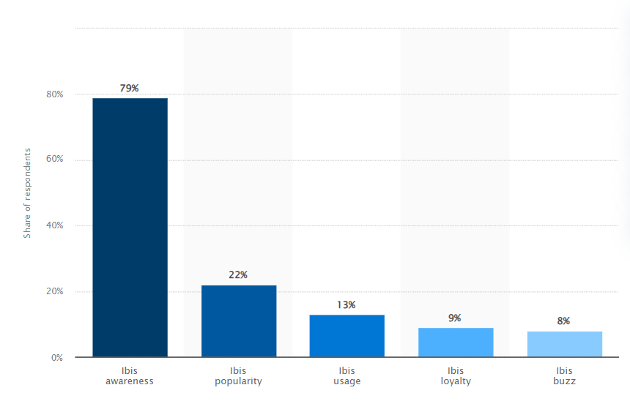
Figure 4: Ibis Brand Metrics Among UK Hotel Customers (2022)
Source: (Kunst, 2023)
Among UK hotel customers, Ibis Hotels has an impressive 79% brand awareness, giving them an important market share. Surprisingly 13% actively use Ibis's services, and 22% have affection for it. The percentage of loyal customers is 9%, which means that many of them are likely to return. Even with little mention in the UK media, Ibis still has 1,200 hotels spread over 69 countries (Kunst, 2023).
Understanding Customer Demographics
Value-conscious travellers, like youngsters and those on limited funds who want access and limited facilities, are the target market for Ibis. Ibis draws visitors looking for easy access and reasonable prices with a balanced range of business and leisure facilities. Geographic differences in travel demographics lead to business travellers being more common in major cities and leisure travellers that dominates in tourist areas (Ishraq and Zakaria, 2023).
Evaluating Brand Perception
People view Ibis Hotels as a reliable choice that is affordable and has good locations (Nelwan, 2020). Younger people are attracted to it due to its modern styling, which make it better from standard hotels. Ibis maintains consistency with its brand by focusing on standard facilities and services, even if their business strategy is heavily franchise-based. In the minds of travellers looking for simple experiences without losing comfort, this improves positive reviews and strengthens the brand's identity (Faliha et al., 2021).

Section 3: Growth Potential Exploration

Growth Potential for Corinthia Hotels
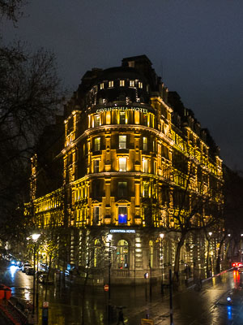
Figure 5: Corinthia Hotel – London • UK
Source: (Corinthia Group, 2021)
Strategic Expansion Analysis: Focusing on important areas with strong brand recognition, such as Europe, the Middle East, and Asia, Corinthia prioritises growing within current markets. It is expected that Corinthia will stand out itself from competitors by analysing specific luxury markets like wellness travel and cultural immersion activities. Strategic brand expansions that target specific areas of the premium market are also taken into mind (Hassanien and Dale, 2019).
Identifying Market Opportunities: Identifying potential in the richest developing nations, particularly Asia and Africa, Corinthia aims to satisfy the increasing need for real life experiences. Choosing luxury travellers' choices can be seen in their focus on customisation and unique travel experiences.
Assessing Potential Growth Barriers: Corinthia is aware of potential challenges such as major luxury businesses competing with them, economic downturns, and uncertain geopolitical conditions. Variety through unique goods, quick responses to changes in economic conditions, and thorough review of geopolitical issues impacting important markets are every aspect of the strategy (Hassanien and Dale, 2019).

Growth Potential for Ibis Hotels
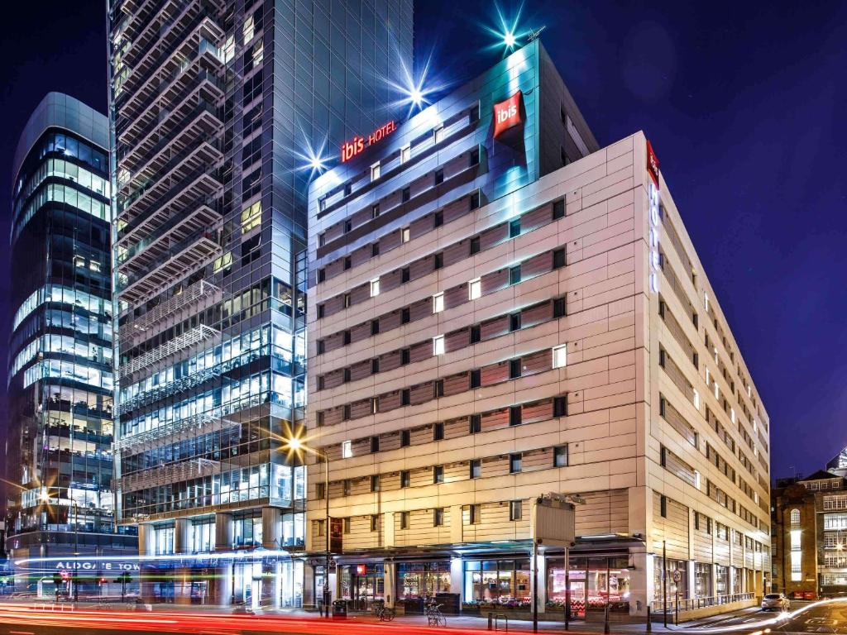
Figure 6: ibis London City - Shoreditch, London
Source: (Accor | Newsroom, 2022)
Strategic Expansion Analysis: Ibis uses its franchising business strategy to grow its brand awareness and maintain quality control. In order to get an overall increase need for cheap accommodation, the hotel structure looked for going for improving the areas like Southeast Asia, Latin America, and Africa. Travellers who depend on technologies too much are attracted to the growth of technology-driven solutions, such as self-service machines and mobile booking platforms, which improve the guest experience.
Identifying Market Opportunities: In order to increase awareness of the brand and maintain quality control, Ibis uses a franchisee company structure (Hassanien and Dale, 2019). The hotel structure focuses on new areas including Southeast Asia, Latin America, and Africa in order to meet the growing need for affordable lodging. The emergence of tech-driven travel solutions that improve the traveller’s experience, such as self-service machines and smartphone booking apps, attracts more than those who depend on technologies too much tourists.
Assessing Potential Growth Barriers: Ibis foresees difficulties such as strong rivalry in the low-cost market and possible damage to the company's reputation. In order to stand out in economic downturns, the plan requires sustaining quality across franchise hotels, important spots, and reliable service, which are all important while adjusting to changing consumer behaviour.

Section 4: Financial Commitment to CSR Activities
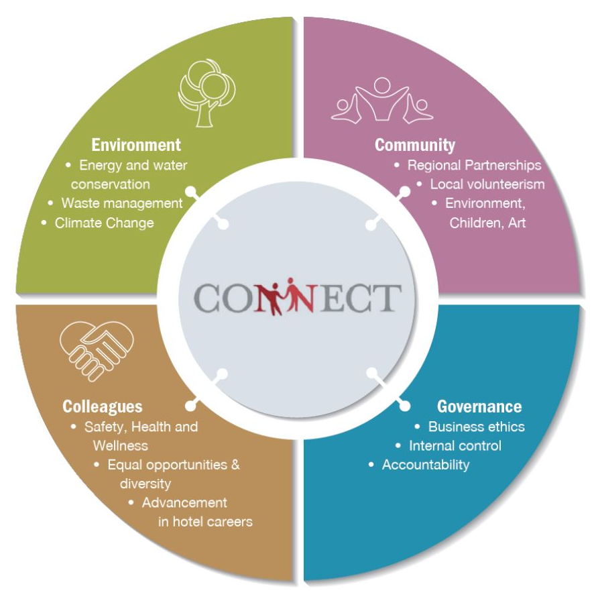
Figure 7: Hotel Corporate Social Responsibility
Source: (Ahn et al., 2020)

CSR Initiatives for Corinthia Hotels
Sustainable Practices
Initiative | Description
Energy Conservation | Use of energy-saving methods for technology.
Waste Reduction | Activities focused on minimising waste production while promoting recovery (Ahn et al., 2020).
Environmental Policies | Applying the rules which ensure the lowest possible level of damage to the environment.

Community Engagement
Initiative | Description
Local Employment Programs | Creating job opportunities and supporting local employment initiatives.
Philanthropic Activities | Involvement with community development and charity activities.
Cultural Preservation | Support to maintain the cultural and historical importance of the preserved area (Ahn et al., 2020).

Ethical Business Practices
Practice | Description
Transparency | Open communication about business practices, which helps to build trust.
Fair Employment Policies | Ensuring fair treatment and opportunities for all employees (Ahn et al., 2020).
Anti-Corruption Measures | Implementation of measures to prevent corruption within the company.

CSR Activities for Ibis Hotels
Sustainable Practices
Initiative | Description
Eco-Friendly Operations | Adoption of eco-friendly technologies and practices for daily operations.
Resource Efficiency | Efficient use of resources, such as water and energy, to lower the overall environmental impact (Peña-Miranda et al., 2019).
Waste Management | Use of effective waste management strategies, including recycling programs.

Community Engagement
Initiative | Description
Local Partnerships | Collaborating with local businesses and organisations to support community development.
Educational Initiatives | Supporting educational programs and initiatives within local communities.
Social Welfare Projects | Donation to charities that improve the health of the community (Peña-Miranda et al., 2019).

Ethical Business Practices
Practice | Description
Fair Trade Practices | Providing fair and social sourcing and purchasing practices.
Employee Well-being | Prioritising the well-being and fair treatment of all employees.
Diversity and Inclusion | Accepting variety while encouraging a diverse workplace (Peña-Miranda et al., 2019).

Recommendations
Diversify Revenue Streams: In order to minimise risks based on economic swings, Corinthia and Ibis need to look for additional sources of income. Sustainability of finances can be improved by offering new services or making branches in related industries.
Collaborative Marketing: Through working together on friendly advertising initiatives, Corinthia and Ibis may take benefit from their mutual benefits. Participating in rewards programmes or promotional campaigns with partners might draw in more customers and create a win-win marketing environment.
Improve Sustainable Practices: Continually make improvements to CSR programmes with a focus on sustainability. Considering long-term success, both hotel groups must focus on lowering their environmental impact, communicating with the community, and supporting ethical business environment.

Conclusion
The financial environment, market positioning, growth prospects, and corporate social responsibility goals of Corinthia Hotel Group and Ibis Hotels within the hospitality sector have all been properly analysed in this business report. An analysis of their overall income patterns, marketing approaches, and corporate social responsibility efforts offers a particular understanding of the overall hotel industry. Even the times during world crises, both businesses have come up with different strong and flexible. The financial health of this industry is based on close connexion with innovative and proper thinking, along with flexibility in marketplace and a deep commitment for sociality and environmentally aware operations which will impact on the path that this major hotel change takes in future.

References
Accor | Newsroom, (2022). Third-quarter 2022 revenue of €1,149 million up 83% like-for-like. [Online] Available at: https://press.accor.com/third-quarter-2022-revenue-of-e1149-millionup-83-like-for-like/?lang=en [Accessed 30 January 2024].
Accor Group, (2021). 2021 INTEGRATED REPORT. [Online] Available at: https://www.google.com/url?sa=t&rct=j&q=&esrc=s&source=web&cd=&ved=2ahUKEwjJ19-J_YSEAxWXSWwGHTlkBZUQFnoECA4QAQ&url=https%3A%2F%2Fgroup.accor.com%2F-%2Fmedia%2FCorporate%2FInvestors%2FDocuments-de-reference%2FACCO_RI_2021_MEL_EN_300322.pdf&usg=AOvVaw2SpPxK [Accessed 30 January 2024].
Ahn, J., Wong, M.L. and Kwon, J., (2020). Different role of hotel CSR activities in the formation of customers’ brand loyalty. International Journal of Quality and Service Sciences, 12(3), pp.337-353.
Corinthia Group, (2021). ANNUAL REPORT. [Online] Available at: https://www.corinthiagroup.com/wp-content/uploads/2021/04/Corinthia-Annual-Report-2020.pdf [Accessed 30 January 2024].
Corinthia Group, (2022). ANNUAL REPORT. [Online] Available at: https://www.corinthiagroup.com/wp-content/uploads/2022/05/Corinthia-Annual-Report-2021.pdf [Accessed 30 January 2024].
Corinthia Group, (2023). 2022 - annual report. [Online] Available at: https://www.corinthiagroup.com/wp-content/uploads/2023/06/37547-CORINTHIA-ANNUAL-REPORT-2022_WEB-min.pdf [Accessed 30 January 2024].
Faliha, N., Siti, A.E., Kusdi, R. and Andriani, K., (2021). Online Reservation System and Online Customer Review: Its Impact on Brand Image, Trust and Hotel Booking Decision. International Journal of Economics, Business and Accounting Research (IJEBAR), 5(4).
Hassanien, A. and Dale, C., (2019). Hospitality business development. Routledge.
Ishraq, S. and Zakaria, A.K.M., (2023). IBIS Hotel's Cultural Pragmatics, Marketing Strategies and Critical Discourse Analysis.
Kirui, O.K. and Siddig, K., (2023). (2022) annual research and policy conference: Agricultural transformation and food security in Sudan (Vol. 3). Intl Food Policy Res Inst.
Kunst, A., (2023). Ibis brand awareness, usage, popularity, loyalty, and buzz among hotel customers in the UK in 2022. [Online] Available at: https://www.statista.com/forecasts/1335566/ibis-hotels-brand-profile-in-the-uk [Accessed 30 January 2024].
Lagarias, A., Zacharakis, I. and Stratigea, A., (2022). Assessing the coastal vs hinterland divide by use of multitemporal data: Case study in Corinthia, Greece. European Journal of Geography, 13(2), pp.001-026.
Nelwan, J.C., (2020). ANALYZING LOGISTICS MANAGEMENT AT IBIS HOTEL MANADO. Jurnal EMBA: Jurnal Riset Ekonomi, Manajemen, Bisnis dan Akuntansi, 8(4).
Peña-Miranda, D.D., Arteaga-Ortiz, J. and Ramón-Cardona, J., (2019). Determinants of CSR application in the hotel industry of the Colombian Caribbean. Sustainability, 11(18), p.5045.
The Economic Times, (2023). Ibis expects 25% growth in top-line at Rs 1,000 cr this year. [Online] Available at: https://economictimes.indiatimes.com/industry/services/hotels-/-restaurants/ibis-expects-25-growth-in-top-line-at-rs-1000-cr-this-year/articleshow/98670867.cms?from=mdr [Accessed 30 January 2024].
Tran, L.T.T., Ly, P.T.M. and Le, L.T., (2019). Hotel choice: A closer look at demographics and online ratings. International Journal of Hospitality Management, 82, pp.13-21.

