Discuss the relationship of Athens to the Macedonian kings before Philip II and its ramifications for Macedonian history
To Athens Macedonia held a precious resource that was vital for their supremacy over the Greek world, that being timber; the Athenian poet Hermippos said once in one of his poems that Perdikkas sent Athens two things, oars and lies, from this we can infer a great deal firstly is the reliance of Athens on Macedonia to supply the timber for their navy and secondly that the relationship between the Macedonian monarch and Athens was tenuous at best. However this comes from an Athenian source as does the majority of our information on this period, with this in mind due to the perspective from which they were written; we can then assume there is some bias towards the retelling and we can almost be certain that a Macedonian source would tell the story of the relationship of this two powers far differently than an Athenian source would. This shall be the basis of my argument in this essay, looking at the Macedonian standpoint and is the reason for the Macedonian negative attitudes towards the Athenians based upon aggressive instigation on the part of the Athenians.
As mentioned before the Athenians had a strong vested interest in hegemonising the Macedonians fruitfull resources as the timber was the backbone of the Athenian navy which was the source of their power. While the Macedonians had a rich abundance of timber which the Athenians greatly sought after, the Athenians themselves had nothing to offer the Macedonians; the soil in the surrounding area of Arcadia was poor so they had little to offer them in the way of crops and the mines of Laurion began producing silver in the 5th century however the Athenians used this to finance the building of its ships rather than the also the acquisition of resources.
During the reign of Alexander I there was an amicable relationship between Athens and the Macedonian monarch, who was declared proxenos by Athens meaning that he had to protect their interests in Macedon and was so during the battle of Plataea. Athens continued to take timber from Macedonia until the founding of Amphipolis which opened up an alternative source of timber to the Athenians, this was successful from 437-423BC until the Spartans took the city thus cutting off the Athenian timber supply and forcing them to go back to Perikkas for timber. The other occasions that Macedon exported timber to Athens were post Sicilian disaster, then after the birth of the second Athenian league and finally an agreement between Amyntas III and Athens to export timber. If we look at the evidence it is clear that there is a direct correlation between Athenian reliance on Macedon and the times its navy was in high demand which does heavily imply that the relationship between Athens and Macedon was directly dictated by the Athenian need for timber.
Perdikkas II and Athens both had an interest in expanding east of the river Struma, both seeking the mines and timber which existed there and before this we do have some suggestion that they shared a working relationship as “Thucydides, referring to Perdiccas as "formerly an ally and friend" of the Athenians, implies that he had held the royal power exclusively or in partnership for some time before 432 (1.57.2).' How far back "formerly" can be taken, it is not, of course, possible to say; one cannot even be sure that Perdiccas had to be king at the time he was an ally and friend. All that is certain are that there had been a formal, and presumably amicable, relationship between Athens and Perdiccas” Worthington does seem to accept this idea “Much of the history of Macedonia under Perdiccas has to be inferred from the vastly better- documented history of Athens. It seems that up to Athens’ alliance with his foes in 433, he was its friend and ally” but as we will discuss later the reliability of the sentiment behind these words is questionable. Athens founded the city of Amphipolis near the mouth of the river; Perdikkas would have seen this as a very aggressive action. As we can see in fig. 1, Macedon being located in such a mountainous region is both a blessing and a curse from a defensive standpoint being surrounded like that makes it very difficult to invade as the mountains surrounding is are nearly impassable and no army dared march over them leaving only three options, you bring your army up from the south past Dion, from the sea or from the east but equally Macedon can only expand via these routes as well. With this in mind with Dion under Athenian control at this time and with the founding of Amphipolis Athenian influence gained further dominance in Macedonia with Athenian forces converging from all sides, threatening Macedon. Perdikkas reigned for some twenty years and for the entirety of that time the Athenians were a constant threat to the northern kingdoms, including the Chalcidians. For the entirety of the Peloponnesian war it is clear that they all had one goal which was to remain autonomous, this is evident by them seeking Spartan aid in the form of Brassidas to claim the city of Amphipolis.
In the Athenian account of these events Thucydides includes details such as Brasidas first arriving at Dion but however conveniently leaves out Athens founding Amphipolis which is a key detail explaining the motivation behind Perdikkas’ hostile attitude toward the Athenians. Athens also allied themselves with the king’s brother Philip who controlled the eastern half empire and on top of this Athens threatened the 3rd entrance into the kingdom of Macedon by establishing a settlement at Brea putting clear pressure on the harbour which Thucydides also does not mention. In light of this information it is hardly surprising that Perikkas displayed a hostile attitude towards the Athenians, in the east his brother who could challenge his claim to the throne had conspired with the Athenians “Thucydides tells us that enmity sprang up between the Athenians and Perdiccas, who had recently been their friend and ally, "because the Athenians had made an alliance with Philip his brother” which likely lead to the founding of Amphipolis, an Athenian foothold in his territory “the Athenians, feeling that war with Sparta was likely within a decade, decided that they must have on the Macedonian throne someone whom they could trust, for the sake both of timber supply and their general position, offensive and defensive”, the founding of Brea near the Macedonian harbour which threatened their connection to the sea. With all these omitted details in mind Perdikkas having an anti-Athenian attitude is quite justified. This paints the picture of Perikkas as a king who served the interest of his kingdom, protecting its independence and allying himself as he saw best to do this, Thucydides however portrays him very differently as a self serving coward who pales in comparison to his successor Archelaos the forerunner of Macedonian development who just happened to be serving Athenian interests. This is a direct example of how the relationship between monarchs and Athens has shaped their history had Perdikkas submitted to Athens he would probably have been recorded in a much kinder way as we can see how a king like Archelaos was portrayed by Thucydides. Worthington makes a good point that Perdikkas was no less reliable than the Athenians as an ally “Perdiccas’ reversals earned him the reputation in Athens of being a deceitful man, which went back to at least the 420s when the comic poet Hermippus included his lies among goods imported to Athens.9 It also informed the depiction of the king by our primary source Thucydides and consequently that of many modern scholars.10 Yet Perdiccas was no more unreliable than the rulers of many other Greek states, including Athens, which as recently as 433 had gone back on its alliance with him by supporting his brother. It is our Athenocentric sources that regard his efforts to survive in a tough neighborhood as displays of dishonesty. It is also naive to think that the Chalcidians had rebelled solely on account of his instigation, for they had good reasons of their own to resent Athens.” An argument which I support as it reiterates the point of depending on which side of history you are on impacts your representation.
Macedon and Athens once again aligned under Amyntas III due to the founding of the second Athenian league which unsurprisingly resulted in an agreement regarding timber again. Aeschines, Xenophon and Diodorus all discuss the peace summit in their respective works however only Aeschines mentions Athens making a claim to Amphipolis based up the right to have its own land. This alignment between Athens and Macedon was short lived however with the emergence of Thebes as power lead to Alexander II and Ptolemy switching alliances and under the direction of Thebes they staved off Athens from reclaiming Amphipolis along with the Chalcidean league. After this Macedon switches sides quickly and as it suits them, with the assassination of Ptolemy and the ascension of Perdikkas III Macedon became allied with Athens and Timotheus capturing Olynthus, Potidaea and Torone. Almost immediately afterwards Perdikkas disassociated with Athens due to a realisation of the spreading power of Athens and worried about the potential repercussions Macedon might face from Thebes and her allies. This time Athens became a threat only because the king worried they would become one, a self fulfilling prophecy. And now Athens once again had a foothold in Methone from which they were ready to launch and invasion of Macedon. In this case unlike the last Macedon created its problems itself and the conflict between Athens and Macedonia was a result of the king fearing aiding and then fearing Athens what does remain similar though is the want for independence.
After Perdikkas III along with thousands of Macedonian troops fell on the Illyrian front Macedonia was open to assault, with no king and a considerable number of its troop’s dead Macedonia was vulnerable to attack and Athens made its move trying to place Argaios on the throne that was rejected at which point Philip II assumed the throne.
To conclude it is clear that all negative Athenian actions by the Macedonians stem from Athens desire to have authority over Macedons natural resources particularly their timber. For Athens it was a bid for survival for Macedon it was a game of cat and mouse with the Athenian presences constantly encroaching upon their borders and autonomy as the prize. Their relationship was purely dictated by the Athenians when Athens required timber their relationship was amicable business relationship however when Athens decided it no longer wanted Macedon to control the supply of timber they became far more aggressive and warlike. Athens desire for dominion in the north also shaped Macedonian history as without Athens taking the role as the prime aggressor there possibly would have been no Chalcidean league which had effect which resonated through to Philip II and Macedon would have been a very different place.
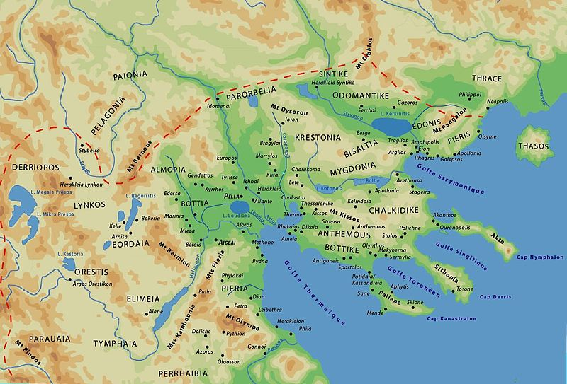
Fig. 1 M. Hatzopoulos: Macedonian Institutions under the Kings, Athens, 1996.

Bibliography
Ancient sources
Thucydides, History of the Peloponnesian War

Modern sources
Psoma, Selene E. "Athenian Owls and the Royal Macedonian Monopoly on Timber." Mediterranean Historical Review 30, no. 1 (2015): 1-19.
Cole, J. W. "Perdiccas and Athens." Phoenix 28, no. 1 (1974): 55-72.
Errington, Robert Malcolm (1990). A History of Macedonia. Translated by Catherine Errington. Berkeley: University of California Press
Borza, E. (1987). Timber and Politics in the Ancient World: Macedon and the Greeks. Proceedings of the American Philosophical Society, 131(1), 32-52. Retrieved from http://www.jstor.org/stable/987115
Roisman, Joseph (2010). "Classical Macedonia to Perdiccas III". In Roisman, Joseph; Worthington, Ian. A Companion to Ancient Macedonia. Oxford: Wiley-Blackwell. pp. 145–165.
L. Kallet-Marx, Money, Expense and Naval Power in Thucydides’ History 1-5.24, Berkeley 1993

. Hermippos, Phormophoroi, PCG V 1986, fr. 63 l. 8
L. Kallet-Marx, Money, Expense and Naval Power in Thucydides’ History 1-5.24, Berkeley 1993
Thucydides 4.102.1
This was during the Peloponnesian war and Amphipolis was a key strategic location for the both city states, for the Spartans it was an opportunity to cut the Athenians off from all the resources in Macedon and also to be in a threatening position to the Athenian grain supply which came down from the black sea.
Cole, J. W. "Perdiccas and Athens." Phoenix 28, no. 1 (1974): 55-72.
Roisman, Joseph (2010). "Classical Macedonia to Perdiccas III". In Roisman, Joseph; Worthington, Ian. A Companion to Ancient Macedonia. Oxford: Wiley-Blackwell. pp. 145–165.
Cole, J. W. "Perdiccas and Athens." Phoenix 28, no. 1 (1974): 55-72.
Cole, J. W. "Perdiccas and Athens." Phoenix 28, no. 1 (1974): 55-72.
Roisman, Joseph (2010). "Classical Macedonia to Perdiccas III". In Roisman, Joseph; Worthington, Ian. A Companion to Ancient Macedonia. Oxford: Wiley-Blackwell. pp. 145–165.

