Alisha Mahmood
Component 2
PROFESSIONAL DEVELOPMENT IN HEALTH AND SOCIAL CARE LCHS4009 BIRM

Task 1 of 4
Create a two-page professional Cv that highlights your education, achievements, work and voluntary experience, key skills, interests and hobbies, and reference details. Your CV should be tailored to your chosen job role within the health and social care sectors and presented in a clear and professional format.

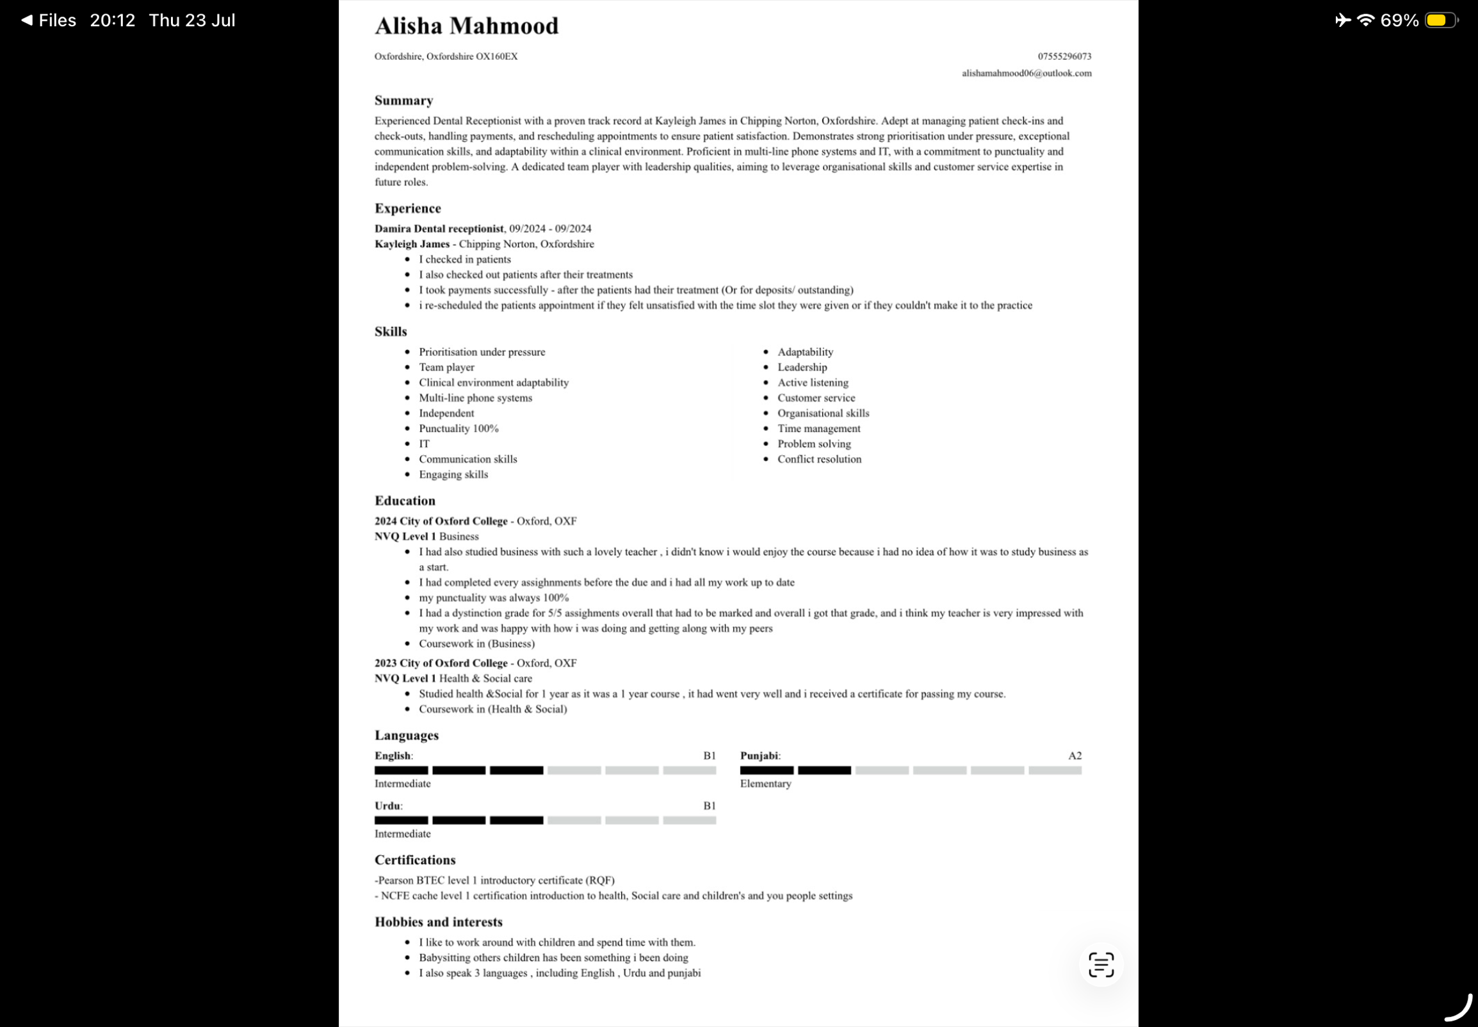
Task 2 of 4
Draft a 500-word personal statement to apply for your own choice job role, outlining your main career aims and experience. Include points about your education, personal strength, and professional skills and why these would be of value to an employer.

Word count- 500

My ambition to become a paramedic comes from a genuine desire to help people during the some of the most difficult moments of their lives. I am passionate about providing care, reassurance, and support to individuals in emergency situations, while remaining calm and professional under pressure. The opportunity to make a positive difference in someone’s life, whether through medical treatment or emotional support, is what motivates me to pursue this career.
Throughout my education, I have developed a strong understanding of science, health , communication, all of which are important for a career in paramedicine. I have always been interested in how the human body works and how healthcare professionals respond to emergencies. My studies have helped me build problem-solving skills, attention to detail, and the ability to learn and apply new information effectively.
In addition to my education, I have gained valuable experience working with a range of people from different backgrounds. Through my previous roles and voluntary experiences, I have developed strong-communication and interpersonal skills. I understand the importance of listening carefully, showing empathy, and treating everyone with dignity and respect. These experiences have taught me how to remain professional and supportive, even in challenging situations.
One of my greatest strengths is my ability to stay calm and focused when faces with pressure. I am organised, reliable, able to manage my time effectively. I can work independently when required, but I also enjoy being part of a team and understand the importance of working collaboratively with others to achieve the best outcomes. As an paramedic, team-work is essential, and I believe my ability to communicate clearly and cooperate with colleagues would make me a valuable member, of any healthcare team.
I am also confident in my ability to adapt to new situations and make informed decisions quickly. Emergency situations often require healthcare professionals to think clearly and act decisively, and I am eager to continue developing these skills through further training and practical experience. I understand that paramedics must demonstrate resilience, professionalism, and compassion at all times, and I am committed to upholding these qualities throughout my career.
Employers would find value in my strong work ethic, willingness to learn, and dedication to helping others. I am dependable, motivated, and always strive to perform to the

highest standard. I am committed to providing excellent care an ensuring that patients feel safe, respected, and supported during their time of need.
My long-term goal is to become a skilled and knowledgeable paramedic who can make a meaningful contribution to the healthcare profession. I Am excited about the opportunities this carer offers and look forward to developing my skills, gaining experience, and making a positive impact within the community. With my determination, compassion, and commitment to helping others, I believe I would be a strong candidate for a role within the paramedic profession.

Task 3 of 4
- Complete a SWOT analysis that identify as your personal strengths, weaknesses, opportunities, and threats in relation to your chosen health and social care job role.
- Develop a personal development plan (PDP) outlining at least three clear and achievable goals that will help you prepare for and progress within this specific role. Describe how you will develop these areas over the next two years and how you will monitor and evaluate your progress.

Strengths | Weaknesses
-Strong communication And active listening skills, helping me reassure and support patients during stressful situations.  -Able To remain calm and focused under pressure, even in emergency situations.  -Work well as part of a team and can communicate effectively with healthcare professionals, patients, and their families. | -I can sometimes spend extra time double checking information to ensure accuracy, which may slow me down.  -i’m still developing confidence in making rapid decisions in a high-pressure environment.  -I need more experience in handling particularly complex medical emergencies independently.
Opportunities | Threats
-Access to paramedic training courses, workshops, and continuing professional development programs.  -Opportunities to learn from experience paramedics through placements, mentoring, and shadowing.  -Gaining experience across different emergency settings will help broaden my clinical knowledge and practical skills. | -The demanding nature of emergency work can lead to stress and fatigue if work life balance is not maintained.  -Exposure to traumatic incidents may have an emotional impact if appropriate support is not used.  -Long shifts, unpredictable workload, and high demand for ambulance services can be physically and mentally challenging.
Personal SWOT analysis

Personal Development Plan Template
Goals | List the actions to complete achieve the goal | Support resources needed | Target | Review date
Improve confidence in emergency decision-making | -Attend simulation training sessions.  -observe experienced paramedics during placements.  -Reflect on Emergency scenarios and identify areas for improvement. | - Mentors and supervisors  -Training workshops  -Clinical simulation resource resources | End of year 1 | Every 6 months
Develop advanced patient assessment skills | -practice patient assessments during placements.  -Study clinical guidelines and protocols.  -Seek feedback from qualified professionals. | -placement opportunities.  -Learning materials and clinical guidance. | End of year 2 | Every 6 months
Build resilience and stress management techniques | -Attend to well-being sessions.  -Use reflective practice.  -Maintain A healthy work life balance. | -Occupational well-being services.  -Support from mentors and peers. | Ongoing | Quarterly
Task 4 of 4
Using an appropriate reflective model (Gibbs model closing (. Write a 600 word critical reflection on your LCHS 4009 component one presentation assessment. Your reflection should explore your thoughts, feelings, performance, and areas for improvement, and cooperating verbal feedback received from your lecturer to support your analysis.

I chase emergency response and team in paramedic practice as my presentation topic because effective teamwork is essential in emergency medical services. My presentation explained to how paramedics work alongside emergency call handlers, nurses, doctors, firefighters, and police officers to provide the best possible patients. I used clear slides, included real life examples, and rehearse my presentation several times to stay within end of time limit. During the presentation, I covered the main points confidently and answered questions from the audience. My lecturer commented that my content was informative and demonstrated a good understanding of the role of a paramedic. However, they also noted that our occasionally spoke too quickly and relied on my notes more than necessary.

Feelings
Before delivering my presentation, I felt nervous but also excited to share what I had planned. I was worried that I might forget important information or lose track of my points. Once I started speaking, I gradually became more confident uncomfortable. Although I felt relieved when I finish, I realise that my nerves had affected my pace and eye contact with the audience. Receiving positive feedback of my knowledge and preparation increased my confidence and motivated me to improve my presentation skills further.

Evaluation
There were several positive aspect of my presentation. A slides were well organised, easy to understand, and included relevant information about the responsibilities of paramedics. I explained key concepts clearly and use example examples that help the audience understand the importance of teamwork in emergency situations. The lecture of praise my understanding of the topic and my ability to stay within the allocated time.
On the other hand, there were areas for improvement because I was nervous. I spoke too quickly at times, making some sections harder to follow. I also depended heavily on my notes instead of engaging naturally with the audience. While I discussed teamwork effectively, I could’ve included more reflection on my own strength and future contribution as a paramedic.

Analysis
Using Gibbs reflective cycle helped me understand why these issues occurred. My nervousness led me to rely too much on my written notes, which reduced my interaction with the audience. As a future paramedic, communication is a crucial skill, particularly when reassuring patient and working with healthcare professionals in high-pressure situations. The feedback I received highlighted the importance of maintaining eye contact, speaking clearly, and demonstrating confidence. These skills are just as important as having good clinical knowledge because they help build trust and ensure information is communicated effectively.

Conclusion
Overall, I believe the presentation was successful because I demonstrated a good understanding or paramedic practice and the importance of teamwork in emergency care. However, I recognise that I need to improve my confidence when speaking in front of others and reduce my reliance on Notes. Reflection on this experience has helped me identify practical way to strengthen my communication skills and become a more effective healthcare professional.

Action plan
– Practice presentations regularly to improve confidence and reduce anxiety.
– Use key cards instead of a full script to encourage more natural speaking.
– Record myself presenting and review my pace, volume, and body language.
– Seek feedback from lecturers, classmates, and placement supervisors.
– Continue developing communication and teamwork skills to classroom activities and practical experiences.
– Take part in simulation exercises to improve confidence when speaking and make decisions under pressure.

