
Module Name: Digital Skills for Personal Development and Business Growth
Module Code: BMSW4008
Assignment Title: Portfolio
Student Name: Georgia Vatougios
Student Number: 2520837
Lecturer: Scott James
Deadline: 16th March 09.00 2026

AI Acknowledgement Statement:
I confirm that I have not presented any AI generated materials as my own work.
I confirm that I have copies of my drafts, notes, and other resources I used, which I may be asked to provide in evidence.

Contents
Task 1: Assessment of Digital Skills (700 Words) 3
Introduction: Importance of Digital Skills 3
Overview of the JISC Digital Capability Tool 4
Summary of JISC Results 4
Strengths in Digital Skills 5
Areas for Improvement 5
Action Plan Using SMART Goals 6
Reflection and Conclusion 6
Task 1 References (Minimum 5) 6
Task 2: LinkedIn Learning Certificates – Office 365 7
Outlook Essential Training (Microsoft 365) 7
Word Essential Training (Microsoft 365) 8
Excel Essential Training (Microsoft 365) 9
PowerPoint Essential Training (Microsoft 365) 10
Task 3: Relevance and Importance of Microsoft Excel (1,000 Words) 10
Introduction 11
Uses of Microsoft Excel 11
Data Analysis 11
Budgeting and Financial Management 12
Reporting and Decision-Making 12
Practical Spreadsheet Task 12
Reflection and Conclusion 13
Task 3 References (Minimum 5) 14
Task 4: Reflective Presentation Summary (5 Minutes) 14
Overview of Presentation Content 14
Learning and Skill Development 14
Links to Task 1 14
Links to Task 2 14
Links to Task 3 14
Application to Studies and Career 14
Task 3 References (Minimum 5) 14

Task 1: Assessment of Digital Skills

Introduction: Importance of Digital Skills
Digital skills are the skills that are needed to use digital technologies in an effective manner. Digital skills are an essential skill for someone to have in both higher education and in the modern workplace. These skills in higher education play a vital role to help students to progress further with their academic studies. They are used continuously during their studies such as accessing the internet for researching, accessing online modules and using digital technology to complete and submit assignments. Having a strong understanding of digital literacy is important as it plays a big contribution to successful studies. This plays a big part in students developing critical thinking skills and organisational skills as it helps them to engage better. Getenet et al. (2024)
In the modern workplace, digital skills are used just as frequent. They are relied upon to communicate between staff and customers, manage the workload and data analysis. This helps the workplace to run in a more efficient and organised manner. As technology evolves further over time, digital skills are key to future education and career development.

Overview of the JISC Digital Capability Tool
The JISC Digital Capability Tool is a tool for students to self-assess their level of digital skills. It focuses on the key skills that are used in learning in higher education. I answered a series of questions about my level of digital skills and how capable I am using these skills for different tasks. My results from the JISC tool were shown on a graph to highlight the level of my understanding and knowledge of each of these areas.

Summary of JISC Results
The results from the JISC Digital Capability Tool show that I have a mixed understanding of digital skills. My strongest point was digital communication, digital proficiency, digital wellbeing and digital identity management. This shows that I am capable of using these to be more successful during my time studying higher education and later for future career opportunities. There is a lot of room for improvement in other areas such as digital creation, problem solving and media literacy as I scored lower in these sections.
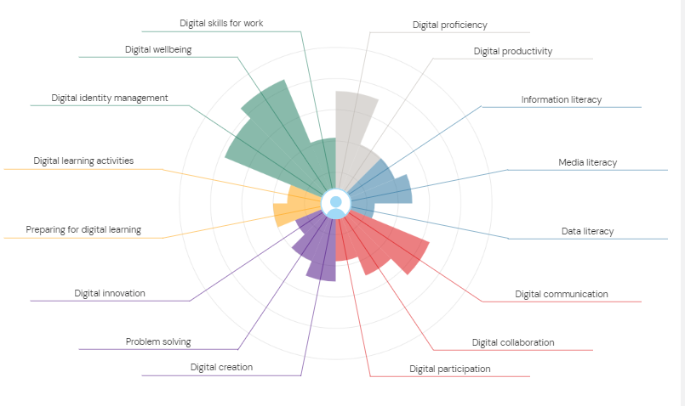

Strengths in Digital Skills
One strength of mine is digital communication. I use this skill on a regular basis to check my timetable, email lecturers and other professionals in the university and communicate with my classmates through teams. This is a vital skill for me to have as it is heavily relied upon during my studies and future career plans.
Another strength of mine is digital wellbeing; this is the ability to manage my screen time effectively and understanding online safety in a positive way which will support my own overall wellbeing during my time studying at university as reducing screen time has shown to reduce screen fatigue. (Thomée et al., 2011; Faelens et al., 2021).

Areas for Improvement
Preparing for digital learning is a skill that needs improving for myself as this is key for understanding and completing the tasks and assignments that I have been set. I often find it a struggle to focus and manage my time wisely between the note taking in class and then getting started on an assignment.
Another skill that I found needs improving is digital innovation. I lack the ability to understand how to use new technologies quickly and I will need to go over it a few times before I can understand the basics. This skill is important for my studies as new technology can improve my way of learning and writing assignments, creative thinking skills and help me prepare for future workplaces that may use modern technology. (Alenezi, 2023).

Action Plan Using SMART Goals
To make improvements in my weaker areas I have used SMART Goals:
- Specific: Improve digital innovation by trying new digital tools related to my work.
- Measurable: Experimenting with one new digital tool each week.
- Achievable: Set one evening a week dedicated to this only.
- Relevant: This will improve confidence in using technology for my studies.
- Time-bound: I aim to achieve this by the start of next term in four weeks.

Reflection and Conclusion
Improving my abilities with digital skills will improve my academic studies and future career developments. This will help me in higher learning with my research for sources and information, organise and prepare for assignments in a productive manner. This will also improve my future career opportunities as it will allow me to use technology in a confident manner and expand my choice of career.

Task 1 References
Getenet, S., Cantle, R., Redmond, P. et al. Students' digital technology attitude, literacy and self-efficacy and their effect on online learning engagement. Int J Educ Technol High Educ 21, 3 (2024). Available at: https://doi.org/10.1186/s41239-023-00437-y
Kadhim, M.J. (2024) Digital Literacy and Its Importance in the Modern Workforce, International Journal of Social Trends, 2(2), pp. 44. Available at: https://www.researchgate.net/publication/382641453_Digital_Literacy_and_Its_Importance_in_the_Modern_Workforce
Jisc Discovery Tool , Available at https://uwtsd.potential.ly/ (Accessed 13 January 2026)
Burr, C., Taddeo, M. and Floridi, L. (2020) ‘The ethics of digital well-being: A thematic review’, Science and Engineering Ethics, 26, pp. 2313–2343. Available at: https://doi.org/10.1007/s11948-020-00175-8
Alenezi, M. (2023) ‘Digital transformation and technological innovation on higher education post-COVID-19’, Sustainability, 15(3), p. 2466. Available at: https://doi.org/10.3390/su15032466

Task 2: LinkedIn Learning Certificates – Office 365

Outlook Essential Training (Microsoft 365)

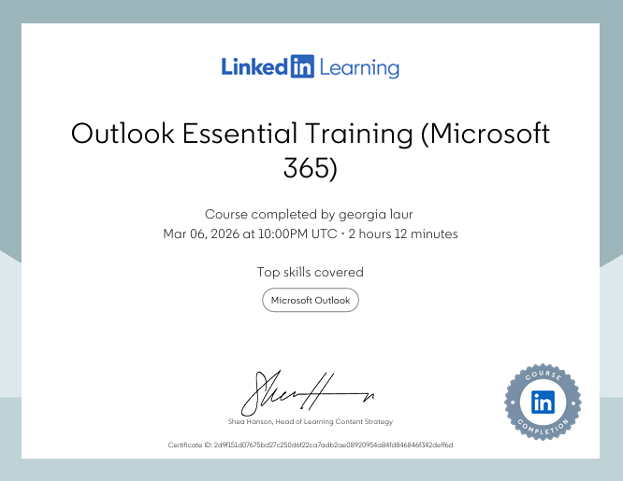

Word Essential Training (Microsoft 365)

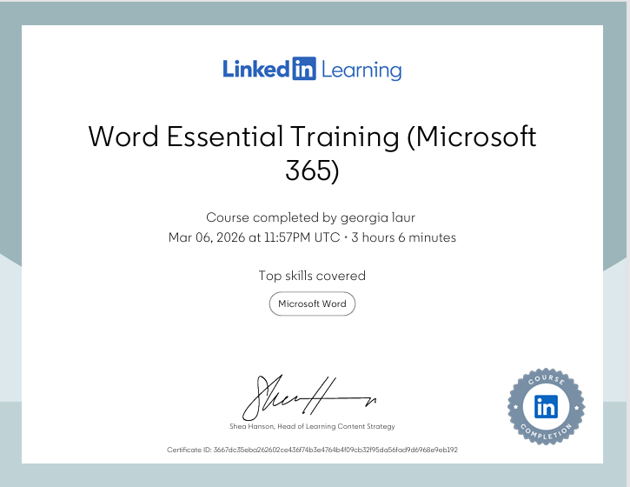

Excel Essential Training (Microsoft 365)

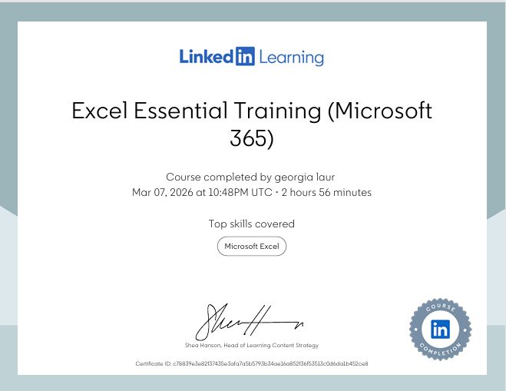

PowerPoint Essential Training (Microsoft 365) 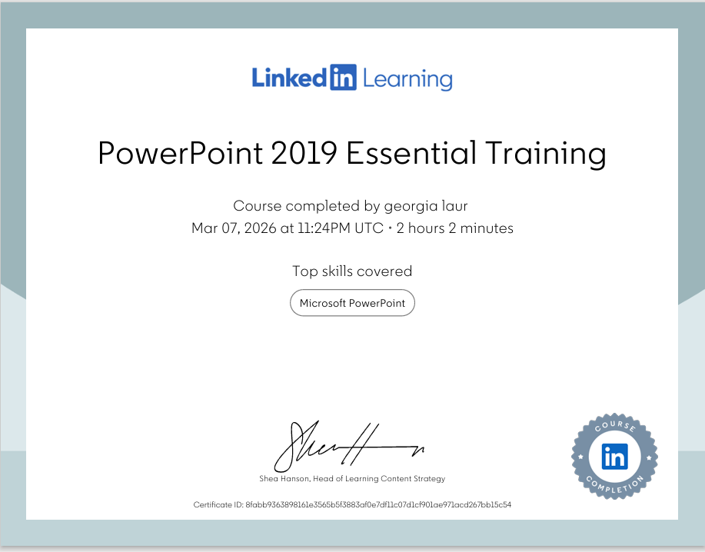

Task 3: Relevance and Importance of Microsoft Excel

Introduction
Microsoft Excel is a spreadsheet software that is used in higher education, in the workplace and in everyday life. It allows people to organise data and analyse it thoroughly by using charts, tables and graphs. (Simaremare & Siregar, 2024). It is a useful tool for storing and navigating information and data in an organised formation.
In higher education, Microsoft excel is very useful to students as it is essential in managing data for various studies and assignments. It helps students to organise information and analyse the data needed. In business, Excel is essential in using for budgeting and project management. It can be used to analyse important data such as sales, staff, profit and organising.
Excel also helps manage everyday life situations such as personal finances, managing bills, income and outgoings. It helps to organise everyday routines and personal schedules making everything easier to keep track of having it all on a spreadsheet.
Microsoft excel is a useful and reliable tool to make everyday life, education and work easier to understand and keep to a structured routine.

Uses of Microsoft Excel

Data Analysis
Microsoft excel is a useful tool that uses formulas to analyse data, it also sorts and filters the data. This makes it an effective and more simple way to sort through the data to get the outcome needed. Using the functions SUM, MIN AND MAX, AVERAGE and more advanced formulas such as VLOOKUP create a quick and simple way to calculate and get the correct information.
Sorting creates a more efficient and user-friendly way of organising data. It can sort data from lowest to highest or in alphabetical order. Filtering displays only the information needed to the user to make it easier to breakdown and view without filtering all the information manually.
Pivot tables can be used in summarising large amounts of data, taking out the necessary information needed without losing useful information. These can be used in many settings to look at results, analyse data and sales.
Microsoft excel is an essential to higher learning and career development as it enables its users to process information and data in an effective manner, helping with organisational skills and managing personal needs.

Budgeting and Financial Management
Microsoft Excel is a tool used in education, everyday life and in the workplace to manage budgeting, track income and expenditure. Using spreadsheets help the users to organise all data easily and notice patterns in spending from creating graphs and charts. Using the formulas above this makes it easier for excel to calculate these correctly. It is used in everyday life to track bills, rent and any other outgoings. Excel is an efficient and reliable way to make budgeting more organised

Reporting and Decision-Making
Microsoft Excel allows user to do more than just budgeting, it transforms data into charts, tables and dashboards making it easier to calculate and view results instead of doing it manually without technology. Using charts, tables and dashboards on excel give a more informed decision for its users. It is used widely in the workplace for various tasks such as tracking expenditure in sales or managing sales.
Tables are used to filter that information into rows and columns creating a structured way to view results. Charts come in many forms such as pie charts and bar charts used for calculating numerical data, making it easier to compare results and identify patterns. Dashboards in excel are used to show all important data in one place combining charts and tables making it a more simple and effective way for users to get a better understanding of the outcome of the results.

Practical Spreadsheet Task
The purpose of this household income and expenditure spreadsheet was designed to create a way to easily identify the household’s disposable income after expenses. Using excel is a simple way to keep track of monthly income and spending patterns as it calculates automatically making budgeting for the year much easier and less complicated. It is an effective way to track all outgoings and bills such as rent, council tax, petrol, food and hobbies all in one place. It enables the users to identify their spending habits over the year and what is being spent each month making it easier to plan ahead for future spending.
Organising the data into rows and columns with each row showing the income and outgoings and the columns showing the months creates an easy overview of what is going in and out. The formulas used in excel help calculate both the wages together to show the combined total monthly income.

Reflection and Conclusion
Excel is used often in education and the workplace particularly jobs that require digital skills. It is important to have knowledge in excel as it is used in many roles such as finance and online businesses. Having skills in Excel allows the opportunity to work various industries.

Task 3 References
Simaremare, S. and Siregar, R. (2024) Effectivity of the Microsoft Excel Application on Student Understanding in Statistics Courses, Indonesian Journal of Education and Social Humanities, 1(2), pp. 9–19. Available at: https://journal.mgedukasia.or.id/index.php/ijesh/article/view/60
Park, T., Hong, M. and Kondrat, D. (2022) ‘Undergraduate students’ attitudes toward statistics: How Excel makes a student’s life easier’, Journal of Evidence-Based Social Work, 19(3), pp.263–271. Available at: https://www.tandfonline.com/doi/abs/10.1080/26408066.2022.2025968
Kelly, O., Hall, T. and Connolly, C. (2023) ‘Digital workplace skills: Designing the integrated learning of accounting and Microsoft Excel’, Accounting, Finance & Governance Review, 30. Available at: https://afgr.scholasticahq.com/article/77593-digital-workplace-skills-designing-the-integrated-learning-of-accounting-and-microsoft-excel

Task 4: Reflective Presentation Summary

Learning and Skill Development

Microsoft Excel is a very useful tool to support my time in university and in future career opportunities. It will teach me the skills needed to improve my studies and career. Excel will teach me how to organise, how to look at and how to create bars and charts to analyse data and create my own. Using excel for my studies will enable me to organise my work effectively. It enables me to analyse data and add it to my assignments to show my research

Links to Task 1
The JISC Discovery tool was useful in collecting the data you provide and giving results that show which skill needs improving on. This enables students to focus on improving the skills they scored lower on improving overall digital skills.

Links to Task 2
Linkedin Learning Office 365 certificates were informative in showing a visual step by step guide on how to use Outlook, Word, PowerPoint and Excel which is beneficial in developing digital skills.

Links to Task 3
Excel has created the opportunity for me to learn many skills such as data analysing and organising work and finances which are key in education and the workplace and will continue to develop further in future as technology continues to advance.

Application to Studies and Career
I will apply these digital skills in my academic work and future career by using spreadsheets to manage and keep track of studies/work hours. Track my income and spending

