Dance and Choreography
Leah Sheridan

This Photo by Unknown Author is licensed under CC BY-SA-NC
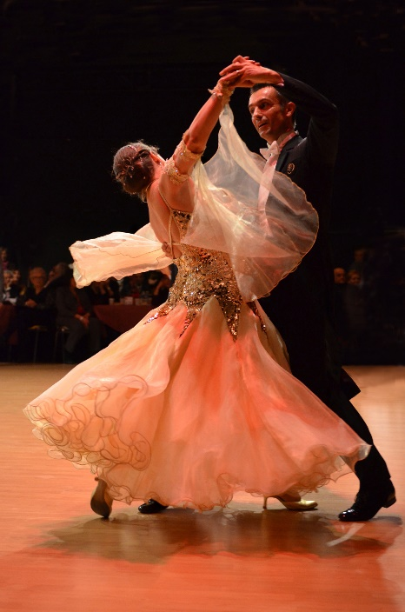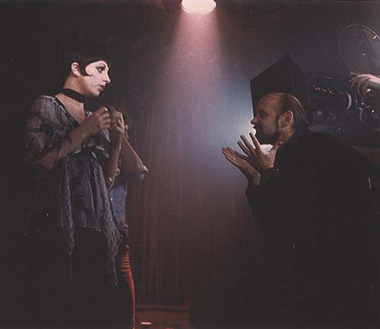
This Photo by Unknown Author is licensed under CC BY-NC-ND

This Photo by Unknown Author is licensed under CC BY-SA-NC
We started off our initial class discussing dance principles, BASTE, Body; Action; Space; Time; Energy. Using ‘BASTE’ we approached each style to dissect (Bodensteiner, 2022). We looked at work from chorographers such as Merce Cunningham and Christopher Bruce, we explored 11 different styles of dance and worked on eight in detail for our assessment. I will discuss our warm-up, Lindy Hop, red rooster, Bob Fosse and the Waltz.

WARM-UP
We started with yoga, focusing on the movements in a ‘sun salutation’. I noticed that the salutation involved stretching out our whole body with a special emphasis on the spine in the movements of ‘child’s pose’ and ‘cobra’. ‘The spine is designed to be flexible and stable, enabling free movement of the torso and limbs … as well as being the main support of the upright human form’ (Callery, 2001, p. 72). I noticed that throughout the module I started to become more flexible from stretching, which allowed me to increase my physical literacy, as I could perform more dance moves more precisely. For example, in our ’Pulp Fiction’ dance.

‘Yoga also helps dancers improve their proprioceptive sensation (feeling of one’s body position, movement, and strength) and body awareness, which helps in being more mindful of their movement. Dancers can apply this to become more mindful of their movement they do on the stage and ensure that their alignment is correct’
(Sano, 2022, p. 109).

I found that when I was fully warmed-up, my body was able to hit the dance moves in ‘red rooster’ much more easily. I was also more focused and could learn choreography easier because I was not stressed.

Lindy Hop- Energy
Our introduction to Lindy hop was a video from a dance competition, see appendix 1 for link. I noticed that there was a very individualistic feeling of spirit, bounce and joy in this style. The energy was free with a strong rhythm, and I played with different techniques to represent that in my body. As the dance is primarily a 6-count step, our lecturer emphasised the importance of mastering the steps, so we can focus on creating the uplifting energy of the dance. I started with repetition of the step to keep the dance in my body. I really listened to the music and how it was telling me to move through the tempo. Maarc and I started to attend lindy hop classes to explore the language. See appendix 2 for more information.
I enjoyed getting to learn both leader and follower steps. It made me understand more about how different each role is, which benefited me greatly. For example, If I was the follower I could see how my leader communicates the next dance move so when I swapped, I can be more receptive as the lead. ‘The man must give clear signals for his partner to follow. If he does not achieve this, and his partner does her steps just because she already knows them, it becomes choreography instead of dancing’ (Selmon, 1993, p. 8). Even though we had a choreographed section for the partner dances, I have learned the skills to lead in our extra classes. I could then add a swaying quality, embodying the style even more.
As a class in our independent sessions, we then began adding uplifted facial expressions and cheers to create a lindy hop atmosphere.

Red Rooster by Christopher Bruce- Action
As well as getting to learn more contemporary choreography, I found rooster to be great for exploring different types of energies or traits that I can give off during a dance, through different types of action. I found this piece to be quite a ‘masculine’ presenting piece, given the nature of the performance and how it dictates men and women in the 1960s. I was inspired to do this as one lesson we added images to each dance move, many of those image names had more indications of male traits, for example an Elvis style axial movement.
‘Within these brief dance sketches performed to songs Bruce frequently draws choreographic motifs from the lyrics’ (Academy, 2018). There were connections in the lyrics from ‘roosters’ and ‘dogs howling’ to images of the rooster and dog movements, which let me have a more masculine energy because I associated those animals with masculine traits. See appendix 3 for lyrics of the song.
I struggled most with this dance due to the intensity of the timing and overall speed of the movements. I found that applying Laban’s effort graph to the dance helped me solidify the action of each movement, as I was able to put a description to each movement. I used flicking and gliding motions mostly, see appendix for effort graph. ’The techniques taught in Laban movement analysis help actors gain control over their body and find specificity in each movement’ (Palmer, 2025). See appendix 4 for laban effort graph.

Bob Fosse - Space
I enjoyed learning about Bob Fosse the most, I found the isolated movements somewhat challenging but extremely satisfying to get correct. I noticed that the very specific choreography of high levels and mixed pathways were important to creating that famous ‘Fosse’ style. During the module I discovered Merce Cunningham, a performer and choreographer. We undertook a technique when we would only move our chest and have an almost pulse like movement. I found when I practised that isolating movement and how it feels in my body, I was able to apply it to other sections of the dance. ‘Fosse relies on clarity of dynamics and performance to carry the mood and meaning of the piece’ (Lacinski, 2015).
We first looked at Fosse by teaching the class a few movements we had learnt, this was a fantastic way for me to learn choreography as I found myself being really precise when learning, as I knew when I would be teaching it, and I would have to be confident about each step. I would dissect each movement and question each head bob or hand flick. This then led to when I would practise the dance, I would pretend that I would have to teach it so I could be very detailed. See appendix 5 for link to Bob Fosse dance we got inspiration from.

Waltz – Body
I found that learning the waltz, the most important part was the hold and how that translated to the body. I have always wanted to learn how to waltz, so it was a fantastic opportunity to get to learn. As the box step was simple to maintain, I got to focus on the floating quality of the step and practice the bobbing up and down motion with each step. 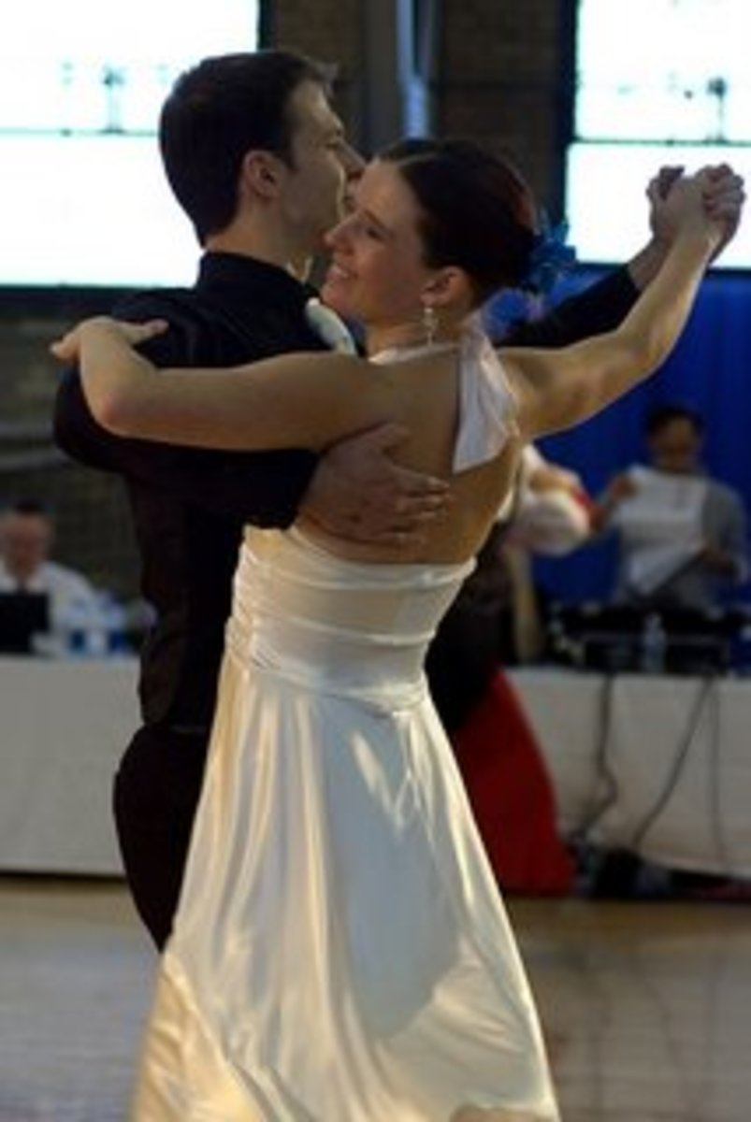
(classic waltz hold)
The hold was also important as it gave me the ‘feel’ of the dance. Our lecturer encouraged me to maintain the hold the whole time, as I was moving my head and shoulders in different ways, and I found it did make the dance look more rehearsed. ‘Maintaining a proper dance frame is crucial when you learn how to dance a waltz. The frame refers to the way you hold your upper body and arms in relation to your partner. A strong stable frame allows for clear communication and seamless movement between partners’ (Me & Studio, 2024). The hold let me have a rounded image with my arms reinforcing that iconic waltz aesthetic.

Reflection on assessment
We started the morning off by doing our yoga warm-up; this was important to keep our usual warm-up structure. I was anxious before the assessment, but I found the yoga took my mind off the pressure and I was able to be more present in the room. ‘It also relaxes the mind and brings peacefulness. Thus, doing yoga before a performance could benefit dancers and reduce their anxiety levels’ (Marieta, 2021).
Overall, I was very proud of myself for undertaking the assessment and felt I showed the different styles of dance through body language, facial expressions and the difference in the embodiment of each genre to the best of my ability and research. It was great to relax and enjoy dancing freely during the authentic dance section at the start. If I was doing it again, I would have been more attentive during the waltz, as I noticed I was focusing more on the embodiment and hold and therefore forgot the counts at the start; but I got back to the rhythm with the help of my partner, Carys.

Appendix
Appendix 1:
Lindy hop introduction video
https://youtu.be/VmvKrPUo97E?si=D_LbGaJ-_1qXjSt3

Appendix 2:
Going to classes
I cemented my knowledge on how to indicate to my follow what move we would do next by using my arms to guide my follow in the direction/ move. By increasing my simple lindy hop moves, Maarc and I were able to focus on putting together a more complicated dance for our dance together. We were able to bring sections we learnt at class back to lessons and develop our skills further. I felt this made me much more explorative as I had grown in confidence through class and lecture rehearsals.

Appendix 3:
Little Red Rooster by The Rolling Stones lyrics
I am a little red rooster
Too lazy to crow for day
I am a little red rooster
Too lazy to crow for day
Keep everything in the barnyard
Upset in every way
Oh, the dogs begin to bark now
Hounds begin to howl
Oh, the dogs begin to bark
Hounds begin to howl
Oh, watch out stray cat people caught up
Little red rooster's on the prowl
If you see my little red rooster
Please, drive him home
If you see my little red rooster
Please, drive him home
There been no peace in the barnyard
Since that little red rooster's been gone

Appednix 4:
Laban’s Effort graph based upon Newlove and Dalby

 | Weight | Space [Direction] | Time [Speed] | Flow
Pressing | Strong | Direct | Sustained | Bound
Slashing | Strong | Flexible / indirect | Sudden / quick | Free
Flicking | Light | Flexible / indirect | Sudden / quick | Free
Gliding | Light | Direct | Sustained | Free
Wringing | Strong | Flexible / indirect | Sustained | Bound
Thrusting / Punching | Strong | Direct | Sudden / quick | Bound
Dabbing | Light | Direct | Sudden / quick | Bound
Floating | Light | Flexible / indirect | Sustained | Free
 | Could also use the word ‘Heavy’ rather than ‘Strong’.

Appendix 5:
Bob Fosse dance https://youtu.be/JFt2x20JuYs?si=pDDj7vmlOaT1YpIP

Bibliography
Academy, K. A., 2018. Kensington Aldridge Academy Rooster. [Online]
Available at: https://kaa.org.uk/wp-content/uploads/2018/07/Year-13-Dance-Briding-Work-2018.pdf
[Accessed 13 March 2025].
Ballet, C. D., n.d. Core De Ballet. [Online]
Available at: https://coredeballet.com/the-benefits-of-yoga-for-a-dancer/
[Accessed 3 March 2025].
Bodensteiner, K., 2022. Do You Wanna Dance? Understand the 5 elements of dance. [Online]
Available at: https://www.kennedy-center.org/education/resources-for-educators/classroom-resources/media-and-interactives/media/dance/do-you-wanna-dance/
[Accessed 24 Feburary 2025].
Bodensteiner, K., 2022. Do You Wanna Dance? Understanding the 5 elements of Dance. [Online]
Available at: https://www.kennedy-center.org/education/resources-for-educators/classroom-resources/media-and-interactives/media/dance/do-you-wanna-dance/
[Accessed 20 Feburary 2025].
Bottomer, P., 1996. Line Dancing, Steps, STYLE AND BEAT, THE ALL-AMERICAN COUNTRY WAY . In: R. B. D. Limited, ed. London : Anness Publishing Limited , p. 63.
Callery, D., 2001. Through the Body . In: A Physical Guide to Physical Theatre. New York: Nick Hern Books Limited, p. 72.
Judy Dygdon, T. C., 1996. Country Line Dancing . In: STEP-BY-STEP INSTRUCTIONS FOR COWGIRLS & COWBOYS . Cheshire: Sigma Press, p. 6.
Lacinski, C., 2015. A Dynamic Performance The Ohio State University|BFA Dance. [Online]
Available at: https://callielacinski.wordpress.com/2015/08/06/a-dynamic-performance/
[Accessed 8 March 2025].
Marieta, 2021. do you. [Online]
Available at: https://www.doyou.com/3-reasons-why-yoga-is-a-great-practice-for-dancers/
[Accessed 27 Feburary 2025].
Me, S. B. & Studio, D., 2024. Master the Waltz: Learn How to Dance the Waltz for Beginners. [Online]
Available at: https://stepbymedancestudios.co.uk/2024/09/24/master-the-waltz-learn-how-to-dance-the-waltz-for-beginners/
[Accessed 3 March 2025].
Nereyeth, D., 2016. The Lewis Foundation of Classical Ballet (TLFCB). [Online]
Available at: https://www.thelewisfoundation.org/2015/06/an-introduction-to-iyengar-yoga-for-the-dancer/
[Accessed 1 March 2025].
Palmer, B., 2025. Could Laban Movement Analysis Help Your Practice?. [Online]
Available at: https://www.mandy.com/magazine/article/laban-movement-explained-78284/
[Accessed 17 Feburary 2025].
Pizer, A., 2024. Illustrated Step-by-Step Sun Salutation Instructions. [Online]
Available at: https://www.verywellfit.com/illustrated-stepbystep-sun-salutation-3567187
[Accessed 3 March 2025].
Sano, D. C., 2022. Yoga Helps To Be A Better Dancer: An Exploratory Analysis.. ODISHA JOURNAL OF SOCIAL SCIENCE, 9(1), p. 109 .
Selmon, S., 1993. Let's Lindy . In: London: Dance Books LTD , p. 8.
Smith, S., 2025. Lindy Hop History. [Online]
Available at: https://www.lindycircle.com/history/lindy_hop/
[Accessed 25 Feburary 2025].
Zoltan, n.d. Top Tips and Techniques: How to Waltz Dance - The Ultimate Tutorial. [Online]
Available at: https://zoltanballroomlatin.co.uk/top-tips-and-techniques-how-to-waltz-dance-the-ultimate-tutorial
[Accessed 18 March 2025].

