Targedau / Targets | Sut rydych wedi gweithio ar hwn /  How you have worked on this | Ceir enghraifft ar /  An example can be found on
Targed/Target 1 | Refer to literature to support your points wherever possible | Page 2  Page 7  Page 8
Targed/Target 2 | Read extensively so that you rely less heavily on a small number of sources | Reference list
Targed/Target 3 | Create longer paragraphs that support and extend the discussion | All pages

Barriers to Learning and Transitions

Introduction
James is 9 years old and a few months ago his family relocated from Poland to Swansea. In preparation for the move, the family started to improve their use of English so that they could integrate into their local community. James has been placed by the Local Authority into a year 5 class at Penlan Primary, a school with very few English as additional language (EAL) pupils. In Wales, there are almost 32,000 EAL pupils with Swansea having the third largest number with 3,500, behind two other major cities of Cardiff and Newport (Welsh Government, 2022). The spread of EAL pupils is not equal across localities and It can be seen from the data that some schools have a disproportionate number compared to others. This gives Penlan Primary the opportunity to collaborate with other schools and adopt initiatives that have proved to be successful into their own lessons and routines and emphasises a need for a joint approach between schools across Wales. Examples of good practice can be seen later in this text.

The term transition is used to describe a person’s movement from one place to another or a change in routine. Simple, everyday transitions are called ‘horizontal’ transitions and include moving from the classroom to the playground, a supply teacher being in class for a day or travelling from home to school. Major transitions are ‘vertical’ and are comparable to milestones in a person’s life, that is, they are more pronounced, memorable and sometimes traumatic. James relocating to a new country is a ‘horizontal’ transition and could potentially have a major effect on his well-being, but with careful planning and management any negative effects can be lessened. All children are different in the way they deal with transitions so an understanding of the individual is important to manage them. For example, a child with an adverse childhood experience (ACE) or a child with additional learning needs (ALN) might find any sort of change to routine more difficult than a child without these issues. The key is to understand the individual and what we, as teachers, can do to make these unavoidable transitions as easy for the child as possible. This process can include a child taking a personal item into school such as a cuddly toy or creating a visual representation of their daily routine so they know what to expect (Zawaly n.d.).

Evidence suggests that EAL pupils joining English medium schools at reception age will have better attainment levels than their English speaking peers with later joiners displaying lower attainment (Department for Education, 2019). Further evidence shows that EAL pupils have lower attainment than expected at 7 years old but any difference disappears by the age of 16 (Office for National Statistics, 2019), these statistics are perhaps a testament to the work of schools to ensure the inclusion of EAL pupils. Also, there is no evidence of correlation between EAL pupils in any local area with overall attainment. James has joined the school at a late stage and, therefore, we will have to make sure we have an effective plan to ‘scaffold’ James as much as possible so that he can be given the best opportunity to succeed. Language is key to cognitive and social development and “competence in literacy, including competence in the spoken word, syntax and spelling, is essential for learning across the curriculum, not least because of the fundamental role of language in thinking” (Donaldson, 2015, p.40). For James, this means without the ability to speak or understand English to a good standard, accessing the curriculum will not be possible.
On entry to Penlan Primary, James was assessed as having a basic understanding of English, can follow simple instructions and ask simple questions. His favourite subjects are mathematics and Physical Education where he shows a particular interest in football and other team sports. This fondness for team sports will be utilised by the school to help him with his social development, see the support plan for more details on this. He is a gifted maths student and is able to complete simple sums using mental arithmetic quicker than any other student in the class. He does, however, become upset if he gets the wrong answer and often refuses to accept he is incorrect, at which point he becomes withdrawn and quiet. His resilience will be worked on in and around the support plan. The aim is to use multiple strategies to support James holistically and target the areas identified for support together. James will require tailored support based on his specific needs. The support plan in part 2 details the actions to be taken by the school in order for James to access the curriculum and be part of an inclusive learning environment and progress appropriately along the learning continuum.

Part one
As explained in the introduction, James has recently moved from Poland to Swansea, a traumatic experience for a person especially a young child. He speaks some words in English as his family has been learning together and practicing prior to their move. James’ uncle has lived in Swansea for some years and on the whole has a good grasp of the English language. He runs his own successful business and when he asked James’ father to move to Wales to become a partner in the business the family decided to take the opportunity, knowing the difficulties they would face. James has one older brother who will attend the local comprehensive school.
There are many transitions taking place in this situation for all members of James’ family and the stress and uncertainty of moving to a new country might have a negative effect on their well-being. In Swansea, there are 3,568 EAL pupils over the age of 5 with 700 of these completely new to the language. The most spoken language as a first language other than English is Polish, with over five thousand speakers (Welsh Government, 2022).

The inability to speak English fluently will obviously affect James’ ability to access the curriculum and will hinder his progress. The school needs to concentrate on improving his use of English over and above any other subject until he can participate fully in lessons while at the same time developing his social skills through his favourite sport, football. This is an opportunity for James’ to build relationships with other pupils who also share his passion. Following a move like this, James’ well-being should be at the forefront of any discussion and he needs to be involved at each stage of the plan. His well-being should improve as his use of English improves, he feels more comfortable in the classroom and can join in with discussions. If he makes friends through his passion for football this will further increase his well-being.
We can develop James’ acquisition of English through repetition, strengthening his neural pathways and synapses through the use of repeating key words and phrases to help him get through situations during the school day. The theorist B.F. Skinner suggested that language can be taught through operant conditioning just like any other behaviour whilst Albert Bandura suggests that children copy language from those around them. The opposing view of Noam Chomsky believed that everyone has the ability to learn language ‘pre-programmed’ from birth as nearly all languages are made up similarly, meaning James could learn how similar words and phrases in English are also similar in Polish and therefore activate his prior knowledge of Polish to assist him with English. (Doherty and Hughes, 2014). In practice, teachers could model more advanced language than the pupil currently uses through a scaffolding technique in line with Vygotsky’s zone of proximal development theory. If James tries to say something incorrectly, the teachers repeats it back correctly so James can try to get it right next time. These theories and techniques can be used simultaneously to assist James with learning English.
The support plan detailed in part 2 shows the activities James will participate in on a daily basis. However, it is suggested that outside of the support plan, we can introduce several initiatives to aid James’ progression along with the rest of the pupils in the class. It should be noted that although James will require additional assistance and changes to be made during and after his transition, there are many pupils in the class who will need a continued sense of normality so as to not interrupt their learning journey. Provision for whole-class inclusion with the added benefit of assisting James personally will be introduced alongside his support plan.
To support James holistically, we must look beyond the support plan activities detailed in part two and look at his wider environment where we can also offer support. Good practice can be seen in Rhondda Cynon Taf, where the local council have published information on their website emphasising the need for planning and collaborative working to view transitions as ongoing events. They emphasise the importance of including the child and family in the process and building relationships with all stakeholders to ensure smooth transitions. This guidance is of particular use when it comes to James as his family is new to the country and will need the support and guidance of James’ new school and other members of the community. Another example of good practice with EAL pupils can be seen in the case study from Westbourne School. Here, pupils are assessed prior to school, have the opportunity to attend a summer school to develop their language skills and then a series of intense and high impact English lessons are taught to EAL pupils. Emphasis is placed on the whole school philosophy of inclusion and integration supporting the theories of social interaction and language as the key to development (Estyn, 2018).
Prior to the commencement date of the support plan, James will be consulted along with his parents and all key stakeholders for their input. The plan should then be signed by all relevant parties indicating a commitment to the participation in and completion of the plan.
Additional to the plan and following discussions with the headteacher and class teaching assistant (TA) we will select a group of pupils to assist with James’ integration into the school. He will be introduced to a ‘reading buddy’ who will spend time with James, under supervision, to assist him with his reading, beginning with lower level texts to gauge where James is with his reading and comprehension. This can be done on a daily basis for short periods of time to ensure James doesn’t become overwhelmed. Other, everyday strategies used in conjunction with the support plan will be; a key words poster with Polish words translated to English on the wall where James can see it, with a smaller version for him to keep with him; class ‘buddies’ who can help James throughout the day if the teacher or TA is not available; encouragement to join the ‘active reading’ group who read and review books weekly and if James is not comfortable with reviewing at this stage he can just listen to other children telling the stories; the school will support his parents by ensuring they have a single contact who they can reach at any time during the school day. Keeping the same contact should reduce stress on the parents. Assessment for learning (AfL) techniques are in place and used throughout lessons, lollipop sticks, questioning techniques and peer reviews can be used to assess where James is with his learning and well-being throughout the day.
The psychosocial development theory of Erik Erikson describes that people go through various stages or conflicts throughout their lifetime from birth to death. This theory explores the social and relationship aspect of development. James is 9 and would, according to Erikson’s theory, be firmly at the fourth stage, ‘industry versus inferiority’, with the most important event at that stage being attendance at school. Getting through this stage of his life will develop his confidence and belief in his skills. A failure to emerge successfully from this stage will leave James with a sense of Inferiority and will have a great impact on the rest of his life. This stage focuses heavily on social interactions and relationships with the people James will come into contact with. With a language barrier, this is made extremely difficult but it is imperative that his school do all they can to support James for his well-being and future. This theory, however, does not describe how to get through the stages successfully which will depend on many factors and influences. Social interaction is important at this stage, along with a sense of growth in the context of the larger community. We can link this to James’ development in that he can’t speak the language and therefore will struggle to access the curriculum. Therefore he will feel inferior as his peers quickly develop new relationships and social interactions that his language barrier will prevent him from participating in.
Jerome Bruner’s spiral curriculum theory states children are capable at any age of learning anything as long as we use language and concepts they understand. revisiting ideas as the child’s cognitive skills develop and they are able to deal with more abstract ideas (Harden and Stamper, 1999). Linking this to James, he will have skills and knowledge from his previous school in Poland but now is faced with a language barrier preventing him from utilising his prior knowledge. He will not be able to think in abstract terms if he cannot access the material being taught.
Contacting the secondary school that James’ brother will attend so we can work collaboratively with them is an effective strategy that means they could have joint English lessons after school twice a week with a professional who is trained to deal with the situation. This gives Penlan Primary the opportunity to use the additional resources available at the comprehensive school as well as forging new alliances with the school for future collaboration.
Penlan Primary currently has two members of staff trained as Emotional Literacy Support Assistants (ELSAs). This is an initiative brought in by the Headteacher in response to the detrimental effect of isolation due to the COVID19 pandemic. It will be recommended to James’ parents during a meeting that James attends some sessions following the mid-point review of his plan as all stakeholders will be aware of the potential negative effects of the transition on his emotional well-being. His one page profile states that he sometimes gets angry if he gets something wrong which is something he can work on during his ELSA sessions. The aim of ELSA sessions is to promote emotional literacy and give pupils the vocabulary to express and subsequently deal correctly with their emotions. These sessions will be especially pertinent given that James might have difficulties expressing his emotions in the normal way due to the language barrier.

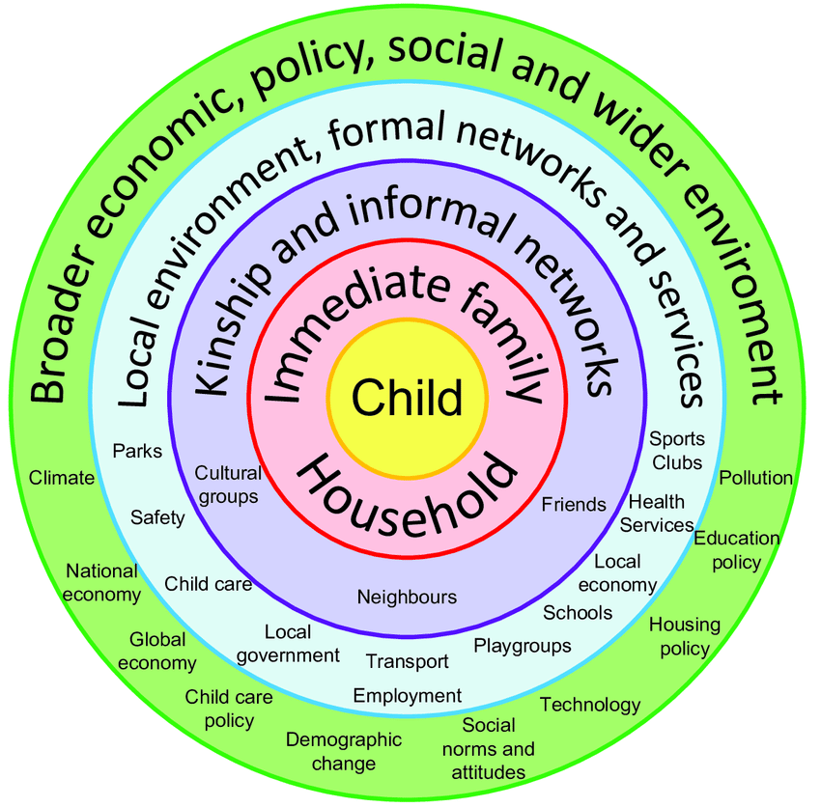
Bronfenbrenner’s Ecological Systems Model
Above is the Ecological Systems Model theory by Urie Bronfenbrenner. It shows the child at the centre with the various outer layers illustrating the degree of influences over a child’s development (Doherty and Hughes, 2014). We can use this model to identify the immediate family members that could work collaboratively with the school to assist James during this transition. We can give the family information relating to local amenities and help with access to community initiatives to help them integrate into their new life. We must remember that although James is the priority for the school, his parents are also going through their own transition and we must be tentative when approaching them.

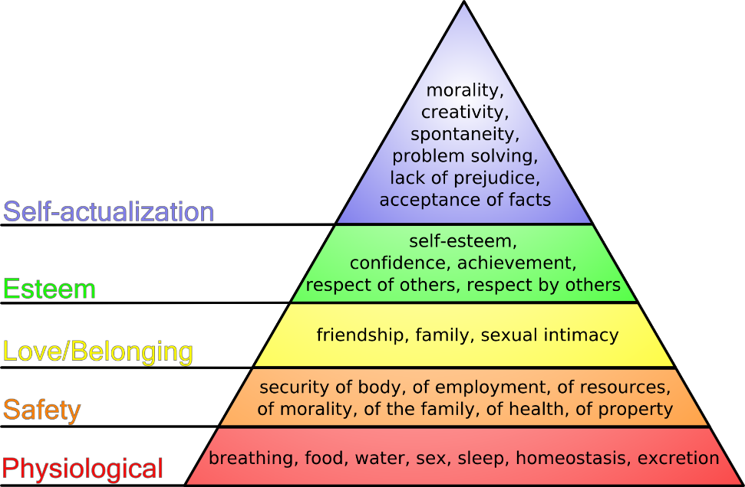
Maslow’s Hierarchy of Needs

Above is a diagram of Maslow’s Hierarchy of Needs. According to this theory, James will need to have his lower level needs met before he can be in a state of self-actualisation and have the most effective learning experience (Education Library, 2022). If we take the bottom layer as a starting point for James, we can, following a tactful discussion with his parents, ascertain their financial situation and offer breakfast club for James and, referring to the outer layers of Bronfenbrenner’s Model, assist them with applications for free school meals and any other assistance available. We can offer to arrange a meeting at the local council office with a representative with expertise to assist with the forms.
I have ensured to use specific, measurable, attainable, relevant and time based (SMART) targets and activities in James’ plan. The plan should be simple to follow should a support member of staff be required to continue with it at any point over the 6 week plan. I have purposefully kept the plan to a short 6 week period so that it can be reviewed appropriate times to make changes should any be necessary. If James makes good progress over the first 3 weeks we can discuss at the mid-point review and add or remove activities as we , in our professional judgement, see necessary.
The targets of developing language and relationships are specific. We can measure them quite easily with weekly reviews and significant progress is attainable in a 6 week period. The targets are relevant to James as language, communication and social skills are key to success in other areas. They will be over a 6 week half term to be reviewed and continued into the next half term with activities and targets amended where necessary. Any problems arising can be addressed either at the weekly review points or at the end of the course depending on teacher’s, parent’s or pupil’s feedback.
The support plan has been designed with the 4 purposes of the Curriculum for Wales (CfW) (Welsh Government, 2020) in Mind with a particular focus on specific areas of learning and experience (AOLEs) selected by the stakeholders involved in the preparation of the plan. We have based the activities on James’ one page profile (refer to Part 2) and taken his interests into account. The idea is that by using his interest and subject matter that he is confident in, he will feel more comfortable with the activities and therefore will be focused when working on them.
To ensure that the support plan is successful, stakeholders specific to the plan have been identified. They are; James, who’s role will be to give his opinion on the plan, participate to the best of his ability and raise any concerns he has at any time; James’ teacher, who’s role will be to deliver relevant material using appropriate pedagogy and reflection on the plan at regular intervals; James’ parents, their role will be to be active participants in helping James become fluent in English, to be collaborators in the design and implementation of the plan and to understand that language is the key to James’ success in school. They have the right to be informed at each stage of the plan or when anything is amended, James’ peers; their role will be to show empathy and assistance and to be understanding of his situation, the class will be briefed on this. Breakfast club and lunch staff; they will be made aware of James’ situation and must be patient and accommodating when helping him with his food. Playground staff; similar to lunchtime staff in that they need to be aware that James might have a problem that he is unable to communicate to them, his class ‘buddies’ can stay with him at breaktimes to assist other school staff when required. The headteacher; his role is to approve and monitor any support plan put in place for James, to be updated with progress reports regularly and to be one of the main contacts for James’ parents alongside his class teacher. He must show that the school are fully committed to providing an inclusive learning environment for James. Support staff and supply teachers; they should be made aware of James’ situation and show patience when dealing with any incidents. We can achieve this by reading his support plan and one page profile to give background information. The profile, plan and detailed notes can be available at all times with the headteacher for any emergency staff that are required to be in class due to unforeseen circumstances.
The plan has been timetabled so that the lessons are spread throughout the day, are not overly challenging to begin with and they have as little impact as possible on James being included with the rest of the class. We have also ensured the lessons are not during PE or maths lessons, two of James’ favourite subjects. The lessons are all done on the first day of the week so that James is available to do all the other lessons planned for the class that week. The benefit of this is time between sessions to amend the upcoming activities if necessary and give time for reflection with both James and the TA.
During the first 3 weeks we will focus on activities to promote James’ language development. Week 1 begins with a phonics lesson with the TA. This will be with a small group of other pupils also requiring this intervention. It is thought that James will feel more at ease in a small group rather than in a one to one scenario. The TA will then go through key words with the same group. The next lesson on handwriting skills will be a test to see how well James can form letters and words on paper. Again, there will be other pupils from the class in the same intervention.
The second week’s sessions begins with another key words and handwriting skills. If James practices these at home, improvement since week 1 should be evident. The session at 1:30 is a whole-class, expressive arts lesson where groups can work together to produce a poster on facts about Poland. They will be allowed to use any media they choose such as digital posters, paint, drawings or abstract using any items available. James can be consulted as the ‘expert’ during this lesson and this should help him feel important to the class and remind him that he should be proud of who he is and where he comes from. This is also a chance for the rest of the class to learn about culture and practices outside of Wales. Week 3 begins with the TA reading a short, simple story to James and using follow up questions to judge his comprehension. Week 3 ends with James using his new vocabulary and writing skills to write a letter to his friends from his last school in Poland. He can tell them about his new house, school, teachers and friends. We will help him find the address and take him to the school office for it to be posted out.
There is a planned mid-term review following the conclusion of the third week where key stakeholders will be invited to evaluate the first half of the support plan. Following the review, we can amend sessions or include additional sessions where required.
The last 3 weeks will be activities designed to work on developing James’ social skills and building relationships. After a discussion with James and the class TA it was decided that, given James’ gift for maths, that he would become the ‘teacher’ for a maths lesson. The hope is that James is comfortable enough having been part of the class for a number of weeks, to share his knowledge with his peers. The teacher will stand at the front of the class with him to assist when needed. If this is successful, 2 further ‘masterclass’ sessions are planned for the next 2 weeks. The other sessions for these weeks are specifically football based PE lessons. These are in addition to the regular PE lessons and were planned due to James’ passion for football. If we can encourage him to play together with his peers and he has a particular gift for football, he will find it easy to make friends quickly.
The plan ends after week 6 when all the stakeholders evaluate its success and give recommendations for next steps.
Conclusion
James has had a traumatic experience. Having to move from his home, friends and familiar surroundings is likely to have a profound and lasting effect on his well-being. With time and the right support, James will be able to integrate with, and feel part of the community. As teachers, it will be difficult to identify and communicate effectively with key stakeholders in a situation like James’, but it is of utmost importance to his learning and well-being that we do everything we can to help him and his family. School does not start and end at the school gate, and help needs to extend to his immediate family. It is worth noting, however, that although James is likely to be fearful of his new home, school and surroundings that no two people will react the same way to events like this and the extensive research into James and his progress at his previous school along with his involvement in discussions from the outset, will indicate the level of support required. The CfW identifies 4 purposes of our education system in Wales and in order for us to provide learning opportunities that aspire to these purposes, we need to build an inclusive and safe learning environment for our pupils. James will not be able to access any materials or participate fully without the ability to use the language the lessons are presented in and although we must not take away his sense of pride for his home country and first language, James needs to understand the necessity for him to speak English fluently. using the support plan and with input at each stage from key stakeholders, James and his family will make good progress to be continued following the 6 weeks and into the future. Information about James’ history, communication with his previous school and contact with his brother’s comprehensive school means we can produce a coherent, collaborative approach to facilitate inclusion, well-being and a successful future.

Part 2
One Page Profile

Support Plan for James Nowak
Date: 01/10/22

Prior the commencement of support plan, meeting between Teacher, James and parents to discuss support plan aims and expectations. Evaluations to be completed at mid term end of week 3 and progress and revisions to plan discussed.
Week | Date | Target Area of Development | Participating Stakeholders | Target AOLES |  | Start Time | Finish Time | Strategy / Activity | Evaluation Method
1 | 10/10/22 | Language | - James  - Teacher | - LLC  - Humanities |  | 9:30  2:00  2:50 | 10:15  2:45  3:15 | - Phonics  - Key Words  - Handwriting skills  - About me | Teacher or TA evaluation through observation and pupil feedback after each session with notes for Mid Term.  Review Pupil feedback form
2 | 17/10/22 | Language | - James  - Teacher  - Whole-class | - LLC  - Humanities  - Expressive Arts |  | 9:30  11:00  1:30 | 10:15  11:45  3:15 | - Key Words  - Handwriting Skills  - About Poland Posters | As above
3 | 24/10/22 | Language | - James  - Teacher  - Whole-class | - LLC  - Expressive Arts  - Humanites |  | 9:30  1:30 | 10:30  3:15 | - Short Story Comprehension  - Letter Writing to Friends in Poland | As above
MID TERM REVIEW WITH KEY STAKEHOLDERS

4 | 07/11/22 | Social | - James  - Teacher  - Whole-class | - Maths  - Health & WB |  | 9:30  1:30 | 10:30  2:30 | - ‘James’ Maths Masterclass’  - Football Lesson | Teacher observation and pupil feedback
5 | 14/11/22 | Social | - James  - Teacher  - Whole-class | - Maths  - Health & WB |  | 9:30  1:30 | 10:30  2:30 | - ‘James’ Maths Masterclass’  - Football Lesson | As above
6 | 21/11/22 | Language & Social | - James  - Teacher  - Whole-class | - Maths  - Health & WB |  | 9:30 | 10:30 | - ‘James’ Maths Masterclass’ | As above
REFLECTION AND RECOMMENDATIONS WITH ALL STAKEHOLDERS

Reviewed and approved by:

………………………………………… Headteacher (Date ../../22)
………………………………………… Class Teacher (Date ../../22)
………………………………………… Pupil (Date ../../..)
………………………………………… Parent(s) / Guardian(s) (Date ../../22)

References
Department for Education (2019) Attainment of Pupils with English as an Additional Language. Available at: Attainment of pupils with English as an additional language (publishing.service.gov.uk) (Accessed: 3 November 2022)
Doherty, J and Hughes, M (2014) Child Development Theory and Practice. 2nd edn. Harlow: Pearson.
Donaldson, G. (2015) Successful Futures. Available at: successful-futures.pdf (gov.wales) (Accessed: 3 November 2022)
Education Library (2022) Maslow’s Hierarchy of Needs in Education. Available at: Maslow's Hierarchy of Needs in Education - Education Library (Accessed: 6 November 2022)
Estyn (2018) Supporting pupils will English as an Additional Language. Available at: Supporting pupils with English as an additional language to help them integrate | Estyn (gov.wales). (Accessed: 4 November 2022)
Harden, R. and Stamper, N. (1999) ‘What is a Spiral Curriculum?’ Medical Teachers, 21(2) pp.1-4.
Office for National Statistics (2019) International immigration and the Education Sector. Available at: https://www.ons.gov.uk/peoplepopulationandcommunity/populationandmigration/internationalmigration/articles/internationalmigrationandtheeducationsectorwhatdoesthecurrentevidenceshow/2019-05-03 ) (Accessed: 4 November 2022)
Rhondda Cynon Taf Council (n.d.) Transition Information for Early Years. Available at: https://www.rctcbc.gov.uk/EN/Resident/SchoolsandLearning/AccessandInclusiontoEducation/WorkinginPartnershipwithParents/SchoolTransitionAdvice/TransitioninformationforEarlyYears.aspx (Accessed: 4 November 2022)
Welsh Government (2022) Stats Wales. Available at: https://statswales.gov.wales/Catalogue/Education-and-Skills/Schools-and-Teachers/Schools-Census/Pupil-Level-Annual-School-Census/Ethnicity-National-Identity-and-Language/pupilsaged5andoverfirstlanguageotherthanenglishwelsh-by-localauthorityregion-year (Accessed: 3 November 2022)
Zawaly, S. (n.d.) Tips for Making Transitions Easier. Available at: Tips for Making Transitions Easier - Children, Inc. (childreninc.org) (Accessed: 7 November 2022)

