

BMSW4002
Effective Team Working and Communication

Assessment Component 1 - Practical

Student Name- Daniela Obis
Student ID-2007875
Tutor’s name: Timothy Hopkins

Table of Contents
Section 1- Introduction 3
An overview of MARIA and PEDRO Case Study 4
Section 2- Models of communication 5
2.1 Shannon and Weaver (1948) Models of communication 5
2.2 Schramm (1954) Models of communication 5
2.3 Berlo (1960/64) model of communication 6
Section 3- Communication Skills 8
3.1 Verbal – both oral (spoken) and written, choice of words, tone, pitch [para-verbal] 8
3.2 Non-verbal – body language, posture, gesture, tone, signals 8
3.2 Listening – Active Listening – Empathetic Listening 9
Tools and approaches that can link and support these skills 10
Referring to MARIA and PEDRO Case Study 11
Why do you think Pedro misunderstood Maria? 11
Whose Model of Communication explains this confusion and why? 11
How could this have been prevented? 11
Whose Model of Communication explains how it could have been avoided? 12
Section 4- Conclusion 13
References 14

Section 1- Introduction
Communication means the imparting or exchanging of information by using the medium to express the feelings or to deliver a message that is likely to be understandable by both of the users. Here, the report is based on MARIA and PEDRO case study where the misunderstanding due to the miscommunication has occurred. So, the discussions in Section 2 includes Models of communication considering Shannon and Weaver, Schramm & Berlo, in Section 3 includes verbal, non-verbal and listening. Moreover, the linkage with different tools e.g. SOLER, Personal Awareness KEYS etc. and so, MARIA and PEDRO case study will be supportive to figure out a well understand of this report (Bartfiled et al, 2010)

An overview of MARIA and PEDRO Case Study
Pedro who works on the building site had got a phone call from his wife Maria to get chicken on the way back to his home. Pedro also replied positively and but after reaching the home, Pedro went to the kitchen for Maria after putting off his dress. But Maria found him without any chicken that she told her over the phone. Consequently, Pedro said that the entire issues he understood that when he will reach home then he will find it in the kitchen. There was a misunderstanding point due to miscommunication and that’s why the word “chicken” was replaced by “kitchen”. The report is all about Effective Team Working and Communication by giving focus on some key attributes that are highly associated with effectiveness and so, there is co-relation with this case study and the core purposes of this report.

Section 2- Models of communication

2.1 Shannon and Weaver (1948) Models of communication
Shannon and Weaver Models of communication are considered the aspects of communication channels including transmitter, channel, receivers & noise to transmit the message from Point A to Point B. According to MARIA and PEDRO Case Study, Maria & Pedro communicated through phone call and that’s the medium to deliver the message. Pedro who works on the building site had got a phone call from his wife Maria to get chicken on the way back to his home (Custodio et al, 2019).
Fundamentally, in this case, there was a misunderstanding point due to miscommunication and that’s why the word “chicken” was replaced by “kitchen”. In the communication model of Shannon and Weaver, it might have happened that Pedro misunderstood Maria due to Noise within the communication channel (Moore et al, 2017)
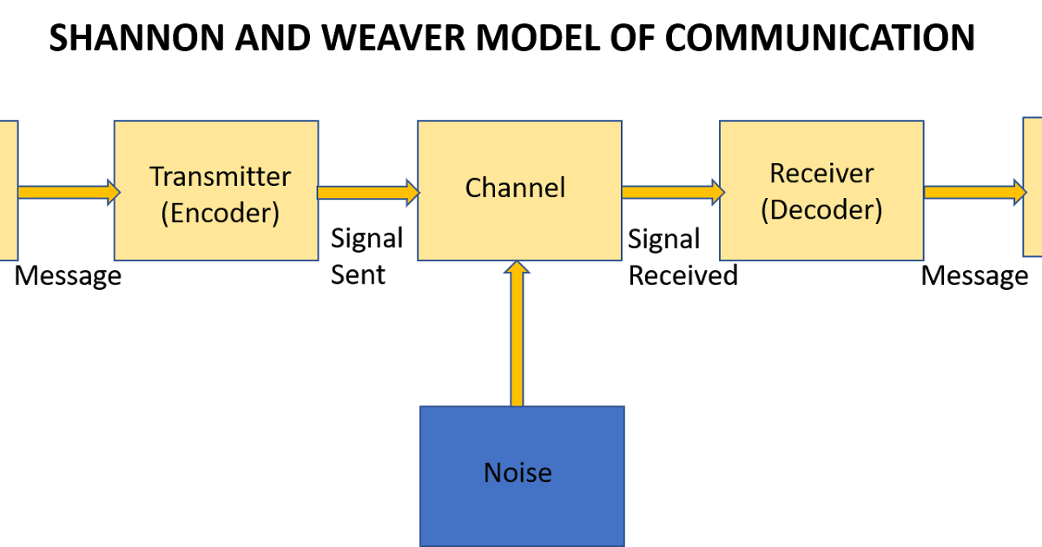
Figure: Shannon and Weaver Models of communication (Bartfiled et al, 2010)

2.2 Schramm (1954) Models of communication
Schramm Models of communication considers a circular flow of communication to transmit the message where the sender can be receiver and vice versa- depending on where the cycle is. The key attributes of this communication model include an encoder, interpreter and message. According to MARIA and PEDRO Case Study, Pedro also replied positively and but after reaching the home, Pedro went to the kitchen for Maria after putting off his dress.
That’s means, the communication was fine in the normal sense as both of them responded clearly and actively but the situation goes to a misunderstanding because Pedro went to the kitchen after reaching home (Bartfiled et al, 2010)
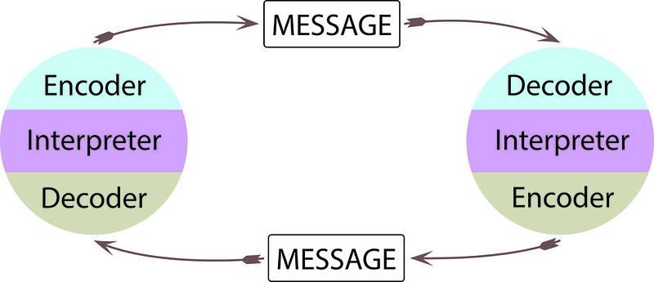
Figure: Schramm Models of communication (Custodio et al, 2019).

2.3 Berlo (1960/64) model of communication
Berlo's model of communication considers the facts of sources, message, channels and receiver that is likely to others model but it is linear and without feedback. In Berlo's model of communication, the communication context can be explained from cultural perspectives such as…
Difference of first language
Difference of first language means the variation between one people to another person in response to their mother language. In this model, the message is sent from the sender but the associated noise make disrupts in receiving sections that cause a slightly hampering to the message and not at all. Here, the communication may disrupt if the first language varies from one to another either the second language is not properly understood by both of them.
Differences of expected behaviour between manager & staff
Differences of expected behaviour between manager & staff can be happened when the communication channel is not appropriate in the communication channel. The key attributes of the model explain some important parts that make communication combined. The communication might get obstacles when any of the parts gets errors.

According to MARIA and PEDRO Case Study, though Pedro also replied positively and but after reaching the home, Pedro went to the kitchen for Maria after putting off his dress but if Pedro wants to make Maria more ensured about either he is bringing chicken or not then it might be more effective (Maxwell et al, 2015)

Figure: Berlo's model of communication (Bartfiled et al, 2010)

Section 3- Communication Skills

3.1 Verbal – both oral (spoken) and written, choice of words, tone, pitch [para-verbal]
Fundamentally, verbal communication means the way of communication which considers both oral (spoken) and written, choice of words, tone, pitch in respect to delivering the specific messages. As we know that communication considers the facts of sources, message, channels and receiver. The basic types of verbal communication include public communication, small group communication, interpersonal communication and intrapersonal communication (Dansieh, 2011)
According to MARIA and PEDRO Case Study, there was verbal communication like Pedro who works on building site had got a phone call from his wife Maria to get chicken on the way back to his home. In this case, it might be happened due to a lack of effective verbal words that might be helpful to make the communication more understandable (Maxwell et al, 2015)
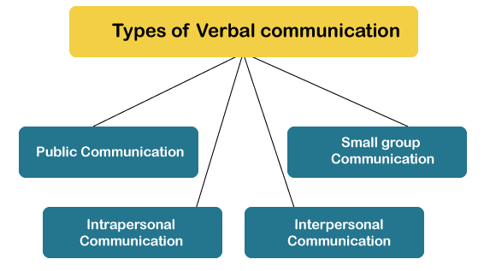
Figure: Verbal communication (Bartfiled et al, 2010)

3.2 Non-verbal – body language, posture, gesture, tone, signals
Non-verbal is the medium of communication that considers body language, posture, signals, gesture, tone etc. to express the things that are likely to be understandable by both of the users. There are different ways to consider non-verbal communication like using sign, posture, gesture, tone, signals and even body language. For example, to conduct non-verbal communication, there can be a different facial expression like the following figure. According to MARIA and PEDRO Case Study, they don’t use this communication channel but they had used verbal communication (Mackenzie et al, 2009)
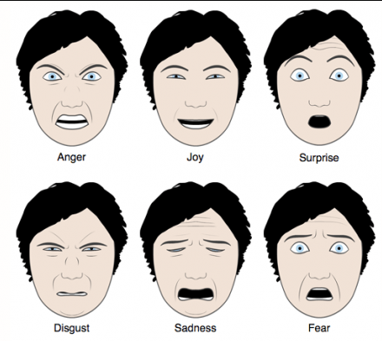
Figure: Non-verbal (Dansieh, 2011)

3.2 Listening – Active Listening – Empathetic Listening
Listening is all about paying heed to the contents of what the speaker is saying. Moreover, active listening means the effective listening approaches where the key issues include summarising, questioning, self-awareness, paraphrasing etc. Moreover, Empathetic Listening refers to questioning and structured listening techniques.
According to MARIA and PEDRO Case Study, Pedro should be more active to listen to what Maria is trying to say & also, Pedro needs to clearly understand the fact and then the response to the fact. As there was a misunderstanding point due to miscommunication and that’s why the word “chicken” was replaced by “kitchen” then Pedro needs to ensure active listening to understand chicken properly (Dawson et al, 2018).
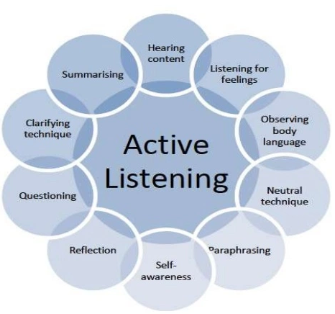
Figure: Listening (Bartfiled et al, 2010)

Tools and approaches that can link and support these skills
Fundamentally, the Tools and approaches that can link and support these skills include S.O.L.E.R and Proxemics etc. that will be supportive to understand these skills such as…
S.O.L.E.R
S.O.L.E.R model is abbreviated as square up, open posture, lean in slightly, eye contact and finally, responding respectfully. As we know that listening is all about paying heed to the contents of what the speaker is saying then the activeness in listening is a must that Pedro needs to consider in our case study (Dawson et al, 2018).
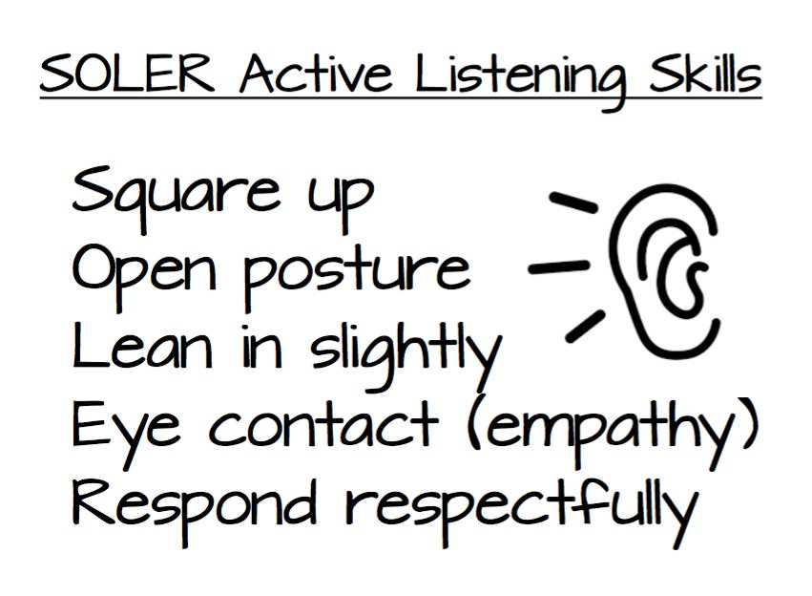
Figure: S.O.L.E.R. (Arnold et al, 2019).
Proxemics / Kinesics
Proxemics means the distances of the sender during communication where communication means the imparting or exchanging of information by using the medium to express the feelings or to deliver a message. As we know that the aspects of communication channels including transmitter, channel, receivers & noise to transmit the message from Point A to Point B then the distance between the sender and receiver might be effective in response to communication channels (Keevy et al, 2018).
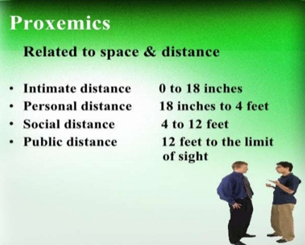
Figure: Proxemics / Kinesics (Bartfiled et al, 2010)

Referring to MARIA and PEDRO Case Study

Why do you think Pedro misunderstood Maria?
I think that actually, there was a misunderstanding point due to miscommunication and that’s why the word “chicken” was replaced by “kitchen”. The core reasons for misunderstanding is that Maria is lack active listening due to side noise from the building site because all the things to make a communication are available in our case study like channels, verbal, understandable languages etc. But the thing that is missing in MARIA and PEDRO Case Study is active listening as Pedro who works on the building site and the side noise make the communication misunderstand (Arnold et al, 2019).

Whose Model of Communication explains this confusion and why?
Shannon and Weaver (1948) Models of communication can explain this confusion because this model considers the aspects of communication channels including transmitter, channel, receivers & noise to transmit the message from Point A to Point B. The Shannon and Weaver (1948) Models of communication gives focus on the noise and that’s why it might happen that Pedro misunderstood Maria due to Noise within the communication channel. According to MARIA and PEDRO Case Study as there was a misunderstanding point due to miscommunication and that’s why the word “chicken” was replaced by “kitchen” then Pedro needs to ensure active listening to understand chicken properly (Dawson et al, 2018).

How could this have been prevented?
Fundamentally, this can be prevented if Pedro gives focus on active listening anyhow by going to the normal zone where the construction site noise is not more acute. As we can see that after reaching the home, Pedro went to the kitchen for Maria after putting off his dress. That means that Pedro is not active to listen as there was side noise from the building site is and so, Maria found him without any chicken that she told her over the phone. Consequently, Pedro said that the entire things he understood that when he will reach home then he will find it in the kitchen and so, the side noise make the communication misunderstand (Dansieh, 2011)

Whose Model of Communication explains how it could have been avoided?
Berlo (1960/64) model of communication can be used to ensure that as it could have been avoided. The core rationale is that in this model, the message is sent from the sender but the associated noise makes disrupts in receiving sections that cause slightly hampering the message and not at all. According to MARIA and PEDRO Case Study, though Pedro also replied positively the actual feedback from Pedro is not effective based on what Maria had said. Moreover, Empathetic Listening refers to questioning and structured listening techniques that might be supportive of Maria & Pedro case. So, Berlo (1960/64) model of communication can properly explain how it could have been avoided (Kesson et al, 2012).

Section 4- Conclusion
Thus, it can be concluded that effectiveness in communication is a must that can be ensured by both sender and receiver perspectives. According to MARIA and PEDRO Case Study, as Pedro who works on building site and the side noise make the communication misunderstand. That’s why, the effective listening approaches where the key issues include summarising, questioning, self-awareness, paraphrasing etc. All the things, MARIA and PEDRO could ensure proper communication which could remove misunderstanding point as it might have happened that Pedro misunderstood Maria due to Noise within the communication channel (Arnold et al, 2019).

References
Arnold, E.C. and Boggs, K.U., 2019. Interpersonal Relationships E-Book: Professional Communication Skills for Nurses. Elsevier Health Sciences.
Bartfeld, E. and Lass, A., Irody Inc, 2010. System and method for real time management of a drug regimen. U.S. Patent 7,747,454.
Boissy, A., Windover, A.K., Bokar, D., Karafa, M., Neuendorf, K., Frankel, R.M., Merlino, J. and Rothberg, M.B., 2016. Communication skills training for physicians improves patient satisfaction. Journal of general internal medicine, 31(7), pp.755-761.
Cottrell, S., 2017. Critical thinking skills: Effective analysis, argument and reflection. Macmillan International Higher Education.
Custódio, C., Ferreira, M.A. and Matos, P., 2019. Do general managerial skills spur innovation? Management Science, 65(2), pp.459-476. ME
Dansieh, S.A., 2011. SMS texting and its potential impacts on students' written communication skills. International Journal of English Linguistics, 1(2), p.222.
Dawson, P. and Guare, R., 2018. Executive skills in children and adolescents: A practical guide to assessment and intervention. Guilford Publications.
Keevy, M. and Mare, D.J., 2018. Pervasive skills development for aspirant chartered accountants: Academic versus training programmes. Journal of Economic and Financial Sciences, 11(1), pp.1-9.
Kesson, E.M., Allardice, G.M., George, W.D., Burns, H.J. and Morrison, D.S., 2012. Effects of multidisciplinary team working on breast cancer survival: retrospective, comparative, interventional cohort study of 13 722 women. bmj, 344, p.e2718.
Mackenzie, A. and Nickerson, P., 2009. The time trap: The classic book on time management. Amacom.
Maxwell, S.M., Hazen, E.L., Lewison, R.L., Dunn, D.C., Bailey, H., Bograd, S.J., Briscoe, D.K., Fossette, S., Hobday, A.J., Bennett, M. and Benson, S., 2015. Dynamic ocean management: Defining and conceptualizing real-time management of the ocean. Marine Policy, 58, pp.42-50.
Moore, T. and Morton, J., 2017. The myth of job readiness? Written communication, employability, and the ‘skills gap’in higher education. Studies in Higher Education, 42(3), pp.591-609.

