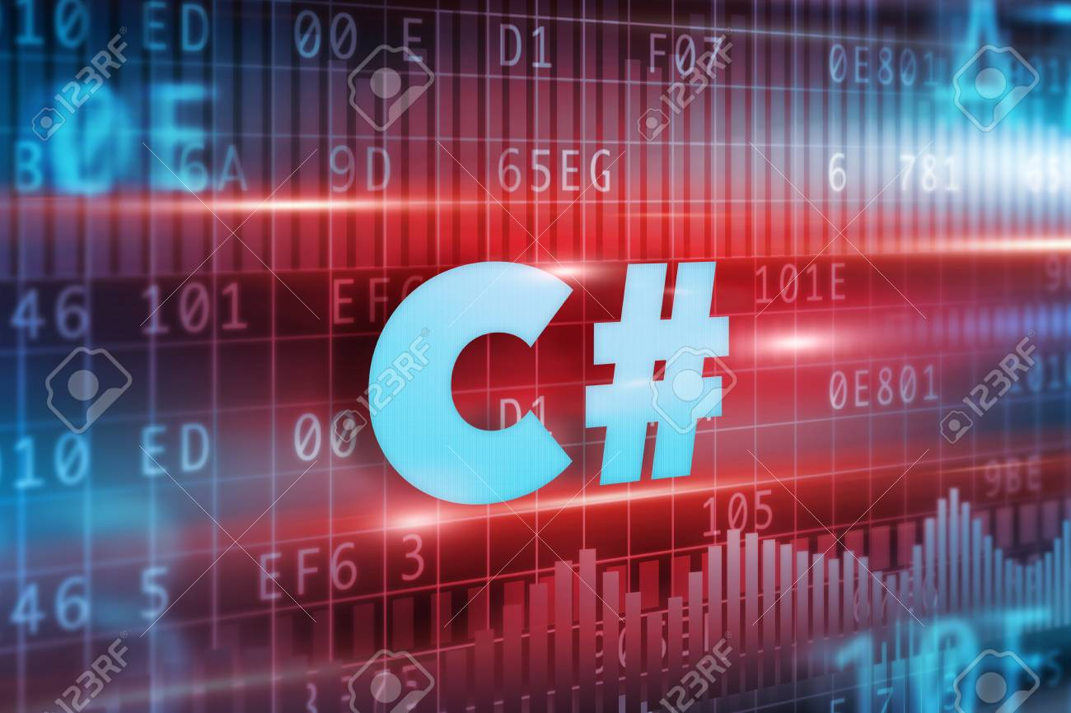


UNIVERSITY OF WALES TRINITY SAINT DAVID

MOODLE TITLE: SOFTWARE DEVELOPMENT
MODULE CODE: ACCC4006
ASSIGNMENT TITLE: C# /section 2/

STUDENT NAME: Lachezar Emilov Hristov
STUDENT NUMBER: var StudentID = new list<int>() {1907081}
LECTURER: string name = “Suneth Fernando”

Content

Part A (Understanding)……………………………………………………………………………….……………………………page 3

- Define Arrays and explain the importance of arrays in programming. Give relevant examples to support your answer…………………………………………………………………………….………………….page 3

- Define function and discus about function definition and explain the call by reference and call by value with suitable examples……………………………………….………………………………….page 7

Part B…………………………………………………………………………………………………………………………….………..page 11
In the application provided in the Appendix, there are three problems:
1. When choosing an option from the menu, try entering text instead of numbers.
2. When the user is asked if they wish to quit, the only input value that can be entered is “YES”. Try other variations e.g. “Yes”, “yes”, “y”, etc.
3. Try displaying all the numbers entered. Run the code perform a series of tests to check these problems exist then:
a. Write a description of these problems, what is causing the problem.
b. Create tests to simulate them (this may take the form of test documentation) and provide evidence that you have run these tests.
Part C………………………………………………………………………………………………………………………………..……..page
Reference………………………………………………………………………………………………………………………………page 15

PART A

- Arrays

Arrays are essential parts in most programming languages. They are packs of variables which are called elements.
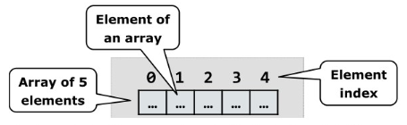
Picture 1

The Elements in the array are indexed, every index is a number starting from zero i.e. the first element in the array is indexed by zero, second with one and etc. The sum of all elements in given array is called length of an array. As it is shown on the picture the array has 5 elements. Always the elements in a given array are form one type, it does not matter if they are from primitive or reference type, because of this arrays are group of similar elements with ordered sequence which provide the opportunity to work on them as one entity. Arrays exist in different dimensions and most popular are single-dimensional and multi-dimensional arrays. Single-dimensional arrays are called vectors and multi-dimensional ones are called matrices. Because the length of array is fixed the number of its elements must be set when it is initialized. The length of array can not be changed once created. The declaration of single-dimensional array happens as follow:
Int [] MyArray; - example 1
Here “MyArray” is the name of the array and “int” in the beginning is declaration of integer data type of array and with the brackets “[]” we declare that this is an array of elements not a single variable. When array type variable is declared it is a “reference” which does not have a value or the value is “null”. This is because the memory for the elements is not allocated yet. In picture 2 is shown declared array variable and the memory for its elements is still not allocated.

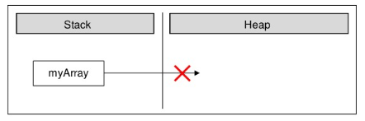
Picture 2

In the program’s execution stack the variable “MyArray” is created and its value is null which means it holds no value. Creation of array happens with the help of the keyword “new”. The key word “new” is used to allocate memory for the elements.
Int [] MyArray = new int [6]; - example 2
In example 2 array is created with length of six elements of type “int” – integer. That means in the dynamic memory (heap) an area of six integer numbers is allocated and they are all initialized with the value of zero as shown in picture 3.
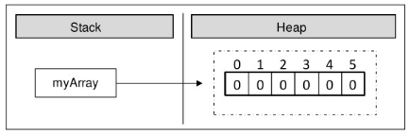
Picture 3

In C# programming language elements of an array are always stored in the dynamic memory also known as “heap”. An array to be used it is needed to be initialized or to has default value. In C# all variables including the elements of array have a default initial value. Default values are decently described in section /assignment/ 1. Values could be assign in array in different ways for example please refer to “example 3”
Int [] MyArray = {0,1,2,3,4,5,6} ; - example 3
In example 3 the elements are created and initialized at the moment of the declaration of the array. In picture 4 is shown how the array is allocated in the memory when its values are initialized at the moment of its declaration.

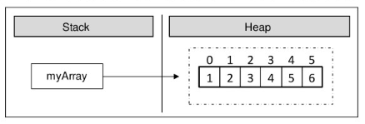
Picture 4

Another example of declaration and initialization of an array in the same way is shown in example 4
string [] DaysOfWeek = { Monday, Tuesday, Wednesday, Thursday, Friday, Saturday, Sunday} ;– example 4
In example four there are 7 elements of type string. The type string is reference type (object) and the values of this object are stored in the heap. The variable “DayOfWeek” is stored in the stack memory and points to a part in the dynamic memory where the elements of the array are stored.

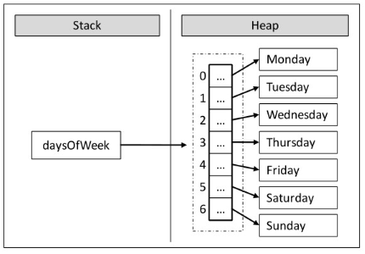
Picture 5

Another way to create array is as shown in example 5
Var numbers = new int [5] {1, 2, 3, 4, 5}; – example 5
In example 5 key word “var” is used in this case compiler auto-detect the type of the array. The length of the array is designated in square brackets [] and the values of arrays’ elements are assigned in the curly brackets {}.
The elements in the array could be accessed directly through their indices and the name of the array for example:
Console.writeline(Numbers[1]); - example 6
Access to element of the array could be for reading or writing mode that means elements can be treated as variables on example 6 the program will display element 2 of array named “numbers” with index 1 and the value which will be displayed is “2” this is read mode. In example 7 a value of 66 to element 1 with index 0 has been assign so in this case the array is in writing mode.
Numbers[0] = 66 – example 7
There are two types of multi-dimensional arrays – Rectangular and jagged.
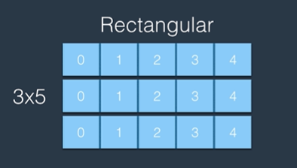
In Rectangular array there are exactly the same number of columns . In picture six can be seen example for rectangular array which has 3 rows and every row has exactly 5 columns.
Picture 6

In the jagged array numbers of columns can vary.
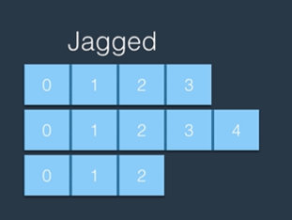
Picture 7

Jagged arrays can be described as array of arrays. It can be presented as single dimensional array and every element as a separate single dimensional array. The difference between jagged and rectangular one is that .NET CLR (common language runtime) is optimized single dimensional arrays and because of this jagged arrays are considered as faster than rectangular array but the difference is not tangible with the devices nowadays. Syntax for Declaration of rectangular array is as follows:
Var matrix = new int [ 3, 5 ]; - example 8
In example 8 the rectangular array has 3 rows and 5 columns as displayed on picture 6. Values in this array are assign in the following way:
Var matrix = new int [ 3, 5 ];
{
{ 1, 2, 3, 4, 5},
{ 6, 7, 8, 9, 10 },
{ 11, 12, 13, 14, 15 }
} ;
Accessing elements happens when the name of arrays is called and the element of certain element in the model arrays in a array.
Var element = matrix[0, 0];
Also exist three-dimensional array. Its declaration happens in the following way:
Var colours = new int[ 3, 5, 8];
The declaration of jagged array like on picture7 is:
Var array = new int [3][];
Array[0] = new int[4];
Array[1] = new int[5];
Array[2] = new int[3];
Accessing element in jagged array happens as name of the array is called and then index of the array of the main array and then index of the element in this array
Array[0][0] = 1;

- Define function and discus about function definition and explain the call by reference and call by value with suitable examples

The best way to solve complex task is to divide it in small subtasks it is much easier to solve small tasks than a big and complex one. In the end when all small tasks are solved the main complex task will be solved too. The tasks in programming are called subroutines. In the different programming languages subroutines are called in different ways like functions and procedures in C# they are called methods. Methods are essential part of a program. Method can solve given problem also it can take parameters and return a result. Basically the method is the program’s logic they are place where the “real job” is done. Methods are the base units in the hole program. Method can be structured as small blocks and use many times in the program in this way we can form a big and complex program using this small and simple pieces of blocks.
Here is example for method:
Static decimal rectArea( decimal width, decimal height)
{
Decimal area = width*height;
Return area;
}
Because of methods the structure of the program is better and the code is easier to read. Readability of the code and good structure are extremely important because only 20% are the efforts of creating and testing the program the other 80% are maintenance and adding new features to the origin version and third party interference is very likely that is why readability and good structure is so important.
Another advantage of using methods is avoiding code repeating and because of them easily code can be reused. This happens when one piece of code is considered to be used more than once in the program then it is better to set this code in a method and just call the method later when is needed the same piece of code this is how code repeating can be avoided.
Another very useful feature of the methods is that when the method is used many times instead a piece of code repeatedly and change in the code is needed it is necessary only change in the code in the method and the job is done alternatively when a piece of code is used repeatedly the developer needs to go through every piece of block code and change it that is not time cost effective and also the developer is possible to miss some block or blocks which will lead to errors and perplexing.
There are three different actions related to the existence of a method and they are:
1. Declaring 2. Implementation (creation ) and 3. Calling of the method
1. Declaration – this is a stage where method is registered in the program so lately it can be identified.
2. Implementation – this is piece of code /block/ which find solution to certain task. This piece of code represent the logic of the solution of the task.
3. Method call – this is point where the already created method is invoked. Method is called when certain task is needed to be solved through it
It is important to be known that method can be declared only between curly brackets {} in the class, methods can NOT be declared out of the class. Also method can NOT be declared inside in another method. Example for method is Main() method which persist in every program.
Public class HelloCSharp
{
Static void Main(string [] args)
{
Console.WriteLine(“Hello C#!”);
}
}
Some elements when method is declared are compulsory. They need to be ordered also in exact sequence.
Static void Main(string [] args)
[static] < return_type > <method_name> ([<parameter_list>])
- Type of the result, returned by the method - <return_type>
- Method’s name - <method_name>
- List with the parameters - <parameter_list> which can be empty or can consist sequence of parameters.

In the main method the meaning of the elements is:
<return_type> - “void” which means that the method does not return result
<method_name> - “Main” this is the name of the method
<parameter_list> - it is only one parameter “string [] args”

Access modifiers in the method are two types “public” and “static” and are optional.
When the method is static it means that can be used only in the current class when the method is public mean it can be accessed in other classes.
Creation of own method happens as the method is declared then body of the method needs to be written which will be executed when the method is called. The code in the method represent its logic. The body is placed in curly brackets {} and follows method declaration:
Variables declared inside of a method are called local variables.
Static void PrintLogo()
{
Console.WriteLine(“Microsoft”)
}
We call the method like call its name + parameters in () round brackets if have any if do not only round brackets () after the name of the method for example:
PrintLogo()
It is important to differ very well parameter and value.
The parameter is a variable in a method definition and the argument is actual value of this variable
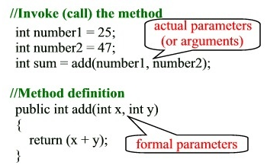
When a parameter is passed by reference, the caller and the callee use the same variable for the parameter. If the callee modifies the parameter variable the effect is visible to the caller’s variable
When a parameter is passed by value the caller and callee have two independent variables with the same value. If the callee modifies the parameter variable , the effect is not visible to the caller

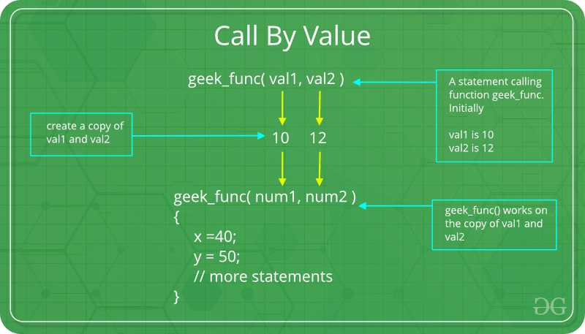
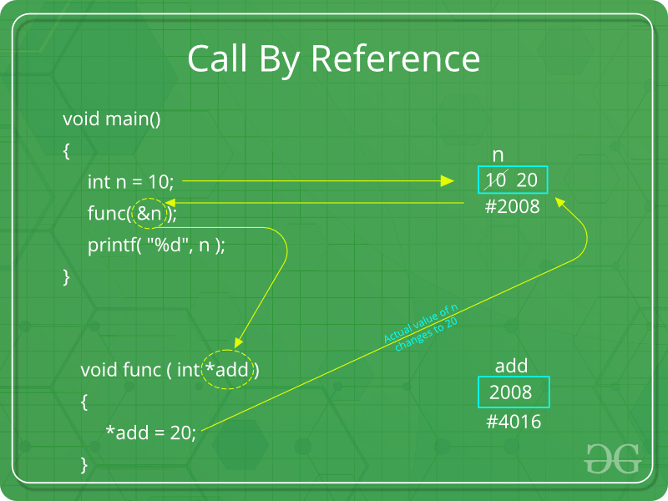

PART B
a. Write a description of these problems, what is causing the problem.
1. First problem occurs because in the code is written only to get numbers
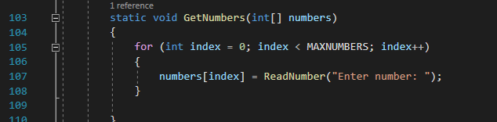
Could be fixed like when the user enter anything different from int to display a message “need to enter a numbers” with “while” and “if” cycle
2. Second problem occurs because in the code is written just “yes”
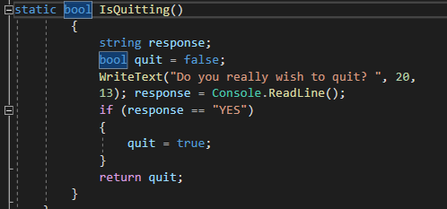
This problem can be solved in two ways as “y” or “Yes” is added or as function is used to capitalize all letters or lower all letters in a string.

3. Problem three exist because the function which display the numbers is missing
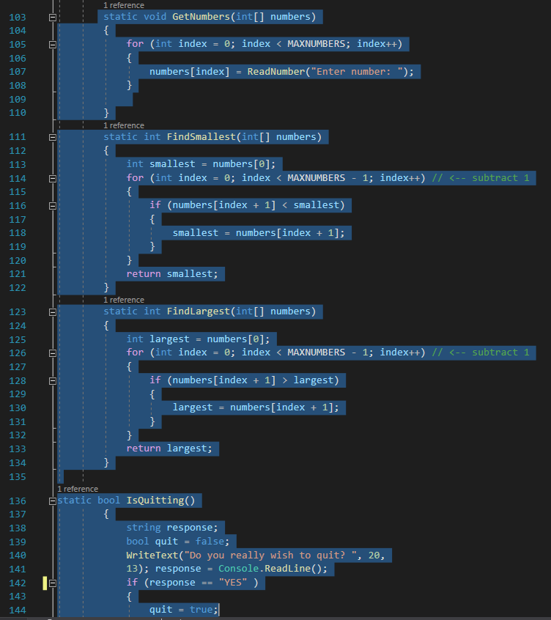

b. Create tests to simulate them (this may take the form of test documentation) and provide evidence that you have run these tests.
Test 1. Entering letters instead of numbers
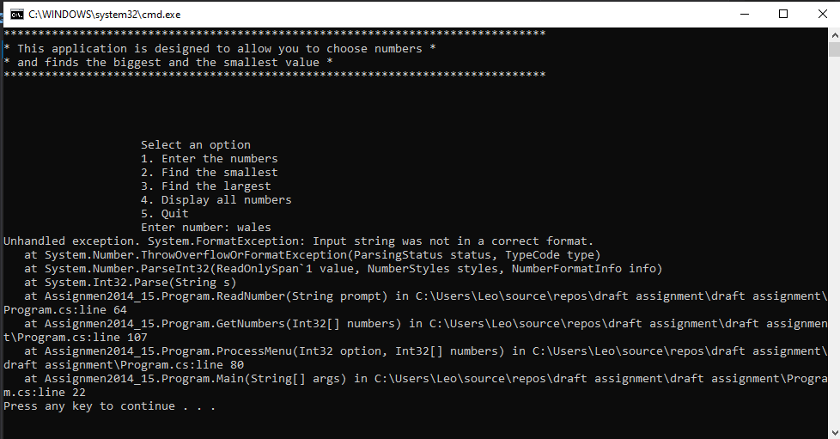

Test 2. Entering “y” instead of “yes”
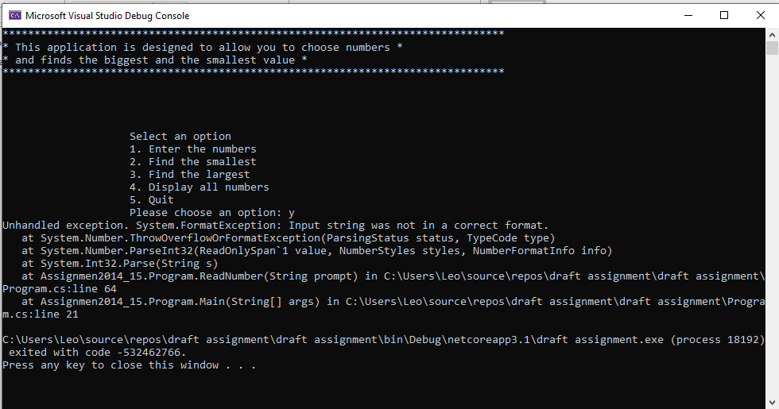

Test 3. Nothing happens when option 4 is selected
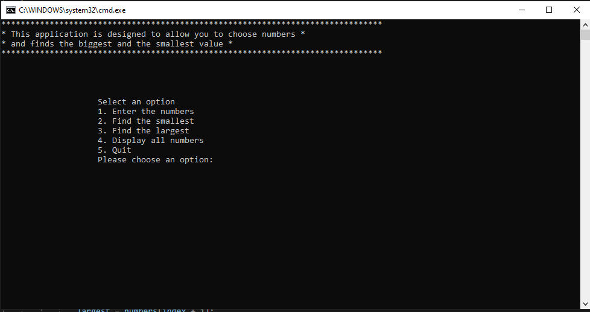
PART C

Exercise 1.
(a) Ask the user to enter an arbitrary set of numbers into an array and display all the entered numbers.
(b) Then multiply pairs of numbers together and display the results. If you have an odd number of numbers then just display the last number

Reference
[1] C# Basics for Beginers: Learn C# Fundamentals by coding[online] at www.udemy.com 13/05/20
[2] Svetlin Minev (2013) Fundamentals of computer programming with C#

