
HOtel Hilton Financial statement and horizontal RATIOS 2019-2020


Module: Financial Management for the Hotel Industry

BMIH5007

Lecturer : Dale Clarke
Student : Radasanu Manuela 2021029
May 2022

Executive Summary

In this report will be presented a short story of Hilton Hotel, calculation of Horizontal ratios analysis, based on 2019 and 2020 balance sheet and income statement of Hotel Hilton, extracted from the financial statement reports and a split analyse based on Horizontal ratios found after the calculation.
It will also be presented 3 charts diagrams:
- Income Statement 2019-2020
- Balance Sheet 2019-2020
- Price rates for 2019-2020
A good understanding of the financial management, rations and their fluctuations is very important in Hotel Management sector because is helping in analysing all information seen in the financial statements.
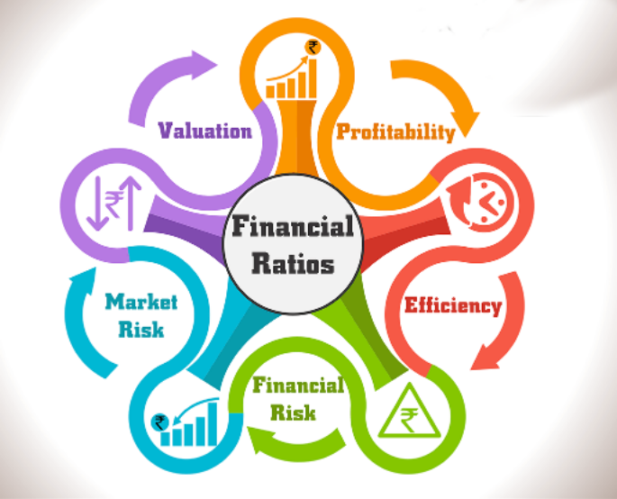

Content

Executive Summary………………………………………………………………………………….1
Table of content ………………………………………………………………………….2
Introduction……………………………………………………………………………….3
Financial Analysis / Horizontal Ratios……………………………………………….4-6
Financial Analysis Trends/ Horizontal Ratios……………………………………….6-9
Conclusion…………………………………………………………………………….9-10
Reference list…………………………………………………………………………11-12

Introduction

Hilton Hotels Corporation is a global hospitality company that owns and manages over 2,000 hotels and over 74.000 employees. Its international division, Conrad Hotels, is known for its locations in countries such as Ireland, Australia, Singapore, and Egypt. Although the company is publicly traded, its founder Conrad Hilton started the chain as a small hotel in 1919. During the 1940s, Hilton owned a variety of premium hotels around the world. In the 1960s, it started to focus on its international operations and franchised properties. It then started to investigate the casino-hotel business. Through its joint ventures, the company was able to create a standard industry practice for the development of hospitality businesses. In 1971, Hilton started to expand its gaming operations. By 1989, the company's gaming revenue had grown to 44 %. In 1996, Hilton gave up his day-to-day management of the company to Stephen F. Bollenbach, who then led the company's gaming operations until they were spun off in 1998.In 1999, Hilton acquired Promus Hotel Corporation, which included the brands such as the Embassy Suites, Hilton, and the Harrison Conference Centers (www.referenceforbusiness.com).The financial statements , Income statements and Balance Sheets Statement are calculate with the Horizontal Ratios Analyses helped by the general formula:

Horizontal Analysis (absolute) = Amount in Comparison Year – Amount in Base Year
Horizontal Analysis (%) = [(Amount in Comparison Year – Amount in Base Year) / Amount in Base Year] * 100 (Thakur, 2018)

Financial Analysis / Horizontal Ratios

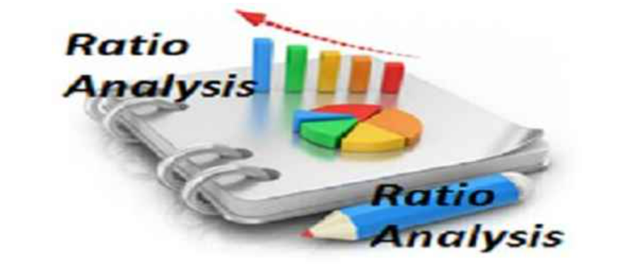
(www.qsstudy.com)
Financial management refers to the process of managing monetary resources in a business. Basically, it represents the process of planning, organizing, directing and controlling the financial resources in a company. Financial management is necessary to supervise all receipts and payments and to manage efficiently. This is achieved by using the principles of management (Weetman, 2013). One of the most effective ways to perform some analysis is by preparing vertical and horizontal income statement analyses. These types of analyses are commonly used by managers and other financial professionals to evaluate the performance of their companies. In addition to being able to analyse the financial statements of their companies, these types of analyses are also beneficial for internal users. If the calculation reveals any sudden differences in the accounts of income statements, the management team and accounting employees of the company should detach the reasons and implement measures to remedy the problem (Zolfaghari & Darzi,2019). Horizontal analysis is a method of comparing past financial data across multiple periods. It can also be used to measure the effectiveness of the information. This type of analysis is generally a transparent grouping of numbers that are split by period, but it can also be used to express the numbers in each succeeding year (www.accountingtools.com, 2022).
Below we have the financial data of 2019 and 2020 for the Hilton hotel, with their help and the calculation formula we will found out the percentages necessary to fulfil the financial report.

Income Statement | Hilton Worldwide Holdings Inc. (HLT)
 | 2020 | 2019 | Change | % Change
Fiscal Year Ends | 31/12/2021 | 31/12/2020
Sales | 4,307,000 | 9,452,000 | -5.145.000 | -54%
Cost of goods sold | 3,724,000 | 7,017,000 | -3.293.000 | -47%
Gross profit | 583,000 | 2,435,000 | -1.852.000 | -76%
Operating Expenses | 702,000 | 859,000 | -157.000 | -18%
Operating income | -119,000 | 1,576,000 | -1.695.000 | -108%
Interest Expense | 429,000 | 414,000 | 15.000 | 3.6%
Total Other income/ expenses net | -376,000 | 82,000 | -458.000 | -559%
Income before taxes | -924,000 | 1,244,000 | -2.168.000 | -174%
Net income | -715,000 | 881,000 | -1.596.000 | -181%

Balance Sheet
 | 2020 | 2019 | Change | % Change
Current Asset | 4,202,000 | 2,093,000 | 2.109,000 | 101%
Non-Current Asset | 15,810,000 | 12,558,000 | 3.252.000 | 26%
Total Asset | 16,755,000 | 14,957,000 | 1.798.000 | 12%
Current Liabilities | 2,431,000 | 2,871,000 | -440.000 | -15%
Noncurrent Liabilities | 15,810,000 | 12,558,000 | 3.252.000 | 26%
Total Liabilities | 18,241,000 | 15,429,000 | 2.812.000 | 18%
Common Stock | 3,000 | 3,000 | 0 | 0
Retained Earnings | -6,732,000 | -5,965,000 | -12.697.000 | 213%
Total Stockholders' Equity | -1,490,000 | -482,000 | -1.972.000 | 409%
Total Liabilities and Stockholder | 16,755,000 | 14,957,000 | 1.798.000 | 12%

The scope of the financial diagnosis is to appreciate the financial stage of the enterprise. Based on this examination, the elaboration of a new strategy for the maintenance & development in the environment specific to limited economy takes place. Overall, the purpose of the financial examination includes in sending financial dates to the enterprise and to those involved. Financial diagnosis is a process utilized by financial professionals to analyse the current and future financial situation of a company. It involves considering the information provided by the management regarding the company's operations (Barrow,2008).
The date base necessary to make the financial examination is taken from the simplified financial statements that include: the balance sheet, the profit & loss account, the annex to the balance sheet & income statements.
The balance sheet is an accounting document in which all the equity and sources of liabilities of a company, at a specific time, are represented. In literature we can find them in the word of assets, liabilities, and equity. Equity is as well a liability item because it is a source of financing obtained from shareholders or from commercial activity (reinvested profit). The company will return at some point this money (dividends) (Stice&Stice,2019).
The profit and loss account are a part of the financial statement that shows the company's income and expenses for the previous year. It's also one of the multiple financial statements that are used by financial professionals.
[ Income - Expenses = Net profit]
The profit and loss account are a vital part of any company's financial statement, as it shows how the company's income and expenses have changed over time. It allows financial professionals to quickly identify areas of savings that could be made. The fact that previously it was called a profit and loss account and now a profit or loss account is totally irrelevant. Irrelevant in the sense that his name will depend on the analyst or the person. In Hilton case is called income statement, based on daily sales reports / revenue report / F&B report (Chen,2021).
Why is the income statement important?
Investors study the statement of profit and loss as part of a company's value analysis, while borrowers examine the statement of profit and loss to see how easy it is for the company to repay them. Revenues are the direct amounts of money that the company has obtained from the sale of its products or services, while expenses are the amounts of money that the company had to bear in order to obtain that income. An example could be the cost of goods sold, transportation, wages, interest and taxes (Chen,2021).
In accounting, records are used to keep track of all the movements of the elements that are part of a company (assets and liabilities), in such a way as to allow the extraction of information on the state of the mentioned elements and of the company in general at a certain time. In turn, companies keep a record of all expenses and income that occur in the company, inflows and outflows of money, which subsequently allow the calculation of gross operating result (the difference between operating income and expenses). In this aspect, the statement of income and expenses reflects in an aggregated manner all the records of income, expenses, losses and gains that have been produced as a result of the operations and years of economic activity. Which allows, at any time, to calculate the gross profit or loss in the company (McCamish & Siegel ,2021).

Financial Analysis Trends/ Horizontal Ratios
A trend analysis is a statistical method that can help predict the future actions of a variable by analysing its historical trends. It uses a horizontal line to plot the data collected from various time periods (www.efinancemanagement.com), for our example 2019 and 2020.
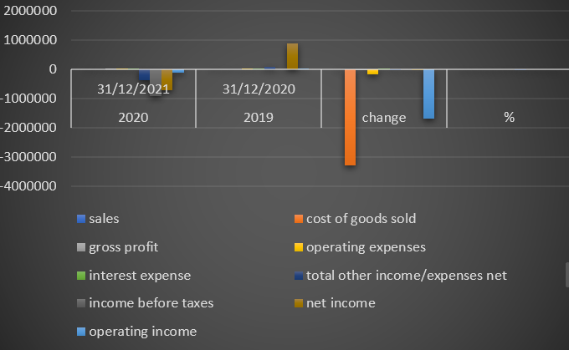
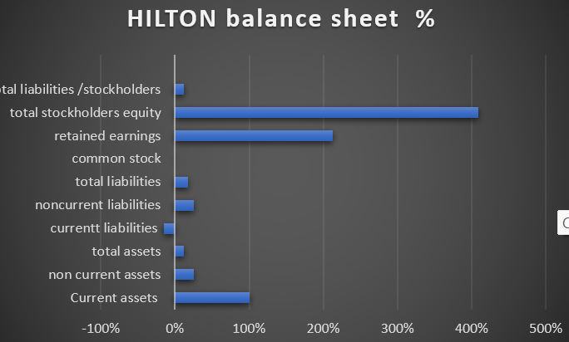
According with Yahoo Finance prices of Hilton from 01.01.2019- 31.12.2020 were:
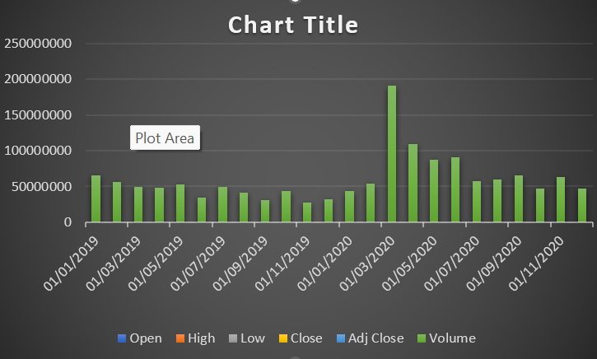
(www.finance.yahoo.com) Fig 3. Rate room prices 2019-2020.

In our case Sales decreased with -54 % (2019-2020) this is because of Covid Pandemic, people didn’t travel the same as in 2019 and Hilton didn’t sale the same number of rooms(services). The Net Income decrease with -181%. The best way to calculate the horizontal is to start from the top to the bottom. We seen that Sales decrease by – 5.145.000 (-54%) from 2019, this is not good. This generally result in less profit and higher other income net expenses because Hilton didn’t sale too many rooms.
Cost of good sold decrease by – 3.293.000 overall of -47%. This is not a surprise because decrease in sales, result in decrease on inventory costs. If we look at – 3.293.000 and – 5.145.000 and that the percentage is -47% less then – 54%(sales), this ‘’decrease’’ is not surprising, the difference is 13% more. This is good because we want the revenue to grow, is profitable but we always want cost and expenses to decrease, and that because small costs mean higher profit for a business.
We always want higher profit and lower expenses. Higher profit means higher retain earnings. Going back to green the fact that cost of goods sold increase in comparation with sale is good; our result shows that is good for the company, because will increase gross profit and potentially overall profitability. As a result:
Gross profit result is -1.852.000( -76%) from 2019. If the sales profit was -54% we want gross profit to be usually the same, in this case decreasing by -76% with a difference of ( -54%- (- 76%) = -22%) which is good overall. Gross profit is a crucial indicator for businesses. This indicates the amount that is available for operating/interest and income taxes. Gross profit is also the total that allows profit to be given for the owners if the gross profit is too small to cover the costs, then the profit is going down. Gross profit is the amount available to cover all the thinks. If is too low, then potentially the company will not be profitable at all. For Hilton we seen that gross profit is lower by -76% ( -1.852.000). This is good because we have more profit to cover all our income expenses/operating taxes as well as ultimate profit expectations but in our case is still decreased from the previous year, cause is Covid Pandemic and the restrictions.
Operating expenses decrease by – 18 % ( -157.000). This is not surprising due to decrease of sales. The fact that operating expenses decrease only by -18 % and the sales by -54% is not good.
Interest expenses or financial cost increase by 3.6% (15.000)/ is a factor of borrowing/ is like a bank, never affected by the sales changes. The company borrows more money from they creditors or they interest rate went up this is bad as we can see in Fig 3 on March 2020 Hilton has a massive increase in his rates.
Total other income decreases by – 458.000 (-559%). Profit before income taxes decrease by -559%, this is not surprizing although sales decrease by -54% and the company had an increase of 3,6, the decrease of goods sold by -47% wiped out the sales.
Income tax expenses has decrease by -2.168.000 (-174%)/ if the tax rate was the same for 2020 as it was in 2019 then the decrease in income tax expenses would be the same/the percentage on the difference -that indicates a change in the income tax rate.
This give us a higher profit overall because total other income decreases by -559% and the income before taxes is -174%.
Hilton profit went down by 181% - 2020 was bad for Hilton profit but was good because they reduce expenses/interest expenses and income expenses (Grech,2019).
Taking a close look at the Balance sheet we observe that 80% of the amounts are increase in 2020 from 2019 in comparation with the Income statement where all the percentage are decreased. But this doesn’t mean that Hilton is doing Bad, in reality is doing very good, and 2020 was a less profitable year but good in operating expenses.

Conclusion
One of the most important profitability indicators is ROCE –Return on Capital Employed – which is commonly used by shareholders to determine the performance of the management team.
Roce = (profit before interest and tax/ capital employed) *100%
Where capital employed = total assets – liabilities, or
= shareholders' capital + long-term liabilities
(James,2021)
If we look at the balance sheet or the profit and loss account, how do we know if the evolution of the company is good or bad/ If we were investors, how would we decide if it should be invested in this company or not. In general, the indicators are the most relevant in obtaining relevant information about the evolution of the company.
There are 5 main categories of indicators:
– profitability indicators.
– solvency indicators.
– liquidity indicators.
– efficiency indicators.
– indicators related to the profitability of shareholders' investments
And yes, we can conclude that Hilton is a profitable company overall.

Reference list:

Accountingtool.com, (2022), Horizontal analyses definition, Available at: https://www.accountingtools.com/articles/horizontal-analysis, Review 02 April, Accessed on: 30 May 2022.
Barrow, C. (2008), Practical Financial Management: a Guide to Budgets, Balance Sheets and Business, 7th Edition, London, Kogan Page Publication [online library], Available at: https://www-proquest-com.ezproxy.uwtsd.ac.uk/publication/105890?accountid=130472&OpenUrlRefId=info:xri/sid:primo, Accessed on: 25 May 2022.
Chen, J. (2021), Income Statement, [online article], Available at: https://www.investopedia.com/terms/i/incomestatement.asp, Upload on 16th March, Accessed on 29 May 2022.
Efinancementmanagement.com, Trend Analysis – What It Means, Uses, Types and More [online article], Available at: https://efinancemanagement.com/financial-analysis/trend-analysis#:~:text=In%20finance%2C%20trend%20analysis%20is%20a%20technique%20to,the%20basis%20of%20past%20performance.%20Table%20of%20Contents, Accessed on: 26 May 2022.
GoogleImages.com/ Ratios Picture/ Available at: https://qsstudy.com/advantages-ratio-analysis/, [online].
Grech, E. (2019), Horizontal Analysis, Video 1&2, [online YouTube video learning], Available at: https://www.youtube.com/watch?v=AOuMP8xeArw, Accessed on 17 May 2022.
HLTfinanceyahoo.com, Price rate Charts, Available at: https://finance.yahoo.com/quote/HLT/history?period1=1546300800&period2=1609372800&interval=1mo&filter=history&frequency=1mo&includeAdjustedClose=true, Accessed on: 24 May 2022.
James, V. (2021), Return on Capital Employed (ROCE) Ratio Formula, 17th December, [online article], Available at: https://businessquant.com/return-on-capital-employed-roce, Accessed on: 27 May 2022.
McCamish, B. & Siegel, R. (2021), What is the Net Profit? [online article], Available at: https://investinganswers.com/dictionary/n/net-profit, Accessed on: 22 May 2022.
Referenceforbusiness.com, Hilton profile/Background [online] Available at: https://www.referenceforbusiness.com/history2/76, Accessed on: 28 May 2022.
Stice, J. & Stice, K. (2019), Video learning [online library]. What is financial statement analysis, Available at: https://www.linkedin.com/learning/corporate-financial-statement-analysis/what-is-financial-statement-analysis?autoplay=true&u=77966930, 21st August, Marriot School of Management, Accessed on: 29 May 2022.
Thakur, M. (2018) Horizontal Analyses Formula, [online] Available at: https://www.educba.com/horizontal-analysis-formula/, Accessed on: 22 May 2022.
Weetman, P. (2013), Financial and management accounting : an introduction, 6th Edition, Pearson Publication [online library] Available at: https://www-vlebooks-com.ezproxy.uwtsd.ac.uk/Product/Index/309045?page=0, Accessed on: 21 May 2022.
Zolfaghari, M.R.& Darzi, A. (2019),,, A prediction model for vertical-to-horizontal ratios’’, Vol. 23(4) , Jul 2019, pp.819-937, Dordrecht Publication, Iran, Journal of Seismology [online library] Available at: https://www.proquest.com/docview/2237716374?accountid=130472&parentSessionId=bN%2B8b9ZS%2B21jOLCldDg%2F8VEW1lobzr2ELo7DFj%2BaJbA%3D&pq-origsite=primo, Accessed on: 28 May 2022.

