Changemakers – Creativity and Value Creation (ACCA5033)
Assignment 2

Adam Smith (2317631)
Digital Degree Apprenticeship

Contents
Introduction 2
Task 1: Project management 3
Question 1. Project Management & Planning 3
Question 2. Project Design: 5
Task 2: Enterprise & Innovation: 6
Question 1. 6
Question 2. 9
Task 3: Project Reflection: 10
Conclusion 11
References 11

Introduction
For my project I have chosen to investigate a centralised work hub for an audit department. The current system makes use of several separate office programs, manual folder organisation and work tracking spreadsheets. Due to this it is often hard to find required information, files can be moved and lost, and work tracking spreadsheets are often left without updates leaving gaps in workflow and giving incorrect information for tracking length of time spent in certain processes. The intention is to make a centralised work hub which will allow audits to be written, sent and replied to, along with providing automated communication and tracking of stages, and the provision of data to be taken from the process and allow analytics and analysis.

Task 1: Project management

Question 1. Project Management & Planning
Document the Project scope inc. proposed solution to your project aim/idea/problem, the required Technologies/resources to be used, a project timeline, a schedule & constraints.
Using a software tool of your choice, create a Gantt chart to document your project stages.
Document a suitable Development method to help you plan and complete your project.

Project scope.
To provide a centralised working hub which houses and allows access to all work product for an audit department. The hub must allow for several layers of access to account for separate roles with differing levels of access and privileges. It must also:
Allow for unique user access for work product and amendments to be identified.
Allow for communication between auditors and stakeholders.
Make provision for automated communication in set circumstances.
Follow the audit process from start to finish
Allow for several types of audit process – adherence, off plan assurance and non-specific targeted reviews.
Allow for reports to be written and saved within the hub, as well as accessed and reviewed.
Allow for integration with a calendar to set dates and responses within set timeframes
Allow for data to be tracked from processes to analytics at a later point

Required technologies
Technologies required for this project will range from physical to software with the majority being coding.
The first consideration will be for platform infrastructure, cloud hosting services such as AWS or Google Cloud, Database systems such as MySQL and web frameworks such as Vue.js and Node.js.
Programs such as Figma or Adobe XD can be used to create a user interface (UI) and ensure it is intuitive and accessible for all users [1].
Project management tools such as JIRA can be used to track overall progress and plan work schedules, in addition to Microsoft outlook for calendar management and scheduling [2].
Communication programs such as MS Teams will be vital to ensure the team are able to collaborate, allowing for messaging, meetings, video conferencing and file sharing.
Cloud storage systems such as Microsoft OneDrive and Google Drive allow for storage solutions giving remote access and physical storage solutions to be less costly.
Google Analytics provide a service which will track user behaviour – providing insight into trends and the data held [3].
Chat GPT and Microsoft Copilot can provide IA assistance, automating some elements to the system and streamlining processes.
Tools such as GitHub Actions and GitLab will be used for continuous development, improvement and integration.

Time scale | Phase | Work detail
4 Weeks | Scoping and planning | Key requirements & must haves  Nice to have’s and hard No’s  Mark and competitor analysis  Build team and assign roles
4 Weeks | Requirements and Design | SOP’s  wire frames and UI mock up’s  functional specifications
16 Weeks | Development | Building databases  Core elements – Login, messaging, calendar, dashboards
4 weeks | Testing and Quality Assurance | Core functionality  Usability  Performance  Intuitiveness
2 Weeks | Test Launch (Beta) | Launch to restricted and selected audience
3 Weeks | Final improvements | Implementing feedback obtained from test launch
2 Weeks | Launch | Deploy to live environment
Ongoing | Monitoring / support | Track performance  Address any issues identified
Table 1 – project timeline

Figure 1 – Gantt chart of predicted project timeline

I have chosen an Agile methodology for the project. The Agile methodology breaks down projects into small, manageable units referred to iterations or sprints [4]. Instead of working on everything at once, work is delivered in stages, allowing for continuous development and improvements [5]. As work is broken down into stages it also makes Agile highly adaptable – if changes are required, they can be implemented quickly. It also allows for continuous feedback and improvement [6].

Question 2. Project Design:
Document and describe some project ‘Design’ work. 2 pieces required e.g. requirements specification, sketches/drawings, storyboard, wireframes, flow chart/UML diagram, ERD data structure), network structure diagram, network security architecture/diagram.
Project requirement specification
Functional Requirements
- Access –
Secure Login – Users must use the business 2 factor authentication to verify their identity and provide secure access to the data they will be processing.
Access must be split across several levels with differing levels of authority, both allowing for differing abilities and also differing view of available data.
- Communication –
2-way communication must be possible between auditors and stakeholders. Communication must be secure and documented for posterity
Provision must be made for automated communication, such as emails with reminders of approaching deadlines, or reminders of meetings etc.
- Calendar integration –
Auditors and Stakeholders must be able to arrange meetings / interviews, view appointments and cancel or reschedule at their discretion.
- Audit integration –
Must follow audit process from start to finish, with clear indicators of current position, and allow for the differing types of audits the department completes, along with the differing types of work output – i.e allow for standard written reports along with spreadsheets with numerical findings.

Non-Functional Requirements
- Provision must be made for approx. 40 concurrent users, with capacity to scale this up in the future.
- Interface must be accessible to all levels of staff who will utilise the product.
- All data must be encrypted both in transit and at rest.
- System uptime must be constant throughout business hours with provisions made for planned maintenance.
- Must comply with all GDPR [7], ISO 27001 and NIST Standards.

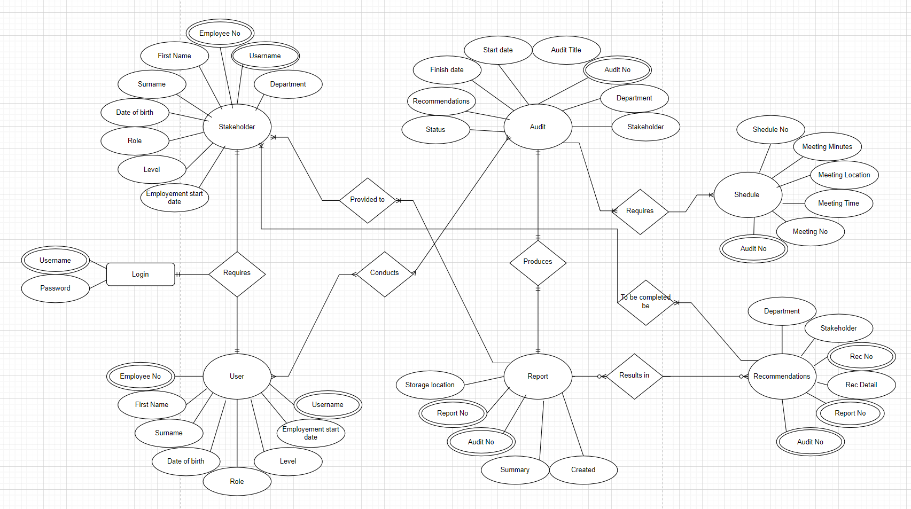
Figure 2 – ERD

Task 2: Enterprise & Innovation:

Question 1.
Document some key considerations from an example PESTLE & SWOT analysis for a Tech Company of your choice including some legal & ethical considerations.
I have chosen to complete an analysis of my employer, the Admiral Group PLC. While the Admiral Group is not a traditional tech company, the group can be considered a tech company due to its investments and focus on technology as a core part of its business. The group utilises AI, robotics, machine learning and data analytics as well as partnering with firms such as Wayve for autonomous vehicles.

Political
Regulatory Oversight - The UK insurance market is highly regulated by the PRA and FCA. The introduction of consumer duty and the lack of guidance around expectations from regulators or a clear definition of what a good customer outcome is leaves ambiguity and potential for fines on non-compliance.
Taxation - Corporation tax was increased in 2023 to take effect from 2024, from 19% to 25% on all profits over £250,000
Government initiatives - Initiatives and task forces brought in to address rising insurance costs directly affect business practices and threaten profitability. Government action such as Legal Aid Sentencing and Punishment of Offenders (LASPO) act and whiplash reforms directly affects how the business is run.
Geographical Risks - The Ukraine-Russia war and Brexit have had large impacts on supply chains, increasing things such as costs for parts and energy costs for supporting the business
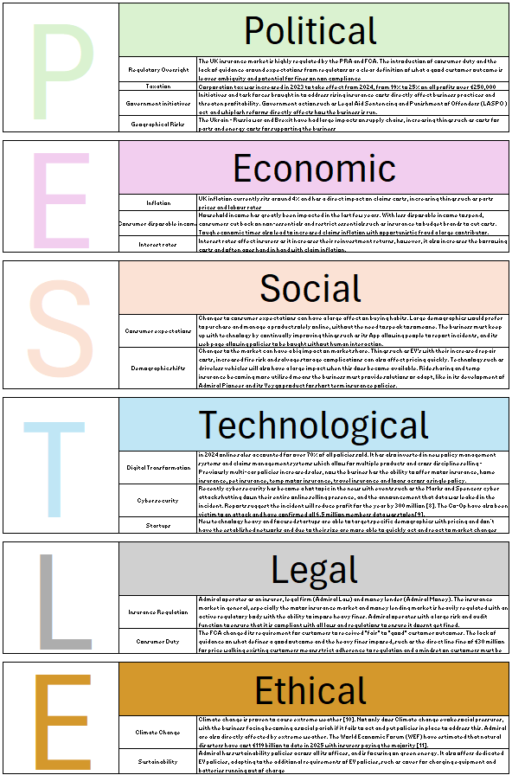
Figure 03: PESTLE Analysis
Strengths
Brand Recognition The group is now the UK's largest motor insurer by market share. All the groups’ brands are established and known across the sector.
High profit margins The group has market leading profit margins, tracking ahead of its competitors.
Class leading loss ratio The average combined loss ratio for the UK motor insurance market for 2023 was 112% The admiral group loss ratio for the same period was 63.9%

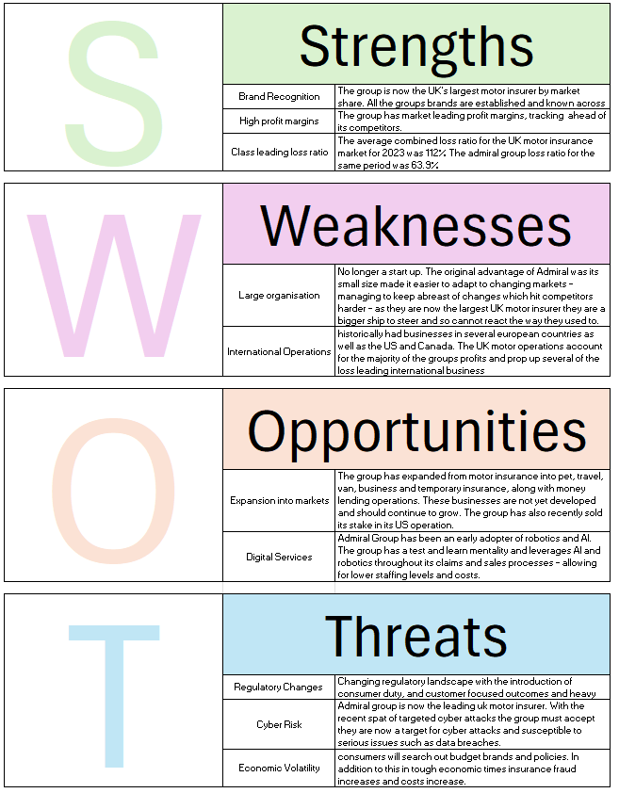
Figure 04: SWOT Analysis

Question 2.
Related to your project idea describe the concepts, methods, practices and tools you would use to develop, deploy, maintain and evolve the practical element of your project if it was implemented within a large organisation.
Concepts
Modular architecture – The system would be designed to keep components individual, allowing for areas to be worked on in isolation, allowing for flexibility and scalability in the future.
Scalability – The system will have an initial target of 40 concurrent users but must have provision for this figure to expand – both for concurrent users, total users (as staff attrition will dictate an increase) and scale of departments involved if the project is successful and utilised across the entire group.
Security – Security will be a main priority from the outset. Data must be encrypted at all stages, and users will be required to utilise 2 factor authentication. Within the system there must be separated levels and accounts for users and stakeholders as audits will contain confidential and business critical information which cannot be shared across users or platforms.
User centred design – Ease of use is a large consideration. The system will be built with feedback from auditors who would be using the system in the future, focusing on intuitive interfaces, workflows and methods. The users will be auditors and stakeholders and so may not be technologically literate but must be able to use the system without need for assistance.
Agile development – The methodology allows for the system to be built in stages with constant feedback from stakeholders and auditors allowing for things such as user centred design to be centre stage in the process. As Agile utilises scrums and sprints, breaking work down into small sections it also allows for changes and adaptations to be made and put in place relatively quickly.

Methods
Agile Scrums – Part of the Agile methodology, allowing for work to be broken down into small iterations and feeding into the modular concept sought after. Within the scrum this will further be broken down into sprints with specific goals and targets [12].
DevOps – Methodology which merges development and operations teams to improve collaboration and accelerate delivery of software. Will help with the automation or routine repetitive tasks. DevOps methodology will also help with the continuous cycle of feedback and improvement [13] and also integrates the test and learn mentality of the Admiral Group as a whole.

Practices
Version control – Secure method of managing code changes, allows for easy rollback if a new iteration fails or an issue is identified. Allows for tracking of changes – who changed what, when and why. Allows branching and merging for features or fixes.
Code review – Peer reviews, useful for identifying issues early, good quality control tool which also builds a team mentality and is a good training resource, allowing for junior team members to become proficient, understand what is required of them whilst also maintaining good quality.

Tools
Development and deployment Frameworks – Node.js and Vue.js
Databases – MySQL
Version control - GitHub
Cloud hosting - AWS

Project Management Agile boards - Jira

Monitoring and analytics User analytics - Google analytics

Maintenance and evolution
The system will be built with cloud services to facilitate scalability in the future, allowing for growth, flexibility and support and reassurance around downtime.
Regular updates will be implemented to maintain the system, minimise vulnerabilities and help improve performance.
Business Continuity and Disaster Recovery plans will be implemented – tied in with cloud services to help provide automated switch over features.

Task 3: Project Reflection:
Produce a reflection in which you reflect on a project idea that you could take forward. Your reflection should document the following points below. The answer to this task should be approx. 600 words, with several citations.
How you intend to use this opportunity to develop new skills?
How could your project/new skills have a positive impact on and contribute to society?
Identify some risks/challenges your project could face and document what you can do to reduce/remove them.

My intended project of an online audit management portal would be a benefit to my employer both at a claims level (auditing of specific elements such as the claims department), company level (auditing for specific company’s within the group, and group level (across all entities within the group). Starting at a smaller scale, such as at claims level allows for testing and ensuring the final product is fit for purpose before scaling up to the point it would be able to be used across the group.
The opportunity would allow for further development of existing skills such as project management, and the development of new skills, such as database management, coding, data analytics, stakeholder management and people skills.
Whilst audit can seem to be an unnecessary and boring element of business, audit and risk management is a vitally important part of the group – not just for the protection of the business, but also for the protection of its customers. Audit as a function is the testing of controls put in place by a business to ensure they are working as intended. Controls are put in place to ensure that a business is working as intended – both mitigating risk and increased cost to the business, but also to ensure that customers are treated fairly, receive the product they are paying for and do not fall through the cracks in standard operating procedures designed for a set circumstance and which potentially don’t reflect the needs of a vulnerable customer and the additional requirements they need.
Having a more efficient and effective audit management system will allow for time to audit to fall, meaning each auditor is able to complete more reviews, providing more assurance in the same workspace, allowing for more varied work to be taken on, looking at additional areas rather than simply meeting the compliance requirements put in place by the FCA and PRA. Additional resource such as above can help stop instances where businesses are not acting as they should – such as Direct Line being ordered to review 5 years of previous work where customers were under paid vehicle valuations [14]. With the current increased financial pressures and economic situation vulnerable customers can need even more support, having additional resource to ensure this need is met would be of benefit to society as a whole – customers are paid what they should be, no customers are left without support, company valuations are correct, meaning investors are able to make more accurate decisions, business don’t need to reassess previous years business after involvement from regulators and insurers stay in business, meaning no customer looses out when a business goes bust.

Challenges
Security Risks – Audits by definition, will have access to a large amount of restricted information. This will make the system a target for attacks attempting to gain access. This also includes insider threats, people with legitimate access who can cause issues through both careless and malicious actions. In an attempt to mitigate some of these risk the project specification has included 2 factor authentication, along with multi-level access in an attempt to limit access without authority.
Downtime and outages - Server failures will now affect the entire department. As all work will be processed through the hub it will mean that anyone without access to it will be unable to work, meaning minor outages can now have large knock-on effects with the amount of work hours lost. In an attempt to mitigate this the specification states cloud hosting to provide some assurance with most quoting uptime of around 99%.
Cost overruns - Underestimating development, or maintenance costs. Also becoming locked in to specific vendors who can then increase costs whilst holding the project to ransom. To mitigate some of these risks the project has been planned with a large allocation of time for contingency and overruns. It is also vital that any contract for cloud hosting is scrutinised, ensuring no future costs hikes and ease of switching services if required.

Conclusion
The project will benefit the organisation by providing a centralised audit system, allowing for all work product to be stored and accessed from one place. It will allow or ease of use and streamline procedures such as trying to locate information. As all work will be run through the system it allows for certain areas to be automated, such as the tracking or progress and minor elements of testing. Once work is recorded as it is processed it will allow for analytics to be run, meaning greater insight into findings and work processes and procedures.
The project could be further improved by the inclusion of AI in the future, helping with the writing of reports, providing insight on testing completed, and automating part of the processes.

References
[1] A. Ahmed, “Figma vs Adobe XD (2025): Which UI/UX Design Tool Is Right for Your Business?” Reactree, Jul. 29, 2025. [Online]. Available: https://reactree.com/figma-vs-adobe-xd-2025-which-ui-ux-design-tool-is-right-for-your-business/
[2] B. Döhler, “Jira Outlook Calendar Integration: Your Complete Setup Guide,” Resolution Atlassian Apps, Jun. 4, 2025. [Online]. Available: https://www.resolution.de/post/jira-outlook-calendar-integration/
[3] K. Azarenko, “How to Understand User Behavior With Google Analytics,” Search Engine Journal, Jul. 21, 2021. [Online]. Available: https://www.searchenginejournal.com/google-analytics-user-behavior/202964/
[4] M. Nehra, “6 Stages of the Agile Development Lifecycle [2025 Expert Guide],” Decipher Zone, Jul. 30, 2025. [Online]. Available: https://www.decipherzone.com/blog-detail/agile-development-lifecycle
[5] S. Laoyan, “What is Agile methodology? (A beginner’s guide),” Asana Resources, Feb. 20, 2025. [Online]. Available: https://asana.com/resources/agile-methodology
[6] P. Amajuoyi, L. B. Benjamin, and K. B. Adeusi, “Agile methodologies: Adapting product management to rapidly changing market conditions,” GSC Advanced Research and Reviews, vol. 19, no. 2, pp. 249–267, 2024. [Online]. Available: https://gsconlinepress.com/journals/gscarr/content/agile-methodologies-adapting-product-management-rapidly-changing-market-conditions
[7] UK GDPR Guidance and resources, Information Commissioners Office (ICO) [Online]. Available: https://ico.org.uk/for-organisations/uk-gdpr-guidance-and-resources/
[8] M&S Click and collect returns 15 weeks after cyber-attack, BBC News, 11/08/25, [Online] Available: https://www.bbc.co.uk/news/articles/cewyyjdzql4o
[9] Co-Op boss confirms all 6.5 million members had data stolen, BBC News, 16/07/25, [Online] Available: https://www.bbc.co.uk/news/articles/cql0ple066po
[10] Extreme Weather and climate change, National Aeronautics and Space Administration (NASA), [Online], Available: https://science.nasa.gov/climate-change/extreme-weather/
[11] Natural disasters have cost us $162 billion this year. Insurance covered most of it. World Economic Forum (WEF), 08/08/25, [Online] Available: https://www.weforum.org/stories/2025/08/global-insurance-industry-gap/
[12] M. A. Silva and R. M. Lima, “Scrum Agile Project Management Methodology Application for Workflow Management: A Case Study,” 2018 IEEE International Conference on Industrial Engineering and Engineering Management (IEEM), Bangkok, Thailand, Dec. 2018, pp. 1331–1335.
[13] IEEE Computer Society, IEEE Std 2675™-2021: IEEE Standard for DevOps: Building Reliable and Secure Systems Including Application Build, Package, and Deployment, IEEE Standards Association, Apr. 2021. Available: https://standards.ieee.org/ieee/2675/6830/
[14] Insurance Business UK, “Direct Line responds to FCA’s notice to reassess claims,” Insurance Business Magazine, Aug. 18, 2023. [Online]. Available: https://www.insurancebusinessmag.com/uk/news/auto-motor/direct-line-responds-to-fcas-notice-to-reassess-claims-450965.aspx

Table 01 – Project timeline

Figure 01 – Gantt chart detailing project timeline.
Figure 02 – Entitry Relationship Diagram for proposed project
Figure 03 – PESTLE analysis completed on Admiral Group PLC
Figure 04 – SWOT analysis completed on Admiral Group PLC

