Reflection on Study Skills Report

Study Skills

Module code ACDB4010

Alex Clarke
2309711@student.uwtsd.ac.uk
Level 4 OME Course
January 2024.


Table of Contents
1 Introduction 3
2 Presentation 3
3 Skills evaluation 4
3.1 Skill identification 4
3.2 Self-evaluation 5
3.3 Goal setting 5
4 Application 6
4.1 Looking after your data 6
4.2 Time Management 6
4.3 Self-organisation 8
4.4 Independent study 9
5 Conclusion & Evaluation 9
6 References 10
7 Appendices 11
7.1 Appendix A– Presentation feedback 11
7.2 Appendix B – Learning style self-assessment results 12
7.3 Appendix C – Personality self-assessment results 14
7.4 Appendix D – PDP and Action plans 15

Figure 1 Screenshot 1 of presentation Figure 2 Screenshot 2 of presentation 3
Figure 3 Screenshot 3 of presentation Figure 4 Screenshot 4 of presentation 3
Figure 5 Priority Matrix 7
Figure 6 Learners work calendar 7
Figure 7 University account outlook calendar 8
Figure 8 Learners e-Portfolio structure 8

Introduction
This report documents and reflects on all content taught to the learner during the study skills module using the skills and knowledge gained.

Presentation
Each learner was asked to produce and deliver a 5-minute ice breaker presentation using MS PowerPoint to the other learners on the course. A short timescale of less than a week was provided for the learners to prepare and deliver said presentations. The learners ice breaker presentation was titled “A little about me” with the first slide being the title slide. The learners second slide covered his personal life including the following information, the third slide covered the learner’s hobbies and interested and the fourth and fifth slides covered the learner’s career to date.
Figures 1-4 below show the first four slides of the learner’s presentation, showing the formatting, the wording and images used.
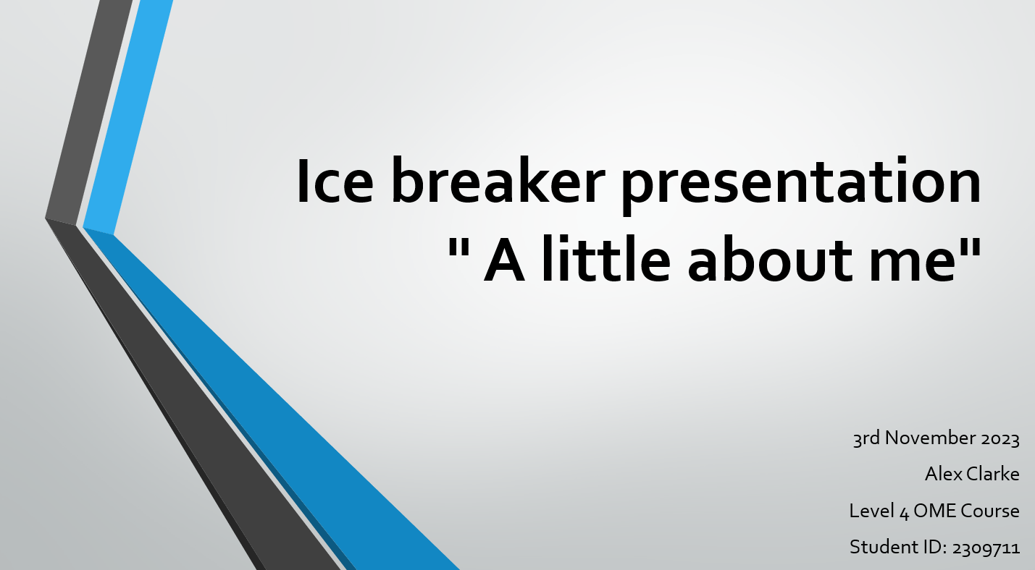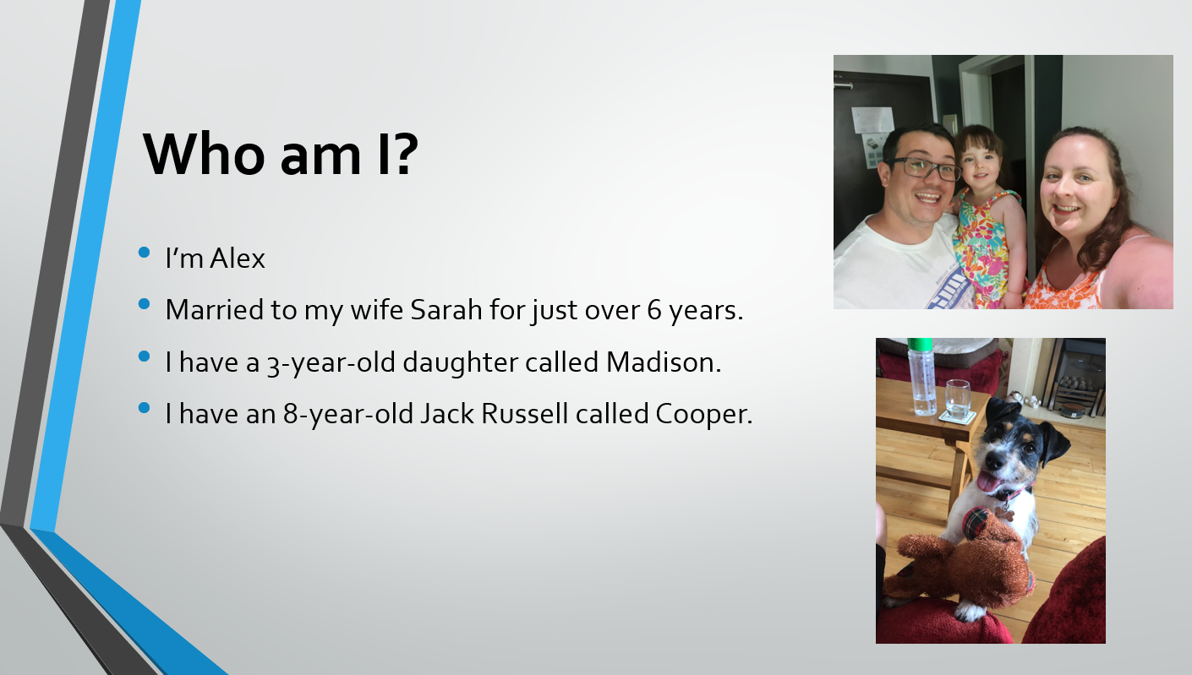
Figure 1 Screenshot 1 of presentation Figure 2 Screenshot 2 of presentation

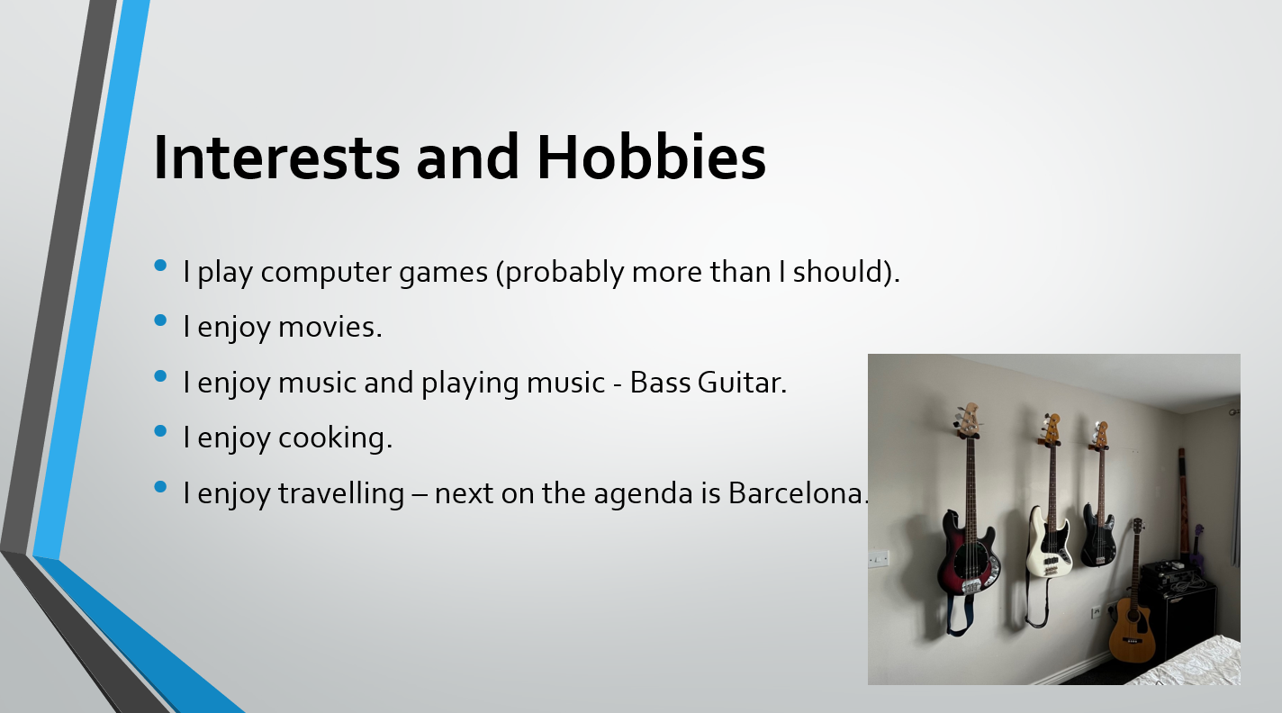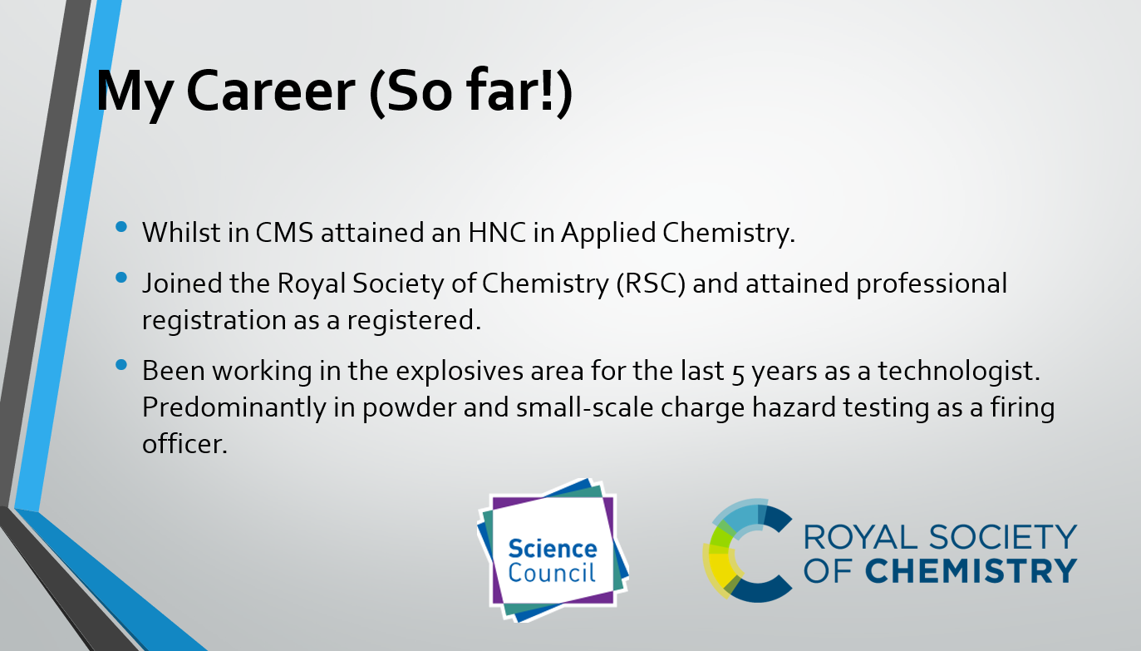
Figure 3 Screenshot 3 of presentation Figure 4 Screenshot 4 of presentation

The key point learnt by the learner from producing and presenting the ice breaker presentation was that practicing multiple times is key. This was to ensure that the learner was confidence with the content and was able to present it with an air of confidence and knowledge of the subject matter. The learner’s main aspects to improve upon for future presentations is managing their anxiety towards presenting in front of an audience. The learner has the confidence that they can learn the content and subject matter, but the actual process of presenting is something that is far outside of their comfort zone.
The learner received feedback from his fellow students, which provided some incite to what was presented well and where improvements could be made with the learners presenting skills. These included time management as learner overran by about 1 minute past the requested time of 5 minutes. This feedback can be read in Appendix A.

Skills evaluation

Skill identification
Further education requires a slightly diverse set of skills compared to that which is required during statutory education. This is due to the face that the learner has a lot more control over their learning during further education due to a large part of it being individual/ independent learning. In the case of the OME HNC Level 4 apprenticeship, this is around 25% in person learning and 75% individual/ independent learning. Some of the essential skills required by learners include [1]:
- Time management – Ability for the learner to ensure that they manage their time correctly to attend in person teaching/lectures as well as time to conduct their assignments and revision in the sense of individual learning. Planning is key to the learner’s success.
- Critical thinking – Ability for the learner to conduct objective thinking and assessment without bias and being able to see arguments from both sides. This is an exceptionally good skill for learners to have in scientific fields.
- Writing – Ability for the learning to conduct writing to an academic standard to ensure they are able to convey their thoughts and findings through assignments, assessments and dissertations. A good understanding of the English language is key to ensure that correct grammar and spelling is used in any academic writing.
- Reading – Ability for the learner to conduct suitable research on their subject matter. This aids in the ability for the learner to learn added information and reference correct information.
- Communication – Ability for the learner to communicate what they have learned/ studied through either presentation, class discussions or even discussions with fellow learners during study sessions.
- Soft skills - Soft skills or transferable skills are discussed further on this section of the report.

Understanding the learner individual learning styles can aid by ensuring they are taking in information in a way that works for them. Learning skills can be split into four different learning styles/ preferences which are Visual, Auditory, Reading and writing and Kinaesthetic which is known as the VARK model [2].
Below is a description of each of the learning styles from the VARK model along with examples of how the learner may take on information [3].
- VISUAL: Individuals that use the visual learning styles prefer learning information through images, graphs, symbols diagrams etc as opposed to written information and instructions.
- AUDIABLE: Individuals that use the Auditory learning styles prefer learning information through audible means like lectures, podcasts, discussions, lectures etc.
- READING AND WRITING: Individuals that use Reading and writing learning styles prefer learning information through written means like papers, journals, writing notes, assignments etc.
- KINAESTETIC: Individuals that use the Kinaesthetic learning styles prefer learning by being direct with the subject matter. This could include demonstrations and direct learning a new skill like learning to play a musical instrument.

Multimodal learning styles can also occur for individuals who do not just sit in one the of the VARK learning styles.
Transferable skills (also known as soft skills) are skills that individuals can apply to many areas of life including education, employment and personal.
Below is list of a few transferable skills [4] that are appealing to employers:
- Problem solving – Ability to solve problems.
- Leadership – Ability to lead projects and teams.
- Adaptability - Ability to adapt to evolving projects and situations.
- Communication – Ability to communicate with colleagues and stakeholders.
- Creativity – Ability to think outside the box.
- Attention to detail - Ability to not miss the finer requirements of the job.
- Project management – Ability to manage a project efficiently.
- Computer skills- Ability to use computer-based media.

Self-evaluation
The learner undertook self-evaluation to determine their learning styles using two different assessments. The first was on the “Vark-learn” website [5] which evaluated the learner to have a Multimodal Learning style. The second was on the “Robertson college” website [6] which evaluated the learner to have an auditory learning style. Appendix B shows screengrabs of the results from the learning style assessments from both websites along with information of how to study and suggested career options.
The learner undertook further self-evaluation to determine their personality type using a personality assessment found on the “16 personalities” website [7]. This assessment found the learner to have an “Advocate” personality. Advocates are known to be quiet visionaries and often server as inspiring and tireless idealists. Full details relating to the Advocate personality type, including strengths and weaknesses can be found in Appendix C.
The results from the self-assessments conducted by the learner provided the learner a good understanding of their learning styles and personality. The results of the learning style came as a bit of a surprise to the learner as they had always seen themselves as a more kinaesthetic learner. The personality test was a particularly good representation to how the learner had perceived themselves before taking the test especially with the list of traits, strengths and weaknesses shown in Appendix C. The learner believes that areas for improvement from these self-assessments are being less introverted and little more outgoing as well as working on how susceptible they are to burning out.

Goal setting
Goal setting is important to ensure the learner had a goal and target to reach during their academic/ professional career and personal life. Below is a list of the learner’s short term and long term personal and academic goals.:
Short term goals:
- Finish this assignment.
- Get first exam out of the way.
- Complete the first year of the HNC OME apprenticeship.
- Sign up with the institute of explosive engineers.
Long term goals:
- Complete the HNC OME apprenticeship.
- Finish garage conversion

From these long- and short-term goals, the learner complied action plans which conform to the S.M.A.R.T guidelines (Specific, Measurable, Achievable, Relevant, and Time-bound). These action plans can be seen in Appendix D.

Application

Looking after your data
The importance of being able to back up and recover data is something that has always been important within academia, industry, and individuals. It is becoming increasingly relevant as the reliance of digital and computer managed data becomes more widely accessible and interconnected. Back-up and recovery of data is defined as “The process of creating and storing copies of data that can be used to protect organisations against data loss. This is sometimes referred to as operational recovery. Recovery from a backup typically involves restoring the data to the original location, or to an alternate location where it can be used in place of the lost or damaged data. A proper backup copy is stored in a separate system or medium, such as tape, from the primary data to protect against the possibility of data loss due to primary hardware or software failure.” [8]. Although this definition states organisations, this can also describe academia, industry, and individuals’ data.
The main reason behind data backup is to provide resilience that any form of data can be restored following any kind of data failure. Data failure can include software or hardware corruption i.e. software driver failure or hard drive or solid-state drive failure. Accidental deletion is another form of data failure that can sadly happen when an individual user will accidentally delete a single file or number of files that should not have been deleted. A third form of data failure can occur through malicious means with an example of this being the data owner being “hacked” or their data being altered. These malicious actions can lead to further impact on the owner’s data in the sense that any data reported could be wrong and this impact any conclusions formed from said data.
Following the principles from the definition of data backup and recovery the learner will be using the “in 3 different places” rules which were discussed in class and documented on the MS PowerPoint slides on Moodle [9] The “in 3 different places” rules do exactly what is say in the sense that 3 copies of the same data are stored in at least 2 different location and 1 copy off site. This ensures resilience that if data failure that occurs on one of the storage locations, then there are two further locations where the data can be recovered from and limits the risk of total data loss. It is worth noting that this method cannot guarantee that total data loss may happen as there is a chance that all three storage locations could undergo data failure, but the general likelihood of this occurring is low. The way that the learner will be implementing this will be the following:
- One copy will be stored locally on the leaner’s personal laptop on their C: drive (solid state drive).
- One copy will be stored on the cloud using the learner’s university OneDrive storage.
- One copy will be stored on a standalone USB/pen drive to which the learner only will have access to.
Data will be backup periodically by the learner with a minimum of once a week but also when the learner has finished updating any of data in the form of reports and documents etc. This backup will be conducted across all 3 location of data storage.

Time Management
Time management is a key aspect of this OME HNC level 4 apprenticeship, as in-person learning only takes place for a small percentage of around 25% with the large bulk of study time being covered by independent learning of around 75% by the learner. Due to the learner being in a full-time employment along with being a father to a year 3 old daughter, time management holds a slightly higher level of importance to the learner to ensure that they can deliver all aspects expected of them to pass the OME HNC level 4 apprenticeship whilst maintaining stress levels.
The first thing that the learner is undertaking to ensure effective time management is prioritisation of what tasks to conduct. This is managed by defining how important and how urgent the task is. The learner can manage this by using the priority matrix seen below in figure 5 [10], which defines the priority of the task using the urgency and importance of the task. An example of the learning using this would be submission of this assignment for the 10th of January 2023 deadline. This is both urgent and important so outcome action would be to do now. An example of the do next action would be for the learner to start forward reading of subjects that will be covered in the next semester. This is of high importance, but the urgency is lower compared to the maths exams. This priority matrix will evolve over time as modules of the OME HNC level apprenticeship are completed.
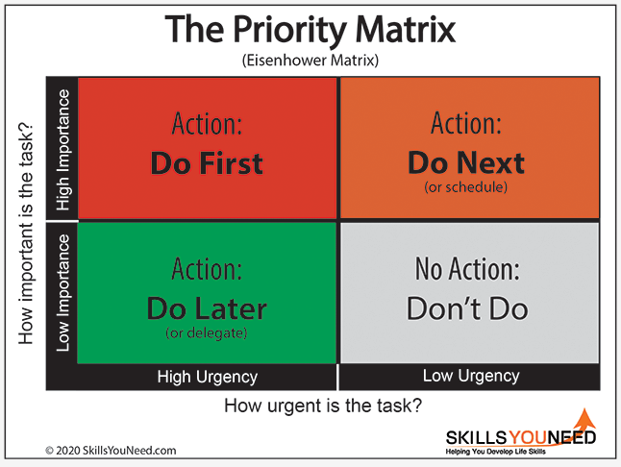
Figure 5 Priority Matrix
The second thing that the learner is undertaking to ensure that their time is managed well is to ensure that a minimum amount of time is allocated to doing independent learning per week whilst not attending in person learning. The target minimum amount of time is currently around 10 hours per week, and this is normally in the evenings when the learner has some quiet time away from his work and parental obligations. Sadly, this time allocation is on a much more flexible plan than the learner would prefer but life does get in the way sometime. On top of this minimum time allocated, the learner is allowed to allocate a portion of his working week to support his independent studies which is being supported by his line manager, if it does not impact on his work deliverables. Figure 6 below shows an example of the learners work calendar with time allocated for independent studies.
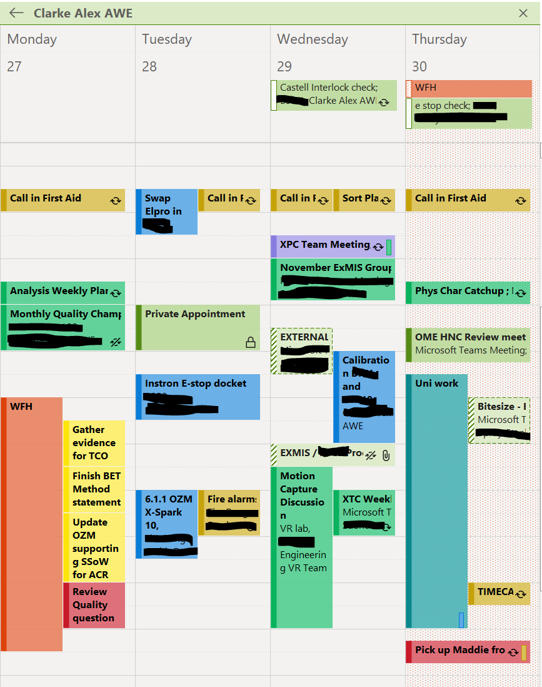
Figure 6 Learner’s work calendar

The third thing the learner is undertaking to ensure their time is managed well whist attending in person learning is to ensure that the learner is utilising time between lectures. This can be the learner having study days in the library to work on assignments or study sessions with the learners’ fellow students. This is managed by use of the learners MS Outlook calendar for their university account. This can be seen in figure 7 below.


Figure 7 University account outlook calendar

Self-organisation
Self-organisation is key to ensure that the learner has easy access to supporting information relevant to their academic studies and professional work and development.
The learner’s academic PDP is documented in Appendix D and documents short term and long-term goals along with what needs to be completed and expected delivery dates. The learner chose this structure for the PDP as its clear and concise whilst being S.M.A.R.T The learners e-Portfolio structure is documented in figure 8, showing the folder structure used for storage of each modules assignments and supporting documentation.
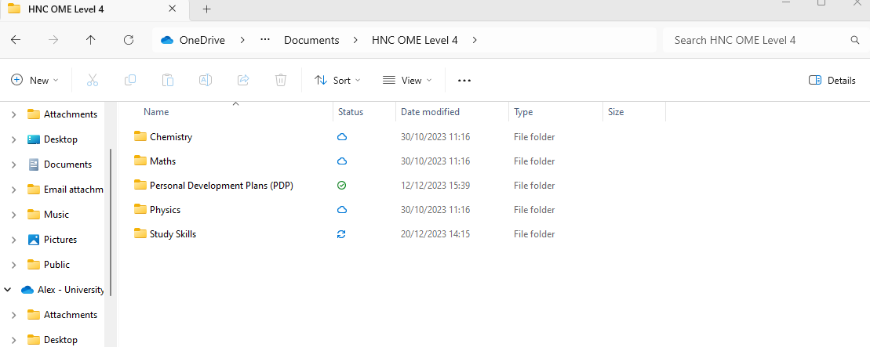
Figure 8 Learners e-Portfolio structure
The learner’s professional PDP is documented in Appendix D and documents the learners, current technical capabilities, 1,3- and 5-year plans, opportunities for development and opportunities for mentoring. The learner chose this single page approach as it again is clear, concise, and easy to track when reviews are held with the learner’s line management.

Independent study
Torpex (or Torpedo Explosive) is a castable secondary high explosive composition comprised of RDX (Research Division Explosive or Hexogen, TNT (Trinitrotoluene) and Aluminium powder normally in the ratios of 41: 41: 18. The composition also included wax as a phlegmatizing agent to desensitise it and improve handlining properties. [11]. Torpex was developed by the allies during World War 2 as an alternative explosive to TNT as it was 50% more powerful by mass compared to TNT alone [12] and 20% more powerful by mass competed to Composition B (59.5% RDX and 39.4% TNT) [12] .Torpex was used as an underwater explosive (used in torpedoes, naval mines and depth charges) due to the addition of the aluminium powder in the composition. The addition of the aluminium improved the performance of the explosive by an increase of in the heat of explosion and thus providing an increased temperature. This increase in the heat of explosion was due to alumina (aluminium oxide/ Al₂O₃) having a high heat of formation at 1658 kJ/mole. The addition of aluminium also included a secondary improvement in the form of the possibility of “post-heating” thus increasing the air blast of the Torpex or even the ability for a delayed secondary explosion to occur. This “post-heating” occurred if any aluminium had not reacted in the initial detonation and would oxidise in atmospheric oxygen and produce alumina (aluminium oxide) which has the higher heat of formation [13].
Aswell as Torpex being used for naval warfare during World War 2, it was used in “bouncing bombs” and “earthquake bombs” which were dropped from planes. A famous example of the “bouncing bombs” being used was Operation Chastise, also known as the Dam busters Raid carried out by the RAF in May 1943. The 6600lb Torpex filled “bouncing bombs” where dropped from aircraft and skimmed along the water surface towards the damns in the Ruhr Valley which they then detonated [13].

Conclusion & Evaluation
From the learner undertaking the study skills module and reflecting on it in this report, the learner’s key findings are summarised in the bullet points below:
- The learner has improved his presentation skills and is aware of areas for self-improvement.
- Through self-assessment, the learner now has a much stronger understanding of their personality type and learning styles they will be implementing during the OME HNC Leve 4 course.
- The learner has a greater understanding of the skills required for further learning and can implement some of the soft skills already applied during the learner’s professional career.
- The learner had a good understating of time management, self-organisation, and goal setting from their current job but what has been covered in this module has assisted the learner in applying this to further education.
- The learner improved their knowledge on data storage and backing up and can applied knowledge to their further education and professional career in the future.
- The learner had a good understanding of how to gather and present new information from their current job by previously carrying out literature reviews. However, the learner has improved their capacity to reference and cite information correctly in the correct format through this module.

An area of interest gained from this module is looking further into the affect that metallization of explosives has and the applications it can be used for as the learner found this remarkably interesting to read about during the review of Torpex.

References
- R. Needleman. "What are 6 essential skills for university students?" Uniadmissions.co.uk. Accessed: December. 14,2023. [Online]. Available: https://www.uniadmissions.co.uk/application-guides/6-essential-skills-for-university-students/
- "Introduction to VARK - for better learning" Vark-learn.com Accessed: December 13, 2023. [Online]. Available: https://vark-learn.com/introduction-to-vark/
- "The VARK Modalities - What do they mean?" Vark-learn.com Accessed: December 13, 2023. [Online]. Available: https://vark-learn.com/introduction-to-vark/the-vark-modalities/
- R. Pelta. "15 Transferable skills that companies want: examples and definitions." felxjobs.com. Accessed: December 15. 2023. [Online]. Available: https://www.flexjobs.com/blog/post/transferable-skills/
- "VARK Questionnaire: How do you learn?" VARK-learn. Accessed: December 13, 2023. [Online]. Available: https://vark-learn.com/the-vark-questionnaire/
- "What type of learner are you?" Robertson College Accessed: December 13, 2023. [Online]. Available: https://www.robertsoncollege.com/news/studying-at-robertson/what-type-of-learner-are-you/
- "Personality types." 16personalities.com". Accessed: December. 11,2023. [Online]. Available: https://www.16personalities.com/profiles/a82b9472781e4
- "What is Backup and Recovery." NetApp Accessed: December. 12,2023 [Online]. Available: https://www.netapp.com/cyber-resilience/data-protection/data-backup-recovery/what-is-backup-recovery/
- J. Steen. (2023) Backing up data. [PowerPoint Slides]. Available: Moodle - L4 - Study Skills (OME HNC Sem 1) ACDB4010
- "Time management skills - Priority Matrix." Skills you need. Accessed: December. 12, 2023. [Online]. Available: https://www.skillsyouneed.com/ps/time-management.html
- R Meyer, J Kohler, A Homburg, Explosives, 6th ed. Federal republic of Germany: Wiley-VCH, 2007.
- "Torpex." Wikipedia. Accessed: January. 5,2024. [Online]. Available: Torpex - Wihttps://en.wikipedia.org/wiki/Torpex#CITEREFGannon1996kipedia
- Baxter, C. F. (2018). The Secret History of RDX The Super-Explosive that Helped Win World War II. University Press of Kentucky.

Appendices

Appendix A– Presentation feedback
This appendix documents email feedback to the learner for the ice breaker presentation which was presented on the 3rd of November 2023.
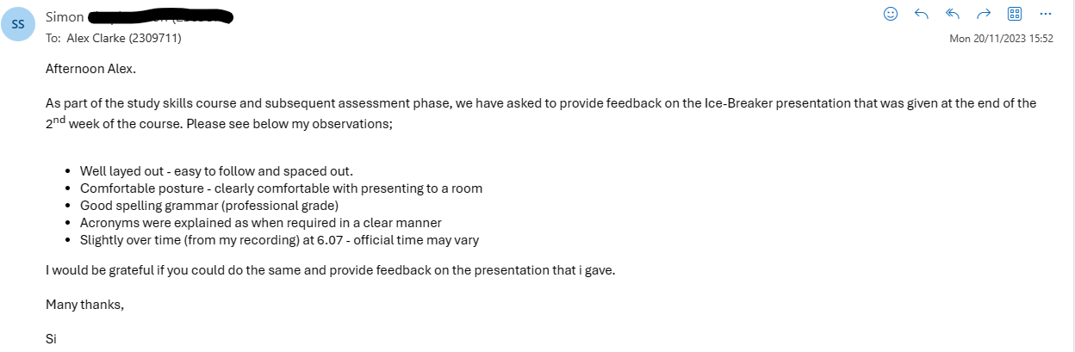

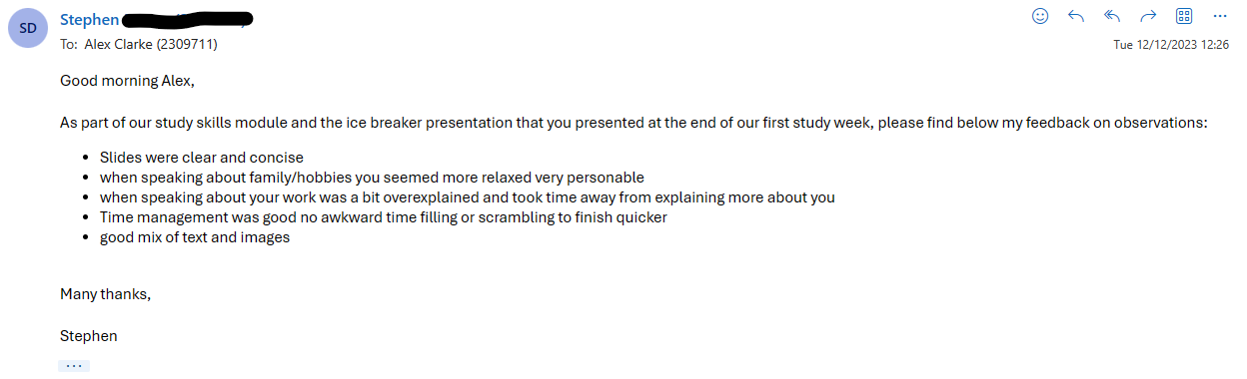

Appendix B – Learning style self-assessment results
This appendix documents screengrab results from learning style self-assessments conducted by the learner.
Robinson college assessment:
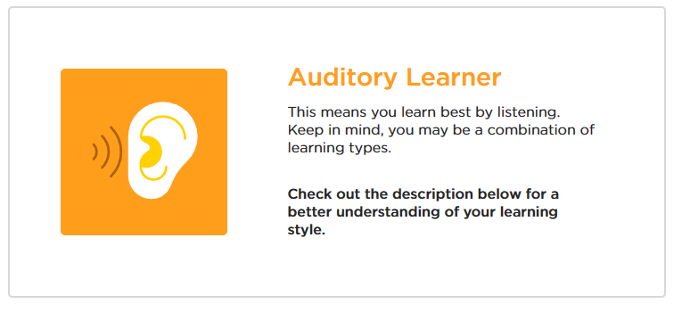
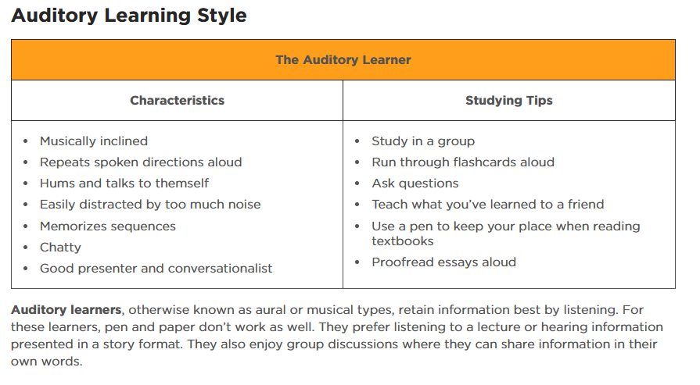
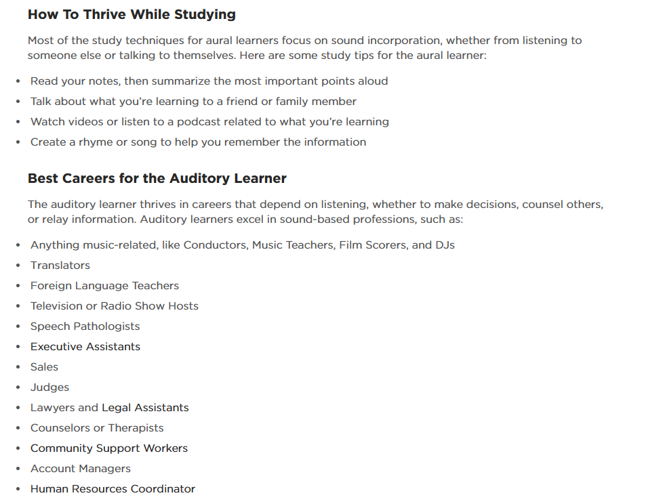

VARK-learn assessment:
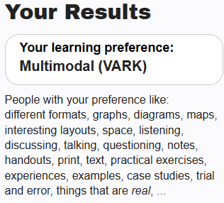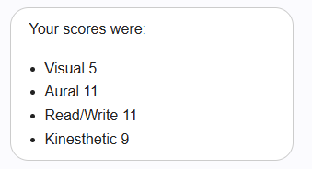

Appendix C – Personality self-assessment results
This appendix documents results from the personality assessment conducted by the learner using the “16 personalities” website.
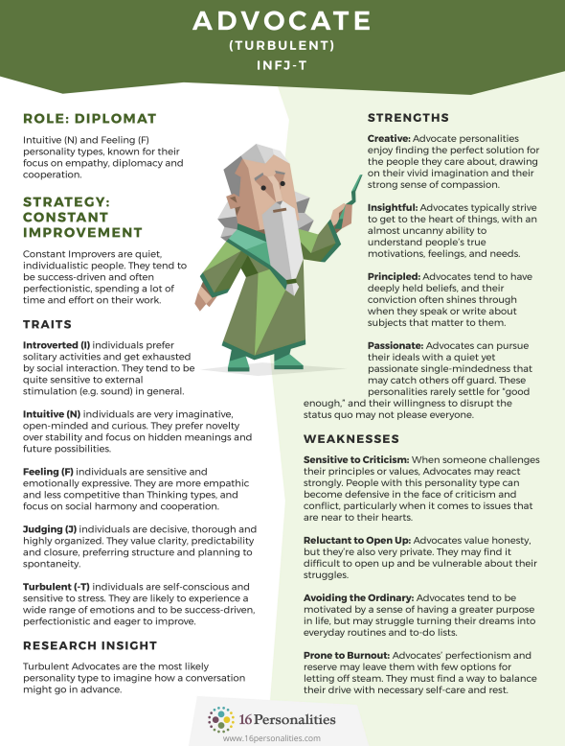

Appendix D – PDP and Action plans
Academic action plan
Objective | Task(s) | Success Criteria | Time frame
Complete Study skills module | - Attend lectures.  - Complete reflection on study skills portfolio assignment. | Pass mark or higher for study skills module. | Completion for January 10th, 2024.
Complete maths exams | - Attend lectures.  - Revision  - Sit exam in early January.  - Sit exam in May. | Pass mark or higher for math module. | Sit first exam 9th, January 2024.  Sit second exam May 2024.
Complete first year of OME HNC Apprenticeship. | - Attend lectures.  - Complete assignments  - Sit exams | Pass mark or higher for all modules in year one. | August 2024
Fully complete OME HNC Apprenticeship. | - Attend lectures.  - Complete assignments  - Sit exams.  - Complete apprenticeship assessment. | Complete HNC with a pass or higher mark. | August 2026
Personal action plan
Objective | Task | Success Criteria | Time frame
Finish garage conversion. | - Get electrics sorted.  - Get pluming sorted.  - Plaster walls.  - Decorate.  - Do flooring. | Garage conversion completed and ready to be used as an office/ mancave. | December 2024
Join the Institute of Explosive Engineers. | - Decide which level of membership to apply for.  - Get membership reference from colleague who already holds membership.  - Collate portfolio of evidence for application.  - Undertake interview. | Successfully gain membership with the institute of explosive engineers. | December 2024.
Professional Personal development plan
Below is a screen shot of the learner’s professional personal development plan for their current role as a technologist at AWE.


