

COVER PAGE

BMHP5015_BIRM – Changemakers: Building Your Personal Build for Sustainable
Component 2
Research proposal.

Student Name: Hassana Allaiouti
Student Number: 2323005
Lecturer Name: Raheela Shaikh

Content Page
Page 1: Cover Page
Page 2: Content Page
Page 3: Introduction and job advertisement
Page 4: Job role employability skills

Page 5: Job role employability skills and Evaluate my own skills

Page 6: Evaluate my own skills

Page 7: Action plan

Page 8: Action plan

Page 9: Action plan

Page 10: Building and marketing my professional identify

Page 11: Building a network and Conclusion

Introduction
The reason I want to apply for the role of Assistant Educational Psychologist, is because I wish to help children and young people overcome difficulties and support them in realizing their potential. Both personal and professional experiences have crystallized my desire to work in a role that can measurably and positively aid a child’s learning, wellbeing and development. Hence, this report will identify the skills required for the role of Assistant Educational Psychologist for Tameside Council, identify my own current strengths and weaknesses, and demonstrate a clear plan to develop new knowledge and gain new experiences in order to feel confident and prepared to apply for this position.

Job Advertisement
Below is a screenshot of the job posting of an assistant educational psychologist from Tameside Council that outlines the job description, responsibilities and personal skills needed are to apply.

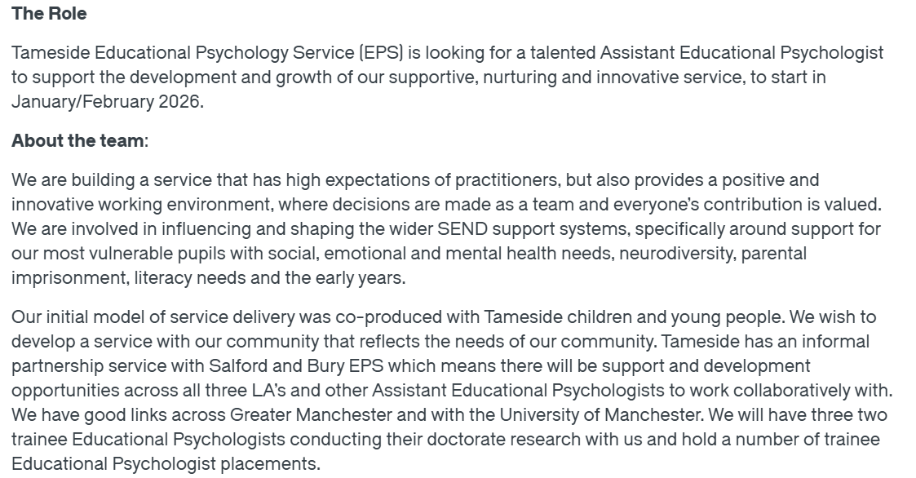
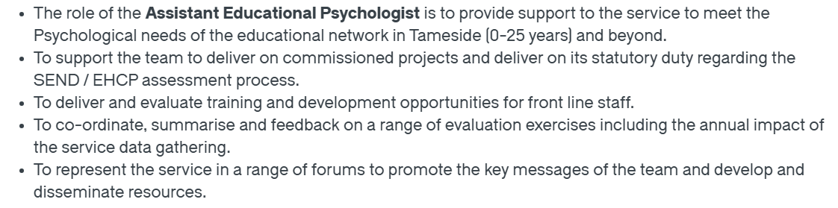
(Tameside Council, 2025)

Job Role Employability Skills

Applied Psychological Knowledge
Applying psychological knowledge is paramount to the role of a Tameside AEP as the ability to use psychology to promote positive outcomes, provision of support to assessments and in interventions provided under the supervision of an EP aligns with the position. Having a firm grounding in theory allows assistants to accurately interpret CYP behaviour, learning needs and developmental profiles that can lead to assessments being better informed and to the planning of interventions being evidence-based, thus improving CYP outcomes (Gaskell & Leadbetter, 2009; Kelly & Gray, 2000). Having a solid base of psychological and theoretical knowledge also promotes a consistent level of professional judgement and contributes to the likes of high-quality case formulation for example (BPS, 2019).

Organisational Skills
The job description explicitly states the organisational skills are required, describing the postholder must demonstrate “excellent organisational skills” and to coordinate project work and evaluation tasks. Good organisation enables the AEP role to juggle multiple assessments, intervention tasks, deadlines and school visits, ensuring tasks are completed efficiently and to a high quality. Good time-management practice not only assists individual AEPs but is a vital skill to support the wider EP service to provide timely impact for CYP across educational settings (Dunsmuir & Kratochwill, 2013).

Values Alignment
It is important to align with and work within Tameside EPS core values of Kindness, Curiosity, Connection, Authenticity, and Reflection, as these values support ethical practice and are mindful and responsive working with children, families and school staff. Kindness and a connection both allow trust and engagement, curiosity enables the openness of assessment, and support in skill and or, problem solving, authenticity empowers professional relationship and reflection is focused on continually reflecting on practice instrument to improve practice (HCPC, 2016; Cameron and Monsen, 2005). Moreover, modelling these values enhances the relational and supportive nature of EP within practice.

Collaboration
The job description clearly maps to collaboration, through expectation to work in a team and participating in multi disciplinary arrangements integral across Greater Manchester. Collaboration enables AEPs to team and partner with SENCOs, teachers, parents and other professionals to support collaborative problem solving. Multi-disciplinary working supports a wider range of assessments, which enables better outcomes for children with Special Educational Needs & Disability (SEND) (Farrell et al., 2006; DfE, 2015). Effective communication and team work can be integrated into EP assessment to ensure that the psychological understanding is understood and agreed in the modifications of recommendation.

Reflective Practice
Tameside EPS explicitly values reflective practice, the professional aspect of the role involves being comicatible with supervision and reflective practice. It is understood that reflection enables professional development, encourages self-awareness, and supports ethical practice. Through reflection, AEPs evaluate their own practice, develop their assessment and communication skills, and increase their professional confidence (Schon, 1983; BPS, 2018). By engaging in reflective practice, the AEP is furthering their professional development as well as the wider EP service.

Evaluate My Own Skills

Strengths
Reflecting on my present experience, values and developing skills, I can identify a few strengths that closely align with the role of Assistant Educational Psychologist (AEP) while identifying some areas for development.
A strengths of mine is academic development and study. As a second year student studying for my Bachelor of Health and Social Care, I am developing a sound basis of key areas including human development, safeguarding, professional practice and the broader social context for children and families. I believe that this educational course provides me with a sound account of understanding behaviour and the development needs of children, whilst recognising the importance of a evidence based approach to education and apply it to psychological thinking.
My part-time work as a receptionist has also improved my organisational skills. Dealing with bookings, responding to enquiries, balancing priorities, and record keeping has developed my time management and attention to detail. These are all skills that will translate to the AEP role, where managing appointments, resourcing, supporting projects and working with schools are part of everyday practice.
In addition, my last job as a carer demonstrates that I have sound relational and emotional skills. Supporting vulnerable people has taught me the importance of engagement with people with dignity, patience, empathic responses, and active listening. All of these skills are essential when working with children, young people, parents and professionals. I also have my own four children, which has meant gaining an understanding of children's different learning styles, behaviours and emotional needs, allowing me to think about child development and positive behaviour support through lived experience.

Areas for Improvement
I have several strengths and some areas for improvement that would make me a more competitive candidate for an AEP position. I think it would be useful to have more experience in educational contexts, whether that be volunteering in a school context, supporting the delivery of interventions, or working alongside SEND provision, or other experiences, to provide evidence of my applied practice. Additionally, becoming comfortable working with a range of psychological frameworks, valid assessments and procedures, and some entry-level research skills would support my readiness to engage in supervised practice with an Educational Psychology Service. Understanding how to collaborate within multi-agency arrangements, in addition to understanding at a minimum how safeguarding legislation and policy applies to schools, would also be vital points of development for me to see and experience as professional development.

Who can help?
In terms of pursuing any of this, I would likely reach out to university tutors to provide me insight, particularly those who's research interests were in the areas of child development and/or social care. I may also be able to consider experience bases in local schools, SEND teams or voluntary organisations, such as a young carers service. Careers Advisers could provide significant insight into what AEPs do in practice, as well as other possible opportunities for observational and shadowing experiences.

Action Plan
Short-Term (0-12 Months)
Focus: Experience foundational, increase self-confidence, improve organizational and interpersonal skills.
1. Get Experience in Education Settings
- Actions:
- Volunteer for a local primary/secondary school for one or two hours per week (e.g., classroom support, SEND support, reading interventions).
- Get in touch with their SENCOs to ask about shadow opportunities.
- Reason: Experience working with children in practice builds experience, reinforces the learning and children with SEND emphasis.
- 2. Develop Psychological / SEND Knowledge
- Actions:
- Take short online courses (e.g., trauma-informed practice, autism awareness, safeguarding, behaviour support).
- Go to university workshops on child development or SEND learning.
Reason: Increases theoretical understanding relevant to AEP work.
3. Develop Trust in Working With Others and Communication
• Actions:
• Look for opportunities in your receptionist role to take the lead on smaller tasks (e.g., more independent scheduling, assisting with customer questions, etc.).
• Practice reflective writing after difficult and challenging interactions.
Reason: Increases professional communication, teamwork, and reflection.

Mid-Range (1-2 years)
Focus: Continue practical experience, employ research development, engage in reflective practice.
• 1. Work or Volunteer in a Related Support Role
• Actions: You can apply for a few hours a week in part-time roles positions like Teaching Assistant, Learning Support Assistant, SEND support worker or as a family support volunteer.
Reason: This is practical experience working with children and learning about how schools operate.
2. Develop Research and Evaluation Skills
- Actions:
- Complete university modules involving research methods and psychology-related theory.
- Support small projects in schools (e.g., evaluating a reading programme or behaviour strategy).
- Reason: EP services value data-informed, evidence-based practice.
3. Improve Professional Values and Reflective Practice
• Actions: Keep a weekly reflective diary regarding your experiences with children and families.
• Ask for feedback on your communication and kindness model from a supervisor, teacher or manager.
• Reason: Reflection is key to Educational Psychology practise.

Long Term (3-5 years)
Focus: Prepare for AEP roles and future training courses.
1. Apply for Assistant Educational Psychologist Posts
• Actions: Prepare a professional CV summarizing your extremely well, hands-on, experience and kindness, organization, and abilities in academic and other progress
• Contact your local Educational Psychology Services to find out whether they have vacancies or opportunities for you to shadow or participate in project work.
• Reason: At this point you will have the experience and understanding you need to apply.

2. Enhance Understanding in Psychological Assessment and Intervention
• Actions: Engage in higher-end training of specific curriculums focused on emotional literacy interventions, cognitive development, and, if possible, anxiety interventions.
• Reason: This will enhance preparedness for your future own work or supervised work, with Educational Psychologists.

3. Consider Future Qualifications
• Actions: To the extent this is something of interest to you: prepare for further training (e.g., a conversion MSc in Psychology to satisfy admission criteria for the EP doctorate)
• Reasons: Preparation for, and continued professional development, will assist successful progression into the future.

Building and Marketing My Professional Identity
Building and marketing your professional identity will be crucial as I work towards applying for an Assistant Educational Psychologist position. There are several practical tools I can use to develop this.
An excellent first indication of marketing my professional identity could be to create an ASP. This would involve creating a LinkedIn profile, where I can highlight my relevant experience, academic achievements, and values-based approach to working with children and families. As I begin to share my reflections of my learning, engage with posts made by Educational Psychologists and join professional groups, I can show I am curious, committed, and developing expertise. Once I have a profile, a good move would be to informally update it with voluntary roles, roles or training I have attended, and reflections based on educating for my degree to show a developing professional journey.

Networking events - either university-led, a local authority training session, SEND, or conference, or a webinar will allow me an opportunity to meet, question, and learn from practitioners about current issues within Educational Psychology. These opportunities help me to gain confidence, become visible, and feel aligned to a network or professional community.
Professional use of social media, such as following organisations like the BPS, local EP services, and SEND charities will also enhance my professional identity. I will keep informed of areas of Educational Psychology that are most relevant and engage thoughtfully with opinions and discussions demonstrate my passion and engagement.

Finally, I can enhance my professional identity by ensuring a tailored CV and cover letter for every application. By ensuring I highlight experiences I have had, strengths I possess, and values that resonate with each role – this complements my value base, as noted above. In doing so, I will be able to present a background in health and social care, experience of working with vulnerable individuals, and my growing understanding of child development whilst constructing my CV and application letter. Overall, I would like to present as reflective, committed, and aligned in ethos to an Educational Psychology service.

Building a Network
Connecting with potential mentors is another dynamic approach to enhance and cultivate my professional identity. Relationships with experienced practitioners - for example, Educational Psychologists, SENCOs, or university lecturers - offer perspectives and experiences that are valuable in terms of guidance, reflection, and career insights that cannot be offered in a book or journal. Mentors can provide personalized feedback, assist me in identifying areas for growth, and help me to set realistic goals. Events like local authority SEND briefings, psychology career workshops, BPS branch events, or university research seminars all provide the opportunity to meet with these professionals face to face. In these situations I've been able to have really valuable conversations, ask questions related to the AEP role, and relieve my anxieties around working in this space. In addition to establishing these relationships incurring confidence but is an increased presence in a professional community. This leads to further dialogues about shadowing, volunteer opportunities or job leads.

Conclusion
This report has described the essential components of the Assistant Educational Psychologist (AEP) position at Tameside Council, such as applied psychological knowledge, strong organisation, reflective practice, partnership working and scope for the core professional values. Through self-reflection exercises, I identified elements of my practice that link closely to these expectations. My Health and Social Care degree is giving me a solid understanding of child development and safeguarding, while my experience as a receptionist has developed strong organisational and communication skills. My experience as a carer and parent has enhanced my patience, empathy and capacity to work with vulnerable populations - all important elements of Educational Psychology practice.
I also identified areas to develop, such as experience in schools, improving my understanding of psychology approaches and improving my research skills. A five-year plan consider various realistic objectives to meet these goals, and a professional identity through networking and a skills, strategies and experience based education. Overall, I am highly committed, and supervised, to pursue the AEP role wth the utmost professionalism and care for children and families.

Reference List:
BPS (2018) Standards for the accreditation of educational psychology training programmes. Leicester: British Psychological Society.
Cameron, R.J. and Monsen, J.J. (2005) ‘Quality professional support: ABCDE—A model of professional support for educational psychologists’, Educational Psychology in Practice, 21(4), pp. 311–326.
DfE (2015) Special educational needs and disability code of practice: 0 to 25 years. London: Department for Education.
Dunsmuir, S. and Kratochwill, T.R. (2013) International handbook of evidence-based practice in school psychology. New York: Springer.
Farrell, P., Woods, K., Lewis, S., Rooney, S., Squires, G. and O’Connor, M. (2006) A review of the functions and contribution of educational psychologists in England and Wales in light of “Every Child Matters”. London: Department for Education and Skills.
Gaskell, S. and Leadbetter, J. (2009) ‘Educational psychologists and multi-agency working: Exploring professional identity’, Educational Psychology in Practice, 25(4), pp. 349–364.
HCPC (2016) Standards of conduct, performance and ethics. London: Health and Care Professions Council.
Kelly, B. and Gray, C. (2000) ‘Educational psychology services in Northern Ireland: Perceptions of effectiveness’, Educational Psychology in Practice, 16(4), pp. 415–423.
Schön, D.A. (1983) The reflective practitioner: How professionals think in action. New York: Basic Books.
Tameside Council (2025) Assistant Educational Psychologist – Educational Psychologist jobs, Glassdoor. Available at: https://www.glassdoor.co.uk/Job/united-kingdom-educational-psychologist-jobs-SRCH_IL.0,14_IN2_KO15,39.htm (Accessed: 20 November 2025).

