NN

Name: Rabia Khatun
Student ID: 1915747
Module: Introduction to Physiology
Module Code: BMHP5003_BIRM
Lecturer: Mumtaz Goolam
Assignment Tile: Task 1- Part 1- Individual Academic Poster

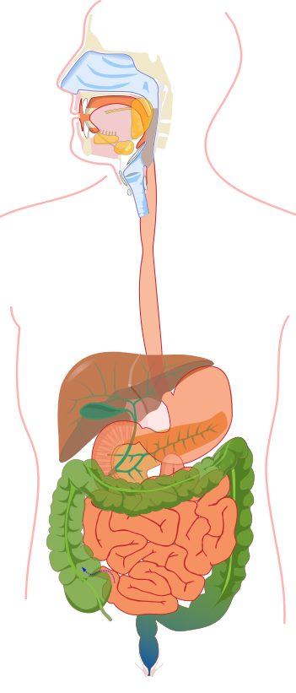
Gallbladder
The gallbladder is a small organ. It looks like a pouch. It is in the upper right part of the tummy, and it stores bile, a fluid produced by the liver that helps break fatty food.

Large Intestine
It absorbs water and salts from various materials that the body has not digested. It removes any waste products left over. The waste products in your large intestine spend approximately 36 hours. This function is responsible for processing waste so emptying the bowels is easy.

Pancreas
The pancreas creates various enzymes. They crush sugars, fats and starch. They also regularly create hormones that send chemical messages through the blood. The main function is that the endocrine function regulates blood sugar levels.

Liver
The liver processes the nutrients that were absorbed by the small intestine from the food. The liver is also in charge of producing bile which is a substance that helps the body absorb fat into the bloodstream.

Salivary Gland
The salivary gland produces saliva and saliva helps to moisten the food and aids digestion by allowing us to swallow food easily.

Mouth The mouth is where digestion starts. Food is broken down into small pieces to make digestion easier and this is mixed with saliva to break it down further into a form that your body can absorb easily.

The Digestive System
Anus
It is the opening where the gastrointestinal tract ends and exits the body. It starts at the bottom of the rectum, the last portion of the colon. The fascia (a tough tissue) surrounds the anus and attaches it to nearby structures.

Small Intestine
It supports the duodenum, jejunum and ileum. It helps to further digest food that has travelled from the stomach. It absorbs nutrients such as minerals, carbs, fats and proteins. It turns mixed digestive food into chyme and moves the food along to the colon. It absorbs 90% of water that you digest meaning it is the main part where the all the digestion takes place.

Oesophagus
The oesophagus acts as a tube and delivers the chewed food from the pharynx into the stomach.

Stomach
The stomach holds the food
inside it, it is mixed with enzymes which helps break down the food further.

The digestive system breaks down and absorbs nutrients from the food and liquid a person consumes throughout the day. It enables the body to consume more energy, develop its growth and repair cells. The system ingests and digests food and then releases the absorbed nutrients. Then finally excretes the food components that are not digestible. 6 steps are involved during this process ingestion, motility, mechanical digestion, chemical digestion, absorption and defecation. (Waugh et. Al, 2004)

(Mayo Foundation, 2021).

Appendix
It is a narrow, finger-shaped, tube-like pouch that extends out from the colon. It facilitates the movement and removal of digestive waste. It lies in the lower right of the abdomen.

Rectum
It is a chamber that begins at the end of the large intestine, following the sigmoid colon, and ends at the anus. It is the suction of the digestive tract above the anus where stool is held before it passes out.

Reference: Waugh et al (2004) and Robinson (2020).

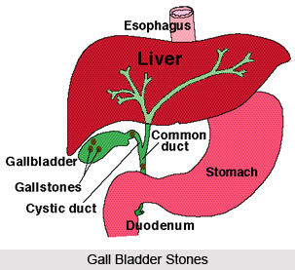
Who is at risk?
- People who are overweight
- Diabetic people
- Age 60 and over
- Taking medication which contains estrogen
- Having a family history of gallstones
- Being a female
- Having crohn’s disease
- Disease that affects how food is
- Absorbed
- Having liver disease (Mark, 2018).

Gallstones
Gallstones can occur when there is substances in the bile. For example, cholesterol, bile salts and calcium. These substances block the passageway to the gallbladder.
It is most likely to occur when the gallbladder does not empty completely or often enough (Mohammed, 2018).
What problems can you have with your gallbladder?
- Gallstones blocking the tube leading out of your gallbladder cause cholecystitis.
- Bile build up can cause inflammation
- Tumours
- Serious illness
- Infections (Robinson, 2020).

What is the Gallbladder?
It is a small pouch like organ. It is situated in the upper right part of the tummy. A fluid called bile which is produced by the liver helps break down fatty food. We can survive without a gallbladder and some people may need to have it removed if they develop a problem with it (Waugh, 2004).
Gallbladder Disease
(Hoffman. 2020)
Signs you may have gallstones
- Intense tummy pain (in the centre or under the ribs on your right-hand side
- Jaundice (yellow skin or eyes)
- A high temperature
- A loss in appetite (NHS, 2018)

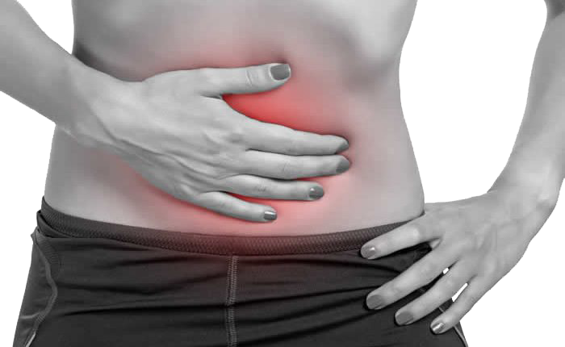
Recommendations
- Avoid gallstones by:
- Having a low-fat diet
- Eat plenty of greens and fruits
- Avoid eating food fried in oil
- Drink plenty of water
- Lose weight
- Avoid low-calorie, rapid weight loss diet
- Exercise regularly (NHS, 2018)
- If you have gallstones
- Seek medical advice
- Take painkillers to manage pain
- Eat a healthy diet
- Monitor your symptoms
- Create a care plan with your health professional (NIH, 2021).

(Hoffman, 2020)
REFERENCES
Hoffman, M (2021) Picture of Gallbladder, Human Anatomy. Available at: https://www.webmd.com/digestive-disorder/picture-of-thegallbladder
Mark. H (2018) Gallbladder Disease- who is at Risk. Available at: Gallbladder Problems — Are You at Risk? | Everyday Health Accessed on: 19th October 2021
Mohamed, A (2018) Gallbladder Disease. Available at: https://www.healthline.com/health/gallbladder-disease Accessed on 17th October 2021.
Mayo Foundation, (2021) Available at: https://www.mayoclinic.org/digestive-systemsls-20076373 Accessed on 27th October 2021.
NHS (2018) Prevention Gallstones. Available at: https://www.nhs.uk/conditions/gallstones/prevention/ Accessed on 16th October 2021
NHS (2018) Symptoms Gallstones, Available at: https://www.nhs.uk/conditions/gallstones/symptoms/ Accessed on 17th October 2021
NIH (2021) National Institute of Diabetes. Available at: Symptoms & Causes of Gallstones | NIDDK (nih.gov) Accessed on: 18^{th October 2021}
Waugh, A. & Grant, A. (2004) Ross and Wilson Anatomy and Physiology in Health and Illness (9th Edition). Churchill Livingstone.
Robinson, J (2020) Your Digestive System. Available at: Digestive System (Anatomy): How It Works (webmd.com) Accessed on: 19th October 2021

