Student: Oksana Mrsic (2131895)
Lecturer: Xavier Matieni



UNIVERSITY OF WALES
Trinity St. David

BA (Hons) Leadership and Management Skills for the Workplace

Strategic Management for SMEs
BMSW6104

Table of Contents
Strategic Development and Implementation for SMEs 2
Current Strategic Direction 3
Vision 3
Mission 3
Values and Ethical Considerations 4
Goals and Objectives 4
Core Values 5
Strategic Positioning 5
Critical Analysis of Lucocoa Chocolate 6
PESTEL Analysis 6
VRIO Analysis 8
SWOT Analysis 11
Supply chain vulnerabilities due to climate change 14
Strategic Growth Choices and Proposed Strategy for Lucocoa Chocolate 15
Strategic Growth Models Analysis for Lucocoa Chocolate 15
Proposed Strategy: 19
Implementation Roadmap for Ethical Innovation Expansion 20
Stakeholder Analysis and Strategic Options 23
Key Strategic Recommendations 23
Conclusion 24
References 25

Strategic Development and Implementation for SMEs

Lucocoa Chocolate exhibits the typical characteristics of many small businesses that attract the little candy market because of their creativity and hand-making nature. Therefore, due to the founder’s passion for making delicious chocolate without compromise (Berkay et al., 2023), Lucocoa has positioned itself within a market niche involving flavourful combinations and sustainability. Lately, there has been a growing number of specialised Luccocoa chocolates aiming to satisfy the demanding customers who seek perfect products that have not caused any negative impact on the environment. This is happening in an industry where massive multinational companies formerly dominated (Eravia, Handayani, and Julina,2018). Noted that dealing with new conditions is challenging for SMEs such as Lucocoa, as there are advantages and threats. It needs to add value to its products and services, ensure it meets the highest quality standards, and work out how to organise through complex supply webs. Among them are customer preferences, environmental issues, and new technologies, which are crucial for small and medium-sized businesses (SMBs) in the food and drink industry. All these forces act as stimuli, transforming how businesses operate and the market functions (Neklyudova, 2022). Lucocoa’s positioning and the company's steps demonstrate that small businesses must be fluid, distinctive, and tangible in a field that heavily emphasises creativity and individuality. This research will also focus on Lucocoa Chocolate’s growth prospects, competitive direction, and challenges to understand the probabilities and risks facing SMEs in the contemporary global business world (Whittington et al., 2020).
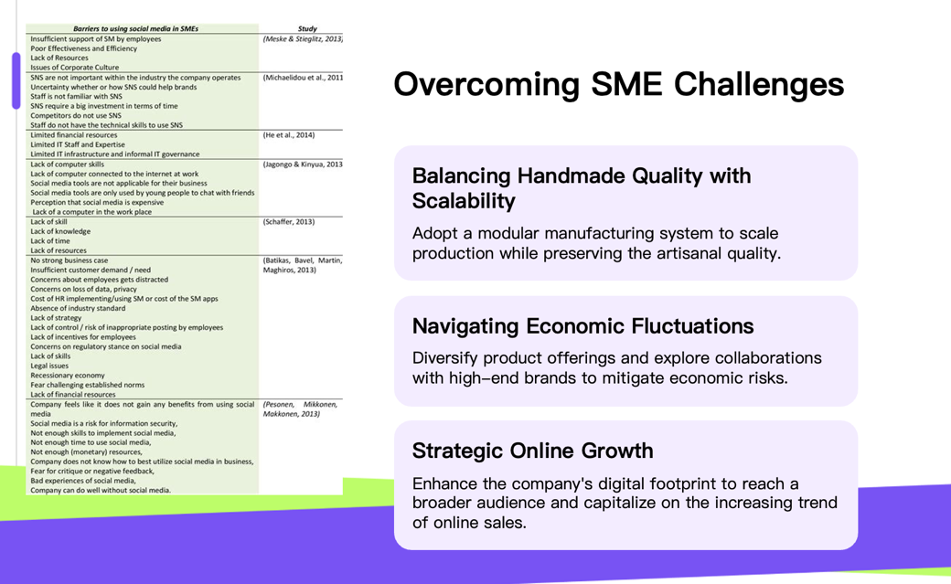

Current Strategic Direction

Vision

The vision of Lucocoa Chocolate is to establish its position as an artisanal luxury chocolate brand synonymous with unique flavours, environmental concerns, and superior quality (Perez et al., 2020). With this outlook in mind, customers are now hungry for good candy made correctly. This issue is shared by many small businesses, which struggle to popularise Lucocoa and get the product in as many people’s hands as possible. This is an excellent goal to work for. Still, the company might not be ready to achieve it with the available resources today, hence competing against more prominent and established firms (Lynch, 2018).

Mission

The company aims to support farmers who grow cocoa, encourage fair buying, and create fantastic chocolate experiences. This goal statement successfully combines the company's core competencies with its viewpoint on ethics, which could appeal to customers who care about ethics (Bello-Bravo et al., 2022). The mission's scope might make it hard for a smaller group with fewer resources to focus and utilise resources well (Spence, 2021). Lucocoa can stand out in the chocolate market, which is already very crowded, by focusing on its unique selling points (USPs), such as its creative flavour mixtures or commitment to using eco-friendly methods.
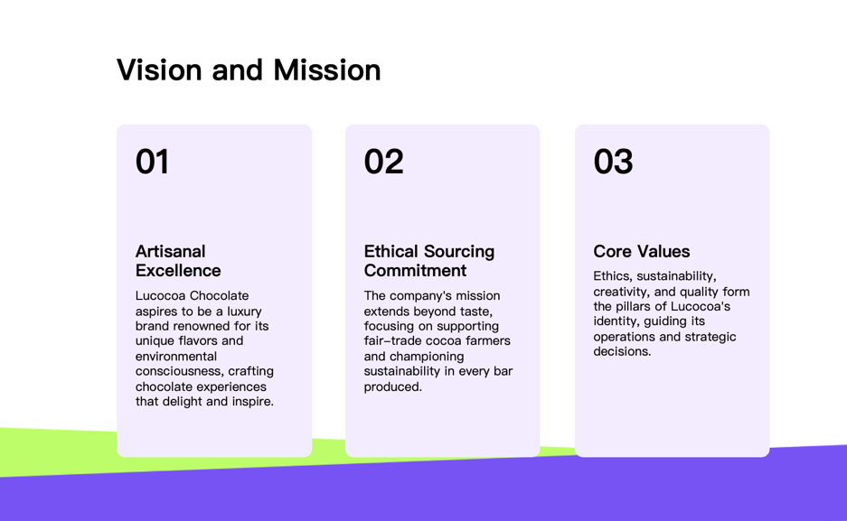

Values and Ethical Considerations

Commitment to ethics, environment, creativity, and quality drives Lucocoa Chocolate. Businesses must be open and answerable to their customers in this market (Perez et al., 2020). For environmentally conscious customers, Lucocoa is a good choice because the company is dedicated to using sustainable methods and ethically providing products. Despite these high social standards, competing with more extensive, cheaper businesses is still complex. The company must find a way to match its ongoing commitment to quality and ecology with its desire to grow and make money. For this tricky balancing act, you need to do much strategic planning because if you do not, you might cost more and reach fewer customers.
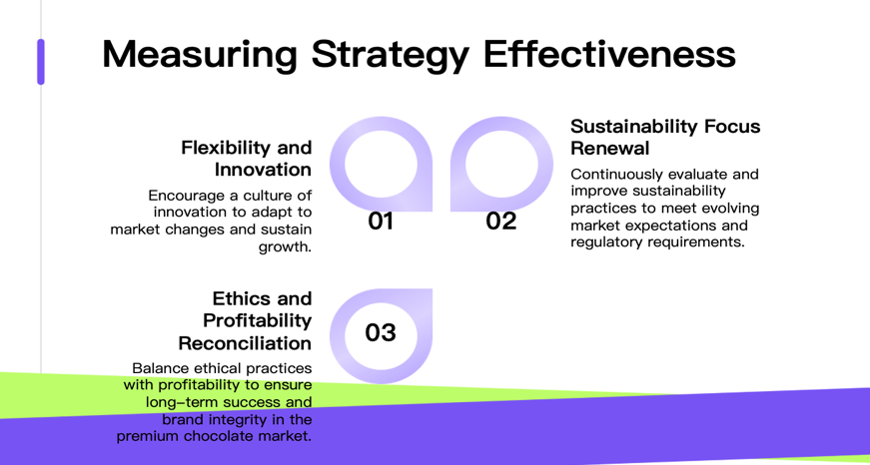

Goals and Objectives

As part of its long-term plan, Lucocoa Chocolate wants to become more well-known in the handmade chocolate business, offer more products, and make more people aware of its brand. These goals help the company reach its long-term goal of becoming the best place to get handmade chocolate. It might be necessary to change the goals, so they are more transparent and more accessible to measure to make sure the plan works. More specific goals, like getting a particular part of the market in certain countries or releasing a certain number of new product lines within a certain amount of time, would be suitable for Lucocoa. For a small or medium-sized business (SME) that wants to grow in a competitive market, scalability and operating efficiency are two of the most important goals. To keep up with demand, Lucocoa might have to find a way to make more products without changing the way they are made by hand. Finding this balance is essential to grow your business and maintain the quality of your products and your brand's reputation.

Core Values

Lucocoa Chocolate's goods and how they run their business show what their company stands for. Some of these ideas are quality, creativity, ecology, and honestly getting materials. The company's dedication to creating new flavour mixes shows that they value imagination and new ideas in traditional chocolate making (Perez et al., 2020). This creative mindset drives the creation of new products and the finding of new market opportunities. This, in turn, promotes a culture of trying new things and constantly getting better across the whole company. Because Lucocoa cares about being socially and environmentally responsible, it only uses sustainable methods and gets its products from fair trade suppliers (Barney and Hesterly, 2019).

Lucocoa Chocolate's focus on strategy points to several critical areas where they want to focus. One of their main goals is to get a more significant piece of the expensive chocolate market in the UK and elsewhere. To reach this growth goal, they must increase production while keeping the unique quality of hand-made items that make their business stand out. Another possible goal is to improve their relationships with sellers. This will ensure a steady supply of high-quality cocoa beans and other parts that are gathered ethically (Perez et al., 2020). They must reach this goal to keep their promises of environmental and product quality. Lucocoa might wish to expand its product line by adding new shapes or taste combinations to get a more significant share of the handmade chocolate market. Another goal could be making them seem more expensive and appealing on the shelf by using new packing and presentation ideas.

Strategic Positioning

Lucocoa Chocolate is in a good spot in the market because it focuses on making high-quality, hand-crafted goods with exciting stories about ethics and the environment. The company's stance is different from that of mass-market chocolate makers, showing that customers want high-quality foods made in a way that does not harm the environment. Lucocoa draws people willing to take risks and try new things by focusing on odd taste pairings. This strategy can boost sales and brand trust (Spence, 2021). Their commitment to ethical sources and sustainable practices makes them more appealing to customers who care about the environment and lowers supply chain risks in the chocolate business. Lucocoa can fight on things other than price because it does not have to go up against more prominent, better-known names.
The company may need help to reach a large audience or grow because of its narrow focus, which also presents some problems. In the market for handmade chocolate, Lucocoa might have to keep coming up with new ideas to stay ahead of the rest of the pack. When times are bad, people may spend less on nice things, which could hurt the business's bottom line because of their premium setting (Perez et al., 2020). To improve Lucocoa's strategic position, you could team up with other high-end brands that share your values, enter new markets like high-end hospitality, or use your ethics reputation to enter the business-giving market (Odhiambo & Wanjira, 2019). To keep the brand identity that supports its current image, it will have to find a balance between its growth goals and its handmade quality values.

Critical Analysis of Lucocoa Chocolate

PESTEL Analysis
Political | Economic | Social
Given the current political climate, Lucocoa Chocolate is faced with several obstacles as well as possibilities. There are now uncertainties in trade rules and possible tariffs because of Brexit, which might make it more difficult for Lucocoa to manage its supply chain and take advantage of export prospects. When the firm grows into European markets or sources ingredients, this may result in a rise in expenditures as well as administrative responsibilities for the company. | The political and economic factors are considered key determinants that affect the activities of Lucocoa Chocolate and its location in the market. These factors influence the cost of producing cocoa in the global market, affecting the revenues of the firm. Subsequently, the firm has the propensity to cut down on its profit margins if it can be better managed throughout the whole process. The volatility of currency exchange rates, especially after Brexit, contributes a significant risk to Lucocoa, especially when dealing with overseas suppliers or when there are envisaged expansion plans to export its products. | Social factors are also aligned well with Lucocoa Chocolate's business model. More and more people are becoming health-conscious, and when it comes to chocolates, consumers go for dark, organic, and ethically sourced chocolates, which perfectly fit Lucocoa. This trend can help the company to market its products as premium and low-impact products for consumers’ health.
Technological  Technological developments are both prospects and threats for Lucocoa Chocolate. Thanks to modern technologies, such as e-commerce and the possibilities of internet advertisement, even ‘niche’ brands, like Lucocoa, can gain a significant number of customers cheaply, while the need to deliver products from Manchester to the edges of the country can become a significant problem. Social media and content marketing are the most vital tactics suited for storytelling and brand development in accordance with Lucocoa's artisanal image. | Environmental  Environmental factors are particularly relevant and potentially advantageous for Lucocoa Chocolate. Growing consumer awareness of sustainability issues in cocoa farming benefits Lucocoa's ethical stance and sustainable practices (Odhiambo & Wanjira, 2019). This increased consciousness creates an opportunity for Lucocoa to differentiate itself through its commitment to environmentally friendly production methods and responsible sourcing. | Legal  When it comes to Lucocoa Chocolate, the legal environment provides a few different issues. Compliance with standards governing food safety is of the utmost importance, and continuous attention must be paid to manufacturing processes and the source of ingredients. It is essential that the labeling standards, especially those pertaining to allergy information and nutritional value, be adhered to rigorously in order to prevent any potential legal complications and to preserve the faith of consumers. Because of the possibility that changes in import/export restrictions might impact Lucocoa's capacity to obtain ingredients or grow into new markets after Brexit, the company must keep a close eye on the developments in regulatory policies.

VRIO Analysis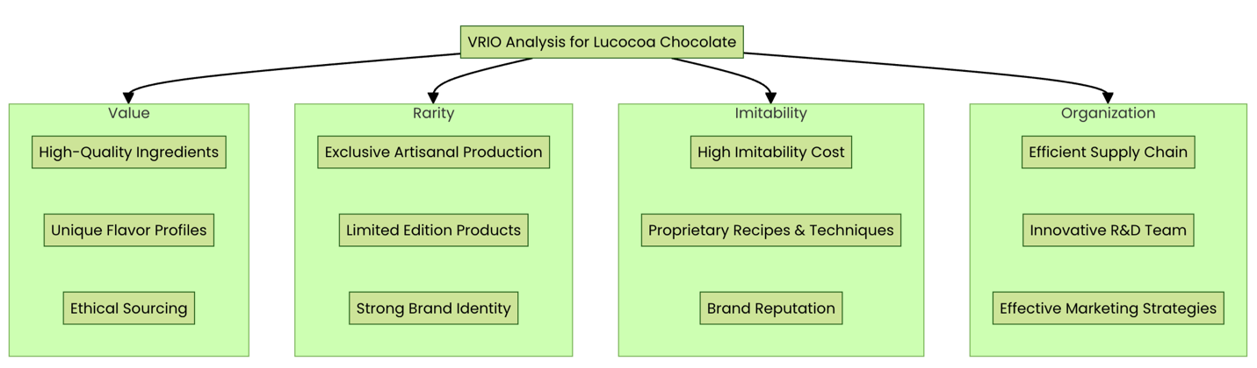

VRIO Component | Lucocoa's 'Chocolate' Assets
VALUE  The value added by Lucocoa’s products is that they do not simply appeal to the typical dark chocolate standards, but they are far more exotic and sophisticated, as the combinations of ingredients are much more elaborate. These new combinations cater to the high-end taste of chocolate enthusiasts in the same way a touch of a specific type of spice compliments a bar of chocolate. Ethical sourcing also offers the company one more value proposition, given that today’s consumers increasingly consider the ethicality of the products they consume (Odhiambo & Wanjira, 2019). This commitment to quality and ethics is as simple as using the finest cocoa beans – it could be costly in terms of production, but it earns respect, brand loyalty, and, predominantly, a premium price. | Rare  Lucocoa's bean-to-bar expertise is akin to crafting a small-batch, single-origin chocolate - increasingly sought after but only readily available from some manufacturers. While artisanal chocolate makers are growing in number, Lucocoa's specific combination of ethical sourcing, innovative flavors, and sustainable practices remains relatively uncommon. This rarity is like finding a limited-edition chocolate bar, attracting consumers looking for something beyond the ordinary. | Inimitable  Lucocoa's production techniques and unique recipes are like a closely guarded secret formula - complex for competitors to replicate quickly or easily (Odhiambo & Wanjira, 2019). The specific combination of ingredients, processing methods, and flavor profiles that create Lucocoa's distinctive taste is the result of extensive experimentation and expertise. This is comparable to the skill of a master chocolatier, developed over years of practice. | ORGANISED  The organizational structure of Lucocoa is analogous to a chocolate mold that has been constructed with great precision in order to bring out the finest in the chocolate. Because of its small size and artisanal emphasis, the firm is able to be agile in terms of product development and market reactivity. This is analogous to a chocolatier who is able to swiftly modify their creations to seasonal inspirations or feedback from customers. With the help of this organizational agility, Lucocoa is able to harness its resources fully, which are very precious, uncommon, and equal. The organization is able to adapt to new taste trends swiftly, react to changes in ethical sourcing regulations, or tweak manufacturing to satisfy the unique wants of individual customers.
Impact on Competitive Advantage
Provides competitive parity | Offers temporary competitive advantage | Sustains competitive advantage | Enables full exploitation of resources

SWOT Analysis

Strengths
Quality commitment and innovative flavours
Among Lucocoa's many strengths are the company's commitment to making premium chocolate with unique taste profiles. This dedication helps the business stand out in a competitive industry and appeal to customers with high standards looking for unique flavours (Augusto & Bolini, 2022). Because of its dedication to quality, Lucocoa can charge more, following the premiumisation trend in the chocolate market. Also, new tastes get people talking, increasing sales and positive word of mouth.
Ethical sourcing practices
Customers who care about a company's ethics will love Lucocoa's commitment to fair sourcing. This method is in line with the increasing demand from consumers for honesty and environmental responsibility in the food industry, and it also guarantees a high-quality result (Odhiambo & Wanjira, 2019). Ethical sourcing may be a strong differentiator in attracting clients ready to spend more on items that reflect their beliefs. More reliable quality and supply chain resilience may result from these methods' added benefit of fostering long-term partnerships with vendors.
Agility in market response
Being a small-scale manufacturer allows Lucocoa to react quickly to changes in the market and customer tastes. Because of this adaptability, the corporation may swiftly change its product lineup, packaging, or marketing approaches to take advantage of new possibilities or satisfy shifting customer preferences (Neklyudova, 2022). Changing directions quickly gives you a leg up on more significant, bureaucratic competition. Because of its skill, Lucocoa may also try out seasonal or limited-edition items, generating excitement and urgency among its customers.
Weaknesses
Limited production capacity
The restricted manufacturing capacity from Lucocoa's small-scale activities means that the firm needs help keeping up with demand spikes or seizing expansion possibilities. Because of this restriction, Lucocoa may have to decline big orders or find it difficult to enter new markets (Madar, 2020). The inability to take advantage of economies of scale due to limited capacity might cause the company's per-unit expenses to rise. For a small firm to overcome this limitation, investing significantly in manufacturing facilities and equipment may take a lot of work.
Higher operational costs
Lucocoa, being an artisanal, small-scale manufacturer, probably has to pay more to run than its more significant, industrialised rivals. Reasons for these inflated prices include using high-quality ingredients, labour-intensive manufacturing processes, and smaller batch sizes. Profit margins might be impacted, and price competition with mass-market brands will become more complex as expenses rise (Madar, 2020). To be competitive and financially sustainable in the long run, Lucocoa must meticulously control its costs, even if the premium positioning of the firm may partially justify higher pricing.
Opportunities
Growing premium chocolate market
Lucocoa has a great chance to capitalise on the growing demand for premium and artisanal chocolate. There is an excellent fit between Lucocoa's goods and the consumer desire to pay a premium for premium, one-of-a-kind chocolate. Thanks to this trend, the corporation might establish itself as a premium brand, which could lead to a rise in its market share. Lucocoa may use this opportunity to sell its high-quality ingredients, unique tastes, and artisanal manufacturing techniques.
Increased online sales potential
The increase in online shopping allows Lucocoa to cover a broader audience while sacrificing nothing. In this way, online sales might help surmount some of the company’s market reach limitations derived from expanding its d-to-c sales beyond its regional geography. Other opportunities for e-commerce to tell stories and build brands include appealing and intriguing website content and social media. Online sales can be made more accessible by creating a user-friendly online shop and using digital marketing platforms. While this might be the case, Lucocoa can benefit from this opportunity by developing partnerships with online speciality food stores.

Threats
Intense competition from established brands and other artisanal producers
The market competition in chocolate is high, which is one of the significant challenges that Luccocoa is bound to face. The problem is that the key players have tons of capital to invest in advertising, introducing new products, and distribution; hence, it is hard for start-ups to penetrate the market. In addition, because of the increasing artisanal cocoa chocolate market, Lucocoa competes with many more competitors in its niche market as it finds small-scale manufacturers attracted (Berkay et al., 2023). To reduce the effect of this risk for Lucocoa, the firm must make sure it produces new products and services more frequently than the competitors while making the value offer very clear.

Supply chain vulnerabilities due to climate change
Some of the risks that threaten cocoa production due to climate change are supply shocks and the rise of the cost of production for Lucocoa. The actual quality of crops such as cocoa may be affected by events such as floods, droughts, changes in precipitation regime, and elevated temperatures where cocoa is produced (Bello-Bravo et al., 2022). This could be a problem for Lucocoa since maintaining a constant quality and price of its products on the market can sometimes be a struggle, mainly if some of these variables result in supply constraints and unpredictable price fluctuations. These misfortunes might threaten Lucocoa’s regular supply of cassava; however, the latter can minimise it by diversifying the list of suppliers, investing in climate-friendly farming practices, and developing contingency plans in case of supply disruptions.

Strategic Growth Choices and Proposed Strategy for Lucocoa Chocolate
Various strategic models show that SMEs like Lucocoa Chocolate have many possibilities for strategic development. According to Porter's generic strategies, you should aim for cost leadership, specialised markets, or distinctiveness (Ali & Anwar, 2021). The development of products, expansion into new markets, diversification, and market penetration are the four pillars on which the Ansoff Matrix rests. Bowman's Strategic Clock provides a variety of choices that strike a balance between the perceived value of a product and its price (Bello-Bravo et al., 2022). Strategies including product and market development (Ansoff), high perceived value (Bowman), and differentiation and targeted differentiation (Porter) are likely to be the most appropriate for Lucocoa. They align with Lucocoa's values of honesty, creativity, and excellence.

Strategic Growth Models Analysis for Lucocoa Chocolate

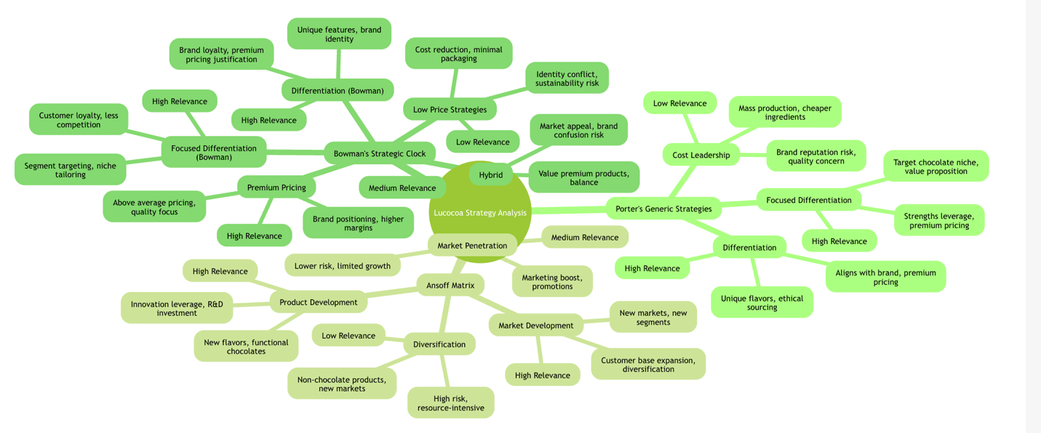

Strategy Models | Option | Relevance | Potential Implementation | Impact on Lucocoa
Porter's Generic Strategies | Differentiation | High | - Unique flavor combinations  - Ethical sourcing practices  - Artisanal production methods | - Aligns with brand identity  - Justifies premium pricing  - Requires continuous innovation
 | Cost Leadership | Low | - Mass production techniques  - Cheaper ingredients  - Streamlined operations | - Conflicts with artisanal approach  - Risk to product quality  - Damages brand reputation
 | Focused Differentiation | High | - Target premium chocolate niche  - Emphasize unique value proposition  - Tailor marketing to specific segments | - Leverages existing strengths  - Allows for premium pricing  - Limited market size
Ansoff Matrix | Market Penetration | Medium | - Increase marketing in current markets  - Offer promotions to existing customers  - Enhance distribution in current areas | - Lower risk  - Limited growth potential  - Intensifies local competition
 | Product Development | High | - Create new flavor combinations  - Develop functional chocolates  - Introduce seasonal/limited editions | - Leverages innovation strengths  - Attracts new customers  - Requires R&D investment
 | Market Development | High | - Enter new geographic markets  - Target new customer segments  - Explore B2B opportunities | - Expands customer base  - Diversifies market risk  - Requires market research and investment
 | Diversification | Low | - Introduce non-chocolate products  - Enter unrelated markets | - High risk  - Resource intensive  - Potential brand dilution
Bowman's Strategic Clock | Premium Pricing | High | Set prices above the market average  Emphasized quality and exclusivity  Create luxury packaging and experiences | - Aligns with brand positioning  - Higher profit margins  - Limited market size
 | Hybrid | Medium | - Offer 'good value' premium products  - Balance quality and affordability | - Broader market appeal  - Risk of brand confusion  - Pressure on margins
 | Differentiation | High | - Unique product features  - Strong brand identity  - Innovative marketing | - Builds brand loyalty  - Justifies premium pricing  - Requires continuous innovation
 | Focused Differentiation | High | - Target specific market segments  - Tailor products to niche demands | - Strong customer loyalty  - Less direct competition  - Limited growth potential
 | Low Price Strategies | Low | - Reduce production costs  - Minimize packaging  - High-volume sales | - Conflicts with brand identity  - Unsustainable for artisanal production  - Risk to product quality

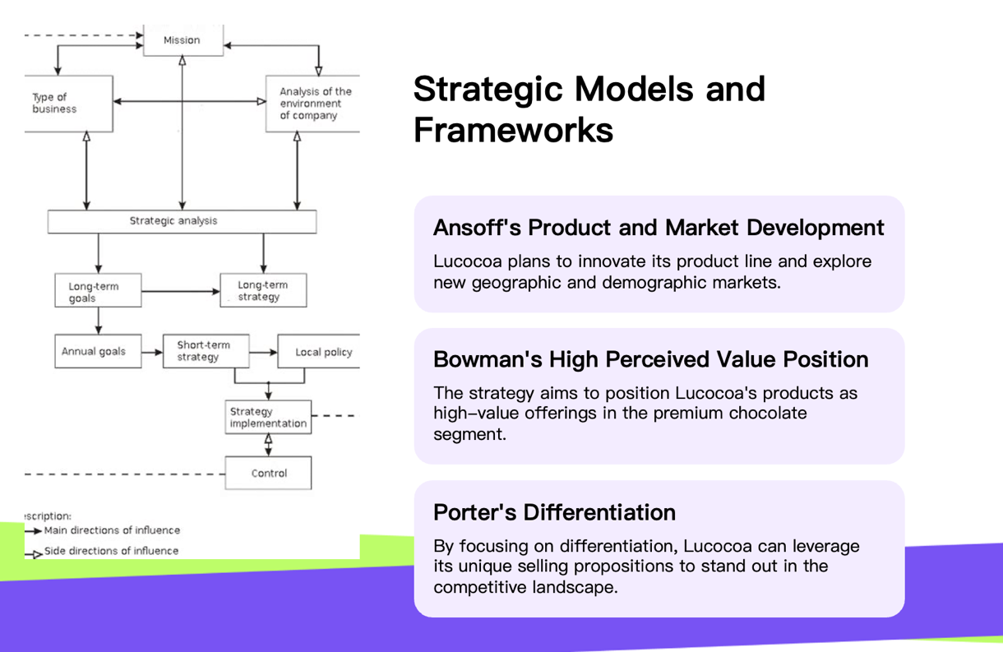

Proposed Strategy:

"Ethical Innovation Expansion"
I suggest an "Ethical Innovation Expansion" plan to ensure Lucocoa Chocolate's continued success in the future. This strategy incorporates aspects of Ansoff's product and market development, Bowman's high perceived value position, and targeted differentiation (Porter) (Augusto & Bolini, 2022). Entering new geographic or demographic markets that appreciate premium, sustainable confectionery is part of the plan, as is extending Lucocoa's product line with creative, ethically sourced chocolate products (Ali & Anwar, 2021). Leveraging Lucocoa's capabilities in ethical sourcing and taste innovation, this strategy enables scalable expansion without sacrificing brand values and fits with rising customer demand for responsible luxury goods.

Implementation Roadmap for Ethical Innovation Expansion


Phase | Focus Area | Key Actions | Expected Outcomes | Timeline
1: Foundation | Product Innovation | - Develop three new flavor combinations  - Research functional chocolate ingredients  - Design limited edition packaging | - Expanded product range  - Increased customer interest  - Higher sales volume | Q3-Q4 2024
 | Ethical Sourcing | - Audit current suppliers  - Identify two new ethical sourcing partners  - Implement a supply chain tracking system | - Strengthened ethical credentials  - Improved supply chain transparency  - Enhanced brand reputation | Q3 2024 - Q1 2025
2: Market Expansion | Geographic Expansion | - Identify three new urban markets  - Establish partnerships with local distributors  - Launch targeted marketing campaigns | - Increased market presence  - Diversified customer base  - Higher revenue streams | Q1-Q3 2025
 | New Customer Segments | - Conduct market research on health-conscious consumers  - Develop marketing materials for this segment  - Participate in health & wellness expos | - Broadened customer demographics  - Increased brand awareness  - New product opportunities identified | Q2-Q4 2025
3: B2B Opportunities | Hospitality Partnerships | - Identify potential high-end restaurant/hotel partners  - Develop B2B product line  - Create co-branded marketing materials | - Established B2B revenue stream  - Increased brand prestige  - Stable bulk orders secured | Q1-Q3 2026
4: Consolidation & Growth | Performance Review | - Analyze sales data from new markets/segments  - Gather customer feedback  - Refine product offerings based on insights | - Optimized product portfolio  - Improved customer satisfaction  - Increased market share | Q4 2026
 | Future Planning | - Identify the next phase of innovation opportunities  - Explore the potential for ethical chocolate 'experiences'  - Consider limited international expansion | - Clear growth trajectory established  - Continued brand evolution  - Foundations laid for long-term success | Q1 2027 onwards

Stakeholder Analysis and Strategic Options
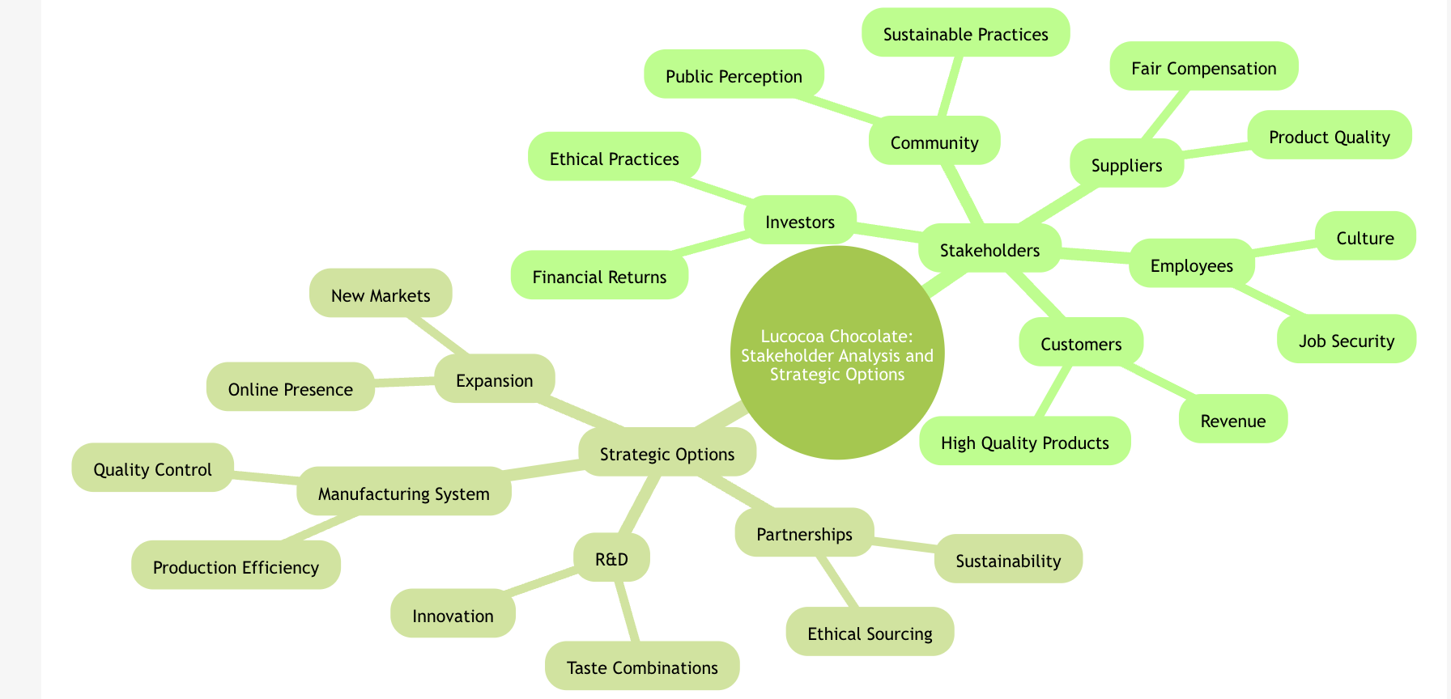

Examining Lucocoa Chocolate's stakeholders uncovered a complex web of interests and power relations. Investors expect financial returns and responsible growth; employees seek job security and alignment with company values; suppliers, especially cocoa farmers, desire fair compensation and sustainable practices; and customers expect high-quality, ethically sourced products (Ali & Anwar, 2021). Many locals and eco-activists are vested in Lucocoa's success because they hope for good social and ecological results. The suggested "Ethical Innovation Expansion" plan is the best, most workable, and most acceptable choice based on analysing stakeholder power and expectations (Augusto & Bolini, 2022). This strategy supports workers' values, satisfies customers' wants for premium, sustainable goods, and offers development potential to investors while also addressing supplier concerns via ethical sourcing. A well-rounded option that considers the demands of many stakeholders while capitalising on Lucocoa's capabilities, it benefits local communities and meets the expectations of environmental stakeholders.

Key Strategic Recommendations

- Invest in research and development to consistently provide new taste combinations and eco-friendly packaging, ensuring you stay ahead of the competition.
- For more transparent supply chains and more ethical sourcing procedures, strive to establish direct partnerships with cocoa producers.
- Promote the company's progress towards new geographical areas, enhance the company’s web presence, and build a sound strategy for using the web.
- If you would like to find a good balance between a handmade piece’s style and production on a large scale, you should consider a modular manufacturing system.
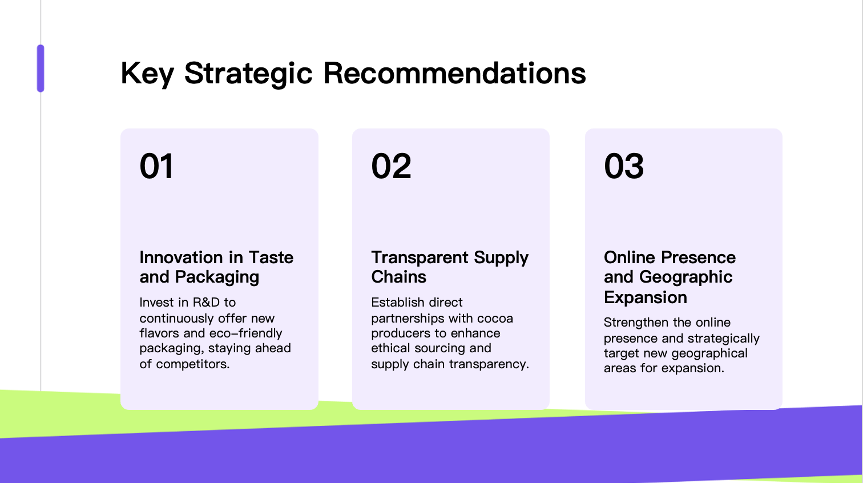

Conclusion

Conclusively, it is also a relatively young, independent chocolate maker in Bushwick, Brooklyn, and is at a particular point in its timeline. To satisfy the premium chocolate industry's evolving position, the firm recommends a new strategy called an “Ethical Innovation Expansion” plan that will capitalise on the firm’s strengths in ethical sourcing and in giving new tastes to chocolates. This is why the company involved in candy production should focus on the conceptualisation of new products, increasing its market audience, and enhancing the company’s image of ethical conduct. Since Lucocoa plans to deal with various stakeholders, balance the handcrafted image with the company’s growth objectives, and overcome the challenges faced by SMEs, this will define the strategy’s effectiveness. It is the question of the organisation’s ability to think and act flexibly, support innovation, and renew the focus on sustainability. One consequence of this conflation of ethical practices with the requirements of the marketplace lies in the potential to advise small and medium-sized enterprises (SMEs) navigating today’s business environments, and the examples provided by the Lucocoa case suggest the opportunities and risks that SMEs have to develop reconciled visions of ethics and profitability.

References

‌
‌
‌
Ali, B.J. and Anwar, G. (2021). Porter’s Generic Competitive Strategies and its Influence on the Competitive Advantage. International Journal of Advanced Engineering, Management and Science, [online] 7(6), pp.42–51. doi:https://doi.org/10.22161/ijaems.76.5.
Augusto, P.P.C. and Bolini, H.M.A. (2022). The role of coaching in chocolate flavour development: A review. Comprehensive Reviews in Food Science and Food Safety. Doi:https://doi.org/10.1111/1541-4337.12975.
Barney, J.B. and Hesterly, W.S. (2019). Strategic management and competitive advantage : concepts and cases. Harlow, England: Pearson.
Bello-Bravo, J., Lutomia, A.N., Medendorp, J.W. and Pittendrigh, B.R. (2022). Chocolate Industry Sustainable Sourcing Practices. Trends in Sustainable Chocolate Production, pp.259–290. doi:https://doi.org/10.1007/978-3-030-90169-1_8.
Berkay Seçuk and Yılmaz Seçim (2023). Concept of artisan chocolate from the perspective of chocolatiers. International journal of food design. Doi:https://doi.org/10.1386/ijfd_00064_1.
Eravia, D., Handayani, T. and Julina (2018). The Opportunities and Threats of Small and Medium Enterprises in Pekanbaru: Comparison between SMEs in Food and Restaurant Industries. Procedia - Social and Behavioral Sciences, [online] 169, pp.88–97. doi:https://doi.org/10.1016/j.sbspro.2015.01.289.
Lynch, R. (2018). Strategic Management. 8th ed. Harlow, United Kingdom ; New York: Pearson Education Limited.
Madar, A. (2020). "ENTERING NEW MARKETS BY IMPLEMENTING APPROPRIATE QUALITY STRATEGIES. " SERIES V - ECONOMIC SCIENCES, 13(62)(2), pp.101–108. doi https://doi.org/10.31926/but.es.2020.13.62.2.10.
Neklyudova, N. (2022). Adaptation of Small and Medium-sized Enterprises During the COVID-19 Pandemic. SHS Web of Conferences, 135, p.01008. doi:https://doi.org/10.1051/shsconf/202213501008.
Odhiambo, E. and Wanjira, J. (2019). Strategic Positioning and Competitive Advantage of Commercial Banks in Uasin Gishu County, Kenya. International Journal of Current Aspects, 3(II), pp.83–97. doi:https://doi.org/10.35942/ijcab.v3iii.8.
Perez, M., Yerena, A.L. and Queralt, A.V. (2020). Traceability, authenticity, and sustainability of cocoa and chocolate products: a challenge for the chocolate industry. Critical Reviews in Food Science and Nutrition, 62(2), pp.1–15. doi https://doi.org/10.1080/10408398.2020.1819769.
Spence, C. (2021). Gastrophysics: Getting creative with pairing flavours. International Journal of Gastronomy and Food Science, p.100433. doi https://doi.org/10.1016/j.ijgfs.2021.100433.
Whittington, R., Regner, P., Angwin, D., Johnson, G. and Scholes, K. (2020). Exploring Strategy. 12th ed. Hoboken: Pearson.



