Project Planning and Management in work place
(BMSW5104_SWAN)
by
BILKIS HUSSAIN
(1816043)

University of Wales Trinity Saint Davies
Date: 25th June 2021

Executive Summary

This report looks into the barriers and support mechanism that are available to BAME and female entrepreneurs in Wales. It involves managing a project and obtaining the relevant information and project management tools.

A group of formed to complete the project and a quad chart was completed to provide an overview of the project and the desired outcome. A stakeholder analysis was completed to identify the relevant stakeholders and a risk assessment was competed to indentify the risks involved.

The primary stakeholder of this project are the BAME participants and the team who are leading the project. Some of the identified risks were team members not engaging or participants not taking part in the survey.

Further project management tolls such as WBS, Gantt Chart, Network Diaggram was use to help aid the development of the project.

A large amount of research was done and government website to identify what support is available to the BAME female community. In addition to that UTWSD business support provided support to further enhance the knowledge available to the team.

It was identified that 71% of participants knew of the help available to them and 80% felt they were treated with bias as one of the barriers to being a female entrepreneur.

Table of Contents
- Introduction 4

- Findings 5
  - Project life cycle 5
2.1.1. Initiation Phase 7
2.1.1.1.Quad Chart..........................................................................................7
2.1.2. Planing phase..........................................................................................................10
2.1.2.1.Stakeholder analysis.............................................................................................10
2.1.2.2.Risk analysis....................................................................................................11
    - Execution Phase......................................................................................................................13
2.1.3.1.WBS................................................................................................................................13
2.1.3.2. Gantt Chart 15
2.1.3.3. Newtrok Diagaram 17
2.1.4. Closure Phase 18
- Conclusion...................................................................................................................................20
- Recommendations.........................................................................................................................21
- References..................................................................................................................................22

- Introduction

The purpose of this report is to look into the barriers and support mechanisms available to BAME and female entrepreneurs. In order to achieve this it was classified as a project and a group was setup to manage the project and provide the goals and objectives of the project.

A project is “a temporary endeavour undertaken to create a unique product, service, or result” (PMBOK Guide 2004, p. 5)

This endeavour will have goals and objectives which must be met within a set period of time and there may be budget and quality issues which have to be dealt with. In order to do that a project must be managed.

Project management is “the application of knowledge, skills, tools and techniques to project activities to meet project requirements” (PMBOKGuide 2004, p. 8)

The above definition of project management gives a brief overview of what the process if project management involves. Ultimately it’s about ensuring a project provides the required deliverables within the timescale and all other relevant constraints using the most appropriate tools for the job.

In order to do that the full project life cycle will be considered an implemented and this would involve the following tools and techniques to be applied: Stake holder analysis, Risk analysis, Quad chart, Work Breakdown Structure (WBS), Gannt chart, and network diagrams.

The project will involve primarily research as well as the use of secondary research methods such as books, online articles, journals, and official websites.

- Findings

  - The Project Life Cycle

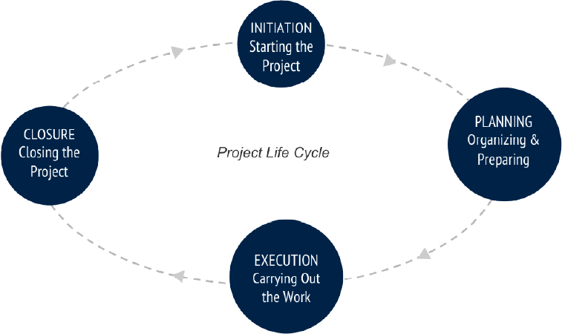

The project life cycle provides a detailed process by which a project can be delivered and provides the steps one must take to make things happen (DPM, 2021).

A project management life cycle will define the work that needs to be carried out, formation of a team, what the deliverables of the project are, and how performance can be monitored at each phase of the cycle.

As indicated in the above diagram, the project life cycle has four phases and these are as follows:

- Initiation Phase – this is the beginning of the cycle where its attained whether a project is feasible. Identify who the project stakeholders are and what the deliverables of the project are.

- Planning Phase – in this phase the project team is built, risk analysis is undertaken to establish potential risk and how they can be avoided,

- Execution Phase – this is the phase where the project tasks are undertaken and communication and monitoring of outcomes becomes crucial.

- Closure Phase - this is the final phase where the success of the project is evaluated.

Some of the benefits of applying the project life cycle as per (Parallel, 2020) are as follows:

• It provides a structure for project delivery – participants can constantly monitor the progress of the project and identify potential problems within the implementation of the project.

• It improves communication between team members – as roles and tasks are defined it allows team members to understand their roles and tasks better and ensures no resource is being wasted by duplicating efforts or tasks.

• It enables progress to be tracked across the organisation – the project manager will be able to establish where the project is at by looking at the tasks which have been performed. This will ensure no time is wasted and if the project is behind then appropriate action can be taken.

• It provides for the progressive evolution of the project – as each stage of the life cycle is defined it becomes easier to focus on particular tasks at certain stages for example, initially risk management must be given priority and at the implementation stage carrying out routine reviews of the project becomes essential to good project management.

• It enables structured reviews that support governance – as the project is structured, reviewing progress also becomes easier and quicker. It can confirm to the stakeholders if the project is target.

However, there are some disadvantages to the use of a project life cycle and these are as follows:

- Complexity – some projects and become overly complex and large which will hinder communication and progress of the overall project.

- Higher overheads – some businesses hire a project management team to manage the phases of the project and this can increase the cost of labour as well as reduce the initial speed by which the project can progress.

- Lack of creativity – sometimes tight time management rules are set and project managers allow very little to no room for creative thinking by team members. This can lead to poor project results (Biz Fluent, 2018).

- Difficult to measure progress – measuring progress in larger project can be very difficult. However, the use of Network diagrams can make it easier but it is not foo, proof.

    - Initiation Phase

This phase where the project facilitators met and decided which project to undertake. The project to be undertaken was to establish the barriers and facilities available for BAME and female enterpreuneures.

Teams members were selected for the project and a Belbin test was carried out to establish the characteristics of group members.

<talk about belbin>

Whether the project was feasable was discussed at this stage and it was decided that the project was feasible given the resources and the time frame provided.

      - Quad Chart

“A quad chart is a form of technical documentation used to briefly describe an invention or other innovation through writing, illustration and/or photographs” (The Audiopedia, 2018).

A quad chart is made up of four quadrants which contains information about the project. This chart is a simple yet very powerful tool that can be used in the project management life cycle. They are usually a one page document.

There are many benefits of using a Quad chart in project management and these are as follows:

- Quick overview – as the chart is on a single page and the information on the chart contains the basic outcomes of the project, its very useful to ensure that one is staying within the parameters of the project.
- Communication – due to the simplicity of the quad chart all team members can refer to it and ensure they are focused on the outcomes of the project.
- Performance can be measured throughout the project life cycle by observing the chart.

Though there are many more advantages of using a Quad chart, it does have some limitations too, and some of these are as follows:

- Not enough information – it cannot be regarded as a detailed plan on what needs to be done.
- No time table – it does not say what tasks needs to be done and when or the order of the task. This is where the other tools such as Gantt Chart and Network diagram become useful.
- Doesn’t have information on what to do if matters do not go as planned.

A Quad chart was discussed and produced in order to identify the purpose of the project, the stakeholders, how success is measured and the desired end result. The resultant Quad chart is shown below:

Title: Researching the needs of BAME and female led enterprises
Purpose  (Aims/Objectives)  Aim: identify needs of BAME entrepreneurs and provide appropriate support.  Objectives:  To explore the needs, barriers faced by BAME or female entrepreneurs.  To identify support available for the BAME or female entrepreneurs. | Stakeholders  - Female/ BAME entrepreneurs  - Team  - UWTSD Business support  - Government  - Module Lecturer
Desired End Results  (Critical Success Factors)  Finding out the need of BAME and Female led enterprises barriers. And advising what support is available, through conducting surveys and formalising a report.  Identifying support needs of Female/BAME BAME entrepreneurs and matching them with what support is available to help them to grow their business further via links with UWTSD business support and Welsh Government initiatives. | Measures of Success  (Standards/Criteria)  Recruit and survey 4 local Female/BAME entrepreneurs  Increased awareness among the BAME entrepreneurs regarding support available on possible issues that they are facing by 14/6/21.  Link BAME/ Female entrepreneurs with appropriate support agencies.

In the above Quad chart it was established the two main objectives would be to explore the barriers and needs faced by BAME or female entrepreneurs and identify the support available to them. A stake holder analysis then provided ho the stakeholders were in the project. They included the BAME female entrepreneurs, UWTSD business support team, Government, the team itself etc.

Furthermore, what constitutes success for the project was established i.e. recruiting people to conduct a survey to establish the barriers and their needs, then making them aware of the potential support available and then networking them to the appropriate support mechanisms.

Finally, the end result was established as per Quad chart. This involved using UWTSD business support and Welsh Government resources to establish support mechanisms.

    - Planning Phase

There are many tools which can be used in the planning phase to help the process of a smooth project completion. Some of these tools are discussed below.

      - Stakeholder Analysis

It’s important to understand who a given project will affect and involve. Without understanding the stakeholders it would not be feasible to genuinely complete a project. Stakeholders are people who have significant power and influence over the work (Mindtools, 2021). The results of the stakeholder analysis is shown below.

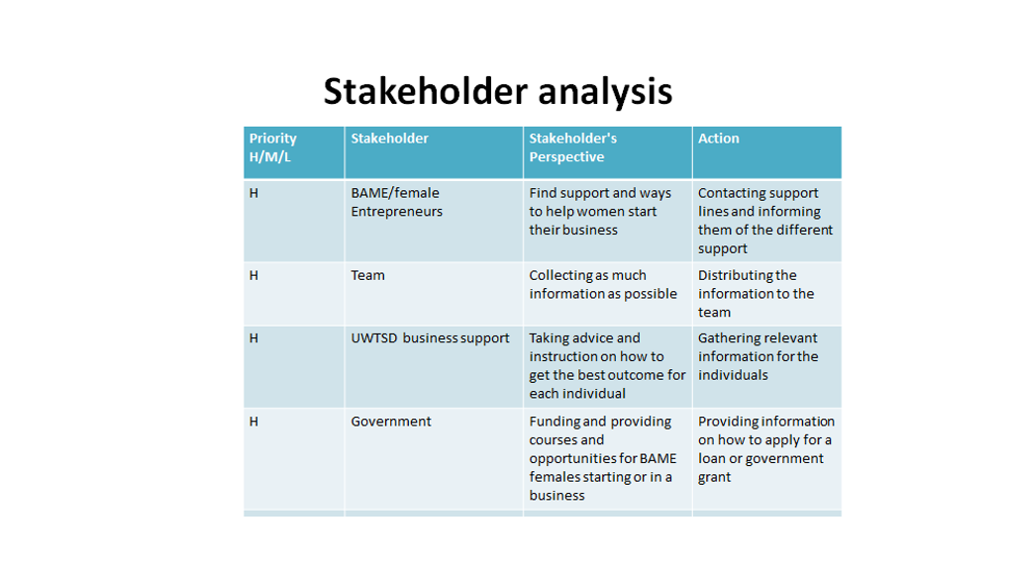

All stakeholders in the project play key roles in the success of the project and the ultimate beneficiary of the project are the BAME and female entrepreneurs. The aim of the project is to find ways in which support can be provided to that particular stakeholder via the project team who used available resources from UWTSD business support and the Welsh government websites.

Stakeholder analysis helped establish a well communicated set of people and what was expected of them. It helped in the running of the project. However, the project cannot allow be run by simply knowing who the stakeholders were, further tools have to be used in order to establish the tasks that are required to be competed in order to succeed at the project.

      - Risk Analysis

Risk analysis involves looking into the probability of something going wrong and the negative consequences of it (MindTools, 2021).

In any project if one does not consider the issues that can arise throughout the life cycle of the project then the project may be delayed, it may have to be stopped, or the results may not be as desired.

A risk analysis was carried out to ensure when certain issues arose what action can be taken. These are described in the table below. An example would be if the team is unable to obtain feedback from one of the entrepreneurs then the appropriate action would be to ensure a backup volunteers are available to conduct the survey. This ensures the project is not halted due to lack of planning.

Impact  (H/M/L) | Likelihood  (H/M/L) | Risk | Mitigating Action
M | M | Illness or lack of engagement with a team member (Internal/ Human resource Risk) | Conduct online meetings, have regular communication via emails and phone (using the advanced knowledge and availability of Technology via Microsoft Teams from the PESTLE analysis it is easy overcome this risk
H | M | Entrepreneurs not engaging or completing questionnaire (External- Product/ quality risk) | Ask numerous (5/6) Entrepreneurs to fill out the questionnaire. If one person doesn't fill it out there's more people to fall back on. Communicate with them and inform them benefits of the project and reassure confidentiality. Using the strength from teams SWOT analysis, of the group of having personal contact who are entrepreneurs will make it easy to engage with them and get them to commit to completing the Questionnaire.
H | H | People resources- Completing tasks on time – (internal and Time risk) | Support team members keep, everyone involved on each task. Meet regularly, check targets, check progress with lecturer. Keep all motivated and follow the project plan, to ensure all task are completed within time frame.

    - Execution Phase

In the phase most of the required work is carried out and some of the tools which were utilized in the planning phase are put into action. These tools include WBS, Gantt chart, and Network diagram.

      - Work Breakdown Structure (WBS)

“A work breakdown structure (WBS) is a visual, hierarchical and deliverable-oriented deconstruction of a project.” (projectmanager.com)

The Work Breakdown Structure (WBS) is one of the most important tool to use in managing a project. A WBS splits the project into a hierarchy of tasks, deliverable, sub deliverables and activates and they are interlinked and interdependent on each other.

WBS makes the project easier to see what needs to be achieved and how they can be achieved. A WBS can be done two ways which are ‘bottom up approach’ and a ‘top down approach. For the chosen project the group have decided to go for top-down approach as it gives a clear overview of the whole process and make it easier to organise them in a step by step manner.

Some of the benefits of the WBS method is as follows:
- Reduce risk – when all team members understand the task at hand the risk of the project not succeeding is reduced.

  - Subdivide the project into smaller tasks - this makes it easier to understand and carry out tasks which in return helps the project complete at a quicker rate.
  - Engage project members​ - as each member can see what needs to be completed they may feel more engaged in the project and may be more motivated and willing participant.
  - Boost productivity – more motivated team members will yield higher levels of productivity.​

Though there are many advantages of using a WBS as a project management tool, there are some downsides to it too and these are as follows:
- WBS is not a plan or schedule​
- No time line for task completion – there are no time table of when each task must be carried out and if they can also be carried out concurrently or the order of the task. There are tools that can help establish that such as a Gantt chart.​
- No information on task assignment​ – team members would not know who has been assigned which task by simply looking at the WBS chart.
- Lack of clarity in order of task​ – order of task is not defined.

The WBS chart produced for the project is provided below.
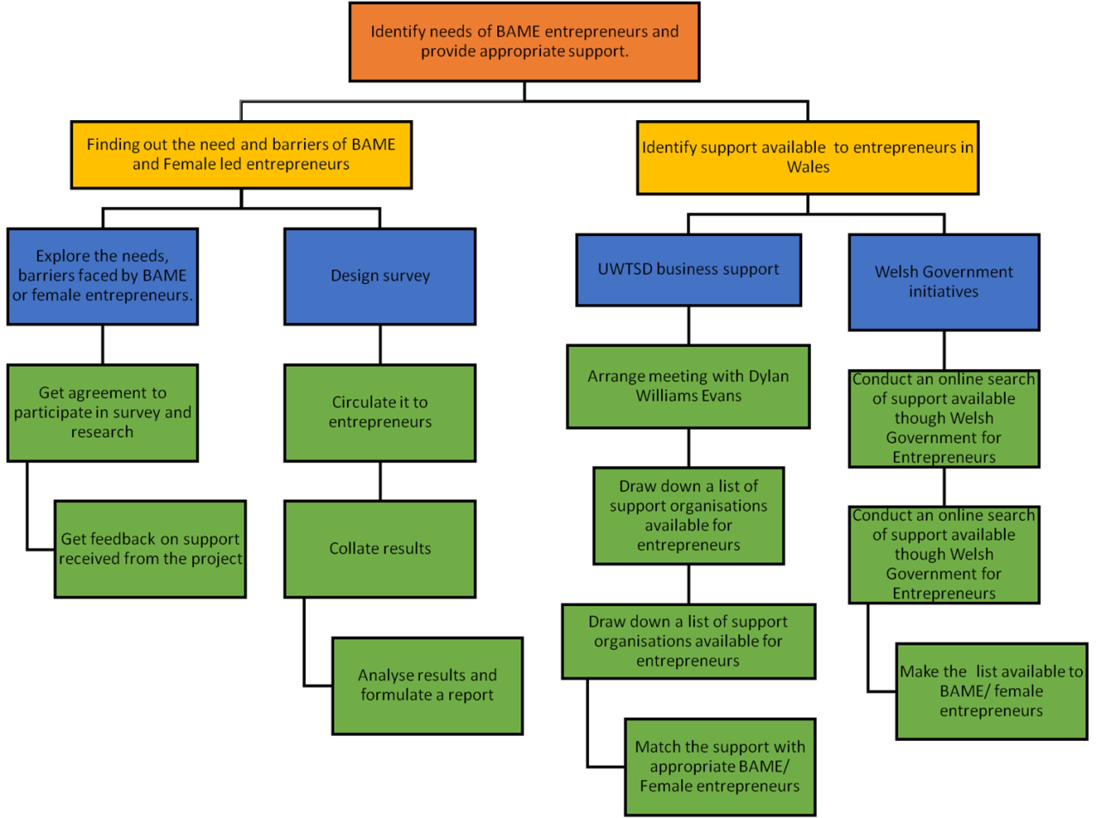
Figure: 1.1 Work Breakdown Structure

The main aim of the WBS as indicated in the chart is to identify the needs of BAME entrepreneurs and provide appropriate support.

Then there are 2 deliverables:

- one is to explore the needs and barriers faced by BAME or female entrepreneur
- Identify the support available for the BAME or female entrepreneurs.

The chart then flows down indicating how each of the deliverables can be obtained and the processes involved. As mentioned earlier WBS does not advise who will be carrying out the tasks and the order of these tasks (Gantt Chart). Furthermore, its difficult to identify each tasks. For example if it had a task number it would be easier to identify (Network diagram).

In order to be able to thoroughly complete the project more tools and techniques would be required and they are the Gantt Chart and the Network Diagram.

      - Gantt Chart

“A Gantt chart is a bar chart that provides a visual view of tasks scheduled over time.” (Projectmanager, 2021)

In 1910 Henry Gantt devised a chart which provided not only the tasks that were to be done but also the start and the end time of those charts.
These types of charts are of great help in project management as they show what tasks need to be completed before another can be started. It would also show what tasks can be completed at the same time as another task.
Gantt charts are great in keeping track of deadlines, certain milestones, and hours worked. They can however be very time consuming to do. The team produce a Gantt chart which enabled better manage the production of the project plan.

The Gannt chart for the project is shown below.

Figure: 1.2 Gantt chart

On the left hand side of the Gantt chart illustrate all the tasks and on the horizontal axis records the time when each activity was start and finish. There is correlation between a WBS and Gantt chart. As WBS breakdown all the task into subtasks whereas Gantt chart shows who was doing the task and time length of the task.

The Gantt chart itself has it own limitation such as not having detailed information on the nature of the task but when used in conjunction with other told it is a must and highly effective project management tool.

      - Network Diagram

A network diagram is a very useful tool to use when managing projects. A network diagram is a graph that shows the activities, duration, and interdependencies of tasks within your project (Wrike.com, 2021).

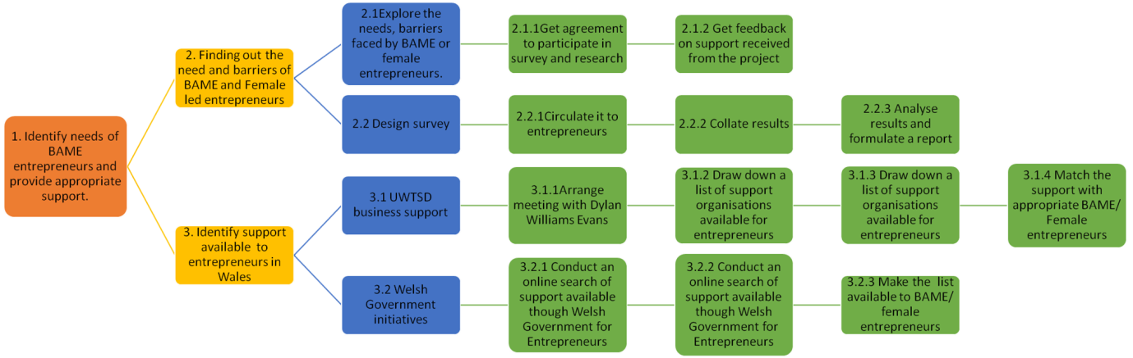
Figure: 1.3 network diagram

Network diagrams also allow the team to give specific tasks to each member and this task can be referred to in task number i.e. task 2.1.1 is to get agreement of participants to the survey.

    - Closure: Monitoring & Evaluation

This is the final phase of the project management cycle. The risk analysis carried out earler in the project is constantly being reviewed and applied if necessary.

Monitoring is the process of collection and analysis of data while the project in ongoing (SOGATE, 2021). Whereas, evaluation is the systematic and objective assessment of an ongoing or completed project (ILO, 2021).

Monitoring

The risk assessment was used to monitor whether team members were engaged in the project, we used online meetings to ensure they would not delay the project.

BAME volunteers were also no too respondent and had to be chased up to complete the questionnaires.

The Iron Traingle was used by the team to identify the main cost involved the in project was the team itself (Human Resource), therefore they were all given equal importance in the project in order to keep them engaged and motivated.

Evaulation

Participant numers – there were 7 participants to the questionnaire. This is a hard fact. The participant size of the project is relatively small and this should be noted as if this project was to be performed again a bigger sample size would be welcome. According to (Tools4dev, 2021) a sample size should be at least 100.

- Find out the needs of BAME / female entrepreneurs
  - 80% of female participants felt subconscious bias affects them
  - Felt people believed they did not not what they were doing

- Identify support available to entrepreneurs in Wales
  - 71% of participants were aware of support available
  - 57 % knew where to obtain support from
  - 42.9% of participants were either not aware or not sure of were support can be obtained

Team Performance

Overall team performance was satisfactory. However it was very difficult to establish a communication channel with all team members. Engagement with the lecturer helped resolve some of the matters.

- Conclusion

There are many forms of support and advise available to the BAME female community via the Welsh government schemes.

There are many BAME entrepreneurs who are aware of these facts (71%). This is a relatively high percentage but the number of participants is only 7, which is very low and is not a true reflection of the BAME female population and hence should be taken with a pinch of salt.

It is clear that there are funds and support available for BAME female entrepreneurs and they need to take advantage of that.

BAME female entrepreneurs feel that there is a bias towards them which they feel is a barrier for them.

- Recommendations

- Further investigate why 80 % of the participants felt bias towards them
- Encourage participants to take out grants and loans to aid their business
- Educate and advise the 42.9 % who were not aware or sure of the access to funds / help available to them

References

APM (2021), Definition, Available at: https://www.apm.org.uk/resources/what-is-project-management/what-is-quality-management-and-control/, [Accessed on 06/03/2021]

Biz Fluent (2018), Describe the advantages and disadvantages of project management, Available at: https://bizfluent.com/info-8774906-describe-advantages-disadvantages-project-management.html, [Accessed on 17/06/2021]

DPM (2021), Project management life cycle phases and why its important, available at: https://thedigitalprojectmanager.com/project-management-life-cycle/, [Accessed on 12/06/2021]

ILO (2021), Project evaluation, Available at: https://www.ilo.org/wcmsp5/groups/public/---dgreports/---exrel/documents/genericdocument/wcms_172679.pdf, [accessed on 23/06/2021]

Mindtools (2021), Stakeholder analysis, available at: https://www.mindtools.com/pages/article/newPPM_07.htm, [Accessed on 20/06/2021]

Parallel (2020), Explain 5 benefits of a project life cycle, Available at: https://www.parallelprojecttraining.com/explain-5-benefits-of-a-lifecycle/, [Accessed on 20/06/2021]

PMBOK Guide, (2004). A guide to the project Management Body of knowledgement, Third edtion, Project Management Institiute Inc, USA.

Project manager (2021).What is a Work Breakdown Structure? Why Use a WBS? Available at: https://www.projectmanager.com/work-breakdown-structure [Accessed on: 12th June 2021]. ​
Project Manager, (2021). What is a Gantt Chart? Available at: https://www.projectmanager.com/gantt-chart [Accessed on: 19th of June2021]

SOGATE (2021), Monitoring and evaluation, Available at: https://www.geog.ox.ac.uk/research/technologies/projects/mesc/guide-to-monitoring-and-evaluation-v1-march2014.pdf, [accessed on 23/06/2021]

The Audiopedia (2018). What is QUAD CHART? What does QUAD CHART mean? QUAD CHART meaning, definition & explanation. YouTube. Available at: https://www.youtube.com/watch?v=TkRyzUVWtm0 [Accessed on 20/06/2021].​

Tools4dev (2021), How to choose a sample size, available at: https://www.tools4dev.org/resources/how-to-choose-a-sample-size/, accessed on 23/06/2021

Wrike.com (2021), What is a network diagram in project management?, available at: https://www.wrike.com/project-management-guide/faq/what-is-a-network-diagram-in-project-management/, [Accessed on 21/06/2021]

