Angharad Evans (2204700)

Distribution of covid-19

In this essay, we will discover some of the notable features of the frequency and distribution of covid-19 outcomes, and then move on to the second question which is the risks of covid-19 outcomes in active and inactive populations. We will study these questions on an epidemiological level, looking at statistics and graphs to determine and finalise our findings.

- Describe some of the notable features of the frequency and distribution of covid-19 outcomes in the UK population.

First of all, what is covid-19? Covid-19, also known as coronavirus, is a highly contagious infectious disease caused by severe acute respiratory syndrome that has had a devastating impact on the world. It’s a respiratory infection, a very contagious one that’s impacted many lives, causing loses in many families. It started in the year of 2020, but many civilians suspected it started at the end of 2019. More than 6 million people died worldwide (National Library of Medicine, 2023). Only recently was it reported that covid-19 is no longer a global pandemic. That doesn’t mean no one can have it again (The Guardian, 2023). It remains a national crisis, just like some other things like influenza (flu). A man stated that the virus entered the human market through infected frozen wild animals from farms in southern China, subsequently causing an epidemic (Embarek, B, Nature Journal, 2021).

In the most recent week, which ended on March 17th 2023, there were 619 deaths associated with covid-19 that were recorded in the UK, up from 605 the week before (Office for National Statistics, 2023).

Figure 1: Graph to show the deaths registered weekly in the UK (Office for National Statistics, 2023).
512 of these deaths were registered in England, 47 in Wales, 56 in Scotland, and 4 Northern Ireland. In the UK, older adults were hospitalised more frequently than younger ones, who were more likely to have milder instances of the illness. Coronavirus primarily impacted older adults (Hopkins, J medicine, 2022). Not only are covid 19 infections necessitating hospitalisations feasible in younger persons, but the incidence of these instances is rising as the SARS-COV-2 coronavirus spreads. Although younger people can get COVID, they are less likely to require hospitalisation or pass away from it; instead, they frequently just experience and develop severe and long-lasting symptoms, especially if they already have diabetes, obesity, or hypertension. According to research data, more than 3,000 adults aged 18-34 have contracted COVID-19, and it has become severe enough to require hospital treatment. 21% were in intensive care, 10% were ventilated, and 2.7% died. Some findings for some people with long covid included ansomnia, difficulty concentrating and recalling memories, weakness, dizziness, shortness of breath, and tonsilitis. All of these symptoms are persistent symptoms. 14.7% of people reported to having persistent covid-19 symptoms at least 2 months after acute illness (Wick, J, 2023). Young and Hispanic men and women are at higher risk than white men and women, according to Hopkins Medicine. This is because racial health disparities and social determinants of health have long existed, making them more vulnerable (Hopkins, J medicine, 2023). As we know, older people tend to have a weaker immune, meaning their bodies won’t be able to fight the infections as rapid as younger people – saying this, older people may keep up to date more with their vaccinations, compared to the younger generation. The government states that 53.8 million people had the first dose of the vaccinations, 50.7 million had the second dose, and 40.3 million had the booster/ third dose. In total, 151,248,820 total vaccinations were given in the UK (Covid-19, GOV, 2023). (AP News, 2021), states that “nearly all COVID deaths in US are now among unvaccinated”. This shows the importance of vaccinations, and how much it can impact someone’s life (Johnson & Stobbe, 2021). The article also stated the “staggering demonstration” about the effectiveness of the vaccinations and indications that the number of deaths per day – currently under 300 – could be close to zero if all eligible people were vaccinated (AP News, 2021).

To conclude, our findings finalised the importance of the covid-19 vaccine, what could happen if you don’t get vaccinated, the importance of identity – i.e, racial status – how it affects your health. At the start, we discovered the definition of ‘coronavirus’ and what it really is- which gave us a better understanding of what this essay was really about. We then moved on to the hospitalisation part, where we discovered the amount of deaths happened, how many people had treatment and survived. We also discovered the amount of people who got vaccinated – which ended up being 151,248,820 people in total. We also discovered the potential beginning to covid-19 (although many say different things).

References
England summary | Coronavirus (COVID-19) in the UK (2023) Vaccinations in United Kingdom. Available at: https://coronavirus.data.gov.uk/details/vaccinations (Accessed: 11 May 2023).
Features, evaluation, and treatment of coronavirus (COVID-19) (2023) Features, Evaluation, and Treatment of Coronavirus (COVID-19). Available at: https://www.ncbi.nlm.nih.gov/books/NBK554776/ (Accessed: 10 May 2023).
Johnson, C.K. and Stobbe, M. (2021) Nearly all COVID deaths in US are now among unvaccinated, AP NEWS. Available at: https://apnews.com/article/coronavirus-pandemic-health-941fcf43d9731c76c16e7354f5d5e187 (Accessed: 11 May 2023).
Mallapaty, S. (2021) Where did covid come from? Five mysteries that remain, Nature News. Available at: https://www.nature.com/articles/d41586-021-00502-4#:~:text=The%20WHO%20team%20concluded%20that,and%20then%20sparked%20an%20outbreak. (Accessed: 11 May 2023).
Maragakis, L.L. (2022) Coronavirus and covid-19: Younger adults are at risk, too, Coronavirus and COVID-19: Younger Adults Are at Risk, Too | Johns Hopkins Medicine. Available at: https://www.hopkinsmedicine.org/health/conditions-and-diseases/coronavirus/coronavirus-and-covid-19-younger-adults-are-at-risk-too (Accessed: 10 May 2023).
Mckie, R. (2023) Is Covid really over? who’s announcement sounds more like surrender than victory, The Guardian. Available at: https://www.theguardian.com/world/2023/may/07/is-covid-really-over-whos-announcement-sounds-more-like-surrender-than-victory (Accessed: 11 May 2023).
Person (2023) Coronavirus (COVID-19) latest insights: Deaths, Coronavirus (COVID-19) latest insights - Office for National Statistics. Available at: https://www.ons.gov.uk/peoplepopulationandcommunity/healthandsocialcare/conditionsanddiseases/articles/coronaviruscovid19latestinsights/deaths (Accessed: 09 May 2023).
Yeznach Wick, J. (2023) Fourteen percent of those who contracted covid-19 face long-term challenges, Pharmacy Times. Available at: https://www.pharmacytimes.com/view/fourteen-percent-of-those-who-contracted-covid-19-face-long-term-challenges#:~:text=Investigators%20found%20that%2014.7%25%20reported,2%20months%20after%20acute%20illness. (Accessed: 11 May 2023).

- Describe the risk of different covid-19 outcomes in active and inactive populations.

To start off with, the most active population group is between ages 19 and 24, and then people aged 75+ for inactive population group (Physical inactivity, 2019). As much as this makes sense in our world, we might fall into some disagreements when we say that teenagers may be the most inactive group – due to social media, technology and so forth. Yes, they may be influenced by their peers and social media influencers/ movie starts etc to look a certain way, but then with that comes motivation and the individualised need to change for themselves.

The British Journal of sports medicine carried out a strategic method to find out if being inactive had an effect on a person – to determine whether it increased their likelihood of having covid-19 or not. They measured vital signs at least three times during exercise between 1st January 2020, and 21st October 2020, and then 19th March 2018 and 18th March 2020, and they had identified 48, 440 adult patients diagnosed with coronavirus infection. They correlated each patient’s self-report. Physical activity categories were consistent inactivity = 0-10 minutes per week; any activity 11-149 minutes per week; consistent adherence to guidelines = >150 minutes per week) and post-COVID-19 hospitalisation, ICU admissions and risk of death. Covid-19 patients who remained physically inactive had a higher risk of covid-19 hospitalisation, ICU admission, and death than those who consistently adhered to physical activity guidelines. Patients who remained physically inactive had a higher risk of covid-19 hospitalisation, ICU admission, and death than those who exercised (BJSM, 2021).

The pandemic was not a healthy time for anyone, physically nor mentally. Maybe one reason someone wasn’t adhering to physical activity or wanting to do any physical activity is when at that time no one was allowed to leave the house, many people didn’t have gyms, couldn’t go for a run or a long-distanced walk – making people not want to do any form of physical activity. It had a lot to do with the rules given. This would then lead to unhealthy eating and ending up gaining weight. COVID-19-related mortality remained 1.64 and 1.62 times higher in obese men and women than in non-obese men, respectively. This suggests that some, but not all, of the increased risk associated with obesity is due to comorbidities (Bosworth & Nafilyan, 2022). The website also stated that the age standardized mortality rate (ASMR) for death from all causes was higher in obese people (413.4 and 286 deaths per 100,000 person-years for men and women) than in non-obese people (317.6 and 217.8, respectively) was higher. After adjusting for factors associated with obesity and mortality risk (such as age, ethnicity, socioeconomic, geographical characteristics, smoking status), overall mortality was 1.22 and 1.12 times higher in men, respectively – which is the comparison of obese and non-obese people.
Risk ratios for all-cause covid-19-related and unrelated covid-19 deaths in obese compared to non-obese people, stratified by sex in the UK:
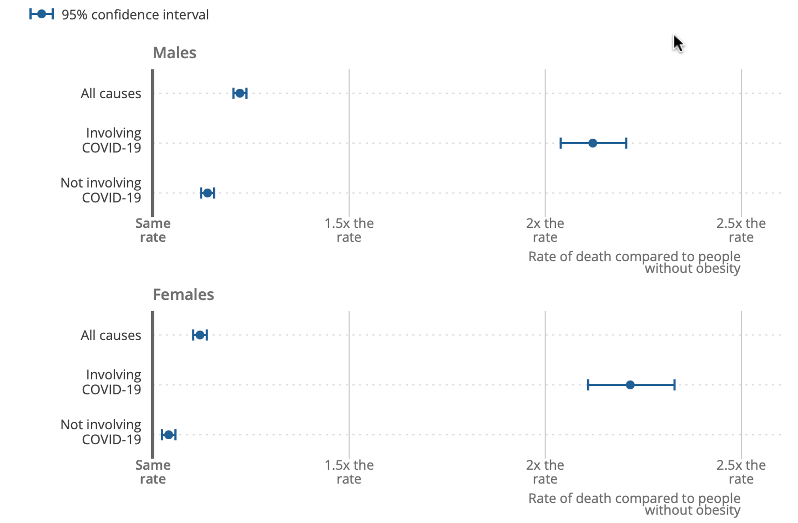
Figure 2: People with obesity had higher adjusted rates of all-cause mortality, death involving covid-19, along with death not involved with covid-19. Source: Office for National Statistics, 2022.

As we can see from this figure, the blue parts are the “95% confidence interval”. The confidence interval for not involving covid-19 remained around the same rate for both males and females. It is obvious to state that the “involving covid-19” section, has a longer confidence interval compared to the all causes and not-involving covid-19. The rate for involving covid-19 in both males and females lay around the same kind of place, which is between “2x the rate” and “2.5x the rate”. The comparison of COVID-19 related deaths is additionally corrected for COVID-19 vaccination status.
The NIH says that obese patients with covid-19 infection have experienced increases respiratory symptoms, renal damage, thrombosis (e.g., pulmonary embolism), and coagulopathy (Lavie et al., 2021). According to one research, obesity rates increased across England in 2020 (the first year of covid-19 epidemic), and disparities in obesity prevalence between the least and most poor districts developed (Holmes, J, 2022). The obesity rates have increased quite a bit between 2019/20 and 2020/21, by just 2 points (16 and 18). This means that more people are becoming obese, which will almost certainly lead to poorer health and add to health inequities. Social, economic and environmental factors make it extremely difficult for people living in disadvantaged areas to eat healthy. For example, following the government’s Eatwell policy, food costs would nearly triple the current weekly average per person. There is also a very strong link between poverty and the number of fast food restaurants in the neighbourhood. Furthermore, the measures taken to curb the spread of COVID-19 in 2020/21 may have affected people’s health behaviours, including diet and physical activity, in different ways. Since the obesity strategy was announced, governments have rolled back, suspended, or abolished various measures that make up the strategy. This includes a £30 million subsidy from local governments to ‘adult weight management services’, which NICE believes will change people’s behaviours, improve nutrition and give them a better understanding of nutrition. There is evidence-based guidance that emphasizes that it can provide effective support for (Holmes, 2022).

To conclude, we’ve discovered the mortality rates of covid-19 for people that were obese and not obese. We’ve seen the effects of COVID-19 had on people – lack of motivation to exercise leading to obesity and binge eating. We also found out that people who are obese are more likely to get more ill to covid-19. We also included some figures to back up the evidence, and then explained it, like in figure 2, we can see the obesity rates for covid-19 in both males and females. We’ve also discovered some of the symptoms obese patients experience with covid-19 – seeing some being some long term symptoms (such as renal damage and a pulmonary embolism). So, to come to a conclusion, re-installing adult weight management services would be a great idea for those who struggle with obesity, especially now – where people may struggle more due to post-lockdown. As it stands now, 25.9% of adults in the UK are obese. So this strategy would be beneficial.

References
Bosworth, M. and Nafilyan, V. (2022) Obesity and mortality during the coronavirus (COVID-19) pandemic, England: 24 January 2020 to 30 August 2022, Obesity and mortality during the coronavirus (COVID-19) pandemic, England - Office for National Statistics. Available at: https://www.ons.gov.uk/peoplepopulationandcommunity/birthsdeathsandmarriages/deaths/articles/obesityandmortalityduringthecoronaviruscovid19pandemicengland24january2020to30august2022/24january2020to30august2022#:~:text=After%20further%20adjusting%20for%20comorbidities,may%20be%20attributed%20to%20comorbidities. (Accessed: 11 May 2023).
Holmes, J. (2022) Obesity, deprivation and covid-19, The King’s Fund. Available at: https://www.kingsfund.org.uk/blog/2022/07/obesity-deprivation-and-covid-19 (Accessed: 12 May 2023).
Lavie, C.J., Coursin, D.B. and Long, M.T. (2021) The obesity paradox in infections and implications for covid-19, Mayo Clinic proceedings. Available at: https://www.ncbi.nlm.nih.gov/pmc/articles/PMC7835093/#:~:text=In%20our%20current%20pandemic%2C%20patients,including%20pulmonary%20embolism%20(PE).&text=In%20addition%2C%20obese%20individuals%20have,abnormalities%20and%20have%20premature%20disabilities. (Accessed: 12 May 2023).
Physical inactivity (2019) GOV.UK Ethnicity facts and figures. Available at: https://www.ethnicity-facts-figures.service.gov.uk/health/diet-and-exercise/physical-inactivity/latest#:~:text=people%20aged%2075%20years%20and,make%20any%20generalisations%20less%20reliable (Accessed: 11 May 2023).
Sallis, R. et al. (2021) Physical inactivity is associated with a higher risk for severe COVID-19 outcomes: A study in 48 440 adult patients, British Journal of Sports Medicine. Available at: https://bjsm.bmj.com/content/55/19/1099#:~:text=meeting%20PA%20guidelines.-,Patients%20who%20were%20consistently%20inactive%20also%20had%20a%20greater%20risk,other%20COVID%2D19%20risk%20factors. (Accessed: 11 May 2023).

