An Application of Semiotics Within the Field of Art

Semiotics is the process of experiencing sound, images, video or other auditory or visual stimuli and gaining a further understanding of said experience by interpreting what we see and hear via a societally induced connection between the experience, the symbols and triggers we are exposed to, and what they allude to. For example, a road sign may be the colour red, and we would read that sign as relating to danger and warnings; despite the colour being independent from this meaning, we have culturally formed this association, therefore when posters, paintings, cinema, fashion and objects are red, if the context supports this, we attach a indication of danger to it- the colour red now stands in for something other than itself. However, depending on the surrounding context, the reading may be different; in addition to danger, we use red to imply seduction, lust, and romance. If red is displayed in the context of a tight dress, lipstick, and roses, the interpreter will naturally understand the scene as relating to the latter. A technical format of this is the “Triadic Relation” (Charles Peirce, ca. 1960s). Easiest understood in practical application, you may use this theory to deconstruct a stop sign. Peirce’s “Triadic model” labels the red octagonal board mounted on a pole containing the word “stop” in white lettering as the representamen. The sign would be facing traffic and the “interpretant,” or the way this sign would be understood to drivers and pedestrians, is that traffic must stop at this junction. The referent that the sign refers to is the action of stopping therefore the act of drivers stopping their vehicles is the “object” of this sign. (Lesley Lanir, 2019)
Semiotics also relates to the idea of questioning the reality of what we see; an image of an apple for instance is not in fact a real apple. Joseph Kosuth’s One and Three Chairs (1965) demonstrates this notion; the piece consists of a chair, a printed photographic image of the chair, and a printed dictionary definition of the word chair. By doing this, Kosuth unpicks how different portrayals and existences of an object can recontextualise it, even though they are all depictions of the same thing. The dictionary definition and the photograph were able to stand in for the real chair, but do they have the ability to completely be the chair? By doing this, Kosuth challenges “which representation of the chair is the most accurate” (MoMA Learning online, no date).
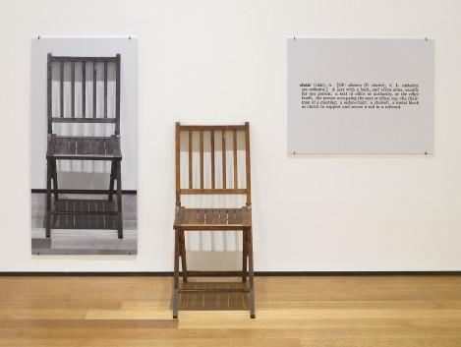
Joseph Kosuth, One and Three Chairs (1965)

Semiotics has a direct application to art as a tool to understand the message of a painting, photograph, installation etc. It equips you with a way to engage with the artwork, and to read the piece as if it were a book, with each section revealing another clue to the context and story of the artwork. You can inspect the colour, text, and shape to pick apart the individual meaning of them and what new meaning they have once curated within the piece to form a whole. Iconography directly relates to the use of semiotics specifically within interpreting art:
“An iconography is a particular range or system of types of image used by an artist or artists to convey particular meanings. For example (…) the dove which represents the Holy Spirit. In the iconography of classical myth however, the presence of a dove would suggest that any woman also present would be the goddess Aphrodite or Venus, so the meanings of particular images can depend on context” (Tate online, no date).

This demonstrates the relevance of knowing historical, geographical, and religious context, amongst others, when viewing a work of art. The semiotics and iconography of a piece may differ across these contexts, so we must look through the relevant lens when trying to decode art.

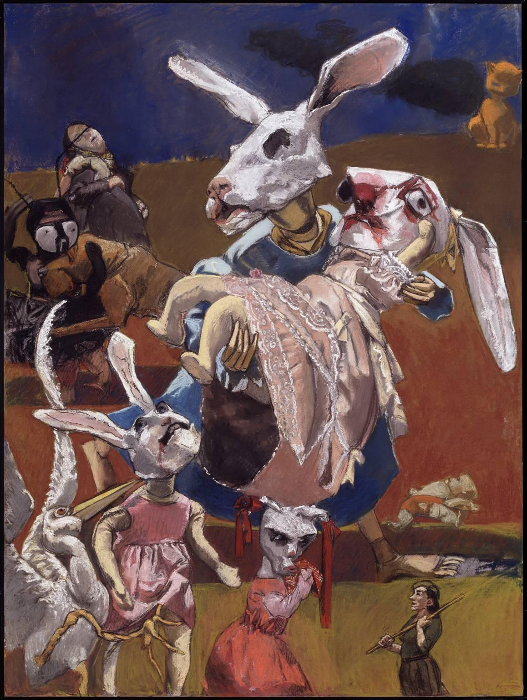

Paula Rego, War (2003)

To demonstrate the practice of using semiotics within art, I’ve selected Paula Rego’s War (2003) to analyse. The first interaction with a painting is observing the literal elements i.e. what the painting physically depicts or denotes, and then via the use of semiotics we can begin to deconstruct the meaning and story. War (2003) consists of 12 figures (four rabbits, one baby, two storks, two women, one cat, one dog, one beetle- all humanoid) most are wearing clothes and two also have blood on their faces. We categorise most of these animals as domesticated pets or at least non-threatening to humans. This suggests a level of weakness or vulnerability to the characters in the painting. Furthermore, the central rabbit and the rabbit in the lower section of the painting have limbs that resemble those of stuffed toys, which has connotations of youth and innocence. In addition to this they, and the third smaller rabbit, all wear pink frilly dresses which add to the recurring theme of childhood. The central rabbit is the largest figure in the painting, and carries one of the other rabbits. This figure is painted with no eyes and has limbs that mimic a wooden figurine. The difference in limbs would imply a higher level of strength thus a higher level of maturity. By these denotations we can assume they are the parent of the rabbit they carry. The lack of eyes not only suggests an injury, but could also link to a metaphorical blindness and confusion the character is experiencing. The mother rabbit wears a blue dress, which when combined with the position of her holding her child, takes the form of Michelangelo Buonarroti’s The Pietà- the Virgin Mary cradling Jesus who lays dead in her arms (Every Picture Tells a Story online, no date). From this the audience understands feelings of grief, love, and desperation along with purity and sacrifice. The Virgin Mary appears frequently in Rego’s work, often relating to one or more of the following: innocence, sexuality, enforced corruption, motherhood, and the repression of women (Paula Rego: Secrets and Stories 2021). The theme of death and innocence runs throughout the image, perhaps the most poignant element being the discarded and lifeless looking baby in the lower right hand side of the canvas. The baby is one of the smallest characters in the painting, which contrasts how enormous the catastrophe of the death of an infant should be. The small size and off centre placement within the composition grants a level of insignificance to the baby, which demonstrates how even the worst deaths are glazed over when there is so much devastation everywhere else and normalises the death of children within war. This is not the only use of scale within Rego’s piece that feeds the audience a reading of catastrophe. Rego uses inconsistent proportions within the work, which throws off the depth of the piece, creating a sense of confusion, and lack of order. This is built upon by the wild composition of Rego’s wide placement of the characters. This conveys to the viewer the chaos that ensues within this simultaneously fictional and all too real world. The strained, exasperated and desperate expressions and varied lines of sight that the figures have further contributes to the confusion and maelstrom of the crowd. In contrast, the cat in the top right corner appears calm, creating an eerie juxtaposition against the disarray of the other figures. It’s presence casts a large smoke-like shadow across the dark background. Rego’s selection of a cat as the looming figure is perhaps due to the viscous associations that follow, especially in relation to the other types of animals depicted; cats often kill birds and rabbits, but they don’t eat them. This can be interpreted as an allusion to the mindless and cruel killings of civilians in war. Furthermore the cat's shadow acts as a metaphor for the consequence of war, as it is cast by the cat's presence and it mimics a plume of smoke, as seen in many images of war following an explosion.

To further our understanding of the painting, we must observe it through the lenses of a wider context. 2003 was the start of the Iraq War (2003-2011) and Rego has stated that War (2003) is a response to a photograph published in the guardian that year which “featured a screaming girl in a white dress running from an explosion, while a woman and a baby remain stationary behind her” (Tate online, no date). Whilst there is no further information on which specific photograph, it isn’t hard to find many similar images as they become commonplace when a country is experiencing conflict; below (image 1) is an image that reflects a similar scene as the photograph Rego claims as her inspiration. Rego explains her use of animals for responding to the photograph - “I thought I would do a picture about these children getting hurt, but I turned them into rabbits’ heads, like masks. It’s very difficult to do it with humans, it doesn’t get the same kind of feel at all. It seemed more real to transform them into creatures” (Museo Nacional Centro de Arte Reina Sofía 2007, p.268). This further information paired with a viewing of Rego’s artwork entitles us to form an empathetic connection to Rego, and the figures depicted.
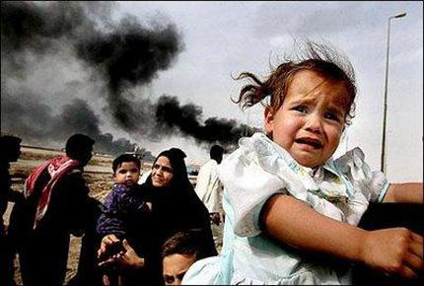
Image 1, Dan Chung, The Guardian, 2010

Ultimately, the use of semiotics is crucial and natural to understanding and interpreting artworks, especially when applied in conjunction with a knowledge of a wider context. You can view the artwork as an expressive and interesting image but also as a form of information and/or narration. These tools have allowed artists to use their art to communicate political and emotional messages, which is the key to how art has such a power to evoke a societal reaction, and even change the course of history.

Bibliography

Museo Nacional Centro de Arte Reina Sofía (2007) Madrid

BBC (2021) BBC Arts - BBC Arts - Fantasia in paint: How Paula Rego made Disney dance. [online] Available at: <https://www.bbc.co.uk/programmes/articles/4Q2pdBRHySwrJPwJrS1stBv/fantasia-in-paint-how-paula-rego-made-disney-dance> [Accessed 3 November 2021].

Drohan, M (2021) Opinion: How to Destroy a Country Totally. [online] Newpeoplenewspaper.com. Available at: <https://newpeoplenewspaper.com/2010/09/07/opinion-how-to-destroy-a-country-totally/https://newpeoplenewspaper.com/2010/09/07/opinion-how-to-destroy-a-country-totally/> [Accessed 8 November 2021].

Chulov, M (2010) Iraq littered with high levels of nuclear and dioxin contamination, study finds. [online] the Guardian. Available at: <https://www.theguardian.com/world/2010/jan/22/iraq-nuclear-contaminated-sites> [Accessed 8 November 2021].

Crow, D (2018) Visible Signs. [Place of publication not identified]: Bloomsbury Visual Arts.

Guardian (2010) Iraqi Civilians stand before an explosion. [image] Available at: <https://www.theguardian.com/world/2010/jan/22/iraq-nuclear-contaminated-sites> [Accessed 8 November 2021].

Horrocks, C (1996)Baudrillard - Beginners Guide. Totem Books.

Tate (2021) Iconography – Art Term | Tate. [online] Available at: <https://www.tate.org.uk/art/art-terms/i/iconography> [Accessed 28 October 2021].

Kosuth, J (1995) One and Three Chairs. [Mixed media].

Lanir, L (2019) Charles Sanders Peirce’s Semiotics — The Triadic Model. [online] Medium. Available at: <https://medium.com/@llanirfreelance/charles-sanders-peirces-semiotics-the-triadic-model-f3363a3a883f> [Accessed 13 November 2021].

Lisboa, M (2021) Paula Rego's Map of Memory: National and Sexual Politics. Michigan: Ashgate.

Moma.org (2021) MoMA | Joseph Kosuth. One and Three Chairs. 1965. [online] Available at: <https://www.moma.org/learn/moma_learning/joseph-kosuth-one-and-three-chairs-1965/> [Accessed 20 October 2021].

Tate (2021) Paula Rego, War. [online] Available at: <https://www.tate.org.uk/art/artworks/rego-war-t12024 https://www.tate.org.uk/art/artworks/rego-war-t12024> [Accessed 21 October 2021].

Rego, P (2003) War. [Pastel on paper on aluminium].

Every Picture Tells a Story. 2021. War by Paula Rego, 2003. [online] Available at: <https://www.everypicture.org/war-by-paula-rego> [Accessed 24 October 2021].

Paula Rego: Secrets and Stories (2021) [video] Directed by N. Willing. London: BBC.

