Module Name: Introduction to Web and Database Concepts
Module Code: ACCA4023
Student Name: Edoard Buzga
Student ID: 2439674

Abstract
This report has developed a website for a fictional coffee shop, The Gilded Spoon. It has effectively used the concept of HTML and CSS to develop. The theoretical study of various literatures has provided a better understanding of UX design and its importance. This website has focused on ensuring web accessibility by abiding by WCAG regulations and has checked it using the WAVE Accessibility Tool. However, this evaluation has indicated some minor issues that can restrict its compliance with WCAG 2.2 standards, such as a lack of contrast between the hero section background image and text and two separate links to the same URL. These future enhancements can make this website much more accessible.
Table of Contents
1. Introduction 4
2. Requirements Analysis 5
3. Implementation 6
4. Evaluation 12
(A) Theoretical Framework 12
(B) Application and Critique of The Gilded Spoon 13
(C) Comparative Website Analysis 15
5. Conclusion 18
References 19
Appendices 21

1. Introduction
This report will cover the process of creating a responsive multi-page website, from research and design to implementation and evaluation, for a fictional artisan coffee shop called “The Gilded Spoon.” The project will involve the demonstration of a systematic understanding and application of web concepts, technologies, and web standards, with a focus on HTML5 and CSS3. The implementation part will involve hand-coding at least five interrelated, accessible web pages: a Home, Menu, Our Story, Gallery, and Location page, making sure that the site is strongly viewable as a standalone [1]. The specification report that accompanies this will consist of the site’s business requirements, technical validation results, and assessment of the final product in terms of quality metrics such as: usability, web accessibility, with particular reference to 2.1 guidelines, and search engine optimisation (SEO). Analysis of usability, web accessibility (with particular reference to 2.1 guidelines), and search engine optimisation (SEO) has been thoroughly supported by academic and peer-reviewed materials.

2. Requirements Analysis
Subject Matter and Website Objective
The Gilded Spoon is a fictitious, autonomous, artisan coffee shop that has been placed in the energetic Northern Quarter of Manchester, UK. The coffee shop is the owner of the website which is a significant digital presence for the business, a source that is filled with branding and information. The main goal of the website is threefold: to present a detailed and accessible menu of master roasted coffees and freshly baked pastries to express the company’s strong commitment to ethical sourcing and sustainability, a core brand value described on the “Our Story” page, and to provide all relevant visitor information such as location, opening hours, and contact details through a dedicated form.
Target Audience
The main target audience is divided into two basic, high-value groups [2]. The first group is made up of local people and office workers aged 25-55 who are located in or around Manchester’s Northern Quarter and are looking for a premium, trusted daily office and cozy place for meetings or work. This group will always choose access to the Menu and Locations pages first. The second group consists of tourists and new visitors (Ages 18-45) who are in Manchester for the first time, especially those who are looking for highly-rated, independent cafes via search engines. They will be attracted by the visuals Gallery and require a clear, mobile-friendly navigation as well as strong Search Engine Optimisation (SEO) to help them in their discovery and decision-making process [3].

3. Implementation
The implementation stage involved the development process of a complete responsive, five-page informational website. The website is created using core web technologies, especially HTML5 for the structure of the webpage and CSS3 for adding responsiveness features [4]. The project needed the hand-coding of the five pages, that are interconnected, namely the Home, Menu, Our Story, Find Us and Gallery. All these pages are managed through an individual, external stylesheet. The main objective of the project was to build a large and manageable website.
Code Compliance and Validation
The core website files were systematically analysed by applying official W3C validation services to ensure security regarding strict compliance with global web standards [5]. These processes of evaluation are necessary for assuring cross-browser compatibility, maintenance ease for future and operational performance across several user agents.
File | Validator | Correction Required | Result
intex.html (Home Page) | W3C Markup Validation Service | 1 Error | Yes
style.css (Main Stylesheet) | W3C CSS Validation Service | 0 Error | No

The CSS validation of the actual stylesheet reported zero errors, validating that each styling rule was consistent with the CSS Level 3 specification and syntactically appropriate. This positive result provides validation of the integrity of the responsive features and design across the entire site.
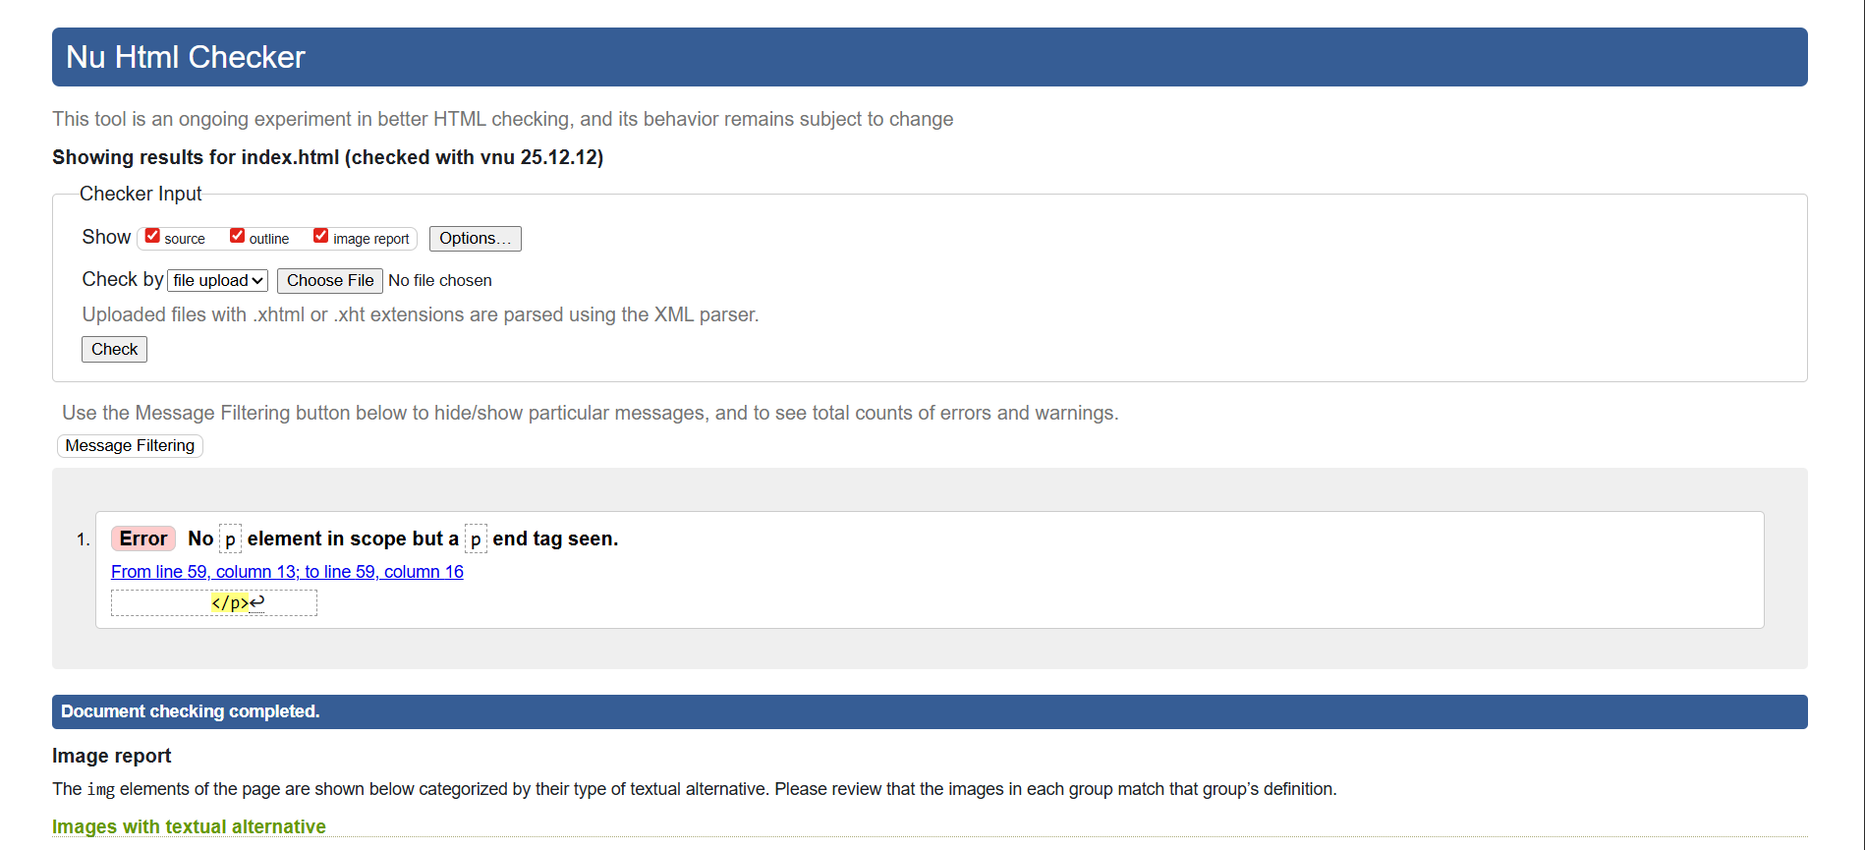
The index.html is the primary page of the website, that has a single critical structural error: No p element in scope, but a p end tag seen. This error refers to an invalid content model where a block-level element was nested inside a phrasing element. The div element was placed under a p tag. HTML 5 rules recommend that a <p> tag cannot contain block-level children as it actually breaks the logical structure of the document. The suspected cause was an attempt to not correctly wrap a div within a textual paragraph block for grouping visually.
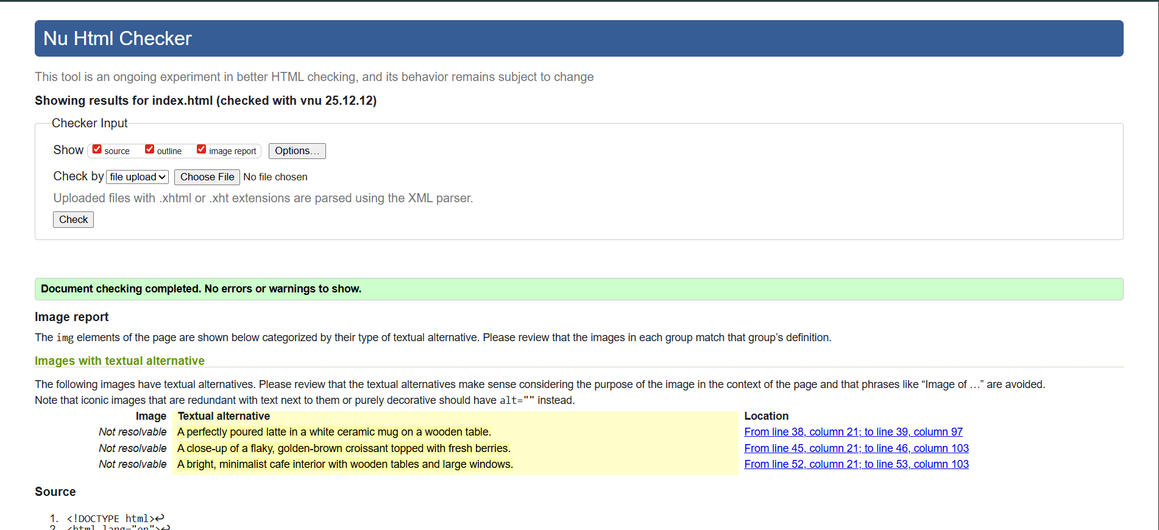
The error was erasing through erasing redundant opening and closing <p> tags that contained the block-level content wrapper. This structural revision in the right way positioned the div tag as a direct child of its enclosing <section>, resolving the validation issue. The process of Re-validation guaranteed that the documentation was completely compliant as well as reporting zero warnings and zero errors. This structured error correction process ensures that the final base of code is clean and appropriate in a systematic way.
Structural Implementation and Design
The website structure demonstrates semantic HTML5 elements in an extensive manner, implementing <main>, <section>, and article to offer valuable insights to the content structure [6]. The semantic transparency provides benefit accessibility (screen readers) and machine interpretation (search engine indexing).
The website implements a sticky <header> that actually contains the main navigation. This process ensures the main links are always available, regardless of the scroll position of the user. As well as enhancing the site efficiency and user experience during website scrolling. Responsiveness is actually obtained through the exclusive application of CSS-oriented media queries, that is dynamically adjust the size of the font, layout and properties for displaying images. It provides an optimal viewing experience from mobile devices up to the big screen of a desktop. All pages incorporate innovative <title> tags and an individual descriptive <h1> element to communicate in an effective way of the primary theme of the page.
The design and content implementation are visually documented by the following screenshots:
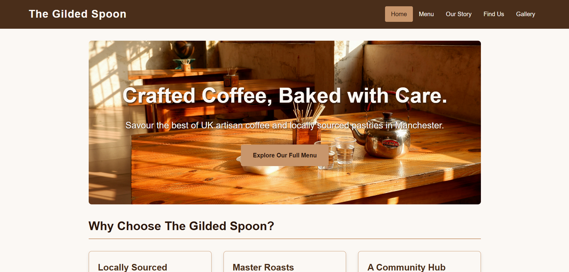
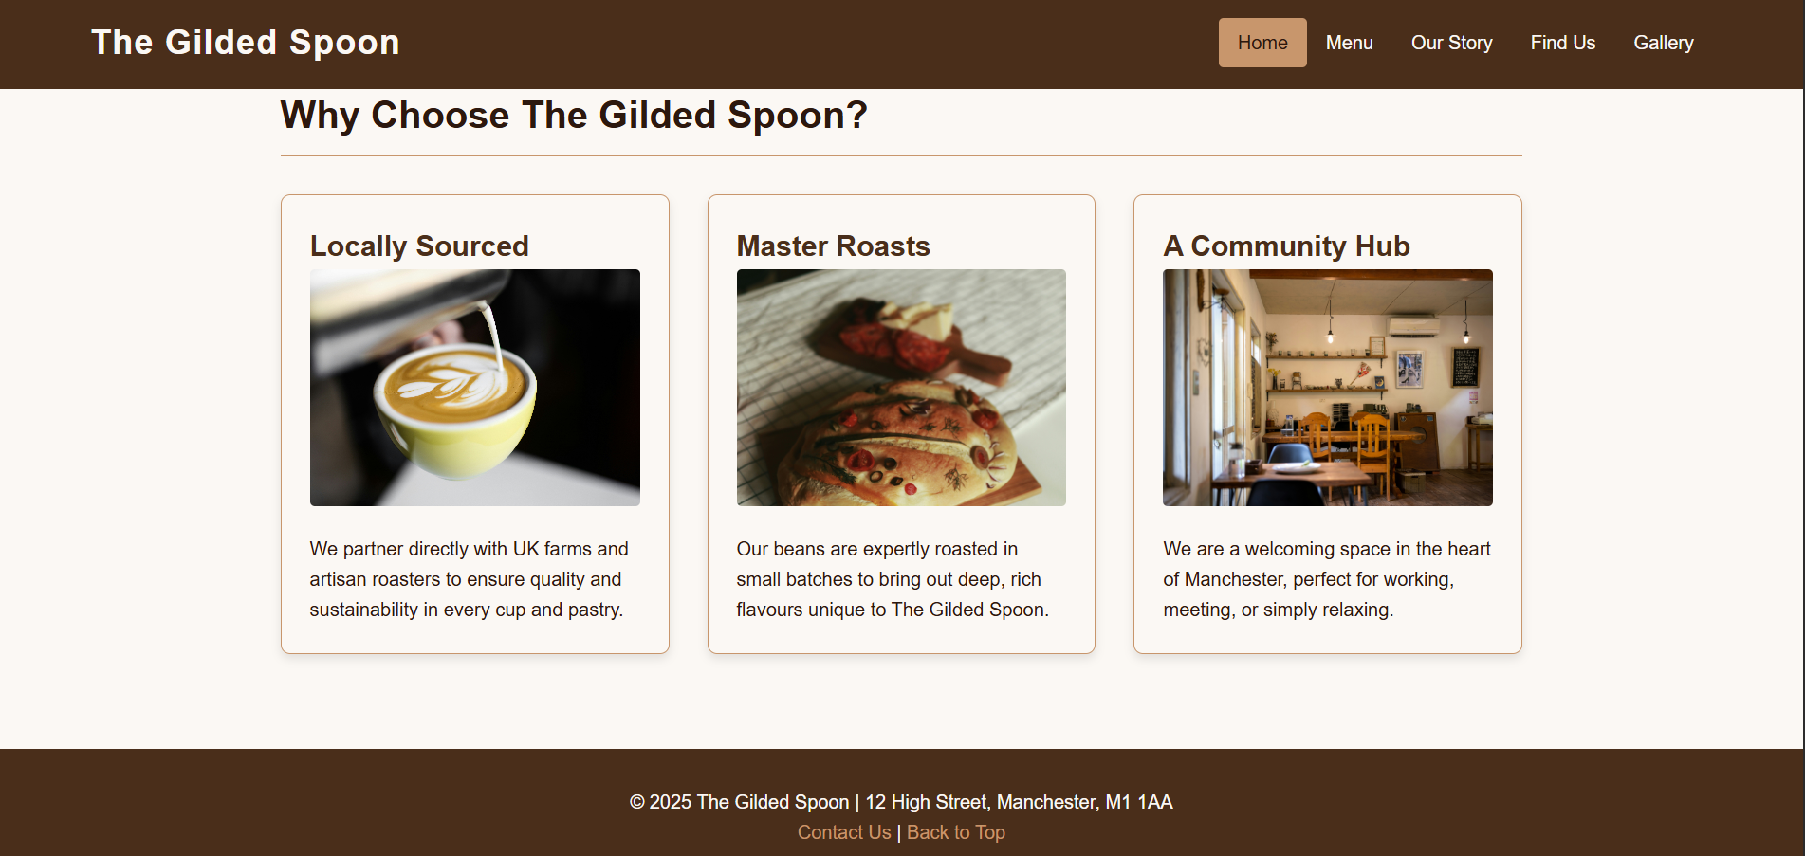
Figure: (Home Page)
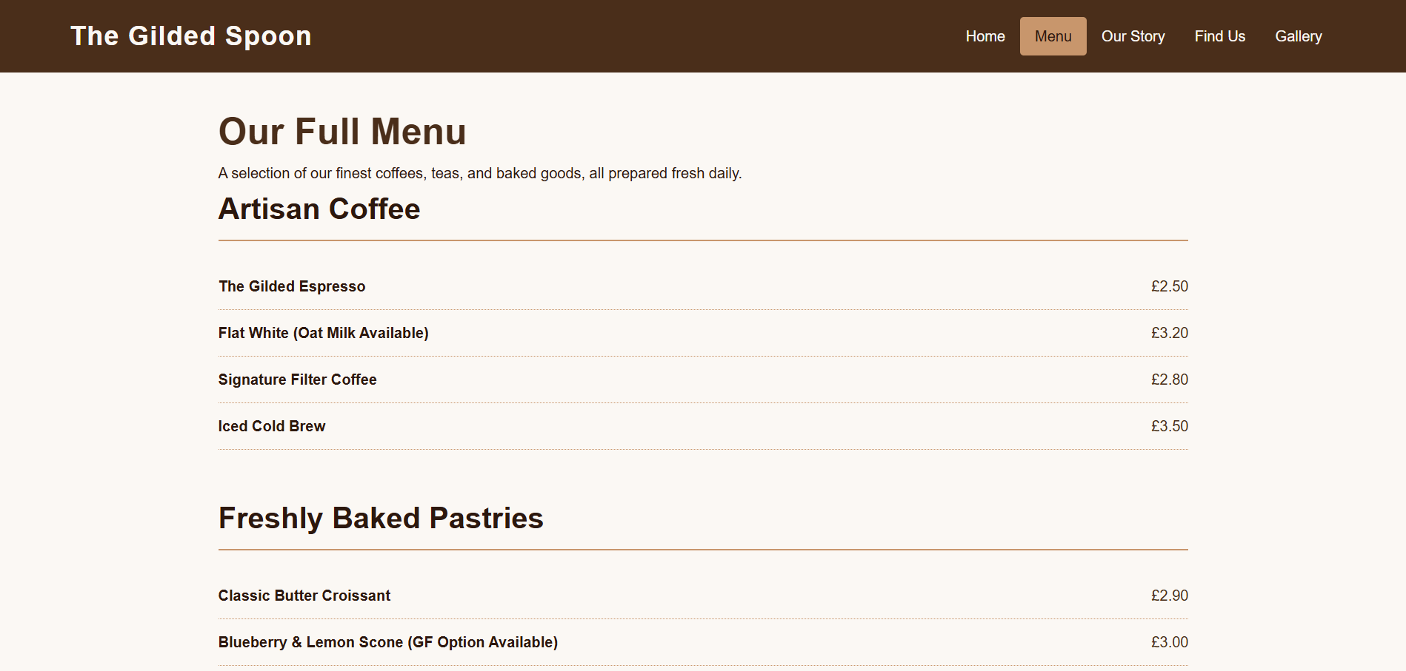
Figure: (Menu Page)
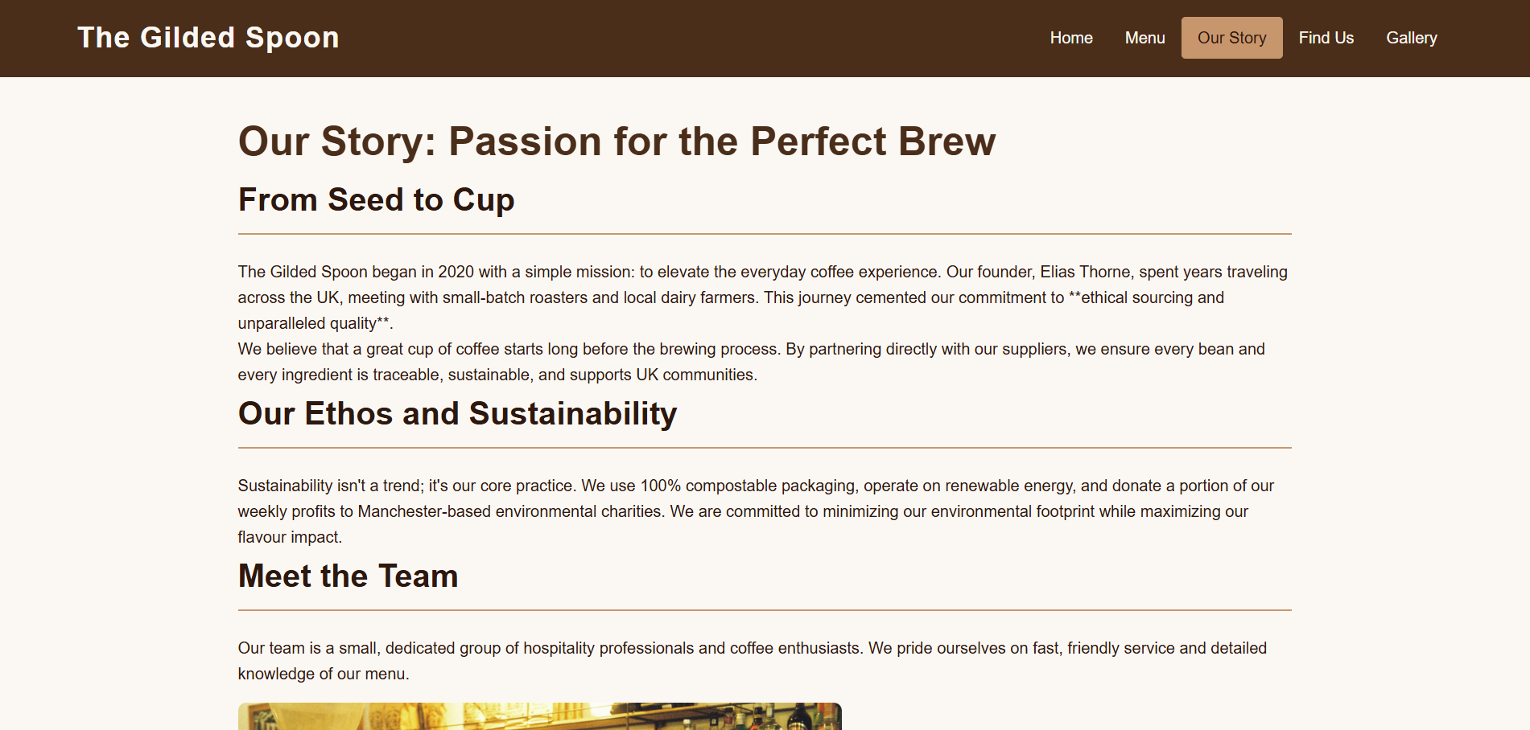
Figure: (Our Story Page)
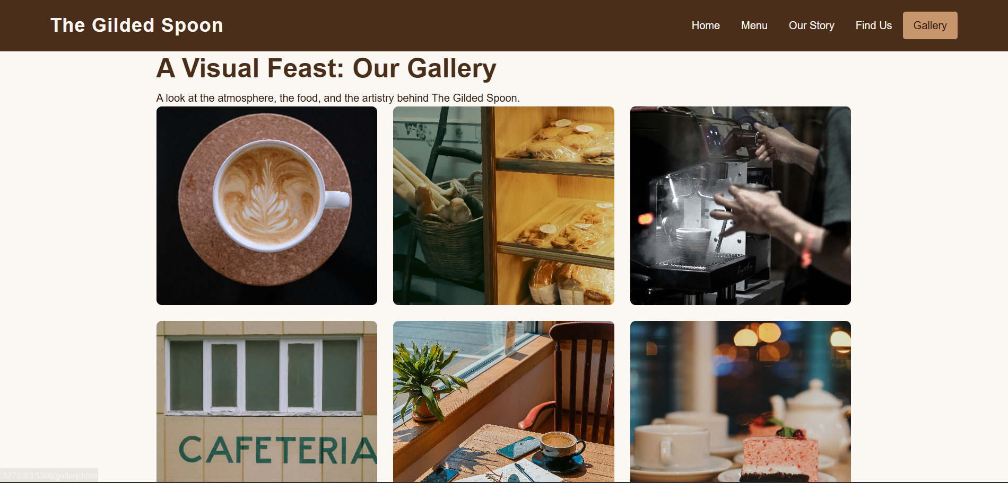
Figure: (Gallery Page)
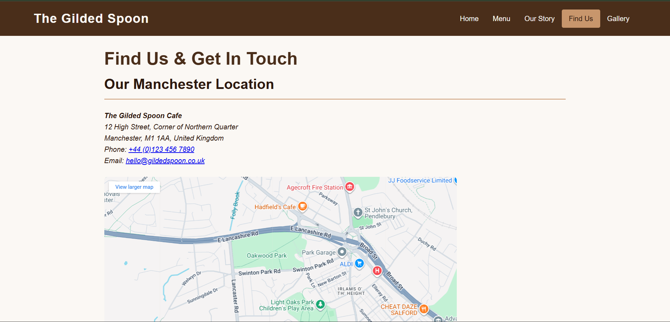
Figure: (Find Us Page)

4. Evaluation
This section of the evaluation discusses the quality metrics to improve contemporary websites. This is based on usability, web accessibility and Search Engine optimisation (SEO). This provides a theoretical study by analysing the website of The Gilded Spoon and comparing two live websites to better understand the WCAG compliance.

(A) Theoretical Framework
Usability and User Experience (UX)
Usability outlines the effectiveness, efficiency and satisfaction of a system when a user uses it. According to Hassenzahl (2013), modern UX design constitutes four interrelated dimensions: goal-oriented efficiency, reduction of cognitive load, prevention and recovery from user errors and hedonic quality that reflects aesthetic appeal and perceived trust. Recent research shows that integrating User-Centred Design (UCD) with Agile Methodologies can further enhance these dimensions [9]. In this research, the users contributed to the enhancement of the entire design as co-designers, that increased goal-oriented efficiency, reduced cognitive load and ensured error prevention and recovery. Additionally, Hedonic quality indicates aesthetic appeal and trust that reflects user satisfaction and return visits.
Web Accessibility and WCAG 2.2
Web accessibility ensures that the web content is perceivable, understandable, navigable and interactive for individuals with disabilities. Web Content Accessibility Guidelines (WCAG) is the international standard for accessibility compliance [7]. Though WCAG 2.1 is widely used, WCAG 2.2 added success criteria regarding the modern interface and cognitive accessibility (W3C, 2018).
WCAG is based on four primary principles: Perceivable, Operable, Understandable and Robust (POUR). Content should have proper colour contrast and alternative text. It ensures that the entire website is navigable through keyboard buttons and the language and structure should be simple. WCAG 2.2 updates emphasise on importance of visibility and unobstructed navigation, that makes digital navigation strong.
Search Engine Optimisation (SEO)
Search Engine Optimisation is the way to increase website visibility in organic search results. The recent research shows that ranking algorithms place more emphasis on user experience signals rather than distinct keyword usage. In an industrial analassysis, Core Web Vitals (CWV) is identified as a ranking factor.
Present CWV metrics are Largest Contentful Paint (LCP), Interaction to Next Point (INP), that replaced First Input Delay in 2024 and Cumulative Layout Shift (CLS) [8]. Along with that, topical authority, semantic relevance and structured local data are crucial for businesses with physical presence. In the context of Cafe enterprises, correct location data and business schema influenced discoverability and footfall in local search results.

(B) Application and Critique of The Gilded Spoon
Usability and Utility
The utility of The Gilded Spoon website has been achieved through a five-page structure and minimalist design that supports high efficiency and learnability. The navigation system uses a sticky header that uses the <nav> element. This ensures that key user goals, such as menu or location information, can be accessed in one click [10]. This design decision aligns with the efficiency and goal orientation of usability principles.
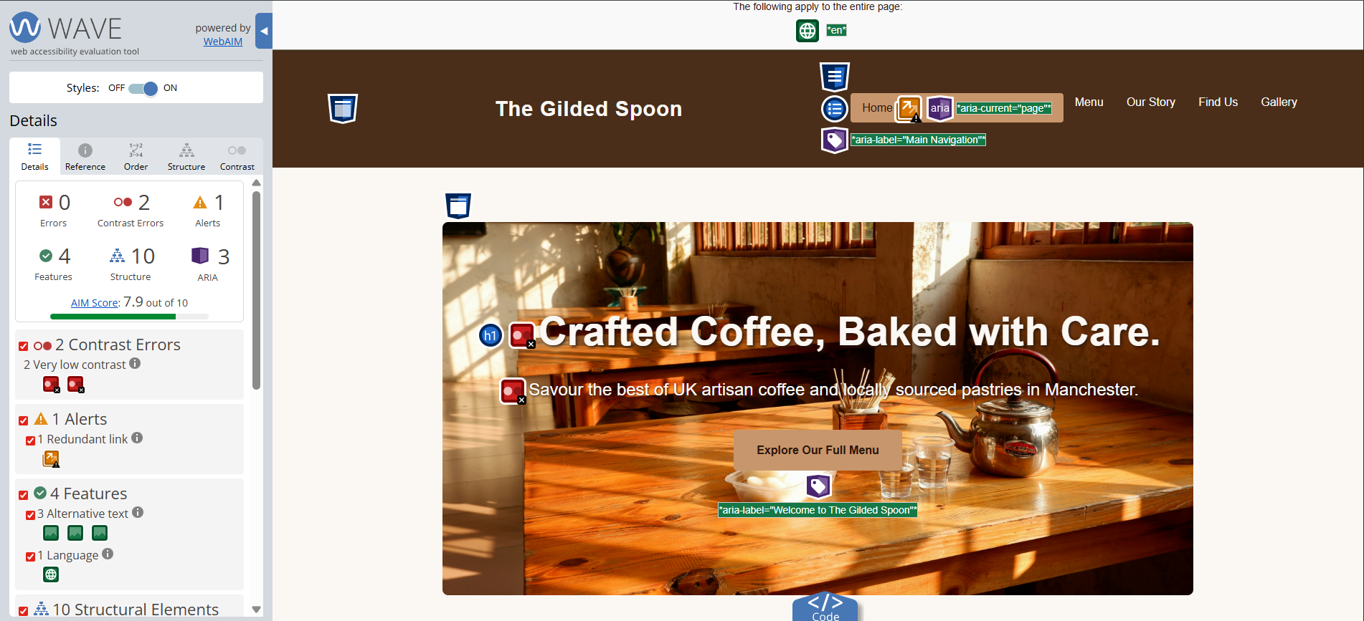
(Source: Self-Created; WAVE Accessibility Tool)
The high-contrast colour palette has increased user satisfaction and proper spacing helps to reduce visual clutter or cognitive load. The home page contains “Explore Our Full Menu”, a clear call-to-action button that directs the user towards the primary commercial content of the website. However, having no client-side form validation is a limitation that restricts reducing user errors and enhancing interaction feedback.
Accessibility
This website aligns with WCAG 2.1 AA standards, that have been evaluated using the WAVE accessibility tool [11]. From the context of perceivability, all the images contain meaningful alternative texts that align with screen readers. However, the “very low contrast” error identified on the hero image section of the homepage can reduce readability for individuals with visual impairments.
In the context of operability, the website is fully navigable through the keyboard, that highlights correct semantic link usage. The one redundant link is not a major issue however, this can create confusion for screen reader users. Robustness is ensured by using semantic HTML5 elements such as <header>, <nav>, <main>, <section> and <footer>.
Search Engine Optimisation (SEO)
This website implements basic on-page SEO techniques to enhance local visibility. Each page contains a descriptive <title> tag and proper heading structure using the <h1> tag. Local and industry-relevant keywords, such as geographic location and artisan food descriptors, are added in the body texts and alternative attributes.
Though having these strengths, the static nature of the website limits the website’s SEO potential. No dynamic content, such as blog posts or news updates, is available, that reduces the content velocity. Additionally, no structured data, such as Schema Markup, has been used, which limits the chances of getting rich search results [12].

(C) Comparative Website Analysis
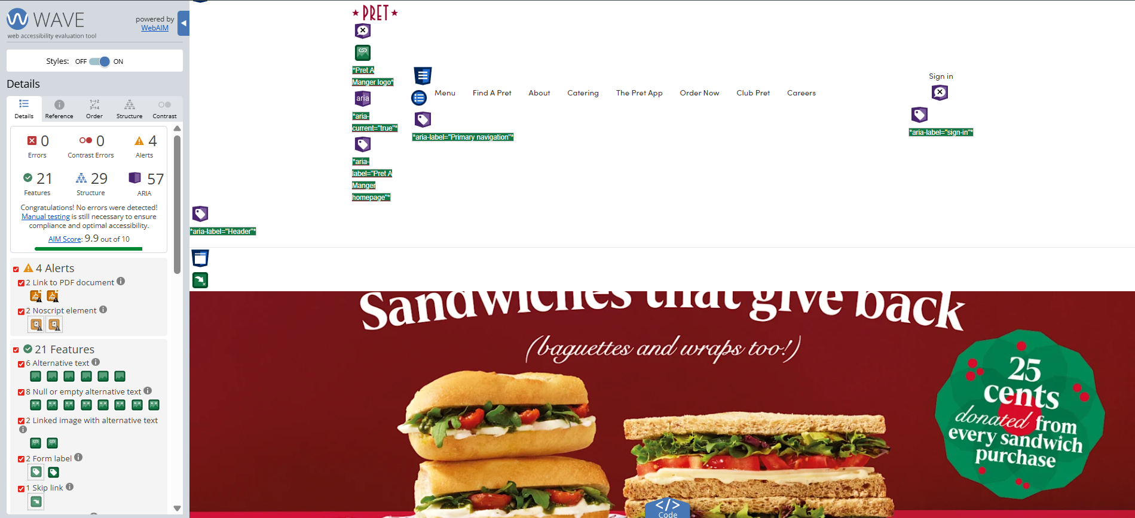
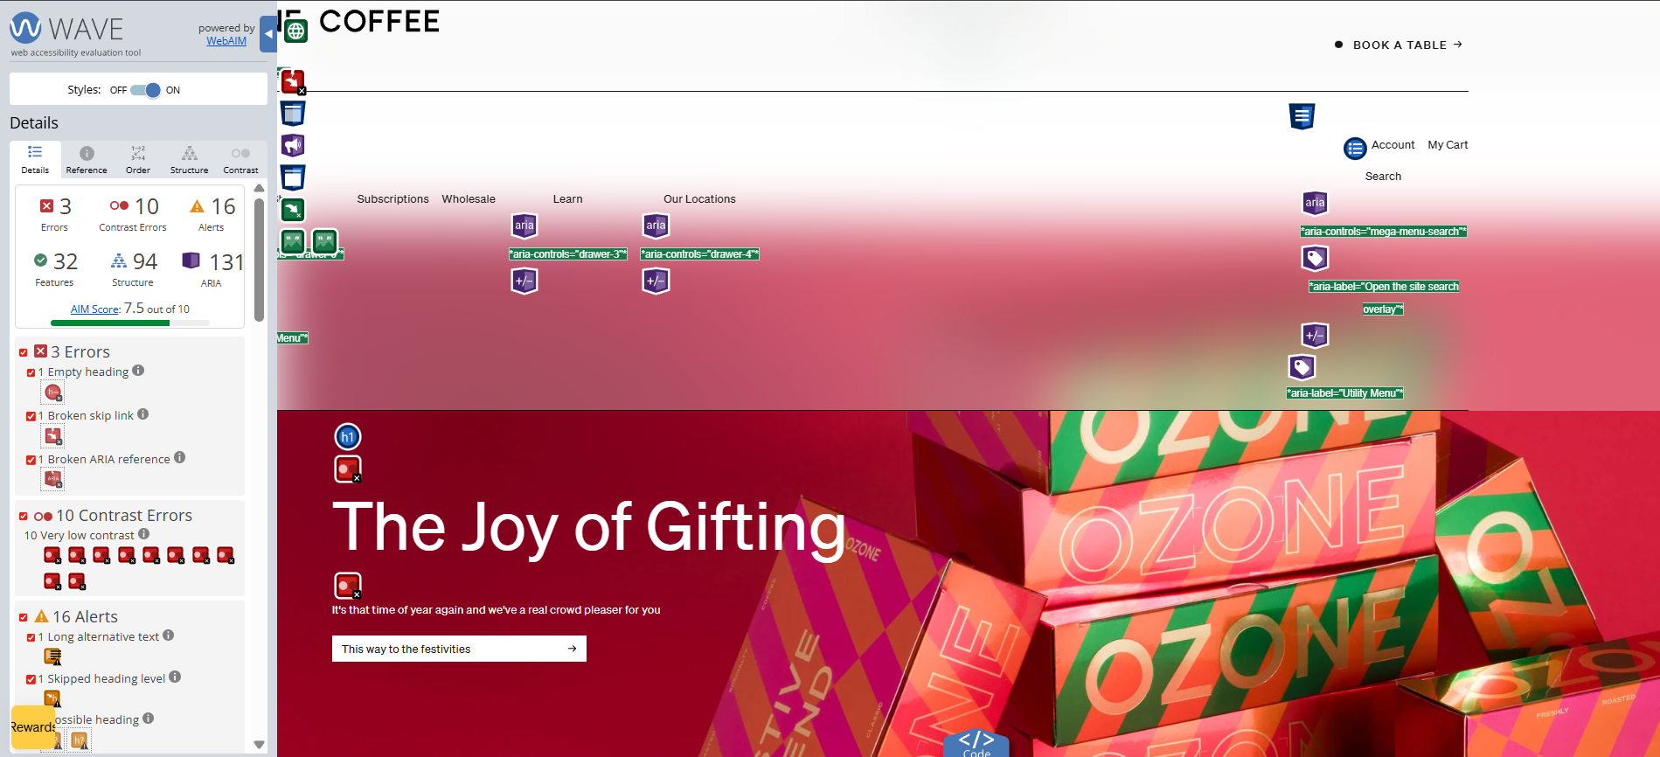
(Source: Self-Created; WAVE Accessibility Tool)
This section presents a comparative discussion between Pret A Manger and Ozone Coffee Roasters.
Area | Pret A Manger | Ozone Coffee Roasters
Usability and UX | High: Through a structured visual menu system. | Moderate: Uses high-quality images but contains multiple elements above the main content.
Accessibility | High: Very effective ARIA attribute and structured content. | Moderate: Contains several contrast and empty headings errors.
SEO and Structure | Very High: Uses strong technical SEO and deep internal linking across product pages. | High: Strong commercial SEO, but a broken skip link error negatively affects SEO.
Mobile Responsiveness | Very High: Fully optimised for mobile-responsive transactions. | High: Fully responsive, but the number of menu items on the small screen can cause clutter.

This comparison highlights that Pret A Manger is comparatively stronger than Ozone Coffee Roasters. The strong SEO compatibility of Pret A Manger highlights its strong WCAG 2.1 compliance, but Ozone Coffee Roasters has multiple accessibility issues.
The Gilded Spoon is a standards-compliant and usable informational website that shows a strong base on usability, semantic structure and accessibility awareness. The simplicity of the website enhances learnability and efficiency, that effective for the target audience. However, the comparative analysis indicates some enhancements. Solving the colour contrast failures and applying advanced SEO techniques such as dynamic content or Schema Markup can improve the website further and enhance both accessibility compliance and competitive visibility.

5. Conclusion
The Gilded Spoon website was able to handle its primary goal of being a functional, compliant with standards, and usable informational platform successfully. The application of a minimalist design and the use of strong semantics, HTML structure, made the site easy to learn and operate, which was reflected in the high scores against the basic WCAG 2.1 principles.
On the contrary, the evaluation raised some issues that needed to be addressed. The website is not completely accessible yet, and it must pass this test to get the full WCAG 2.2 certification. Moreover, static HTML usage and lack of dynamic content or Schema Markup have seriously hampered its position in modern SEO. The analysis reveals that the site, though simple and efficient, is lagging behind its competitors in terms of the technical execution (Pret A Manger's transactional efficiency) and content strategy (Ozone Coffee's topical authority).

References
[1] K. M. Wilkinson et al., “An Evidence-Based Approach to Augmentative and Alternative Communication Design for Individuals With Cortical Visual Impairment,” American Journal of Speech-language Pathology, vol. 32, no. 5, pp. 1939–1960, Sep. 2023, doi: https://doi.org/10.1044/2023_ajslp-22-00397.
[2] C. Graham and R. Kennedy, “Quantifying the target market for advertisers,” Journal of Consumer Behaviour, vol. 21, no. 1, Sep. 2021, doi: https://doi.org/10.1002/cb.1986.
[3] D. Goodwin, “What Is SEO / Search Engine Optimization?,” Search Engine Land, 2025. https://searchengineland.com/guide/what-is-seo
[4] B. Frain, Responsive Web Design with HTML5 and CSS. Packt Publishing Ltd, 2022.
[5] J. Wolf, HTML and CSS. 2023.
[6] B. Frain, RESPONSIVE WEB DESIGN WITH HTML5 AND CSS - THIRDEDITION : develop future-proof responsive... websites using the latest html5 and css techniques. S.L.: Packt Publishing Limited, 2020.
[7] Ş. S. MACAKOĞLU and S. Peker, “Web accessibility performance analysis using web content accessibility guidelines and automated tools: a systematic literature review,” IEEE Xplore, Jun. 01, 2022. https://ieeexplore.ieee.org/abstract/document/9799981
[8] N. Wehner, M. Amir, M. Seufert, R. Schatz, and T. Hossfeld, “A Vital Improvement? Relating Google’s Core Web Vitals to Actual Web QoE,” 2022 14th International Conference on Quality of Multimedia Experience (QoMEX), pp. 1–6, 2022, doi: https://doi.org/10.1109/QoMEX55416.2022.9900881.
[9] Gibson Kimutai and A. Förster, “A User-Centred Interaction Design: A Holistic Approach,” pp. 468–475, Oct. 2024, doi: https://doi.org/10.1109/ghtc62424.2024.10771531.
[10] A. Krysiak-Adamczyk, “Website usability: The Ultimate Guide for 2025,” Survicate, https://survicate.com/blog/website-usability/ (accessed Dec. 16, 2025).
[11] W3C, “Web Content Accessibility Guidelines (WCAG) 2.1,” W3.org, May 06, 2025. https://www.w3.org/TR/WCAG21/
[12] van Son, “Tasmanic,” Tasmanic®, May 27, 2025. https://www.tasmanic.eu/blog/seo-search-engine-optimization/ (accessed Dec. 16, 2025).

Appendices
Appendices 1: index.html
<!DOCTYPE html>
<html lang="en">
<head>
<meta charset="UTF-8">
<meta name="viewport" content="width=device-width, initial-scale=1.0">
<title>The Gilded Spoon - Artisan UK Cafe | Home</title>
<link rel="stylesheet" href="css/style.css">
</head>

<body>
<header>
<div class="logo"><a href="index.html">The Gilded Spoon</a></div>
<nav aria-label="Main Navigation">
<ul>
<li><a href="index.html" aria-current="page">Home</a></li>
<li><a href="menu.html">Menu</a></li>
<li><a href="about.html">Our Story</a></li>
<li><a href="locations.html">Find Us</a></li>
<li><a href="gallery.html">Gallery</a></li>
</ul>
</nav>
</header>

<main>
<section class="hero" aria-label="Welcome to The Gilded Spoon">
<h1>Crafted Coffee, Baked with Care.</h1>
<p>Savour the best of UK artisan coffee and locally sourced pastries in Manchester.</p>
<a href="menu.html" class="button">Explore Our Full Menu</a>
</section>

<section class="features">
<h2>Why Choose The Gilded Spoon?</h2>

<div class="feature-grid">
<article>
<h3>Locally Sourced</h3>
<img src="images/coffee-cup.jpg"
alt="A perfectly poured latte in a white ceramic mug on a wooden table.">
<p>We partner directly with UK farms and artisan roasters to ensure quality and sustainability in
every cup and pastry.</p>
</article>
<article>
<h3>Master Roasts</h3>
<img src="images/pastry.jpg"
alt="A close-up of a flaky, golden-brown croissant topped with fresh berries.">
<p>Our beans are expertly roasted in small batches to bring out deep, rich flavours unique to The
Gilded Spoon.</p>
</article>
<article>
<h3>A Community Hub</h3>
<img src="images/cafe-interior.jpg"
alt="A bright, minimalist cafe interior with wooden tables and large windows.">
<p>We are a welcoming space in the heart of Manchester, perfect for working, meeting, or simply
relaxing.</p>
</article>
</div>

</section>
</main>

<footer>
<p>&copy; 2025 The Gilded Spoon | 12 High Street, Manchester, M1 1AA</p>
<p><a href="locations.html">Contact Us</a> | <a href="#top">Back to Top</a></p>
</footer>
</body>

</html>
Appendices 2: about.html
<!DOCTYPE html>
<html lang="en">
<head>
<meta charset="UTF-8">
<meta name="viewport" content="width=device-width, initial-scale=1.0">
<title>Our Story - The Gilded Spoon</title>
<link rel="stylesheet" href="css/style.css">
</head>
<body>
<header>
<div class="logo"><a href="index.html">The Gilded Spoon</a></div>
<nav aria-label="Main Navigation">
<ul>
<li><a href="index.html">Home</a></li>
<li><a href="menu.html">Menu</a></li>
<li><a href="about.html" aria-current="page">Our Story</a></li>
<li><a href="locations.html">Find Us</a></li>
<li><a href="gallery.html">Gallery</a></li>
</ul>
</nav>
</header>

<main>
<article>
<h1>Our Story: Passion for the Perfect Brew</h1>

<section>
<h2>From Seed to Cup</h2>
<p>The Gilded Spoon began in 2020 with a simple mission: to elevate the everyday coffee experience. Our founder, Elias Thorne, spent years traveling across the UK, meeting with small-batch roasters and local dairy farmers. This journey cemented our commitment to **ethical sourcing and unparalleled quality**.</p>

<p>We believe that a great cup of coffee starts long before the brewing process. By partnering directly with our suppliers, we ensure every bean and every ingredient is traceable, sustainable, and supports UK communities.</p>
</section>

<section>
<h2>Our Ethos and Sustainability</h2>
<p>Sustainability isn't a trend; it's our core practice. We use 100% compostable packaging, operate on renewable energy, and donate a portion of our weekly profits to Manchester-based environmental charities. We are committed to minimizing our environmental footprint while maximizing our flavour impact.</p>
</section>

<section>
<h2>Meet the Team</h2>
<p>Our team is a small, dedicated group of hospitality professionals and coffee enthusiasts. We pride ourselves on fast, friendly service and detailed knowledge of our menu.</p>
<img src="images/team.jpg" alt="A professional photo of the cafe team, three people smiling behind the counter." style="width: 100%; max-width: 600px; margin: 1rem 0; border-radius: 8px;">
</section>
</article>
</main>

<footer>
<p>&copy; 2025 The Gilded Spoon | Committed to Quality and Community</p>
<p><a href="locations.html">Contact Us</a> | <a href="#top">Back to Top</a></p>
</footer>
</body>
</html>
Appendices 3: locations.html
<!DOCTYPE html>
<html lang="en">

<head>
<meta charset="UTF-8">
<meta name="viewport" content="width=device-width, initial-scale=1.0">
<title>Locations & Contact - The Gilded Spoon</title>
<link rel="stylesheet" href="css/style.css">
</head>

<body>
<header>
<div class="logo"><a href="index.html">The Gilded Spoon</a></div>
<nav aria-label="Main Navigation">
<ul>
<li><a href="index.html">Home</a></li>
<li><a href="menu.html">Menu</a></li>
<li><a href="about.html">Our Story</a></li>
<li><a href="locations.html" aria-current="page">Find Us</a></li>
<li><a href="gallery.html">Gallery</a></li>
</ul>
</nav>
</header>

<main>
<h1>Find Us & Get In Touch</h1>

<section>
<h2>Our Manchester Location</h2>
<address>
<p><strong>The Gilded Spoon Cafe</strong></p>
<p>12 High Street, Corner of Northern Quarter</p>
<p>Manchester, M1 1AA, United Kingdom</p>
<p>Phone: <a href="tel:+441234567890">+44 (0)123 456 7890</a></p>
<p>Email: <a href="mailto:hello@gildedspoon.co.uk">hello@gildedspoon.co.uk</a></p>
</address>

<div class="map-container" style="margin: 1.5rem 0;">
<iframe
src="https://maps.google.com/maps?q=The+Gilded+Spoon+12+High+Street,+Manchester&t=&z=15&ie=UTF8&iwloc=&output=embed"
width="100%" height="450" style="border:0; max-width: 800px; border-radius: 8px;" allowfullscreen=""
loading="lazy" referrerpolicy="no-referrer-when-downgrade"
title="Interactive map of The Gilded Spoon, Manchester">
</iframe>
</div>
<h2>Opening Hours</h2>
<ul>
<li>Monday - Friday: 7:30 AM - 5:00 PM</li>
<li>Saturday: 9:00 AM - 6:00 PM</li>
<li>Sunday: 9:00 AM - 4:00 PM</li>
</ul>
</section>

<section>
<h2>Send Us a Message</h2>
<form action="#" method="POST">
<div class="form-group">
<label for="name">Your Name (Required)</label>
<input type="text" id="name" name="name" required aria-required="true">
</div>
<div class="form-group">
<label for="email">Your Email (Required)</label>
<input type="email" id="email" name="email" required aria-required="true">
</div>
<div class="form-group">
<label for="message">Your Message</label>
<textarea id="message" name="message" rows="5"></textarea>
</div>
<button type="submit" class="button submit-button">Send Enquiry</button>
</form>
</section>
</main>

<footer>
<p>&copy; 2025 The Gilded Spoon | Registered in the UK</p>
<p><a href="locations.html">Contact Us</a> | <a href="#top">Back to Top</a></p>
</footer>
</body>

</html>
Appendices 4: menu.html
<!DOCTYPE html>
<html lang="en">
<head>
<meta charset="UTF-8">
<meta name="viewport" content="width=device-width, initial-scale=1.0">
<title>Menu - The Gilded Spoon</title>
<link rel="stylesheet" href="css/style.css">
</head>
<body>
<header>
<div class="logo"><a href="index.html">The Gilded Spoon</a></div>
<nav aria-label="Main Navigation">
<ul>
<li><a href="index.html">Home</a></li>
<li><a href="menu.html" aria-current="page">Menu</a></li>
<li><a href="about.html">Our Story</a></li>
<li><a href="locations.html">Find Us</a></li>
<li><a href="gallery.html">Gallery</a></li>
</ul>
</nav>
</header>

<main>
<h1>Our Full Menu</h1>
<p>A selection of our finest coffees, teas, and baked goods, all prepared fresh daily.</p>

<section class="menu-category">
<h2>Artisan Coffee</h2>
<div class="menu-item">
<span class="item-name">The Gilded Espresso</span>
<span class="item-price">£2.50</span>
</div>
<div class="menu-item">
<span class="item-name">Flat White (Oat Milk Available)</span>
<span class="item-price">£3.20</span>
</div>
<div class="menu-item">
<span class="item-name">Signature Filter Coffee</span>
<span class="item-price">£2.80</span>
</div>
<div class="menu-item">
<span class="item-name">Iced Cold Brew</span>
<span class="item-price">£3.50</span>
</div>
</section>

<section class="menu-category">
<h2>Freshly Baked Pastries</h2>
<div class="menu-item">
<span class="item-name">Classic Butter Croissant</span>
<span class="item-price">£2.90</span>
</div>
<div class="menu-item">
<span class="item-name">Blueberry & Lemon Scone (GF Option Available)</span>
<span class="item-price">£3.00</span>
</div>
<div class="menu-item">
<span class="item-name">Cinnamon Swirl</span>
<span class="item-price">£3.20</span>
</div>
<div class="menu-item">
<span class="item-name">Vegan Chocolate & Hazelnut Cookie</span>
<span class="item-price">£2.50</span>
</div>
</section>

<section class="menu-category">
<h2>Lunch & Light Bites</h2>
<div class="menu-item">
<span class="item-name">Soup of the Day (V)</span>
<span class="item-price">£4.50</span>
</div>
<div class="menu-item">
<span class="item-name">Local Cheddar & Chutney Toastie</span>
<span class="item-price">£5.50</span>
</div>
</section>
</main>

<footer>
<p>&copy; 2025 The Gilded Spoon | All Prices Subject to Availability</p>
<p><a href="locations.html">Contact Us</a> | <a href="#top">Back to Top</a></p>
</footer>
</body>
</html>
Appendices 5: gallery.html
<!DOCTYPE html>
<html lang="en">
<head>
<meta charset="UTF-8">
<meta name="viewport" content="width=device-width, initial-scale=1.0">
<title>Gallery - The Gilded Spoon</title>
<link rel="stylesheet" href="css/style.css">
</head>
<body>
<header>
<div class="logo"><a href="index.html">The Gilded Spoon</a></div>
<nav aria-label="Main Navigation">
<ul>
<li><a href="index.html">Home</a></li>
<li><a href="menu.html">Menu</a></li>
<li><a href="about.html">Our Story</a></li>
<li><a href="locations.html">Find Us</a></li>
<li><a href="gallery.html" aria-current="page">Gallery</a></li>
</ul>
</nav>
</header>

<main>
<h1>A Visual Feast: Our Gallery</h1>
<p>A look at the atmosphere, the food, and the artistry behind The Gilded Spoon.</p>

<section class="gallery-grid">
<img src="images/gallery-1.jpg" alt="A close-up shot of latte art: a swan design in the foam.">
<img src="images/gallery-2.jpg" alt="A basket full of fresh, golden brown bagels on a counter.">
<img src="images/gallery-3.jpg" alt="A barista pouring steamed milk into an espresso shot for a cappuccino.">
<img src="images/gallery-4.jpg" alt="A rustic wooden sign outside the cafe entrance with the name 'The Gilded Spoon'.">
<img src="images/gallery-5.jpg" alt="Sunlight streaming through the cafe window onto a potted plant.">
<img src="images/gallery-6.jpg" alt="A slice of carrot cake topped with cream cheese frosting on a small plate.">
</section>
</main>

<footer>
<p>&copy; 2025 The Gilded Spoon | Follow us on social media!</p>
<p><a href="locations.html">Contact Us</a> | <a href="#top">Back to Top</a></p>
</footer>
</body>
</html>
Appendices 6: style.css
/*
* File: style.css
* Description: Main stylesheet for The Gilded Spoon Cafe.
* Focus: WCAG 2.1 AA Compliance and Responsive Design.
*/

/* --- 1. WCAG AA Colour Palette and Resets --- */

:root {
/* High-Contrast Palette: Ensures readability (WCAG 1.4.3 Contrast Minimum) */
--color-primary: #4A2E1A; /* Dark Brown - Headers, Navigation */
--color-secondary: #C8966C; /* Tan/Gold - Accents, Buttons, Focus */
--color-light: #FBF8F4; /* Cream/Off-White - Main Background */
--color-dark: #2C180E; /* Very Dark Brown - Main Text */
--color-success: #38761D; /* Green - For form success messages */
}

/* Base Resets */
*, *::before, *::after {
box-sizing: border-box;
margin: 0;
padding: 0;
}

body {
font-family: 'Arial', sans-serif;
background-color: var(--color-light);
color: var(--color-dark);
line-height: 1.6; /* Improved readability (WCAG 1.4.8 Visual Presentation) */
font-size: 100%; /* Default font size is 16px. Users can resize. */
}

/* --- 2. ACCESSIBILITY CORE --- */

/* Visible Focus Indicators (WCAG 2.4.7: Focus Visible & 2.1.1: Keyboard) */
/* Essential for users navigating via keyboard (Operable Principle) */
a:focus, button:focus, input:focus, textarea:focus, select:focus {
outline: 3px solid var(--color-secondary);
outline-offset: 4px; /* Space between the element and the outline */
}

/* Headings (WCAG 2.4.6: Headings and Labels) */
h1 { font-size: 2.5rem; color: var(--color-primary); }
h2 { font-size: 2rem; border-bottom: 2px solid var(--color-secondary); padding-bottom: 0.5rem; margin-bottom: 1.5rem; }
h3 { font-size: 1.5rem; color: var(--color-primary); }

/* --- 3. LAYOUT & NAVIGATION --- */

header {
background-color: var(--color-primary);
padding: 1rem 5%;
display: flex;
justify-content: space-between;
align-items: center;
position: sticky; /* Sticky header for better navigation on scroll */
top: 0;
z-index: 100;
}

.logo a {
font-size: 1.8rem;
font-weight: bold;
color: var(--color-light); /* Passes WCAG AA contrast against primary background */
text-decoration: none;
letter-spacing: 1px;
}

nav ul {
list-style: none;
display: flex;
}

nav a {
color: var(--color-light);
text-decoration: none;
padding: 0.75rem 1rem;
transition: background-color 0.2s;
border-radius: 4px;
}

/* Current page link styling (WCAG 2.4.4: Link Purpose - better context) */
nav a:hover, nav a:focus, nav a[aria-current="page"] {
background-color: var(--color-secondary);
color: var(--color-dark); /* Passes WCAG AA contrast against secondary background */
}

main {
padding: 2rem 5%;
max-width: 1200px;
margin: 0 auto;
}

/* --- 4. COMPONENTS --- */

.hero {
background: url('../images/hero.jpg') center/cover no-repeat;
height: 60vh;
display: flex;
flex-direction: column;
justify-content: center;
align-items: center;
text-align: center;
color: var(--color-light);
padding: 2rem;
margin-bottom: 2rem;
border-radius: 8px;
}

.hero h1 {
font-size: 3.5rem;
margin-bottom: 1rem;
color: var(--color-light);
/* Adding text shadow to improve readability over busy background images */
text-shadow: 2px 2px 4px var(--color-dark);
}

.hero p {
font-size: 1.5rem;
margin-bottom: 2rem;
text-shadow: 1px 1px 3px var(--color-dark);
}

.button {
background-color: var(--color-secondary);
color: var(--color-dark);
padding: 1rem 2rem;
text-decoration: none;
font-weight: bold;
border-radius: 5px;
display: inline-block;
transition: background-color 0.2s;
}

.button:hover {
background-color: var(--color-dark);
color: var(--color-light);
}

/* Feature Grid for Homepage */
.feature-grid {
display: grid;
grid-template-columns: repeat(auto-fit, minmax(300px, 1fr));
gap: 2rem;
margin-top: 2rem;
}

.feature-grid article {
background-color: var(--color-light);
border: 1px solid var(--color-secondary);
border-radius: 8px;
padding: 1.5rem;
box-shadow: 0 4px 8px rgba(0, 0, 0, 0.1);
}

.feature-grid img {
width: 100%;
height: 200px;
object-fit: cover;
border-radius: 4px;
margin-bottom: 1rem;
}

/* --- 5. FOOTER --- */

footer {
background-color: var(--color-primary);
color: var(--color-light);
text-align: center;
padding: 2rem 5%;
margin-top: 3rem;
}

footer a {
color: var(--color-secondary);
text-decoration: none;
}

/* --- 6. MENU PAGE SPECIFIC STYLES --- */

.menu-category {
margin-bottom: 3rem;
}

.menu-item {
display: flex;
justify-content: space-between;
padding: 0.75rem 0;
border-bottom: 1px dotted var(--color-secondary);
}

.item-name {
font-weight: bold;
}

.item-price {
color: var(--color-primary);
}

/* --- 7. LOCATION/FORM STYLES (WCAG 3.3.2: Labels or Instructions) --- */

.form-group {
margin-bottom: 1.5rem;
}

label {
display: block;
margin-bottom: 0.5rem;
font-weight: bold;
color: var(--color-primary);
}

input[type="text"], input[type="email"], textarea {
width: 100%;
padding: 0.75rem;
border: 1px solid var(--color-secondary);
border-radius: 4px;
font-size: 1rem;
/* Ensure text in field has good contrast with the background */
color: var(--color-dark);
background-color: var(--color-light);
}

textarea {
resize: vertical;
}

.submit-button {
border: none;
cursor: pointer;
width: auto;
/* Reuses the accessible button styling defined earlier */
}

/* --- 8. GALLERY STYLES --- */

.gallery-grid {
display: grid;
grid-template-columns: repeat(auto-fit, minmax(280px, 1fr));
gap: 1.5rem;
}

.gallery-grid img {
width: 100%;
height: 300px;
object-fit: cover;
border-radius: 8px;
transition: transform 0.3s ease;
}

.gallery-grid img:hover {
transform: scale(1.05);
}

/* --- 9. RESPONSIVENESS (WCAG 1.4.10: Reflow) --- */

@media (max-width: 900px) {
h1 { font-size: 2rem; }
h2 { font-size: 1.75rem; }
.hero {
height: 50vh;
}
}

@media (max-width: 600px) {
/* Stack Header and Navigation */
header {
flex-direction: column;
align-items: flex-start;
}
nav ul {
flex-direction: column;
width: 100%;
margin-top: 0.5rem;
}
nav li {
width: 100%;
text-align: center;
border-top: 1px solid rgba(255, 255, 255, 0.1);
}
nav a {
padding: 0.5rem;
}
.hero h1 {
font-size: 2.5rem;
}
.hero p {
font-size: 1.2rem;
}
}

‌

