A scenic assessment of 4 Gower beaches.
Asahi Isabella Pollock – 1702021
Contents Page

- Introduction
- Site Description
- Methodology
- Results
- Discussion
- Conclusion
- Referencing

Introduction.
Travel and tourism is fast growing and is one of the largest industries we have. This industry comprised of which many other business rely on; such as transport, accommodation, restaurants, bars & cafes etc. (Statistica Research Department, 2018) Another side of the industry is visiting areas of natural beauty, such as beaches, which has increased in popularity as “eco-tourism” has created more of a global interest. Defined as “Responsible travel to natural areas that conserves the environment, sustains the wellbeing of the local people, and involved interpretation and education”, eco tourism has gained more of a reputation as there has been an uprising of environmental awareness (TIES,2019)
Being one of the largest industries, it supports one in 10 jobs worldwide and generating 10.4% of world GDP. In 2018, the travel & tourism industry also experienced 3.9% growth, compared to the global economy (3.2%). Contribution of travel and tourism to GDP from the UK amounts to 11.0% of our total economy. (WTTC, 2019, p.6)
The great Britain day visit survey is the official survey which measures tourist day visits in Britain by residents of England, Scotland and Wales. (WGSR, 2014) An annual average of 2.14 million overnight trips to wales by British residents feature a visit to a beach, with an average annual total of expenditure of £407 million. Shown in figure 1, when asked “which of the following, If any, are your reasons for visiting Wales/this part of Wales for this particular trip?” 39% selected “to enjoy the landscape/countryside/beach” coming second highest in the survey.
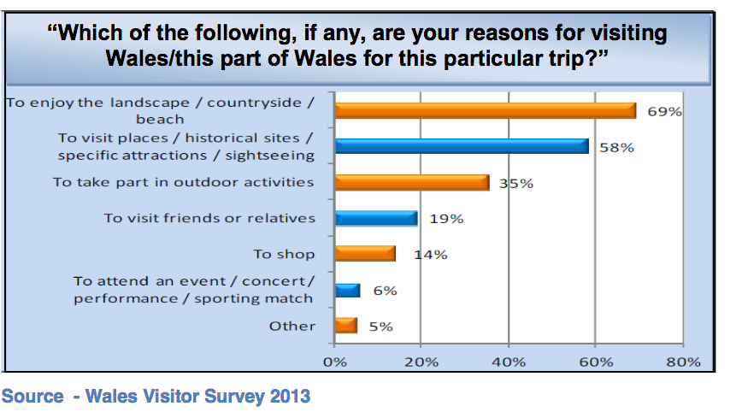
Figure 1 (WGSR, 2014)
Tourism is worth £360.5 million to the Swansea economy, attracts 4.3 million visitors and supports 5,600 jobs. A survey of tourists to Swansea bay in 2012 found that the factors which most influenced their decision to visit was the scenery/landscape (44%) the coast (44%) and the beaches (35%). (TTC, 2015)

Site Description.
Back in 1956, the Gower Peninsula was designated the UK’s first area of outstanding natural beauty. This making it a popular destination for tourists and of course locals too. (Visit Swansea Bay, 2019) The gower is a hotspot for the welsh surf scene and llangennith is the most popular spot, ranked 6th in the UK.(Redbull,2018) But of course it is not just popular among surfers; families, conservationists, holiday makers all use these beaches for both recreational and scientific purposes which is why there is some difficulty within the beach rating system which I will go into more detail about further into the report. The south wales coastline has the second highest tidal range in the world, creating large expanses open space used by the public to enjoy.
Methodology.
The 4 beaches were assessed using an established beach rating system based on three categories; physical factors, biological factors and human use and impacts. The questionnaire is comprised of 50 factors. Some questions were quantitative such as factor number 11 (size of breaking waves) or factor number 1 (Beach width at low tide) are subject to direct measure. While other questions were qualitative such as sand softness and had to be estimated. Nevertheless, even the factors which are estimated can be assigned numerical positions when coming to interpret data.
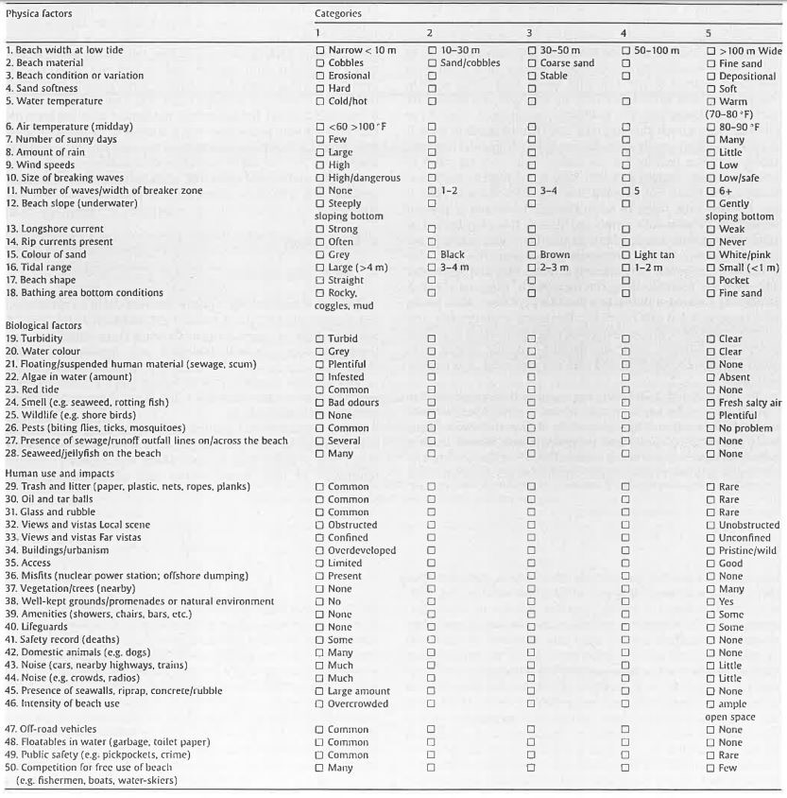
Table 1 – Beach rating checklist (Leatherman, 1998; Williams et al., 1993, 2000) -
The beaches which we assessed were Swansea bay, Port Eynon, Rhossili and Langland. We spent around 3o minutes on each beach to collect the data and any additional information such as “Safety record (Deaths)” which were not present at the site were researched further once we finished the survey.
The categories are 1 – 5, typically 1 being unfavored beach characteristics and 5 being considered admirable. Though, it can seem slightly confusing as the 1st category can be described at both “None” and “Many” which are both have opposing meanings.
In another scenic assessment by Luna Leopold, a study was conducted using a similar checklist - quantitative comparison of some aesthetic factors among rivers. It is recognises in this report that it is difficult to evaluate the factors contributing to aesthetic but still attempts to quantify some elements of aesthetic appeal. (Leopold, 1969) Due to the philosophical nature of this judgement, this methodology is criticised.
Results.
For the results I have calculated an individual percentage for each beach for each factor; physical, biological and human use. For example, to work out the percentage for physical factors for each beach I first calculated the maximum score that could be achieved then calculated what each beach scored then divided it by the beach score by the maximum. This meant that I could then rank them accordingly. The higher the percentage such as 80-90% reflects a high rating in that factor and a low percentage such as 50-60% reflects a low rating in the factor.

Figure 1 Data collected for scenic assessment
For Port Eynon; located on the far south tip of the Gower peninsula scored 63% for physical factors, 86% for biological factors and 81% for human use and impacts. Scoring an average of 77%.
Rhosilli; located on the southwestern tip of the Gower peninsula scored 66% for physical factors, 82% for biological factors and 93% for human use and impacts. Scoring an average of 80%.
Langland; located closer to Swansea city scored 59% for physical factors, 78% for biological factors and 85% for human use and impacts. Scoring an average of 74%.
Swansea; located at the forefront of Swansea city scored 58% for physical factors, 72% for biological and 56% for human use and impacts. Scoring an average of 62%.
Overall ranking of the beaches is Rhosilli coming first with 80%, Port Eynon second with 77%, Langland third with 74% then Swansea ranking last overall with 62%.

Discussion
The questionnaire was completed by myself and my scenic values could be completely different from others which automatically makes this scenic assessment bias. Also, due to the fact that this questionnaire was completed over one day does not give my results an accurate representation of what the beaches are like on a day to day basis. For example; factor 46 - intensity of beach use will differ on a number of factors such as weather, seasonality, half term school holidays etc. Swansea for example on this particular day was not that busy and scored a 3 for factor 46 (Intensity of beach use) but if it was during the summer holidays and on a hot sunny day it would most certainly score a 1 due to the urban surroundings of this beach. For this reason, I would suggest that if this would to be repeated I would do it all year round and have a more accurate database.
Rhosilli scored highest in the assessment, its highest scoring factor is Human use and Impact. This high percentage shows how untouched the beach is and suggests that this beach is perhaps more attractive to people who prefer a scenic view with little human intervention. High scoring factors such as “Building and urbanisation” and “Views and Vistas far vista” show how little urbanisation has impacted the views and beach itself. Thus, making this beach a 3 mile stretch of natural beauty.
Due to the little human impact the beach itself has, it could be less attractive to other groups of people such as families. There is very little in terms of amenities on the beach such as toilets, seating, cafes, changing room etc. These services prove useful to families which have young children/babies to look after; café to feed them instead of carrying it around, somewhere to take shelter and rest, a baby changing room. The access for Rhosilli scored a 3 as from the car park down to the bay was a rather steep decline which would be rather difficult for people with limited/challenging mobility. But this path is in fitting with the natural aesthetic and to enhance it for mobility to keep in fitting could be difficult. Improvement such as a railing for safety purposes could be applied for walkers who may be elderly or children.
The lowest scoring beach in terms of human impact is Swansea bay at 56% meaning that there is high urbanisation around the bay and offers little in terms of natural beauty. The beach stretches for five miles long and is popular for dog walkers and cyclists along the cycle track. This beach is heavily used for recreational activities such as beach sports, bonfires, BBQ’s, fireworks, dog walking etc. Making it very susceptible to factors such as “Trash and Litter” and “Floatables in water” which can lead to the beach looking unattractive and also lead to water quality being low. Swansea Bay’s water quality can dip up and down regularly due to a number of things, the main microbiological inputs are:
- Sewage treatment works
- Urban and rural watercourses
- Combined sewer overflows.
Swansea has had issues with their water quality as when there is heavy rainfall, excess flows are discharged into nearby waters to [prevent homes from being flooded with sewage. (Swansea Council, 2018) Despite this issue, there was no obvious sewage that day so During the survey I rated factor 21 which relates to sewage a 5 which is “none” but after further research I can say that the water quality for the exact date (14/10/2019) is not available online but the days leading up to October were stated as “POOR WATER QUALITY PREDICTED”.(Swansea Council, 2018) This however does not seem to stop the intensity of beach use throughout the summer as when there is a sunny day the beach is overcrowded.
The Swansea sewage and intensity of beach use brings up the issue with this survey, if it is not repeated over at least a year to cover all seasons then it is difficult to get an accurate perspective of what the beaches are like. It was difficult too as my scenic value of something could be completely the opposite of another’s. It proves difficult to measure scenic value using this questionnaire.
A coastal scenic assessment and tourism management which was carried out in western Cuba were very thorough with their methodology in collecting data to assess the scenic value of 43 sites (Afuso, G., Williams, A,T., Cabrea Hernandez, J.A. and Pranzini, E, 2014). The aim of their study was to help managers improve bathing areas, mainly for tourism. The initial survey consisted of interviewing more than one-thousand bathing area users – asking the question “What are the essential parameters that make up a beautiful coastal scene” and also asking the converse. The replies then were analysed and then the number of times a parameter was mentioned was summed. Asking specifically for parameters and then ordering them into a table meant that the results were quantifiable and using checklist approach loosely based on Leopold. A mathematical analytical tool was then applied, the Fuzzy Logic Assessment (FLA) (Arnett, 2015).
The FLA helps to solve a problem after considering all available data, something similar to the process of human reasoning. This method is applied as measuring a landscapes aesthetic is difficult to quantify, an in-depth process must be applied to attempt to measure this such as the FLA as a blunter logic such as Boolean Logic could give in accurate results for such a complex environment. Figure 2 shows an example of fuzzy logic compared to Boolean logic. (Guru99, 2019).

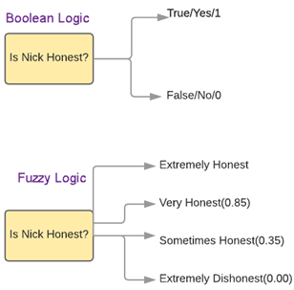
Figure 2 Fuzzy Logic Assessment (FLA) example. (Guru99, 2019)

The Cuban study complied the most common parameters which resulted in 26 in factors – 18 physical and 8 human. The main questionnaire being focused on the physical factors of the beach as it is the scenic value they are trying to quantify to improve beach management for tourist purposes. The process of interviewing over 1000 beach users makes their questionnaire thorough and therefore reliable also.
In another research paper, An evaluation of priorities for beach tourism (House, C. and Phillips, M.R, 2008) the same questionnaire was used but the methodology was still quite different. In this case three different beach users were selected for the physical, biological and human use. These were surfers (physical), conservationists (biological) and mothers (human use). The idea is that all factors of the beach mentioned in table 1 are covered by a group of people. Using the same questionnaire but applying it differently maximises the reliability of the results and get’s a wide range of different views on what is wanted off a beach. E.g. the surfer’s priorities were mostly the physical factors such as “size of breaking waves” or “number of waves/width of breaker zone” as these are applicable to their sport. Whereas the mother’s priorities were weighted more on the human use factors such as “Safety records” or “Amenities”.
Another study on beach quality assessment and management in Portugal used the Bathing area registration and evaluation (BARE), which recognises five beach types, though rive priority issues of concerns to beach users. The research data on beach users’ preferences and priorities were obtained though the same questionnaire; the BARE framework with the questionnaire allowed the management of priorities for each unique beach to have tailored and individual management plan to increase the quality of beach to, in turn, increase tourism for income. (Semeoshenkova,V., 2010)
Site Management recommendations.
Each beach ideally would have a tailored management plan as they’re all unique, like the beach quality assessment plan and management in Portugal approached their management. Although, there are some recommendations which could be made about the Gower beaches which include:
- Rhosilli access - The pathing down the bay from Rhosilli car park is rather steep and uneven which could cause some serious accidents/no access at all. To combat this, a railing (which perhaps ties in with the aesthetic of the natural environment e.g. wood) could be installed to improve access down to the beach and provide an aid for stability.
- Swansea litter - There is an abundance of litter along Swansea bay due to the fact it is an urban area, regular litter picks could be implemented once or twice a month to reduce the rubbish to improve the aesthetics of the beach. More bins along the cycle path too could be an option.

Conclusion.
4 welsh beaches were assessed, using an established beach rating system. Assessment showed that Rhosilli ranked first, Port-Eynon second, Langland third and Swansea Bay last.
Overall, I think that the survey which I conducted on the 17th of October is un-reliable to assess the scenic values of the 4 Gower beaches. If I was to repeat this survey throughout the year and collect data and possibly use other methods such as the BARE framework combined with it or use a wider audience such it would improve the assessment dramatically. This method could be time consuming but the long-term benefits of assessing our beaches properly can in turn create many benefits for our communities economically and environmentally.

Referencing

- Afuso, G., Williams, A,T., Cabrea Hernandez, J.A. and Pranzini, E. (2014) Coastal Scenic assessment and tourism management in western cuba. Available at: https://www.sciencedirect.com/science/article/pii/S0261517713002136 (Accessed 29 November 2019)
- Global Economic Impact & Trends. (2019) Contribution to the world’s economy. London: World Travel & Tourism Council.
- Guru99 (2019) Fuzzy logic tutorial: What is, Application & Example. Available at: https://www.guru99.com/what-is-fuzzy-logic.html (Accessed 27 November 2019)
- House,C. & Phillips, M.r. (2008) An Evaluation of priorities for beach tourism: Case Studies from south wales, UK. Available at: https://www.sciencedirect.com/science/article/pii/S0261517708000976 (Accessed: 27 November 2019)
- Luna Bergere Leopold (1969) Quantitative Comparison of some Aesthetic Factors among Rivers. Available at: https://play.google.com/books/reader?id=wesSQLAxD4oC&hl=en&pg=GBS.PP4 (Accessed 28 November 2019)
- Redbull (2018) The UK’s Best surf spots. Available at:https://www.redbull.com/gb-en/UK-best-surf-spots (Accessed 25 November 2019)
- Statistica research Department (2018) Global travel and tourism industry - Statistics and Facts. Available at: https://www.statista.com/topics/962/global-tourism/ (Accessed 23 November 2019)
- Swansea Council (2018) Bathing water frequently asked questions. Available at: https://www.swansea.gov.uk/bathingwaterFAQs (Accessed 28 November 2019)
- Swansea Council (2018) Bathing Water. Available at: https://www.swansea.gov.uk/bathingwater (Accessed 28 November 2019)
- The International Ecotourism Society (2019) What is Eco Tourism? Available at: https://ecotourism.org/what-is-ecotourism/ (Accessed 23 November 2019)
- The Tourism Company (2015) City and county of Swansea beaches management plan and actions for blue flag beaches of gower (draft). Available at: https://www.swansea.gov.uk/gowerbeachesmanagementplan?fbclid=IwAR1jGHm9lpAvMPX5fsXpZSudMBKJCGIR7oTqt0gvNF_SszTNeQRPBCj33qE (Accessed 25 November 2019)
- Tim Arnett (2015) An introduction to Fuzzy logic [video]. Available at: https://www.youtube.com/watch?v=rln_kZbYaWc (Accessed 25 Novemeber 2019)
- Vera Semeoshenkova (2010) Beach quality assessment and management in the Sotvavento (Eastern) Algarve, Portugal. Available at: https://core.ac.uk/download/pdf/61516587.pdf (Accessed:27 November 2019)
- Visit Swansea Bay (2019) The Gower Peninsular. Available at: https://www.visitswanseabay.com/destinations/gower-peninsula/ (Accessed 24 November 2019)
- Welsh Government Social Research (2014) Tourist Attractions: Current Trends. Available at: https://gov.wales/sites/default/files/statistics-and-research/2019-05/visits-tourist-attractions-trends-2013.pdf (Accessed 24 November 2019)

