

Jack Charles Burden

Reflection on Study Skills

School of Science and Art
HNC Level 4 Ordinance, Munitions and Explosives

Academic Year: 2023 - 2024

Supervisor: Jenni Steen

© UWTSD 2023. All rights reserved. No part of this publication may be reproduced without the written permission of the copyright owner.

Academic integrity declaration
I declare that:
- the thesis submitted has been written by me alone.
- the thesis submitted has not been previously submitted to this university or any other.
- that all content, including primary and/or secondary data, is true to the best of my knowledge.
- that all quotations and references have been duly acknowledged according to the requirements of academic research.
I understand that to knowingly submit work in violation of the above statement will be considered by examiners as academic misconduct.

Abstract
Presentation skills are essential for any presentation, within this assignment we look into those skills and why they are needed. We also investigate learning styles and employability skills, conduct a self-evaluation, and talk about data protection. Finally, a brief review of Torpex a torpedo explosive.

Keywords:
Learning Styles
Employability Skills
Data
Torpex
Table of Contents
1 – Presentation
2 – Skills Evaluation
3 – Application
4 – Conclusion and Evaluation

List of Abbreviations
IT | Information Technology
OME | Ordinance Munitions and Explosives
Torpex | Torpedo Explosive
PBX | Polymer Bonded Explosive
RAF | Royal Air Force
RBX | Royal Demolition Explosive (Cyclonite)

Presentation

Overview
The objective of the presentation was to give a brief overview of yourself to the class so everybody present would then know more about everyone. Jack Burden’s presentation consisted of a deep explanation of his experiences throughout his time at the Royal Air Force Air Cadets, as it took up a lot of his free time over the last 6 years. The student’s cadet career ended in December 2023 due to turning 20 years old. He made my way up the Non-commissioned Officer ranks to Flight Sergeant as well as accumulating many awards and life skills that will be useful in any life scenario. These include the Duke of Edinburgh Bronze award, First Aid training, extensive leadership training, and Method of Instruction. Cadets also allowed teenagers to experience activities they would not normally get the chance to. For example: He has flown a plane as well as performed Aerobatics, He has also shot two rifles as well as underwent Initial Weapons Training for both and he also got the opportunity to learn and perform arms drill in front of a Royal Air Force Regiment Group Captain. These skills and experiences he has been through have shaped the person he is today which is why he chose to focus on cadets for this personal presentation.

Personal Presentation Reflection
When producing the presentation, Jack Burden believed that it was important for the audience to focus on himself and his commentary over the slides. All the slides consist of almost all photos [1][2][3][4]. Looking back on the presentation, he did have a lot of the allocated time left after he finished speaking. This was due to speaking quickly because of stress over the condensed time limit of five minutes. After he completed creating the presentation, the student did not practice at all, he thought as he had prior experience with presenting, that he wouldn’t have to. This was a mistake, in the future, he will not underestimate any type of presentation, no matter how small the project is.

What makes a Successful Presentation?
After this presentation as well as watching others present, Jack Burden feels that he now knows what presentation skills are required for a successful presentation. All presentations with both visual aids as well as an effective and confident speaker were the most engaging. Confidence from the speaker was portrayed with body language and fluid/non-ridged movements projecting a human side to the presentation. Even though each individual had five minutes to present, he has learnt a lot from watching others and the skills they showed, he has taken these into account and will use these skills effectively for his next presentation.

Skills Evaluation

Skills Required for Successful Learning
After extensive research, a common frequency when talking about skills that are essential for a successful higher education learning environment was different learning styles. Each student has a unique learning style they find easier than the rest. These styles are as follows: Visual, Auditory, Reading and Writing, Kinaesthic. These skills each have individual traits for learning and revision. For example, a student that is more inclined towards the kinaesthetic learning style would perform better within university when exposed to hands-on demonstrations. Whereas a student more acquitted towards the auditory learning style would prefer to sit in on a verbal presentation. A visual learner is more inclined to learn through videos or visually appealing presentations however a reading and writing student would favour a book or making detailed notes on a case study. Learning styles don’t just affect a student learning within a lecture hall but their own independent revision as well. Our kinaesthetic student would prefer making a revision game or puzzle. Compared to our auditory student who would favour listening to a recorded lecture.
It is not just learning styles that are developed and enhanced during higher education but learning skills as well. Universally, there are a number of qualities and skills that make up a good learner. These qualities include: realising that learning is a lifetime process, having confidence in yourself as a learner, believing in yourself and keeping a positive attitude. These skills are imperative when a student goes through higher education as the learning environment around them is a lot more ruthless compared to sixth form or college.

Skills Required in a Professional Environment
Within the working world, employers search for job applicants who have good employability skills. Similarly to the qualities of a good learner, employability skills are an essential asset for anybody within their professional life. These attributes each represent a different key quality an employer desires from their employees. Teamwork is always required in any sort of professional environment. The ability to work as a team also demonstrates a sense of self discipline. Whereas leadership, on the other hand, is not always required. When leadership is needed, however, it is imperative that the employees with this specific skill understand the difference between a boss and a leader as both styles of leadership are required in different scenarios. Timekeeping is an essential quality for anyone attempting to acquire a job. If someone cannot show up on time to work or meetings, why would an employer shortlist said person? Arguably, problem solving is the most important skill in anyone’s professional toolbox. It applies to every job. The more complex problem someone can solve, the more money an employer will pay that person. Initiative goes hand in hand with problem solving. Communication is key within a working environment. Without communication, the rest of these skills become useless. Employers look for a trustworthy employee as they are entrusting their company information to them. Reliability is another important quality as, like communication, many other skills require being reliable. Self-management. An employer can’t hold all their employees hands all day every day so self-management is an imperative skill.
Employers look for all the aforementioned skills as all of them combined are used day in and day out in any type of business. An employer needs to be able to trust their employees to work and that is what these qualities illustrate.

Self-Evaluation
After conducting a self-evaluation online, the student (Jack Burden) discovered his personality type was a “Mediator” (INFP-T) [5]. Jack's strengths are that he is empathetic, generous, open-minded, creative, passionate, and idealistic [6]. On the contrary, his weaknesses state that he is unrealistic, self-isolating, unfocused, emotionally vulnerable, too eager to please, and self-critical [6]. Reflecting on both the strengths and weaknesses, the student seems to be mostly idealistic with life however this proves unrealistic in the real world which is ultimately a weakness. All the strengths and weaknesses link into this overall comparison. ‘Mediators’ prefer a career that they are passionate about. People with this personality type often lean towards a career in the performing arts like music, drama or dance [5]. Comparing this to Jack’s current job, he doesn’t work in the performing arts however he does DJ in his spare time. He is very passionate about his work at QinetiQ and is always very eager to learn more about the job and the defence sector. Before taking the test, Jack felt that the test wouldn’t be accurate. However, he was proven wrong, the test was scarily accurate to how he is and how he acts in different scenarios. Jack learned that he is more inclined to a career in the performing arts and that he could improve his unfocused emotional outlook on life.

Academic and Personal Goals
Jack Burden’s academic and personal goals all comply with the SMART guidelines. This synonym stands for Specific, Measurable, Achievable, Relevant and Time-bound. These attributes are essential for any goal that anyone is trying to achieve. Jack’s short-term academic objectives consist of passing the study skills module and researching compatibility groups. Passing the Study Skills module at university is important for Jack as this module directly impacts all other areas of study during his course, hence why this is one of his short-term goals. Compatibility groups are imperative to his job role within QinetiQ as he frequently works around Ordinance, Munitions and Explosives (OME) and deals with storing them. This information will be helpful to Jack going forwards in his HNC course as well as his job within QinetiQ. His long-term goals consist of passing his HNC course and becoming a knowledgeable ammunition inspector within QinetiQ. Jack wants to pass his course as that would open many doors for him academically and professionally. If he wanted to, he could go on to study for the Degree or he could apply for a higher position in QinetiQ, this is an important goal as it directly impacts Jacks future. Becoming a knowledgeable ammunition inspector is a key next step in his professional career after finishing the HNC. This would allow Jack to gather more information about his job on top of the knowledge he would have gained from university.

Application

Looking after your data
Backing up data in an academic and professional setting is essential. Ensuring that the work you do doesn’t get lost in the event of a virus or malware on a computer. The “in 3 different places” rule was created for this reason. This rule outlines how you need to have 3 total copies of a piece of work, 2 in separate locations and 1 off-site. This is done so that if a file becomes corrupt, you have 2 backups. In the same way, if a computer becomes compromised, you will have a spare copy off-site completely that has no risk of being harmed. The “in 3 different places” rule provides a strong level of data protection in many different scenarios. The student, Jack Burden, uses this method. He keeps 2 copies of a piece of work in the documents folder and the desktop folder on the same device. Similarly, he keeps a spare copy on a completely different device, his work laptop. For work, Jack keeps those off-site copies on his personal laptop at home if he can. Sometimes it is difficult to do this as a lot of the work he does is secure and cannot be on personal devices that aren’t a part of the REST network. In this case, he will email the file to himself.

Time Management and Self-organisation
Jack Burden the author of this assignment’s organisation skills are not consistent. They are dependent on what the task is and the requirements of said task. His organisation is affected by stressful situations, if a task is extensive and time consuming then he gets stressed easily. To counteract this, Jack breaks down the task at hand into smaller jobs to not overwhelm him. Smoking cigarettes also helps him de-stress when dealing with a large job. He also listens to music whilst working. What this does is relax Jack and puts him in a good mentality to work. The music he plays is on low volume so he can still focus on the task at hand. Jack admits he takes regular breaks when working. This is so he doesn’t get burnt out. He takes a break each hour and a half on average. Jack’s time management outside of a professional environment are not good. He leaves most activities until last minute. He does not use a calendar outside of work despite him finding the work calendar useful. He does endeavour to use a calendar for university revision as well as tasks within work that do not involve the rest of his team.

Independent Study
Within this section, we will be talking about Torpex. Torpex (or Torpedo Explosive) first came into military service in 1942 during the Second World War. It was made up of 40% RDX, 40% TNT and 18% aluminium powder [7]. Torpex was an improvement to its predecessor, a 50% improvement was seen as well as a 75% improvement in volume for volume [7]. As the name suggests, it was mostly used in a maritime setting for torpedoes it was also the most powerful underwater explosive in the Allies arsenal at the time. Before 1941 it was believed torpex was useless in the air however, in 1943 it was reported that it was 20% more effective than bombs filled with Composition B, [7] which is what the RAF were using previously. When torpex was introduced into aerial combat, it was mostly used for airbourne depth charges [7]. It was famously also used during the daring Dambusters Raid making up the ‘Bouncing Bombs’. Barnes Wallis would go on to produce the most powerful non-atomic bomb used during the Second World War which contained a staggering 9000 pounds of Torpex, reaching almost supersonic speed [7]. Torpex was later made obsolete by PBX (or Polymer Bonded Explosive) with PBX’s composition being an oxidiser, a binder and a plasticizer. This was an easy change as Torpex is classed as an Intense Munition otherwise known as a raw explosive, it was very volatile as any little thing that could disrupt its state and could set it off. PBX is a lot safer as the bonds are stronger, meaning it is a less sensitive explosive. Overall the student, Jack Burden, feels that torpex was a good explosive at the time of its use however in modern times there are safer options like PBX that are also more powerful giving torpex little to no roles in the defence field today.

Conclusion and Evaluation

To summarise this assignment, the student reflected on his presentation as well as the skills required for a successful and engaging presentation. Jack Burden, the student, also researched and explained different learning styles and the skills needed in a higher education setting also identifying what learning style he is. Similarly, Jack recognised what skills are essential within a professional workplace. On top of this, he also underwent a self-evaluation discovering his personality type as well as his strengths and weaknesses. Jack listed and explained his long and short-term goals that conform with the SMART guidelines. Jack dove into how to successfully look after his data and discussed time management and self-organisation skills. Finally, he finished with a short review on Torpex a powerful underwater explosive. More research needs to be done with regards to his personality type for him to fully understand it as well as fully understanding the difference between learning skills and employability skills

Appendices
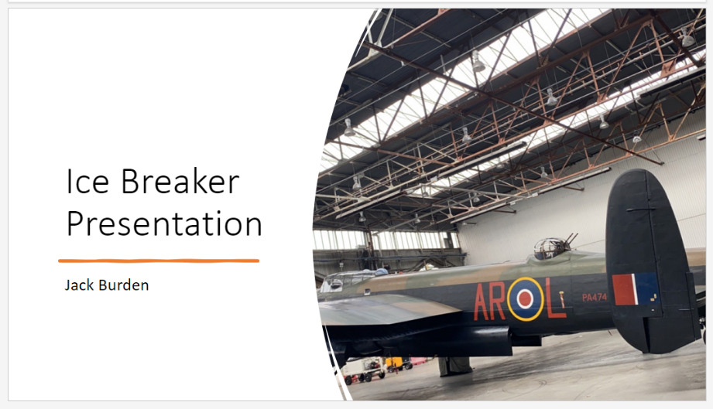
[1]

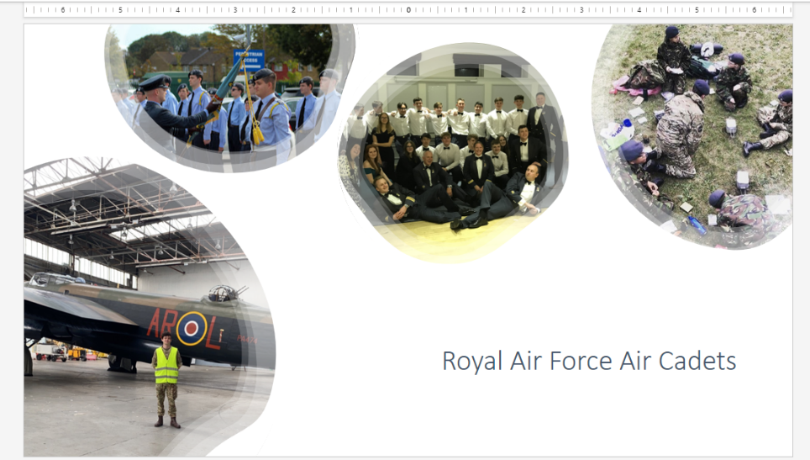
[2]

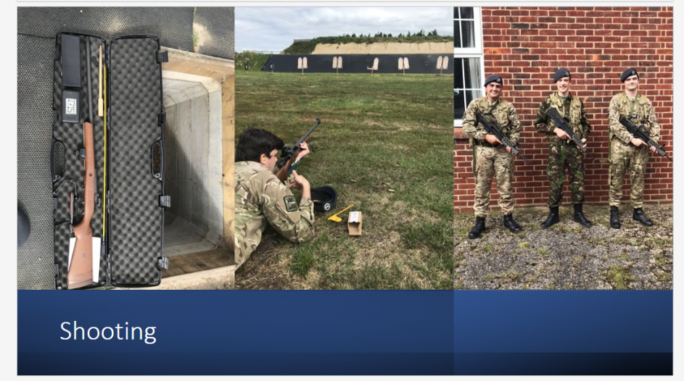
[3]

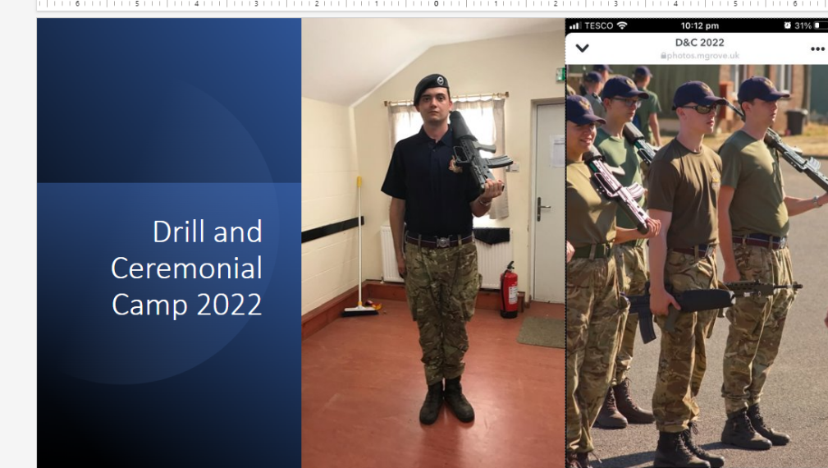
[4]

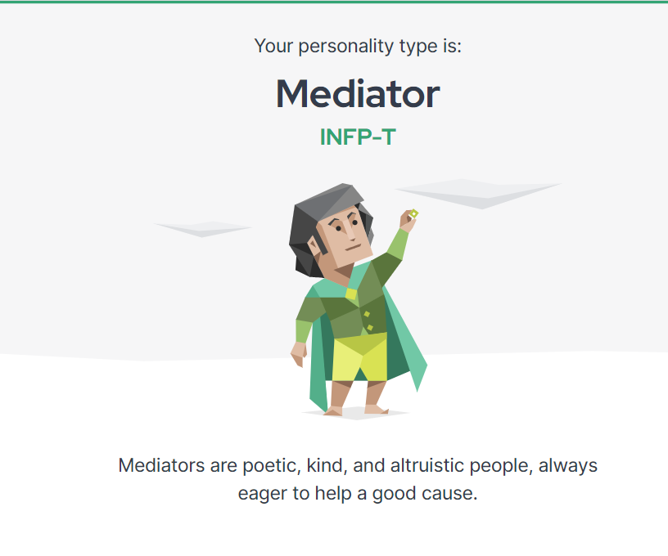
[5]

[6] Analytics Limited. (2011 - 2024), 16 personalities [online]. Available: https://www.16personalities.com/infp-careers (accessed on 08/01/2024)
[7] CFB. Baxter, The Secret History of RDX, 1st edition. United States: The University Press of Kentucky. 2018.

