Jodie Chung
2203184
Graphic Design
Module: ADAD5004 Research in practice, Donna Williams
This essay is an investigation into three chosen keywords which will eventually form a question for my independent project. The words are protest, publication, and nostalgia. These words were chosen, based on their connection to design and my fascination within each of them. In researching protest art, this essay will review the evolution of designers in providing symbols and visual identities to movements in various mediums. Expanding on the impact of design as a means of communication between people who need support and those who can provide it to create social consciousness, encourage action and force change only through the use of design. Then, I will look at the word, publication by analysing the art form that relies heavily on crafting careful layouts with typography and graphics to entice readers. With a focus on questioning the people who refer to print as dead with concerns about the rise of digital media, my question is, is there a threat to publication? The essay will, furthermore, be providing research on nostalgia and its role in design where reinventing familiar items help brands resonate more with consumers, as nostalgia is described as a bittersweet longing for one’s past.
Protest is described, as a “statement or action expressing disapproval of or objection to something.” the bridge between art and protest has been a stable one as art is a powerful tool for social and political change as, Rippon suggests, “visual imagery has provided a powerful vehicle for dramatizing injustice and urging reform. Posters, photographs, drawings, banners, and symbols” (Rippon, 2020, p11) Protests that have been expressed visually have been conveyed throughout the ages with early examples from, the pre-1900s with the use of the political print with imagery depicting the actions done against the people by their leaders, to spread ideas to people who couldn’t read, to the 21st century calling for an end to racial discrimination and LGBT+Q rights. For example, in the early twentieth century an art movement that has been prominent with the social power of arts is Avant Garde where it developed into more movements such as Dada, futurism and surrealism came and questioned how the arts could be political interventions (Reed, 2016)
Mostly every art form has been a part of protest, especially with the rise of digital media it’s much easier to advertise movements and build community. The most widely used medium is poster art, as Reed (2016) mentions, posters are inexpensive in comparison to some art mediums, the style may have changed with people screen printing to collage or via the computer, but the message has stayed the same, which is to tell a story in a short burst. In the book How the Arts and Humanities are Transforming America Ella Diaz looks back at the art of protest done by students at her university and the process behind marchers making their posters. There’s a sense of power to the poster and its maker defying what it means to be an artist, which is constantly questioned when “the reality that most art is made at the crossroads of political uprising and social and cultural change” (Diaz, 2020, p150) The designs and art coming from protests aren’t an answer to the injustices they speak on, but an entertaining way of raising peoples consciousness and a space for hope in a future that involves their lives mattering and becoming more visible to everyone.
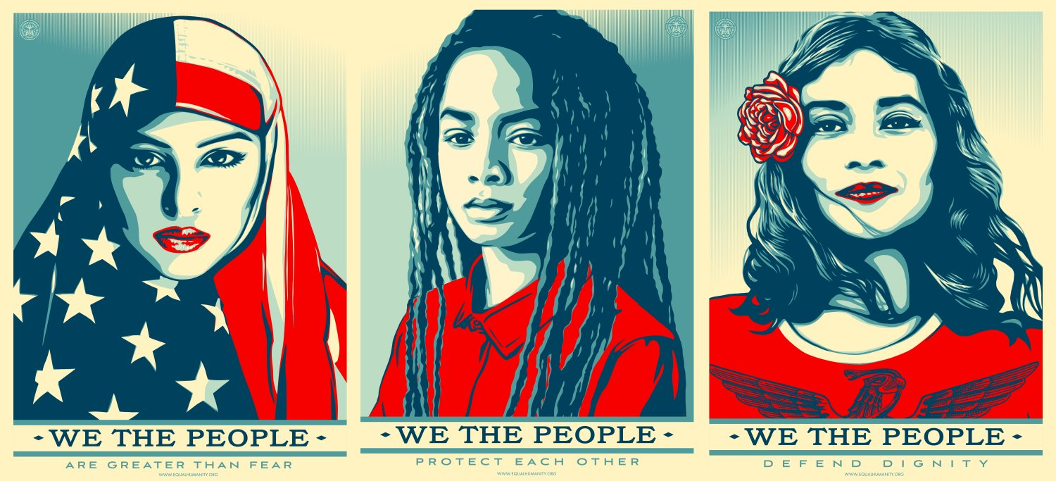
Figure1. Fairey, S. (2017) We The People
poster

For example, a prominent activist artist was Shepard Fairey famous for the Barack Obama portrait captioned hope. Fairey has always created artworks to promote social issues and in this series of posters they’re aimed against Donald Trump. He created a series of portraits of groups that are frequently the target of hate or racism with the slogan “we the people” to be distributed and used at protests, representing the mission of the artwork being a call to action via community engagement and conversion through art. Fairey’s street art style of vibrant colours and clear paint strokes is reminiscent of socialist realism where the art had a similar style and message which was to be easily understood by viewers, and the imagery often glorified the working class portraying them as hero’s with a sense of optimism for the future as it’d emphasize on progress and the collective agreement of people under socialism. This relates to the ‘we the people’ campaign as they aimed to convey a feeling of togetherness and, provide power to those who are usually the ones in the back or scared to express their point of view.
The following keyword, ‘Publication’, is a combination of many design principles that have the role of capturing a specific aesthetic and feeling of a book just through layout, structure, and visual imagery. To create an effective publication, research into my audience would dictate how the project is perceived as different audiences respond to visual stimuli in various ways. As Bhaskaran mentions in “What is publication design?” books and magazines have the potential to sell a lifestyle through design, meaning subscribing to a particular topic can associate you with like-minded individuals or transport you to another time and place. Publication design has changed drastically as the design process has become digitalised, causing people to predict the death of print. However, there’s been much digital resistance from oppositional groups like “punks” whose ethics often describe living an individualistic life based on producing their own goods and avoiding unnecessary consumption from corporations. (Malott and Pena 2004) This has led to the creation of zines and self-published, non-profit magazines as a use of communication and tool of resistance, and with that there comes a sense of personability to the zines in comparison to the mass-produced books with lack of originality. From there, researching the aspects that make a good design in the publication world relies heavily on the cover, as people should be actively consuming the covers as they work as a promotional tool.
Another factor to consider alongside typography and grid layouts within the book is a publication’s life span, as magazines are on occasion obligated to follow the latest design trends, causing them to not stand the test of time, although, they work as a way of looking back at a specific time in culture. Being able to question what is important in publishing is key to maintaining relevance and appeal to changing audiences over time. The goal of a publication is mainly four categories: to inform if it’s a textbook or instruction manual, as you want to instruct the reader on what to do, persuade by convincing the reader to make a decision or act in a specific way, and sell by getting them to buy a particular product you’re
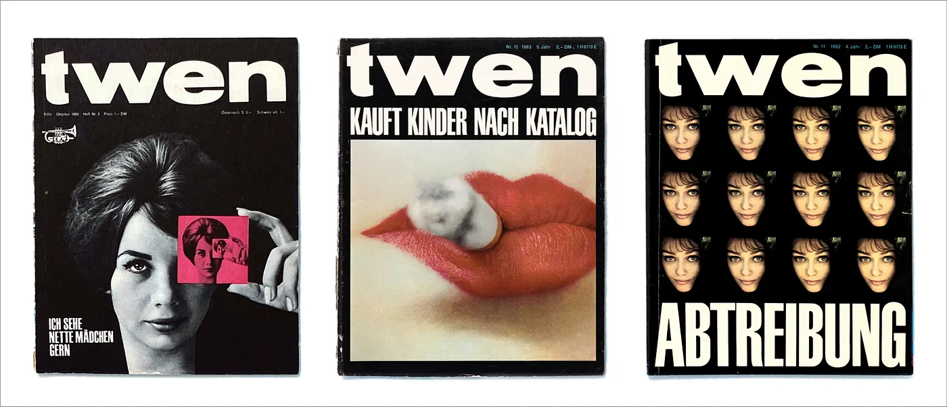
promoting, lastly entertain such as comics and novels (Evans, 2006) when these goals, are achieved it allows for an effective design approach.
Figure2. Fleckhaus, W. (1959-71) Twen Magazine Covers

Willy Fleckhaus was a German graphic designer and art director who was known for his revolutionary work in the magazine ‘Twen’ with the modern typography style and distinctive layouts transforming publishing. In his magazine covers, they included features of swiss design and his own approach where we can see his manipulation of images by scale and contrast to seize the reader’s attention, as Fleckhaus’s covers often contained visuals that captures the emotions of the time and provoked viewers to engage with the content. His choice in typography is notable too, mixed with his unconventional grid structures of a 12-grid column providing a range of flexibility for the text and visuals to take over white spaces within the spread. Since his layouts were one of the first to break conventional rules as he contrasted a mix of differently sized media alongside his bold headlines of text. There’s a debate within publication with readability versus legibility and Fleckhaus’s typography selection is not only visually appealing but highly readable as we can see the text for the magazine title stretches across the page to fill the most space to accompany the image, leading to questions of whether does type just exist to be read or is there an illustrative element that overrides the importance of legibility. (Bhaskaran, 2009)
Nostalgia was once considered a medical disease comparable to homesickness and in the 17th century some physicians described it as “a sharp differential in atmospheric pressure causing excessive body pressurization” (Chrostowska, S.D. (2010) but slowly as general knowledge and the switch to psychiatry, nostalgia studies Svetlana Boym defines nostalgia “as a longing for a home that no longer exists or has never existed. Nostalgia is a sentiment of loss and displacement”. This section will investigate the various themes that nostalgia fits into, including but not limited to, how nostalgia has affected design through aesthetics and the capitalization of nostalgia. These effects are particularly interesting due to the way that capitalization causes us to no longer have private and personal memories but become products to be used and consumed by the wider media market.
An aspect in design I want to focus on, that nostalgia affects most in my opinion is packaging design, as it has a power to evoke strong emotions via the history of the product that will resonate with consumer’s memories which creates brand loyalty but also, still entice new customers, to be introduced to a brand with a long history. Relating to their duty of staying relevant and not falling behind, is why in some cases companies will rebrand to a more modern font choice or colours. Amongst this there’s a trend of nostalgic products that are produced and labelled as ‘retro’ which is where they have the aesthetic features of when they were popular but made with more modern technology. (Sardinha et al, 2016, p223) In Retro: The culture of revival (2006) , Guffey briefly mentions nostalgic items in comparison to retro items and depicts nostalgia as the tug of a childhood memory and sentimental values of the past rooted in significance for the viewer whereas retro is more of recreating the style of an era celebrating the aesthetics and trends of the past, not any particular personal memories.
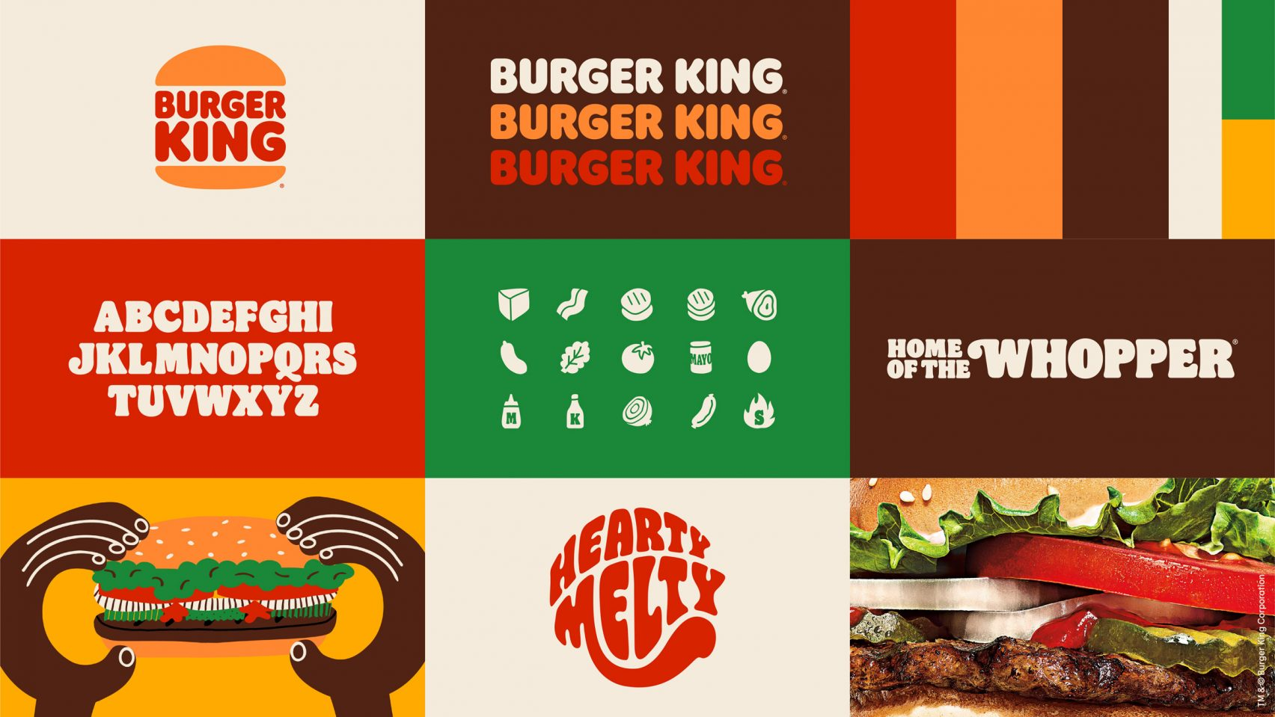
Packaging is something that affects the consumer the most, as it has an important role in communicating the brand values, features of said brand, and their content and quality of the product as “A message that is appealing to several senses stands a better chance of breaking through and makes a stronger connection between the sender and receiver of the message.” (Nasir et al, 2019) In Nostalgic design (2018) we see how nostalgic longing is described as a loss and a critique of the present as it rebels against modernity, showing how a yearning for the past in this ever-changing society can affect the future with community and our connection to others as we become more individualistic, people long for a sense of belonging and simplicity of the past.

Figure3. JKRglobal. (2021) Burger king brand redesign

Within my research of designs that implement ‘nostalgia’ in their branding, I found out about the Burger king rebrand, the first in over 20 years which ranged from a new logo which was a return of an old logo used in the late 60s with a few alterations as well as an updated colour palette and packaging design. This redesign is significant because, of the thought process behind the logo change as Raphael Abreu, head of design for restaurant brands international says, “we modernised a classic, making sure the new design was long-lasting, timeless” (Abreu, R, 2021), by utilising the influence of nostalgia they’ve balanced the connection of older consumers with the brands past by refreshing an vintage logo but also, mixed it with modern elements to stay relevant and resonate with a wider audience of new consumers and generation. It’s often found that brands incorporate nostalgia within their work as there are linked to themes of trustworthness and it strengthens customer loyalty (Kurklinkus, W. 2018) as the brand looks and feels as though they’ve been here for a long time and the authenticity is higher in comparison to other brands in the fast-food market. Moreover, not only having the retro design elements they’ve reintroduced old favourite menu items which allowed them to extend the hand to the consumers beyond aesthetic looks and giving a sense of familiarity with the brand and reinstating their presence in the community.
In this proposal I have discussed my three words, protest where I have examined the variations of protest art and the relationship between artists and social resistance, as I focused on how the arts are a way of sending a message to those who don’t have a voice. I have also looked at publication as a method to present my practice next year and the various factors needed to create effective communication through publication design and a wider demographic for my audience to respond to. Then in Nostalgia, I fixated on “The future of nostalgia” by key thinker, Svetlana Boym as she emphasized on how viewing the past nostalgically isn’t to recall it exactly as it happened but describes it more as a distortion of the past which can be dangerous as the longing we feel stop us from engaging with the future, and the impact of nostalgia on our designs to create work that resonates with consumers.
Based on all this research, a possible end project or area to investigate could relate to the influence of nostalgia and the blurring between the past and the future through a publication format such as a zine, that takes the viewer through time within certain design techniques whether it’s the timeline of poster design or style of packaging of fruit stickers. It’d be a collection of mundane objects as they are the true proof of the progression of time, and it would show the beauty within the ordinary. Having this would mean research into the history of the product and how certain aspects have changed due to trends and possibly the core brand values over time might have altered leading to rebrands. This whole process has generated some questions, involving the keywords for instance, how does the commercialization of nostalgia affect the authenticity behind designs as in is there any originality left in the design space or is everything a recycle of the past design culture.
Bibliography

Breeding, G. (2022). Revisiting Order and Chaos after the Pandemic. [online] Journey Group. Available at:https://medium.com/journey-group/revisiting-order-and-chaos-after-the-pandemic-e479aeb7bc1d (Accessed 24 Apr. 2024)

Brewer, J. (2021). The Burger King rebrand celebrates its design history and irreverent personality. [online] www.itsnicethat.com. Available at: https://www.itsnicethat.com/news/burger-king-rebrand-jkr-graphic-design-070121. (Accessed 24 April)

Chrostowska, S.D. (2010). Consumed by Nostalgia? SubStance, 39(2), pp.52–70. doi:https://doi.org/10.1353/sub.0.0085. Available at: https://muse.jhu.edu/pub/19/article/389606/summary

Debies-Carl, J. S. (2015). ‘Print Is Dead: The Promise and Peril of Online Media for Subcultural Resistance.’ Journal of Contemporary Ethnography, 44(6), 679-708. Available at: https://doi.org/10.1177/0891241614546553 (Accessed 22 April 2024)

Eye Magazine. (n.d.). Eye Magazine | Review | A single-minded art director. [online] Available at: https://www.eyemagazine.com/review/article/a-single-minded-art-director. (Accessed 23 April 2024)

Nasir S et al. (2019). ‘Consumers' Nostalgia Proneness and Their Attitude Towards Nostalgic Packaging’, Congress of International Applied Social Sciences. Turkey, 4-6 April. Available at: https://www.researchgate.net/publication/339018346_Consumers'_Nostalgia_Proneness_and_Their_Attitude_Towards_Nostalgic_Packaging#:~:text=Findings%3A%20Findings%20of%20the%20study,respondents%20are%20evoked%20by%20nostalgia.
(Accessed 24 April)

Readymag Stories: Willy Fleckhaus. (n.d.). Readymag Stories: Willy Fleckhaus — Aufwarts. [online] Available at: https://readymag.com/designstories/willy-fleckhaus/aufwarts/. (Accessed 23 April 2024)

"Retro Design and Marketing of Nostalgia: Influence of the nostalgic trend on consumer behavior" (2016) Revista Vértices, 17(3), p. 215–233.doi:10.19180/1809-2667.v17n315-12. (Accessed 24 April)

The Editors of Encyclopaedia Britannica (2019). Socialist Realism | art. In: Encyclopædia Britannica. [online] Available at: https://www.britannica.com/art/Socialist-Realism. (Accessed 22 April 2024)

The Art Story (n.d.). Shepard Fairey Paintings, Bio, Ideas. [online] The Art Story. Available at: https://www.theartstory.org/artist/fairey-shepard/.(Accessed 22 April 2024)
‌

Books
‌Bhaskaran, L. (2006). What is Publication Design?.

Boym, S. (2001). The Future of Nostalgia. New York: Basic Books.

Caruso, H.Y. (2008) “The art of Shepard Fairey: questioning everything,” International Journal of Multicultural Education, 10(2). ‌

Curry Malott and Peña, M. (2004). Punk rockers’ revolution : a pedagogy of race, class, and gender. New York: Peter Lang.

Fahlenbrach, K., Klimke, M. and Scharloth, J. (eds) (2016) Protest cultures a companion. New York ; Berghahn.

Henseler, C. (2020). Extraordinary partnerships : how the arts and humanities are transforming America. Amherst, Massachusetts: Lever Press.

Hurlburt, A. (1976). Publication Design. New York : Van Nostrand Reinhold Company.

Kauffman, L.A. (2018) How to read a protest : the art of organizing and resistance. Berkeley, CA: University of California Press.

Lau, L. and E. Dawson Varughese (2015). Indian Writing in English and Issues of Visual Representation. Palgrave Pivot.
McQuiston, L. (2019) Protest! : a history of social and political protest graphics. Princeton, NJ: Princeton University Press.

Poppy Evans (2006). Exploring publication design. Clifton Park, Ny: Thomson/Delmar Learning.

Rippon, J. (2020). ART OF PROTEST : a visual history of dissent and resistance..

Roy Paul Nelson (1991). Publication design. Dubuque, Ia: Wm. C. Brown.

White, D. and Hartle, S. (eds) (2022) Visual activism in the 21st century art, protest and resistance in an uncertain world. First edition. London [England: Bloomsbury Visual Arts.

Xue, H. (2017). On design and nostalgia : from the perspectives of culture, experience and design strategy. Helsinki: Aalto University, School Of Arts, Design And Architecture, Department Of Design.

List of Figures
figure 1 - Shepard, F. (2017) We the people [Screen prints]. Available at: https://www.artsy.net/artwork/shepard-fairey-we-the-people-58 (Accessed: 21 April 2024)

figure 2 - Fleckhaus, W. (1959-1971) Twen Magazine Covers [Magazines}. Available at: https://medium.com/journey-group/revisiting-order-and-chaos-after-the-pandemic-e479aeb7bc1d (Accessed 24 April 2024)

figure 3 - JKRGlobal (2021) Burgerking redesign [Packaging] Available at: https://jkrglobal.com/case-studies/burger-king/ (Accessed 24 April 2024)

