  Component One: Student Journal (learning log) | Student No: | 2238997
 | Module Title: | Operating Hotel Facilities
 | Module Code: | BMIH4006
 | Lecturer: | Natalie Brailsford
Introduction
Reflective practice guarantees that a student can identify what additional knowledge and skills they will need to become more proficient and effective in their future professional and career paths (Williams et al., 2020). I have conducted my placement at DoubleTree Hotel, and I had to perform different activities related housekeeping department. Here, I will present an activity log with my reflection using the Gibbs reflective model with proper critical analysis and justifications.
Journal on front housekeeping department placement
Description
As my placement covered all the departments’ work, I have worked within the housekeeping department of the hotel. I have conducted a variety of activities like ensuring orderliness and cleanliness of the rooms, corridors, and public areas (Bridger, 2018). I made beds, replenished amenities, cleaned rooms, and meticulously vacuumed floors. I worked with the laundry department also. I washed and folded clothes maintaining the hotel standards. These activities are highly related to cleanliness. Besides, these activities help improve the overall experiences of the guests and enjoy their stays with comfort (Cottrell, 2019). I was taught properly to ensure and establish attention to detail so that the hotel can provide better value addition to the customer experience.
Feelings
As housekeeping staff members have higher responsibilities to manage the rooms and places around the room and hotel, I felt high pressure because of the higher level of responsibilities. If a guest finds any improper things that may ruin their experiences, the hotel may face greater consequences that may make them choose other hotels (Leiter and Bakker, 2010). Activities here were controlled by a fast-paced environment with tight deadlines. Initially, some of the staff members were reluctant to let me conduct some activities that needed perfection. In this department, both self-practices and collaboration are essential based on different activities (Mullins and Dossor, 2013). Though I was not slower in the individual activities at first, I managed to balance myself with the workflow. I encountered challenges like time management. consecutively, I became effective with proper adaptability, resilience, and management.
Evaluation
From my activities, I have analysed that I need both physical abilities and mental creativity while doing work in this department (Raghubalan and Raghubalan, 2016). I have better mental creativity which helped me show my practice of attention to detail. Besides, I was very much committed to my activities. hence, other staff members appreciated my endeavours. Also, I was able to demonstrate effective communication to the other members regularly. I was good with managing timelines and chronological lists of activities. However, I lacked a bit of physical balance while helping the laundry team and cleaning the backyard areas. Besides, like my performance in front office operations, I was not very good at solving instantaneous issues or providing extra value to resilient needs (Quick, 2020). Hence, I need to prepare myself to tackle unexpected challenges.
Analysis
From the study of the module, it is quite clear to me that the housekeeping department serves as the backbone of the hotel's operations (Casado, 2012). It only serves as the surface activity but also plays a multifunctional role to enhance the overall value and maintain highly satisfied guests (Sharma et al., 2020). I have directly participated in different activities in this department and enhanced myself. One important matter I must say is that I am now a better manager of hotel service resources. Daily operations help me get the direct various facets of hotel management. Besides, the initiatives that ensure safety and health standards have improved my ability to control and manage resources well (Ferdinand and Kitchin, 2017). The management styles adopted within the housekeeping department significantly influence employee morale, productivity, and job satisfaction (Bridger, 2018). I have also observed these matters and I think I will be able to manage these things properly. In the future, I will try to become more efficient in resource planning in management with my experience from here.

Conclusion
I have started to view these activities from new points. Also, I found how activities in this department help in efficient resource planning. Besides, I am able to find some drawbacks in me which I must manage. Balancing all these can help me be a better hospitality professional.
Action Plan
I must be efficient in managing tasks and must improve my resilience and problem-solving skills. Hence, I will try to manage my personal activities based on a time log and will try to manage things accordingly. Also, I must conduct different workshops and training activities so that my problem-solving skills are improved. Finally, I must be continuously improving myself with literature and practical knowledge.
Conclusion
In conclusion, along with my other operations during the placement, the experience from the housekeeping department has shaped my perception of the hospitality industry. Keeping all of these things in check can help me become a more effective hospitality professional.

Component Two: Practical task assessment- scenario.
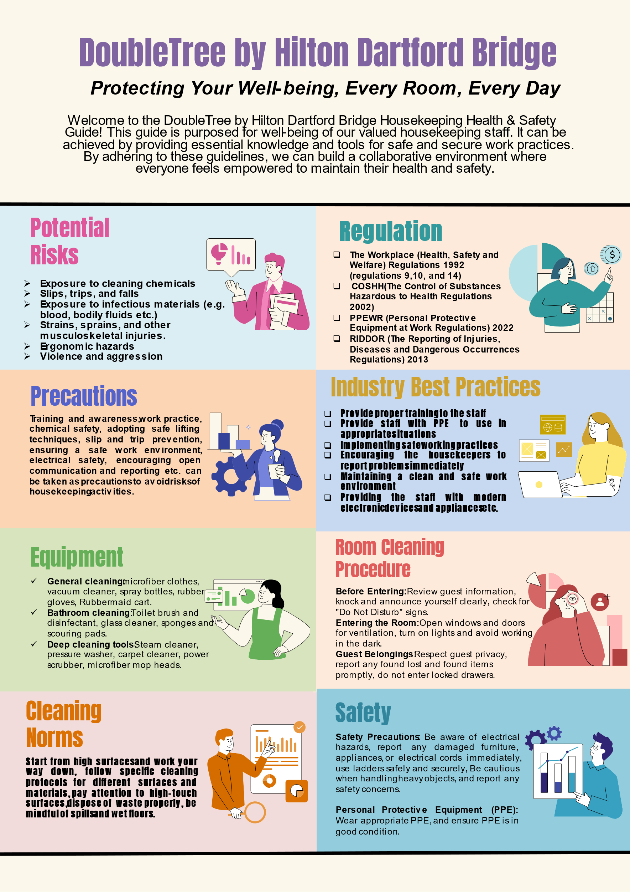

DoubleTree by Hilton Dartford Bridge
Welcome to the DoubleTree by Hilton Dartford Bridge Housekeeping Health & Safety Guide! This guide is purposed for the well-being of our valued housekeeping staff. It can be achieved by providing essential knowledge and tools for safe and secure work practices. By adhering to these guidelines, we can build a collaborative environment where everyone feels empowered to maintain their health and safety.
Regulation
- The Workplace (Health, Safety and Welfare) Regulations 1992 (regulations 9,10, and 14)
- The Control of Substances Hazardous to Health Regulations 2002 (COSHH)
- Personal Protective Equipment at Work Regulations 2022
- The Reporting of Injuries, Diseases and Dangerous Occurrences Regulations (RIDDOR) 2013
Potential Risks
- Exposure to cleaning chemicals
- Slips, trips, and falls
- Exposure to infectious materials (e.g., blood, bodily fluids etc.)
- Strains, sprains, and other musculoskeletal injuries.
- Ergonomic hazards
- Violence and aggression
Precautions
Training and awareness, work practice, chemical safety, adopting safe lifting techniques, slip and trip prevention, ensuring a safe work environment, electrical safety, encouraging open communication and reporting etc. can be taken as precautions to avoid risks of housekeeping activities.
Industry Best Practices
- Provide proper training to the staff
- Provide staff with PPE to use in appropriate situations
- Implementing safe working practices
- Encouraging the housekeepers to report problems immediately
- Maintaining a clean and safe work environment
- Providing the staff with modern electronic devices and appliances etc.
Equipment
General cleaning: microfiber clothes, vacuum cleaner, spray bottles, rubber gloves, Rubbermaid cart.
Bathroom cleaning: Toilet brush and disinfectant, glass cleaner, sponges and scouring pads.
Deep cleaning tools: Steam cleaner, pressure washer, carpet cleaner, power scrubber, microfiber mop heads.
Room Cleaning Procedure
Before Entering: Review guest information, knock and announce yourself clearly, and check for "Do Not Disturb" signs.
Entering the Room: Open windows and doors for ventilation, turn on lights and avoid working in the dark.
Guest Belongings: Respect guest privacy, report any lost and found items promptly, and do not enter locked drawers.
Cleaning Norms
Start from high surfaces and work your way down, follow specific cleaning protocols for different surfaces and materials, pay attention to high-touch surfaces, dispose of waste properly, be mindful of spills and wet floors
Safety
Safety Precautions: Be aware of electrical hazards, report any damaged furniture, appliances, or electrical cords immediately, use ladders safely and securely, be cautious when handling heavy objects, and report any safety concerns.
Personal Protective Equipment (PPE): Wear appropriate PPE, and ensure PPE is in good condition.

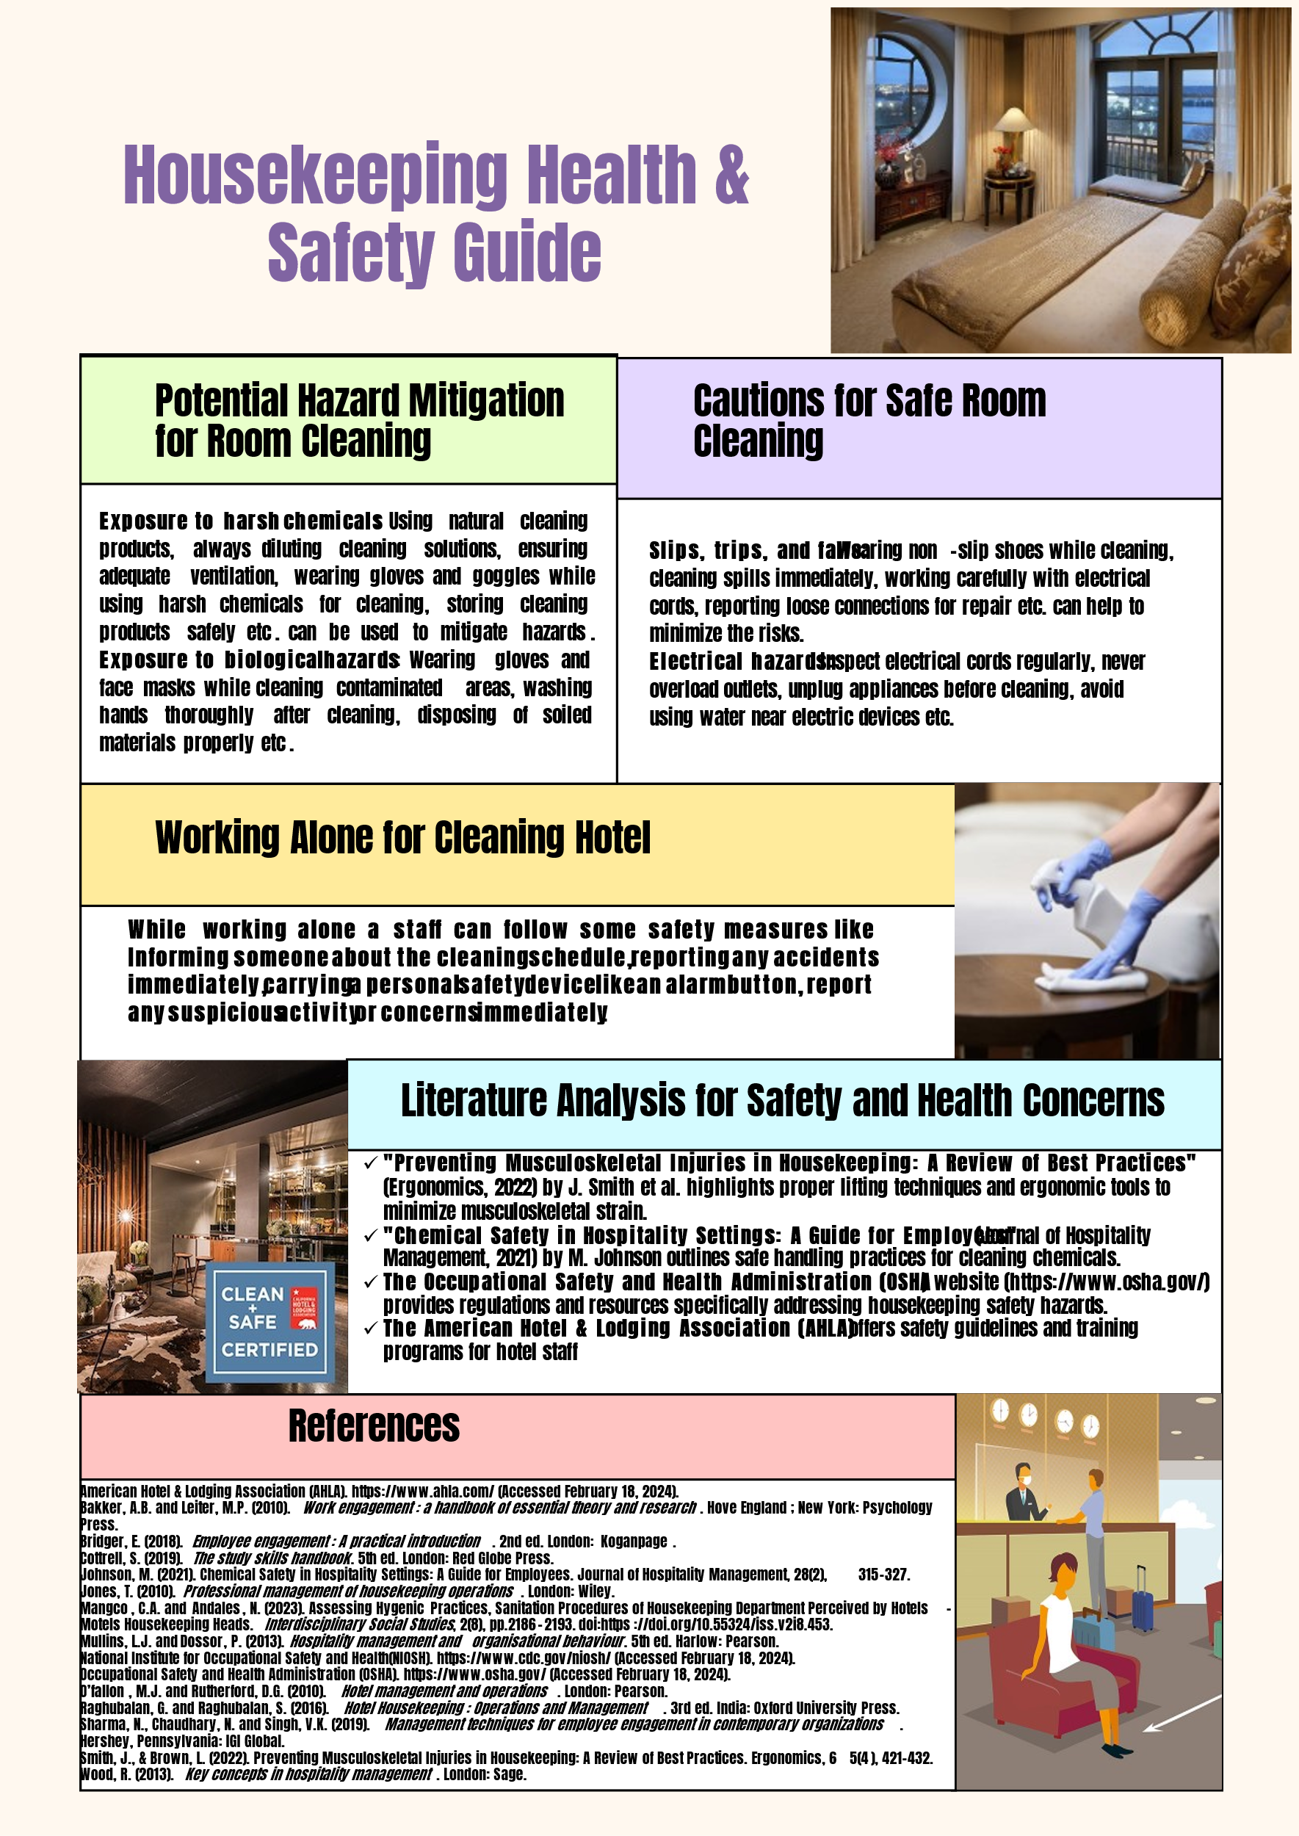

Housekeeping Health & Safety Guide
Potential Hazard Mitigation for Room Cleaning
Exposure to harsh chemicals: Using natural cleaning products, always diluting cleaning solutions, ensuring adequate ventilation, wearing gloves and goggles while using harsh chemicals for cleaning, storing cleaning products safely etc. can be used to mitigate hazards.
Exposure to biological hazards: Wearing gloves and face masks while cleaning contaminated areas, washing hands thoroughly after cleaning, disposing of soiled materials properly etc.
Cautions for Safe Room Cleaning
Slips, trips, and falls: Wearing non-slip shoes while cleaning, cleaning spills immediately, working carefully with electrical cords, reporting loose connections for repair etc. can help to minimize the risks.
Electrical hazards: Inspect electrical cords regularly, never overload outlets, unplug appliances before cleaning, avoid using water near electric devices etc.
Working Alone for Cleaning Hotel
While working alone a staff can follow some safety measures like Informing someone about the cleaning schedule, reporting any accidents immediately, carrying a personal safety device like an alarm button, report any suspicious activity or concerns immediately.
Literature Analysis for Safety and Health Concerns
- "Preventing Musculoskeletal Injuries in Housekeeping: A Review of Best Practices" (Ergonomics, 2022) by J. Smith et al. highlights proper lifting techniques and ergonomic tools to minimize musculoskeletal strain.
- "Chemical Safety in Hospitality Settings: A Guide for Employees" (Journal of Hospitality Management, 2021) by M. Johnson outlines safe handling practices for cleaning chemicals.
- The Occupational Safety and Health Administration (OSHA) website (https://www.osha.gov/) provides regulations and resources specifically addressing housekeeping safety hazards.
- The American Hotel & Lodging Association (AHLA) offers safety guidelines and training programs for hotel staff.

Component Three: Presentation.
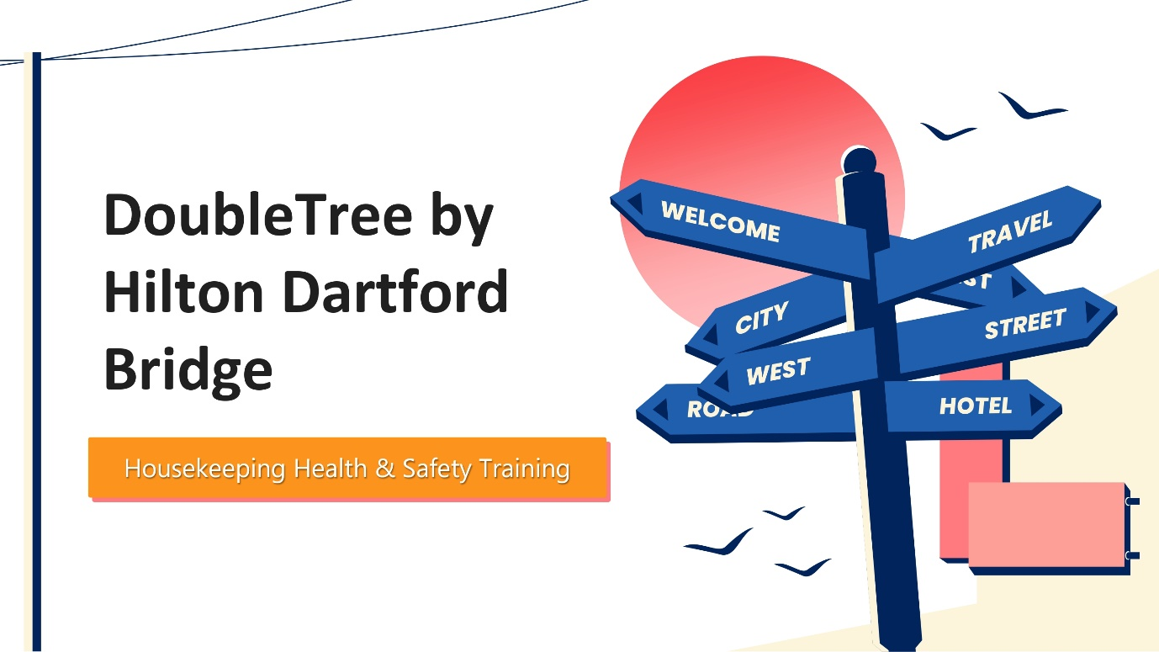
Hello, this is a presentation on housekeeping health and safety training of DoubleTree by Hilton Dartford Bridge.
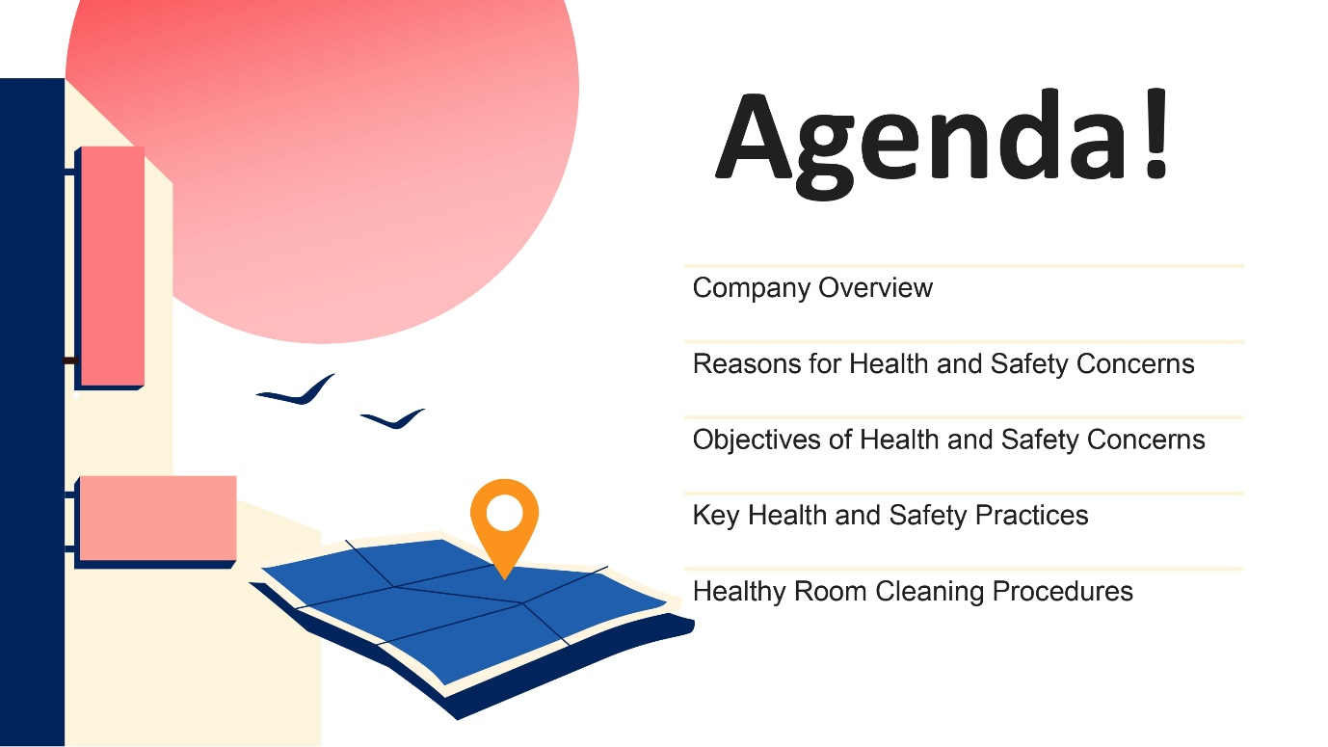
This session is targeted to focus and cover some topics related to health and safety concerns.
- A brief overview and the position of DoubleTree by Hilton Dartford Bridge. What it offers and how it is the choice of a certain group of people.
- It discussed the critical reasons for health and safety concerns.
- It analysed the objectives of these concerns.
- Key health and safety practices are followed and should be followed further in DoubleTree by Hilton Dartford Bridge by the workers and service providers to the customers.
- Total room cleaning practices and norms are discussed for the best convenience for both workers and customers.
- Overall analysis of the well-being of workers' health and safety concerns and awareness discussed has been done.
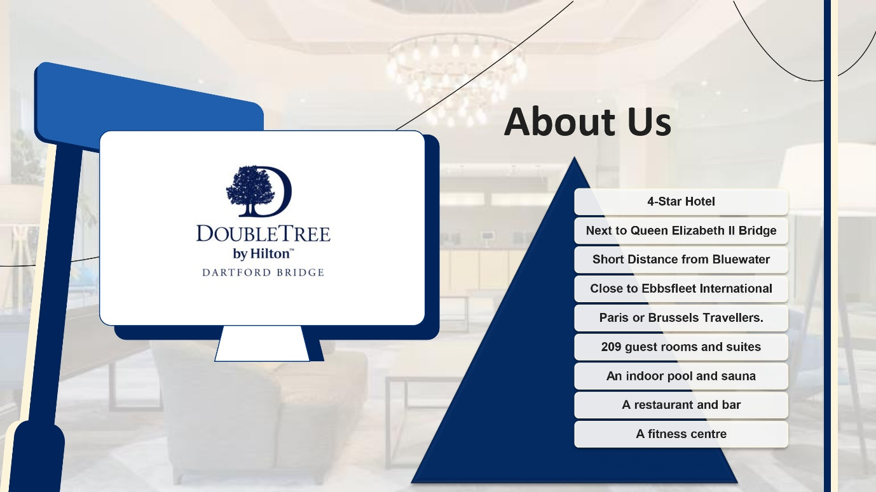
The DoubleTree by Hilton Dartford Bridge is a 4-star hotel located in England. It is next to the Queen Elizabeth II Bridge which is over the River Thames in Dartford in Kent. It is just a little away from Bluewater and close to Ebbsfleet International Station. All these make it convenient for travellers heading to Paris and Brussels. This Hotel has 209 guest rooms and suites, an indoor pool and sauna, a fitness centre, a restaurant and a bar (Hilton.com, 2024). All these options make the hotel convenient and preferable for travellers around here.
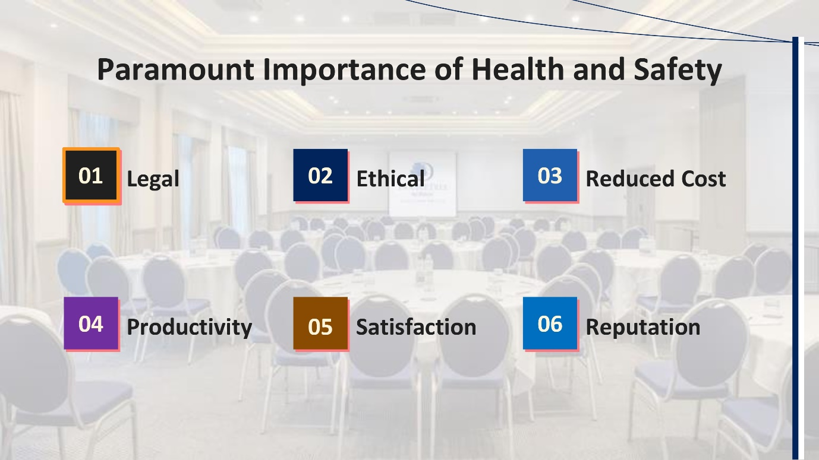
The importance of health and safety concerns is paramount in facilities management and guest service delivery.
- All companies are legally obliged to follow rules and regulations according to the safety of workers. A safe work environment should be provided for the workers and guests. Violating these rules will cause the company hefty fines, legal repercussions and reputational damage.
- It is the company’s ethical responsibility to protect the well-being of the employees and guests. A company that prioritises safety demonstrations is respected in the industry.
- Accidents and injuries cause late work and cost in medical services. Maintaining health and safety concerns reduces these costs (Bridger, 2018).
- A safe and healthy environment increases productivity. It promotes employee morale, engagement and focus. This ultimately increases productivity and efficiency (Cottrell, 2019).
- A good environment creates satisfaction for both the customers and workers. This creates a positive environment in the business.
- Demonstrating a commitment to safety and a healthy environment increases reputation.
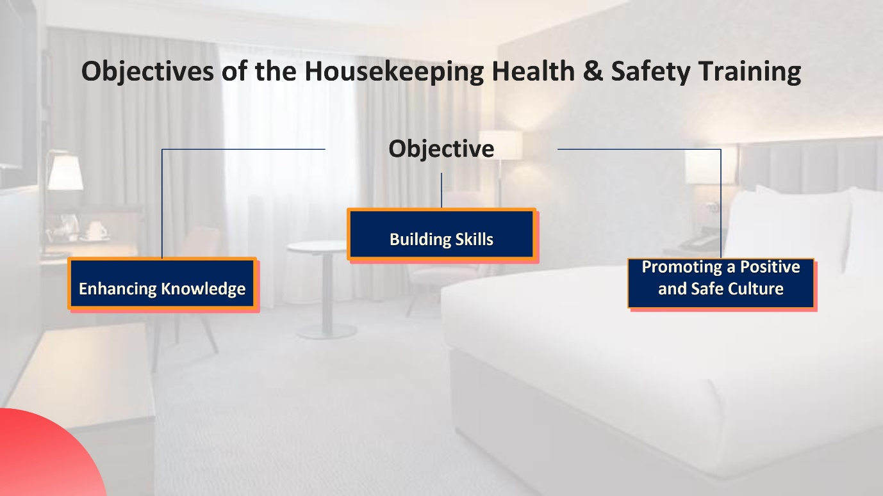
The objectives of housekeeping health and safety training are –
- Enhancing knowledge of about different factors like understanding health and safety regulations, identifying key housekeeping risks, chemical safety and handling, proper manual handling, and maintaining a clean and sanitary environment (Johnston et al., 2012).
- It’ll build skills like safe work practices, emergency preparedness guest interaction and privacy.
- It promotes a positive and safe culture such as open communication, teamwork and collaboration and continuous improvement (Leiter and Bakker, 2010).
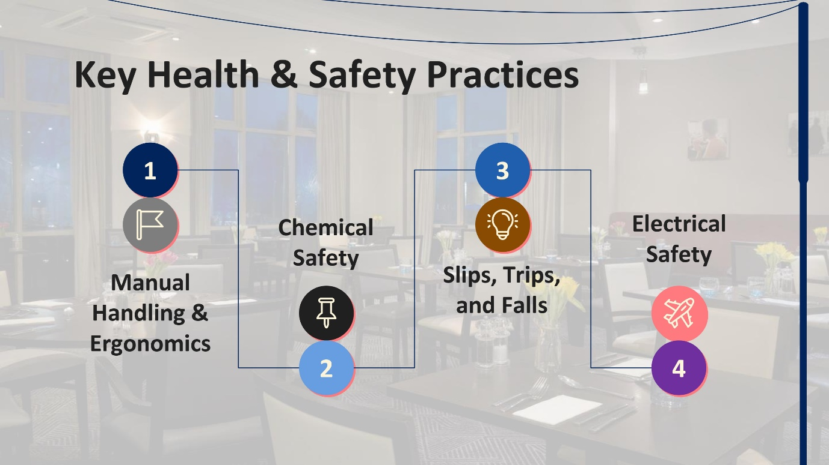
There are several key health and safety practices for housekeeping which will be helpful for our hotel.
- The first one is manual handling and ergonomics. It includes proper object-lifting techniques, utilizing relevant assistive equipment, maintaining good posture while doing work etc.
- Next is chemical safety. This includes wearing proper PPE while using chemical cleaners, storing chemicals safely, avoiding mixing of chemicals, and following safety datasheets (Rosemberg, 2020).
- The third one is slips, trips and falls. This practice advises staff to report spills immediately, wear appropriate footwear, and keep walkways clear to avoid trips and falls.
- Electrical safety says that the staff should be careful while using electrical appliances. They should avoid water contact while using electronic appliances and never use damaged cords or appliances (Tesone, 2010).
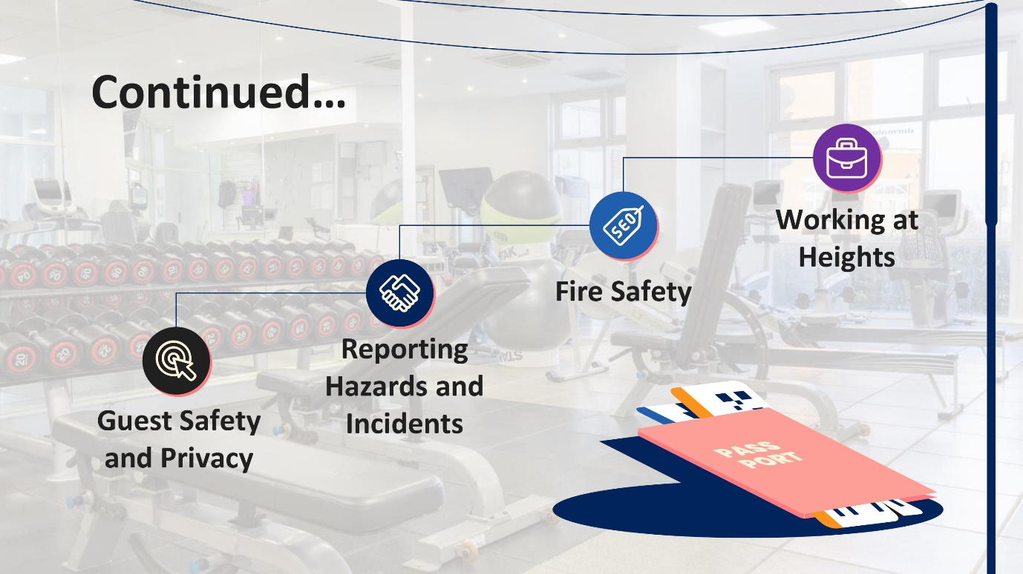
- Maintaining guest safety and privacy is one of the major aspects of housekeeping practice. Staff should maintain hygiene and ensure good cleaning and sanitation practices for the guests. Moreover, they should maintain guest privacy sincerely.
- The staff should report hazards and incidents to the hotel authority immediately. Early reporting allows for corrective actions, preventing future incidents and ensuring everyone's safety. They should not hesitate to report any accidents or mistakes to the supervisor or the authority (Chan et al., 2021).
- Next is fire safety. The staff should know about the fire evacuation process as well as emergency exits. They should never block emergency exits and understand the locations of fire extinguishers.
- While working at heights, the staff should be provided with proper safety equipment. They should use ladders safely and never overload ladders (Shin and Kang, 2020).
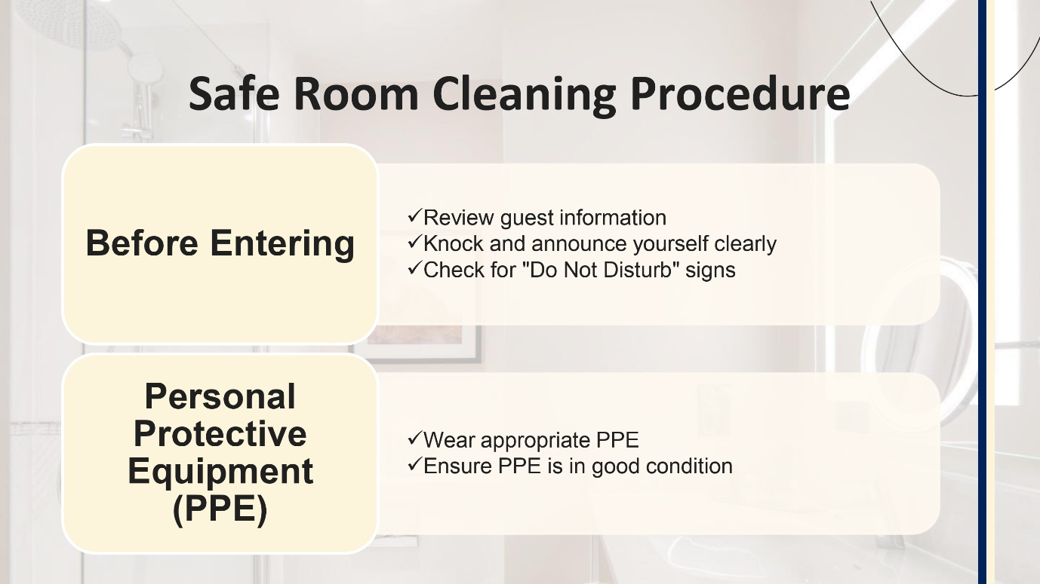
Certain room cleaning procedures should be followed by the workers. They are-
- Before entering the workers should consider some things like any special requests or concerns regarding allergies, disabilities about potential hazards in the room. Knock and always wait for a response. respect the privacy of the customer and leave the room if a do not disturb sign is displayed (Mullins and Dossor, 2013).
- Personal Protective Equipment (PPE) should be worn based on cleaning tasks and potential hazards. These may be gloves, masks, eye protection and non-slip shoes. The PPE should be in good condition and replaced regularly.
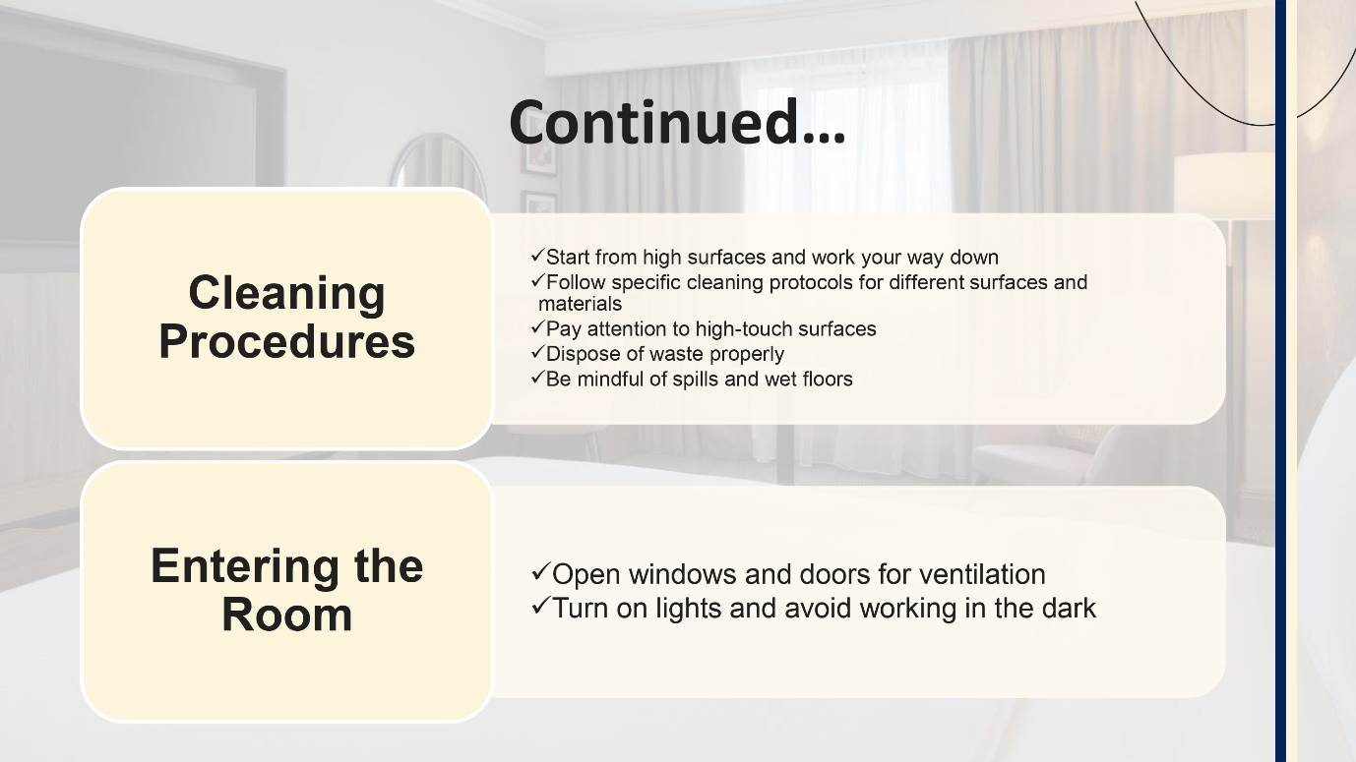
- Certain cleaning procedures should be followed like starting from a high surface and working to the way down. Different surfaces may have different cleaning protocols. Disposing of the waste properly is necessary. Workers should be mindful of spills and wet floors.
- Workers should open windows and doors for ventilation when entering the room. Workers are not advised to work in the dark so the lights should be turned on too (Rawal et al., 2020).
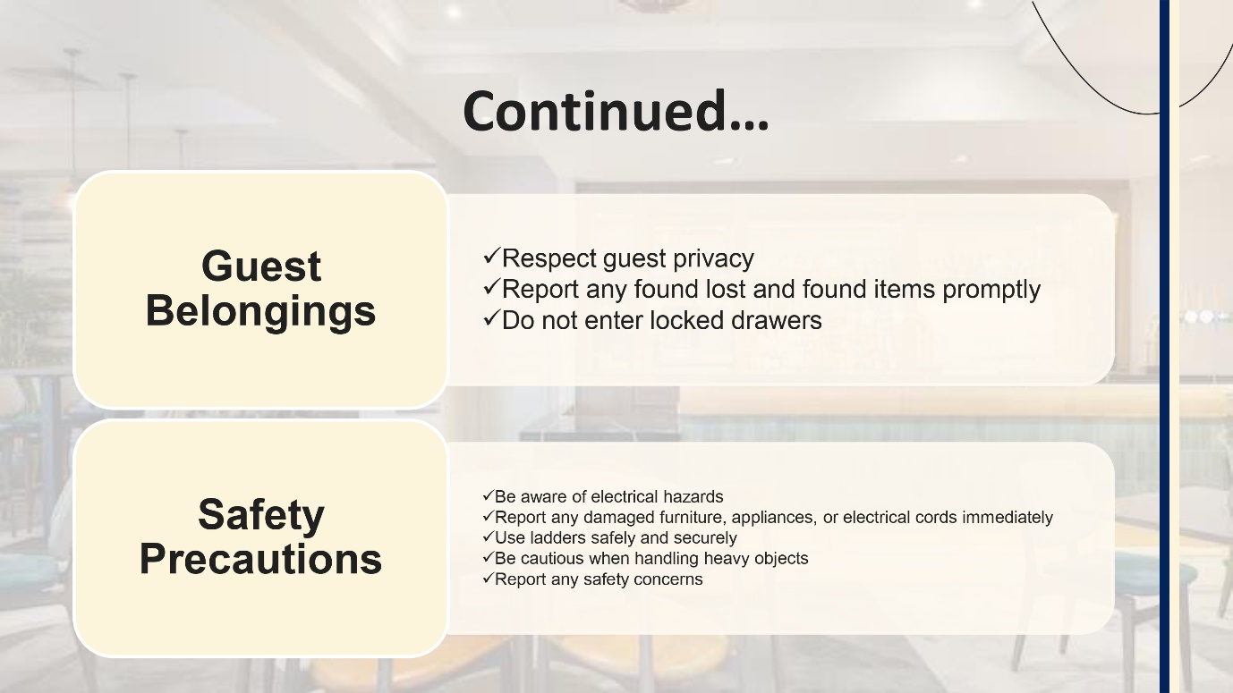
- The workers are required to respect the guest’s privacy and avoid touching personal belongings. An exception can be made in need of cleaning. Lost and found items should be reported properly. Workers are strictly prohibited from entering locked drawers and cabinets (Raghubalan and Raghubalan, 2016).
- Safety precautions should be taken like being aware of electrical hazards. Report if there are any damaged furniture, appliances or electrical cords. Use of ladders safely and securely is advised. There should be precautions when handling heavy objects. Supervisors should be informed if any health and safety concerns occur (Hsieh et al., 2016).
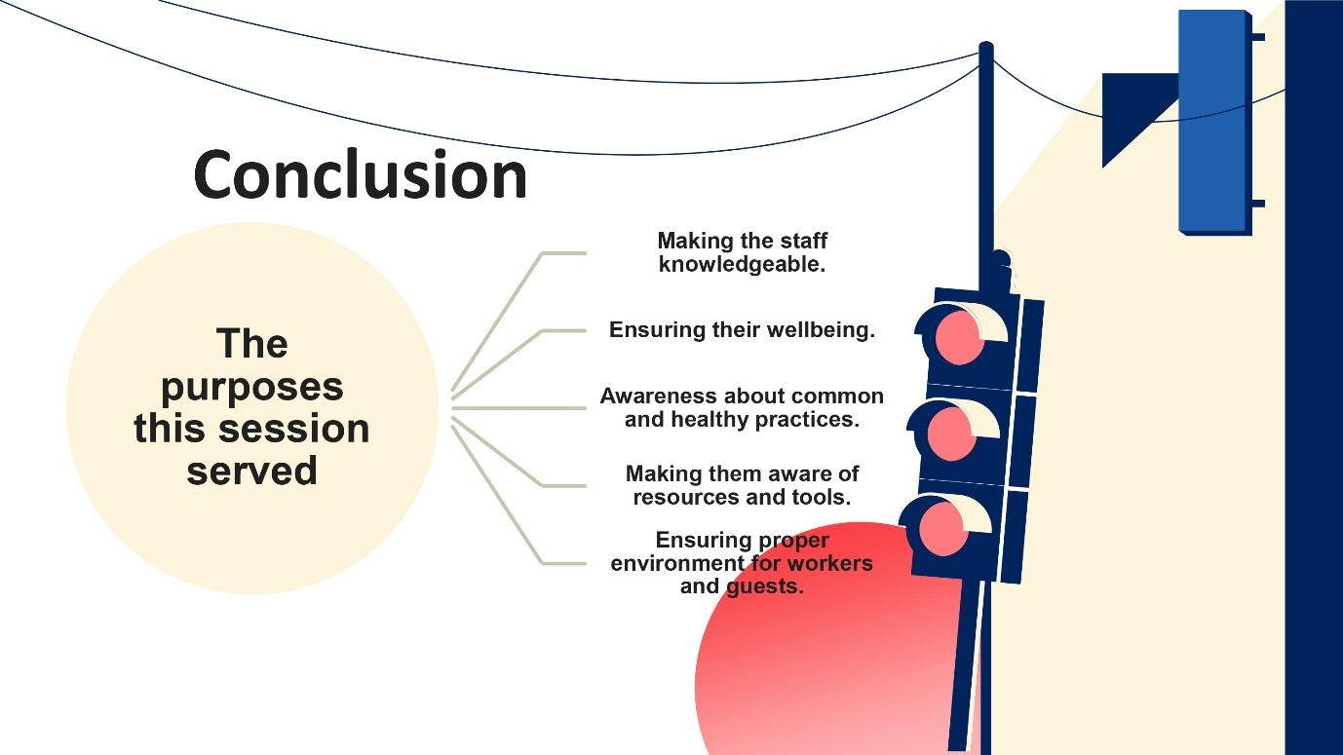
This session overall discussed different well-being, health and safety concerns of workers that are important for both workers and customers. This session created awareness and knowledge among the workers about their work in the business. How to ensure a proper environment for both the customers and workers is discussed.
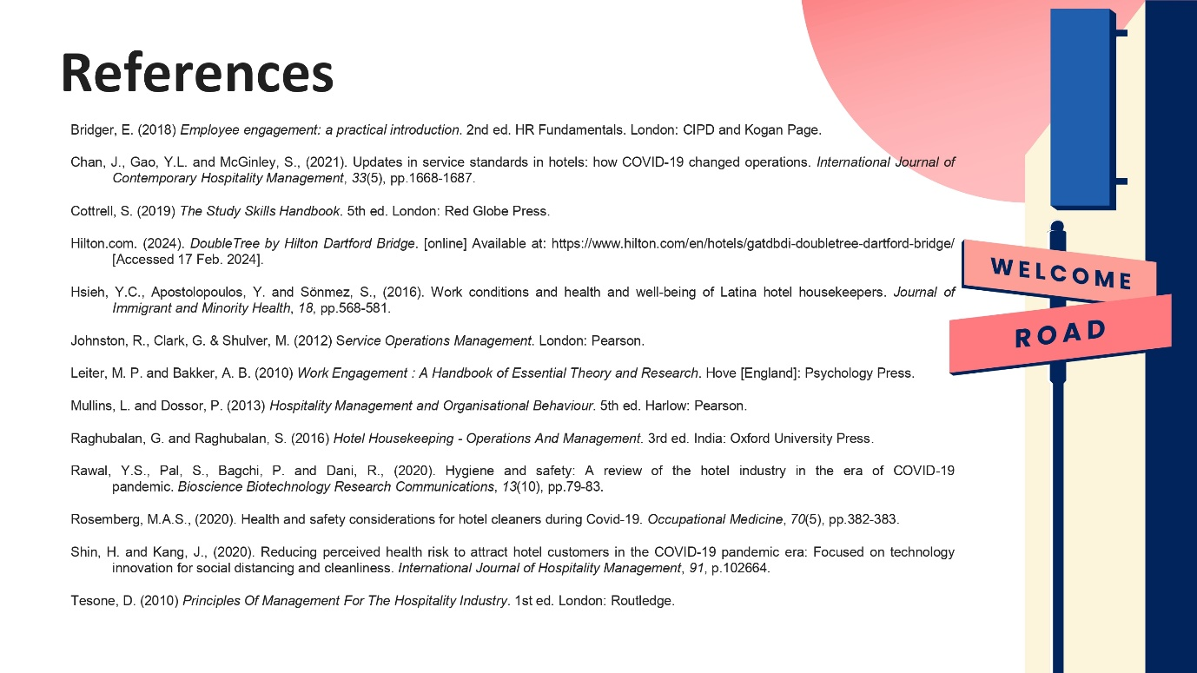
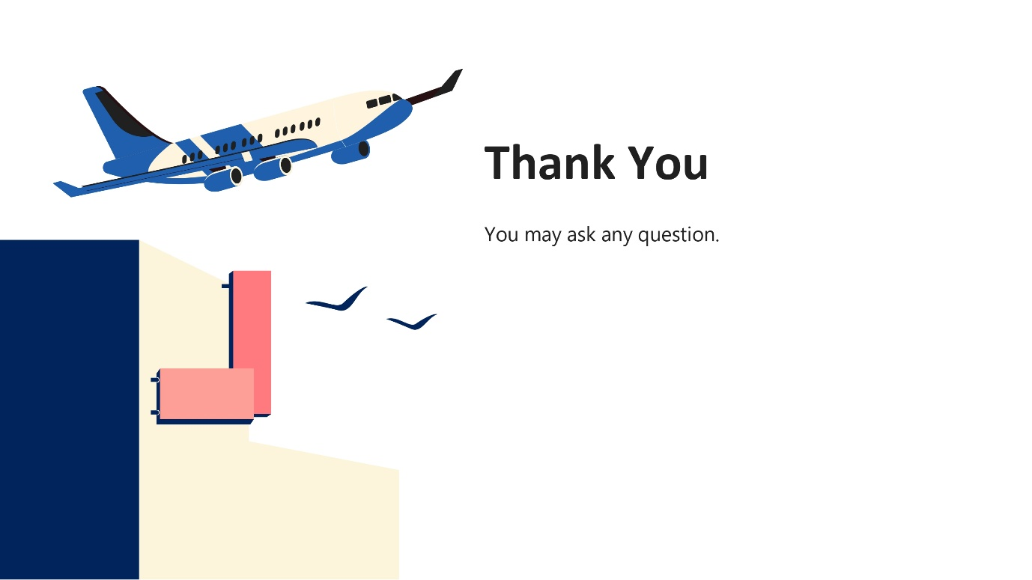
Thank you for your time. You’re welcome to ask any questions.
Reference List
American Hotel & Lodging Association (AHLA). https://www.ahla.com/ (Accessed February 18, 2024).
Bakker, A.B. and Leiter, M.P. (2010). Work engagement: a handbook of essential theory and research. Hove England; New York: Psychology Press.
Bridger, E. (2018) Employee engagement: a practical introduction. 2nd ed. HR Fundamentals. London: CIPD and Kogan Page.
Casado, M. (2012) Housekeeping Management. London: Wiley.
Chan, J., Gao, Y.L. and McGinley, S., (2021). Updates in service standards in hotels: how COVID-19 changed operations. International Journal of Contemporary Hospitality Management, 33(5), pp.1668-1687.
Cottrell, S. (2019) The Study Skills Handbook. 5th ed. London: Red Globe Press.
Ferdinand, N. and Kitchin, P. (2017) Events Management - An International Approach. 2nd ed. London: SAGE Publications Ltd.
Hilton.com. (2024). DoubleTree by Hilton Dartford Bridge. [online] Available at: https://www.hilton.com/en/hotels/gatdbdi-doubletree-dartford-bridge/ [Accessed 17 Feb. 2024].
Hsieh, Y.C., Apostolopoulos, Y. and Sönmez, S., (2016). Work conditions and health and well-being of Latina hotel housekeepers. Journal of Immigrant and Minority Health, 18, pp.568-581.
Johnson, M. (2021). Chemical Safety in Hospitality Settings: A Guide for Employees. Journal of Hospitality Management, 28(2), 315-327.
Jones, T. (2010). Professional management of housekeeping operations. London: Wiley.
Leiter, M. P. and Bakker, A. B. (2010) Work Engagement: A Handbook of Essential Theory and Research. Hove [England]: Psychology Press.
Mangco, C.A. and Andales, N. (2023). Assessing Hygenic Practices, Sanitation Procedures of Housekeeping Department Perceived by Hotels-Motels Housekeeping Heads. Interdisciplinary Social Studies, 2(8), pp.2186–2193. doi: https://doi.org/10.55324/iss.v2i8.453.
Mullins, L.J. and Dossor, P. (2013). Hospitality management and organisational behaviour. 5th ed. Harlow: Pearson.
National Institute for Occupational Safety and Health (NIOSH). https://www.cdc.gov/niosh/ (Accessed February 18, 2024).
O’fallon, M.J. and Rutherford, D.G. (2010). Hotel management and operations. London: Pearson.
Occupational Safety and Health Administration (OSHA). https://www.osha.gov/ (Accessed February 18, 2024).
Quick, L. (2020) Managing Events. Real Challenges, Real Outcomes. London: SAGE Publications Ltd.
Raghubalan, G. and Raghubalan, S. (2016). Hotel Housekeeping: Operations and Management. 3rd ed. India: Oxford University Press.
Rawal, Y.S., Pal, S., Bagchi, P. and Dani, R., (2020). Hygiene and safety: A review of the hotel industry in the era of COVID-19 pandemic. Bioscience Biotechnology Research Communications, 13(10), pp.79-83.
Rosemberg, M.A.S., (2020). Health and safety considerations for hotel cleaners during Covid-19. Occupational Medicine, 70(5), pp.382-383.
Sharma, N., Chaudhary, N. and Singh, V.K. (2019). Management techniques for employee engagement in contemporary organizations. Hershey, Pennsylvania: IGI Global.
Shin, H. and Kang, J., (2020). Reducing perceived health risk to attract hotel customers in the COVID-19 pandemic era: Focused on technology innovation for social distancing and cleanliness. International Journal of Hospitality Management, 91, p.102664.
Smith, J., & Brown, L. (2022). Preventing Musculoskeletal Injuries in Housekeeping: A Review of Best Practices. Ergonomics, 65(4), 421-432.
Tesone, D. (2010) Principles Of Management For The Hospitality Industry. 1st ed. London: Routledge.
Williams, K, Woolliams, M and Spiro, J. (2020) Reflective writing, Macmillan International, Oxford.
Wood, R. (2013). Key concepts in hospitality management. London: Sage.

