Nicu-Robert Moraru
2010773
Software Development
Software Development
Assessment 1
Lecturer: Renuga Jayakumar

Contents
Introduction 2
Variables in programing 2
If/else statemen in programing language 3
Works Cited 7

Introduction

This report aims to show the understanding of variables, statements, and loops in Python programming language and, also to implement that knowledge by resolving some programming tasks.
Python programming language is powerful and relatively straightforward to learn. Python contains an adequate data framework (high-level) plus an uncomplicated but, at the same time very efficient technique to programming (object-oriented). Python programming language’s syntax is effective and effective scripting, plus the interpreted nature of it, consolidates the fact that Phyton is an excellent programming language for fast application augmentation and scripting in various areas of expertise on majority of platforms. [1]

Variables in programing
A variable in Python is comparable whit a crate in the memory of a computer that has the ability to hold (for later use) an individual value. If a user wishes to utilize the outcome of an assessed statement at a later time in his program, the user has the ability to store it in a variable. The user has to utilize an assignment statement to be able to store a variable. All assignment statements have a variable name (will be used to call the value of the variable), the equal sign also known as the assignment operator, and the actual value needed to be stored. If the user types the assignment statement my_number = 2, the system generates a variable named my_number that will hold the value of 2 (integer).
A variable is created (name of the variable plus the initial value) when the user stores for the first time a value. The value will be used by the software in all scenarios until a new value is given to that variable (the old value is being discarded). This happens because in Python language, the script is executed line by line, from top to bottom, so the program will always remember the last value read from the script. [2]
Variables are in the category of the most fundamental concepts in Phyton. The main reason for that is in the name itself (variable), the users can code adjustable software programs. As a substitute to the process of typing the data straight into the software program, the user can use variables to show the data. Upon execution of the software, program variables can be replaced whit the needed data (this can be done multiple times whit a different set of data).
Types of variables in Python:
- String: in Python any expression that exist inside triple, double or single quotes is referred to as a sting variable (str)
- List: in Python lists can be used to store a multitude of sequence items in a single variable (built in data type). Items can be of any type of data. Lists in Python are mutable (user can modify them)
- Tuple: in Python tuple variables have the same characteristics as the list variables except that they are immutable (user cannot modify them)
- Number (int, long, float, complex): In Python numeric variables can store numbers. Based on the type of numbers that they hold the are four categories of number variables. The integer (int) variable can only store whole numbers (3, 52, 3048775, etc). The long variable in Python store long 32 bits numbers (-2,147,483,648 to 2,147,483,647). Float variables in Python can store the real numbers (even if is a decimal number like 54.2325). Complex variables in Python have two parts to them (the real one and the imaginary one).

- Dictionary: in Python a dictionary variable holds a selection of data values (key-value pairs), data that is unstructured and modifiable. [3]

If/else statemen in programing language

The if/else statements are part of the decision-making structure in programming. This category of statements is referred to as selection statements. That type of statement is used to give control to a specified section in the program code by jumping over part of the lines of code. Depending on the condition code segment, it needs to be carried out or not that is decided by the condition code when condition code is “false” statement code stops from being executed (will be skipped). Python has the next statements:
- If statement: this statement is a sequential statement, and it always initiates the sequential process (If the statement is true, will execute the block corresponding to this statement, and when false, will skip the code and jump to the next sequence of statement)
- Else statement: this statement is the alternative statement (when all other options are false, this statement becomes the remaining logical option and execute the block of code corresponding to this statement)
- Elif statement: this statement gives the programmer the option to analyse multiple statements (when the statement is true, executes the corresponding block, and when false will skip code and jump to the next statement). [4]
Example of if/elif/eses statement:
day = int(input("Enter day:"))
month = input("Enter month:")
year = int(input("Enter year:"))
x = ()
if day == 1 or day == 21 or day == 31:
x = "st"
elif day == 2 or day == 22:
x = "nd"
elif day == 3 or day == 23:
x = "rd"
else:
x = "th"
print(str(day) + x + " " + month + " " + str(year))

Loops in programing language

A loop statement allows the programmer to run a statement in numerous cycles. The for loop and the while loop statements do the checking conditions at the beginning of the loop. The testing at the end of the loop is made by the do statement. This ensures that the body of the loop is executed. The variables of the loop statement can also be declared, within the scope of the loop’s inner statement. Whit every loop iteration, the inner statement scope of the loop is reactivated. (declared objects in the inner statement and, also the ones declared in the condition of the loop will be generated and then erased every time a loop iteration happens).
A while loop statement continues a given statement as long as the condition is true. (a while loop can be an infinite loop, meaning that the condition is always true, and the statement will always execute therefore blocking the system). The while loop condition is assessed and then transform into a Boolean statement. (when the condition is true, the loop statement is implemented and then the loop is repeated; when the condition is false, the statement of the loop does not execute because the loop is interrupted, and the next statement is implemented). A break statement is used for exiting any type of loop statement. [5]
Python language has two types of loops:
- The while loop: in Python, the while loop has the while keyword, the condition, and the block of code for that condition (the break statement will interrupt the loop even when the condition is still true, and it only lives in the block of code for that condition)
- The for loop: In Python, the for loop acts similar to the while loop. The "for" element in for loop cites the thing to do for a certain amount of time.
Example of while loop in Pyton:
print("My counters")
mycounter = 1
while (mycounter <= 10):
print("Conting...", mycounter)
mycounter = mycounter + 1
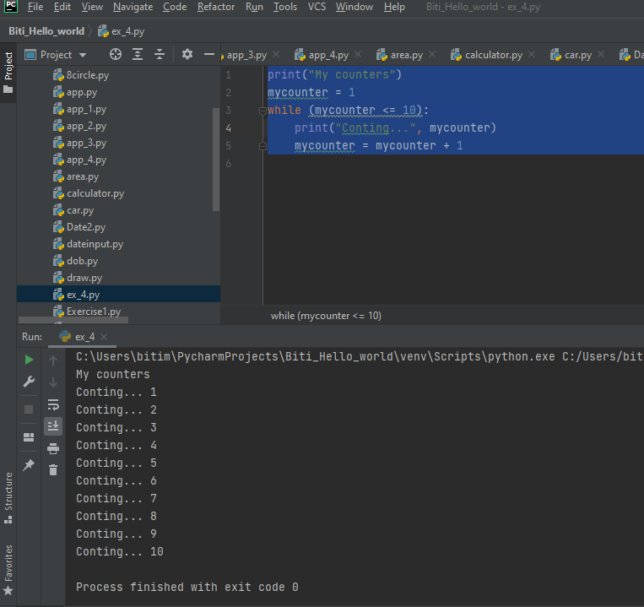

For loop in python example:
n = int(input("Enter the value of n: "))
for x in range(0, n+1, 2):
print(x, end=" ")

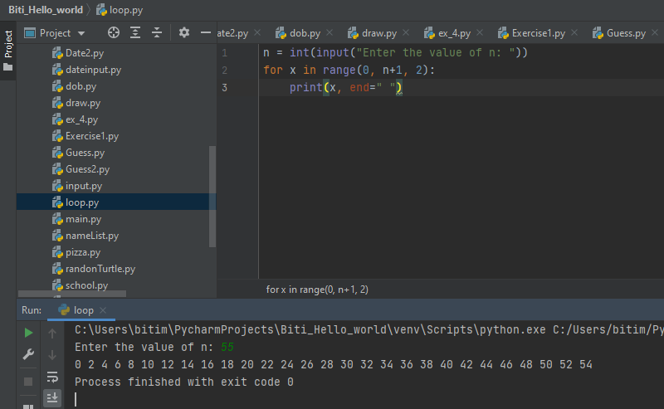

Exercise 1

The Python program need to be able to hold different types of values (car make, car model, milage, and number of doors) whit appropriate data types.
The code for this program is:
carMake = str(input("Please enter the make of car:"))
carModel = str(input("Please enter the model of car:"))
carMileage = int(input("Please enter the mileage of car:"))
DoorsNumber = int(input("Please enter number of doors for car:"))
print("This car make is " + carMake + "," + " the model is " + carModel + "," + " " + "has " + str(carMileage) + " miles on the odometer, and the car has " + str(DoorsNumber) + " doors.")

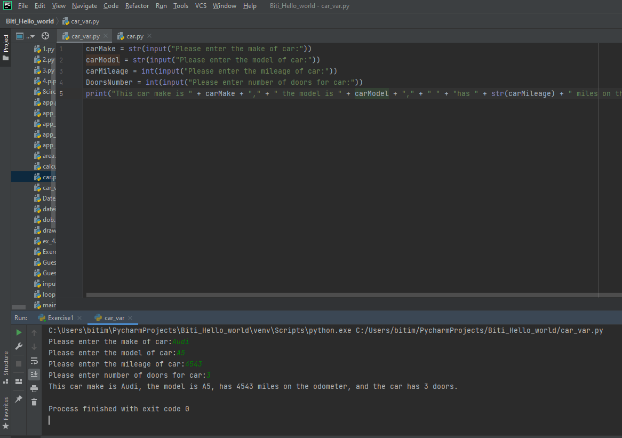

Exercise 2

The program needs to show how to many carrots can a person grow on a land when the space needed for a carrot to grow is 8cm by 8cm. The code for that is:
# carrot required space 64 square cm (needs to be 8cm by 8cm patch)
vegetable_bed_size_width = int(input("Please enter width of vegetable bed in cm:"))
vegetable_bed_size_length = int(input("Please enter length of vegetable bed in cm:"))
carrots_grown_in_length_when_width_is_8cm = vegetable_bed_size_length // 8 # this is the number of carrot squares that can fit in the length of the vegetable bed if the width is 8cm
carrots_grown_in_width_when_length_is_8cm = vegetable_bed_size_width // 8 # this is the number of carrot squares that can fit in the width of the vegetable bed if the length is 8cm
print("The amount of carrots that you can grow on a vegetable bed whit the width of " + str(vegetable_bed_size_width) + " and the length of " + str(vegetable_bed_size_length) + " is of " + str(carrots_grown_in_width_when_length_is_8cm * carrots_grown_in_length_when_width_is_8cm) + " carrots")
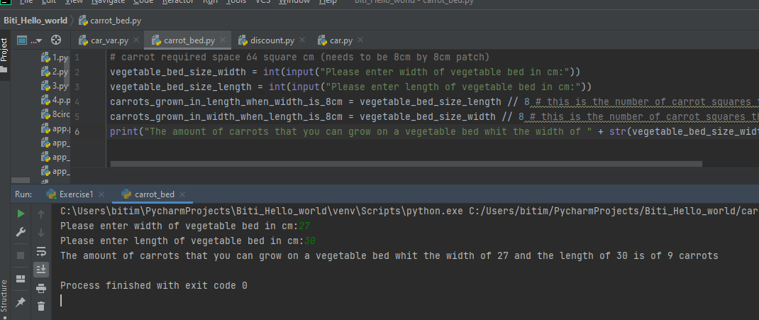

Exercise 3

The code for this exercise is:
# For list of products
list_of_products = []
# For list of product prices
list_of_product_prices = []
x = 0
while x < 5:
x = x + 1
list_of_products.extend([item for item in input("Enter product name : ").split()]) # adds extra item to the array
list_of_product_prices.extend([float(item) for item in input("Enter product price : ").split()]) # adds extra item to the array , float is added in front of item for pice decimals
total_price = 0
for i in range(0,len(list_of_product_prices)):
total_price = total_price + list_of_product_prices[i]

print("Total price is: £" + str(total_price))
print("Total with staff discount is: £" + str(total_price - total_price * 15 / 100))

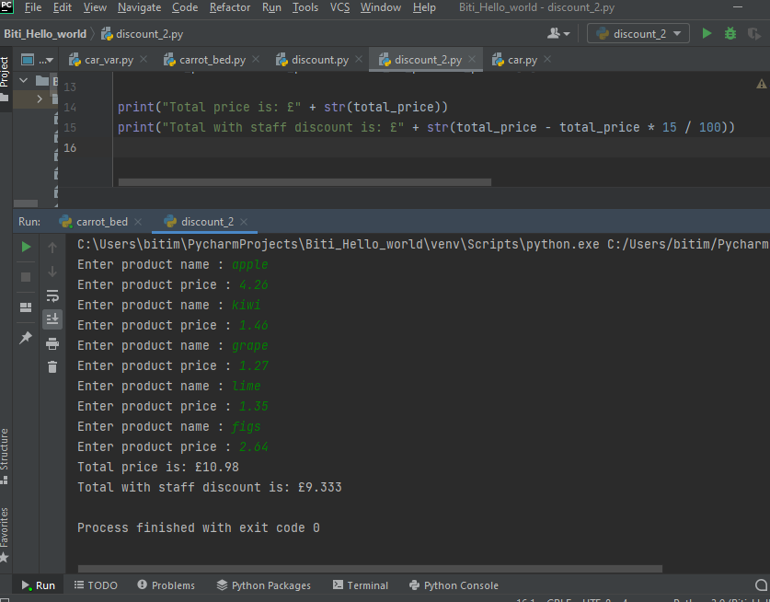

Exercise 4

Works Cited

[1] | G. Rossum, Python Tutorial: Release 3. 6. 6rc1, CreateSpace Independent Publishing Platform, 2018.
[2] | A. Sweigart, Automate the Boring Stuff with Python: Practical Programming for Total Beginners, No Starch Press, 2015.
[3] | E. K. E. L. Steven Bird, Natural Language Processing with Python, O'Reilly Media, 2009.
[4] | K. Banerjee, Simplified Python: For Class 11 and 12, Educreation Publishing, 2018.
[5] | R. Lischner, C++ In a Nutshell: A Desktop Quick Reference, O'Reilly Media, 2009.

