LCMB7034 International Business Concepts

Apple Inc. in the United Kingdom: An International Business Analysis of the Consumer Electronics Industry

Student Name: Md. Habibur Rahman
Student ID: 2432474

Lecturer: Jean Wang

Word Count: 5495

Table of Contents
Section 1: Industry and Business Report 4
1. Introduction 4
2. Industry and Country Overview 4
2.1 The Consumer Electronics Industry in the UK 4
2.2 Major Firms and Competitive Positioning 5
3. Porter's Diamond Model Applied to the UK Consumer Electronics Industry 7
3.1 Factor Conditions 7
3.2 Demand Conditions 8
3.3 Related and Supporting Industries 8
3.4 Firm Strategy, Structure, and Rivalry 8
4. Critical Evaluation of Apple Inc.'s Operations in the United Kingdom 10
4.1 Apple Inc.: A Financial and Strategic Overview 10
4.2 Political Environment 12
4.3 Economic Environment 13
4.4 Legal and Regulatory Environment 14
4.5 Cultural Environment 15
4.6 Overall Market Attractiveness 17
5. Conclusion 17
Section 2: Reflective Account: Gibbs Reflective Cycle 18
Description 19
Feelings 19
Evaluation 20
Analysis 20
Conclusion 21
Action Plan 21
References 23

List of Figures
Figure 1: Apple's Integrated Ecosystem Architecture in the UK Market. 6
Figure 2: Porter's Diamond Model: UK Consumer Electronics Industry. 9
Figure 3: Dunning's OLI Eclectic Paradigm: Apple's FDI Justification in the UK. 11
Figure 4: Apple UK Regulatory Risk Ecosystem — Key Legal & Political Pressures. 12
Figure 5: Cultural Dimensions Framework by Hofstede for the UK. 15
Figure 6: Gibbs ' reflective model 19
List of Tables
Table 1: UK Consumer Electronics Market — Key Indicators (2024–2025). 5
Table 2: Key Competitors in the UK Consumer Electronics Market. 7
Table 3: Porter's Diamond Model — UK Consumer Electronics Industry Summary. 10
Table 4: Apple Inc. — Key Financial Performance Data. 10
Table 5: PESTLE Analysis — Apple Inc. in the United Kingdom. 17

Section 1: Industry and Business Report

1. Introduction
Competitive international business has been fundamentally changed by the accelerating forces of globalisation, the fast-moving technology innovation and the changing regulatory frameworks. Transnational companies that engage in international business have to deal with a complicated political, economic, legal, and cultural context to maintain a competitive edge (Hitt, Li and Xu, 2016). This report analyses the consumer electronics sector in the United Kingdom (UK), with Apple Inc. being the case in point multinational company. Apple has a unique niche of being a vertically integrated and high-end technology conglomerate with a strong presence in the UK market.
Using the known international business models, such as Porter's Diamond Model, the PESTLE model, and the OLI eclectic paradigm by Dunning, this report provides a critical assessment of the competitive forces in the UK electronics industry, the strategic positioning of Apple, and the main forces influencing the success of its operations in the UK. The analysis will be informed by the latest Form 10-K annual report (fiscal year ended September 27, 2025) and the Q1 FY2026 consolidated financial statements of Apple.

2. Industry and Country Overview

2.1 The Consumer Electronics Industry in the UK
The United Kingdom is one of the most vibrant and important markets for consumer electronics in Europe. In 2025, the UK consumer electronics market earned a revenue of about USD 66.9 billion, and it is projected to attain USD 100.98 billion by 2033 with a CAGR of 5.4% (Grand View Research, 2026). The leading product segment is smartphones, which represents 53.65% of the total UK consumer electronics revenue in 2025 (Grand View Research, 2026). A number of structural forces are driving this growth trend: the deployment of 5G infrastructure, an increase in internet adoption, the rising demand for wearable devices, and the increasing levels of consumer income (IMARC Group, 2025). The UK is one of the five leading consumer electronics spending markets in Europe, with a digitally literate population.
The high intensity of competition, the speed of new products' development, and the increasing regulatory attention characterise the industry structurally, especially in data privacy, regulation of digital markets, and right-to-repair legislation. AI continued to be a major trend in consumer electronics in 2025, with the technology playing a role in driving innovation in the entire industry, with integration being seen in mobile phones, smart wearables, televisions and laptops (Euromonitor International, 2025). The change in technology is transforming product differentiation strategies and forming new frontiers for both the incumbents and the challengers.
Indicator | Value
Market Revenue (2024) | USD ~43.6 billion (IMARC Group, 2025)
Market Revenue (2025 est.) | USD ~66.9 billion (Grand View Research, 2026)
Projected CAGR (2026–2033) | 5.40%
Smartphone Revenue Share (2025) | 53.65%
Online Sales Share (2024) | ~45.5%
Total UK Smartphone Users (2025 forecast) | 60+ million
Table 1: UK Consumer Electronics Market — Key Indicators (2024–2025).

2.2 Major Firms and Competitive Positioning
The market in the UK consumer electronics is characterised by an oligopolistic market structure, where Apple and Samsung take the biggest market shares. Apple holds 45.19% of the UK market as of August 2025, while Samsung holds 33.25% (Accio, 2026). Others with considerable presence, such as Google (Pixel), Sony, Huawei (restricted access to the market after sanctions), and Chinese competitors (Xiaomi and Oppo). In 2025, Apple Computer UK Ltd were the market leader in the consumer electronics sector in terms of their retail volume, manufacturing Apple-branded products in a variety of lines such as computers and peripheral devices, mobile phones, wireless headphones and wearable electronics (Euromonitor International, 2025).
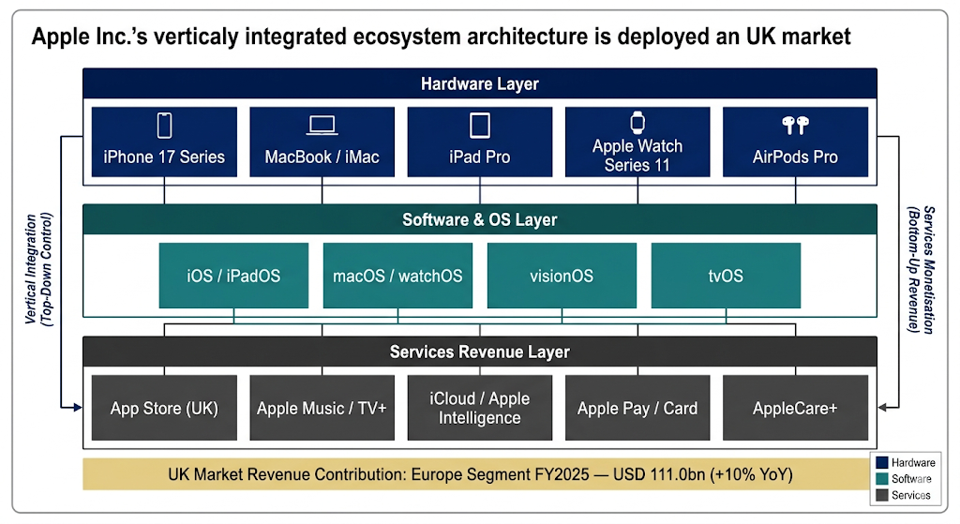
Figure 1: Apple's Integrated Ecosystem Architecture in the UK Market.
Source: (Self-Made); Prepared by (Canva)
These firms have wide differences in their competitive strategies. Apple has a premium differentiation strategy based on its closed ecosystem, vertical integration, and brand equity. In its turn, Samsung implements a more diversified product portfolio, including budget, mid-range, and high-end, based on its hardware production capabilities and the ubiquity of Android on the market. The PESTLE environment and SWOT profile of Apple, as Chen, Liu and Gong (2021) noted in their strategic marketing analysis of Apple, indicate distinctive strengths and weaknesses that set the company significantly apart in its competition with other MNCs.
Company | UK Market Share (2025) | Strategy | Key Strength
Apple Inc. | ~45% | Premium, closed ecosystem | Brand loyalty, services integration
Samsung | ~33% | Broad portfolio, mass market | Hardware diversity, Android flexibility
Google | ~5% | Software-led, AI-first | Android ecosystem, Pixel innovation
Sony | ~4% | Premium audio/visual | Gaming (PlayStation), audio
Xiaomi/Other | ~13% | Value pricing | Price competitiveness
Table 2: Key Competitors in the UK Consumer Electronics Market.
Sources: Accio (2025); Liu (2023); Euromonitor International (2025).
The unparalleled brand loyalty and stickiness of the integrated ecosystem, including iPhone, Mac, iPad, Apple Watch, AirPods, and a fast-growing services layer, are the sources of the competitive moat of Apple in the UK. As noted by Tang (2025), what sets the Apple business model apart is the design of the hardware-software integration and platform ecosystem construction that places it above competitors who rely on hardware specifications or cost as key factors in competing. More importantly, though, Apple has made its high-end pricing subject to weakness in economic crises, and its closed ecosystem has drawn antitrust attention by UK regulators, an aspect to be discussed in greater detail in Section 4.

3. Porter's Diamond Model Applied to the UK Consumer Electronics Industry
The Diamond Model of National Competitive Advantage by Porter offers a powerful analytical tool with which one can question the nature of the emergence of sustained international competitiveness in some sectors of specific countries (Porter, 1990). The model can be used to describe four interdependent determinants (factor conditions, demand conditions, related and supporting industries, and firm strategy, structure, and rivalry), which are the main drivers of industry competitiveness. According to scholars like Sölvell (2015), the diamond has not lost its analytical relevance twenty-five years after its launch, especially in explaining the microeconomic forces behind competitive advantage, but it needs to be used with consideration of the trend of competitive advantage towards greater globalisation.

3.1 Factor Conditions
The UK has highly advanced factor conditions that enable it to have a competitive consumer electronics ecosystem in the world. The nation is blessed with universities of the calibre of Imperial College London, the University of Cambridge and the University of Edinburgh, and this has resulted in huge reservoirs of engineering, computer science and design talent. There are significant R&D centres of companies such as Apple, Google, and Samsung in the UK. The sophisticated financial and regulatory infrastructure of the UK, the status of the intellectual property protection system, and the digital infrastructure (5G coverage is increasing) are important basic and advanced factor endowments. As Fainshmidt, Smith and Judge (2016) emphasise, the quality of governance is a key factor of national competitiveness, and the stable institutional framework of the UK supports this strength. Nevertheless, the difficulties related to the post-Brexit era, such as losing access to the EU talent pools without restriction and the inability to migrate to countries with skilled people, are the emerging drawbacks of this dimension.

3.2 Demand Conditions
The UK has a consumer electronics innovation environment which is highly favourable. The consumers in Britain are highly advanced and technologically educated, and in 2024, the number of iPhones sold in the UK was estimated at 8.9 million, which is about 24,000 daily (Sweeney & Barber, 2025). The strong economic base of the UK further favours the use of consumer electronics, as the average revenue per capita is expected to increase to €424.80 in 2025 (Verma, 2025). At the low end, the UK consumers are highly price sensitive but are also willing to pay to receive quality, design, and privacy-protective technology, all of which fit the value proposition of Apple. The popularity of subscription-based online services has added to the need for connected, multi-gadget economies.

3.3 Related and Supporting Industries
The UK has the advantage of an established set of related sectors, such as developed telecommunications networks (BT, EE, O2, Vodafone), a well-developed financial services sector (to support mobile payments infrastructure), software development companies and a creative industries sector that overlaps with the consumption of digital content. Apple and the UK have a strong digital economy and app development community, which is crucial to the ecosystem and services of the App Store. Nevertheless, an identified weakness is that the UK does not produce consumer electronics on a mass scale anymore, and most production is based in Asia. This dependency on the global supply chains, which was identified as a risk factor in Apple's 10-K (Apple Inc., 2025), creates geopolitical disruption vulnerabilities and tariff regimes.

3.4 Firm Strategy, Structure, and Rivalry
The UK consumer electronics market faces extremely competitive rivalry as a result of duopolistic competition between Apple and Samsung and an increasing threat from Chinese OEMs and Google Pixel products.
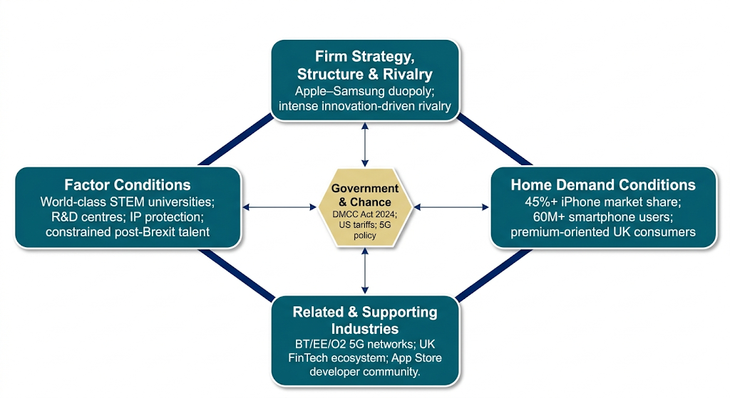
Figure 2: Porter's Diamond Model: UK Consumer Electronics Industry.
Source: (Self-Made); Prepared by (Canva)
The diamond of Porter puts the analytical focus on the industrial (meso-competitiveness) nature of rivalry as a force of innovation, as Vlados (2019) contends. Competition between the iOS ecosystem and Android in the UK has developed a high-tech and innovative competitive space. Park (2021) illustrates that the interaction between first mover and late mover advantages in the smartphone market is not symmetrical and that the first mover premium positioning stance that Apple has maintained has enabled it to maintain brand premiums, which have never been eroded by the competitors.
Diamond Dimension | Assessment | Implication for Competitiveness
Factor Conditions | Strong advanced factors (talent, R&D, IP); some weakness post-Brexit | Moderate-High
Demand Conditions | Sophisticated, premium-oriented, high-volume consumers | High
Related & Supporting Industries | Strong telecoms, fintech, digital services; weak domestic manufacturing | Moderate
Firm Strategy & Rivalry | Intense Apple-Samsung duopoly; growing Chinese competition | High (drives innovation)
Table 3: Porter's Diamond Model — UK Consumer Electronics Industry Summary.
Source: (Self-Made)
More importantly, one of the limitations of the Diamond Model when used in the context of the UK electronics industry is that it was initially premised on the benefits of domestic production, which does not augur well with an industry where global value chains (mainly based in Southeast Asia) are the standard of manufacturing competitiveness. Abramov, Otarbayeva and Khitakhunov (2025) argue that the determinants of Porter are only able to account for 55–60% of the changes in economic growth, which indicates theoretical flaws in the digitalisation and fragmentation of supply chains.

4. Critical Evaluation of Apple Inc.'s Operations in the United Kingdom

4.1 Apple Inc.: A Financial and Strategic Overview
Apple Inc. has the highest market capitalisation of technology companies in the world, with an aggregate market value of about USD 3.25 trillion as of March 2025 (Apple Inc., 2025). Fiscal year 2025, with total net sales of USD 416.2 billion (6%-year year-on-year growth) and net income of USD 112.0 billion, indicates outstanding profitability, which was achieved due to the high-margin services segment of its business (Apple Inc., 2025).
Metric | FY2025 | FY2024 | Q1 FY2026
Total Net Sales | $416.2bn | $391.0bn | $143.8bn
Europe Segment Revenue | $111.0bn | $101.3bn | $38.1bn
Net Income | $112.0bn | $93.7bn | $42.1bn
Total Gross Margin % | 46.90% | 46.20% | 48.20%
Services Gross Margin % | 75.40% | 73.90% | —
R&D Expenditure (FY25) | Part of $62.2bn opex | — | $10.9bn (Q1)
Table 4: Apple Inc. — Key Financial Performance Data.
Sources: Apple Inc. (2025), Apple Inc. (2026).
The Europe segment (including the UK, European countries, India, the Middle East, and Africa) produced USD 111.0 billion in FY2025, 10% higher than the USD 101.3 billion in FY2024. This growth is attributed to an increase in net sales of services, iPhones and Macs in the European market by Apple 10-K (Apple Inc., 2025). Europe was the second-largest geographic segment, with USD 38.1 billion of the total global revenues of USD 143.8 billion in Q1 FY2026 (Apple Inc., 2026). These statistics highlight the strategic value of the UK – the largest consumer electronics market in Europe – to Apple's worldwide revenue structure.
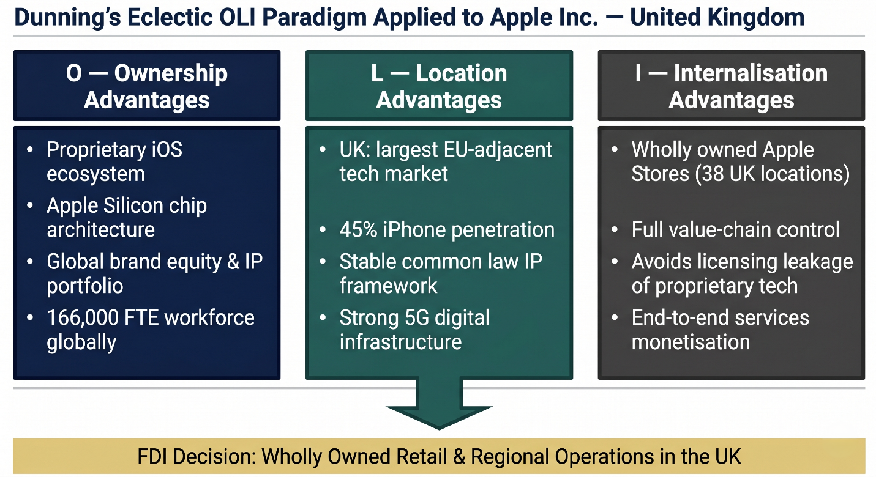
Figure 3: Dunning's OLI Eclectic Paradigm: Apple's FDI Justification in the UK.
Source: (Self-Made); Prepared by (Canva)
In theory, the existence of Apple in the UK can be explained in terms of the OLI eclectic paradigm of Dunning (Dunning, 1980), which states that the FDI is implemented when the firm has ownership advantages (unique assets and capabilities), locational advantages (features of the host country that make direct investment better than exporting), and internalisation advantages (reasons why the firm should control its operations).
There are three requirements that must be met to have FDI: the firm should have a comparative advantage in the form of intangible assets; it should be in its best interest to internalise this advantage; and locational factors should favour foreign expansion. In the UK, Apple fulfils all three criteria: its proprietary iOS ecosystem, the design of hardware is an intellectual property, and its brand delivers strong ownership advantages; its UK retail stores and regional headquarters allow it to take complete control of the value chain; the large and premium-focused market in the UK makes direct FDI more desirable than licensing or partnering options.

4.2 Political Environment
The UK political environment offers opportunities that are related to the operations of Apple in the United Kingdom and material risks. In recent decades, one of the most significant political events that has affected the UK-based MNCs is Brexit. As Du, Satoglu and Shepotylo (2023) show, the EU-UK Trade and Cooperation Agreement created a serious and lasting decline in trade in the UK, as companies had diminished access to the European market and disruption of supply chains. Hassan et al. (2019) showed with corporate earnings data that the uncertainty created by Brexit led the US and international firms most affected by Brexit to lose a large portion of market value and to decimate hiring and investment. To Apple, the most immediate effects of Brexit are associated with the imposition of import tariffs on hardware parts, the lowering of labour mobility of EU-based technical expertise, and divergence in the UK and the EU digital market regulations.
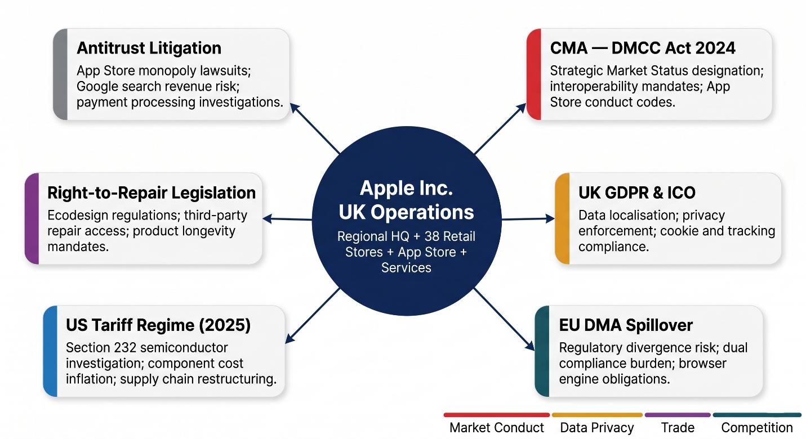
Figure 4: Apple UK Regulatory Risk Ecosystem — Key Legal & Political Pressures.
Source: (Self-Made); Prepared by (Canva)
It is against this backdrop that Apple must deal with a politically tricky environment insofar as the UK Digital Markets, Competition and Consumers Act 2024 is concerned, which grants designation authority to the Competition and Markets Authority (CMA) to apply tailor-made codes of conduct to companies with Strategic Market Status (SMS). It is widely anticipated that Apple will get SMS designation, which will force the company to open its ecosystem to rival browsers and payment systems, which may have far-reaching consequences for its services revenue stream. The 10-K clearly recognises antitrust investigations in various jurisdictions as significant business risks (Apple Inc., 2025). The company is also under constant criticism over its App Store business, which is similar to the compliance issues that the EU Digital Markets Act is grappling with.
In 2025, the US tariff landscape, with new tariffs on imported goods and services by China, India, Taiwan, Vietnam, and the EU, has created new cost pressures on the global supply chain of Apple. Apple's 10-K cautions that the final effect is unknown and will depend on numerous factors, such as the exposure of additional sector-specific tariffs on semiconductor products based on Section 232 investigations (Apple Inc., 2025).

4.3 Economic Environment
The macroeconomic environment in the UK in 2024–2025 has been defined by slow disinflation after a phase of post-pandemic inflation, and the Bank of England has been slowly reducing rates in response to levels in 2023. The consumer buying power has also revived partly, thereby contributing to new spending in high-value electronics. Although the premium positioning of Apple is aspirational to a large group of consumers, it is price elastic, especially since the iPhone 16 Pro Max is priced at an average of a monthly contract of about £58.40 (Accio, 2026). The relative price cost of Apple products is evidenced by the fact that the average yearly income after tax of an average British consumer is 3% of what they must pay to purchase an iPhone 15 (Sweeney and Barber, 2025).
Another economic aspect is currency risk. In its 10-K, Apple states that the devaluation of foreign currencies against the U.S. dollar negatively impacts the U.S. dollar equivalent of the company's foreign currency-denominated sales and earnings (Apple Inc., 2025). The sterling depreciation is a long-term effect of Brexit uncertainty, which lowers the dollar-equivalent worth of Apple revenues in the UK and may squeeze gross margins on sterling-priced goods. In the Impact of Brexit on FDI (McGrattan & Waddle, 2020), the authors modelled a variety of post-Brexit outcomes and discovered that limits on FDI and trade have significant negative welfare effects, and the extent of these effects depends crucially on how the multinationals react to the policy. In the case of Apple, it means continued pressure on prices, where it has to decide whether to impose the exchange rate costs on the UK consumers or absorb them in the margins.
On one hand, the strong digital economy of the UK, the high percentage of households that have access to broadband networks, and the growing base of 5G networks present strong demand factors. The UK is especially well-positioned to serve the growth of Apple services, which are USD 109.2 billion worldwide and have a gross margin of 75.4% (Apple Inc., 2025). Apple Music, Apple TV+, iCloud, Apple Pay, and the App Store are services that have the advantage of being well-penetrated by smartphones and have shown consumers a willingness to pay for digital subscriptions.

4.4 Legal and Regulatory Environment
The UK has a generally favourable legal climate to multinational investment, which is typified by a stable common law system, high protection of intellectual property, an independent judiciary and a clear regulatory framework. These characteristics are in line with the ownership strengths of Apple, proprietary technology and brand, which would be expected by the OLI paradigm (Paul and Cestero, 2020). The fact that the UK has been ranked among the highest in the world in the rule of law and commercial and IP indices offers good ground for the contractual, commercial, and IP-based operations at Apple in the UK.
Nevertheless, the new post-Brexit regulatory environment creates an element of complexity and the possibility of breaking with the EU standards. Fuller (2021) looks at the impact of institutional uncertainty on Brexit, where foreign subsidiaries in the UK technology industry have been impacted more than others, especially those with low corporate specificity and with European market requirements. The UK subsidiary of Apple deals with the UK consumers and, via its operations in Europe, the pan-European market. Any additional regulatory differences between the UK and EU privacy framework (UK GDPR and EU GDPR) and competition law and digital market regulation may entail the imposition of duplicate compliance costs.
It is remarkable that the interventionist stance of the CMA. In 2024, the CMA was examining the practices of Apple in terms of browsers and cloud gaming, and under the DMCC Act, Apple is in danger of receiving binding interoperability requirements. This is a reflection of the effect of the EU DMA: Apple, in its 10-K disclosures, states that the compliance of iOS and iPadOS applications with the DMA has necessitated substantial changes to the applications themselves, including to the terms of business and alternative fee arrangements in iOS and iPadOS applications and different distribution arrangements of iOS and iPadOS applications (Apple Inc., 2025). The same can be done in the UK, and this can give rise to what the literature refers to as 'regulatory risk' – the legal risk that a trading partner will expropriate or otherwise limit the property rights of the firm.
On the data protection front, the Information Commissioner's Office (ICO) of the UK maintains a rather strict data privacy requirement. The privacy-first marketing message of Apple is 'Privacy. That's iPhone' would be a strategic fit with the UK consumer values and regulatory demands, and it would be a competitive strength against competitors, which have less strong privacy backgrounds.

4.5 Cultural Environment
One of the most subtle and yet significant aspects of market appeal to technology MNCs is cultural factors. Based on the cultural dimension’s framework by Hofstede, the UK is a highly individualistic country with a score of 76, a fairly low uncertainty avoidance index (35), medium power distance (35), and a masculine orientation, which greatly influences technology adoption trends (The Culture Factor, 2025).
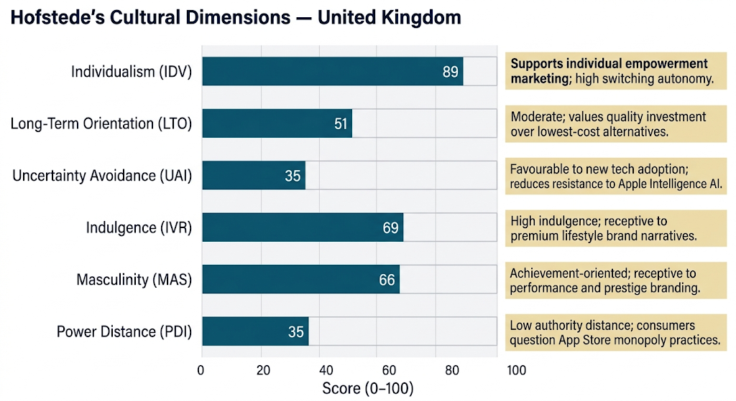
Figure 5: Cultural Dimensions Framework by Hofstede for the UK.
Source: (Self-Made); Prepared by (Canva)
The study conducted by Irshad et al. (2025) substantiates the conclusion that cultural dimensions, especially individualism and uncertainty avoidance, have a significant mediating role between the features of technology and brand loyalty in the UK. Frimpong et al. (2020) also show that the adoption behaviour of technology in the UK is moderated by the highly individualistic culture, with the personal utility and performance expectancy becoming the main factors behind the adoption of technology, which is exactly what Apple focuses on in promoting its products.
The individualistic orientation that the UK has is in sync with the Apple brand. Apple has always focused its brand marketing on empowering the individual, creative expression and individual differentiation – messages that find great acceptance in a high-individualism cultural environment. Additionally, the low uncertainty avoidance of the UK implies that consumers are comparatively more ready to embrace new technologies and new digital services, which will make it easier to adopt new lines of Apple products like Apple Vision Pro, Apple Pay, and Apple Intelligence AI features.
The cultural demand for quality and design aesthetics, coupled with brand heritage, by the UK consumer, also justifies the premium positioning of Apple. Song (2024) notes that brand reputation, innovative products, and customer loyalty are a self-reinforcing competitive advantage of Apple. The psychological switching costs associated with the Apple brand in the UK are extremely high due to the connection enjoyed over many years in the country through 38 retail outlets, full carrier relations and cultural presence that shields market share.
But there are no cultural barriers. A strong consumer rights culture and media criticism of business practices in the UK have helped to build up pressure on the public and politics against Apple on right-to-repair, planned obsolescence, and App Store monopoly issues. According to Svensson-Hoglund et al. (2021), one of the new governance issues of consumer electronics manufacturers is the UK and EU right-to-repair regulation. The cultural demands of transparency and responsibility by corporation’s demand that Apple take care of its environmental, social, and governance (ESG) story in the UK market.
Factor | Key Elements | Implication for Apple
Political | CMA digital market regulation; Brexit; post-Brexit regulatory divergence; US tariff environment | Moderate-High risk; compliance obligations and supply chain costs
Economic | Gradual disinflation; recovering consumer spending; Sterling volatility; digital economy growth | Mixed; services growth opportunity, but FX and pricing pressure
Social/Cultural | High individualism; low uncertainty avoidance; design and quality-oriented consumers; right-to-repair sentiment | Strong alignment; supports premium positioning and services adoption
Technological | 5G rollout; AI integration in devices; strong digital infrastructure | High opportunity; accelerates demand for Apple's ecosystem products
Legal | UK GDPR; DMCC Act 2024 (CMA); IP protection; common law framework | Mixed; stable IP protection but growing interoperability obligations
Environmental | E-waste regulation; Net Zero commitments; Eco-design regulations | Opportunity (sustainability positioning); compliance costs on device longevity
Table 5: PESTLE Analysis — Apple Inc. in the United Kingdom.
Source: (Self-Made)

4.6 Overall Market Attractiveness
Summing the above strands of analysis, the UK consumer electronics market offers a strong, yet growing, complex operating environment to Apple. A big, high-end and high-technology consumer base; a stable system of legal and intellectual property protection; a fast-growing services economy; and a high cultural fit with the Apple brand image all add up to good locational strengths in the OLI framework by Dunning. These reasons support and substantiate the long-term, extensive FDI investment of Apple into the UK market, including retail, regional headquarters and the infrastructure of services.
However, new regulatory headwinds, especially those of the strategic market status regime of the CMA, and the complexity created by Brexit, price volatility, and macroeconomic uncertainty, are significant risks that must be continuously managed strategically. The interdependence of digital business strategies and internationalisation strategies in national institutional contexts, as defined by Meyer et al. (2023), needs to be increasingly accommodated in the international strategy of Apple. With the maturity of the regulatory framework in the UK to regulate digital markets post-Brexit, the capacity of Apple to safeguard the economics of its ecosystem will be put to the test in a manner that has far-reaching consequences on its European and international business model.

5. Conclusion
This report has critically analysed the consumer electronics market in the United Kingdom and has analysed the influence of factors that determine the success of the operations of Apple Inc. in this market. The UK is the highest consumer electronics market in Europe in terms of per capita expenditure and one which is typified by highly developed demand, strong competitive rivalry, and an ever-changing regulatory landscape. The strong fit between the premium differentiation strategy and the individualistic, quality-oriented consumer culture of the UK is seen in the fact that Apple's dominance will be exemplified by the company having a market share of approximately 45% and USD 111 billion in revenues in the European segment, as shown in the FY2025.
The Diamond Model by Porter demonstrates that the industry in the UK has good demand and factor conditions, but there are weak points in the manufacturing industry and post-Brexit limitations on the movement of talent balance the overall competitiveness of the ecosystem. The OLI framework by Dunning can be used to explain why Apple has adopted the best strategic alternative of full FDI, in the form of wholly owned stores and regional operations, as the best alternative to use its proprietary ownership advantages in a high-value market.
A subtle risk environment is revealed in the PESTLE analysis. Political risks – mainly due to the DMCC Act of the CMA and regulatory divergence between Brexit and the UK – are increasing in importance. The economy is stabilising, but it brings about chronic currency and macroeconomic instability. Apple's brand positioning is highly supported by the cultural environment, and legal and environmental acceptance regulations are gradually limiting the flexibility of the business model of the firm. With the UK regulatory framework becoming mature and competition law requirements becoming more important, the most important strategic issue Apple will face will be to maintain its ecosystem economics without appearing to be non-compliant with a more aggressive competition policy. The high-margin, growing services business of the firm, with a 75.4% gross margin in FY2025, affirms this ecosystem approach and justifies the regulatory attention it is receiving.

Section 2: Reflective Account: Gibbs Reflective Cycle
I will use Gibbs' reflective model for presenting the process that I have followed in researching, analysing and preparing the previous section of the assessment. The following figure represents it:
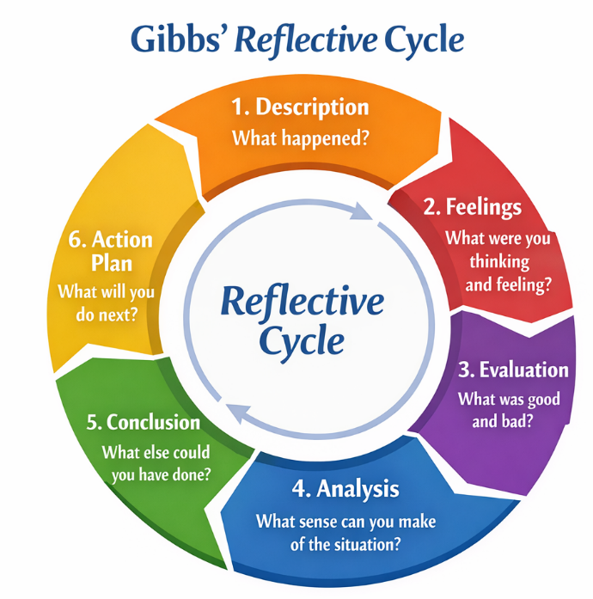
Figure 6: Gibbs ' reflective model
Source: (Self-Made); Prepared by (Canva)

Description
The reflective account is a documentation of researching, analysing and preparing the international business report on Apple Inc. in the UK consumer electronics market. It involved combining various analytical theories, such as the Diamond Model, the OLI paradigm, and the PESTLE analysis, with a large amount of academic research and corporate financial information, as well as industry statistics. The approach consisted of sourcing the annual Form 10-K of Apple for the fiscal year 2025 and Q1 FY2026 financial reports, searching peer-reviewed academic databases (Consensus and Google Scholar) on theoretical and empirical research, and conducting systematic web searches on current market statistics and synthesising course lecture resources in the UWTSD International Business Concept module.

Feelings
Initially, the task seemed large and, to some extent, challenging. The need to arrive at a report that incorporates five separate analytical models, financial information provided by the company, scholarly literature consisting of at least twenty-five peer-reviewed sources and up-to-date industry statistics first created a certain level of cognitive complexity. There was some sense of confusion as to how to balance the conflicting frameworks between putting theoretical models in the foreground or empirical market analysis, and how to remain critical rather than falling into descriptive summarising.
Nevertheless, confidence improved significantly as the research process went on and sources of data started converging. The experience of reading the 10-K and Q1 financial reports of Apple was especially educational; it was truly mind-stimulating to transform raw financial reporting data into analytical knowledge. The fact that the Apple Europe segment had increased by 10% in FY2025 to USD 111 billion gave a tangible root to the macro-level arguments on the strategic value of the UK.

Evaluation
The overall research process proved effective towards its goals, albeit with difficulties. Such strong points as the methodical use of the academic database tools that allowed finding the up-to-date, peer-reviewed literature on the topic of Porter's Diamond Model, OLI theory, the effects of Brexit on MNCs, and cultural aspects of embracing technologies were present. The choice of basing the PESTLE analysis on concrete legislation (specifically, the Digital Markets, Competition and Consumers Act 2024 of the UK and its potential implications on Apple and its App Store) brought about a certain degree of modern context that the generic PESTLE analyses frequently do not have. The triangulation of the financial information between the 10-K (FY2025) and the Q1 FY2026 statements allowed the dynamic, multi-period view of the UK-relevant performance in Europe for Apple.
Nevertheless, there are a number of limitations which should be mentioned. First, Apple does not provide country-specific revenues of the UK market; the segment of Europe combines revenues of European countries, India, the Middle East, and Africa. This necessitated inferential argumentation to project the UK contribution – by relying on data on market share of smartphones, demographics and comparative market analysis, as opposed to specifically referencing UK-related financials. This is a methodological limitation that could use primary interview data or proprietary market intelligence in a future study. Second, the time limit of the assessment implied that the scope of academic literature examined, although significant, could not cover all the studies related to all aspects of the report. Within an ideal research setting, additional primary research, like a survey of consumers of Apple products in the UK, or interviews with industry practitioners, would add to the empirical foundation of the analysis.

Analysis
Analytically reflecting on the experience, multiple important insights can be made. The use of several theoretical frameworks, instead of one, was both strong and complex. Porter's Diamond Model was the best in the diagnosis of the industry level of competitive environment, and the Dunning-Oli paradigm was more robust in explaining the specific strategic decisions of Apple (full FDI through retail ownership and not licensing or franchising). The PESTLE framework played a crucial role in uncovering the relationships between political regulatory changes and business model weaknesses at Apple. The task was, however, to ensure that the critical analytical thread between these frameworks was maintained and not to offer them as standalone checklists. The conceptualisation of the interdependence of digital strategies and internationalisation in the national institutional environment offered by Meyer et al. (2023) was particularly useful to take the analysis to a new level of application of the standard frameworks.

Conclusion
The report-writing process has helped me to realise how complicated international business environments can be in a manner that cannot be solely achieved through theoretical study. Their limitations and usefulness in analysis can be seen at the same time as they are exercised on a concrete company with publicly listed shares and functioning in a particular country by applying abstract frameworks to it, such as the Porter Diamond, OLI, and PESTLE. I also came to appreciate more deeply the value of critically assessing frameworks but not using them in a mechanistic way; Abramov, Otarbayeva and Khitakhunov (2025) and Vlados (2019) independently but equally contributed to the discussion of the shortcomings of the Diamond Model in globalised, digitalised industries. I also gained more proficiency in working with corporate financial disclosures, such as annual reports and segment breakdowns, and risk factors, as the main source material to use in business analysis.

Action Plan
Based on this experience, I would seek to make a number of improvements in research projects in the future. First, I would aim to complement secondary data with primary research – even small-scale primary interviews with industry experts or organised consumer surveys – to decrease the use of aggregate statistics and give a more solid empirical background. Second, I would also devote more time to the legal aspect of PESTLE analysis because it turned out to be the most technically challenging aspect that needs to be worked with, in particular, with certain legislative documents (DMCC Act 2024, UK GDPR). Third, I would consider the application of various country or industry comparisons to heighten the analytical inferences by contrast, e.g., between the UK regulatory environment and the EU DMA requirements of Apple. Lastly, I realise that I need to work more on building a better competency in foreign exchange and macroeconomic analysis, as it would add more economic aspects to the future international business analysis.

References
Abramov, V.L., Otarbayeva, A.B. & Khitakhunov, Z.A. (2025). Transformation of the National Competitiveness paradigm: from M. Porter’s Model to Sustainable Competitive Advantages. Bulletin of ‘Turan’ University, (4), pp.234–246.
Accio (2026). Best Selling Mobile Phone UK 2025: Top Picks. [online] Accio.com. Available at: https://www.accio.com/business/best-selling-mobile-phone-uk [Accessed 20 Apr. 2026].
Apple Inc. (2025). Annual Report on Form 10-K for the Fiscal Year Ended September 27, 2025. [online] Available at: https://s2.q4cdn.com/470004039/files/doc_financials/2025/ar/_10-K-2025-As-Filed.pdf.
Apple Inc. (2026). Condensed Consolidated Financial Statements Q1 FY2026 (Three Months Ended December 27, 2025). [online] Available at: https://www.apple.com/newsroom/pdfs/fy2026-q1/FY26_Q1_Consolidated_Financial_Statements.pdf [Accessed 20 Apr. 2026].
Chen, X., Liu, Y. & Gong, H. (2021). Apple Inc. Strategic Marketing Analysis and Evaluation. In: www.atlantis-press.com. [online] Atlantis Press, pp.3053–3061.
Du, J., Satoglu, E.B. and Shepotylo, O. (2023). How did Brexit affect UK trade? Contemporary Social Science, [online] 18(2), pp.1–18.
Du, J., Shepotylo, O. and Yuan, X. (2025). How Did the Brexit Uncertainty Impact the Services Exports of UK firms? Journal of International Business Policy, [online] 8(1), pp.80–104.
Dunning, J.H. (1980). Toward an Eclectic Theory of International Production: Some Empirical Tests. Journal of International Business Studies, 11(1), pp.9–31.
Euromonitor International (2025). Consumer Electronics in the United Kingdom | Market Research Report | Euromonitor. [online] www.euromonitor.com. Available at: https://www.euromonitor.com/consumer-electronics-in-the-united-kingdom/report [Accessed 20 Apr. 2026].
Fainshmidt, S., Smith, A. and Judge, W.Q. (2016). National Competitiveness and Porter’s Diamond Model: The Role of MNE Penetration and Governance Quality. Global Strategy Journal, [online] 6(2), pp.81–104.
Frimpong, K., Shuridah, O., Wilson, A. & Sarpong, F. (2020). A Cross‐national Investigation of Trait Antecedents of Mobile‐banking Adoption. Thunderbird International Business Review, 62(4), pp.411–424.
Fuller, C. (2021). Understanding the Impact of Brexit: the Case of Foreign Software Corporations in Scotland and South East England. European Urban & Regional Studies, [online] 28(2), pp.173–191.
Grand View Research (2026). UK Consumer Electronics Market Size & Outlook, 2026-2033. [online] Grandviewresearch.com. Available at: https://www.grandviewresearch.com/horizon/outlook/consumer-electronics-market/uk [Accessed 20 Apr. 2026].
Hassan, T.A., Hollander, S., van Lent, L. and Tahoun, A. (2019). The Global Impact of Brexit Uncertainty. SSRN Electronic Journal.
Hitt, M.A., Li, D. and Xu, K. (2016). International strategy: from Local to Global and beyond. Journal of World Business, [online] 51(1), pp.58–73.
IMARC Group (2025). UK Consumer Electronics Market Size & Share Report, 2033. [online] Imarcgroup.com. Available at: https://www.imarcgroup.com/uk-consumer-electronics-market [Accessed 20 Apr. 2026].
Irshad, W., Zhou, E., Rasheed, H.M.W. and Mumtaz, M.U. (2025). Augmented Reality in the Retail Outlet: Shaping the Retail Shopping Experience—A Cross‐Cultural Study. Journal of Consumer Behaviour, 24(4).
Liu, S. (2023). Apple iOS: Mobile Market Share in the United Kingdom 2011-2019 | UK Statistics. [online] Statista. Available at: https://www.statista.com/statistics/271195/apple-ios-market-share-in-the-united-kingdom-uk/ [Accessed 20 Apr. 2026].
McGrattan, E.R. and Waddle, A. (2020). The Impact of Brexit on Foreign Investment and Production. American Economic Journal: Macroeconomics, [online] 12(1), pp.76–103.
Meyer, K.E., Li, J., Brouthers, K.D. and Jean, R.-J. ''Bryan'' (2023). International Business in the Digital Age: Global Strategies in a World of National Institutions. Journal of International Business Studies, [online] 54(4), pp.577–598.
Moradlou, H., Reefke, H., Skipworth, H. & Roscoe, S. (2021). Geopolitical Disruptions and the Manufacturing Location Decision in Multinational Company Supply chains: a Delphi Study on Brexit. International Journal of Operations & Production Management, 41(2), pp.102–130.
Park, C. (2021). Different Determinants Affecting First Mover Advantage and Late Mover Advantage in a Smartphone market: a Comparative Analysis of Apple iPhone and Samsung Galaxy. Technology Analysis & Strategic Management, 34(3), pp.1–16.
Paul, J. and Cestero, aría M.F. (2020). Five Decades of Research on Foreign Direct Investment by MNEs: an Overview and Research Agenda. Journal of Business Research, 124(124), pp.800–812.
Porter, M.E. (1990). The Competitive Advantage of Nations and Their Firms. New York: Free Press.
Sölvell, Ö. (2015). The Competitive Advantage of Nations 25 Years – Opening up New Perspectives on Competitiveness. Competitiveness Review, 25(5), pp.471–481.
Song, J. (2024). A Company Analysis of Apple Inc. Based on Its Internal and External Environment. Highlights in Business Economics and Management, [online] 40, pp.912–918.
Statista (2024). Consumer Electronics - United Kingdom | Statista Market Forecast. [online] Statista. Available at: https://www.statista.com/outlook/cmo/consumer-electronics/united-kingdom [Accessed 20 Apr. 2026].
Svensson-Hoglund, S., Richter, J.L., Maitre-Ekern, E., Russell, J.D., Pihlajarinne, T. and Dalhammar, C. (2021). Barriers, Enablers and Market governance: a Review of the Policy Landscape for Repair of Consumer Electronics in the EU and the U.S. Journal of Cleaner Production, [online] 288, p.125488.
Sweeney, G. and Barber, S. (2025). iPhone Sales in the UK: How Many Are Sold Each Year? How has iPhone Popularity Changed in the UK? [online] Finder UK. Available at: https://www.finder.com/uk/share-trading/share-trading-research/iphone-sales-statistics [Accessed 20 Apr. 2026].
Tang, J. (2025). Apple’s Business Operations and Marketing Strategies: A Comparative Study with Huawei. Advances in Economics, Management and Political Sciences, 138(1), pp.86–94.
The Culture Factor (2025). Country Comparison Tool. [online] Theculturefactor.com. Available at: https://www.theculturefactor.com/country-comparison-tool?countries=united+kingdom.
Thissen, M., van Oort, F., McCann, P., Ortega-Argilés, R. and Husby, T. (2020). The Implications of Brexit for UK and EU Regional Competitiveness. Economic Geography, [online] 96(5), pp.1–25.
UK Government (2024). Digital Markets, Competition and Consumers Act 2024. [online] Legislation.gov.uk. Available at: https://www.legislation.gov.uk/ukpga/2024/13/contents [Accessed 20 Apr. 2026].
Verma, A. (2025). UK Consumer Electronics Market Size | 2019-2033. [online] Datacuberesearch.com. Available at: https://www.datacuberesearch.com/uk-consumer-electronics-market [Accessed 20 Apr. 2026].
Vlados, C. (2019). Porter’s Diamond Approaches and the Competitiveness Web. International Journal of Business Administration, [online] 10(5), pp.33–52.
Zhang, W., He, X., Wang, T. and Wang, K. (2022). Institutional Distance and the International Market Entry mode: a meta-analysis. Journal of International Management, 29(1), p.100990.
Zhang, Z. (2024). Market Strategies and Development Analysis of Apple Inc. Journal of Education Humanities and Social Sciences, [online] 35(1), pp.617–622.

