  Component One: Student Journal (learning log) 750 words +/- 10%  Contribution to Overall Module Assessment: 25% | Student No: | 2241513
 | Module Title: | Operating Hotel Facilities
 | Module Code: | BMIH4006
 | Lecturer: | Natalie Brailsford  Daniel Payne  Lisa Bassler  Giulia Ghifari  Ben Chong  Scott James

Introduction
My placement from the centre of the housekeeping department at the Best Western Abbots Barton Hotel, Canterbury, surpassed my initial expectations, presenting me with a depth and complexity that I had not anticipated (Black, 2015). Using Gibbs’s model of reflection, I explored this transformative experience in greater depth and examined its immense consequences for a professional setting.

Gibbs Reflection Cycle
Description: Managing guest rooms at the Best Western Abbots Barton Hotel took different hours filled with diverse tasks such as cleaning, restocking, and presentation of a perfect room (MacPherson, 2020). Duties ranged from dusting furniture to polishing mirrors, replenishment of toiletries and strict sanitization procedures. All components, from towel restocking to surface cleaning, were crucial as they enhanced guest happiness. That is why attention to detail, a core principle that my supervisors promoted, became a guiding factor, showing that any detail, that can be a dust or a wrinkle on a bedsheet, could influence the guest’s satisfaction (Williams et al., 2020).
Feelings and emotions: Despite the persistent pressure for quick results, the further focus on clean outcomes and appropriate planning made the challenge even more daunting (Mathews, 2020). Eventually, I got used to my work routine and came to enjoy making dirty rooms shiny again. The team spirit at Best Western Abbots Barton Hotel was very evident, and each member of the team complemented the other to ensure the success of the whole department.
During my placement at the hotel, I had an excellent experience that left a lasting impression on me. I was delighted to be part of a highly affable and welcoming team that made me understand each task and the importance of it.
Evaluations: My strengths of mine were revealed like proper communication or effectively conveying information. These included time management and finishing jobs within schedule. The greatest skill that I developed while working at this job was the ability to solve problems efficiently and effectively (Morrison and Abdallah, 2022). It is true, however, that in terms of leadership skills, there was a problem to be solved. It was important for me to refine this skill to guide other people to success in the future. The team at Best Western Abbots Barton Hotel would not be able to function effectively without this skill. Consequently, it is important to make sure that, after all the individual skills have been developed, the team skills need to be guided in parallel (Wood, 2013).
Analysis: The whole housekeeping department is the core of the hospitality industry which identifies as the unsung hero of the industry (Mourby, 2017). It is a very important part of the whole hospitality industry. This part works in the behind-the-scenes of the whole sector. Because of this, the whole industry runs smoothly. From making sure that the rooms are cleaned to making sure of the top-notch hygiene every task of hospitality is important. Every action is important in this sector of the hospitality sector (Vallen et al., 2012).
Conclusion: Coming from the housekeeping department of Best Western Abbots Barton Hotel, I had not only polished skills but also an in-depth understanding of the industry. Appreciating gained abilities and the commitment needed to ensure comfort for hotel clients deepened my insight into the hospitality sector (Hotels, 2020).
Action plan: The journey of growth continues and to develop leadership skills, I intend to volunteer for supervisory roles on the housekeeping teams at the hotel where I will guide and encourage people. Accepting positive criticism will lead to the improvement of skills and the reveal of blind spots (Brookfield, 2017). Furthermore, my understanding of operational processes can be enriched by learning theoretical insights into housekeeping management through industry publications and participating in relevant training programs.

Conclusion
Through the whole process of the housekeeping going on at Best Western Abbots Barton Hotel including the difficulties and success, and the gained awareness, I have acquired rich experiences and knowledge that can be used for the future. The successes and fulfilment that I gain from this placement will unquestionably help me to reach my objectives.

References
Black, C. (2015) A new way of housekeeping.
Brookfield, S.D. (2017) Becoming a critically reflective teacher. John Wiley & Sons.
Hotels, D. (2020) The Design Hotels book: New Perspectives. National Geographic Books.
MacPherson, C. (2020) The Pocket Butler’s guide to good housekeeping: Expert Advice on Cleaning, Laundry and Home Maintenance. Appetite by Random House.
Mathews, J. (2020b) Nellie’s housekeeping. BoD – Books on Demand.
Morrison, K. and Abdallah, E.B. (2022) War Hotels. Merrion Press.
Mourby, A. (2017) Rooms with a View: The Secret Life of Grand Hotels. Icon Books.
Vallen, G. and Vallen, J. (2012) Managing Hotel Operations. London: Pearson.
Williams, K, Woolliams, M and Spiro, J. (2020) Reflective writing, Macmillan International, Oxford.
Wood, R. (2013) Key Concepts in Hospitality Management. London: Sage.

Component Two: Health and Safety Guide
Contribution to Overall Module Assessment: 25%
A housekeeping Health and Safety guide at Best Western Abbots Barton Hotel
Our dedication at Best Western Abbots Barton Hotel has been to ensure that the guests receive a warm and welcoming greeting, resulting in an excellent and pleasurable stay (Birchell, 2018). This booklet is a practical guide for our customers who seek to increase their satisfaction and make their rooms stand out. Throughout this guide, we have carefully addressed every aspect to ensure every detail is noticed. The Best Western Abbots Barton Hotel is internationally acclaimed as one of the world’s best hotels, exemplifying essential elements like security, cleanliness, and comfort for our esteemed customers (Bridger, 2018).

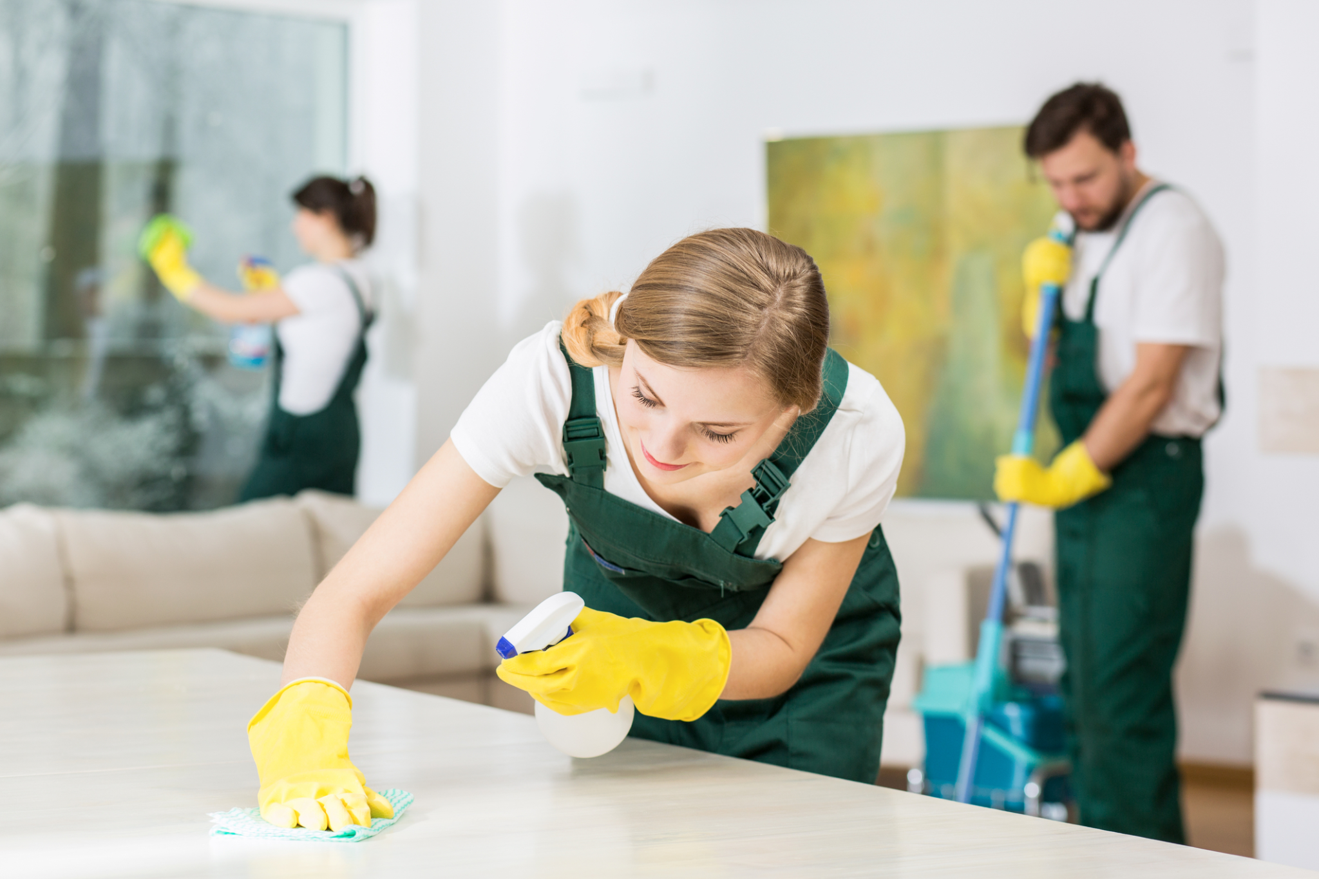
Identifying Potential Risks and Ensuring Housekeeping Safety at Best Western
Figure: Housekeeping (Robinson, 2015)

Abbots Barton Hotel
As a future housekeeping department manager at Best Western Abbots Barton Hotel, we must locate the potential risks and associate safety actions with industry guidelines and regulations to protect our personnel.
Gathering Information on Industry Best Practices and Regulations
- Floor Hazards:
  - Best Practice: Use the “Wet Floor” signs, prompt procedures for cleaning the premises, and periodic cleaning of the floors themselves.
  - Regulation: The required floor safety should comply with local safety regulations (Guides, 2016).
- Chemical Exposure:
  - Best Practice: Conduct thorough orientation on safe handling of chemicals and direct PPE use.
  - Regulation: Comply with regulations on the safe use of chemicals.
- Musculoskeletal Strain:
  - Best Practice: Conduct frequent training on correct lifting procedures and promote cooperation for heavy tasks (Hughes et al., 2015).
  - Regulation: Follow the ergonomic guidelines that are provided in occupational safety regulations.
- Equipment Hazards:
  - Best Practice: Implement routine equipment inspections, train staff to use equipment properly, and practice timely maintenance (MacPherson, 2020).
  - Regulation: The electric safety standards should be followed, and routine checks should be undertaken.
- Waste Handling:
  - Best Practice: Implement a waste removal plan, mark hazardous materials, and abide by environmental rules.
  - Regulation: Dispose of the waste according to the local laws (Robinson, 2015).
This proactive strategy, which is customised to the needs of Best Western Abbots Barton Hotel, focuses on adherence to the industry's best practices and compliance with regulatory requirements. By broadly addressing these inherent risks, we ensure the well-being of our housekeeping staff, upholding our commitment to providing premier and completely safe hospitality service at our prestigious hotel.

Precautions for Accident and Injury Prevention
In Best Western Abbots Barton Hotel, the security of our staff is of the utmost importance. The following precautions are integral to preventing accidents and injuries within our housekeeping department:
- Personal Protective Equipment (PPE): Among other things, prioritise work practices using PPE such as gloves, masks, and recommended footwear during cleaning to reduce exposure to potential risks (Trevor, 2015).
- Chemical Handling Safety: Ensure the staff members are conversant with the safe handling procedures before using any cleaning agents. Emphasise using gloves and other protective gear and securely storing chemicals that should be beyond average reach.
- Hazard Awareness Training: Hold frequent training sessions to develop staff awareness of possible hazards and immediate reporting. Promote a culture of diligence and accountability (Ferdinand et al., 2017).
- Wet Floor Signage: After and during the cleaning process, use the “Wet Floor” signs to inform the staff and customers about the dangers of slips. Immediately address and remediate any spills or wet surfaces.
- Emergency Response Plans: The evacuation procedures and the location of emergency exits should be familiar to all the housekeeping personnel. Conduct drills frequently to ensure readiness (Casado, 2012).
- Regular Health and Safety Reviews: Conduct frequent reviews on health and safety policies, getting staff opinions on the areas that require improvement. Regularly improve safety protocols according to the latest industry standards.
If Best Western Abbots Barton Hotel takes these precautions, the housekeeping team will ensure a secure and proactive environment for all employees and guests.

Procedures for Room Cleaning
One of the main objectives of the Best Western Abbots Barton Hotel is to ensure cleanliness and protect the health and safety of our housekeeping staff. Our step-by-step room cleaning procedure integrates safety measures seamlessly:
- Initial Assessment: The first step is to evaluate the room, recognising any possible risks or maintenance problems. Any issues observed should be immediately reported to the maintenance team (Guides, 2016).
- Personal Protective Equipment (PPE): Get all relevant PPEs, like gloves and masks, before entering the room to avoid any possible chemical poisoning or allergens.
- Waste Disposal: Keep the waste in dustbins and segregate recyclables based on the hotel’s environmental objectives. Handle waste carefully to prevent injuries (Hughes et al., 2015).
- Bedding and Linens: Develop a systematic approach to changing and cleaning the bedding. Use proper techniques to avoid causing musculoskeletal strain when handling heavy mattresses or linens (Raghubalan et al., 2016).
- Floor Care: Use suitable cleaning detergents for different floor types. During and after cleaning, put up “Wet Floor” signs to warn employees and guests of possible slipping (MacPherson, 2020).
- Bathroom Sanitization: Implement a strict procedure for cleaning bathrooms, focusing on disinfectant—properly handling and storing cleaning chemicals to eliminate accidental exposure.
- Final Inspection: Perform a final room check by checking for proper cleaning, arrangement and absence of any safety hazards. Report any maintenance issues promptly.
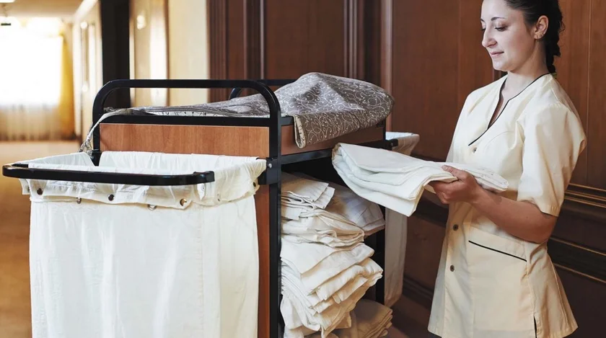

Figure: Housekeeper (MacPherson, 2020)

Equipment and Tools for Safe Room Cleaning
To facilitate effective and safe room cleaning, Best Western Abbots Barton Hotel provides the following essential equipment and tools:
- Cleaning Agents: Approved and safe sanitising solutions for multiple surfaces, offering risk-free and effective sanitisation.
- Personal Protective Equipment (PPE): Protective gloves, masks, and other required gear for protection from hazardous chemicals and allergens (Robinson, 2015).
- Waste Management Equipment: Labeled waste bins, recyclable bins, and durable garbage bags for proper disposal.
- Floor Care Tools: Mops, buckets, and proper floor cleaning solutions for cleaning to ensure cleanliness and safety (Mullins et al., 2013).
- Bedding and Linen Handling Tools: Trolleys or carts for easy transport and suitable lifting apparatus to lift mattresses and linens.
- Bathroom Cleaning Tools: Brushes, scrubbers, and bathroom sanitization-specific disinfectant solutions.
- Signage: “Wet Floor” signs to notify employees and customers of possible slipping hazards when and after cleaning.
- Communication Devices: Walkie-talkies or devices that allow accessible communication among housekeeping staff (Birchell, 2018).
Following these processes and using the supplied equipment, Best Western Abbots Barton Hotel ensures a consistent and safe room cleaning process and the highest cleanliness and guest satisfaction.

Hazard Mitigation for Room Cleaning
The safety of our housekeeping staff during room cleaning is one of the top priorities of Best Western Abbots Barton Hotel. Recognising and managing risks is integral to ensuring a safe working environment. Here are specific hazards associated with room cleaning, along with practical solutions for mitigation:
- Chemical Exposure:
  - Hazard: Potential exposure to cleaning chemicals.
  - Mitigation: Offer detailed training on safe chemical handling, focusing on wearing protective gear such as gloves and masks. Label all cleaning agents and store them securely (Boud et al., 2013).
- Musculoskeletal Strain:
  - Hazard: Improper lifting techniques leading to strain.
  - Mitigation: Hold regular training regarding the proper lifting technique and promote teamwork in handling more significant items. Offer equipment such as carts for better transportation (Cottrell, 2019).
- Slips, Trips, and Falls:
  - Hazard: Wet or slippery surfaces during cleaning.
  - Mitigation: Introduce a structured approach to floor cleaning, including using relevant signage, such as ‘Wet Floor’ signs during and post-cleaning. Immediately clean and dry any spills (Bowen, 2017).
- Equipment Hazards:
  - Hazard: Malfunctioning or damaged cleaning equipment.
  - Mitigation: All cleaning equipment should be scheduled for routine inspections and maintenance. Ensure the staff is trained to identify and report malfunction (Bridger, 2018).
- Hazardous Waste Handling:
  - Hazard: Mishandling of dangerous waste during disposal.
  - Mitigation: Specify clear regulations on waste disposal that must include the separation of recyclables. Highlight the handling and storage of potentially hazardous materials (Bowen, 2015).
Best Western Abbots Barton Hotel is establishing a safe and supportive work environment for the housekeeping team through proactively identifying and mitigating these hazards, strengthening our dedication to safety and quality in the hospitality industry.
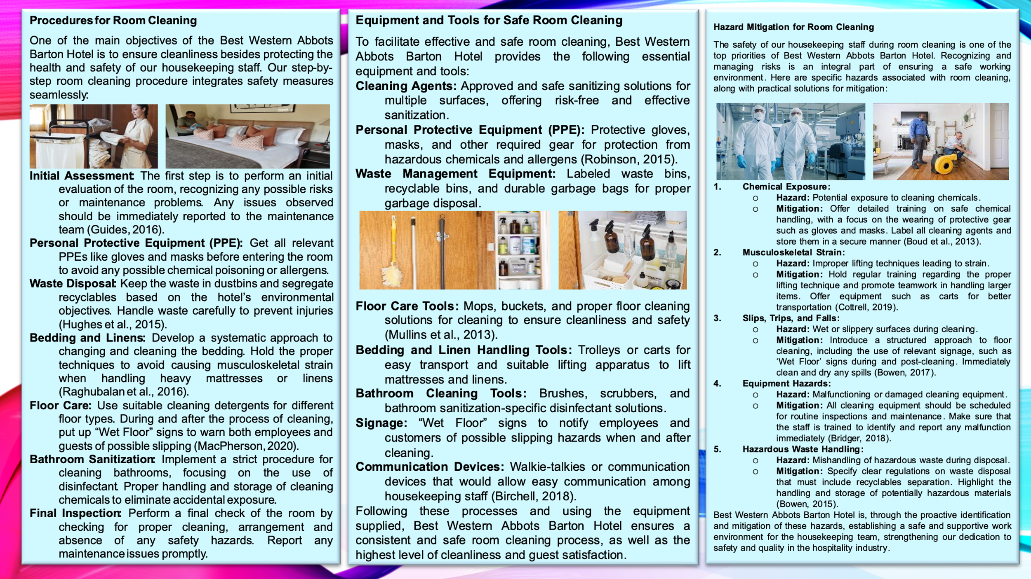

References
Birchell, D.B. (2018). Haunted hotels and ghostly getaways of New Mexico. Arcadia Publishing.
Boud, D., Keogh, R. & Walker, D. (2013). Reflection: Turning Experience into Learning.
Bowen, E. (2015). The hotel. Random House.
Bridger, E. (2018). Employee engagement: a practical introduction. 2nd ed. HR Fundamentals. London: CIPD and Kogan Page.
Casado, M. (2012). Housekeeping Management. London: Wiley.
Ferdinand, N. & Kitchin, P. (2017). Events Management - An International Approach. 2nd ed. London: SAGE Publications Ltd.
Guides, F.T. (2016) Fodor’s the complete guide to the West's national parks. Fodor’s Travel.
Hughes, P. & Hughes, L. (2015). Easy guide to health and safety. Routledge.
MacPherson, C. (2020). The Pocket Butler’s guide to good housekeeping: Expert Advice on Cleaning, Laundry and Home Maintenance. Appetite by Random House.
Mullins, L. and Dossor, P. (2013). Hospitality Management and Organisational Behaviour. 5th ed. Harlow: Pearson.
Raghubalan, G. and Raghubalan, S. (2016). Hotel Housekeeping - Operations And Management. 3rd ed. India: Oxford University Press.
Robinson (2015b) Housekeeping: A Novel. Macmillan.
Robinson, M. (2015) Housekeeping. Faber & Faber. Routledge.
Trevor, W. (2015). Mrs Eckdorf in O’Neill’s hotel. Penguin, UK.

