EIGP 2
Assighment 2 - Report
Luke Webb (1803165)
2020
Ideation
- Ideation: clearly state the new product idea

The product idea that are group has been working on called ‘piece of pie’ is an online interactive site that would allow for people to contact and search for mental health help at anytime that they feel they need it. The idea is the make it so everyone has the access, so we wanted to make a site that later on can be turned into and app, a person seeking out help with be able to go to the site, make an account and search for counsellors, psychologist and therapists or whatever type of help they seek, they’ll be able to message any of these professionals and if the professional can help they can go on to make an appointment and meet in person if that’s something that the client wants.

- Illustration: description and illustration of the new proposed product

- Home page

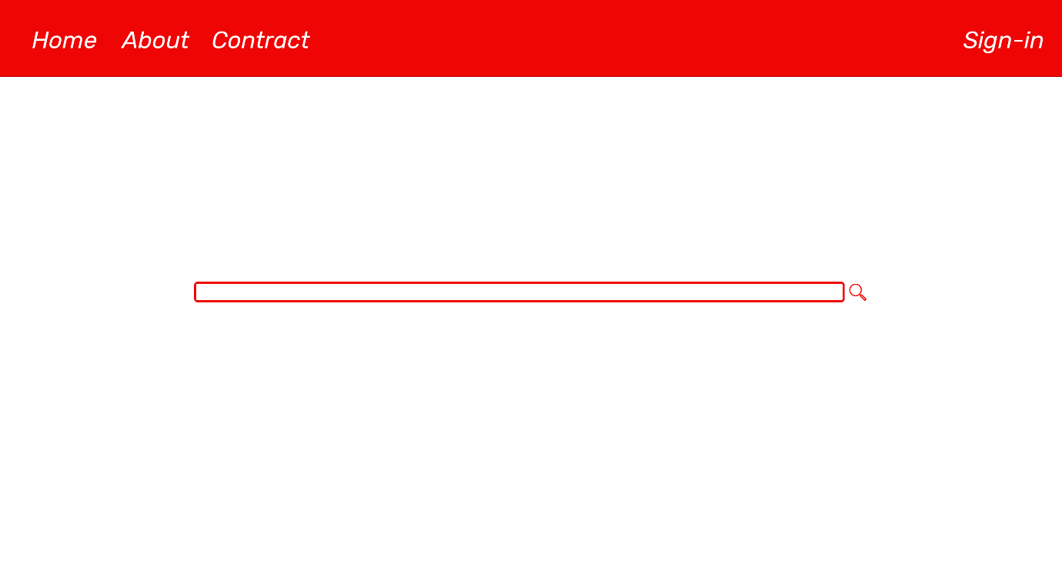
The home page will be the first page a user will see when they click onto the site, they will be greeted by a simple white page with a navigation bar, items hovered over will highlight in red, the home page will remain as simple as possible with a search bar in the centre of the screen with a single button for searching for whatever users type into the box.

- About

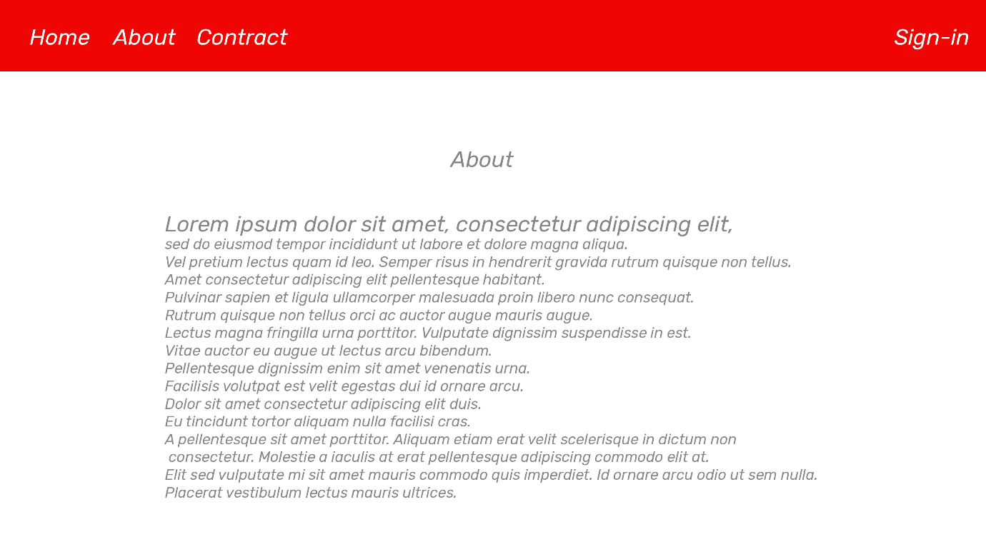
The about page we will want to explain what our website is for how to use it and maybe have some small quote about what our goals are, we would also have a small bit of testimony from user that might have used the site in the past and have them explain how they felt before and after the used the site to seek help.

- Contact

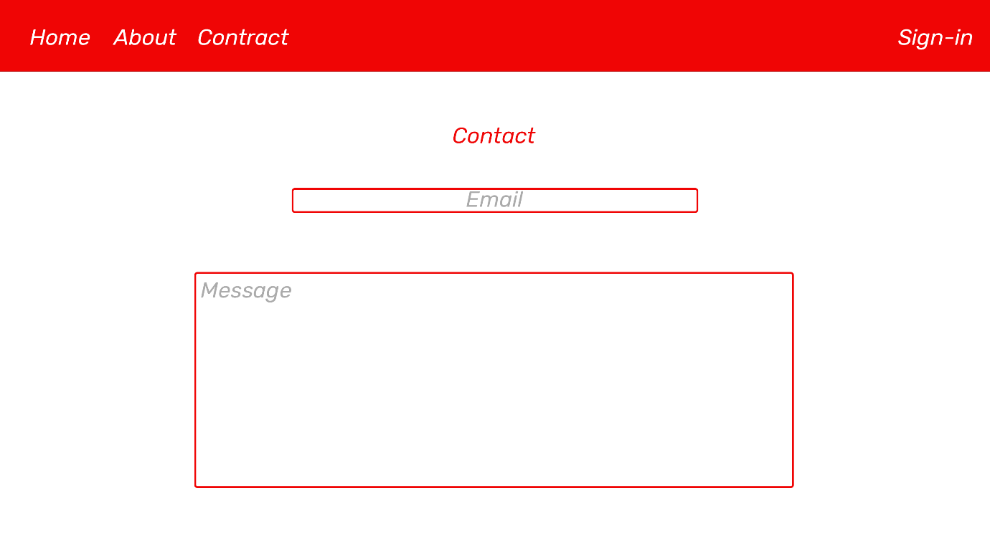
Our contact page will be very simple it should have some text boxes for a user to enter what they are trying to contact us about option might be errors or bug reports, help with accounts, general inquiries and maybe a suggestions options in case users have helpful additions that they would like to see get added to the site.

- Sign-In & Sign Up

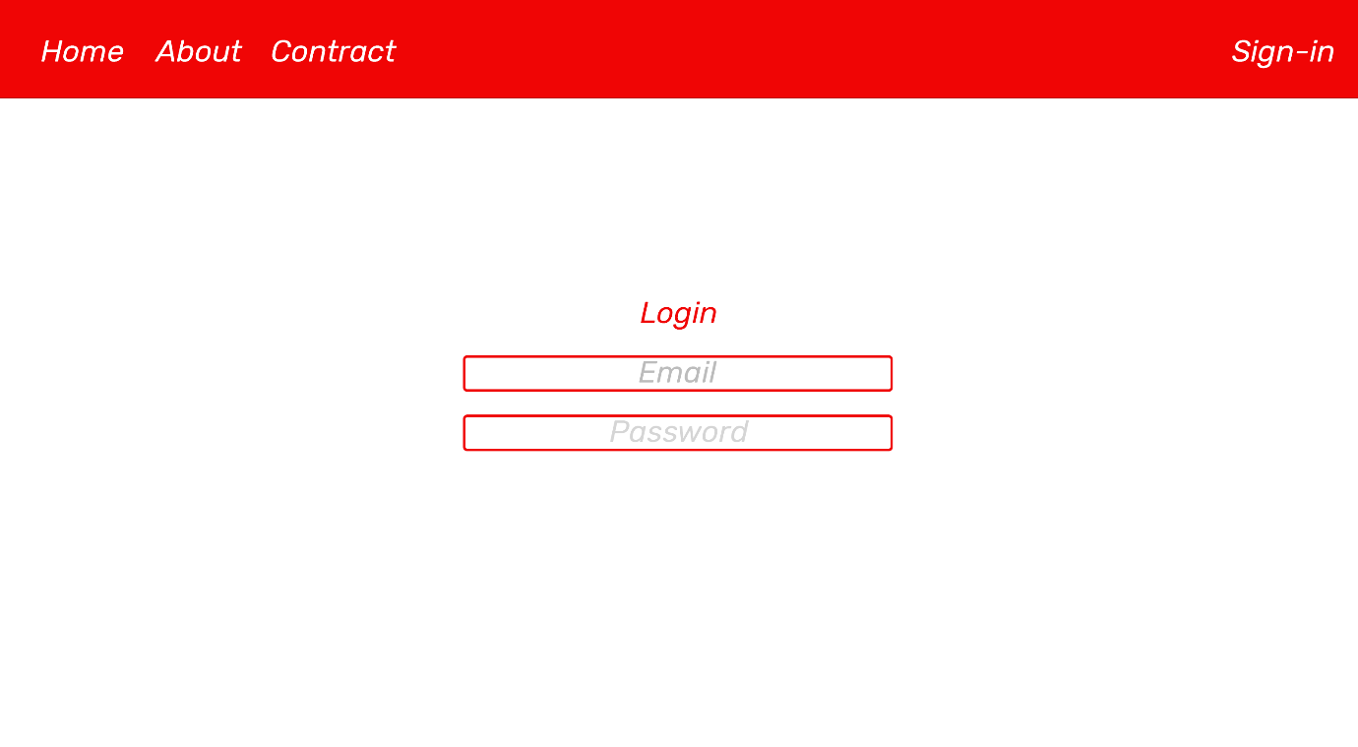
The sign-in and sign up pages will look almost the same the main difference being that users who already have an existing account will be able to sign in using an email and password if a user doesn’t have an existing account there will be a link that will then send them over to the sign-up page that will ask them for a username, email and password so that the site can then identify who is attempting to sign-in to the site.

- User Account Page

This will be the page where after signing in a user will be able to see all of there personal information that they have given to the site like address, email, username and their messages that they might have had with professionals on the site.

They will be able to change any of this information if they need to at any time, they will also be able to see the search history in case they searched for something and forgot what they had typed in order to access that information.

- Results

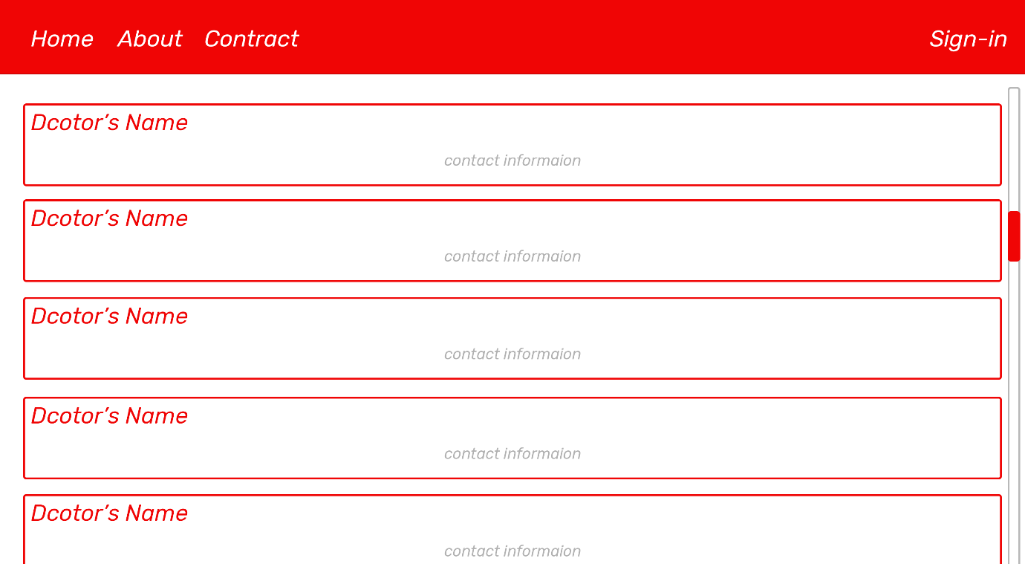
This will be the most important page for the users it will need to layout near by specialists that are near by the user who entered in the information, it will need to layout out the information in a easy to read format almost like a list with some search filters that can be used to more fine tune what the user is looking for things like distance, rating and availability.

- Design: requirements, MVP (Minimum Viable Product) and design documentation

Requirements:

- Accessibility
The site will need to be accessible to as many people as possible this means that the site will need to accommodate to people who might suffer from “impaired vision, motor difficulties, cognitive impairments or learning disabilities, deafness or impaired hearing” according the https://www.gov.uk/ site.
This means that our site will need to be designed so that text is clear with a good contrast with its colour and the background its on and able to change the size of the font if necessary for people who are still struggling to be able to read it, colours should be high contrast and being as simple as possible would also make it easier for people to read, the site could also have a system for reading text out if possible for people who are maybe blind and that can only hear if they don’t have assistance.

- Site Features

- Searching bar

The main feature that the site will need to offer would be the ability to search for help based on the user’s location.

- User accounts with Log-In & Sign-Up

To track user information for additional features like messages we would need to make an account for the user so that we can tell different users apart we would need everyone who plans on using the site for more then a one of time to make a account so we can identify them.

- Messaging

We’d like for the site to have a peer to peer messaging service to make it easier for a user and a professional to communicate instead of having to use something like email this way everything can be contained on the site.

- Data encryption

Handing personal data of users and professionals it is very important that people who shouldn’t have access to sensitive information can’t get access to it, it is also important by law, the GDPR to be exact, means that we be very careful with the information, for this reason we will be using very strong encryption and making sure that there is no way a normal user on the site can access anyone else’s information, these rules will also include things like images and cookies used for the site if we use any.

- Page for displaying information

The site will need additional pages for explaining what the site is and how to use it and well as a contact page so that users can send feedback to us so that we can improve our service.

- Server & Domain

So that people can find the site online we will need to store the site on a server and pay for a custom domain so that users can remember the sites name easier, the domain will also be useful for marketing the site as well.

- MVP

All these Features are what we are using as our guild line for a Minimum Viable Product and later on we would like to use feedback to expand our site to offer even more services.
- Design Documentation

Refer to the documentation in the “design” folder one of our team members has made the design documents.

Differentiation
- How is our product different from other services?
Our product is different because it’s the only type of product like this, there is no competition for us to directly compete with making our product and situation unique, we are trying to lunch a new type of service that might help start a new type of way that people in the future might seek out for mental health help.

Development (ALL)
-document the development of a prototype. Clearly outline key features. Including screenshots / images, code extracts and test to describe the implementation process.

Progress report
Team Name: Piece of Pie
Team Goals:
Our goal is to create an online platform for people to be able to seek help in times of crisis
Team Member Names & Roles:
KP: Karl – Project manager.
E: Ethen – Design leader.
LW: Luke Webb – Website development.

Weekly Progress report 1:
Date: 02/12/2020
In-Attendance: KP, LW. Absent: Ethan.
> Individual Updates:
KP Update: Making progress on getting fund
LW Update: making front end work with the bad end and fixing know bugs in the current build of the website
E Update: N/A

Weekly Progress report 2:
Date: 02/19/2020
In-Attendance: LW. Absent: KP, E.
> Individual Updates:
KP Update: meetings
LW Update: working on use accounts system
E Update: finalising designs
Weekly Progress report 3:
Date: 02/26/2020
In-Attendance: LW. Absent: KP, E.
> Individual Updates:
KP Update: Meetings
LW Update: Adding more pages
E Update: bug testing pages

Weekly Progress report 4:
Date: 03/4/2020
In-Attendance: KP, LW. Absent: E.
> Individual Updates:
KP Update: Deployment planning
LW Update: data encryption
E Update: redesigns

Program Development:

Log-in function:
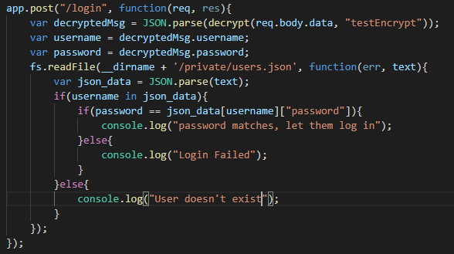
Takes the users data from login text boxes, tries to decrypt the data from the database to make sure that the user exists then if it does returns true allowing the user to log-in.

Decrypt function:
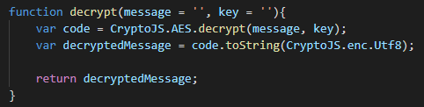
This function takes a message and key used to encrypt and decrypt it and using a library called CrytoJS the message gets encrypt unable to be understood unless you have the original key.

References:
- Accessibility
https://www.gov.uk/guidance/accessibility-requirements-for-public-sector-websites-and-apps
https://en.wikipedia.org/wiki/Web_accessibility

- Data Protection

https://www.wired.co.uk/article/what-is-gdpr-uk-eu-legislation-compliance-summary-fines-2018

https://www.experian.co.uk/business/glossary/data-protection-act/

https://www.gov.uk/data-protection

- Minimum Viable Product

https://en.wikipedia.org/wiki/Minimum_viable_product

https://www.agilealliance.org/glossary/mvp/#q=~(infinite~false~filters~(tags~(~'mvp))~searchTerm~'~sort~false~sortDirection~'asc~page~1).

- Progress report

https://piktochart.com/blog/progress-report/

