Creation of a a short, evidence-based online self-assessment for for professional voice users in Puerto Rico

Lourdes M. González-Caraballo
2318051
Module 5 Assignment
Component 1: 1,629
Component 2: 6,486 (including Critical Reflection)

Component 1 – Project Portfolio

1.1 Introduction
As a voice teacher in Puerto Rico specializing in vocal health, I have observed persistent gaps in access to specialised voice care. ENT physicians who focus on voice are few and concentrated in the metropolitan area, waiting times can extend to several months, and local speech-language pathology (SLP) programmes offer no specialised track for voice or singers. These structural limitations motivated this project. In practice, this means that many singers, teachers, and other professional voice users on the island rely on general practitioners, non-specialist ENT appointments, or word of mouth to navigate their symptoms — making a structured, evidence-informed first point of contact both practically necessary and professionally meaningful.
My professional background — including certification as a Vocal Habilitation Professional (VHP), ongoing training as a Vocal Rehabilitation Specialist (VRS), and visits to specialist voice centres in the United Kingdom — has shaped a long-term vision to establish Puerto Rico's first multidisciplinary voice care centre, Vocare. This project represents a significant step in that development, requiring the integration of clinical knowledge, evidence-based assessment, and digital literacy.
The artefact is an online self-assessment questionnaire — the first point of contact on the Vocare website — designed to guide users towards the category of professional care most appropriate for their presenting symptoms. Its foundation draws on validated patient-reported outcome tools, including the Voice Handicap Index (Rosen et al., 2004) and the Singing Voice Handicap Index (Cohen et al., 2009), ensuring recommendations are grounded in peer-reviewed evidence rather than clinical opinion alone (Laukkanen, Leppänen and Ilomaki, 2009).

1.2 Planned Program of Study

Theoretical Influences
The artefact is shaped by three interconnected theoretical frameworks. First, the biopsychosocial model understands voice disorders as products of biological, psychological, and social factors (Engel, 1977). It includes both voice-specific and anxiety screening tools reflects this multi-dimensional understanding (Flock et al., 2025). Second, patient-reported outcome measures (PROMs) theory underpins the self-assessment approach: PROMs capture the patient's lived experience of disability rather than clinician-rated severity alone, and are now embedded in voice clinic best practice guidance (Francis et al., 2017; Gardner et al., 2025). Third, symptom-severity stratification to direct users to appropriate care is well established in clinical voice practice (Starmer et al., 2014; Stachler et al., 2018), informing the color-coded pathway (Green/Yellow/Orange/Red) used here, which evidence suggests improves appropriate professional allocation (Starmer et al., 2014; Misono et al., 2016).

Best Practice Influences
Best practice in voice care is increasingly interdisciplinary. Evidence demonstrates that outcomes improve when laryngologists, SLPs, voice teachers, and mental health professionals collaborate (Starmer et al., 2014; Misono et al., 2016; Baxter et al., 2019). UK models at the Voice Care Center and Valentine Voice Care reflect this philosophy and directly inform Vocare's envisioned professional network. Using validated brief instruments as first-contact screening is established practice: the VHI-10 (Rosen et al., 2004) and the SVHI-10 (Cohen et al., 2009) are recommended outcome tools by ASHA and the American Academy of Otolaryngology – Head and Neck Surgery (AAO-HNS). The Reflux Symptom Index (Belafsky, Postma and Koufman, 2002) addresses laryngopharyngeal reflux as a frequently under-identified contributor to voice disorders, while the GAD-7 (Spitzer et al., 2006) and the Mazzarolo Music Performance Anxiety Scale (Mazzarolo and Schubert, 2022) reflect growing recognition that psychological wellbeing is integral to vocal function.

Methodological Influences
Artefact development is guided by practice-based research methodology, in which the practitioner-researcher iteratively creates and refines a professional tool through critical engagement with the literature (Smith and Dean, 2009; Nelson, 2022). This is well suited to projects whose output is a professional resource rather than an experimental intervention. Selection and adaptation of validated instruments is further informed by patient-reported outcome methodology; adaptation is acknowledged as a limitation reflecting the tool's informational — rather than diagnostic — purpose.

Aims and Objectives

Aim: To create a short, evidence-based online self-assessment questionnaire that guides users toward appropriate professional voice care within the Vocare network.

Objectives:
- Review peer-reviewed literature on validated voice, reflux, and anxiety self-assessment tools.
- Select and justify specific instruments, producing a written rationale.
- Draft the full questionnaire — including question wording, response scales, and scoring logic.
- Build a functional, shareable online version using an AI-assisted tool.
- Complete functional testing of scoring, triage pathways, and referral logic, producing a brief evaluation report.

Expected Learning Outcomes

Upon completion, I will be able to:
- Critically evaluate the psychometric properties and clinical applications of validated voice, reflux, and anxiety tools.
- Apply biopsychosocial and triage frameworks to multi-dimensional voice health screening design.
- Synthesise peer-reviewed evidence to justify methodological decisions in artefact development.
- Use AI-assisted tools to create a functional, publicly accessible online questionnaire.
- Reflect critically on the limitations of adapting validated instruments for informational use.

Activities, Key Resources, and Assessment Criteria

Key activities: narrative literature review; critical comparison of tool length, scoring, and applicability; drafting items and triage framework; AI-assisted platform development; functional testing.

Assessment criteria — aims and objectives will be considered met when: the literature review covers all five tools with peer-reviewed sources cited; the written justification addresses length, scoring, target population, and validation status; and the completed tool is accessible via shareable link and completable in under ten minutes.

Timescales and Review Dates: Gantt Chart

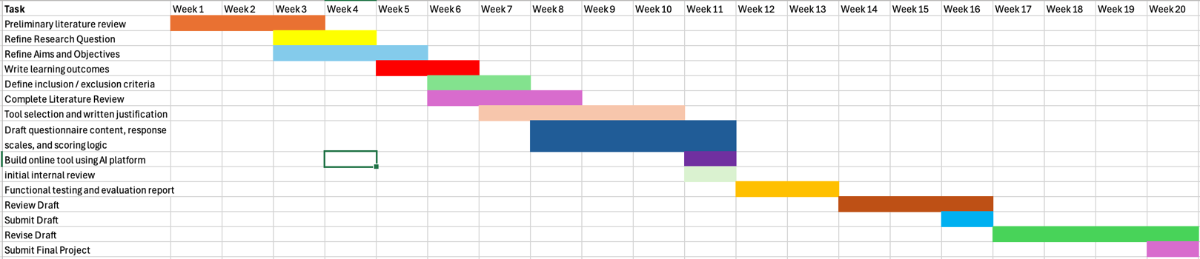

1.3 Methodology
This project combines a narrative literature review with a practice-based artefact development process. A narrative review was selected because the aim is not to produce a systematic synthesis of all existing evidence, but to survey and critically appraise a defined body of validated clinical tools relevant to a specific professional artefact (Grant and Booth, 2009; Ferrari, 2015) This approach is consistent with practice-led research paradigms in which artefact development is guided by critical engagement with the literature rather than formal experimental methods. At the same time, I am aware that this choice has real limits. Without a documented search protocol, it would be difficult for another researcher to verify exactly which sources I included or identify what I might have missed, and unlike a systematic review, a narrative approach cannot tell me the direction or size of effects across the literature as a whole (Grant and Booth, 2009). These are constraints I accepted because the flexibility of a narrative review suited a practice-based project whose goal was artefact development rather than evidence synthesis, but I think it is important to name them rather than only explaining why I made the choice (Ferrari, 2015).

Search Strategy and Inclusion/Exclusion Criteria
Literature searches were conducted via Google Scholar and the UWTSD library. Key search terms included: Voice Handicap Index, VHI-10 validation, Singing Voice Handicap Index, Reflux Symptom Index, laryngopharyngeal reflux questionnaire, GAD-7 validation, and short performance anxiety scale for musicians. No fixed date range was applied, as core validated tools span the early 2000s to the present; however, preference was given to foundational validation studies and recent systematic reviews (2010–2025). Inclusion criteria required peer-reviewed validation studies, clinical applicability to voice or anxiety screening, and availability in English and Spanish. That said, I am aware that the strength of the Spanish-language evidence is not equal across all five instruments. The VHI-10, SVIH-10, RSI and GAD-7 both have well-established Spanish validation data (Diez-Quevedo et al., 2001; Núñez-Batalla et al., 2007; García-López et al., 2010; Calvo-Henríquez et al., 2019), but the M-MPAS has not yet been validated in a Spanish-speaking population, which means I cannot be fully confident that the tool performs in the same way across both languages. This is a limitation I would want to address directly in any future validation study. Tools of excessive length for a first-contact screening context were excluded, as was non-validated or anecdotal guidance. Credibility was maintained by prioritising published validation studies. Grey literature included ASHA's Voice Disorders Practice Portal (ASHA, 2024), AAO-HNS guidelines, and the HNY Voice Hoarseness Pathway (Humber and North Yorkshire Policy and Pathway Repository, 2024).

Table 1. Inclusion / Exclusion Criteria
Inclusion Criteria | Exclusion Criteria
Peer-reviewed validation or normative studies of self-report instruments targeting voice disorders, laryngopharyngeal reflux, generalized anxiety, or music performance anxiety | Tools designed exclusively for pediatric populations
Tools designed for adult populations | Tools with more than 15 items (impractical for an online first-contact screening tool)
Instruments available in, or adaptable to, English and/or Spanish | Diagnostic interviews requiring clinician administration

Tool Selection and Adaptation
Each tool selected was adapted to fit a specific purpose. A summary of the items excluded for each one and their reasons are summarized in Table 2. The VHI-10 (Rosen et al., 2004) was selected as the primary voice instrument; eight of its ten items were retained. The SVHI-10 was included for the singer pathway, retaining six items. The Reflux Symptom Index (RSI) (Belafsky, Postma and Koufman, 2002) addresses laryngopharyngeal reflux — a frequently underdiagnosed contributor to voice disorders — with six of nine items retained. All three instruments use a unified 0–4 Likert format, enabling a consistent response interface. Reducing items from validated scales may affect psychometric properties; accordingly, the tool is framed explicitly as informational guidance rather than clinical diagnosis, and this limitation will be addressed in Component 2. For the psychological component, the GAD-7 was selected to screen for generalized anxiety. Its response scale was adapted from 0–3 to 0–4 to align with the voice items; this modification is acknowledged. The Kenny Music Performance Anxiety Inventory (Kenny, 2023) was considered but rejected due to length (40 items). The five-item Mazzarolo Music Performance Anxiety Scale (Mazzarolo and Schubert, 2022) was selected as a brief, validated alternative, scored 0–6 per item.

Table 2. Summary of Items retained and excluded.
Instrument | Original Items  (Scale) | Items  Retained | Items Excluded — Content | Reason for Exclusion | Scale Adaptation
VHI-10  (Rosen et al., 2004) | 10  (0–4 scale) | 8 | Difficulty in noisy rooms; loss of income | Noisy-room item overlaps with retained hearing item. Income-loss item is culturally specific and less applicable to Puerto Rico's mixed professional voice market. | None — native 0–4 scale retained. Max score adjusted 40→32; triage cutoffs recalibrated (Red ≥22; Orange ≥12; Yellow ≥6).
RSI  (Belafsky et al., 2002) | 9  (0–5 severity scale) | 6 | Difficulty swallowing; coughing after eating/lying down; breathing difficulties/choking | Dysphagia is a medical red-flag handled by the disclaimer. Post-eating cough overlaps with retained cough item. Choking is an emergency symptom inappropriate for numeric scoring. | Native 0–5 severity scale rescaled to 0–4 frequency to harmonise with other instruments. Clinical cutoff >13 recalibrated to ≥14 on adapted scale.
SVHI  (Cohen et al., 2007;  SVHI-10: Cohen et al., 2009) | 36 full / 10 short form  (0–4 scale) | 6 | All other 30 full-scale items; SVHI-10 items duplicating VHI-10 domains; performance-specific anxiety items | Performance anxiety items excluded to avoid construct overlap with M-MPAS. VHI-10-duplicating items excluded to prevent double-counting. Retained items capture singing-specific dimensions (range, fatigue, warm-up) absent from VHI-10. | None — native 0–4 scale retained. Items administered to all users (not only singers) as they apply to all professional voice users.
GAD-7  (Spitzer et al., 2006) | 7  (0–3 scale, 2-week window) | 5 | Easily annoyed/irritable; feeling afraid something awful might happen | Irritability has transdiagnostic overlap with depression and ADHD, reducing anxiety specificity. 'Something awful' item is culturally unstable in Spanish translation and has the lowest factor loading. | Native 0–3 scale expanded to 0–4 to add a high-frequency category and match other instruments. Cutoffs recalibrated: moderate ≥10/20; severe ≥15/20. Two-week reference window preserved in instructions.
M-MPAS  (Mazzarolo & Schubert, 2022)  [replaces K-MPAI subset] | 5 items  (0–6 Likert agreement scale)  [K-MPAI original: 40 items] | 5 (full scale) | N/A — full published scale used. K-MPAI early relational context, depression, and cognitive/memory items not used. | Prior version used an unvalidated 5-item K-MPAI subset. M-MPAS is the only published, validated 5-item MPA screener (α=0.894; r=0.797 vs K-MPAI). K-MPAI excluded due to length (40 items) and unvalidated subsetting. | Native 7-point Likert scale (0–6 per item; total 0–30) retained to preserve validated cutoff (≥11 = high MPA). Item 4 is reverse scored. Administered conditionally to singers/actors/performers only.

Artefact Development Process
Development followed an iterative, reflective process consistent with practice-based research methodology (Smith and Dean, 2009). An initial draft integrating voice and reflux items was created; psychological screening components were added after a gap was identified in the emerging design. The completed item set was built into a functional online tool using Claude (Anthropic, 2026), an AI platform capable of generating shareable, interactive web-based forms. AI-assisted development was a methodological choice driven by the practical constraint of no prior coding knowledge; the accuracy of scoring logic and referral pathways was reviewed and tested carefully. Results are presented as a four-tier triage system (Table 3), with psychological scores routed as additive modifiers: mild-to-moderate anxiety triggers music therapy and vocal health coaching; severe presentations prompt referral to a psychologist prior to other services.

Table 3. Four-Tier Triage System — Score Thresholds, Clinical Interpretation, and Recommended Actions
Level | Score Threshold | Clinical Interpretation | Recommended Action
🟢 Green | VHI < 6  Voice Total < 18 | No significant vocal impairment; scores within normative range (Rosen et al., 2004) | Vocal hygiene education; preventive resources; music therapy for wellbeing
🟡 Yellow | VHI ≥ 6  Voice Total ≥ 18 | Mild–moderate symptoms suggesting inefficient vocal use or early fatigue | Vocal coaching; hygiene program; preventive music therapy
🟠 Orange | VHI ≥ 12, OR  RSI ≥ 14 + VHI ≥ 8, OR  Voice Total ≥ 30 | Moderate–significant handicap; possible structural pathology or musculo tensional dysphonia (Rosen et al., 2004; Belafsky et al., 2002) | SLP voice therapy; laryngological evaluation; reflux management
🔴 Red | VHI ≥ 22  Voice Total ≥ 45 | Severe handicap; consistent with established laryngeal pathology requiring differential diagnosis (Jacobson et al., 1997) | Urgent ENT/laryngologist referral; video laryngoscopy before other intervention

Component 2 – Project Report
Introduction
This project critically evaluates the development of an online self-assessment questionnaire designed as the first point of contact for Vocare, a proposed multidisciplinary voice care centre in Puerto Rico. The artefact was developed in response to persistent gaps in access to specialised voice care services on the island, including limited availability of voice-specialised ENT physicians, long waiting times for assessment, and the absence of specialised voice or singer-focused tracks within local speech-language pathology programmes. These structural barriers have significant implications for professional voice users, singers, teachers, and individuals experiencing voice difficulties who may struggle to identify appropriate professional support pathways.
Rather than functioning solely as a symptom checklist, the questionnaire was designed as an evidence-based triage and educational tool intended to guide users toward the category of professional care most appropriate for their presenting symptoms. The artefact integrates validated patient-reported outcome measures (PROMs), including adaptations of the Voice Handicap Index-10 (VHI-10) (Rosen et al., 2004), Singing Voice Handicap Index-10 (SVHI-10) (Cohen et al., 2009), Reflux Symptom Index (RSI) (Belafsky, Postma and Koufman, 2002), Generalized Anxiety Disorder-7 (GAD-7) (Spitzer et al., 2006), and the Mazzarolo Music Performance Anxiety Scale (Mazzarolo and Schubert, 2022). The project therefore sits at the intersection of vocal health, interdisciplinary voice care, psychological wellbeing, and digital accessibility.
The significance of this study lies in the increasing recognition that voice disorders and vocal difficulties are multidimensional phenomena influenced not only by physiological factors, but also by psychological, behavioural, and social variables. The biopsychosocial model proposed by Engel (1977) provides an important framework for understanding voice disorders beyond purely biomedical explanations. Contemporary voice care literature increasingly advocates for interdisciplinary models in which laryngologists, speech-language pathologists, voice teachers, psychologists, and other professionals collaborate to improve patient outcomes (Starmer et al., 2014; Misono et al., 2016; Baxter et al., 2019). PROMs have also become increasingly central within voice assessment and treatment because they prioritise the patient’s lived experience of vocal difficulty rather than clinician-rated severity alone (Francis et al., 2017; Gardner et al., 2025). However, despite these developments, accessible pathways directing individuals toward appropriate voice-related services remain limited, particularly in emerging contexts such as Puerto Rico. This project therefore attempts to address both a practical and conceptual gap by creating a tool that combines evidence-based screening principles with accessible digital guidance.
The theoretical foundation of the artefact draws primarily from the biopsychosocial model (Engel, 1977), PROMs theory, and symptom-severity stratification frameworks used in contemporary voice clinics (Starmer et al., 2014; Stachler et al., 2018). The biopsychosocial framework informed the inclusion of both vocal and psychological screening elements, recognising the interaction between emotional wellbeing, anxiety, and vocal function (Flock et al., 2025). PROMs theory provided the rationale for privileging the patient’s lived experience of vocal disability (Francis et al., 2017), while symptom-severity stratification informed the development of the questionnaire’s colour-coded referral system designed to guide users toward different levels of professional intervention (Starmer et al., 2014; Misono et al., 2016). The interdisciplinary philosophy underpinning specialist centres such as the Voice Care Centre and Valentine Voice Care also informed the conceptualisation of Vocare as an integrated professional network.
Throughout the project, my understanding of both interdisciplinary voice care and artefact development evolved significantly. Initially, the focus centred primarily on creating a straightforward voice-related screening questionnaire. However, engagement with the literature revealed the importance of incorporating psychological screening, reflux-related symptoms, and broader biopsychosocial considerations into the design. This led to iterative refinements in both the questionnaire structure and referral pathways. Additionally, the process highlighted tensions between maintaining the psychometric integrity of validated instruments and adapting them into a concise, accessible first-contact tool suitable for online use. The decision to adapt shorter versions of established scales therefore became both a practical and methodological consideration requiring critical evaluation (Laukkanen, Leppänen and Ilomaki, 2009).
Methodologically, the project adopted a practice-based research approach informed by narrative literature review and iterative artefact development (Smith and Dean, 2009; Nelson, 2022). A narrative review was selected because the project aimed not to produce a systematic synthesis of all available evidence, but rather to critically evaluate and apply a defined body of literature relevant to the development of a professional artefact (Grant and Booth, 2009; Ferrari, 2015). The artefact itself was developed using an AI-assisted platform, Claude (Anthropic, 2026), to create a functional and publicly accessible questionnaire. The use of AI-assisted development introduced additional methodological considerations concerning accessibility, scoring accuracy, referral logic, and professional responsibility, all of which became central to the evaluative process.
The primary aim of this critical review is to evaluate the theoretical foundations, methodological decisions, and practical implications involved in the development of the Vocare online self-assessment questionnaire. Through this evaluative process, the project seeks to critically analyse the effectiveness, limitations, and interdisciplinary relevance of the artefact within the broader context of evidence-based voice care.

Know-That
I follow a biopsychosocial model of voice care where biological, psychological and social aspects of the individual are explored and taken into account when creating a treatment or lesson plan. The biopsychosocial model was first proposed by Engel in 1977 and has since been widely accepted in healthcare systems around the world (Adler, 2009; Wade and Halligan, 2017). Voice problems are known to have biological, social and psychological components (Starmer et al., 2014; Flock et al., 2025). In my artefact, this orientation is operationalised through five domains: general voice handicap, reflux symptoms, singing voice handicap, generalised anxiety and music performance anxiety, which together provide a multidimensional profile of the client’s vocal health and guided the selection of assessment instruments (see picture below). One thing I have since reflected on is that including both the GAD-7 and the M-MPAS raises the question of how much these two domains actually overlap. The relationship between generalised anxiety and music performance anxiety is itself contested in the literature: Kenny (2023) identifies GAD scores as a strong predictor of MPA severity, while Wiedemann et al. (2022) found that MPA was conditionally independent of all other anxiety disorders once GAD was accounted for — suggesting that for some users, scores on both scales may be measuring the same underlying experience rather than two genuinely distinct dimensions. This could make the composite results harder to interpret in practice, and it is something I would want to explore in a future validation study.

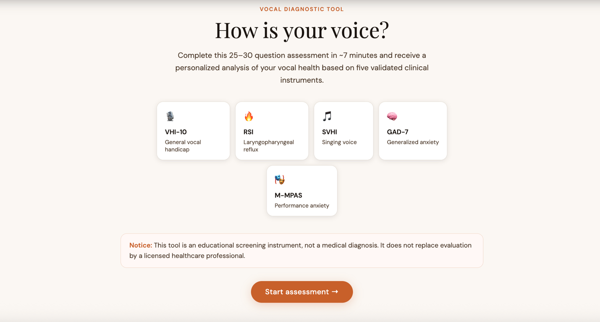

Patient-Reported Outcome Measures (PROMs) are standardised, validated questionnaires that capture how a disorder impacts an individual’s daily life. They bridge the gap between clinical metrics (such as a laryngoscopy) and the patient’s subjective quality of life. In voice care, symptoms are highly multidimensional (Francis et al., 2017), and a patient’s perception of their vocal handicap often differs from a clinician’s objective findings, which makes PROMs the gold standard for measuring treatment efficacy. In broad terms, a handicap is defined by the World Health Organization (WHO, 1980) as “the social, economic, or environmental disadvantage resulting from an impairment or disability that prevents a person from fulfilling a normal social role.” Since these aspects cannot be measured clinically, it is important that the patient reports how their health problems have affected different areas of their life. In the adapted VHI-10 block, items such as “People have difficulty hearing me because of my voice,” “My voice problem limits my personal and social life,” and “I feel my voice is not adequate for my work” explicitly reflect functional, social and occupational disadvantage in line with this definition. The use of PROMs has been widely incorporated into best practices of health care, including voice clinics (Francis et al., 2017; Gardner et al., 2025). Both the VHI-10 and S-VHI-10 include questions related to physical symptoms of the voice and how these affect quality of life, which aligns directly with my biopsychosocial approach. Placing these PROMs at the very start of the online journey signals to the client that their own perception of difficulty and impact is central.
Singers are often more sensitive to changes in the quality of their voice, and these changes have a higher impact on their quality of life (Sobol, Sielska-Badurek and Osuch-Wójcikiewicz, 2019). This is why including the S-VHI-10, a singer-specific PROM, was an important part of my artefact development. As shown below, I prioritised items that capture subtle but professionally significant changes, such as vocal fatigue, loss of range, increased warm-up time, avoidance of situations because of the voice and worry about the future of the voice and career. These aspects recognise that for singers, even early or “invisible” vocal changes can have serious occupational and emotional consequences and therefore require a tailored measure rather than relying only on a general voice handicap scale.
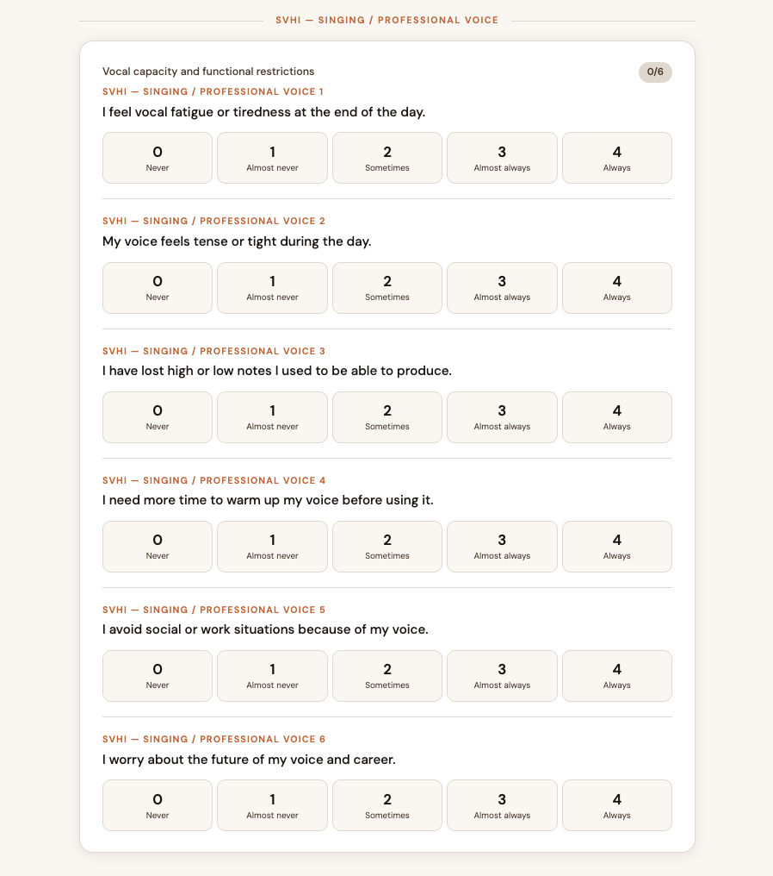

Reflux has been associated with hoarseness, sore throat, laryngitis and other voice-related symptoms (Delahunty, 1972; Braghetto et al., 2003; Handa, 2005). Although the strength of this correlation has been questioned in recent years, reflux remains a probable contributor to some voice problems (Schneider, Vaezi and Francis, 2016; Korsunsky et al., 2023), and treating acid reflux has been observed to alleviate voice symptoms in some patients (Rajput et al., 2025). Within the artefact, I therefore included the Reflux Symptom Index (RSI) (Belafsky, Postma and Koufman, 2002) as one component of a broader biopsychosocial profile rather than as a stand-alone diagnostic tool. The retained RSI items focus on symptoms directly tied to vocal function, such as frequent throat clearing, excess mucus, globus sensation, heartburn or indigestion, hoarseness worse in the morning or after eating, and persistent cough (see picture below). A raised RSI score does not label the client as having reflux; instead, it flags the need to explore behavioural and medical factors that might be contributing to laryngeal irritation, balancing the risk of over-attributing symptoms to reflux with the responsibility not to overlook a modifiable factor in voice care.

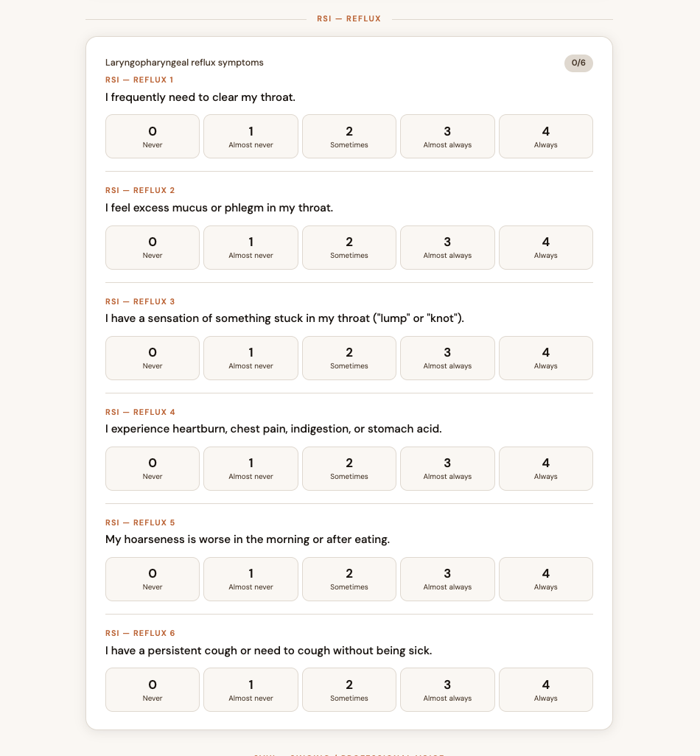
The psychological dimension of my artefact is grounded in evidence regarding anxiety and voice (see pictures below). To keep the assessment brief while relying on validated tools, I used the GAD-7, available in both English and Spanish (Diez-Quevedo et al., 2001; Spitzer et al., 2006), and the Mazzarolo Music Performance Anxiety Scale (M-MPAS), a five-item screener for music performance anxiety (Mazzarolo and Schubert, 2022). Short, validated instruments are particularly suited to an online, self-administered artefact, where longer questionnaires may deter users who are already overwhelmed by their symptoms. General anxiety can trigger voice changes such as shakiness, shallow breathing, muscle tension and hoarseness, and voice problems in professional voice users can threaten their ability to work and disrupt their sense of identity, exacerbating distress and anxiety (Aremu, 2026; Bingaman, Mauger and Cantor-Cutiva, 2026). The GAD-related items in my artefact focus on feeling nervous, being unable to control worrying, worrying excessively about different things, difficulty relaxing and restlessness, all of which are relevant to breath support, laryngeal tension and autonomic regulation in voice use. The performance-anxiety component is behaviourally grounded through M-MPAS items that ask about strong pre-performance anxiety, frequent nerves, avoidance of performing and reluctance to proceed with performances because of anxiety. Combining general and performance-specific anxiety measures acknowledges that a singer may present with mild vocal symptoms but severe anticipatory anxiety, or the reverse, and that both patterns have implications for care.
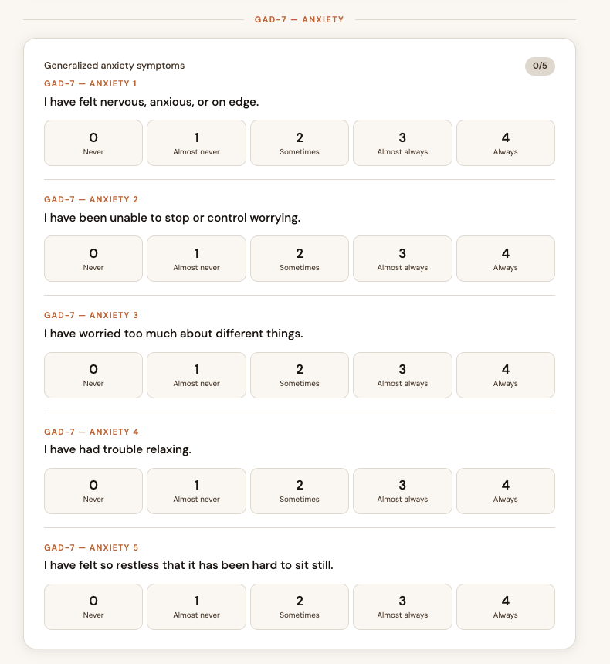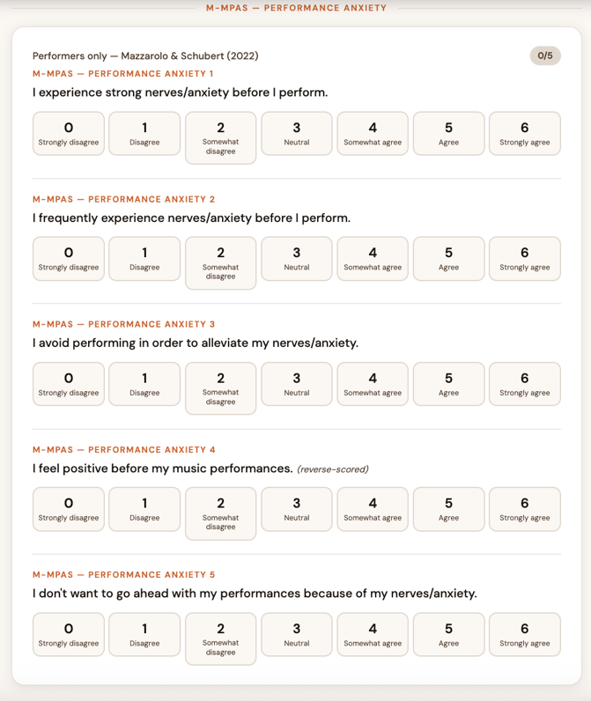

Reflecting, revising and adapting my artefact demonstrates the use of practice-based research (PBR) methodology (Marshall, 2010; Nelson, 2022). PBR emphasises the dual nature of creating and analysing an artefact, where practice and reflection are interwoven to generate knowledge (Pariser, 2009; Gilbert et al., 2022). In developing the questionnaire, I engaged in cycles of design, testing and revision, selecting and adapting items so that they could function together in one brief web-based screener while still preserving their core constructs. This included decisions such as harmonising most response formats into a shared 0–4 scale for usability, conditionally presenting performance-anxiety questions only to singers or performers, and preserving the M-MPAS structure because its published cutoff depends on its original scoring format. Through this iterative process, theoretical understandings of biopsychosocial voice care were reflected upon and recontextualised in the practical realities of designing a user-friendly tool. The artefact thus becomes not only a screening resource for patients and practitioners, but also a site of knowledge production about how biopsychosocial principles can be translated into an accessible digital assessment.

Know-How
My idea of creating a voice care center in Puerto Rico comes directly from my own voice teaching and music therapy practice. Working with singers, teachers and other professional voice users, I repeatedly saw how fragmented local services were and how difficult it was for clients to know where to start. When I started to create my artefact, I therefore wanted to design a questionnaire that would be the first interaction that clients have with the website and would gently guide them towards appropriate care. Practically, this led me to structure the tool as a three-step, web-based flow: first a short demographics screen, then the main questionnaire, and finally a colour-coded results page with recommendations. When choosing my assessment tools, it was important to me that they had been validated both in English and Spanish, as my main target is the Puerto Rican population and I wanted clients to be able to move naturally between languages without losing nuance.
I started constructing my artefact with the most well-known assessment tool for voice: the Voice Handicap Index (VHI). Since my artefact is meant to be a short, informative tool, I used the VHI-10 in English (Rosen et al., 2004) and Spanish (Núñez-Batalla et al., 2007) instead of the original 30-question assessment (Jacobson et al., 1997). One of the main populations that I aim to serve in my voice care center are singers. Because singers often have singing-voice-specific problems, I also incorporated the Singing Voice Handicap Index in its shortened ten-item version into my artefact (Cohen et al., 2007, 2009; García-López et al., 2010; Spuler Fernández, Correa Forno and Azevedo, 2023). In the first prototype, these two sets of items were presented together on a single questionnaire page so that users could see both general and singing-specific impacts side by side. This layout was a deliberate practical choice based on my teaching experience: singers often talk about their “speaking voice” and “singing voice” as interconnected, and I wanted the interface to reflect that continuity rather than splitting them into separate tools.
Version 1 of the artefact only included the two VHI’s. Very quickly, my clinical intuition told me that this was not enough, because many of my clients complain about symptoms such as throat clearing, mucus or heartburn alongside hoarseness. Another factor that I therefore wanted to include in my assessment was acid reflux symptoms. After reviewing the literature and reflecting on my own experience with clients who present with possible laryngopharyngeal reflux, I decided to include the Reflux Symptom Index (RSI) (Belafsky, Postma and Koufman, 2002) as the most appropriate short measure. I selected the six items most directly linked to vocal function, rather than importing the full scale, so that the questionnaire would stay within a realistic online completion time. These three tools constituted Version 2 of my artefact and represented my first concrete attempt to operationalise a biopsychosocial view of voice problems.
After reflecting on this preliminary questionnaire, I realised that I had left out an important factor that is part of my holistic view: anxiety. In both my studio and clinical work I had often seen how anxiety, especially performance-related anxiety, could tighten the voice or reduce breath support even when the vocal folds were structurally healthy. Since my target audience consists of both performers and non-performers, I decided to include a generalised anxiety assessment and a music performance anxiety (MPA) assessment. To keep it short, I used the GAD-7, a seven-item validated tool available in both English and Spanish (Diez-Quevedo et al., 2001; Spitzer et al., 2006). When looking at MPA assessments, I first considered the Kenny Music Performance Anxiety Inventory (K-MPAI) (Kenny, 2023). While I could find evidence of it being a very robust tool, reducing its 40 items to 5–10 would greatly affect its validity, and including all 40 items conflicted with my aim of accessibility. In response, I decided to use the five-item Mazzarolo Music Performance Anxiety Scale (M-MPAS) (Mazzarolo and Schubert, 2022), which was specifically designed as a brief screener. This decision reflects my ongoing negotiation between psychometric rigour and the practical constraint of keeping the tool under approximately 30 questions.
As the content grew, I also needed to make decisions about who would see which questions. In my early drafts, all users saw all scales, but I intuited that this could be confusing for non-singers. Drawing on my experience with intake forms in studio settings, I implemented conditional branching: in the online artefact, both the S-VHI-10 and the M-MPAS blocks only appear if the client indicates on the first screen that they sing regularly or identify as a performer. The user must check a box on the ‘basic information’ page if they sing regularly as a work or hobby (see picture below). This branching required additional programming effort, but it allowed me to keep the questionnaire relevant and reduced the risk of non-performers disengaging when faced with items that did not apply to their voice use. After this stage, I considered that these five tools together provided the biopsychosocial discernment I wanted: general voice handicap, singing voice handicap, reflux symptoms, general anxiety and performance anxiety.
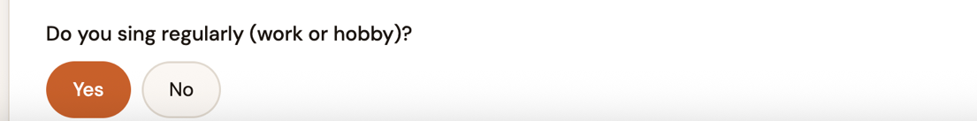

Designing the results page required another set of procedural decisions. After completing the questionnaire, the person receives their results as a colour-coded score: green, yellow, orange or red, in order of severity (see picture below). I used Claude (Anthropic, 2026) to develop a simple algorithm that sums the item scores within each scale, calculates a composite “voice total”, and then maps this to the four levels using thresholds adapted from the original VHI and RSI cut-offs. I chose a colour-coded system because, in my teaching and therapy work, I have found that clients respond better to simple visual feedback than to raw numbers alone. Each colour is accompanied by a short description in plain language and a series of recommendations (for example, preventive tips for green, vocal coaching for yellow, voice therapy for orange and ENT referral for red), which transforms abstract scores into concrete next steps. This structure was not simply a visual preference: the green-to-red progression directly reflects the symptom-severity stratification framework I described in the Know-That section, where the evidence shows that matching intervention intensity to clinical need improves appropriate professional allocation (Starmer et al., 2014; Misono et al., 2016). Grounding the colour-coded design in that literature was a deliberate choice to ensure the results page functioned as an evidence-based triage tool rather than an aesthetic feature.
Multiple versions of the artefact were created and refined. After adding the GAD-7 and M-MPAS, I realised that, despite using short forms, the questionnaire felt too long and dense on screen. Some items overlapped in meaning or were worded in ways that sounded too clinical. Drawing on my day-to-day experience of how clients talk about their voices, I revised the wording for clarity, removed questions that seemed repetitive or inconsequential to my judgement and adjusted the order of items to create a more intuitive flow. For example, I grouped all symptom-based items before those dealing with emotional or social impact so that users could move from “what I feel in my throat” to “how this affects my life” in a logical progression. This iterative editing process is where my experiential knowledge as a practitioner was most visible: I continually weighed what would be ideal from a research perspective against what I knew real people would actually complete and understand.
Through these cycles of building, reflecting and refining the artefact, I learned to translate broad concepts such as the biopsychosocial model and practice-based research into very concrete design choices: which items to keep, how many pages to use, what colours to assign to each triage level, and when to hide or show certain scales. The final version of the questionnaire reflects not only published evidence but also my accumulated hands-on experience working with voice clients in Puerto Rico, and it is this combination of procedural skill and embodied knowledge that underpins the Know-How dimension of my project.

Know-What
My overall aim was to create a short, evidence-based online self-assessment questionnaire that guides users toward appropriate professional voice care within the Vocare network. This aim is directly reflected in the content of the artefact: the questionnaire gathers self-reported information across five domains—general voice handicap, singing-voice handicap, reflux-related symptoms, generalised anxiety and music performance anxiety—and then converts these data into a four-level triage outcome (green, yellow, orange, red) with associated recommendations. On the first screen, the demographic items (see picture below) on hours of daily voice use and primary voice role embed knowledge about vocal load as a risk factor for dysphonia, which has been highlighted in studies of occupational voice users (Spina et al., 2015). Together, these domains capture the biological, psychological and social aspects of vocal health that underpin Engel’s biopsychosocial model of illness and its later applications in voice care (Engel, 1977; Adler, 2009). The triage outcome embodies the guiding function of the tool by signalling how urgently, and what kind of, professional support the user might need, in line with calls for structured referral pathways in voice services (Starmer et al., 2014; Flock et al., 2025).
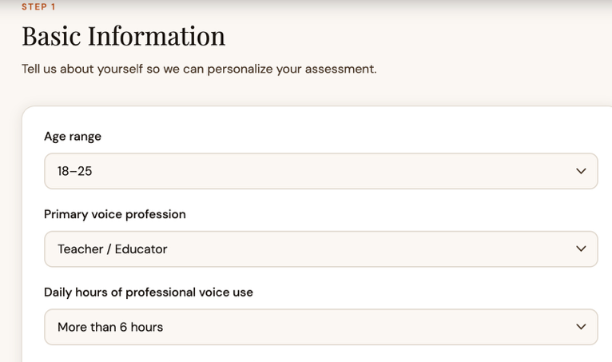
The first objective was to review peer-reviewed literature on validated voice, reflux and anxiety self-assessment tools, and this factual work is visible in the specific instruments embedded in the artefact. The Voice Handicap Index was originally developed and validated as a 30-item measure of functional, physical and emotional impact of dysphonia (Jacobson et al., 1997), and subsequent research supported a ten-item short form, the VHI-10 (Rosen et al., 2004). The Singing Voice Handicap Index and its ten-item version were created specifically for singers and shown to capture singing-voice handicap as a distinct construct (Cohen et al., 2007, 2009; Renk et al., 2017). Spanish adaptations of the VHI-10 and SVHI-10 further established their reliability and cultural applicability in Spanish-speaking populations (Núñez-Batalla et al., 2007; García-López et al., 2010). For reflux, the Reflux Symptom Index has been validated (in both English and Spanish) as a reliable self-report measure of laryngopharyngeal reflux symptoms and is widely used in clinical practice (Belafsky, Postma and Koufman, 2002; Calvo-Henríquez et al., 2019; Lechien et al., 2020). Generalised anxiety is assessed with the GAD-7, a brief tool with good sensitivity and specificity, including in Spanish-speaking hospital samples (Diez-Quevedo et al., 2001; Spitzer et al., 2006). Music performance anxiety is measured using the five-item Mazzarolo Music Performance Anxiety Scale (M-MPAS), which was designed and validated as a short screener for musicians (Mazzarolo and Schubert, 2022). Contrary to the other tools used in the questionnaire, the M-MPAS has not been validated in Spanish. Section 2 of the questionnaire therefore combines items adapted from the VHI-10 and SVHI-10 to address general and singing-voice handicap, from the RSI to cover reflux symptoms, and from the GAD-7 and M-MPAS to capture general and performance anxiety.
The final item set is also the outcome of two further objectives: selecting instruments and drafting the questionnaire. Reviews of patient-reported outcome measures in voice emphasise that tools must balance psychometric robustness with brevity, readability and clinical usefulness (Francis et al., 2017; Gardner et al., 2025). In line with this, I reduced longer scales to a total of approximately 25–30 questions by excluding items that were repetitive, poorly suited to the Puerto Rican context or less directly related to vocal functioning—for example VHI items about income and RSI items about dysphagia have been treated as psychometrically peripheral in several shortening and revision studies, contributing less to overall scale performance in adult dysphonic samples (Roy et al., 2013; Demirci, İncebay and Köse, 2024). This editing reflects broader guidance that PROMs intended for routine clinical use should be fit-for-purpose and minimise patient and clinician burden (Churruca et al., 2021). A table with the specific items selected and excluded can be found in Component 1 (Table 2). The resulting questionnaire focuses on observable symptoms and everyday impact while remaining feasible for online completion, showing that I met my objectives of instrument selection and questionnaire drafting while accepting some compromises between construct coverage and brevity.
The final objectives—building a functional online version and testing its scoring and triage logic—are embodied in the behaviour and structure of the results page. After users complete the questionnaire, the artefact computes subscores for each domain and a composite “voice total”, then maps these values to four triage levels that appear as colour-coded badges with brief explanations (see example below). The use of algorithmic mapping from user-reported symptoms to triage categories and recommended actions mirrors recent digital self-triage tools in health care (Judson et al., 2020). The cut-offs used for this mapping are proportionally based on published VHI-10 and SVHI-10 thresholds for clinically meaningful change (Perrin et al., 2025) and on RSI scores commonly used to indicate clinically significant reflux symptomatology (Belafsky, Postma and Koufman, 2002; Lechien et al., 2020). Anxiety scores modulate rather than dictate triage, reflecting evidence that psychological factors influence vocal symptoms and treatment outcomes but do not always map directly onto structural laryngeal pathology (Aldridge-Waddon et al., 2026; Aremu, 2026). Beneath the color badge, the tool lists suggested services—such as ENT evaluation, speech–language pathology, vocal coaching or music therapy—along with profession-specific tips, echoing recommendations that professional voice users benefit from coordinated medical, behavioural and pedagogical interventions (Sataloff, Hawkshaw and Sataloff, 2022; Ramachandran et al., 2025). While this structure meets my original aim of guiding users toward appropriate voice care, its current limitation is that the recommendations remain relatively brief. Best-practice models describe more detailed, stepwise care pathways that could inform future iterations (Starmer et al., 2014; Ring et al., 2025).
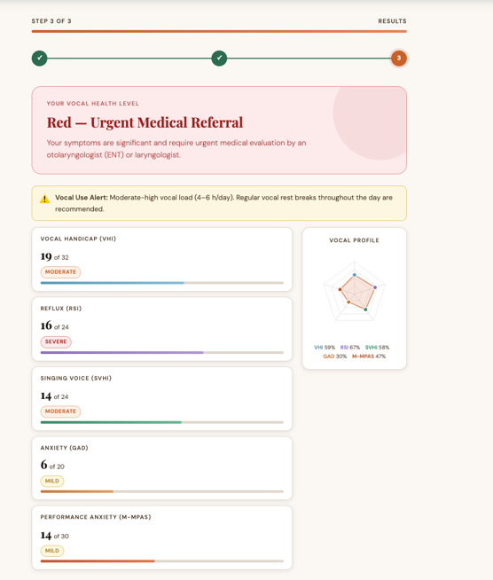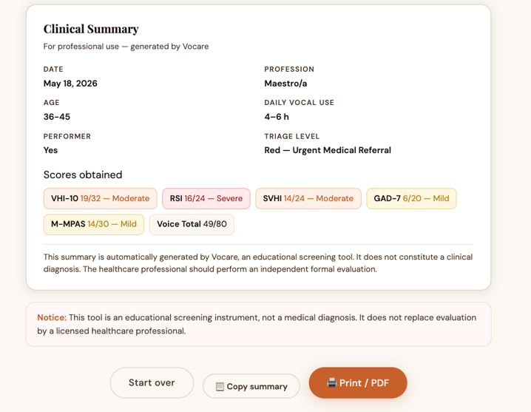

The presence of multiple domains in the questionnaire demonstrates how I applied biopsychosocial and triage frameworks to multidimensional voice-health screening, aligning with calls to move beyond purely biomedical models in chronic voice disorders (Schneider, Vaezi and Francis, 2016; Wade and Halligan, 2017). The way I selected and adapted items from each instrument shows critical engagement with their psychometric properties and with their applicability to a bilingual Puerto Rican population, consistent with recommendations for culturally sensitive adaptation of PROMs (Calvo-Henríquez et al., 2019; Spuler Fernández, Correa Forno and Azevedo, 2023). The finished artefact also illustrates the potential clinical use of validated voice, reflux and anxiety tools when they are combined into a single, user-friendly platform, and it highlights how AI-assisted tools can support practice-based and arts-based research by enabling non-programmers to create and share functional digital questionnaires (Marshall, 2010; Candy and Edmonds, 2018; Unsworth et al., 2021; Nelson, 2022).
At the same time, this artefact should be regarded as a first-generation screening tool rather than a finished clinical instrument. A formal validation study will be required to assess its reliability, responsiveness and diagnostic accuracy, particularly given the item reductions and response-scale harmonisations I introduced. Eexperience with other shortened instruments suggests that such changes can alter factor structure and cut-off behaviour (Kilmen and Bulut, 2025; Çırakoğlu, 2025) . Other factors known to affect voice, such as depression, occupational stress and environmental noise, are not yet represented in the content despite evidence that they influence vocal outcomes in professional voice users (Spina et al., 2015; Bingaman, Mauger and Cantor-Cutiva, 2026). These omissions and the absence of external validation are part of the factual and conceptual landscape of the artefact and indicate where further development is needed for the Vocare questionnaire to reach its full clinical potential.

Conclusion
This project has taken me through a full cycle of planning, creating and evaluating an artefact within a practice-based framework. In the planning phase, the narrative literature review and portfolio work clarified that any meaningful screening tool for professional voice users in Puerto Rico had to be biopsychosocial, bilingual and genuinely brief. The development phase then translated these principles into a concrete questionnaire that integrates VHI-10/SVHI-10, RSI, GAD-7 and M-MPAS items into a single, web-based journey, while the evaluation phase—structured through Nelson’s Know-that, Know-how and Know-what lenses—revealed both the strengths of this integration and the compromises required to make it usable in real clinical and educational settings.
In relation to my aims and learning outcomes, I consider the core goals to have been largely achieved. I set out to design a short, evidence-based, bilingual self-assessment that could triage users to appropriate services within the Vocare network, and the current artefact does this by offering a colour-coded outcome grounded in published cut-offs and linked to concrete next steps. The process of selecting and adapting instruments required me to engage critically with psychometric evidence, and the final questionnaire demonstrates that I can apply biopsychosocial and triage frameworks to multi-dimensional voice-health screening. Learning to construct and deploy the tool with AI-assisted platforms has also fulfilled the outcome of using digital tools to produce a functional, publicly accessible artefact, something that would not have been possible for me using traditional programming alone.
At the same time, the study exposed significant limitations that temper these achievements. Methodologically, the reliance on a narrative review means that the evidence base is curated rather than exhaustive, and item reduction and response-scale harmonisation were driven as much by usability constraints as by formal psychometric analysis. Of all the adaptations I made, the one I feel least certain about is the GAD-7 response scale change from 0–3 to 0–4. Expanding the scale affects both the maximum possible score and what each response option means, so the recalibrated cut-offs I used (moderate ≥10/20; severe ≥15/20) are based on proportional reasoning rather than re-tested norms, and I have no way of knowing whether they perform in the same way as the validated original. This is the kind of modification that would need to be examined empirically before the tool could be used with any clinical confidence. The tool has so far only undergone internal, researcher-led testing, so its reliability, sensitivity to change and diagnostic accuracy remain unknown. Conceptually, important aspects of vocal health—such as depression, occupational stress, environmental noise and cultural attitudes to illness—are not yet directly assessed, even though the literature suggests that they interact with voice, reflux and anxiety in complex ways. Also, the fact that the M-MPAS has not been validated in Spanish, means that a language-specific variation might be needed as well. These gaps do not invalidate the artefact, but they highlight that its current role is that of an informative screener and educational prompt rather than a definitive diagnostic instrument.
Reflecting on the project, the concrete experience of building and using the tool has been as instructive as the literature review. The greatest personal learning has been recognising that practice-based research is inherently iterative; each design decision opens up new questions about validity, equity and accessibility that require further cycles of reflection and adjustment. Future work therefore needs to move in two parallel directions. First, the current version of Vocare should undergo formal validation, ideally through collaboration with voice clinics and music institutions in Puerto Rico, to test its reliability, factor structure and predictive value for clinical outcomes. This would include pilot data collection, statistical analysis of the shortened scales and possible recalibration of triage thresholds. Second, the content of the questionnaire and the recommendations could be expanded to incorporate additional psychosocial factors, more detailed guidance linked to each colour band, and perhaps adaptive questioning that responds dynamically to user profiles. More broadly, the project suggests that AI-assisted, practice-based development of digital assessment tools can be a powerful approach for clinicians and educators who lack coding expertise, and it invites further research into how such tools can be co-designed and evaluated with users rather than for them.
Overall, this project has strengthened my identity as a practitioner-researcher: someone who not only applies evidence-based tools but also participates in shaping them for a specific cultural and professional context. The Vocare questionnaire is still a work in progress, but it already functions as a bridge between theory and practice, offering singers and other professional voice users in Puerto Rico a structured first step toward understanding their vocal health and seeking appropriate care.

Critical Reflection
This critical reflection analyzes my learning across the study and artefact development process using Kolb’s reflective model, which I chose because it offers a clear structure for moving from experience to reflection, conceptual understanding, and future action (Kolb, 1984). I found this model especially useful because the project was not only an academic task but also connected to my longer-term goal of creating the first voice care centre in Puerto Rico. I had held this goal for several years but struggled to define how to begin and what resources would be needed. This module gave me a practical starting point by allowing me to transform that broad ambition into an online assessment designed to guide potential clients towards relevant services.

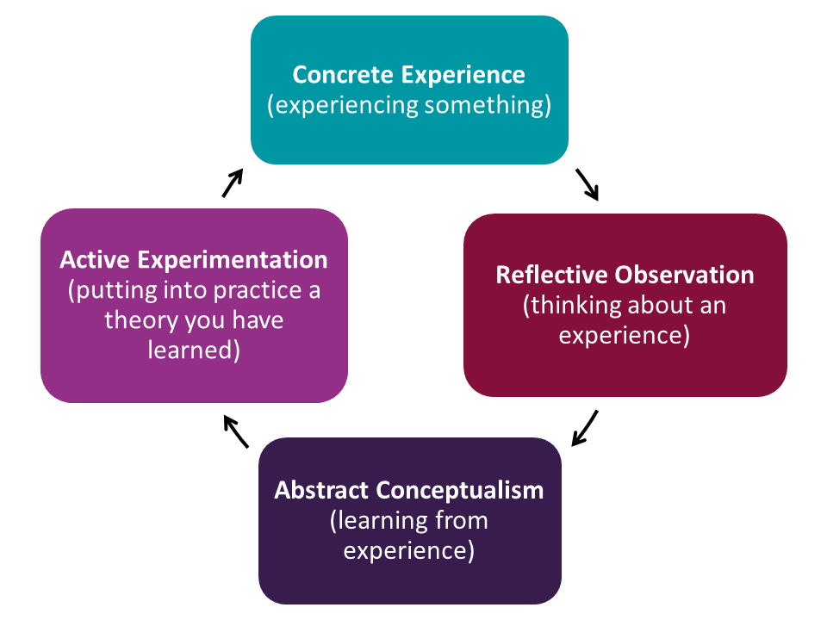
Figure 1. Kolb’s reflective cycle (Kolb, 1984)

Concrete Experience
The artefact emerged from my attempt to define what the first phase of a future voice care centre might realistically involve. After brainstorming and consulting with colleagues, I decided that an online hub would be the most achievable starting point, with the assessment serving as the client’s first interaction with the service. This decision also aligned with the process of obtaining Vocal Rehabilitation Professional certification, giving the project importance beyond the module itself. Once I had identified the need for an assessment, I began reviewing literature on validated tools for voice, anxiety, and music performance anxiety.
This stage was both exciting and unsettling. I felt curious because I could see the potential value of the artefact, but I also felt overwhelmed because many of the tools were rooted in medical or speech-language pathology contexts that were less familiar to me. At the same time, I wanted the tool to reflect my biopsychosocial approach to practice, which recognises that vocal difficulties are shaped by psychological and social as well as physical factors (Engel, 1977). I therefore did not want to focus only on voice symptoms. I also wanted to include anxiety and music performance anxiety because these are highly relevant in my work as a music therapist. However, I knew the questionnaire had to remain short enough to encourage completion, so I had to balance validity, relevance, and accessibility.

Reflective Observation
Looking back, the main tension in the project was between my desire for a holistic tool and the practical need for a concise one. My instinct was to include the many factors I know can affect the voice, including reflux, anxiety, and performance-related pressures. This was shaped by both literature and experience. Before training as a music therapist, I had already worked with voice students and had often seen how singing could bring them into contact with deep feelings and vulnerabilities. I realised that technical vocal work alone was not always enough, and not every student was willing or able to seek mental health support elsewhere. My decision to study Music Therapy came directly from those experiences and from a desire to respond more ethically and competently to what was happening in practice.
That journey influenced the structure of the artefact. I chose to include the VHI and the SVHI so the tool could be relevant to both general voice users and singers (Jacobson et al., 1997; Cohen et al., 2007). I also included the RSI because reflux is a recognised factor in many voice complaints (Belafsky, Postma and Koufman, 2002). The GAD-7 was selected because it is brief and widely used as a screening measure for anxiety (Spitzer et al., 2006). I also included M-MPA (Mazzarolo and Schubert, 2022) because I expect many potential clients to be performers, and this is well established in the literature. What worked well was that the final tool reflected my multidisciplinary philosophy and highlighted the importance of considering both voice and emotional wellbeing. What was more difficult was working across disciplinary boundaries while staying aware of my scope of practice.

Abstract Conceptualisation
One of the most important things I learned is that critical reflection requires more than describing a process; it requires analyzing how decisions are shaped by evidence, assumptions, and professional values (Moon, 1999; Schon, 2011). I began the project wanting to capture the complexity of vocal health, but I gradually realised that a useful artefact is not necessarily the most comprehensive one. In this case, the questionnaire is designed as an initial screening and signposting mechanism, not as a diagnostic instrument. That distinction has become central to my understanding of ethical practice within interdisciplinary work.
The process also helped me see how my professional identity is becoming more integrated. The artefact brought together my background in voice teaching, my development as a music therapist, and my ambition to create a collaborative model of vocal care in Puerto Rico. At the same time, it revealed limitations in my current work. I can now see that I might have explored depression screening, expanded the literature search further, and improved the visual design of the tool with specialist support. These limitations matter because they remind me that reflective practice involves acknowledging not only what has been achieved, but also where further development is needed (Moon, 1999; Schön, 2009).

Active Experimentation
The project has given me a clearer direction for future action. My next step is not simply to expand the questionnaire, but to strengthen its evidence base and practical reliability. One priority would be to explore a validation study for the online tool. I also need to validate the Spanish translations within the Puerto Rican population, since linguistic and cultural relevance will be essential if the tool is to serve the community I aim to support. Another useful step would be to compare the tool’s recommendations with those made by a voice care professional to assess how closely the online screening aligns with expert judgement.
More broadly, this artefact has turned a long-held aspiration into something more concrete. It has shown me that the vision of a voice care centre can begin with a carefully considered, ethically bounded, and evidence-informed first step. Kolb’s model helped me understand that the value of the process lies not only in the artefact itself, but in how the cycle of experience, reflection, conceptualisation, and experimentation has clarified my professional goals and next steps (Kolb, 1984). Looking back, I do think the model has limitations that are worth naming. Kolb presents the four stages as a tidy sequence, but my experience of this project was not like that: I was reflecting and reconceptualising throughout the making process, not after it. The Abstract Conceptualisation stage, in particular, felt less like a distinct phase and more like something that was happening constantly alongside everything else. If I were to revisit this project, I would consider using a more cyclical model alongside Kolb to capture the way reflection and making were happening at the same time rather than in sequence. Overall, this project has strengthened my confidence in developing an interdisciplinary model of care while also reminding me that responsible innovation requires further research, collaboration, and evaluation.

Bibliography:
Adler, R.H. (2009) “Engel’s biopsychosocial model is still relevant today,” Journal of Psychosomatic Research, 67(6), pp. 607–611. Available at: https://doi.org/10.1016/j.jpsychores.2009.08.008.
Aldridge-Waddon, L. et al. (2026) “Clinical Psychology and Voice Disorders: A Meta-Analytic Review of Studies Assessing Psychological Characteristics Across Individuals With and Without Voice Disorders,” Journal of Voice: Official Journal of the Voice Foundation, 40(2), pp. 386–399. Available at: https://doi.org/10.1016/j.jvoice.2023.09.012.
Anthropic (2026) “Claude.” (Sonnet). Available at: claude.ai.
Aremu, S. (2026) “Psychophysiological Mechanisms Linking Psychological Stress to Functional Otolaryngological Symptoms: A Systematic Review and Meta-Analysis,” Journal of African Tropical Medicine and Health, 7(2), pp. 112–131. Available at: https://doi.org/10.5281/zenodo.19681983.
ASHA (2024) American Speech-Language-Hearing Association. American Speech-Language-Hearing Association. Available at: https://www.asha.org/practice-portal/clinical-topics/voice-disorders/ (Accessed: May 12, 2026).
Baxter, M. et al. (2019) “Multidisciplinary team clinic for vocal cord dysfunction directs therapy and significantly reduces healthcare utilization,” Respirology, 24(8), pp. 758–764. Available at: https://doi.org/10.1111/resp.13520.
Belafsky, P.C., Postma, G.N. and Koufman, J.A. (2002) “Validity and reliability of the reflux symptom index (RSI),” Journal of Voice: Official Journal of the Voice Foundation, 16(2), pp. 274–277. Available at: https://doi.org/10.1016/s0892-1997(02)00097-8.
Bingaman, H.M., Mauger, R.E. and Cantor-Cutiva, L.C. (2026) “Relationship between Mental and Vocal Health in Occupational Voice Users: A Systematic Literature Review,” Journal of Voice [Preprint]. Available at: https://doi.org/10.1016/j.jvoice.2026.03.039.
Braghetto, I. et al. (2003) “Enfermedad por reflujo gastroesofágico como causa de daño laríngeo,” Revista de otorrinolaringología y cirugía de cabeza y cuello, 63, pp. 173–180.
Calvo-Henríquez, C. et al. (2019) “Translation and Validation of the Reflux Symptom Index to Spanish,” Journal of Voice, 33(5), p. 807.e1-807.e5. Available at: https://doi.org/10.1016/j.jvoice.2018.04.019.
Candy, L. and Edmonds, E. (2018) “Practice-Based Research in the Creative Arts: Foundations and Futures from the Front Line,” Leonardo, 51(1), pp. 63–69. Available at: https://doi.org/10.1162/LEON_a_01471.
Churruca, K. et al. (2021) “Patient‐reported outcome measures (PROMs): A review of generic and condition‐specific measures and a discussion of trends and issues,” Health Expectations : An International Journal of Public Participation in Health Care and Health Policy, 24(4), pp. 1015–1024. Available at: https://doi.org/10.1111/hex.13254.

Çırakoğlu, O.C. (2025) “Development of a performance anxiety scale for music students.” Available at: https://www.academia.edu/9581340/Development_of_a_performance_anxiety_scale_for_music_students (Accessed: April 15, 2026).
Cohen, S.M. et al. (2007) “Creation and Validation of the Singing Voice Handicap Index,” Annals of Otology, Rhinology & Laryngology, 116(6), pp. 402–406. Available at: https://doi.org/10.1177/000348940711600602.
Cohen, S.M. et al. (2009) “Development and validation of the Singing Voice Handicap-10,” The Laryngoscope, 119(9), pp. 1864–1869. Available at: https://doi.org/10.1002/lary.20580.
Delahunty, J.E. (1972) “Acid laryngitis,” The Journal of Laryngology and Otology, 86(4), pp. 335–342. Available at: https://doi.org/10.1017/s0022215100075356.
Demirci, A.N., İncebay, Ö. and Köse, A. (2024) “Readability of Patient-Reported Outcome Measures Used in Voice Disorders,” Journal of Voice [Preprint]. Available at: https://doi.org/10.1016/j.jvoice.2024.09.014.
Diez-Quevedo, C. et al. (2001) “Validation and Utility of the Patient Health Questionnaire in Diagnosing Mental Disorders in 1003 General Hospital Spanish Inpatients,” Biopsychosocial Science and Medicine, 63(4), p. 679.
Engel, G.L. (1977) “The need for a new medical model: a challenge for biomedicine,” Science, 196(4286), pp. 129–136. Available at: https://doi.org/10.1126/science.847460.
Ferrari, R. (2015) “Writing narrative style literature reviews,” Medical Writing, 24, pp. 230–235. Available at: https://doi.org/10.1179/2047480615Z.000000000329.
Flock, L. et al. (2025) “Working Together to Find a Voice: Recommendations for Voice Healthcare Based on Expert-By-Experience and Practitioner Consensus,” Journal of Voice, 39(4), p. 1137.e9-1137.e17. Available at: https://doi.org/10.1016/j.jvoice.2023.02.023.
Francis, D.O. et al. (2017) “Voice-Related Patient-Reported Outcome Measures: A Systematic Review of Instrument Development and Validation,” Journal of Speech, Language, and Hearing Research : JSLHR, 60(1), pp. 62–88. Available at: https://doi.org/10.1044/2016_JSLHR-S-16-0022.
García-López, I. et al. (2010) “Validation of the Spanish version of the voice handicap index for vocal singing (SVHI),” Acta Otorrinolaringológica Española, 61(4), p. 247−254.
Gardner, D. et al. (2025) “Validated patient reported outcome measures in speech-language pathology: A scoping review of adult practice,” International Journal of Speech-Language Pathology, 27(5), pp. 672–701. Available at: https://doi.org/10.1080/17549507.2024.2399236.
Gilbert, M. et al. (2022) “What Lawrence’s Story Tells Health Researchers About Arts-Based Interactions,” AMA Journal of Ethics, 24(7), pp. 646–656. Available at: https://doi.org/10.1001/amajethics.2022.646.
Grant, M. and Booth, A. (2009) “A typology of reviews: An analysis of 14 review types and associated methologies,” Health information and libraries journal, 26, pp. 91–108. Available at: https://doi.org/10.1111/j.1471-1842.2009.00848.x.
Handa, K.K. (2005) “Laryngopharyngeal reflux: Current opinion,” Indian Journal of Otolaryngology and Head and Neck Surgery, 57(3), pp. 267–270. Available at: https://doi.org/10.1007/BF03008032.
Humber and North Yorkshire Policy and Pathway Repository (2024) Humber and North Yorkshire Health and Care Partnership. Available at: https://hnyppr.org.uk/web/york/w/voice-problems-hoarseness-pathway (Accessed: May 12, 2026).
Jacobson, B.H. et al. (1997) “The Voice Handicap Index (VHI),” American Journal of Speech-Language Pathology, 6(3), pp. 66–70. Available at: https://doi.org/10.1044/1058-0360.0603.66.
Judson, T.J. et al. (2020) “Rapid design and implementation of an integrated patient self-triage and self-scheduling tool for COVID-19,” Journal of the American Medical Informatics Association : JAMIA, 27(6), pp. 860–866. Available at: https://doi.org/10.1093/jamia/ocaa051.
Kenny, D.T. (2023) “The Kenny music performance anxiety inventory (K-MPAI): Scale construction, cross-cultural validation, theoretical underpinnings, and diagnostic and therapeutic utility,” Frontiers in Psychology, 14. Available at: https://doi.org/10.3389/fpsyg.2023.1143359.
Kilmen, S. and Bulut, O. (2025) “Shortening Psychological Scales: Semantic Similarity Matters,” Educational and Psychological Measurement, 85(5), pp. 910–934. Available at: https://doi.org/10.1177/00131644251319047.
Kolb, D. (1984) Experiential Learning: Experience As The Source Of Learning And Development, Journal of Business Ethics.
Korsunsky, S. et al. (2023) “Voice Hoarseness with Reflux as a Suspected Etiology: Incidence, Evaluation, Treatment, and Symptom Outcomes,” Journal of Gastrointestinal Surgery, 27. Available at: https://doi.org/10.1007/s11605-022-05574-9.
Laukkanen, A.-M., Leppänen, K. and Ilomaki, I. (2009) “Self-evaluation of voice as a treatment outcome measure,” Folia Phoniatrica Et Logopaedica: Official Organ of the International Association of Logopedics and Phoniatrics, 61(1), pp. 57–65. Available at: https://doi.org/10.1159/000201000.
Lechien, J.R. et al. (2020) “Validity and reliability of the reflux symptom score,” The Laryngoscope, 130(3). Available at: https://doi.org/10.1002/lary.28017.
Marshall, C. (2010) “A Research Design for Studio-Based Research in Art,” Teaching Artist Journal, 8(2), pp. 77–87. Available at: https://doi.org/10.1080/15411791003618597.
Mazzarolo, I. and Schubert, E. (2022) “A Short Performance Anxiety Scale for Musicians,” Frontiers in Psychology, 12. Available at: https://doi.org/10.3389/fpsyg.2021.781262.
Misono, S. et al. (2016) “Multi‐institutional Study of Voice Disorders and Voice Therapy Referral: Report from the CHEER Network,” Otolaryngology–Head and Neck Surgery, 155(1), pp. 33–41. Available at: https://doi.org/10.1177/0194599816639244.
Moon, J. (1999) Reflection in learning & professional development. 1st ed. Routledge.
Nelson, R. (2022) Practice as Research in the Arts (and Beyond): Principles, Processes, Contexts, Achievements. Cham: Springer International Publishing. Available at: https://doi.org/10.1007/978-3-030-90542-2.
Núñez-Batalla, F. et al. (2007) “Adaptación y validación del índice de incapacidad vocal (VHI-30) y su versión abreviada (VHI-10) al español,” Acta Otorrinolaringológica Española, 58(9), pp. 386–392. Available at: https://doi.org/10.1016/S0001-6519(07)74954-3.
Pariser, D. (2009) “Arts-Based Research: Trojan Horses and Shibboleths. The Liabilities of a Hybrid Research Approach,” Canadian Review of Art Education: Research and Issues, 36, pp. 1–18.
Perrin, C.E. et al. (2025) “Singing Voice Handicap Index-10 Minimal Clinically Important Difference: A Prospective Determination,” The Laryngoscope, 135(2), pp. 752–757. Available at: https://doi.org/10.1002/lary.31808.
Rajput, J. et al. (2025) “Voice Outcomes in Patients With Laryngopharyngeal Reflux: A Systematic Review and Meta-Analysis,” Cureus, 17(8), p. e90357. Available at: https://doi.org/10.7759/cureus.90357.
Ramachandran, A. et al. (2025) “Voice Related Coping in Professional Voice Users-A Systematic Review,” Journal of Voice, 39(2), p. 562.e17-562.e31. Available at: https://doi.org/10.1016/j.jvoice.2022.08.024.
Renk, E. et al. (2017) “VHI-10 and SVHI-10 Differences in Singers’ Self-perception of Dysphonia Severity,” Journal of Voice, 31(3), p. 383.e1-383.e4. Available at: https://doi.org/10.1016/j.jvoice.2016.08.017.
Ring, S. et al. (2025) “National Trends in Treatment of Acute Unilateral Vocal Fold Paralysis at Tertiary Care Voice Centers,” Laryngoscope Investigative Otolaryngology, 10(2). Available at: https://doi.org/10.1002/lio2.70135.
Rosen, C.A. et al. (2004) “Development and Validation of the Voice Handicap Index-10,” The Laryngoscope, 114(9), pp. 1549–1556. Available at: https://doi.org/10.1097/00005537-200409000-00009.
Roy, N. et al. (2013) “Evidence-based clinical voice assessment: a systematic review,” American Journal of Speech-Language Pathology, 22(2), pp. 212–226. Available at: https://doi.org/10.1044/1058-0360(2012/12-0014).
Sataloff, R.T., Hawkshaw, M.J. and Sataloff, J.B. (2022) “Professional Voice Users: An Overview of Medical Disorders and Treatments,” in A. Hamdan, R.T. Sataloff, and M.J. Hawkshaw (eds.) Office-Based Laryngeal Surgery. Cham: Springer International Publishing, pp. 59–97. Available at: https://doi.org/10.1007/978-3-030-91936-8_4.
Schneider, G.T., Vaezi, M.F. and Francis, D.O. (2016) “Reflux and Voice Disorders: Have We Established Causality?,” Current otorhinolaryngology reports, 4(3), pp. 157–167. Available at: https://doi.org/10.1007/s40136-016-0121-5.
Schon, D. (2011) “The Reflective Practitioner: How Professionals Think In Action,” The Journal of Continuing Higher Education, 34. Available at: https://doi.org/10.1080/07377366.1986.10401080.
Schön, D.A. (2009) The reflective practitioner: how professionals think in action. New York: Basic Books.
Smith, H. and Dean, R.T. (2009) Practice-led Research, Research-led Practice in the Creative Arts. Edinburgh University Press.
Sobol, M., Sielska-Badurek, E.M. and Osuch-Wójcikiewicz, E. (2019) “Normative values for singing voice handicap index – systematic review and meta-analysis,” Brazilian Journal of Otorhinolaryngology, 86(4), pp. 497–501. Available at: https://doi.org/10.1016/j.bjorl.2018.12.004.
Spina, A.L. et al. (2015) “Correlation between voice and life quality and occupation,” Brazilian Journal of Otorhinolaryngology, 75(2), pp. 275–279. Available at: https://doi.org/10.1016/S1808-8694(15)30790-4.
Spitzer, R.L. et al. (2006) “A Brief Measure for Assessing Generalized Anxiety Disorder: The GAD-7,” Archives of Internal Medicine, 166(10), p. 1092. Available at: https://doi.org/10.1001/archinte.166.10.1092.
Spuler Fernández, I., Correa Forno, S. and Azevedo, R.R. (2023) “Adaptación lingüística y cultural al español chileno del cuestionario de autovaloración vocal para cantantes Singing Voice Handicap Index (S-VHI),” Revista de Investigación e Innovación en Ciencias de la Salud, 5(2), pp. 129–148. Available at: https://doi.org/10.46634/riics.242.
Stachler, R.J. et al. (2018) “Clinical Practice Guideline: Hoarseness (Dysphonia) (Update),” Otolaryngology–Head and Neck Surgery, 158(S1). Available at: https://doi.org/10.1177/0194599817751030.
Starmer, H.M. et al. (2014) “Attendance in Voice Therapy: Can an Interdisciplinary Care Model Have an Impact?,” Annals of Otology, Rhinology & Laryngology, 123(2), pp. 117–123. Available at: https://doi.org/10.1177/0003489414523708.
Unsworth, H. et al. (2021) “The NICE Evidence Standards Framework for digital health and care technologies - Developing and maintaining an innovative evidence framework with global impact,” Digital Health, 7, p. 20552076211018617. Available at: https://doi.org/10.1177/20552076211018617.
Wade, D. and Halligan, P. (2017) “The biopsychosocial model of illness: a model whose time has come,” Clinical Rehabilitation, 31, pp. 995–1004. Available at: https://doi.org/10.1177/0269215517709890.
Wiedemann, A. et al. (2022) “How does music performance anxiety relate to other anxiety disorders?,” Psychology of Music, 50(1), pp. 204–217. Available at: https://doi.org/10.1177/0305735620988600.
World Health Organization (1980) International classification of impairments, disabilities, and handicaps: a manual of classification relating to the consequences of disease. Twenty-ninth World Health Assembly resolution WHA29. 35. Geneva: World Health Organization. Available at: https://iris.who.int/server/api/core/bitstreams/50556222-5563-44a8-b0db-fd08c6943f29/content (Accessed: May 17, 2026).

Appendix 1: Vocare questionnaire
https://claude.ai/public/artifacts/28172a5e-18d9-4ec1-b27b-c6d397323349



