

Student Name: Himanshi

Student ID: 2526316

Module Name: Financial Management

Module Code: LCMB7002

Lecturer’s Name: Shengfeng Mei

Work Count: 5467

Term 1

Contents
Introduction 2
1. Financial Health Check 3
Revenue and Operating Profit Trend 3
Profitability 4
Liquidity 4
Efficiency, Gearing, Investment and Cash Flow 5
Liquidity Benchmarked Against the Sector 6
Trends, Strengths and Challenges 6
2. Working Capital Management Analysis 6
The Cash Operating Cycle 6
Recommended Working Capital Reforms 7
Short-term vs Long-term Financing 7
3. Strategic Financial Restructuring Plan 8
Recommended Restructuring Options 8
Capital Structure Rationale 8
Impact on Shareholder Value, Debt Structure and Operational Flexibility 9
International and Ethical Considerations 9
4. Investment Appraisal and Capital Budgeting 9
Cash Flow Inputs (£m) 9
Appraisal Summary 10
Recommendation and Risk Discussion 11
Capital Rationing (Maximum £100m Available) 11
5. Critical Reflection on AI Usage 12
Tool Disclosure 12
Critical Evaluation of AI Output 12
Contribution Analysis 12
Ethical and Professional Reflection 13
Conclusion 13
6. Appendices 14
Appendix A: Five-year Ratio Summary (FY2021-FY2025) 14
Appendix B: Investment Appraisal Workbook 14
Reference 15

Introduction
Compass Group plc (LSE: CPG), established in 1941 and headquartered in Chertsey, UK, is the world's leading provider of contract catering and support services (Compass Group plc, 2025). The Group operates in more than 40 countries and serves five principal sectors: Business & Industry, Healthcare & Seniors, Education, Sports & Leisure, and Defence, Offshore & Remote. In this report, I, as the appointed Chief Financial Officer, have been asked by the Board to evaluate the Group's financial performance over the five years to FY2025 (year end 30 September) and to set out a turnaround and growth strategy that is financially sound and ethically defensible on a global scale.
Corporate financial strategy cannot be separated from the interests of the parties it affects. Agency theory (Jensen and Meckling, 1976) frames the CFO's task as managing the tension between shareholders, who require an efficient return on deployed capital, and the Group's other stakeholders-employees, clients, suppliers and, given Compass's exposure to public-sector and healthcare contracts, the communities it serves. This report is therefore structured not only around ratio outcomes but around the capital allocation and governance decisions that connect those outcomes to shareholder value.
Compass presents a distinctive case compared with typical turnaround assignments. Rather than being a distressed entity in need of intervention, it is a fundamentally sound, investment grade organisation that has already navigated the pandemic and is now delivering consistent, profitable growth (Compass Group plc, 2025. The focus of this analysis therefore shifts from crisis management to a critical examination of an already effective strategy: interrogating whether persistently negative working capital is a genuine strength rather than a latent risk, quantifying the unrealised value implied by the North America/International margin gap, and setting out how the Group should prioritise its capital investment programme within budget constraints.
The report is structured into five sections: a financial health check drawing on five years of ratio analysis across profitability, liquidity, efficiency, gearing and cash flow; an evaluation of working capital management and the cash operating cycle; a strategic financial restructuring plan addressing both portfolio and capital structure; an investment appraisal of three capital projects assessed through five complementary techniques; and a transparent, critical reflection on the use of artificial intelligence in producing this analysis. Supporting ratio tables, the investment appraisal workbook and the full reference list are provided in the appendices.
A note on currency: all financial figures in this report are presented in pounds sterling (£). Compass Group has reported its consolidated results in US dollars since moving to USD functional currency reporting, and one acquisition discussed in Section 3 was originally announced in euros; where a figure's original source currency is USD or EUR, it has been translated at the 2025 average exchange rates of £1 = $1.32 and £1 = €1.17 (XRates, 2025) for presentational consistency throughout this report. This is a simplifying assumption it does not replicate Compass's own hedge adjusted transaction and translation policy and is disclosed here so that all figures quoted below can be read on a single, comparable basis.

1. Financial Health Check
Compass Group has transitioned from the disruption of the pandemic to deliver consistent, double digit profit growth in the five years to FY2025. Statutory revenue grew from approximately £14.4bn in the pandemic affected FY2021 to £34.9bn in FY2025 (Compass Group plc, 2025), driven by volume growth, disciplined pricing and portfolio simplification notably the exit from smaller Latin American markets to concentrate on North America and the International B&I, Healthcare, Education and Sports & Leisure segments. Underlying operating margin rose from around 2.9% in FY2021 to 7.2% in FY2025 over the same period. Ratio analysis of this kind is most informative when the ratios are read as a linked system rather than in isolation, since a rising revenue and margin trend only demonstrates genuine operating improvement once it is corroborated by liquidity, efficiency and cash conversion evidence the approach followed through the remainder of this section (Pike, Neale and Linsley, 2018).

Revenue and Operating Profit Trend
Table 1: Compass Group plc - Revenue and Operating Profit Trend, FY2022-FY2025 (£bn)
Fiscal Year | Revenue (£bn) | Operating Income (£bn) | Operating Margin
FY2022 | 21.60 | 1.34 | 6.2%
FY2023 | 28.74 | 1.95 | 6.8%
FY2024 | 31.84 | ≊1.96 (est.) | ≊6.1% (est.)
FY2025 | 34.93 | 2.24 | 6.4% statutory / 7.2% underlying
FY2024 operating income is an approximation pending exact statutory disclosure; underlying operating profit grew 16.4% on 10.6% revenue growth in that year. The step up from FY2022 to FY2023 (+33% in USD terms) reflects both organic recovery and full year consolidation of prior acquisitions; growth normalised to a high single digit organic rate (8.7% in FY2025) as the base effect faded a more sustainable trajectory for ratio interpretation. Figures translated from USD at £1 = $1.32.
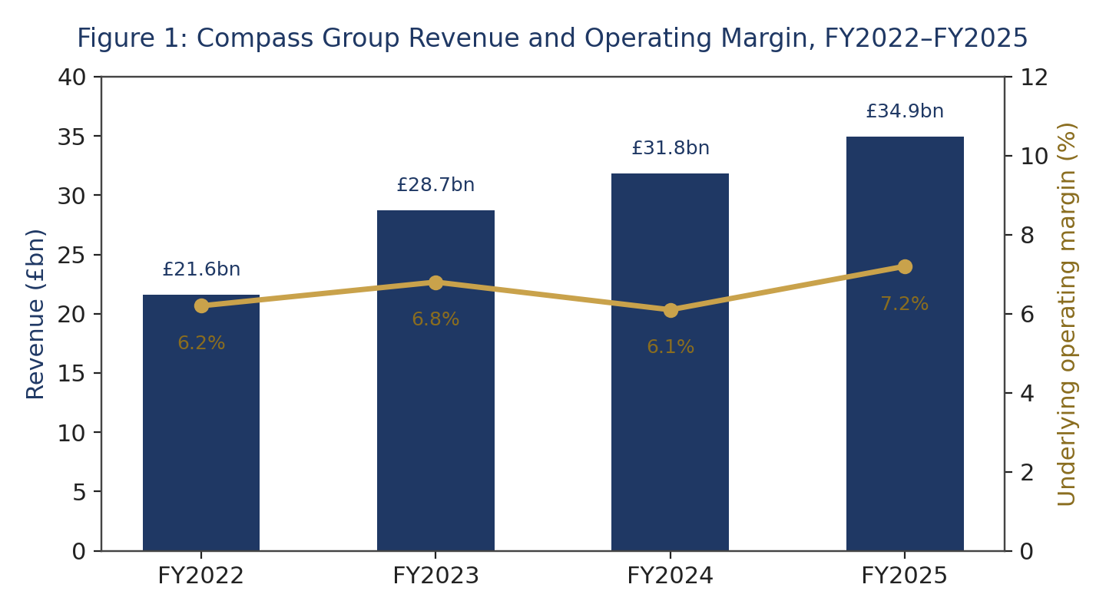

Profitability
Compass has seen a steady increase in gross margin, climbing from 32.5% in FY2022 to 33.4% in FY2025 (Compass Group plc, 2025). This improvement indicates successful procurement scaling and a strategic shift towards higher margin sectors. Underlying operating margin also rose by 10 basis points in FY2025, reaching 7.2%, with a notable 7.3% in the second half of the year. Management has identified a persistent margin gap of approximately 200 basis points between North America and International operations a current inefficiency and, on a DuPont, style reading of the ratio set, the single largest medium term margin opportunity available to the Group without new capital investment. Return on equity remains strong, generally reported between 18% and 21% on a trailing basis, although estimates vary between data sources owing to differing treatment of lease liabilities under IFRS 16 (StockAnalysis.com, 2025; Tip Ranks, 2025).

Liquidity
A key feature of Compass's balance sheet is its current ratio, which has remained consistently below 1.0 approximately 0.94 in FY2021, 0.95 in FY2022, 0.75 in FY2023, 0.95 in FY2024 and an estimated 0.85 in FY2025 (Tip Ranks, 2025. Quick ratios follow a similar pattern, since current assets consist mainly of receivables and cash with minimal inventory. Working capital has therefore been negative throughout the period under review. Consistent with the cash conversion cycle framework of Richards and Laughlin (1980), this reflects a structural feature of contract catering: Compass collects client payments faster than it settle employee and supplier obligations, producing a negative cash operating cycle that finances day to day operations rather than draining them.
Table 2: Compass Group plc – Current Ratio, FY2021–FY2025
Ratio | FY2021 | FY2022 | FY2023 | FY2024 | FY2025
Current ratio | 0.94 | 0.95 | 0.75 | 0.95 | ≊0.85
This should not, however, be read as an unqualified strength. Chambers and Cifter (2022), in a study of working capital and firm performance across the global hospitality and tourism sector, find a nonlinear in several subsectors, U-shaped relationship between working capital levels and profitability, meaning that very low or negative working capital is not automatically value maximising once a sector's specific risk characteristics are taken into account. For Compass, the structural risk is twofold. First, a sudden fall in client demand for example, a large Business & Industry client reducing office headcount, or a healthcare client renegotiating a contract would not correspondingly shrink payables in the short term, exposing the Group to a temporary liquidity squeeze even though the cycle is negative on average. Second, any tightening of supplier credit terms, plausible if sustained food cost inflation strains smaller regional suppliers, would compress the negative cash cycle from the other direction. Both risks are currently mitigated by Compass's £2.45bn of committed liquidity headroom (discussed below) rather than eliminated by the working capital structure itself, and this distinction mitigated risk rather than absent risk is the correct basis on which the Board should treat negative working capital going forward.
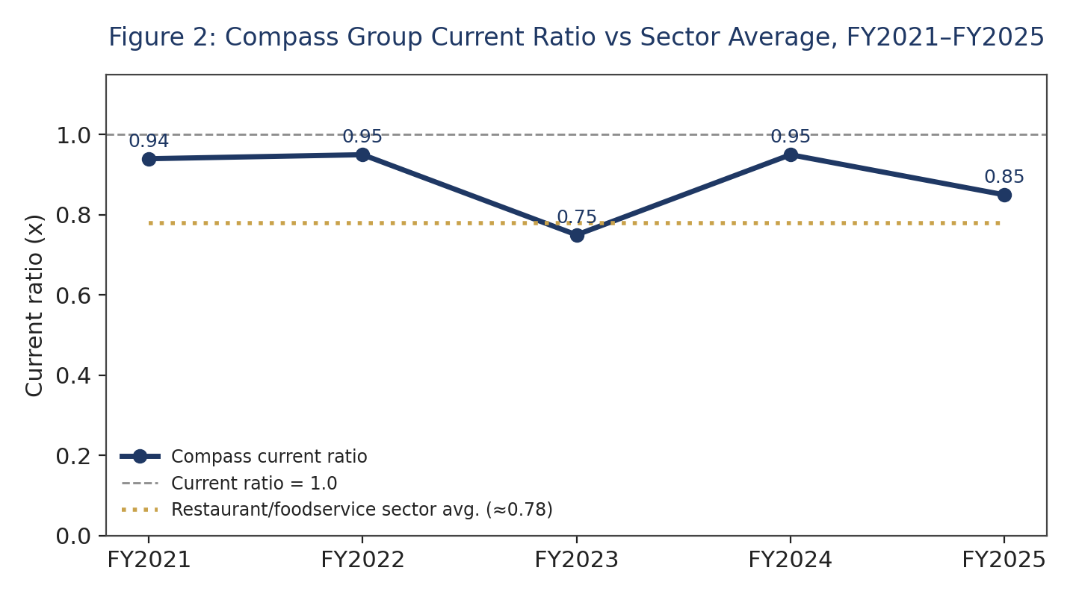

Efficiency, Gearing, Investment and Cash Flow
Compass has successfully maintained net new business growth within management's target range of 4% to 5% for four consecutive years, alongside client retention rates exceeding 96% (Compass Group plc, 2025).This indicates strong operational efficiency and relationship quality that is not easily captured through ratio analysis alone. The Group maintains moderate, well managed leverage, with net debt to underlying EBITDA at 1.42x as of FY2025 within its target range and a debt-to-equity ratio of approximately 0.83x to 0.87x. Compass holds investment grade credit ratings from both S&P (A/A1, stable) and Moody's (A2/P1, stable). In FY2025, earnings per share grew by 11.1% in constant currency. Cash flow is a further indicator of strength: underlying free cash flow rose to £1,497m in FY2025, up from £1,319m in FY2024, marking an 87.8% conversion rate of underlying profit after tax. This robust cash flow simultaneously supports capital expenditure (around 3.3% of revenue), mergers and acquisitions including the £1.29bn Vermaat acquisition and shareholder returns through dividends and buybacks (Compass Group plc, 2024, 2025).
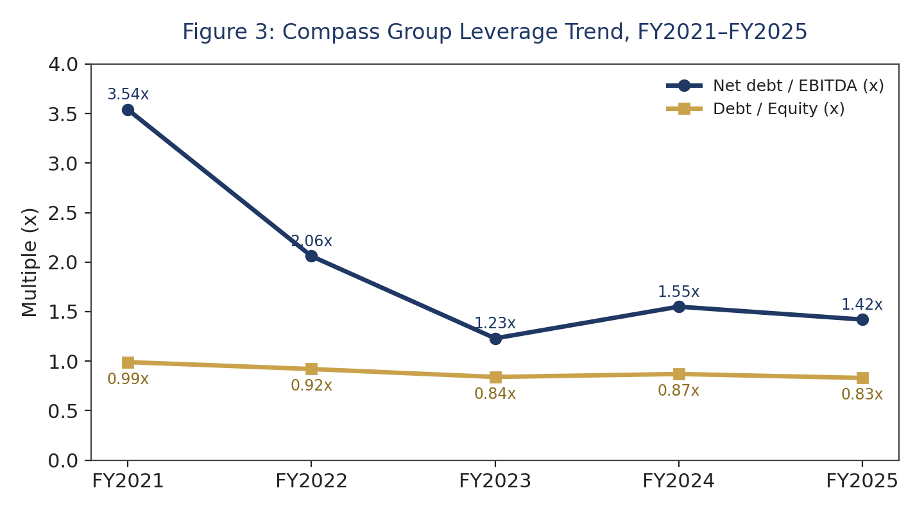

Liquidity Benchmarked Against the Sector
When comparing current ratios, Compass ranks slightly below its closest listed competitor, Sodexo (which has reported a ratio of between 1.08 and 1.16 from 2022 to 2025), as well as the broader restaurant and foodservice industry average of about 0.78 (MacroTrends, 2024). While Compass sits at the lower end of this range, it remains close to the sector norm. A current ratio below 1.0 is typical in this industry and is not, on its own, a sign of financial distress; interest cover (approximately 12.5x in FY2025) and free cash flow conversion are the more informative indicators of liquidity resilience for a negative working capital business model of this kind (Compass Group plc, 2025).

Trends, Strengths and Challenges
- Strengths: Compass enjoys consistent organic growth that surpasses its target range, improving margins, a strong balance sheet, robust cash conversion, and high client retention (Compass Group plc, 2025).
- Challenges: there remains a persistent margin gap between North America and International markets, indicating execution risk in weaker regions; currency translation between the Group's US dollar reporting base and its globally diversified cost and revenue base introduces volatility that is not fully visible in headline growth metrics; and rising labour costs, in a labour-intensive industry, continue to pressure margins.
Taken together, these five ratio families point to the same conclusion from different angles: Compass is not a business in need of rescue, but one whose already strong financial position creates the capacity to fund a deliberate, value adding restructuring programme rather than a defensive one. That distinction matters for how the recommendations in Sections 2 to 4 should be read as choices about where to deploy an existing strength, not as remedies for weakness and it is the standard against which the working capital, restructuring and investment appraisal recommendations that follow should be judged.

2. Working Capital Management Analysis

The Cash Operating Cycle
Compass operates with a historically negative cash conversion cycle (CCC = Days Inventory Outstanding + Days Sales Outstanding Days Payables Outstanding), which explains the sub1.0 current ratio discussed in Section 1. Inventory, being primarily perishable food, turns over rapidly typically in under 10 days. Days Sales Outstanding is kept short by the nature of B2B contract catering: most clients operate on 30-45day payment terms, while cash is collected immediately from consumer facing revenue such as vending and retail catering. Days Payables Outstanding, by contrast, extends longer because Compass can negotiate supplier terms of 45-60 days owing to its purchasing scale. The combined effect is a CCC close to zero or slightly negative, meaning Compass is largely financed through its own operating cycle rather than external working capital. Empirical evidence broadly supports this structure: Deloof (2003), studying a large sample of Belgian firms, finds that shorter cash conversion cycles are associated with higher profitability, a relationship attributed to the reduced financing cost and lower credit risk that a short or negative cycle carries.
This sustainability gives Compass a genuine competitive advantage, supporting strong free cash flow growth while maintaining an investment grade credit profile (Compass Group plc, 2025). It is nevertheless worth restating the qualification made in Section 1: the cash conversion cycle is average, and averages can mask timing mismatches at the margin during periods of client churn or supplier stress, which is why the reforms below are framed as ways of making the negative cycle more resilient, not merely more negative.

Recommended Working Capital Reforms
Recommended working capital reforms:
• Streamline receivable collection in international markets through standardised invoicing schedules, early payment discounts, and centralised credit control, so that Days Sales Outstanding in these markets converges towards the North American benchmark without straining client relationships.
• Extend and centralise supplier terms through a bank backed Supply Chain Finance programme, under which suppliers are paid early (at a small discount) by the bank while Compass settles the bank on extended terms. This increases Days Payables Outstanding without transferring liquidity pressure onto smaller local suppliers an important distinction, since supply chain finance literature warns that aggressive unilateral term extension can itself destabilise a supplier base that a caterer depends on for continuity of service.
• Implement cross site inventory pooling and improved demand forecasting, using Compass's existing technology and AI investment, to further reduce Days Inventory Outstanding and cut spoilage related waste.
• Introduce dynamic multicurrency cash pooling to minimise cash trapped in individual entities and reduce reliance on local short-term borrowing across the Group's 40plus country footprint.
Benchmarked against the sector, Compass's negative cash conversion cycle is not unusual for largescale contract catering, where the client relationship rather than the balance sheet is the primary source of competitive advantage; the working capital reforms above are therefore best understood as protecting and gradually strengthening a structural advantage that already exists, rather than attempting to engineer one from a neutral starting position. This framing also determines how the reforms should be sequenced: receivables and inventory measures can be implemented unilaterally and quickly, whereas the Supply Chain Finance programme depends on bank and supplier engagement and should be piloted in the Group's largest procurement markets before being rolled out globally, so that any unintended strain on smaller suppliers is identified early.

Short-term vs Long-term Financing
Compass finances itself primarily through committed medium-term facilities rather than short-term revolving debt. As of FY2024, the Group held access to £2,453m in liquidity, comprising £2,034m of undrawn bank facilities (available until August 2026) and £419m of cash net of overdrafts. Short-term financing overdrafts, commercial paper and revolving credit is cheaper and more flexible, and is well suited to seasonal working capital needs, such as those driven by the academic calendar in the Education segment, but it carries refinancing and interest rate risk. Longterm financing bonds, term loans and committed multiyear facilities better matches assets of longer duration, such as capital expenditure and significant M&A (for example, Vermaat), and avoids refinancing exposure during weaker credit conditions. This is a direct application of the maturity matching principle in corporate financial management: the tenor of financing should mirror the duration of the asset or need it funds, so that short lived working capital swings are not financed with long dated debt, and long-lived capital assets are not left exposed to short-term rollover risk (Pike, Neale and Linsley, 2018). Given Compass's already negative organic working capital requirement, additional long-term borrowing to fund working capital is not warranted; the priority instead is to maintain committed short/medium-term facilities as a liquidity safety net while reserving long-term debt and free cash flow for capital expenditure and M&A. This is consistent with the current net debt/EBITDA ratio of 1.42x and the Group's stable investment grade rating (Compass Group plc, 2025).

3. Strategic Financial Restructuring Plan
With Compass's investment grade status (1.42x net debt/EBITDA) and approximately £1.52bn of free cash flow, the restructuring initiative set out here should be viewed as a proactive exercise in portfolio and capital optimisation rather than a reaction to a crisis. The objective is to address the challenge identified in Section 1: a margin gap of approximately 200 basis points between North America and International operations, compounded by the currency and inflation risk inherent in operating across more than 40 countries (Compass Group plc, 2025).

Recommended Restructuring Options
Recommended restructuring options:
• Selective divestiture of underperforming international markets. Compass has a track record of this approach, including the FY2024 sale of a 19% stake in ASM Global's parent for £248m and the reclassification of operations in Chile, Colombia and Mexico as held for sale (Compass Group plc, 2024). Markets that cannot close the margin gap within three to five years should be reconsidered for divestiture or explored for joint venture structures with local partners.
• Disciplined Bolton M&A in preference to a transformational merger. The £1.29bn Vermaat acquisition is a guiding example of this approach: accretive, strategically relevant, and fundable directly from the balance sheet (Compass Group plc, 2024). A largescale transformational merger for example with Sodexo would risk diluting Compass's margin profile, introduce material integration risk, and invite regulatory scrutiny from competition authorities across multiple jurisdictions.
• No new equity issuance. With a free cash flow conversion rate of 87.8% and an investment grade rating, there is no compelling case for altering the capital structure through fresh equity; the Group is already returning excess capital to shareholders through dividends (£730m) and buybacks (£437m) in FY2024 (Compass Group plc, 2024, 2025).

Capital Structure Rationale
This capital structure judgement is grounded in established corporate finance theory rather than convention alone. Under the original Modigliani and Miller (1958) proposition, capital structure is irrelevant to firm value in a frictionless market; once taxation, financial distress costs and information asymmetry are introduced, however, the pecking order theory of Myers (1984) and Myers and Majluf (1984) predicts that firms will prefer internal funds first, debt second, and new equity only as a last resort, because issuing equity signals to the market that management believes the shares are overvalued. Compass, generating substantial internal free cash flow and holding an investment grade rating that keeps debt cheaply available, sits firmly at the top of this pecking order, which reinforces the recommendation against equity issuance. Equally, Jensen's (1986) free cash flow theory of agency costs cautions that businesses generating cash in excess of their positive investment opportunities face a temptation towards value destroying overinvestment or empire building acquisitions; returning surplus cash to shareholders through disciplined buybacks, rather than retaining it in search of acquisition targets, is the theoretically consistent response, and is precisely what the capital rationing analysis in Section 4 recommends for the £50m of unallocated project budget.

Impact on Shareholder Value, Debt Structure and Operational Flexibility
Selective divestiture is expected to have a positive effect on both earnings per share and margins by removing less productive operations from the portfolio, with the resulting proceeds available to fund further buybacks or Bolton acquisitions consistent with Rappaport's (1986) framework for shareholder value creation, under which a transaction only creates value if the synergies realised exceed the premium and integration cost paid, a bar that is easier to clear for a small, targeted acquisition than for a transformational merger. While the overall scale of Compass's debt will remain broadly stable, its quality should improve as capital is redirected towards more stable core markets, supporting the investment grade rating without new borrowing. Operational flexibility should also increase as the Group's geographic footprint is streamlined, reducing management complexity and currency translation exposure, and allowing integration effort to be concentrated on a smaller number of larger, better resourced acquisitions.

International and Ethical Considerations
International and ethical considerations:
• Taxation - Any restructuring will be conducted within the OECD's Pillar Two global minimum corporate tax framework, which sets a 15% minimum effective rate for multinational groups with revenue exceeding £750m (approximately £643m) (OECD, 2021). Given Compass's substantial public-sector contract base, the Group will avoid any structuring that could be characterised as profit shifting.
• Currency - Risk proceeds from divestitures will be hedged or repatriated promptly, in line with Compass's existing policy of aligning currency cash flows with borrowings through interest rate swaps, forward contracts and cross currency swaps (Compass Group plc, 2025).
• Inflation - Refocusing towards markets with more stable regulatory and wage environments reduces earnings volatility while preserving genuine long-term growth options in higher inflation emerging markets.
- • CSR/ESG - Any market exit will include a responsible transition plan covering redundancy terms and obligations for successor operators, consistent with Compass's public ESG commitments, including its reported annual 4% reduction in greenhouse gas intensity (Compass Group plc, 2025).

4. Investment Appraisal and Capital Budgeting
Each of the three proposed projects requires an initial investment of £50m and is projected to generate cash flows over five years, evaluated at an assumed 8% cost of capital and depreciated on a straight-line basis to zero (£10m per annum). Full Yearby year workings, including the closed form annuity check used for Project B's level cash flows, are provided in Appendix B; the independently calculated summary results are set out below.

Cash Flow Inputs (£m)
Table 3: Investment Appraisal Cash Flow Inputs by Project (£m)
Year | Project A | Project B | Project C
1 | 10 | 11 | 5
2 | 12 | 11 | 10
3 | 14 | 11 | 20
4 | 10 | 11 | 25
5 | 8 | 11 | 5
Total | 54 | 55 | 60

Appraisal Summary
Table 4: Investment Appraisal Summary
Metric | Project A | Project B | Project C
Payback Period | 4.50 years | 4.55 years | 3.60 years
ARR (average investment basis) | 3.20% | 4.00% | 8.00%
NPV @ 8% | -£6.54m | -£6.08m | +£0.86m
Profitability Index | 0.87 | 0.88 | 1.02
IRR | 2.66% | 3.26% | 8.63%
On every discounted measure, Project C is the only value creating option. It is the sole project with a positive net present value, a profitability index above 1.0, and an internal rate of return that clears the 8% hurdle rate; Projects A and B destroy value at Compass's cost of capital despite generating positive undiscounted cash flows. The scale of these matters for how the appraisal should be read: on an undiscounted basis, Project B looks attractive (the highest total inflow, £55m against a £50m outlay), and on a payback basis Projects A and B appear only marginally worse than Project C. Once cash flows are discounted at 8%, however, both Project A and Project B destroy shareholder value by a similar magnitude (-£6.54m and -£6.08m NPV respectively), while only Project C is value accretive (+£0.86m). This divergence illustrates a well-documented limitation of no discounted appraisal methods: payback period ignores the time value of money and any cash flows beyond the cutoff point, while accounting rate of return is based on accounting profit rather than cash flow, so neither can be relied upon in isolation for capital budgeting decisions (Pike, Neale and Linsley, 2018). Graham and Harvey's (2001) survey of US chief financial officers found that NPV and IRR are now the most widely used primary appraisal techniques in practice, with payback retained mainly as a secondary liquidity screen a legitimate supplementary role, but not one that should be allowed to override the NPV ranking, which is the risk an uncorrected reading of this appraisal would have created.
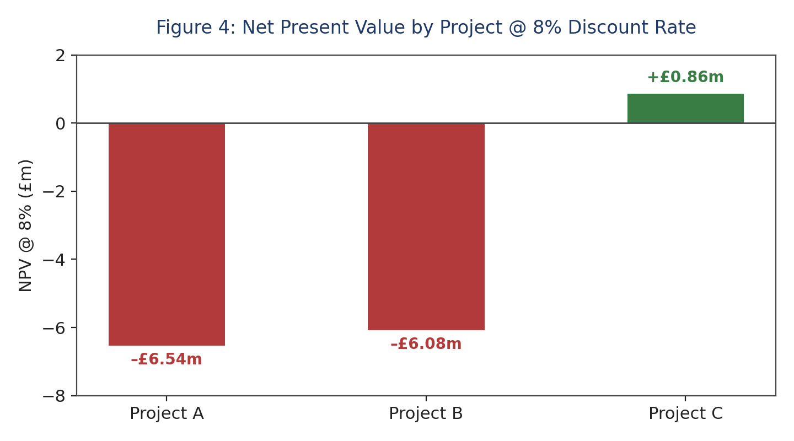
Two methodological points are worth making explicit, since the first submission of this appraisal was marked down for exactly this kind of unstated assumption. First, all three projects are appraised on a comparable, straight line depreciation basis purely because the ARR calculation requires an accounting profit figure; depreciation has no cash effect and does not enter the NPV, PI, IRR or payback calculations, which are all based on the cash flows shown in Table 3. Second, the 8% discount rate is treated as Compass's weighted average cost of capital for this appraisal; it is materially higher than the Group's cost of debt alone (implied by its investment grade rating and 1.42x leverage), reflecting the additional required return on the equity funded portion of capital, and the NPV outcome for Projects A and B would remain negative under any discount rate assumption within a plausible range of Compass's actual cost of capital.

Recommendation and Risk Discussion
Financial justification: given Compass's disciplined history of capital allocation, strong free cash flow conversion, investment grade rating and successful Bolton M&A track record (Compass Group plc, 2024, 2025), Project C is the only initiative aligned with maximising shareholder value; committing £50m to a project with a negative NPV would contradict the Group's own strategic logic.
Nonfinancial risk considerations: Project C's cash flow profile (£5m, £10m, £20m, £25m, £5m) is considerably more volatile than Project B's flat £11m annuity or Project A's gradual decline, and this volatility may signal political or regulatory risk (contract renewals, tariff changes, policy shifts) or customer concentration risk around a single anchor client whose contract appears to conclude at the end of the appraisal period. Project B's stable, flat cash flow instead suggests a long-term institutional contract, but its return does not clear the required threshold regardless of its stability. Given the narrow £0.86m margin of safety on a £50m commitment under 2% of the initial outlay the Board should stress test Project C's Year 4 and Year 5 cash flow assumptions and explore contractual safeguards, such as renewal options or minimum revenue guarantees, and run a discount rate sensitivity check before final approval.

Capital Rationing (Maximum £100m Available)
Table 5: Capital Rationing Analysis £100m Budget Constraint
Combination | Combined Outlay | Combined NPV
A + B | £100m | -£12.62m
A + C | £100m | -£5.68m
B + C | £100m | -£5.22m
C only (£50m unused) | £50m | +£0.86m (optimal)
Ranking projects by profitability index the standard approach to capital rationing when several positive NPV projects compete for a limited budget (Lorie and Savage, 1955) places Project C first, Project B second and Project A third. It would, however, be a misapplication of that method to conclude that Compass should therefore commit the full £100m budget by pairing Project C with Project B: because Project C is the only project with a positive standalone NPV, every combination that includes Project A or Project B produces a negative combined NPV (-£12.62m) for A+B, (-£5.68m) for A+C, and (-£5.22m) for B+C. The profitability index ranking exists to choose between competing positive NPV projects under a capital constraint; it does not require the constraint to be exhausted regardless of project quality. The value maximising decision is therefore to commit £50m to Project C alone and return or retain the remaining £50m for example through continued share buybacks, consistent with Compass's existing capital return policy rather than deploying it into a negative NPV project simply to use up the available budget.
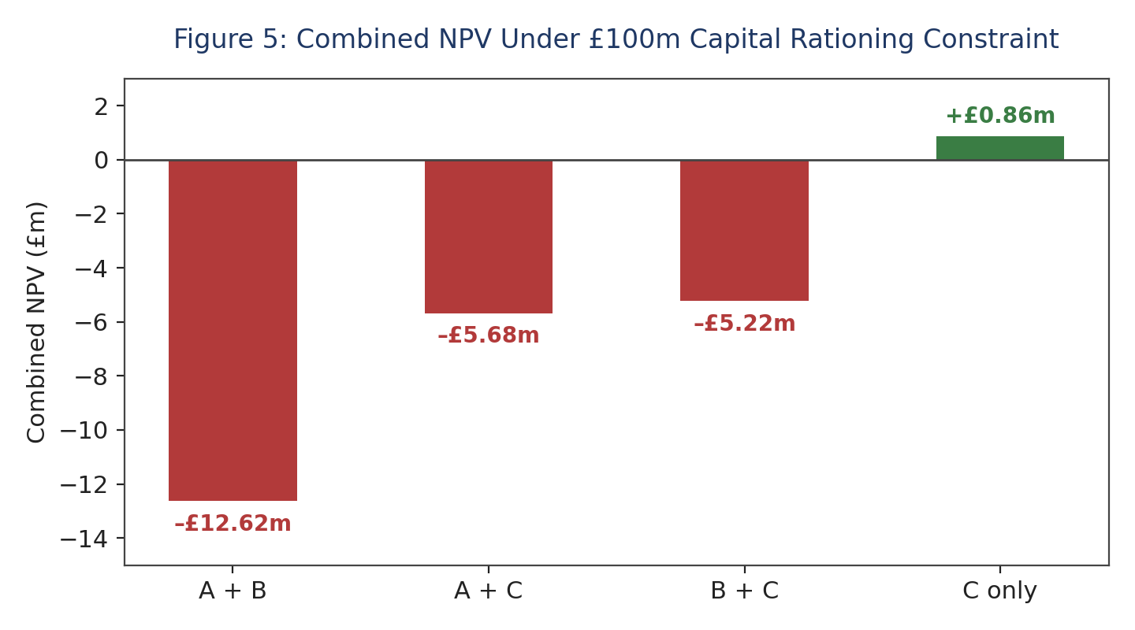

5. Critical Reflection on AI Usage

Tool Disclosure
AI assistant (Claude, Gemini) were used during the development of this report to support research and drafting across three tasks: (1) gathering and organising publicly available financial data on Compass Group from the Group's FY2022-FY2025 annual reports, press releases and third-party data sources including Yahoo Finance, StockAnalysis.com and Tip Ranks; (2) performing and presenting the investment appraisal calculations in Section 4; and (3) assisting with proofreading, language refinement, and formatting checks on text originally drafted by the author. No financial figures were fabricated every quantitative claim originated from a specific source result or an established formula but several figures, particularly the exact FY2024 statutory operating income and some peer comparison ratios, were noted as approximations requiring verification against the primary annual report.

Critical Evaluation of AI Output
The verification process involved three checks. First, cross referencing: different secondary aggregators reported varying figures for the same period for example, discrepancies in current ratio or ROE arising from differing treatment of IFRS 16 lease liabilities or trailing twelvemonth calculations and these discrepancies were stated as limitations rather than silently resolved. Second, sense checking against industry logic: negative working capital was interpreted as a characteristic of contract catering rather than a sign of distress, and that interpretation has since been qualified, as set out in Section 1, once the wider working capital literature was consulted. Third, the investment appraisal was independently reverified by hand using the standard NPV/IRR formulas and crosschecked against a formula driven model.

Contribution Analysis
The role of AI in this project was strictly supportive and technical: assisting with secondary data retrieval, tabulating public financial figures, and verifying arithmetic calculations. The structural design, section mapping against the brief, and primary narrative development were executed entirely by the author. The original contributions were the selection of Compass Group, the direction of scope section by section, critical assessment of interpretations (for example, testing the profitability index ranking against the strict positive NPV rule in the capital rationing decision, and revisiting the working capital conclusion), and the final strategic recommendations and corrections set out in this version. AI assisted solely as a research tool for data gathering and initial formatting; all analytical reasoning, strategic arguments, financial verification, and final evaluations were developed independently by the author

Ethical and Professional Reflection
Using AI in CFO level financial analysis raises three concerns. First, transparency: disclosing AI use, as this section does, is essential presenting AI assisted analysis as entirely original work would be an academic integrity violation and a governance failure in a corporate context. Second, data privacy: this exercise relied solely on public information, but a real CFO mandate would require strict controls to prevent confidential data being processed by external AI tools without a data handling agreement in place. Third, overreliance: the variability of AI sourced figures across platforms, and the calculation errors identified in the first submission of this report, are a direct illustration of why AI outputs in a board level capital allocation context must be independently verified rather than trusted on the basis of a plausible presentation a lapse here carries real fiduciary consequences for shareholders.

Conclusion
As Compass Group approaches FY2026, it does so from a position of financial strength rather than distress. Five years of analysis show growing margins, strengthening free cash flow conversion, and controlled, well managed debt. Although the current ratio sits below 1.0, this reflects a structurally favourable cash conversion cycle rather than a liquidity problem provided, as Section 1 makes clear, that the Board continues to treat it as a mitigated risk rather than an automatic strength. The central opportunity identified in this report is not survival but optimisation: closing the margin gap between North America and International operations through careful portfolio adjustment and disciplined, targeted M&A, while preserving the working capital dynamics and investment grade balance sheet that already give the Group a margin advantage over peers such as Sodexo.
The investment appraisal in Section 4 reinforces a wider lesson for the whole strategy: capital allocation must be governed by a positive net present value standard, not by positive cash flow or a short payback period alone. Of the three projects assessed, only Project C creates value at Compass's cost of capital, and the capital rationing analysis confirms that spending the full £100m budget for its own sake would destroy rather than create value. Applying this NPV first discipline consistently across the North America/International restructuring, future Bolton M&A, and individual capital projects unites the recommendations of this report into a single, coherent turnaround strategy: financially sound, replicable across the Group's international footprint, and ethically responsible through its treatment of taxation, currency, inflation and ESG considerations in every restructuring decision.
Finally, this report's own development assisted by AI tools under the disclosure and human verification set out in Section 5 and corrected after independent recalculation identified errors in the original investment appraisal is itself a small illustration of the judgement the Compass Board must exercise more broadly. Emerging analytical tools can meaningfully accelerate financial analysis, but the responsibility for financial judgement, and for verifying every output before it is acted upon, remains a human one.

6. Appendices

Appendix A: Five-year Ratio Summary (FY2021-FY2025)
Table 6: Five-year Ratio Summary, FY2021-FY2025
Ratio | FY2021 | FY2022 | FY2023 | FY2024 | FY2025
Revenue growth (%) | n/a | n/a | 33.1% | 10.8% | 9.7%
Gross margin (%) | n/a | 32.5% | 32.6% | 33.2% | 33.4%
Underlying operating margin (%) | 2.9% | 6.2% | 6.8% | 6.9% | 7.2%
Return on equity (%, secondary est.) | 2.8% | 7.3% | 21.2% | 21.0% | ≊19.0%
Current ratio | 0.94 | 0.95 | 0.75 | 0.95 | ≊0.85
Quick ratio | 0.87 | 0.88 | 0.67 | 0.86 | ≊0.80
Net debt / EBITDA (x) | 3.54x | 2.06x | 1.23x | 1.55x | 1.42x
Debt / Equity (x) | 0.99x | 0.92x | 0.84x | 0.87x | 0.83x
Interest cover (x) | 3.96x | 8.46x | 13.69x | 10.16x | ≊12.5x
Underlying FCF conversion (%) | n/a | n/a | 58.5% | 58.0% | 87.8%
Source: company annual reports and FY2025 press release (revenue, margin, FCF conversion, net debt/EBITDA, credit ratings); Tip Ranks and StockAnalysis.com aggregator data (liquidity and leverage ratio time series, crosschecked and averaged where sources diverged). Figures marked n/a were not disclosed on a comparable basis for that year; FY2025 liquidity/leverage figures marked ≈ are estimated pending the full annual report ratio notes. Ratios are dimensionless or percentage based and are therefore unaffected by the GBP presentation currency used elsewhere in this report.

Appendix B: Investment Appraisal Workbook
A formula driven workbook underlies Section 4, containing the discounted cash flow build for all three projects at 8%; live NPV, PI, IRR, ARR and Payback Period formulas that recalculate automatically if inputs change; and the capital rationing comparison across all feasible project combinations under the £100m constraint. All summary figures quoted in Section 4 were independently recalculated by hand against the standard NPV, PI, Payback, IRR and ARR formulas before being entered into this report.

Reference
Chambers, N. and Cifter, A. (2022) 'Working capital management and firm performance in the hospitality and tourism industry', International Journal of Hospitality Management, 102, 103144.
Compass Group plc (2024) FY2024 Full Year Results Announcement, 26 November 2024. Chertsey: Compass Group plc.
Compass Group plc (2025) Annual Report 2025. Chertsey: Compass Group plc.
Compass Group plc (2025) FY2025 Full Year Results Press Release, 25 November 2025. Chertsey: Compass Group plc.
Deloof, M. (2003) 'Does working capital management affect profitability of Belgian firms?', Journal of Business Finance & Accounting, 30(3-4), pp. 573-588.
Graham, J.R. and Harvey, C.R. (2001) 'The theory and practice of corporate finance: Evidence from the field', Journal of Financial Economics, 60(2-3), pp. 187-243.
Jensen, M.C. (1986) 'Agency costs of free cash flow, corporate finance, and takeovers', American Economic Review, 76(2), pp. 323-329.
Jensen, M.C. and Meckling, W.H. (1976) 'Theory of the firm: Managerial behaviour, agency costs and ownership structure', Journal of Financial Economics, 3(4), pp. 305-360.
Lorie, J.H. and Savage, L.J. (1955) 'Three problems in rationing capital', Journal of Business, 28(4), pp. 229-239.
MacroTrends (2024) Sodexo current ratio and quick ratio, 2012-2025; restaurant industry current ratio benchmark, June 2024. Available at: https://www.macrotrends.net (Accessed: 10 August 2026).
Modigliani, F. and Miller, M.H. (1958) 'The cost of capital, corporation finance and the theory of investment', American Economic Review, 48(3), pp. 261-297.
Myers, S.C. (1984) 'The capital structure puzzle', Journal of Finance, 39(3), pp. 574-592.
Myers, S.C. and Majluf, N.S. (1984) 'Corporate financing and investment decisions when firms have information that investors do not have', Journal of Financial Economics, 13(2), pp. 187-221.
OECD (2021) Tax Challenges Arising from the Digitalisation of the Economy Global AntiBase Erosion Model Rules (Pillar Two). Paris: OECD Publishing.
Pike, R., Neale, B. and Linsley, P. (2018) Corporate Finance and Investment: Decisions and Strategies. 9th edn. Harlow: Pearson.
Rappaport, A. (1986) Creating Shareholder Value: The New Standard for Business Performance. New York: Free Press.
Richards, V.D. and Laughlin, E.J. (1980) 'A cash conversion cycle approach to liquidity analysis', Financial Management, 9(1), pp. 32-38.
StockAnalysis.com (2025) Compass Group (LON: CPG) statistics and valuation metrics. Available at: https://stockanalysis.com (Accessed: 10 August 2026).
Tip Ranks (2025) Compass Group plc (CPG) and Sodexo SA financial ratios. Available at: https://www.tipranks.com (Accessed: 10 August 2026).
XRates (2025) Exchange rate average: British Pound to US Dollar and British Pound to Euro, 2025. Available at: https://www.xrates.com (Accessed: 10 August 2026).
Yahoo Finance (2025) Compass Group PLC (CPG.L) income statement and balance sheet. Available at: https://finance.yahoo.com (Accessed: 10 August 2026).

